CPA Structural Analysis
November 4, 2019
Argonne National Laboratory: Frank Skrzecz, Ken Wood, Victor Guarino, Steve Magill, Nicholas Wozniak
Contents
Contents 1
1 Introduction 2
2 CPA Design 3
3 CPA Stress and Deflection Analysis 8
Load Case 1 - Lifting the CPA During Installation 10
Load Case 2 - CPA Hanging with Top and Bottom FC Attached in Installation Position 12
Load Case 3 - CPA Hanging with all FC Attached in Deployed Position 19
Load Case 4 - Operational Condition 24
Analysis of Effect of Pressure from Circulating Liquid Argon 29
4 CPA Thermal Considerations 29
5 Conclusion 30

Appendix 1 – CPA Structural Calculations

Introduction
The first detector of the DUNE long-baseline neutrino experiment will be located in the Homestake Mine at the Sanford Underground Research Facility (SURF) in Lead, South Dakota. The detector is a 10 kton Single Phase (SP) Time Projection Chamber (TPC) completely submerged in liquid argon with 3-wire Anode Plane Assembly (APA) readout. The complete TPC volume is approximately 12 m tall by 58 m long by ~14 m in the electron drift direction approximately perpendicular to the direction of the incoming neutrino beam. The elements which make up the HV Field Cage are the Cathode Plane Assembly (CPA) opposite the APA in the drift direction, the top and bottom Field Cage (FC) units, and the two EndWalls (EW) at the beginning and end of the 58 m long structure. The TPC is made up of 25 rows of the field cage elements between the two EWs, each row configured as APA-CPA-APA-CPA-APA where the APA-CPA connections are made at the top and bottom of the 12 m tall structure by the FCs in the drift direction. Fig. 1 shows this configuration with the central APA and two symmetric drift volumes on both sides.
Two cathode planes, 3.5 m away from the anode, terminate the central drift volumes. Two APA’s 3.5 m from left and right CPA respectively delimit the two external drift volumes. At the open sides of each drift volume (top, bottom, upstream and downstream), field cage modules are installed to define the uniform drift field of 500V/cm (nominal value). To reach this field, the cathode planes are biased at -180kV, with the anode planes at ground. The cathode bias is provided by an external high voltage power supply with a HV feedthrough connecting the cathode inside the cryostat.
Each cathode plane is constructed from 50 side by side CPA (Cathode Plane Assembly) Panels. Each CPA Panel is 1.15m in width and 12m tall, formed from 6 vertically stacked modules, and supported by the CPA installation rail above through a single link.
The field cage modules have two distinctive styles: the top/bottom, and the end wall. Each module is constructed from an array of extruded aluminum open profiles supported by two FRP (fiber reinforced plastic) structural beams. The T/B modules are supported by the CPAs and APAs.
This paper describes the CPA structure and the strength analysis of the CPA. The CPA structure has been examined based on the TC approved Analysis Plan EDMS #2142669.
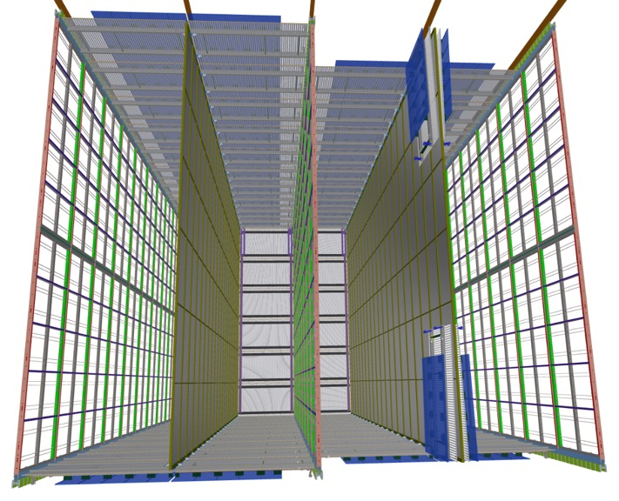
Figure 1. Geometry of TPC in DUNE-SP far detector cryostat. The central APA, and two external ones are shown interleaved with two CPA’s. The top and bottom field cage modules are also present (each equipped with field blocking ground plane modules); on the right in the picture, the front most FC modules are not deployed. For Clarity only the furthermost Endwall panels are shown.
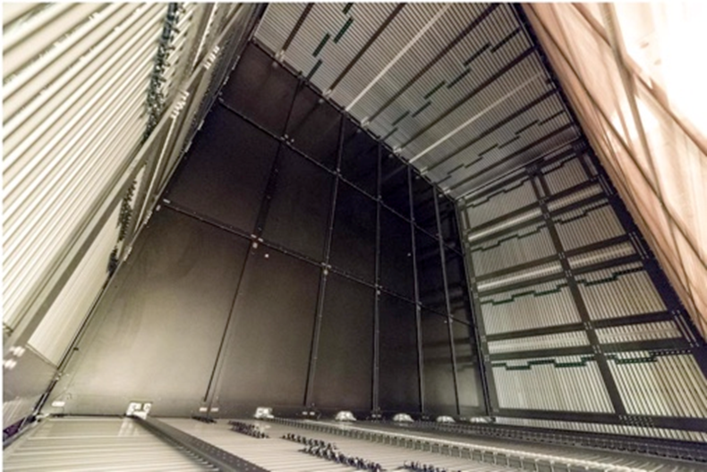
Figure 2. CPA and FC in ProtoDUNE-SP

CPA Design
The CPA is composed of six modules that are bolted and pinned together with tongue/groove joints to form a CPA panel. Figure 4 shows the basic geometry of a CPA panel and Figure 5 shows a typical frame joint. Each module consists of a framework in which the resistive panel is captured inside a groove. Each module weighs roughly 67.5 lbs for a total weight of the CPA panel of 405 lbs. The total weight of a CPA panel at the end of the array is 437 lbs including cables, crossbars and profiles.
The resistive panel is 1/8” thick FR4 and floats within the framework so that no external forces are applied to it. When hung vertically the weight of the resistive panel rests on the bottom cross bar of the module. The weight of the lower module is transferred through the side bars of the frame and up to the top cross bar. The resistive panel will have a layer of carbon-impregnated Kapton laminated on the front and back. The laminating will occur during the fabrication of the FR4 panel itself by an Italian company MDT.
The very top cross bar of the CPA panel has a block attached to it through which the entire load is transferred to the strap which attaches to the supporting stainless steel I-beam. The FR4 strap extends through the FC and then makes a transition to a stainless steel threaded rod for connection to the roof. See Figure 6 and Figure 9. Integral to this main support block is the hinge which supports the top FC modules. Each hinge must support half of the weight of a FC module (157lbs/2 = 78.5 lbs) during installation, and a fourth of its weight (105lbs/4 = 39.25lbs) after installation since 2 CPA panels are paired to form a CPA plane before attaching the top FC module.
Figure 9 and Figure 10 shows the hinge connection for the bottom FC modules. A block is bolted and pinned to the bottom cross bar of the FC module and a hinge attached to protruding wings.

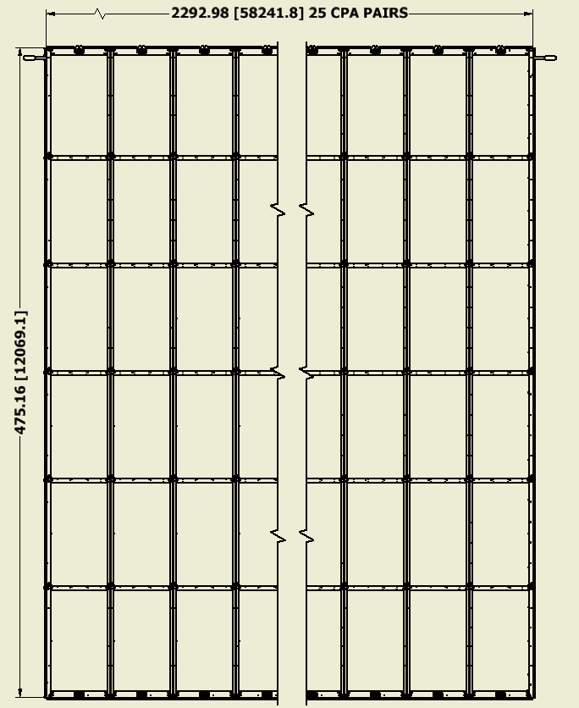
Figure 3. CPA Assembly
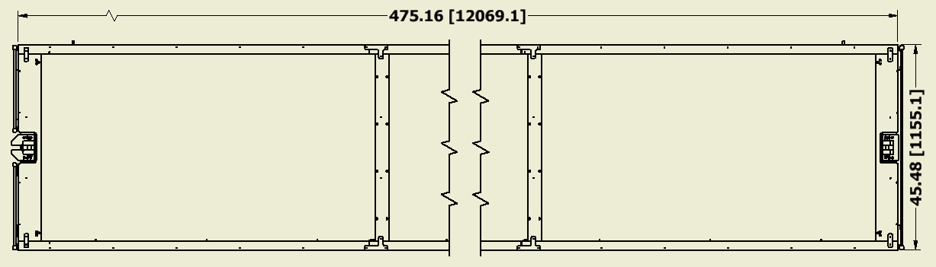
Figure 4. CPA Dimensions

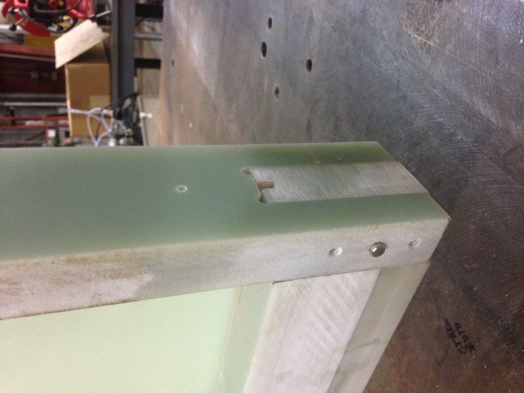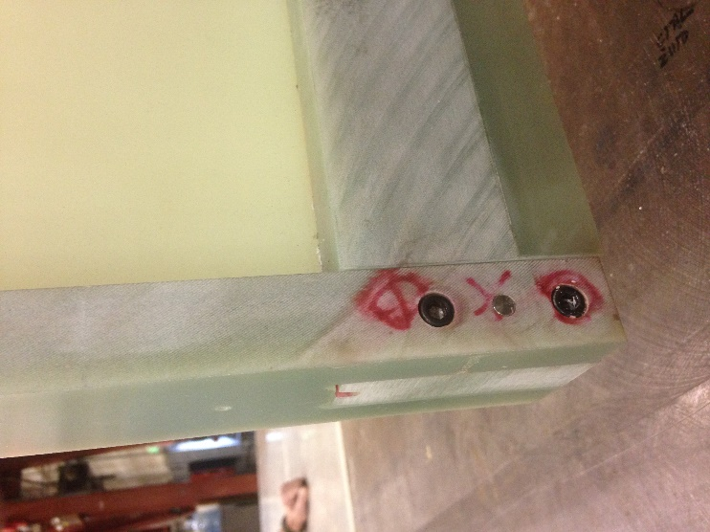
Figure 5. View of Tongue and Groove Joint
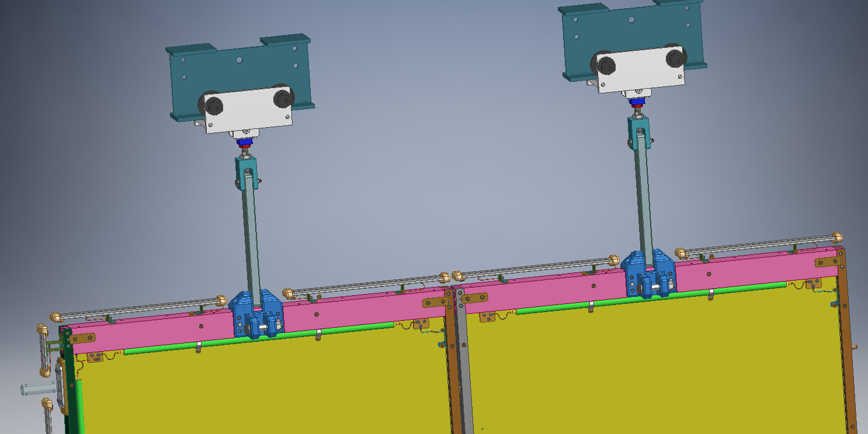
Figure 6. View of the interface between CPA Panels (Field Shaping Strips removed for clarity)
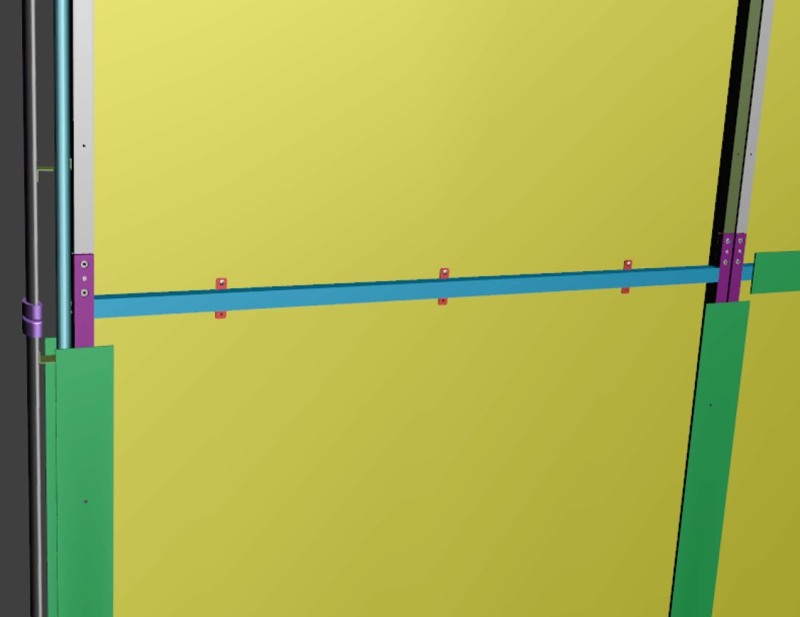
Figure 7. View of the interface between CPA modules. Upper Field Shaping Strips removed for clarity
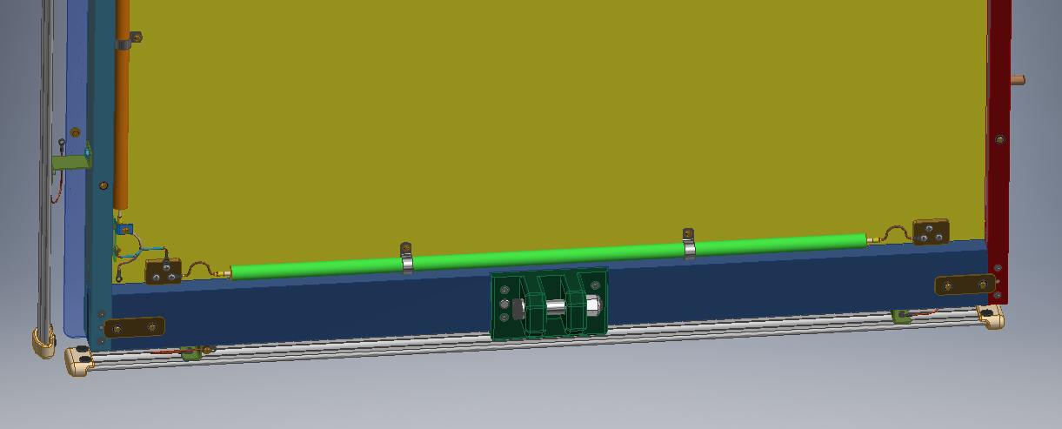
Figure 8. View of the bottom of CPA showing the HV connection and mounting for bottom FC modules. Field Shaping Strips removed for clarity
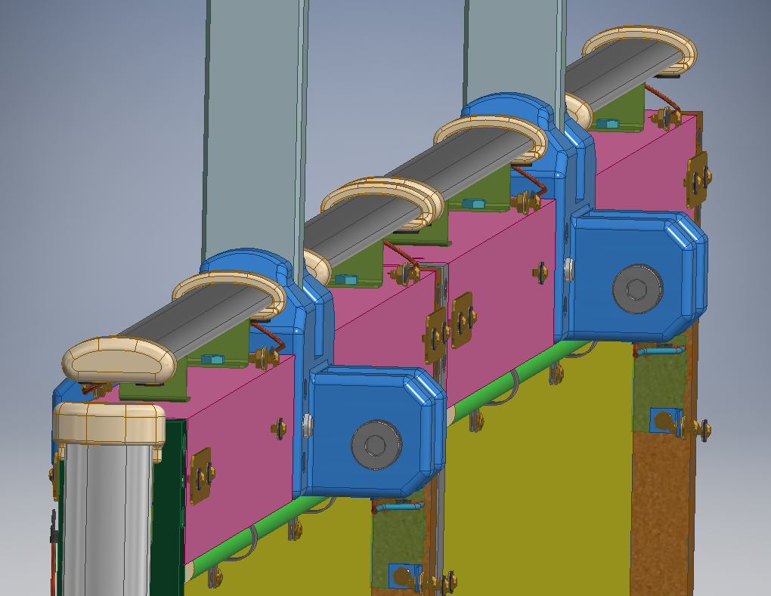
Figure 9. View of top of CPA Plane showing upper support block and hinge for mounting top FC modules. Field Shaping Strips removed for clarity
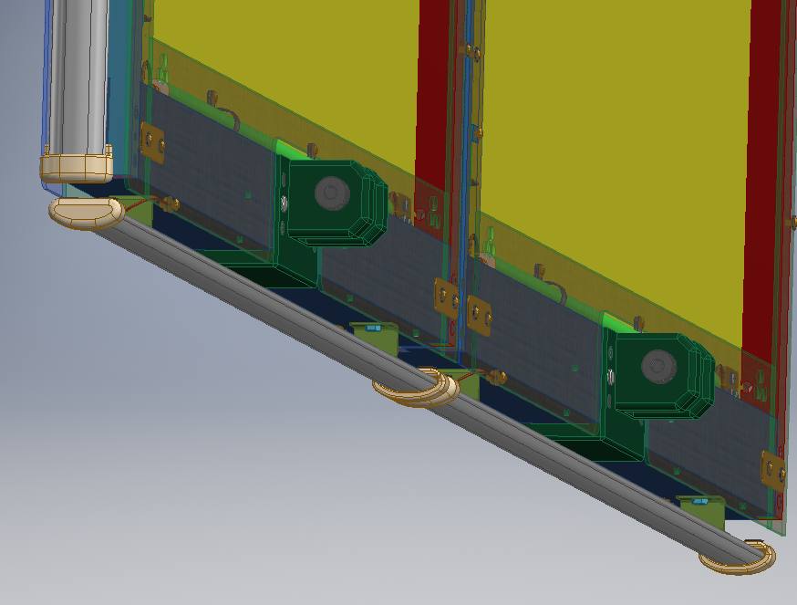
Figure 10. View of bottom of CPA and mounting for bottom FC Modules
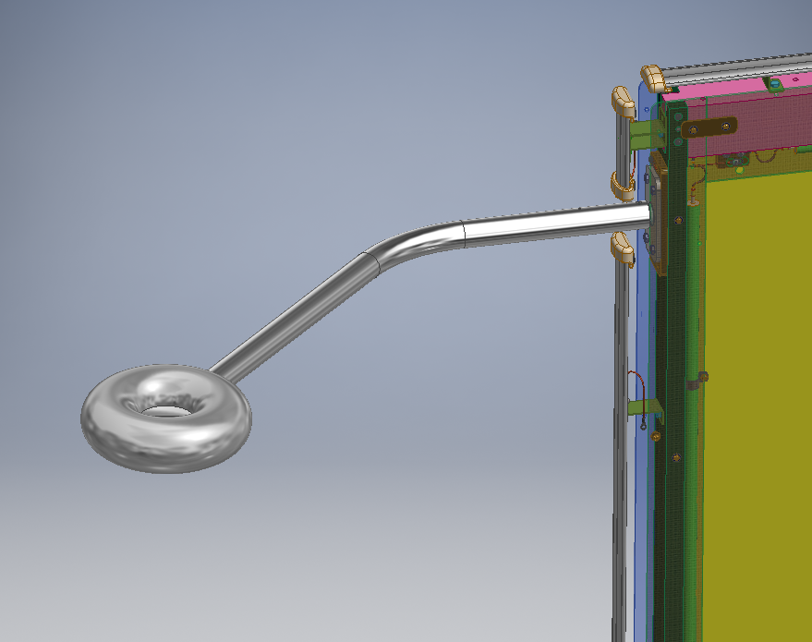
Figure 11. View of Electrical Connection to HV Cup
The HV will be fed to the CPA array through a donut connection shown in Figure 11. HV cable will run along the top and bottom of each CPA panel as shown in Figure 6 and Figure 8. A HV cable will also run down the side of the first CPA as shown in Figure 7 and go to the bottom where a second HV cable will run across CPA’s in the same manner as the top cable. The resistive coating on each module will be electrically connected together with brass tabs that are bolted through the panel to matching tabs on the opposite side, and between panels by running a HV cable that has to be connected during installation, Figure 6.
The CPA’s will also have field shaping strips (FSSs) attached to the outside surface of the frame. Each strip will overhang the internal sides of the frame by 1”. External FSSs on the top, bottom and sides at either end of the CPA Array will extend beyond the outside of the frame by ½ “.
The assembled row of CPAs will have FC profiles attached to them around the outside perimeter and are shown in green in Figure 9, Figure 10, and Figure 11.

CPA Stress and Deflection Analysis
The CPA frame has been evaluated using FEM analysis with ANSYS Workbench alongside empirical calculations. Detailed calculations are shown in Appendix 1. The CPA is a simple frame and the sections are tied together with a tongue and groove joint. Each 2m long module weighs only 73 lbs and is assembled on a table and then shipped, assembled into 2-module CPA units in a stack horizontally under no load. Three 4m long units are lifted out of the shipping crate from the horizontal to the vertical placing the unit in bending, see Figure 13. Once vertical, the 4m sections are attached to each other on an assembly fixture to form a full 12m long panel. Two panels are then brought together to form a CPA plane, and the top and bottom FC modules are hung from them, see Figure 12. This configuration is the maximum loading during installation.
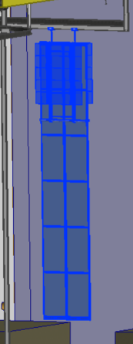
Figure 12. CPA with FC Attached During Installation

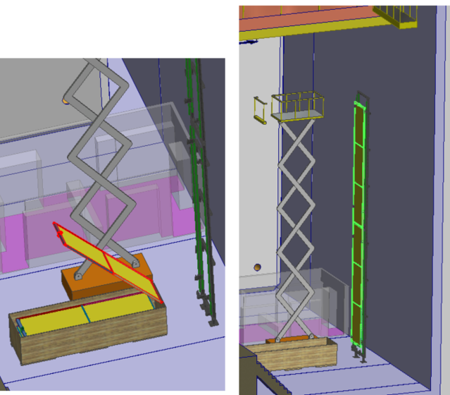
Figure 13. Assembly of CPA
The JRC Science for Policy Report “Prospect for New Guidance in Design of FRP” is used as a guide for the strength calculations. It specifies a strength reduction factor that has been calculated to be 3.75. It does not specify a load factor. In addition, a stress concentration factor of 2.3 has been applied to all pinned joints. See Section 1 of Appendix 1 for details.
FR4 Material Properties:
Thermal expansion Coefficient Normal at 87K 29.4 x 10^-6 cm/cmK
Thermal expansion Coefficient Warp at 87K 9.7 x 10^-6 cm/cmK
Modulus of Elasticity 18.6 GPa (2,770ksi)
Ultimate stress Weak 165.4 MPa (24ksi)
Ultimate stress Strong 200 MPa (29ksi)
Ultimate stress Thickness 64.7MPa (9390psi)
Density 1.8 g/cm^3

The main loading occurs during rotation from the horizontal to the vertical orientation, and then while vertical when the FC modules are hung from the 2-Panel CPA plane. Figure 12 shows a CPA plane supporting the FC modules during installation. Each FC module weighs 157 lbs so a single CPA panel is loaded with 78.5 lbs on both sides at the top and bottom during installation.
The CPA structure has been examined based on the TC approved Analysis Plan EDMS #2142669 which also defines all of the required load cases.
The load cases that have to be considered are:
- Case 1: Lifting of the 4m long CPA unit from horizontal to vertical during installation
- Case 2: CPA hanging while supporting two top and two bottomFC modules that are not deployed.
- Case 3: CPA hanging while supporting four FC modules that are deployed
- Case 4: Operational condition cold.

The highest stresses and deflections occur during assembly before the cryostat is filled with liquid. During installation the CPA must carry the full weight of the FC, rather than sharing it with the APA and the buoyancy force from the liquid Argon which reduces the load from gravity when the cryostat is full.
In all of the analysis the weight of the resistive panels was included but any additional strength or stiffness from them was not included. In the design of the CPA it is planned that the resistive panel will float within a frame without carrying load or contributing to the stiffness of the modules. This assumption was investigated and verified in the ANSYS analysis.
In all of the load cases the loads/stresses are below the allowable loads/stresses. The table below summarizes the safety factor above allowable for each Load Case which occurs for all load cases in the FR4 bar that connects the CPA to the DSS, see Section 6.1.2 of Appendix 1
Load Case | Safety Factor
1 | 8.2
2 | 7.1
3 | 9.4
4 | 25.6

Load Case 1 - Lifting the CPA During Installation
During installation the three 4m frame units that make up a CPA panel will be lifted from the horizontal to the vertical and then attached together to form the full 12m panel. Figure 13 shows a 4m long unit being lifted from horizontal to vertical. The worst case loading occurs immediately after the crane begins to lift the top of the module when it is simply supported at its ends. The stresses are calculated in section 4 of Appendix 1. The unit will sag a maximum of 0.71” and the first principle stresses are about 1150 psi, see Figure 1 which is a factor of 20 below the allowable stress. The stress concentration at the pin hole location is about 2150 psi, which is a factor of 11 below the allowable stress. The safety factor is 8.2 and is calculated from the max applied moment calculated in Appendix 1.
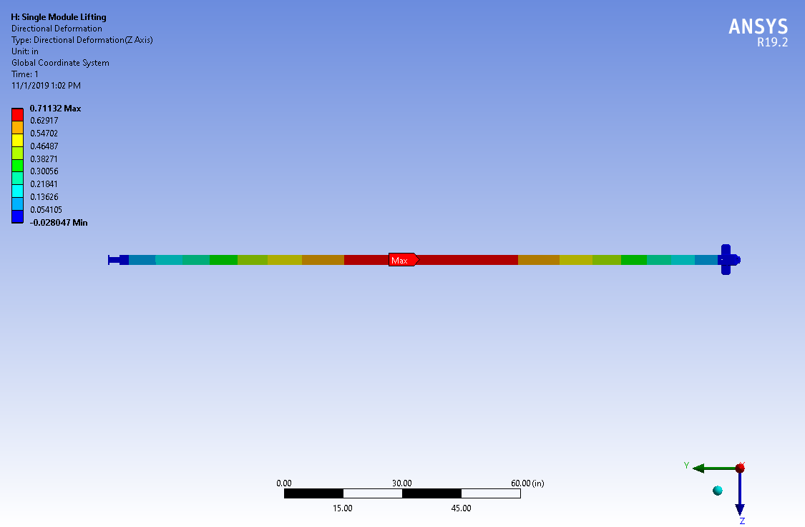
Figure 14. Location and contours for the maximum bending deflection during lifting

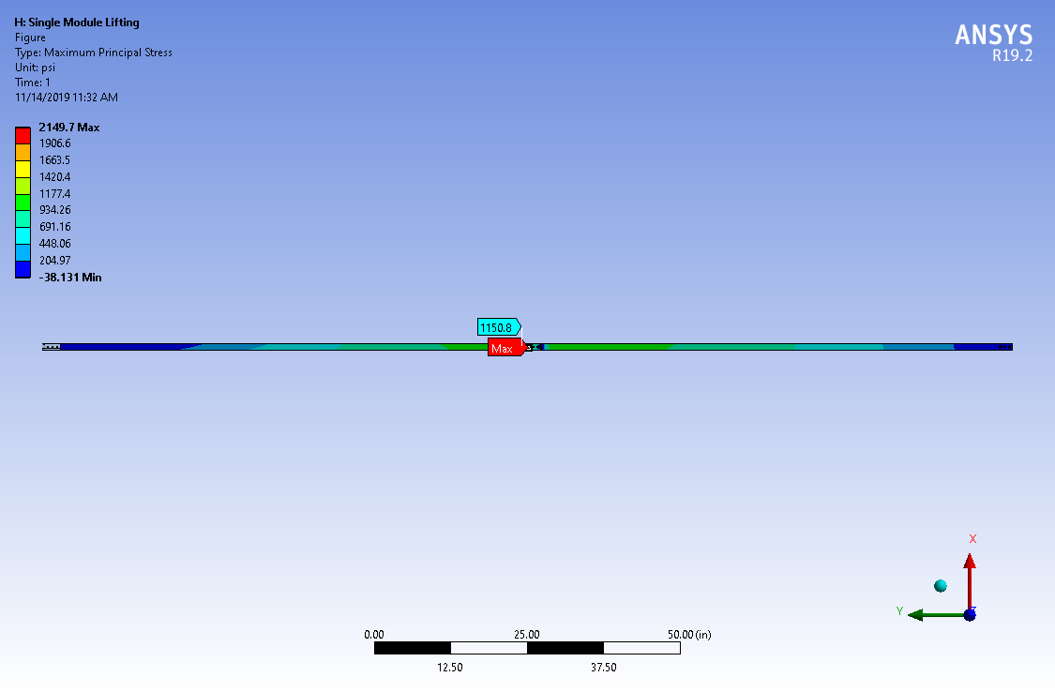
Figure 15. Location and values of maximum bending stress during lifting

Load Case 2 - CPA Hanging with Top and Bottom FC Attached in Installation Position
During installation, the two top and bottom FC modules will be hung from a CPA plane (CPA panel pair). Once installed in the correct location in the detector the top and bottom FC modules will be deployed. The current estimate for the FC weight is 157 lbs. This load is carried by 2 CPA panels so each hinge on the CPA will support 78.5 lbs from each FC in the installation position or a total of 157 lbs per CPA panel. The loads of the top FC modules are transferred through the aluminum hinge directly to the center strap that supports the CPA, see Figure 16 and Figure 17.
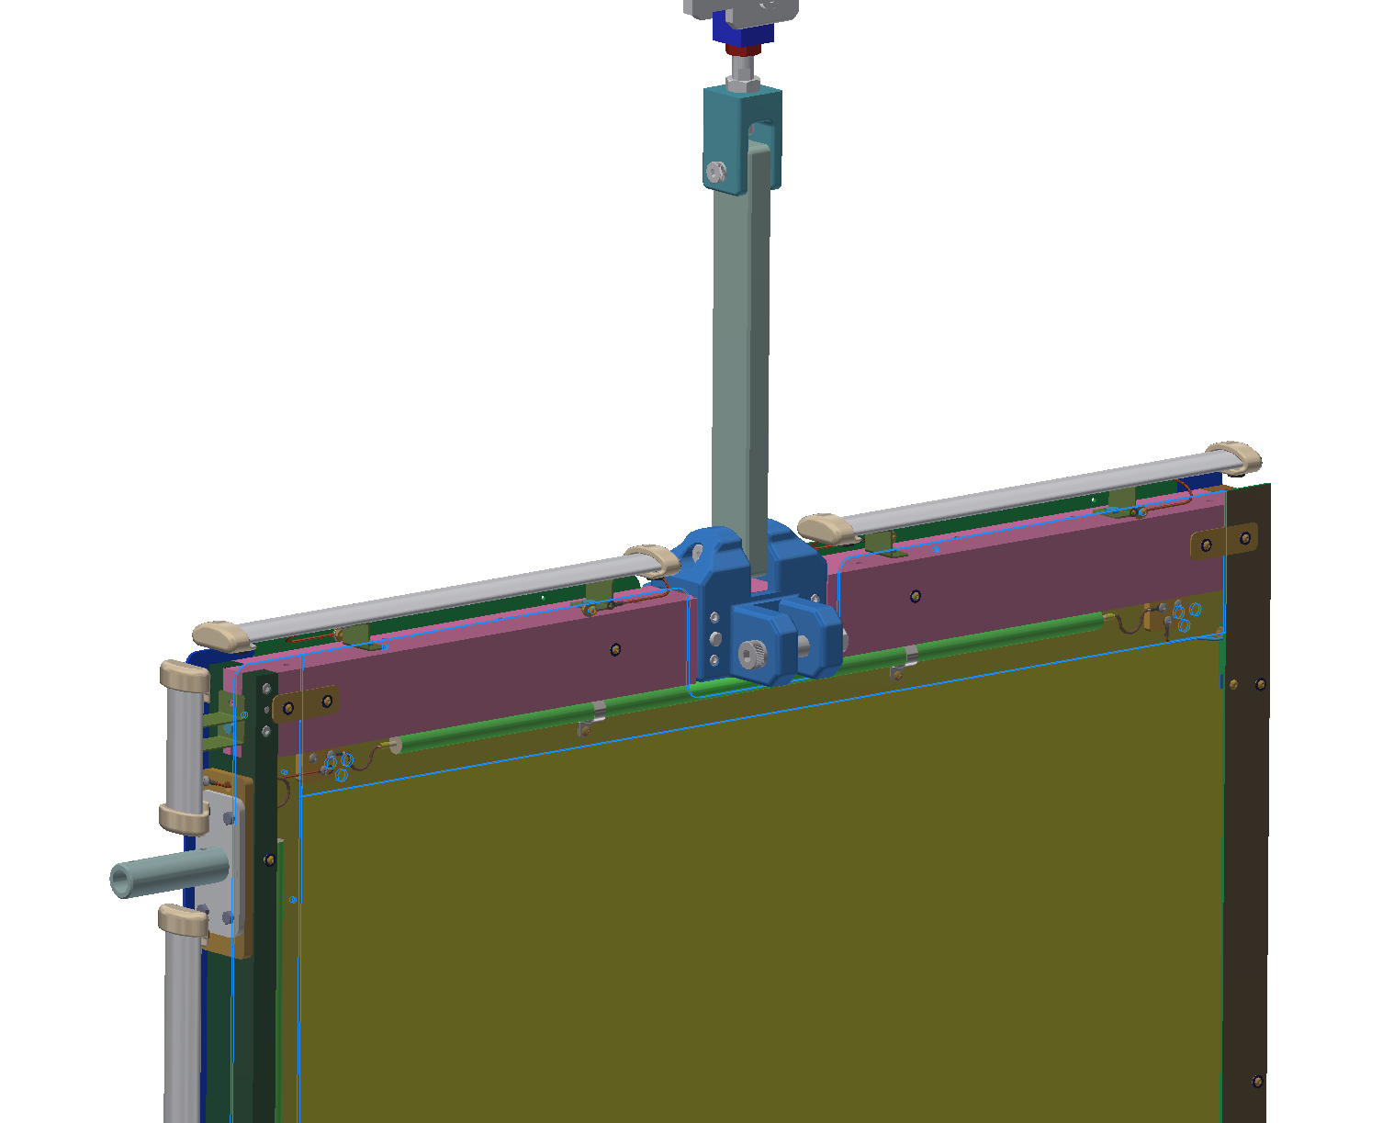
Figure 16. Top Strap Connecting CPA to DSS
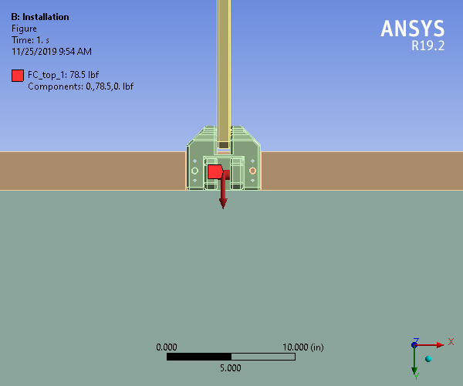
Figure 17. Model showing the loading at the installation case on the CPA panel top hinge on one side
The load of the bottom FC modules are transferred through the aluminum hinge directly to the bottom bar and then through the vertical bar supports on either side of the panel, see Figure 18.
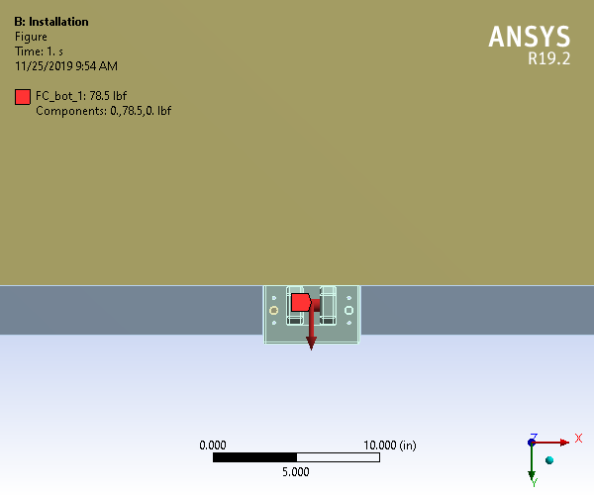
Figure 18. Model showing the loading at the installation case on the CPA panel bottom hinge on one side
The center main strap that supports the CPA has a load of 726 lbs, see Figure 19. The stress distribution away from the holes is about 363 psi with a cross-sectional area of about 2 square inches. At the hole, there is a stress concentration of about 1215 psi which needs to be carried by the strap. There is a safety factor of 7.1 above the strength of the central strap when the pin connection is perpendicular to the fiber mesh, see Appendix 1 Section 6.1. Therefore, during fabrication of the top strap the pin must be oriented perpendicular to the mesh or the size of the strap should be increased so that the pin can be inserted in any direction. Tests on the strap strength showed that the joint can withstand greater than 9000 lbs before failure.
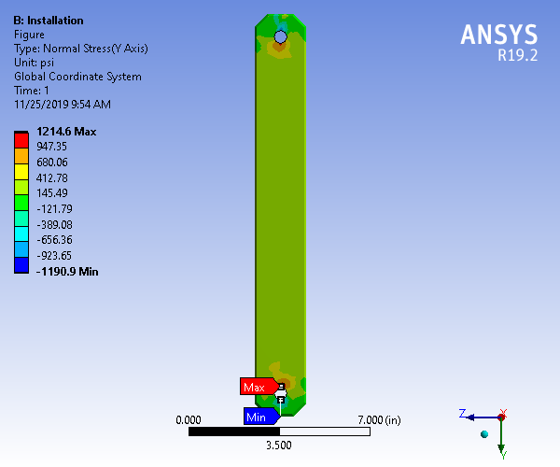
Figure 19. Strap stress distribution, installation
The CPA frame joints between the top bar and the vertical bars only have to support the self-weight of the CPA and half the weight of two FC modules from the bottom of the panel. The load at the top joint is 376 lbs. With the pin perpendicular to the mesh the design joint strength is 4120 lbs for a safety factor of 11. See Section 6.2.2 of Appendix 1. Testing showed that the failure load of the joint is 6600 lbs, see Section 4.2 above. Looking at the stresses, the principal stresses occur in the primary orthogonal axes (X, Y, and Z) based on the plots of the shear stresses showing little to no shearing in any of the primary planes, Figure 20, Figure 21, and Figure 22. The only significant stress is the normal in the Y axis (Figure 24), with a max value around 909 psi as a stress concentration giving a safety factor of about 26.

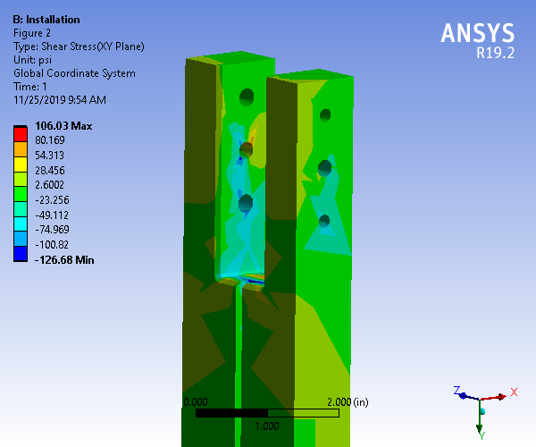
Figure 20. Shear stress (XY plane) for top vertical bar connection

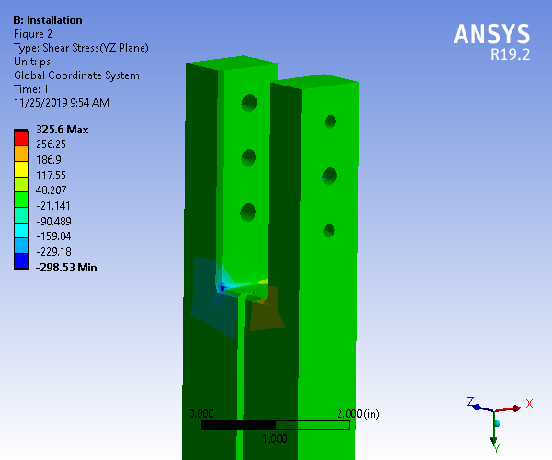
Figure 21. Shear stress (YZ plane) for top vertical bar connection
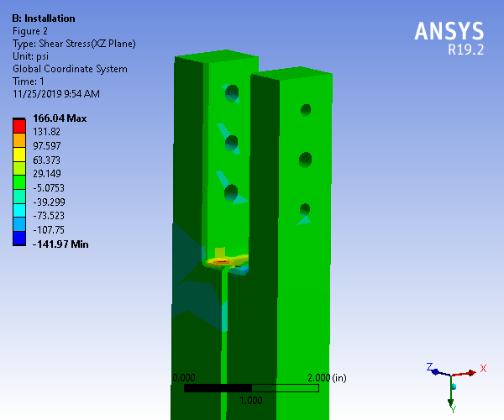
Figure 22. Shear stress (XZ plane) for top vertical bar connection
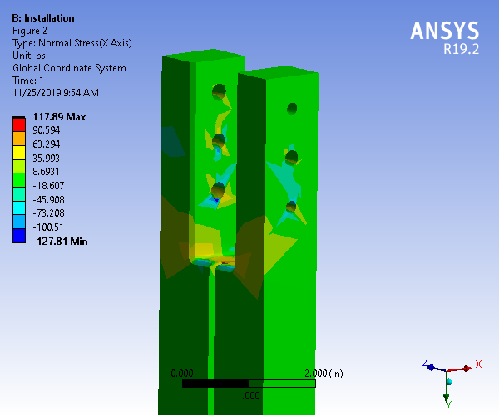
Figure 23. Normal stress (X axis) for top vertical bar connection
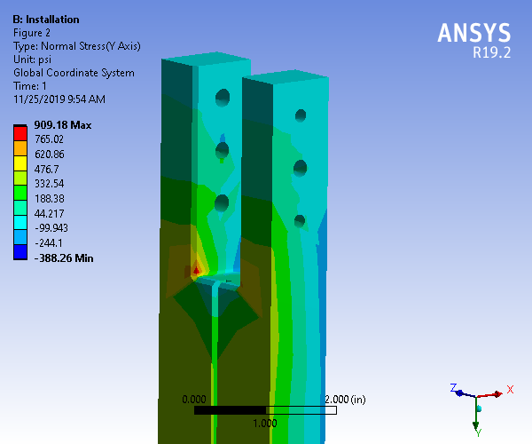
Figure 24. Normal stress (Y axis) for top vertical bar connection

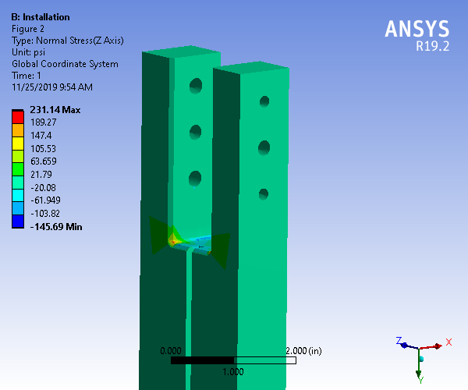
Figure 25. Normal stress (Z axis) for top vertical bar connection

The top bar of the CPA frame is supported in the middle at the aluminum connection and carries the weight of the CPA and the FC at the bottom of the CPA panel through the connections at the end of the bar. The bar behaves like a symmetric double cantilever with loads applied at either end, see section 6.4 of Appendix 1. The maximum stress in the bar occurs at the location where the cross section changes, with a value of 2413 psi giving a safety factor of 9.8. The maximum deflection at the end of the beam is 0.0646 in, which is the difference of the total nodal deflection at the end of the beam minus the deflection of the support location. Thus, the overall safety factor for this load case is governed by the strength of the central strap, with a value of 7.1.

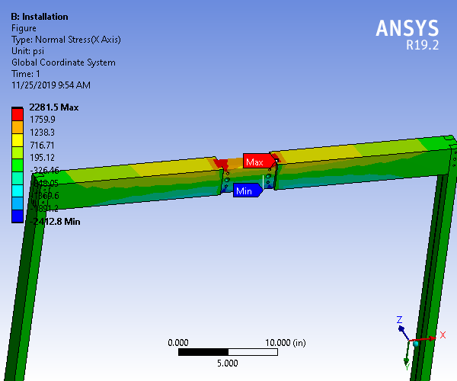
Figure 26. Top bar bending stress, installation loading
An additional case investigated for the installation loading was a worst-case swing loading scenario where the FCs are all loaded on one side, before deployment, to check the maximum amount of swing and the applied moment against the allowable moment, see Section 7 of Appendix 1. As shown in Figure 27, the maximum amount of swing is 4.1 in.
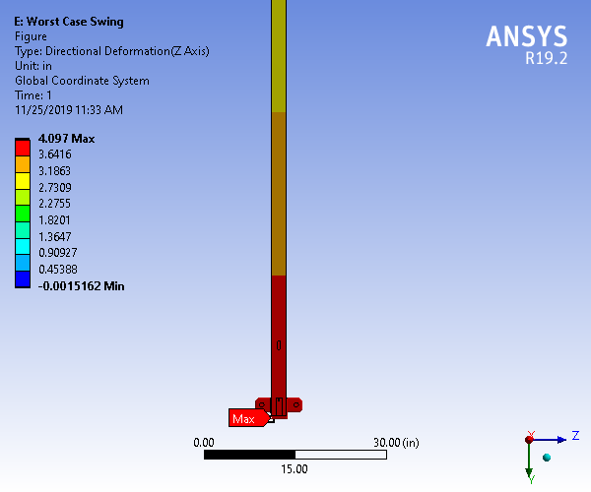
Figure 27. Maximum swing at the bottom of the CPA panel

Load Case 3 - CPA Hanging with all FC Attached in Deployed Position
The current estimate for the FC weight is 105 lbs. This load is carried by 2 CPA panels and by the APAs after deployment so each hinge on the CPA will support 39.25 lbs in the installation position. The top two hinges on the CPA will have 39.25 lbs applied. The bottom hinges will also have 39.25 lbs applied.
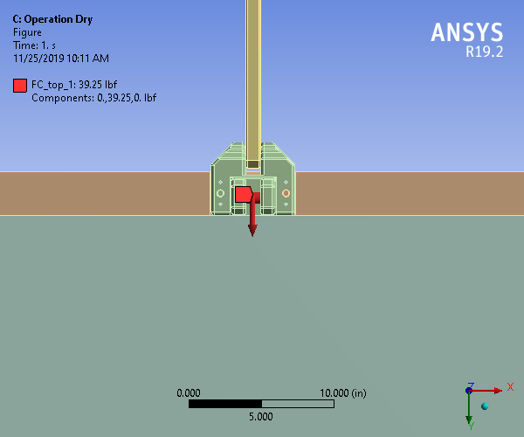
Figure 28. Model showing the loading at the dry deployed case on the CPA panel top hinge on one side
The center main strap that supports the CPA has a load of 568 lbs, see Figure 21. The stress distribution away from the holes is about 284 psi with a cross-sectional area of about 2 square inches. The design load of the strap when the pin is perpendicular to the mesh is 5317 lbs which gives a safety factor of 9.4, see Section 6.1 of Appendix 1. At the hole, there is a stress concentration of about 891 psi which needs to be carried by the strap.
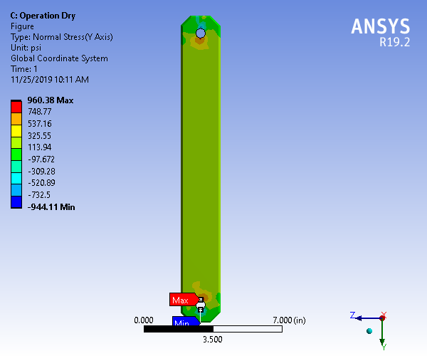
Figure 29. Strap stress distribution, deployed position
The CPA top frame joint should support half the CPA weight and half of the FC weight (two times one quarter of the weight of the FC module). The load at the CPA top frame joint is 297 lbs and the design strength is 4120 lbs which gives a safety factor of 13.9, see Section 6.2 of Appendix 1. Looking at the stresses, the principal stresses occur in the primary orthogonal axes (X, Y, and Z) based on the plots of the shear stresses showing little to no shearing in any of the primary planes, Figure 30, Figure 31, and Figure 32. The only significant stress is the normal in the Y axis (Figure 34), with a max value around 773 psi as a stress concentration giving a safety factor of about 29.8.
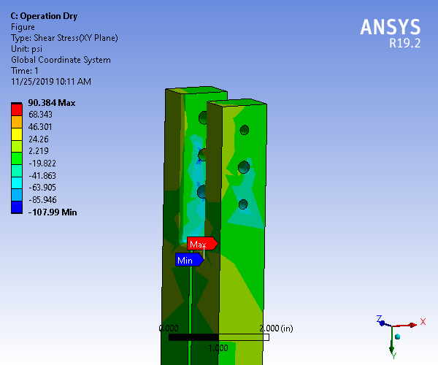
Figure 30. Shear stress (XY plane) for top vertical bar connection
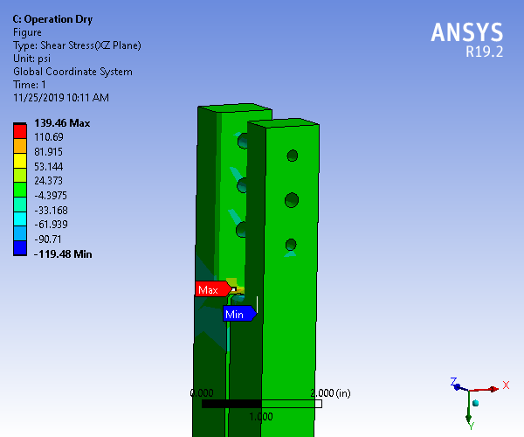
Figure 31. Shear stress (XZ plane) for top vertical bar connection
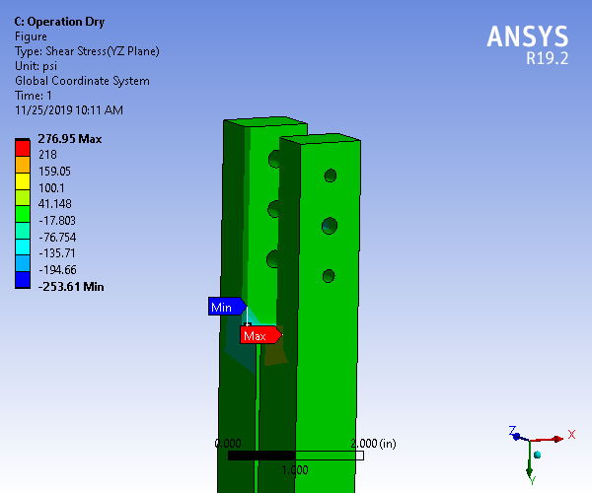
Figure 32. Shear stress (YZ plane) for top vertical bar connection
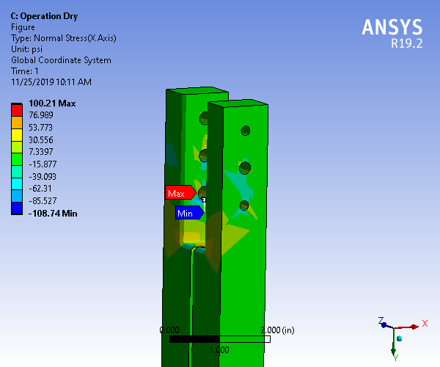
Figure 33. Normal stress (X axis) for top vertical bar connection
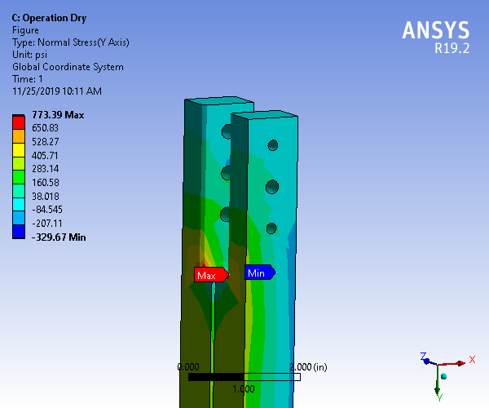
Figure 34. Normal stress (Y axis) for top vertical bar connection
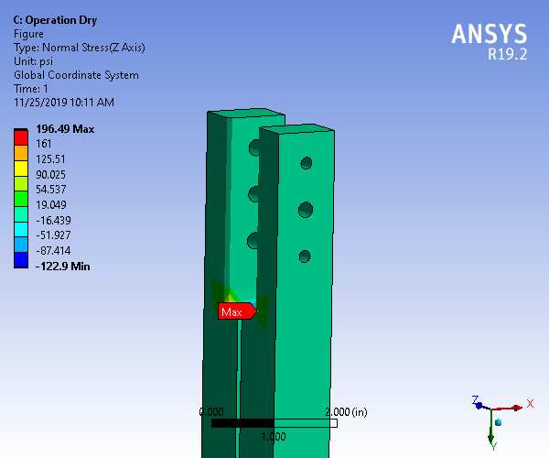
Figure 35. Normal stress (Z axis) for top vertical bar connection
The top bar of the CPA frame is supported in the middle at the aluminum connection and carries the weight of the CPA and the FC at the bottom of the CPA panel through the connections at the end of the bar. The maximum stress in the bar occurs at the location where the cross section changes (Figure 36), with a value of 2069 psi which gives a safety factor of 11.5. Thus, the overall safety factor is governed by the central strap for this deployed load case, with a value of 9.4.

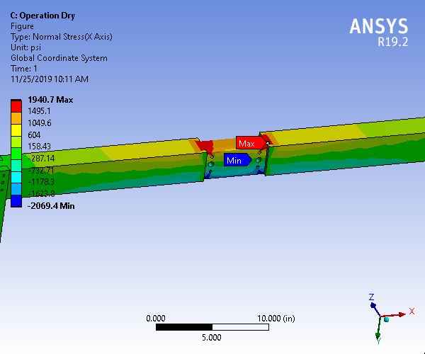
Figure 36. Top bar bending stress, operation loading

Load Case 4 - Operational Condition
The weight of the CPA and FC is substantially lower in the wet condition due to buoyancy. The CPA weighs 98.6 lbs and the FC weighs 102.5 lbs. The top two hinges on the CPA will have 25.6 lbs applied. The bottom hinges will also have 25.6 lbs applied.
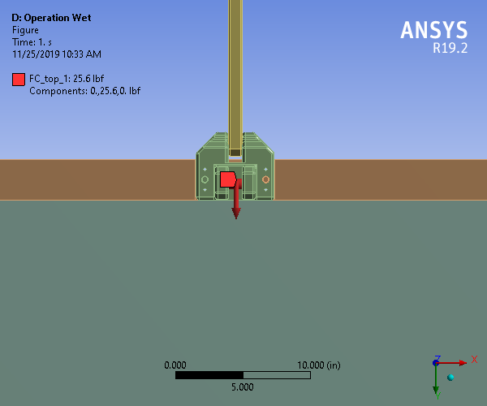
Figure 37. Model showing the loading at the wet operation case on the CPA panel hinge at one side
The load on the top strap is 208 lbs. The stress distribution away from the holes is about 104 psi with a cross-sectional area of about 2 square inches. The design load of the strap when the pin is perpendicular to the mesh is 5317 lbs which gives a safety factor of 25.6, see Section 6.1 of Appendix 1.
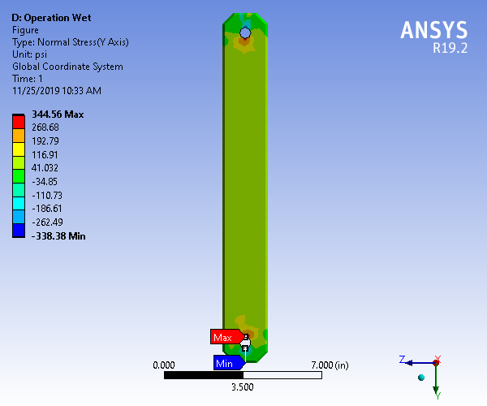
Figure 38. Strap stress distribution, wet operation
The load at the CPA top frame joint is 100 lbs and the design strength is 4120 lbs which gives a safety factor of 41, see Section 6.2 of Appendix 1. Looking at the stresses, the principal stresses occur in the primary orthogonal axes (X, Y, and Z) based on the plots of the shear stresses showing little to no shearing in any of the primary planes, Figure 39, Figure 40, and Figure 41. The only significant stress is the normal in the Y axis (Figure 34), with a max value around 245 psi as a stress concentration giving a safety factor of about 30.
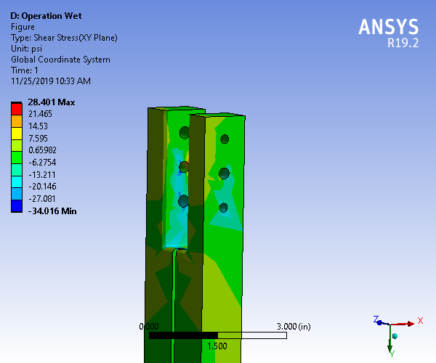
Figure 39. Shear stress (XY plane) for top vertical bar connection
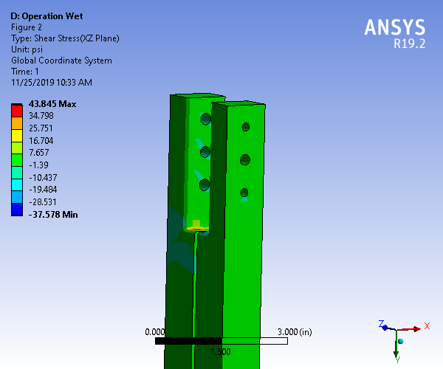
Figure 40. Shear stress (XZ plane) for top vertical bar connection
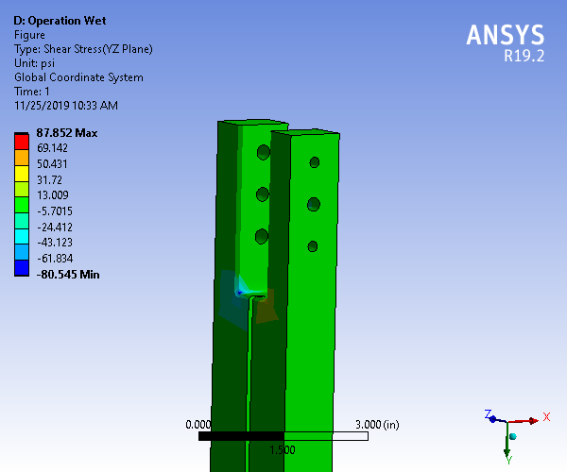
Figure 41. Shear stress (YZ plane) for top vertical bar connection
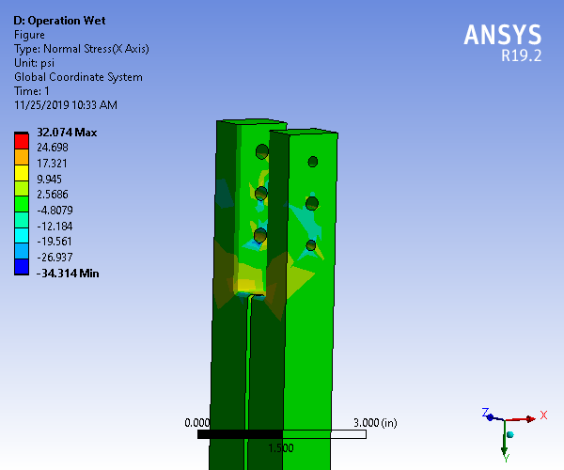
Figure 42. Normal stress (X axis) for top vertical bar connection
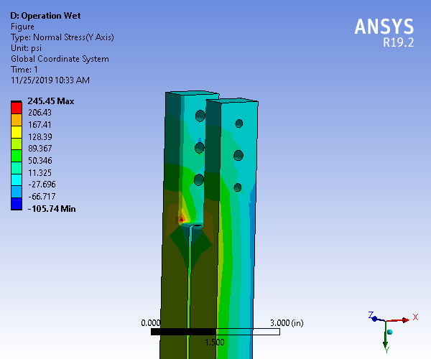
Figure 43. Normal stress (Y axis) for top vertical bar connection
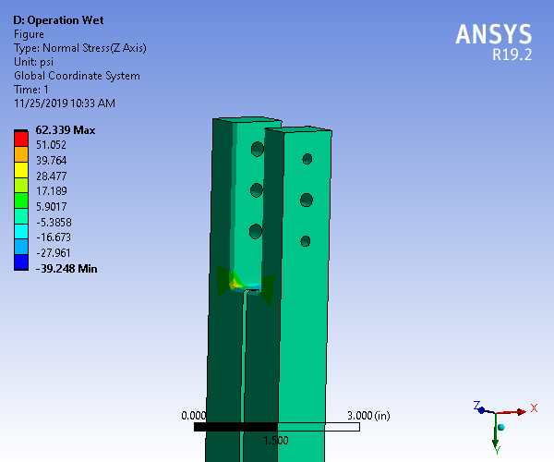
Figure 44. Normal stress (Z axis) for top vertical bar connection
The top bar of the CPA frame is supported in the middle at the aluminum connection and carries the weight of the CPA and the FC at the bottom of the CPA panel through the connections at the end of the bar. The maximum stress in the bar occurs at the location where the cross section changes with a value of 651 psi. Thus, the overall safety factor is governed by the central strap for this load case, with a value of 25.6.

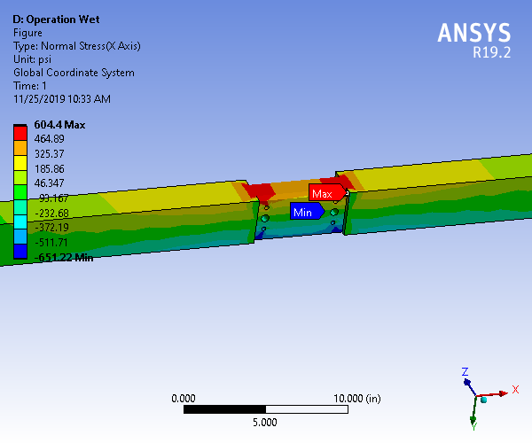
Figure 45. Top bar bending stress, installation loading
In the cold condition the CPA will shrink 24.9mm. In Section 9.4 of Appendix 1 a calculation was done to find the forces acting on the TPC members and DSS connections after shrinkage which showed that the forces remain virtually unchanged.
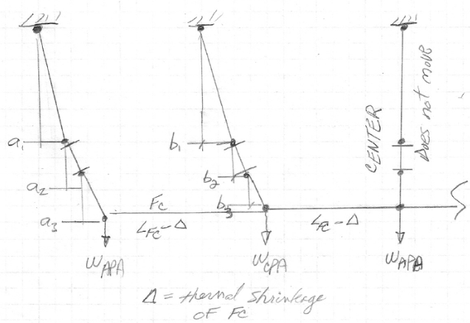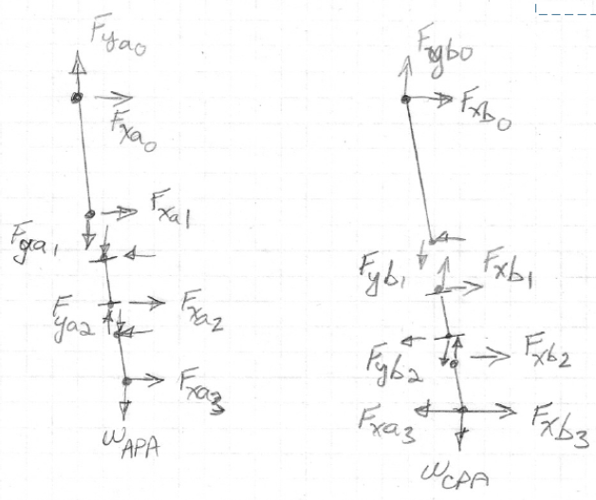
Figure 46. Lateral motion of TPC

Analysis of Effect of Pressure from Circulating Liquid Argon
Calculations done at Fermi Lab (see docdb 886) indicate that a linearly varying pressure during cool down will be applied to the resistive panels. Calculations show that this will result in 0.14” deflections of the panel at its center. The CPA/FC/APA assembly will displace 1.9mm laterally as a result of the net force from this pressure, see Section 5 of Appendix 1.

CPA Thermal Considerations
There is a significant difference in the thermal contraction coefficients between the orthogonal orientations of fibers in the FR4 material that makes up the CPA frame.
There are several areas where compensation is needed to account for differential shrinkage between the FR4 and stainless steel as well as the differences in FR4 direction: differential shrinkage between the support beam and CPA width; differential shrinkage between the stainless beam and the FC length; potential differential shrinkage between the CPA resistive panel and the frame if the fiber orientations are not aligned.
The material for the top member of the CPA frame will be specified so that the warp direction runs in the direction of the width of the CPA. When the CPA modules are cooled their width will shrink by up to -2.4 mm if the top cross beam has the main fibers oriented in the warp direction of the fibers and -7.3 mm if the fibers are oriented in the normal direction. The supporting stainless steel beam will shrink by -3.1mm over the width of the CPA. The CPA strap is attached to the supporting stainless steel beam so an interference of potentially 3.1mm – 2.4mm = .7mm will occur. In order to prevent this interference an initial gap of 3mm between CPA’s is required which will ensure that the CPAs are in contact after cool down and account for alignment and fabrication tolerances.
Another thermal consideration is the steel beam between the CPA and APA which will cool and shrink by 9.7mm. The FC I-beams will shrink by roughly 7mm. The joint between the FC and the CPA must be able to accommodate this shrinkage differential. The hinge between the FC and CPA will a slot to accommodate this shrinkage. See section 2 of Appendix 1.
Section 9.4 of Appendix 1 calculates the movement of the detector cross section. The center APA hangs vertically because of symmetry while the adjacent CPAs will move towards the center by 7.5mm and the outer APAs move towards the center 15mm. There are several pivot joints that support the CPA and APA and allow this motion to occur. As shown in Section 9 of Appendix 1 the resulting increase of loads on the DSS because of this movement is negligible.

Conclusion
A design of the HV System (HVS) for the LAr-TPC of the DUNE single phase far detector has been developed, to meet the physics requirements. The design of the CPA and FC was built on experience learned from past experiments and extensive R&D test stands on material quality and performance as well as small scale LAr-TPC’s.; the construction of prototypes have been performed to thoroughly understand the design. A first implementation of this design was realized and successfully tested in ProtoDUNE-SP. Full size mechanical prototypes are being constructed to evaluate the installation of the TPC into the far detector cryostat.
The CPA structure has been examined based on the TC approved Analysis Plan EDMS #2142669. The CPA exceeds the required safety factor of 3.75 for all load cases.

Appendix 1
Detailed Calculations

