- RF Coupler - Sergei K Submitted
- RF Power
- Cryo
- SRF Gun - Ivan Gonin Submitted
- SRF Cavity - Ivan Gonin Submitted
- Nb3Sn - Sam Posen Submitted

Main coupler.
Accelerator configuration requires a coupler with very low cryogenic loading. Heat flow to 4K has to be not more than 1 W for 250 KW, CW input power. Special high-power coupler was designed for this purpose. Cut view of coupler are presented in Picture XX. Main idea of this coupler is using copper electromagnetic shields to translate cryogenic losses to 70K and minimize cryogenic losses to 4K. Besides the configuration of this coupler protects ceramic from charged particles which can come from accelerating cavity. Possible multipactor in the couplers will be suppressed by high voltage bias. Coupler has standard WR1150 input waveguide.
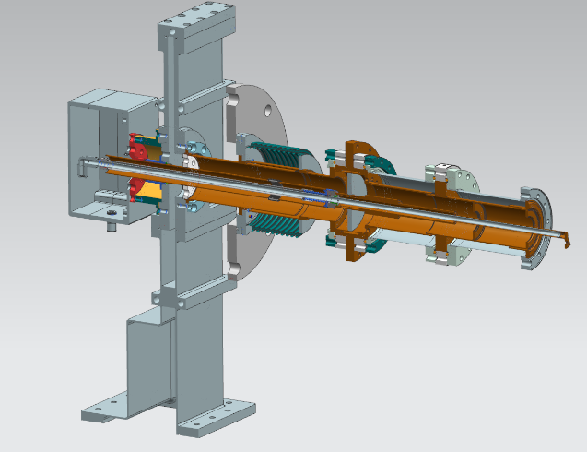
Picture XX. Cut view of new main coupler with low cryogenic loads.

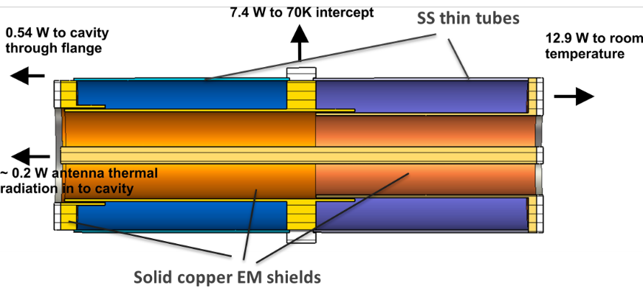
Picture XX. Configuration of vacuum part of main coupler with low cryogenic loads.

At first stage, for single 1.5 cell cavity test accelerator, it is supposed to use 650MHz coupler designed for PIP-II project. It has a similar structure, but its cryogenic property is not good enough to be used at 250 kW full power project, but good enough for ~ 30 kW, 1.5 cell project. Coupler is partly produced already. Using this coupler will save a time and funds. Cut view of coupler is presented at Picture XX.
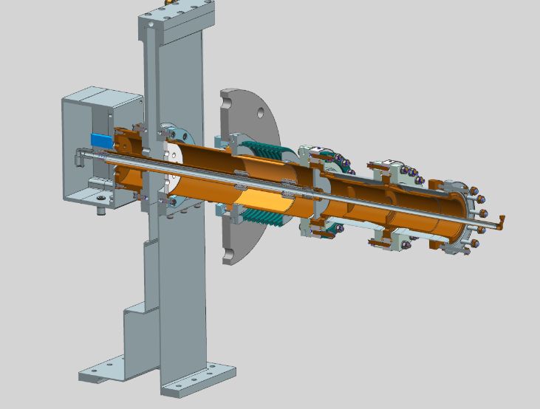
Picture XXX: Cut view of 650 MHz PIP-II coupler.
SRF Gun

A miniature commercial tungsten dispenser thermionic cathode with a diameter of 1.5 mm developed by HeatWave Labs, Inc shown in the Fig. 3. It provides the needed 10 mA beam currents while introducing very small heat loads. Also, the engineering design of the cathode-grid unit has been done.
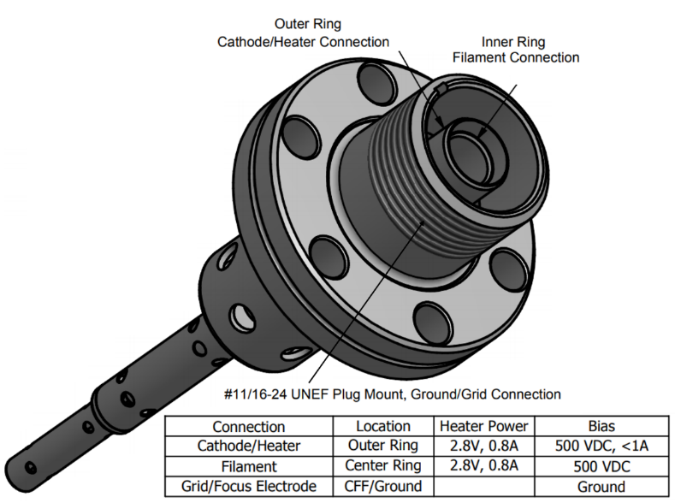
Figure-3: General view of the cathode assembly. Heater power table
During the design optimization the following requirements have been identified that must be met:
- An impregnated cathode of 612M type with a 1.8 eV work function to provide electron current density greater than 15 A/cm² at emitter temperature of 1050ºC, low evaporation rate of less than 0.4 mg/hr./cm², and life time of more than 20 thousand hours.
- The cathode Ø = 1.5 mm to provide low heat load (< 1W) to cryogenic environment. Estimated thickness of the evaporated material on the 4.5-cell cavity after 1 year of operation is ~ 0.12 monolayers.
- A planar shape of the cathode and grid with Pierce angle electrode. The grid transparency is higher than 80%. Planar geometry of the cathode and grid is less sensitive to dimensional errors and misalignments.
- The gun copper resonator will generate RF voltage at 650 MHz between the cathode and the grid.
- The cathode-grid distance of 150 μm, the distance between grid and cavity entrance L = 2.25 mm, the input cavity iris radius R = 3.5 mm.
- MICHELLE simulations show low sensitivity to the deviation of the cathode emission surface position related to the cavity entrance. A deviation of +/- 0.5mm gives a change of the main beam parameters within units of percent
- The DC bias voltage between cathode and grid is 300 V.
- The heater power level < 2 W.
MICHELLE simulations have been performed to optimize the bunch energy spread, beam phase duration, and beam losses during the acceleration.
Table 2. Summary of MICHELLE optimization results
Frequency | 650 | MHz
Energy | 1.6 | MeV
Current | 10 | mA
V_{dc} | 300 | V
V_{a} | 336 | V
φ | 83 | ⁰
Beam energy spread | 1.6 | %
Beam phase duration rms | 6.7 | ⁰
Losses on the grid | 0.2 | W
Back bombardment losses | 0.35 | W
Cathode current density, max | 8.2 | A/cm²
Losses on the cavity walls | 0 | W

Table 2 shows the main parameters of MICHELLE optimization. Beam characteristics and particle distributions at the exit of the 1½ cells cavity are summarized in several plots in Fig. 4.

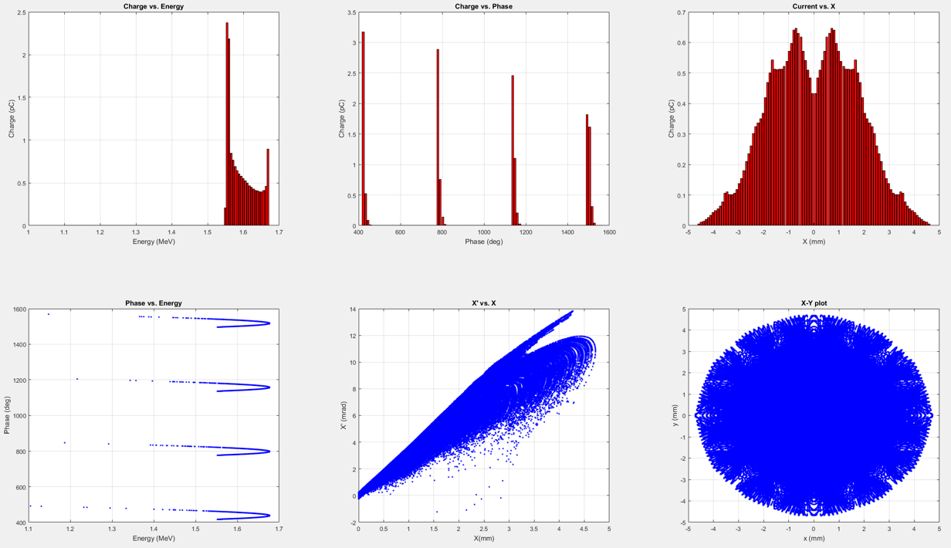
Figure-4: Particle distribution at the exit of the 1½ cells cavity for the optimized parameters and geometry. Top three plots: charge distribution vs. energy and phase, current vs. radius; Bottom three plots: phase vs. energy, x´-x phase-space distribution, x-y plot at the cavity exit.

SRF Cavity. Coupled RF-Mechanical design

RF design

The coupled RF-Mechanical design of the 1½ cavity was done during several COMSOL iterations of the geometrical parameters. The main RF parameters were optimized in association with beam dynamics results.
The scope of issues that needed to be addressed is:
- Minimize peak surface Epeak and Bpeak fields
- Minimize cavity wall losses by maximizing R/Q.
- Achieve the desired 1.6 MeV energy and main beam parameters by optimizing the scale factor of 1st cell, cathode emission face position, input iris diameter etc
- Good mechanical stiffness to withstand vacuum pressure and fulfill all safety requirements.

Fig. 1 shows general view of 1½ RF volume of SRF cavity after optimization. Optimal scale factor of first cell was found 0.36. Iris between cells, beampipe diameters and cells length are shown. Regular cell is like HB β=0.92 PIP-II cavity. Left wall of the 1st cell was chosen flat to simplify mechanical design, which is most critical in this part of the cavity. Table 1 summarize main RF parameters.
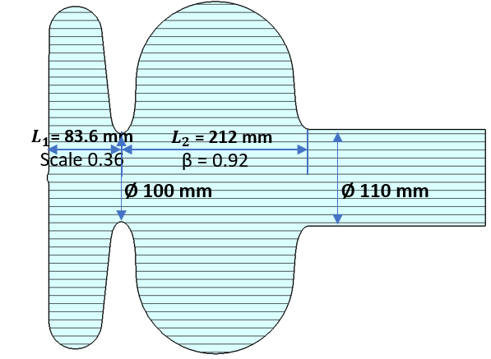
Figure-1: 2D view of RF volume of 1½ SRF cavity with main dimensions
Table 1. Main RF parameters for the 1½ SRF cavity
Frequency | 650 | MHz
Cavity voltage | 1.6 | MeV
R/Q | 178 | Ω
Geometry factor | 197 | Ω
Peak surface electric field | 16.7 | MV/m
Peak surface magnetic field | 27 | mT
Power loss in the cavity walls* | 0.073∙$R_{s}$ | W

*Power losses in the cavity walls depends on the surface resistance $R_{s}$, measured in nΩ.
Mechanical design

The mechanical design and engineering analyses has been performed on the 1½ SRF cavity, to conform to the cavity design requirements set forth in FESHM 5031.6 and Technical Division Technical Note TD-09-005 [1]. The cavity shell is subjected to following 2 loads in room temperature
(more critical) conditions: 1 bar differential pressure during leak check and possible up to 1.5 bar pressure during VTS test. In both cases the cavity also sees dead weight forces due to gravity. For those 2 cases the provisions of ASME Section VIII Division-1 U-2(g) have been applied.

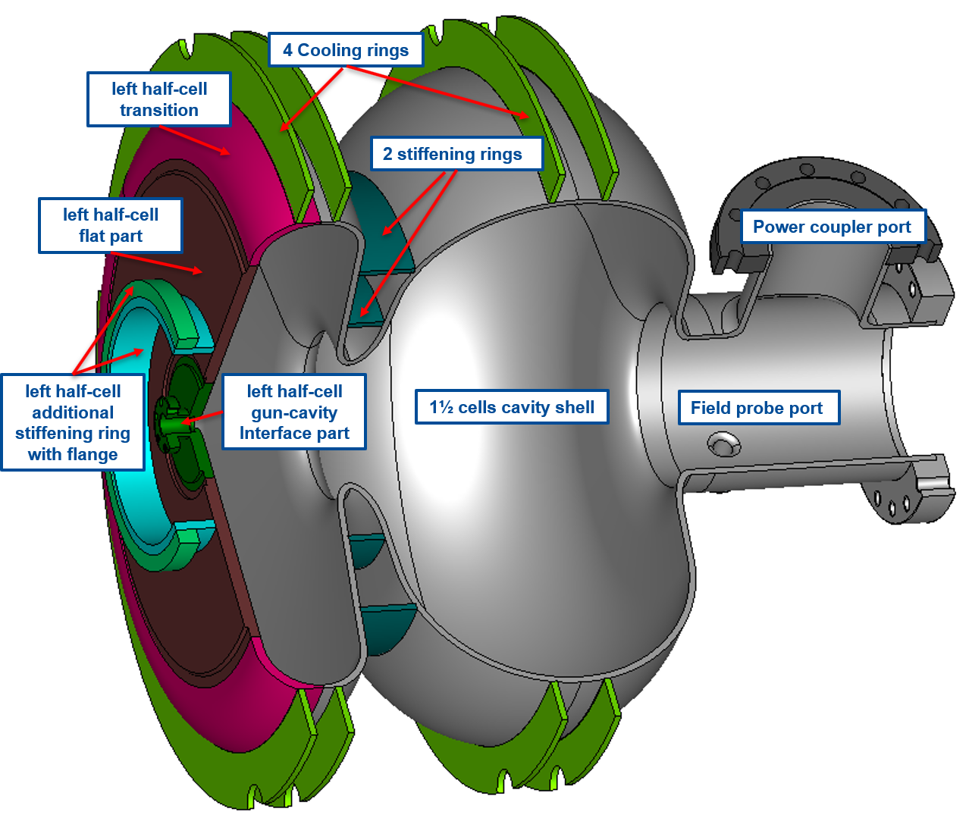
Figure-2: 3D view of equipped 1½ SRF cavity. Mechanical design.
Fig. 2 shows the final mechanical CAD model view of the cavity after comprehensive COMSOL mechanical design. The main concern is the small input aperture diameter in the gun-cavity interface part and consequently very sensitive to stresses of the left part of the squeezed cell. To satisfy all the listed requirements a view changes in mechanical design has been done (shown in the Fig. 2) in comparison with design of standard elliptical cavity.

- Thicker (6 mm) of the flat and transition parts of the left squeezed half-cell. Thickness of the regular shell is 4 mm
- 2 stiffening rings between cells
- Additional stiffening ring with flange welded to the flat part. This feature is used also as support in the VTS test setup

Nb3Sn

Nb3Sn is an enabling technology for the compact accelerator, allowing the superconducting cavity to have sufficiently high quality factor that it can be cooled by the cryocooler. Nb3Sn is also one of the least mature technologies of those needed. However, the development of this part of the design was extremely successful. A 650 MHz single cell cavity with conduction cooling rings was coated with the ERDC funds. These funds went to the infrastructure needed to coat a cavity of this type as well as the labor needed to carry out the coating and testing. The cavity achieved a Q0 of 1x10^10 at 8 MV/m, an promising performance within the range needed for future compact accelerator applications. Leveraging the ERDC funds with Fermilab LDRD, the cavity was later tested with conduction cooling, achieving a maximum gradient of 6.6 MV/m with cooling provided by a single cryocooler providing 2 W at 4 K. This demonstration serves as a strong proof-of-principle for accelerators based on conductively cooled SRF cavities.

Outside of the ERDC program, Fermilab Nb3Sn development has led to a significantly improved performance on a 650 MHz single cell cavity without conduction cooling rings. This cavity achieved a maximum accelerating gradient of 20 MV/m at 4.4 K with a quality factor of 1x10^10. This test was performed in liquid helium, but the lessons learned for the coating process are expected to be able to be transferred to cavities with the conduction cooling rings. This would be expected to allow for even higher gradients to be reached in conduction cooling tests. Another experiments performed outside of ERDC funding was a coating and test of a 9-cell 1.3 GHz cavity, a type of cavity that is used in full-scale accelerators around the world, including in LCLS-II and the European XFEL. The Nb3Sn coated 9-cell achieved a Q0 of 8x10^9 at 10 MV/m at 4.4 K. This is a key demonstration of the ability to scale up the coating process to the types of structures typically used in particle accelerators.

