Department of Atomic Energy (DAE)

Government of India

Anushakti Bhavan, Mumbai 400 001

INDIA

Document No.: DAE/xxxx/yyyyyyy

Fermi National Accelerator Laboratory

P.O. Box 500, Kirk Road & Pine Street

Batavia, Illinois 60510-5011

USA

Document #: ED0006360, Rev A

PIP-II LB650, 650 MHz RF Amplifier

Interface Specification

**IIFC Approvals**

|  |  |  |  |  |  |  |
| --- | --- | --- | --- | --- | --- | --- |
| **Prepared by** | | | | | | |
| Akhilesh Jain | Email | Date |  | James Steimel | Email | Date  16 Nov 2018 |
| **Reviewed by (Sub-Project Coordinators)** | | | | | | |
| Mahendra Lad | Email | Date |  | Dave Peterson | Email | Date |
| **Approved by (Technical Coordinators)** | | | | | | |
| Purushottom | Email | Date |  | Lia Merminga | Email | Date |

**Document Approval**

|  |  |
| --- | --- |
| Signatures Required | Date Approved |
| Originator: James Steimel, L3 Manager for HPRF |  |
| Approver: Elvin Harms, L2 Manager for Accelerator Systems |  |
| Approver: Alex Martinez, Integration Coordinator |  |

Revision History

|  |  |  |
| --- | --- | --- |
| Revision | Date of Release | Description of Change |
| - | 27 Mar 2017 | Initial Draft |
| A |  |  |
|  |  |  |
|  |  |  |
|  |  |  |
|  |  |  |
|  |  |  |

Table of Contents

1. Purpose 5

2. Scope 5

3. Acronyms 5

4. Reference 5

5. Key Assumptions 6

6. Functional Requirements 6

6.1. Primary Requirements 6

6.2. Personnel Safety Requirements 6

6.3. Self-Preservation Requirements 7

6.4. Cavity Protection Requirements 7

6.5. Control & Diagnostics Requirements 7

6.6. Installation and Integration Requirements 8

6.7. Maintainability Requirements 8

7. Safety Requirements 8

# Purpose

The purpose of this document is to map out the external interfaces of the 650 MHz, Solid State RF Power Amplifier (SSRFA) for LB650 cavities, i.e. how it interfaces with the connected systems of PIP-II and the PIP-II Injector Test. This document endeavors to cover all connections to the RFPA that will be made in the PIP-II Injector Test or PIP-II gallery. Figures 1-4 show the RFPA and its various interfaces.

# Scope

The scope of the 650MHz LB650 RF amplifier design consists of all RF power amplifiers used to power LB650 cavities in the PIP-II linear accelerator. Each LB650 cavity in the accelerator will have a dedicated RF amplifier for its power source. Each amplifier will receive a dedicated signal from a 650MHz LLRF control system as an input. The output of the amplifier drives an RF distribution system that is connected to the input coupler of the cavity.

Figure 2.1 shows a block diagram of many of the amplifier interfaces, their labels, and how their physical connections to the amplifier.



Figure ‑: 40kW Amplifier System Block Diagram (showing internal and external connections)

# Acronyms

|  |  |
| --- | --- |
| FEM | Fermilab Engineering Manual |
| FESHM | Fermilab ES&H Manual |
| FRCM | Fermilab Radiological Control Manual |
| FRS | Functional Requirements Specification |
| HPRF | High Power Radio Frequency |
| L2 | WBS Level 2 |
| L3 | WBS Level 3 |
| LLRF | Low Level Radio Frequency |
| MPS | Machine Protection System |
| PIP-II | Proton Improvement Plan II Project |
| RF | Radio Frequency |
| SRF | Superconducting Radio Frequency |
| TC | Teamcenter |
| WBS | Work Breakdown Structure |

# Reference

|  |  |  |
| --- | --- | --- |
| **#** | **Reference** | **Document #** |
| 1 | RF Power Systems EPDM | ED0002850 |
|  | PIP-II Linac RF Systems PRD | ED0010220 |
|  | PIP-II RF Power System L3 FRS | ED0008023 |
| 2 | [Fermilab Engineering Manual](http://directorate-docdb.fnal.gov/cgi-bin/RetrieveFile?docid=34) (FEM) | - |
| 3 | [Fermilab Environmental Safety and Health Manual](http://eshq.fnal.gov/manuals/feshm/) (FESHM) | - |
| 4 | Fermilab Radiological Control Manual (FRCM) | - |

# Key Assumptions

The power necessary to operate the LB650 cavities will be generated by combining two, half-power units with a power combiner. Figure 5-1 shows the configuration of the half-power units and the combiner to give a sense of scale for the size.

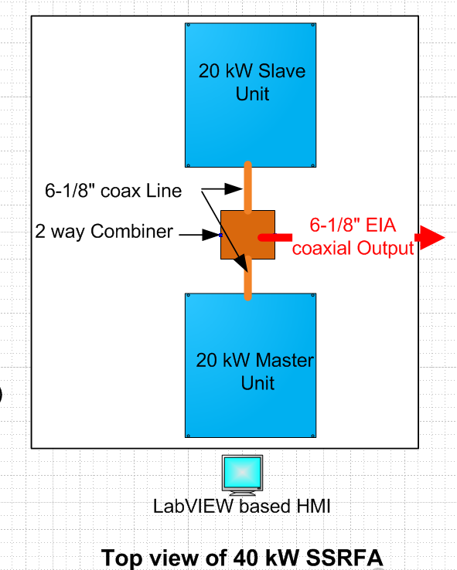

Figure ‑: Assembly of 20kW 650MHz Solid State RF Amplifier Units

# Facility Environment and Utility Connections

## Gallery Environment

These requirements define the gallery space occupied by the units and the ambient conditions of the gallery environment.

|  |  |  |  |
| --- | --- | --- | --- |
| **Requirement #** | **Parameter** | **Value** | **Reference** |
| I-ED0006360-A001 | Volume Envelope | 3.4m-w x 2.44m-h x 1.83m-d Max | F10106148 |
| I-ED0006360-A002 | Environment Temperature | 25°C±10°C |  |
| I-ED0006360-A003 | Environment Humidity | 60%±30% |  |
| I-ED0006360-A004 | Heat Load to Air | 4 kW Max |  |

## Water Cooling

These requirements define the interfaces between the amplifier and the gallery cooling system.

|  |  |  |  |
| --- | --- | --- | --- |
| **Requirement #** | **Parameter** | **Value** | **Reference** |
| I-ED0006360-B001 | Inlet Water Pressure | 125 psig Max |  |
| I-ED0006360-B002 | Required Flow | 180 lpm Min (80-90 lpm per half-power amplifier unit) |  |
| I-ED0006360-B003 | Pressure Drop | 60 psig Max |  |
| I-ED0006360-B004 | Water Temperature | 28°C±2°C |  |
| I-ED0006360-B005 | Water Header | Copper/SS NPT (male) of 1” size |  |
| I-ED0006360-B006 | Heat Load to Water | 27 kW per half-power unit Max |  |
| I-ED0006360-B007 |  |  |  |

## AC Power

These requirements specify the interface to the mains distribution in the gallery.

|  |  |  |  |
| --- | --- | --- | --- |
| **Requirement #** | **Parameter** | **Value** | **Reference** |
| I-ED0006360-C001 | AC Input Power | 3 phase, 5 wire (Y with ground), 480 VAC, 60 Hz |  |
| I-ED0006360-C002 | AC Current Pull | 100 A per half-power module Max |  |
| I-ED0006360-C003 | AC Connection | Internal terminal block / direct on MCCB |  |
| I-ED0006360-C004 | Power Factor | 86% Min |  |
| I-ED0006360-C005 | Efficiency at 1dB Compression | 42% Min |  |
| I-ED0006360-C006 | Efficiency at half power | 26% Min |  |

# RF Power Output

These requirements specify the RF power output parameters.

|  |  |  |  |
| --- | --- | --- | --- |
| **Requirement #** | **Parameter** | **Value** | **Reference** |
| I-ED0006360-D001 | Flange Connection | 50Ω, 6-1/8” EIA flange on rear panel for 6-1/8” air filled (non pressurized) rigid line, coaxial distribution |  |
| I-ED0006360-D002 | Output Power | 40 kW @ 1 dB compression point  44 kW Max |  |
| I-ED0006360-D003 | Output VSWR withstanding | 1.4:1 Min |  |
|  |  |  |  |

# RF Input (LLRF)

These requirements specify the input power limits and connectors.

|  |  |  |  |
| --- | --- | --- | --- |
| **Requirement #** | **Parameter** | **Value** | **Reference** |
| I-ED0006360-E001 | Connection | 50Ω, N-type connector (F) on master rack panel for ½” flexible coaxial cable |  |
| I-ED0006360-E002 | Input Return Loss | 15 dB Min |  |
| I-ED0006360-E003 | Input drive for Max Power | 5 dBm Max |  |
| I-ED0006360-E004 | Input drive (before damage) | 15 dBm Max |  |
| I-ED0006360-E005 | Minimum RF Drive Pulse Length | 10 μs Min |  |

# Interlocks Connections

These requirements define the interlock connections to the RFPI and accelerator safety systems.

|  |  |  |  |  |  |
| --- | --- | --- | --- | --- | --- |
| **Requirement #** | **Name** | **Signal Type** | **Connector** | **Cable** | **Polarity** |
| I-ED0006360-F001 | SSA Inhibit | 50Ω TTL | 50Ω SMA | RG-58 | Active Low |
| I-ED0006360-F002 | DC Inhibit | 50Ω TTL | 50Ω SMA | RG-58 | Active Low |
| I-ED0006360-F003 | SSA Ready/Fault | 50Ω TTL (50mA drive Max) | 50Ω SMA | RG-58 | Active High |
| I-ED0006360-F004 | Trigger/Gate | 50Ω TTL | 50Ω SMA | RG-58 | Active High |
| I-ED0006360-F005 | Safety Permit | Active closed potential free relay contact (input) | 2-pin Phoenix TB | 2-wire twisted pair |  |

# Controls

|  |  |  |  |  |  |  |
| --- | --- | --- | --- | --- | --- | --- |
| **Requirement #** | **Name** | **Signal Type** | **Connector** | **I/O** | **Polarity** | **Min Hold Time** |
| I-ED0006360-G001 | ON/OFF (start) | Opto-isolated 24V (20mA Max) | Standard D | Input | Active High | 200 ms |
| I-ED0006360-G002 | SSA Reset | Opto-isolated 24V (20mA Max) | Standard D | Input | Active High | 200 ms |
| I-ED0006360-G003 | SSA Ready/Fault | Optocoupler C-E (or D-S) pair (35V & 30mA Max) | Standard D | Output | High=Ready |  |
| I-ED0006360-G004 | SSA Alert | Optocoupler C-E (or D-S) pair (35V & 30mA Max) | Standard D | Output | Active High |  |
| I-ED0006360-G005 | Remote/Local | Optocoupler C-E (or D-S) pair (35V & 30mA Max) | Standard D | Output | High=Remote |  |
| I-ED0006360-G006 | Pulse/CW | Opto-isolated 24V (20mA Max) | Standard D | Input | High=Pulse |  |
|  |  |  |  |  |  |  |
|  |  |  |  |  |  |  |

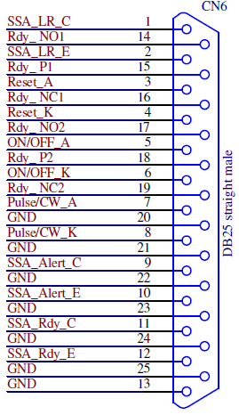

Figure ‑: DB 25 Connections (last letter e.g. A,K,E and C represents opto-coupler terminals, Anode, Cathode, Emitter, Collector, respectively

# Timing and Communication

|  |  |  |  |  |  |
| --- | --- | --- | --- | --- | --- |
| **Requirement #** | **Name** | **Signal Type** | **Connector** | **Cable** | **Protocol** |
| I-ED0006360-H001 | Timing/Gating | 50Ω TTL | 50Ω SMA | RG-58 |  |
| I-ED0006360-H002 | Communication |  | RJ45 | Ethernet | ???? |