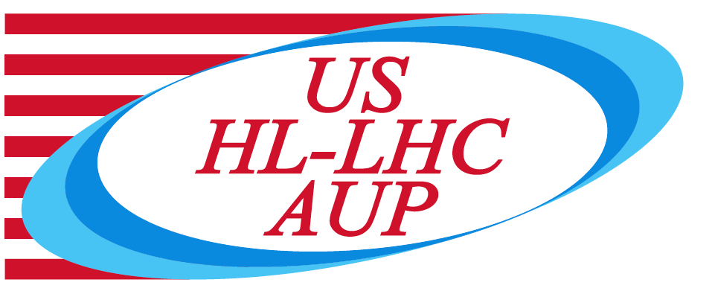

US HL-LHC Accelerator Upgrade Project

Review of Selva Winder Risk Assessment and Lessons Learned

TABLE OF CONTENTS

1. Goal & scope 3
2. Charges 3
3. Technical information 4
4. References 4

- Goal & scope

The HL-LHC AUP project is using FNAL Selva Winder as primary equipment for winding MQXFA coils at FNAL. Some issues occurred during winding of coils 118 [1] and 120 [2] causing the possible loss of the superconducting cables being used.
It is critical for the AUP project to assure that the causes of coil 118 and 120 issues are well understood and will be prevented during winding of future MQXFA coils.
It is also critical to prevent as much as reasonably possible other issues, which may result in the damage/loss of MQXFA superconducting cables. Analysis of possible failure mechanisms, which may result in cable damage, was performed by the Selva teams. Risks were evaluated and mitigation plans were developed and implemented. The post-mitigation risks [3] were evaluated and reviewed by an independent committee on October 25, 2019. Action items [4] were generated to address some post-mitigation risks. Review of Vertical Cable Positioning System Modification was performed in January 2020 [5].
The reviewers are requested to assess the understanding of coil 118 and 120 issues and the effectiveness of preventive actions. They are also requested to review the post-mitigation risk assessment, the implementation of mitigation plans, and to assess if there are other risks not covered by this analysis that may result in cable damage.

On August 3rd, when technicians arrived on Monday to resume winding of coil 120b for Selva re-commissioning, they found the cable severely damaged and that the Windows operating system had crashed [6]. A team lead by Jerzy Nogiec performed Selva inspection and on August 6th sent an email with findings, impression, conclusion and recommendations. This email was shared with the committee of this review.
Considering this recent event and the series of issues occurred during winding of coils 118, 119, 120 and 120b the L3 in charge of MQXFA coil fabrication at FNAL, Fred Nobrega, is requesting AUP to stop using the Selva winder. The charge questions have been revised taking this request into account.

- Revised Charge Questions

The committee is requested to answer the following questions:

- Are the causes of the issues occurred during winding of coils 118, 119, 120 and 120b well understood? Are preventive actions satisfactory?
- Have all Lessons Learned from the issues in question #1 been implemented?
- Is the Post-Mitigation Risk Assessment of Events that Could Lead to Cable Damage [3] complete and satisfactory?
- Are the Roles, Responsibilities, Authorities, and Accountabilities clearly defined and understood regarding the operation and maintenance of the Selva Winder?
- Are travelers and other procedures [7-8] related with Selva operation sufficiently detailed and clear to prevent issues that may result in cable damage?
- Are travelers and other procedures [9] related with Rotating Table operation sufficiently detailed and clear to prevent issues that may result in cable damage?
- Are staff properly trained on the use of the Selva equipment and the coil winding operation?
- Are staff properly trained on the use of the Rotating Table equipment and the coil winding operation?
- Does the committee recommend continuing to use the Selva Winder as main MQXFA winder, or to elevate the Rotating Table to the role of main MQXFA winder?
- Do you have any other comment or recommendation to assure that cables will not be damaged during MQXFA coil winding?

- Technical information

Committee
Vito Lombardo – FNAL, chairperson
Jamie Blowers – FNAL
Luciano Elementi – FNAL

Date and Time
Started on March 13, 2020; on hold because of COVID; resumed on August 3.

Location
IB3 floor during coil winding.

Link to agenda with talks and other documents
https://indico.fnal.gov/event/23691/

- References

- DR 11878 https://vector-onsite.fnal.gov/Tools/DiscrepancyReport/DisplayDiscrepancyReportReadOnly.asp?qsDRNo=11878
- DR 11930 https://vector-onsite.fnal.gov/Tools/DiscrepancyReport/DisplayDiscrepancyReportReadOnly.asp?qsDRNo=11930
- Selva Winder: RISK Assessment of Events that Could Lead to Cable Damage; US-HiLumi-doc-2426
- Action Items on iTrack https://www-esh.fnal.gov/pls/cert/eshtrk_common.audit_details?rid=51168
- Review of Vertical Cable Positioning System Modification for Selva Winder; US-HiLumi-doc-2955
- DR 12077 https://vector-onsite.fnal.gov/Tools/DiscrepancyReport/DisplayDiscrepancyReportReadOnly.asp?qsDRNo=12077
- Selva Operating Procedure Manual, TID-N-728
- Selva Coil Winding Machine Upgrade Maintenance, TID-N-726
- HL-LHC Magnet QXFA Coil Winding and Curing Traveler (Using Rotating Table); https://vector-onsite.fnal.gov/Tools/TravelerWriter/TravelerWriterPreviewDocument.asp?qsSpecificationID=1919&qsRevisionID=5

