PIP-II AccU-BTLBA Beam Absorbers FDR Review Charge

Document number: ED000xxxx

Document Approval

Name: Ioanis Kourbanis  Org: Fermilab  Contact: ioanis@fnal.gov  Role: L2 Manager Accelerator Upgrades | Date: 03/26/2021
Name: Meiqin Xiao
Org: Fermilab
Contact:
Role: L3 Manager Accelerator Upgrades/BSTSR
Name:
Org:
Contact:
Role:
Name:
Org:
Contact:
Role:
Name:
Org:
Contact:
Role:

Revision History

Revision | Date Release | Originator:  Role: | Description of Change

Table of Contents

1. Introduction 4
2. Review Agenda 4
3. Review Charge Statement 6
4. Acronyms 6
5. Reference Documents 6

Introduction

Two beam absorbers will be used in PIP II and they are part of this review.
- A low power straight ahead beam absorber that will be situated at the end of the Linac tunnel and will be used for the Linac commissioning and tuning. This absorber will also used for staged Linac beam commissioning.
- A 25 KW Beam Transfer Line absorber situated in the dedicated dump line in the BTL and is designed to accept the full power LBNF beam.

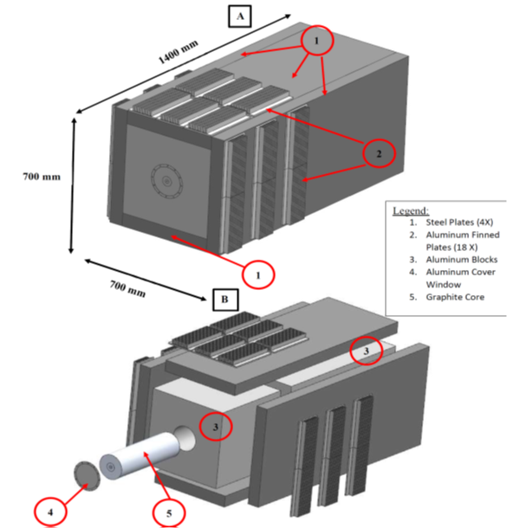

Figure 1: Straight Ahead Absorber

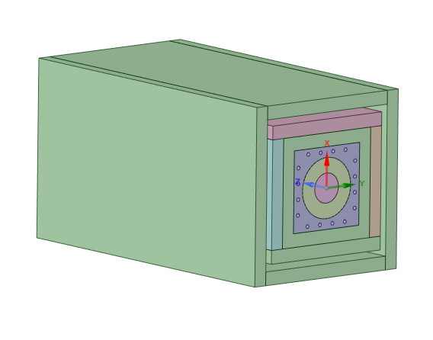
Outer Steel
Aluminum cooling **
Aluminum region 2**
Graphite
Aluminum block **
Inner Steel

Figure 2: 25 KW Permanent Absorber

Review Agenda

“BTLBA Beam Absorbers FDR Review” Agenda
Location: | ZOOM only
Date: | May 18 2021
Time:  Indico Site: | 10:00-16:00  https://indico.fnal.gov/event/24089

Participants:

Ioanis Kourbanis (ioanis@fnal.gov) | Fermilab | L2 Manager
Meiqin Xiao | Fermilab | L3 Manager/Coordinator
Frederique Pellemoine | Fermilab | Review Chair
Marco Calviani | CERN | Reviewer
Brian Hartsell | Fermilab | Reviewer
William Higgings | Fermilab | Reviewer
Igor Rakhno | Fermilab | Presenter
Nandhini Dhanaraj | Fermilab | Presenter
Nnamdi Agbo | Fermilab | Presenter
Yun He | Fermilab
Kris Anderson | Fermilab

Agenda details (Preliminary):

Introduction/Response to PDR Recommendations/Cost & schedule (30’): Ioanis Kourbanis/Meiqin Xiao (L2 manager/Review Coordinator)

[Primary Review Content Overview. E.g. organization, requirements, cost & schedule, etc.]

MARS Calculations (30’+10’): Igor Rakhno

[Technical Content.]

Straight ahead Absorber Design (50’+10’): Nandhini Dhanaraj

[Technical Content.]

25 KW Permanent Absorber Design (50’+10’): Nnamdi Agbo

[Technical Content]

Closeout – Review Chair

[Summary Statement]

[Preliminary Findings]

[Preliminary Comments]

[Preliminary Recommendations]

Review Charge Statement
The reviewers are asked to perform a Final Design Review of Beam Absorbers for PIP II.

Specifically, the panel is asked to answer the following charge questions:

- Are the requirements documented, clear, complete and appropriate?

- Is the design for the straight ahead absorber likely to meet requirements? Explain any deficiencies or concerns.

- Is the design for the Permanent 25 KW absorber likely to meet requirements? Explain any deficiencies or concerns.

- Are there any features present (or absent) that threaten the intended function and performance of this design?

- Have safety and environmental aspects been appropriately considered?

- Have quality aspects been appropriately considered?

- Does the proposed schedule seem reasonable?

The intended outcome of the review:
- Collect and document findings, comments and recommendations necessary to proceed to the Final Design stage.
The following documents will be available at the review site:
- BTLBA FRS document
- Beam Absorbers PRD document
- Beam Absorbers TRS document
- Prevention by Design Table
- Failure Mode Analysis document

.

Acronyms
List and define any relevant acronyms as necessary.

FRS | Functional Requirements Specifications
TRS | Technical Requirements Specifications
PRD | Physics Requirements Document

Reference Documents
List any relevant documents referred to in the Review Charge Statement. Include reference links or locations where the references are found. This list should include all documents with which the review committee should be familiar prior to the review.

1 | PIP-II Technical Review Plan – TC ED0008163
2 | PIP-II Quality Assurance Plan DocDB # 142
3 | PIP-II Systems Engineering Management Plan – TC ED0008164
4 | PIP-II IESH Management Plan DocDB # 141
5
6
7
8 | 121.05 Accelerator Complex Upgrades Design Plan DocDB # 2593
9 | 121.06 Conventional Facilities Design Plan DocDB # 2587
10 | PIP-II Value Engineering Plan DocDB # 2830
11
12
13

The review coordinator should populate this following table with the document list for this review from their SDP.

Table 1 - Document Deliverables for this review from the System Design Plan
 | Document Title | Status  (preliminary, final, released) | Comments
1 | BTLBA FRS/TRS | Released
2 | MICD/ISD for Beam Absorbers | Preliminary
3 | Failure Mode Analysis | Preliminary
4 | Prevention by Design Table | Preliminary
5 | Risk Assessment Document | Preliminary
6 | Updated Schedule | Preliminary | To be presented
7 | Draft Installation Plan | Preliminary | To be presented
8 | QC Plans | Preliminary
9 | Design Verification Methology Plan | Preliminary | To be presented
10 | System Procurement/Manufacturing/Oversight Plan |  | To be presented
11 | Thermal Design of the straight ahead Absorber | Released | To be presented
12 | Thermal Design of the 25 KW Absorber | Preliminary | To be presented

