PIP-II Straight-Ahead Beam Absorber Quality Control Plan

Document number: PIP-II-Doc-5343

Document Reviews / Approvers |  | Date Reviewed / Approved
Originator | Meiqin Xiao
Contributor | Nandhini Dhanaraj
Contributor
Contributor
Reviewer | Tom DiGrazia
Reviewer
Reviewer
Reviewer
Approver | Ioanis Kourbanis

Revision History
Author | Version | Revision Date | Description of Change
Meiqin Xiao | 1.0 | xx/xx/xx | New Document

Table of Contents
1.0 Scope of Quality Control (QC) Plan 4
2.0 QC Tests and Measurements 5
3.0 Requirements Traceability 6
4.0 Travelers, Procedures, and Checklists 6
5.0 Acceptance Tests & Criteria 6
6.0 In-process monitoring and measurement activities 7
7.0 Verification Plans: Methods & Activities 7
8.0 Deliverable Documentation and Records 7
9.0 Associated Equipment 7
10.0 Calibration Plans 7
11.0 Traceability Requirements 7
12.0 Training and Qualification 8
13.0 Planned Vendor Communication & Visits 8
14.0 Control of Nonconformances 8
15.0 Transportation/Shipping 8
16.0 Risk Analysis Documentation 9

Scope of Quality Control (QC) Plan
The delivery of the Straight-Ahead Beam Absorber to the PIP-II Project resides under WBS #121.05.02 (Transfer Line / Beam Absorber). The absorber will largely be fabricated and assembled by an outside vendor, with close oversight and collaboration from Fermilab. A Graphite core surrounded by an Aluminum block are primary components which require tight tolerances be maintained to support the shrink fit assembly and the rest of the components will be bolted together. The absorber assembly will be used for commissioning of the LINAC at two locations: 400 W and 2 kW locations. This Quality Control plan covers the specific QC efforts required to ensure the straight-ahead beam absorber meets Project specifications and is delivered for installation on time and within budget.
A
1
2
700 mm
700 mm

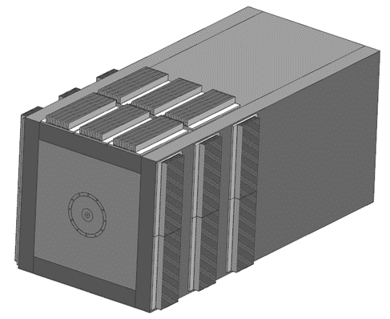
Legend:
- Steel Plates (4X)
- Aluminum Finned Plates (18 X)
- Aluminum Blocks
- Aluminum Cover Window
- Graphite Core
1400 mm
1

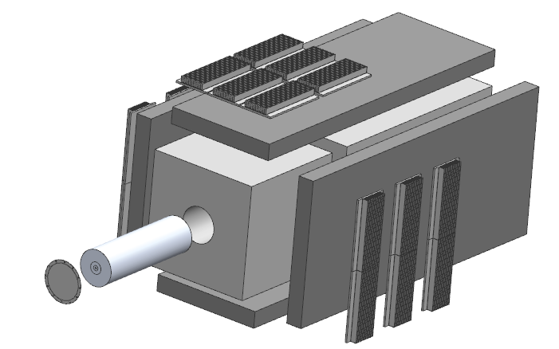
B
3
3
5
4

Figure 1. Absorber Assembly, A: Absorber CAD Model and B. Exploded View

QC Tests and Measurements
QC Tests and Measurements will be performed by the vendor at the vendor site and a QC report will be provided by the vendor. The shrink fit of the Graphite core and Aluminum assembly will also be performed at the vendor site but under the supervision of FNAL personnel. The following are the QC items that will need to be performed to align the design of the absorber and the fabrication process.
- CMM (Coordinate Measuring Machine) measurements to ensure the dimensions and tolerances of the Graphite core outer diameter and the Aluminum block inner diameter are as per production drawings.
- Visual Inspection and dimensional measurements to ensure the location and alignment of the bolt holes between the Aluminum Block and the Steel Plates and also to ensure the flatness of the mating surfaces.
- Bolt torque measurements for all the bolts in the installed assembly and the verification of the placement of Belleville washers.
- Dimensional Measurement of the finned plates to ensure the correct spacing and thickness of the fins as per final drawings.
- Dimensional Measurement of location of slots for Hilman Rollers on the Base plate.
- Other pertinent information and documentation such as material certifications and MSDS shall also be provided by the vendor in addition to the QC report.

3.0 Requirements Traceability

The Technical Requirements Specification (TRS) document (Teamcenter #: ED0011432) links the Functional Requirements Specification (FRS) document (Teamcenter #: ED0008140) to the design of the absorber, i.e. the design shall address the elements in the TRS which has requirements flowing down from the FRS.

The requirements traceability occurs in many ways, such as MARS simulations and ANSYS simulations to ensure that the design of the absorber components fulfill their functions. Also, included are items such as diagnostics (i.e. thermocouples to measure temperature excursions and provide feedback to the beam operations), QC inspections, etc.

4.0 Travelers, Procedures, and Checklists

A general traveler will be prepared to capture all the QC measurements (includes vendor QC reports) and will address the following items:
- Identification of the list of critical dimensions and tolerances as per the final drawing package given to the vendor.
- Torque specifications for the bolted assemblies
- Specifications for Belleville washers including quantity and orientation
- Material certification and verification requirements

5.0 Acceptance Tests & Criteria

The vendor provided QC reports will be verified by FNAL personnel against the production drawings and any other procedural documentation supplied by FNAL. The documents such as MSDS and material certifications provided by the vendor will also be verified by FNAL.

6.0 In-process monitoring and measurement activities

The shrink fit will require in-process monitoring by FNAL personnel at the vendor site, to verify the assembly procedure. In-process monitoring may also be necessary during the dimensional measurement/inspection of the shrink fit components (the Graphite core and the Aluminum block) and during post-machining.

7.0 Verification Plans: Methods & Activities

The QC reports and other related documents such as material certs and checklists and procedures provided by the vendor will be reviewed and verified by FNAL. FNAL personnel will also work to ensure that the results are consistent with the FRS and TRS.

8.0 Deliverable Documentation and Records

The deliverables will include the QC measurement documents and reports, installation/fabrication procedures. Any MSDS (Material Safety Data Sheets) from the vendor.

9.0 Associated Equipment

All equipment and tooling associated with the fabrication of the absorber will be designed and manufactured by the vendor. At this point, no special tooling/fixturing is anticipated as required.

10.0 Calibration Plans

All equipment and tooling associated with the fabrication of the absorber used by the vendor should be calibrated and this information shall be included in the QC reports from the vendor.

11.0 Traceability Requirements

The Teamcenter drawing parts number assigned for each component shall be stamped on the part or by some labeling means. This is more critical for the Graphite core and the steel plates that bolt on to the Aluminum block. Information pertaining to this process shall be provided by FNAL to the vendor.

12.0 Training and Qualification

The straight-ahead beam absorber will not need any specialized training or qualification. Nevertheless, the shrink fit will be performed at a vendor site or shop, some expertise will be needed to understand the aspects of the shrink fit.

13.0 Planned Vendor Communication & Visits

Currently, the final assembly (shrink fit) of the Graphite core is the only aspect that will require a vendor visit. Prior to the performance of the shrink fit, the vendor will have to perform a dimensional measurement of the Graphite core and the Aluminum block to ensure the parts have been fabricated as per the final drawings and upon receipt of this information from the vendor the FNAL personnel shall plan the vendor site visit.

14.0 Control of Nonconformances

Any nonconformances identified will be documented and communicated to the Project Managers. These discrepancies will be reported to the vendor for corrective actions and the nonconforming device shall be returned. Any nonconformance identified by the vendor that will result in schedule delays shall be reported to FNAL as soon as possible and documented via a Discrepancy Report per the PIP-II Nonconformance Handling Procedure.

15.0 Transportation/Shipping

The shrink fit assembly transportation should be handled with care in order to ensure that the components do not dislodge during transportation from the vendor to FNAL. There are no other shipping constraints identified at this time.

16.0 Risk Analysis Documentation

The Engineering Risk Assessment document (Teamcenter #: ED0013593) as required by the Fermilab Engineering Manual has been completed. The thermal design document (Teamcenter #: ED0013689) addresses the design considerations and TRS.

