PIP-II 25KW Beam Absorber
Quality Control Plan

Document number: PIP-II-Doc-5352

PIP-II

 | Document Title | PIP-II 25KW Beam Absorber Quality Control Plan
 | Document Number | PIP-II-Doc-5352

Document Reviewers/ Approvers |  | Date Reviewed / Approved
Originator | Meiqin Xiao
Contributor
Contributor
Contributor
Reviewer | Tom DiGrazia | 05/17/2021
Reviewer
Reviewer
Reviewer
Approver | Ioanis Kourbanis | As in DocDb

Author | Version | Revision Date | Description of Change
Nnamdi Agbo | Initial Release | 05/12/2021 | N/A

PIP-II

 | Document Title | PIP-II 25KW Beam Absorber Quality Control Plan
 | Document Number | PIP-II-Doc-5352

Table of Contents

1. Scope of Quality Control Plan 4
2. Qc Test and Measurements 4
3. Requirements Traceability 4
4. Travelers, Procedures and Checklists 4
5. Acceptance Tests and Criteria 4
6. In-process monitoring and measurement activities 4
7. Verification Plans: Methods and Activities 4
8. Deliverable Documentation and Records 4
9. Associated Equipment and Calibration Plans 4
10. Traceability Requirements 4
11. Training and Qualification 4
12. Planned Vendor Communication & Visits 4
13. Control of Nonconformances 5
14. Transportation / Shipping 5
15. Risk Analysis Documentation 5

PIP-II

 | Document Title | PIP-II 25KW Beam Absorber Quality Control Plan
 | Document Number | PIP-II-Doc-5352

Scope of Quality Control Plan
The delivery of 25KW in-place absorber for the PIP-II Project resides under WBS 121.05.02 (Beam Absorber). Both the mechanical and thermal design of the absorber is to be completed by FNAL but most the fabrication processes and testing are to be carried out by an outside vendor based on the defined specifications. The graphite core is the main component of the absorber and is shrink fitted into an aluminum block as shown on figure 1 while the remaining components of the assembly are bolted together.
This quality control plan covers the specific QC tasks required to make sure that the 25KW beam absorber meets the specified project requirements as highlighted on the FRS and TRS and to ensure that the absorber is delivered on time and within budget for installation and commissioning.
Steel Plug
Aluminum Tubes
Aluminum
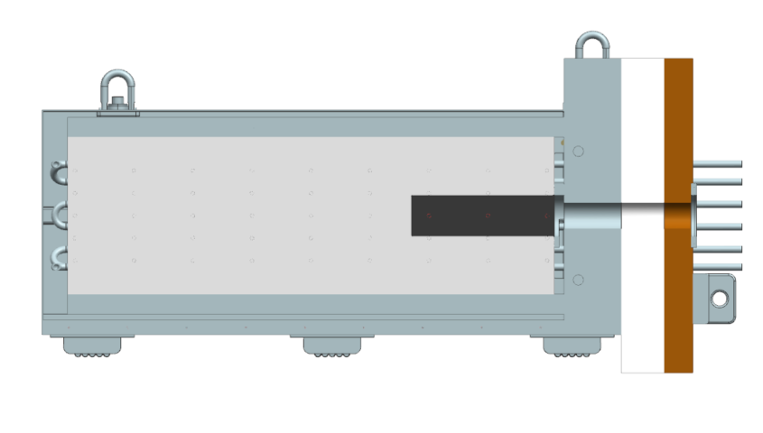
Marble Plug
Hilman Rollers
Graphite Core
Steel
Poly Polyethylene

Figure 1: 25 KW Beam Absorber Assembly
PIP-II

 | Document Title | PIP-II 25KW Beam Absorber Quality Control Plan
 | Document Number | PIP-II-Doc-5352

QC Test and Measurements
Testing and measurement will be performed by the responsible vendor and report sent to FNAL personnel for review, approval and documentation. Both the shrink fitting and welding are to be performed at the vendor’s site but must be supervised by Fermilab Personnel. The following QC test and measurement are required;
- Radiographic testing of the welds to ensure full penetration and eliminate possible leaks
- Dimensional measurement of the graphite core and aluminum block hole diameters to ensure there are machined to specification before shrink fitting process.
- CMM Measurement and/or visual inspection of all bolt hole to ensure proper alignment with interfacing components
- CMM measurement to ensure plates are machined to specified flatness value.

Requirements Traceability
The FRS which feeds into the TRS shall serve as the major document when verifying if requirements have been met or justifying requirements. The FRS and TRS for this project could be accessed on Team center using the following document numbers;
- TRS (ED0011432)
- FRS (ED0008140)
They cover all aspects of the design requirement such as;
- Absorber Lifetime
- Replaceability
- Cooling and Instrumentation
- Interlock, etc.

Travelers, Procedures and Checklists
Travelers will be made to capture all the QC measurements and will address the following;
- Visual and Dimensional Inspection
- Weld Inspection
- Torque Specification
- Material Certification

PIP-II

 | Document Title | PIP-II 25KW Beam Absorber Quality Control Plan
 | Document Number | PIP-II-Doc-5352

Acceptance Tests and Criteria
The responsible design engineer and project manager shall be tasked with the responsibility of making sure that all applicable vendor documentation and reports such as the vendor’s QC report and material specifications and reviewed prior to approval. The post weld testing must be carried out by the vendor under the supervision of FNAL and the report reviewed by the appropriate
FNAL expert alongside the lead design engineer if different to ensure that no weld failure occurs throughout the absorber’s operational life as defined on the FRS and TRS.

In-process monitoring and measurement activities
The following activities will require in-process monitoring by the responsible engineer or technician;
- Shrink fitting process
- Post shrink fit demensional measurement verification
- Welding qualification and procedure
- Welding inspection and monitoring

Verification Plans: Methods and Activities
All results, documentations and procedures are to be verified by the responsible design engineer and project manager to ensure that there are consistent with what was specified in the Technical and Functional Requirement Specifications (TRS and FRS) respectively.

Deliverable Documentation and Records
The list below identifies all required deliverables;
- QC Measurement Document and Reports
- Installation/Fabrication Plan or Procedures
- Material safety Data Sheet (from vendor)
- Weld testing / inspection results and any other material documentation etc.
There shall be reviewed by the appropriate personnel and stored for future reference.

Associated Equipment and Calibration Plans
All equipment needed for the fabrication processes are to be provided by the associated vendor. The calibration plan will also be the responsibility of the vendor. There are no specialized tooling needs at this point, but all required equipment needed for the final installation will be provided by the responsible Fermilab department/team.

PIP-II

 | Document Title | PIP-II 25KW Beam Absorber Quality Control Plan
 | Document Number | PIP-II-Doc-5352

Traceability Requirements
All component must have the assigned drawing number clearly marked on its surface by any permanent means deemed most appropriate.

Training and Qualification
Due to the high severity of a leak failure if such occurs, there shall be a welder’s prequalification to ensure that high-quality standard is achieved. No other specialized training or qualifications will be required. The vendor will however need to show that they possess the needed expertise required for all the specialized works before being awarded this job.

Planned Vendor Communication & Visits
Due to the criticality of the shrink fitting and welding processes, there will be scheduled visits to the vendors site to monitor these processes. The vendor will be responsible for performing all measurement verification prior to the shrink fitting procedure and forwarding the results to the appropriate personnel in Fermilab after which a visit will be scheduled. There will also be a welder’s prequalification visit to the vendors site and subsequent trip if needed to inspect both the shrink fitting and final welding procedure. Otherwise, the vendor will be responsible for providing all applicable inspection document to Fermilab for review/ verification.

Control of Nonconformances
There must be a continuous monitoring of all critical fabrication processes such as the shrink fitting and the aluminum tube welding processes. A post fabrication inspection will also be required to ensure that there are no deviations from the specified requirement. However, all identified nonconformances must be reported to the project manager, the project team and the vendor for corrective action. If this is however discovered outside of the vendor’s facility, the vendor must be immediately informed, and part rejected / sent back to vendor’s site. Due to the potential of an associated delay in such an event, all nonconformances must also be documented as a Discrepancy Report in Vector and added to the PIP-II Master Nonconformance Log per the PIP-II Nonconformance Handling Procedure.

PIP-II

 | Document Title | PIP-II 25KW Beam Absorber Quality Control Plan
 | Document Number | PIP-II-Doc-5352

Transportation / Shipping
The Absorber components are to be fabricated at a vendor’s site and transported to Fermilab. The shrink fitted assembly which equally has some welded aluminum tubes on it is to be handle with utmost care to ensure that the welds and shrink fitted graphite does not experience any damage. The face of the graphite most be covered as well as all gun drilled waterholes to eliminate atmospheric contamination during transportation.

Risk Analysis Documentation
The risk analysis document for the 25 KW Beam absorber has been completed and will be directed to the project manager for review and approval. A comprehensive FEA analysis was also completed and results reviewed by experts to ensure that there is no thermal associated risk in the system. Report will be stored in Teamcenter (ED0013844).

