PIP-II Linac Straight-ahead Beam Absorber
Interface Specification Document (ISD)

Document number: ED0013841

Document Approval

Signatures Required | Date Approved
Author/Owner: M. Xiao | -
Reviewer: Kris E Anderson, Denton K Morris | Concurrence in TC
Reviewer: Alex Martinez, Integration Coordinator | Concurrence in TC
Approver: I. Kourbanis | Approved in TC

Revision History

Revision | Date of Release | Description of Change
- | 04/31/2021 | Initial Draft

Page left intentionally blank.

Table of Contents
1. Purpose 3
2. Scope 4
3. Roles and Responsibilities 4
4. Acronyms 4
5. Linac Straight-ahead beam Absorber delivery and Installation 5
5.1. Linac Straight-ahead beam Absorber/ the High-Bay Building 5
5.2. Linac Straight-ahead beam Absorber/ Mover Interfaces 7
5.3. Linac Straight-ahead beam Absorber/ Bounding Envelopes 8
5.4. Linac Straight-ahead beam Absorber/ Relocation Interfaces 8
5.5. Linac Straight-ahead beam Absorber/ Diagnostic Interfaces 9
5.6. Linac Straight-ahead beam Absorber/ Alignment Interfaces 10
6. Interface Summary Table 10
7. Reference Documents 11

Purpose
This Interface Specification Document (ISD) provides details of interfaces related to the Linac straight-ahead beam absorber, BTLBA.

Scope
This document covers interfaces between the Linac straight-ahead beam absorber/BTLBA and BTLINST.

Roles and Responsibilities
PIP-II Integration Coordinator
Develops and oversees interface management for the PIP-II project. Reviews the ISD for compliance and provides assistance on interface issues.

PIP-II Level 3 Manager (L3M)
Oversees interface management and development within their L3 system. Responsible for development of the ISD.

PIP-II Level 2 Manager (L2M)
As the design authority, is responsible for ensuring full compliance to the PIP-II interface management process within their L2 systems and subsystems. Approves all ISDs within their L2 systems and subsystems.

Acronyms

BTLBA | Beam Transfer Line Beam Absorber
BTLINST | Beam Transfer Line Installation
ISD | Interface Specification Document
L2M | Level 2 Manager
L3M | Level 3 Manager
PIP-II | Proton Improvement Plan II Project
TRS | Technical Requirements Specification

Linac Straight-ahead beam Absorber delivery and Installation
Master ICD interface(s) 3585-004 (BTLINST)

This interface document is between the BTLBA and BTLINST systems and describes the interfaces involved in the delivery and installation of the straight-ahead beam absorber. The following sub-sections provide details of this interface.

Linac Straight-ahead beam Absorber/ the High-Bay Building

BTLBA will provide the straight-ahead absorber components and assembly drawings and installation procedures (Table 1). BTLINST will move the components from the high-bay building to the tunnel entrance through the service hatch. BTLINST will assemble the absorber including the concrete shielding at the tunnel entrance in the high-bay building. Figure 1 shows the absorber assembly with no shielding. Figure 2 shows the absorber within the concrete shielding for the 177 MeV location and Table 2 lists the different components of the absorber without the concrete shielding.

Item | ID #
Absorber CAD Assembly Model | F10151075 (Teamcenter Assembly Number) (Pre-Release)
Absorber Main Assembly Drawing | F1XXXXXXX
Installation Procedure | ED00XXXXX
Table 1. List of documents and drawing numbers

1

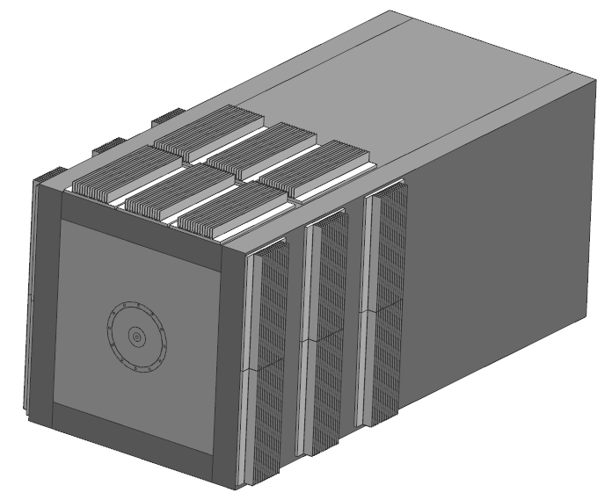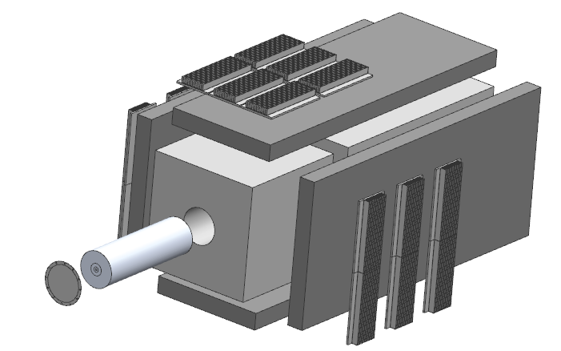
Legend:
- Steel Plates (4X)
- Aluminum Finned Plates (18 X)
- Aluminum Blocks
- Aluminum Cover Window
- Graphite Core
1400 mm
700 mm
700 mm
4
3
3
2
1
5

Figure 1. Absorber Assembly (F10151075) including the Exploded View.

2140.4 mm
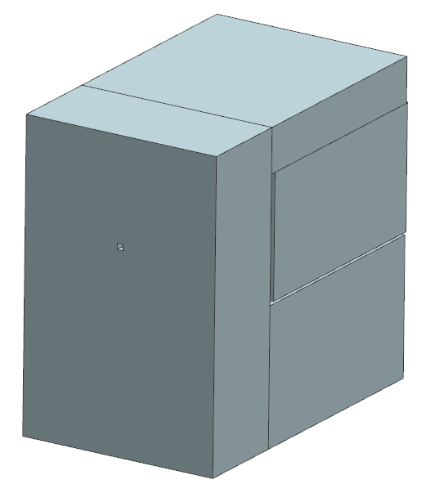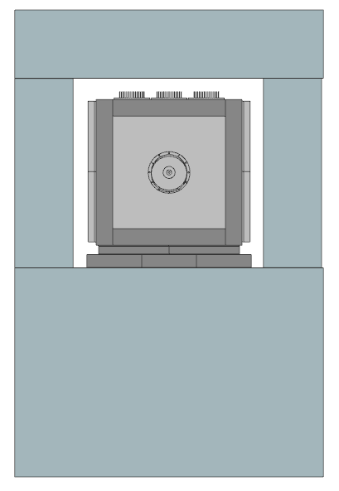
1998 mm
1313 mm
Concrete
Beam Pipe Slot
Absorber Assembly with Air Gap around the Periphery

Figure 2. CAD Model F10151075 of the 177 MeV Location Absorber with the Concrete Shielding.

Component/Part | Nominal Dimensions
Graphite Core (2 segments) | OD 152.4 mm X 254 mm L
Aluminum Block | Center Bore Dia. 152.4 mm X 480 mm Sides X 1400 L
Steel Plates Top and Bottom (2 Nos.) | 480 mm W X 1400 L X 70 mm Thick
Steel Plates Sides (2 Nos.) | 620 mm W X 1400 L X 70 mm Thick
Aluminum Finned Plates (18 Nos.) | 152.4 mm W X 300 mm L X 40 mm Thick
Table 2. The various components of the Absorber.

Linac Straight-ahead beam Absorber/ Mover Interfaces

The full assembly of the absorber including the concrete shielding for the 177 MeV location (shown in Figure 2), which weighs ~15,000 kg will be assembled by BTLINST on to a dedicated exoskeleton-cart (provided by BTLBA) equipped with rollers at the tunnel entrance in the high-bay building as shown in Figure 3. BTLBA to design and provide all the components. The concrete shielding will be the standard Fermilab concrete blocks with some Steel shims (if needed) to measure up to the Beam centerline. BTLINST will move the assembly to its 177 MeV location which is about 205 feet from the shield wall at the upstream end of the tunnel.
Absorber Assembly with Concrete Shielding

Exoskeleton

Rollers

Figure 3. Concept of Absorber move through the LINAC Tunnel.

BTLBA will also provide information regarding the location of pick points/push-pull points on the absorber to BTLINST.

Linac Straight-ahead beam Absorber/ Bounding Envelopes

Figure 4 shows the bounding envelope for the absorber at the 177 MeV location.

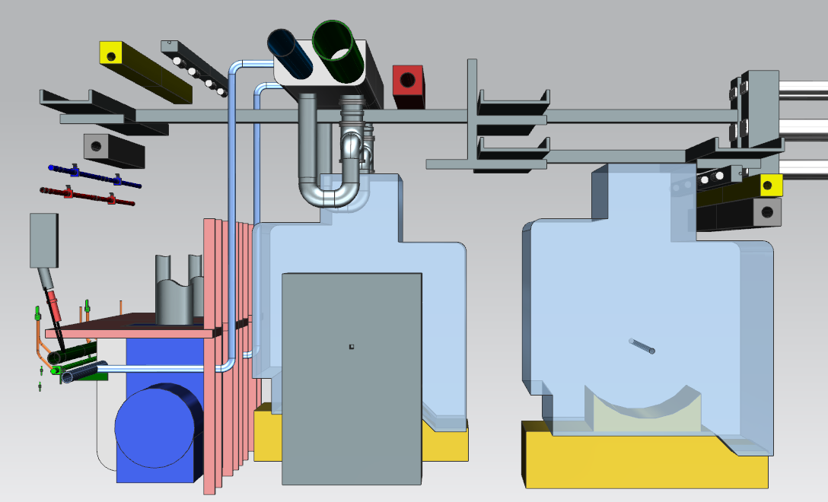
Envelope Space available in the Tunnel Aisleway
Absorber with Concrete Shielding at the 177 MeV Location

Figure 4. Cross Section of the Tunnel showing the Absorber at the 177 MeV Location and the Aisleway.

Linac Straight-ahead beam Absorber/ Relocation Interfaces

The assembled absorber along with the dedicated frame/exoskeleton and rollers will be moved from its initial 177 MeV location to its final 2 kW location at the end of the Linac tunnel, which is ~570 feet from the 177 MeV location. BTLINST will pre-install the extra concrete shielding required for the 2kW location and move the absorber assembly including the concrete from the 177 MeV location after the commissioning of the Cryomodules. Figure 5 shows the absorber in its final 2kW Shielding configuration. The total weight of the absorber assembly including the concrete at the 2kW location is ~ 55,000 kg.

BTLBA to provide information regarding the time required for the absorber at the 177 MeV location to cool off before being moved to the final 2kW location.

3539.4 mm
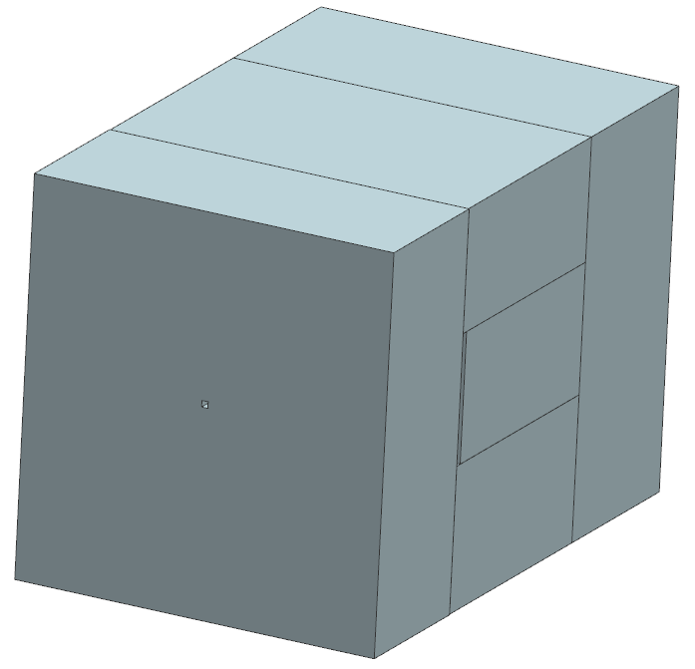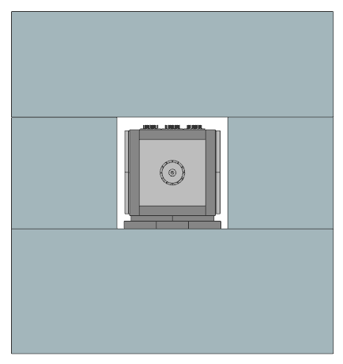
2469.8 mm
2326.8 mm
Concrete

Absorber Assembly with Air Gap around the Periphery
Beam Pipe Slot

Figure 5. Absorber Assembly at the 2kW Location with the extra Concrete Shielding.

Linac Straight-ahead beam Absorber/ Diagnostic Interfaces

BTLBA to provide information on the location of thermocouples for the absorber and provide the thermocouple components as well. BTLINST to install the thermocouples including the wiring and provide routing of the cables as per requirements provided by BTLBA.

Linac Straight-ahead beam Absorber/ Alignment Interfaces

BTLINST to install the absorber assembly in the beamline such that the beam centerline is collinear with the Graphite core of the absorber.

Interface Summary Table

# | Master ICD ID# | Interface Name | Internal Reference | External Reference | Verification Method
1 | 3585-004 | Linac Straight-ahead beam Absorber/ the High-Bay Building | Section 5.1. | TBD | Check the Documents (Final Drawings and Procedures) against facilities drawings and size of hatch in the high-bay building
2 | 3585-004 | Linac Straight-ahead beam Absorber/ Mover Interfaces | Section 5.2. | TBD | Inspect the dedicated cart load ratings and the mover equipment, rigging inspection
3 | 3585-004 | Linac Straight-ahead beam Absorber/ Bounding Envelopes | Section 5.3. | TBD | Check interferences using integrated 3D CAD models before building. Also verify spacing using alignment techniques
4 | 3585-004 | Linac Straight-ahead beam Absorber/ Relocation Interfaces | Section 5.4. | TBD | Check procedures, rigging inspection
5 | 3585-004 | Linac Straight-ahead beam Absorber/ Diagnostic Interfaces | Section 5.5. | TBD | Test and calibrate the instrumentation and interfacing controls
6 | 3585-004 | Linac Straight-ahead beam Absorber/ Alignment Interfaces | Section 5.6. | TBD | Measure the beamline centerline from floor to the absorber core

Reference Documents
# | Reference | Document #
1 | PIP-II Master Interface Control Document | ED0010433
2 | PIP-II BTLBA Beam Absorbers TRS | ED0011432
3 | PIP-II Transfer Line and Beam Absorber FRS | ED0008140
4 | Fermilab Engineering Manual | -
5 | Fermilab Environmental Safety and Health Manual | -
6 | Fermilab Radiological Control Manual | -

