PIP-II BTL Collimators Quality Control Plan

Document number: PIP-II-Doc-xxxx

Document Reviews |  | Date Reviewed
Originator | Meiqin Xiao | xxxx
Contributor | Vladimir Sidorov | xxxx
Peer Reviewer | Tom DiGrazia | xxxx
Peer Reviewer | Lidija Kokoska | xxxx
Peer Reviewer | Denton Morris | xxxx
Peer Reviewer |  | xxxx
Approver | Ioanis Koubanis

Revision History
Author | Version | Revision Date | Description of Change
Meiqin Xiao | 1.0 | Xx/xx/xx | New Document

Table of Contents
1.0 Scope of Quality Control (QC) Plan 3
2.0 QC Test and Measurements 3
3.0 Requirements Traceability 4
4.0 Travelers, Procedures, and Checklists 4
5.0 Acceptance Tests & Criteria 4
6.0 In-process monitoring and measurement activities 4
7.0 Verification Plans: Methods & Activities 4
8.0 Deliverable Documentation and Records 4
9.0 Associated Equipment 4
10.0 Calibrations Plans 4
11.0 Traceability Requirements 4
12.0 Training and Qualification 4
13.0 Planned Partner and Vendor Communication & Visits 4
14.0 Control of Nonconformances 5
15.0 Transportation/Shipping 5
16.0 Risk Analysis Documentation 5

Scope of Quality Control (QC) Plan
The delivery of the BTL Collimators to the PIP-II Project resides under WBS #121.05.02 (Transfer Line / Beam Absorber). BTLBA will deliver two beamline collimators capable of removing up to 1% halo in both the H & V plane of the distribution at the injection foil location for Booster injection. Figure 1.1 and 1.2 give the base of the horizontal and vertical collimator respectively. The collimators will be fabricated and assembled at Fermilab. This Quality Control plan covers the specific QC efforts required to ensure the collimators meets Project specifications and is delivered for installation on time and within budget.
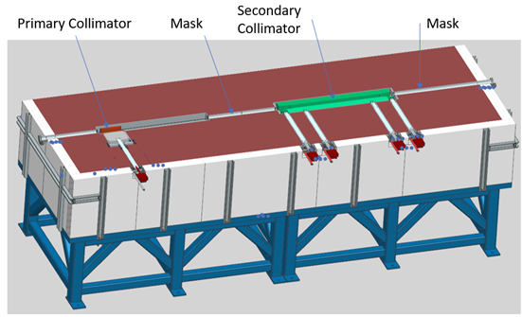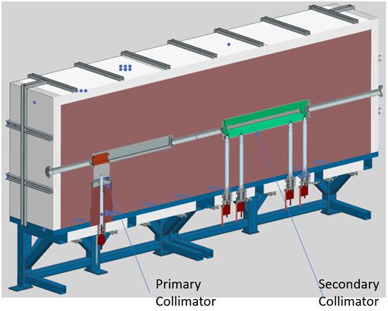
Figure 1.2 The base of the vacuum chamber –Horizontal(left) and vertical(right) collimators.

2.0 QC Test and Measurements
QC Tests and Measurements will be performed by the Fermilab Alignment group on-site and QC technical report will be provided.
The following are the QC items that will need to be performed to align the design of the Collimator and the installation process in the tunnel.
- The Primary and Secondary Collimators jaws working surface flatness.
- The repeatability of jaws location in the operation position.
- The location jaws inside the vacuum chambers according to the alignment fiducials welded to the outside vacuum chamber. (Fiducials are used in the tunnel for the vacuum chamber alignment)
- Quantity motors steps required for jaws travel to the operation position.
The following are the QC items that will be measured directly:
- the beam pipe ID,
- the collimator jaw thickness,
- A36 steel shielding
- external marble

3.0 Requirements Traceability
The Physics Requirements Specification (PRS) document (Teamcenter #: ED0010235) links the Technical Requirements Specification (TRS) document (Teamcenter #: ED0011431) to the design of the collimators, i.e. the design shall address the elements in the TRS which has requirements flowing down from the PRS. Interface Specification Document (ISD) (Teamcenter #: ED0016674). contain the information necessary to define all of the external interfaces for the given system. PIP-II Final design Report (PRD, PIP-II-doc-5310-v7) provide general guidance for the radiation, safety and health parameters. Some requirements are based on the Best practices.

The requirements traceability occurs in many ways, such as MARS simulations and ANSYS simulations to ensure that the design of the collimator components fulfill their functions.

4.0 Travelers, Procedures, and Checklists
A general traveler will be prepared to capture all the QC measurements (includes vendor QC reports) and will address the following items:
- Identification of the list of critical dimensions and tolerances as per the final drawing package given to the vendor.
- Torque specifications for the bolted assemblies
- Specifications for Belleville washers including quantity and orientation
Beamline Collimators Assembly Traveler will be prepared for the Collimators assembly. A Installation Traveler will be prepared specifically for the installation of the beamline collimators.
Material certification and verification requirements

5.0 Acceptance Tests & Criteria
The vendor provided QC reports will be verified by FNAL personnel against the production drawings and any other procedural documentation supplied by FNAL. The documents such as MSDS and material certifications provided by the vendor will also be verified by FNAL.

6.0 In-process monitoring and measurement activities
The FNAL personnel (Fabrication specialist) is providing the monitoring of parts fabrication at the vendor site. In-process monitoring may also be necessary to contact with the design engineer and project management during the dimensional measurement/inspection of the most critical collimator parts and components.

7.0 Verification Plans: Methods & Activities
The QC reports and other related documents such as material certs and checklists and procedures provided by the vendor will be reviewed and verified by FNAL. FNAL personnel will also work to ensure that the results are consistent with the FRS and TRS. Methods and activities are stated in the TRS Metadata sheet as:
- Multiple verification Methods, prior to FDR and on Prototype assembly
- Inspection, verify through direct measurement
- Analysis, verify through design review and direct measurement
- Demonstration/Test, verify through mechanical test and measurement

8.0 Deliverable Documentation and Records
The deliverables will include the QC measurement documents and reports, installation/fabrication procedures. Any MSDS (Material Safety Data Sheets) from the vendor.

9.0 Associated Equipment
All equipment and tooling associated with the fabrication of the collimators will be designed and manufactured by the Fermilab. Conventional tools, such as Tape measure and Calipers, will be used for measuring sizes. At this point, no special tooling/fixturing is anticipated as required.

10.0 Calibrations Plans
All equipment and tooling associated with the fabrication of the collimators used by the vendor should be calibrated and this information shall be included in the QC reports from the vendor.

11.0 Traceability Requirements
The Teamcenter drawing parts number assigned for each component shall be stamped on the part or by some labeling means. This is more critical for the Jaws and the steel shielding . During assembly, all uniquely identified components will be recorded in the assembly traveler documents. Information pertaining to this process shall be provided by L4 manage

12.0 Training and Qualification

The collimators will not need any specialized training or qualification, since many of the collimators at Fermilab have been made here at Fermilab

13.0 Planned Partner and Vendor Communication & Visits
N/A

14.0 Control of Nonconformances
Any nonconformances identified will be documented and communicated to the Project Managers. These discrepancies will be reported to the vendor for corrective actions and the nonconforming device shall be returned. Any nonconformance identified by the vendor that will result in schedule delays shall be reported to FNAL as soon as possible and documented via a Discrepancy Report per the PIP-II Nonconformance Handling Procedure.

15.0 Transportation/Shipping
The collimators assembly transportation should be handled with care in order to ensure that the components do not dislodge during transportation from the vendor to FNAL. There are no other shipping constraints identified at this time.

16.0 Risk Analysis Documentation

The Engineering Risk Assessment document as required by the Fermilab Engineering Manual has been completed. The thermal design document addresses the design considerations and TRS.

