PIP2IT 650MHz HPRF Distribution Technical Requirement Specification

Document number: ED0012142

Name: Ding Sun
Org: AD/RF
Contact:
Role: Primary Engineer
Approver: Victor Grzelak
Org: PIPII/TI
Contact: x6442
Role: Deputy L3 Manager
Approver: Jim Steimel
Org: PIPII/TI
Contact: x4826
Role: L3 Manager

Revision History

Revision | Date Release | Originator:  Role: | Description of Change
A | 8/20/2020 | Coordinator
Revision control is managed via Fermilab Teamcenter Workflows.
Table of Contents

1. Introduction 3
2. Scope 3
3. Aronyms 5
4. References 5
5. Operating conditions 6
6. Technical specifications 6
7. RF Leakage 7
8. Quality Assurance 8

Introduction
The PIP2IT test facility 650 MHz RF distribution system transports output power from power amplifiers to input couplers of 650 MHz superconducting cavities in both LB650 and HB650 cryomodules for testing those cavities up to 110% of their specified maximum E field along beam line.
This document specifies technical requirements which enables this distribution system meet its functional requirements defined in document “PIP2IT 650MHz RF Distribution Functional Requirements Specification”, ED0012138

Scope
The PIP II test facility 650 MHz RF distribution system consists of six separate distribution lines. Each distribution line connects the output port of an RF power amplifier on one end and the input port of the input coupler of a cavity on the other end; and transports RF power from the amplifier to input coupler of the cavity (Figure 1). Each distribution line consists of standard coaxial and waveguide transmission line components, a circulator and a dual directional coupler (Figure 2). The technical specification defined in this document applies to all six distribution lines.

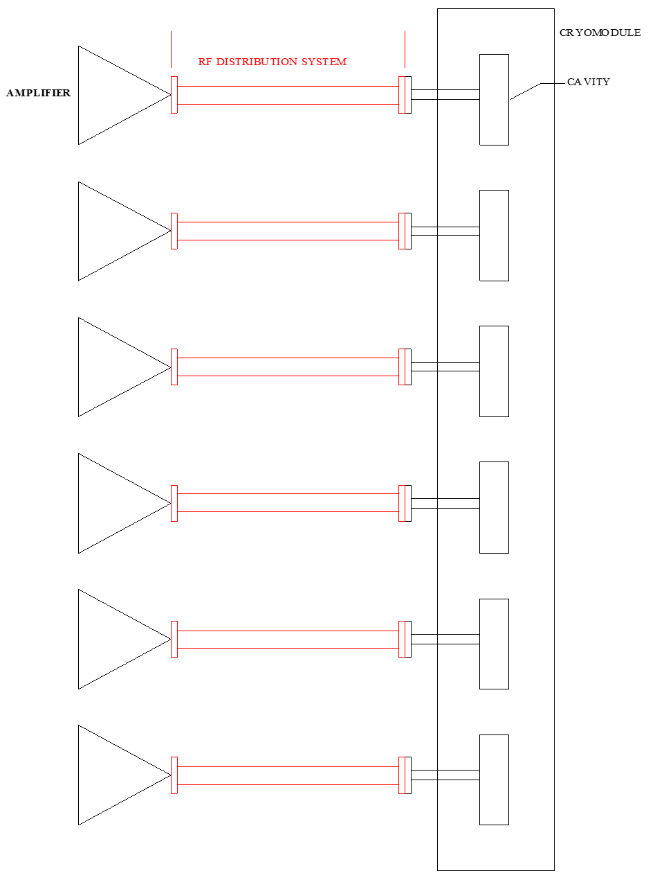
Figure 1. Scope of PIP2IT Test Facility 650 MHz RF Distribution System.
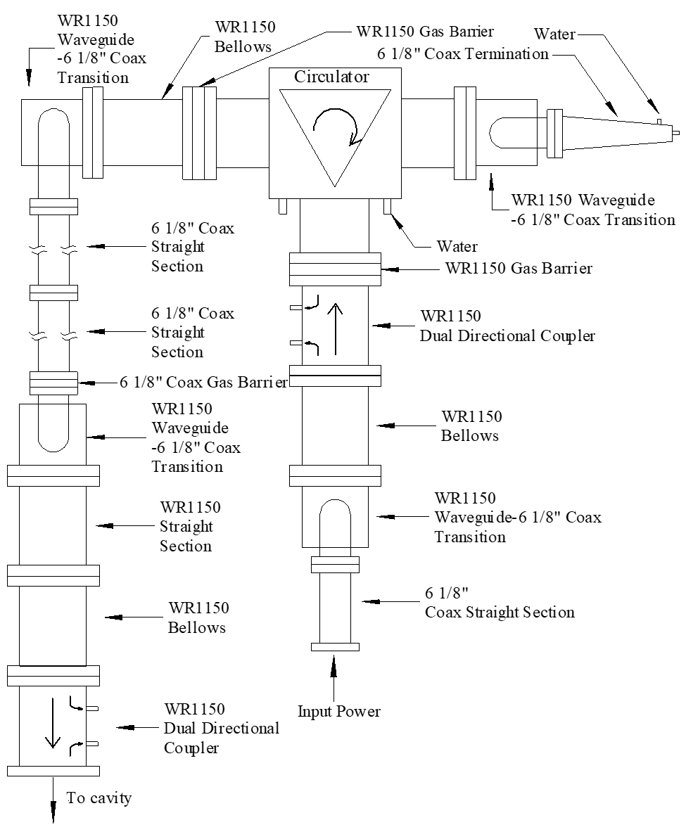

Figure 2. Schematic of the distribution line design plan.

Acronyms
OSHA | Occupational Safety and Health Administration
FCC | Federal Communications Commission
HPRF | High Power RF
PA | Power Amplifier
SSA | Solid State Amplifier
CW | Continues wave

References
1 | PIP-II L3 FRS | ED0008023, Rev. –
2 | Linac RF System PRD | ED0010220-A
3 | PIP-II LB650, 650 MHz RF Amplifier FRS | ED0003413, Rev. B
4 | PIP2IT 650MHz RF Distribution Functional Requirements Specification | ED0012138
5 | FCC OET Bulletin 65, Edition 97-01
6 | Fermilab Engineering Manual,
7 | ESH DocDB Document 4112-v1, FESHM 5100 - Structural Safety FINAL,

Operating conditions

The following operation conditions apply to all technical specifications defined in this document.
The high power test of all cryomodules may be performed with output power up to 40 kW from each power amplifier and with partially or fully reflected RF power at any phase when each cavity is operated in either pulsed or CW mode.
At the end of each pulse or the end of operation the stored energy in a cavity will be released and generate up to 90 kW (peak) of backward RF power which decays exponentially to zero in ~5 milliseconds.

Technical specifications
6.1 Power capability: each assembled distribution line should be capable of transporting 40 kW output power of a power amplifier (PA) to the input port of a cavity in a HB650 cryomodule.

6.2 Total attenuation of each distribution line: less than 0.4 db.

6.3 Cavity side dual directional coupler
Power | 40 kW CW, with up to full reflection @ any phase
Center Frequency | 650 MHz
Bandwidth | 10 MHz (650 MHz +/- 5 MHz)
Coupling | -50 +/- 0.5 dB (forward & reverse, with factory calibrations labeled)
Coupling Flatness | 0.1 db in the 650 MHz +/- 1 MHz frequency region and 0.3 db over bandwidth
Directivity | ≥ 40 dB across bandwidth
Mainline VSWR | < 1.02:1
Insertion loss | < 0.01 dB
Coupling ports | dual broadwall (same side) loop couplers, external termination
Coupling port | VSWR ≤ 1.2:1 Typical
Coupling Port Connectors | Type N, female (non-teflon material), 50 ohm impedance
Material | Aluminum 6061, corrosion resistant
Flanges | standard WR1150, CPRF
Pressurization | Air tight up to 5 PSIG internal pressure
FINISH | RoHS COMPLIANT CHEMICAL CONVERSION COATING

6.4 Circulator
Configuration/rotation | 3 Ports. Rotation: clockwise.
Power handling | The circulator should function normally at 70kW full reflection specifications should not deteriorate, no sparking and  overheating should occur.
Flanges of all ports | WR1150 CPRF
Center Frequency | 650 MHz
Bandwidth (BW) | +/- 6 MHz
Insertion loss at center frequency | ≤ 0.13 dB at center frequency, ≤ 0.3 dB in BW
VSWR at all ports | ≤ 1.10:1 at center frequency, ≤1.20:1 in BW
Isolation | ≥ 26 dB at center frequency, ≥ 20 dB in BW
Cooling system | Water cooled
Cooling Temperature | 86-90F
Coolant connector | 1/2” NPT male connector, stainless steel
Maximum coolant flow rate | ≤10 gpm
Maximum coolant pressure drop | 20% of inlet pressure
Maximum coolant inlet pressure | 145 PSI
Active magnetic adjustment for temperature compensation | To be specified by vendors
Arc Detection | To be specified by vendors

6.6 RF termination (Load, connected to Port 3 of circulator)
Frequency | 650 MHz
Impedance | 50 ohms
Power | 80 kW, CW
Flange | 6 1/8”, 50 Ohm, EIA
VSWR | ≤1.15:1
Coolant | LCW water
Coolant connector | 3/4″ (garden hose) or 1/2” NPT male connector, stainless steel
Coolant flow rate | 10 gpm
Max. Inlet Water Pressure | 145 PSI
Max. Outlet Water Temp. | 90°C
Water Connectors | 3/4″ (garden hose) or 1/2″ NPT
Finish | Conversion Coating & Bright Nickel

RF Leakage
7.1 RF leakage at any joint of the distribution system should be less than 0.4 mW/cm^2 measured at the closest distance from the joint. (FCC OET Bulletin 65, Edition 97-01)

Quality Assurance
8.1 Each dual directional couplers should be measured with a Network Analyzer before being used in the distribution system. The parameters to be measured include return loss at all 4 ports, insertion loss, coupling ratio and directivity.

8.2 Each circulator should go through two step examination before being used in a distribution line.
First, it should be measured with a Network Analyzer. The parameters to be measured include return loss at all ports, insertion loss and isolation between each pair of ports.
Second, after Network Analyzer measurement each circulator should be high power tested up to 40 kW. During the high power test, the return loss at input port and insertion loss between input port and output port should be measured and compared with the results measured by Network Analyzer. The test should be repeated under the condition of: output port is terminated with 50 Ohm load and is shorted with various length of extension (0, 1/8, 1/4, 1/2 wavelength of TEM wave at 650 MHz). The heat compensation function should be monitored during the high power test.

8.3 All mechanical support structures should comply with the standard described in documents of Fermilab Engineering Manual and ESH DocDB Document 4112-v1, FESHM 5100 - Structural Safety FINAL.

