APA Shipping Container Review Notes
Questions from Syd De Vries
Jeff Nelson’s Presentation:
- Do the Shipping Containers get shipped with the carts attached?
No. Our horizontal carts are for the factory sites. The APA frames will be attached to a pallet for shipping in the US. They will be on a pallet and built into a crate in the UK.

- I heard that the APA’s will be monitored for accelerations encountered during transport. What would happen if the maximum allowable values have been exceeded?
It depends on the shipping contract. The insurance policy would include renumeration if case of an APA damaged in shipping. It isn’t clear if that is to be centrally managed or at each factory site in the US. If a systemic issue we would have to add another layer for isolation.

- I heard that the containers should not be allowed to lay flat. In my experience, unless someone is watching every move in the shipping process, someone along the way won’t comply with that requirement. More of a comment than a question – I think there should be consideration in the design of the APA’s or containers to account for the chance that that would happen
We understand and have experienced that. They will be anchored to a pallet so they would have to tip the pallet too, which would not save space. Practically this should eliminate the potential benefit of tipping the frame. They will have appropriate markings for “do not stack” “delicate scientific equipment” and “up^”, but we understand that might not be abided by. We assume we are going to buy the truck and specify point to point shipping, which should reduce the risk for unseen handling in the US shipments. With the RORO trailer for the UK APAs, the issues are localized to the transfers in/out of the warehouses.
We can evaluate the flat/tipping configurations if needed, but this represents a number of unevaluated risks to the boards and wires.
- I heard that the APA’S will be tested after they get underground. Would it not make sense to test them before they get underground? If they are tested before they are lowered down the shaft, it would avoid an unnecessary trip back up the shaft.

The final underground cold test is a full system test that is not possible until they are mated and integrated. The final tensions measurements have to be completed in the final configuration (vertical).

Tests of the wires can be done elsewhere with the equipment being developed at Harvard, and they can be compared to the factory data. The current plan is to test the first 5 crates of UK APAs (and from the other US sites) in the controlled environment of the PSL factory and then to sample.

At least until we build up end enough experience to know shipping issues are rare, we would like to test in the SD warehouse. The issues with testing above ground in the SDWF are related to costs. There needs to be appropriately trained riggers for movements, space allocated, power, and a clean room. The consortium will provide members at the site for these tests as needed. We have asked that appropriate space be provided and are planning so those tests are possible. That availability of the required space and an appropriate cleanroom is not yet confirmed.

The request for SDWF testing is documented in the APA shipping frame requirements document (Introduction and Case 3).

- I noticed that there have been a variety of codes and standards used in the development of the design. Please confirm that the most stringent ones have or will be used.
These were developed by examining US and EU standards and picking the most stringent within each. An equivalence white paper between the standards has been developed by Fermilab for DUNE/LBNF (esh-docdb-4112).
- I thought I heard that a shipper would be selected and then would be checked to ensure that they could comply with vibration requirements. That sounds backwards to me. Would it not make more sense to develop a procurement package that identifies the maximum vibration requirements to be complied with and make the selection that can comply with that?
We are using a shipping standard for evaluation. A recommendation from CO is that we supplement that with the experience of the actual ship/shipper used. This is consistent with the MIL standards:
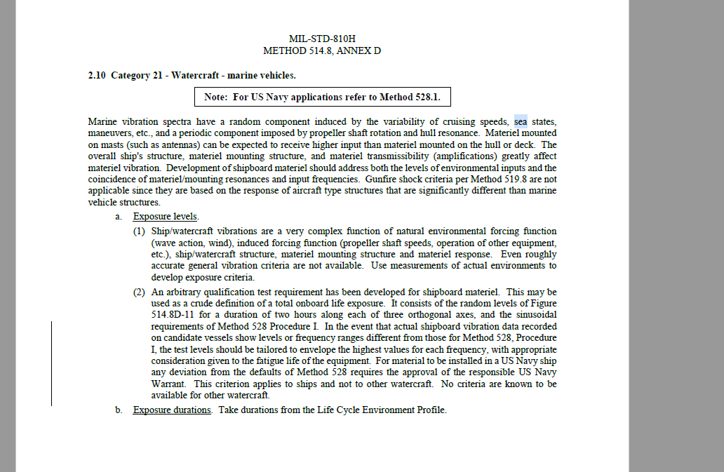
- I saw that the rigging plan for the Shipping container under the cage will incorporate the use of the two outside center lugs. Why not just use the center lug? Why does the container need to be suspended from 2 lugs?
Our thinking was that the two-connection method below the cage would be somewhat more stable to rotation during rigging and swinging side-to-side during the decent. Feedback based on local experience would be helpful for this specification.

