Computing and Software Support for the Fermilab High Intensity Program

Lee Lueking, Mark Messier, Rob Plunkett, Heidi Schellman

April 30, 2009

(Preliminary DRAFT)

I. Overview

This summary of computing needs for the Fermilab High Intensity program has its origin in the Computing for Neutrino workshop held at Fermilab March 11-12 2009. The experiments represented were Minos, MiniBooNE, SciBooNE, MINERvA, NOvA, Argoneut, MicroBooNE, Mu2e, and Daya Bay (and a guest from DUSEL). The CD services represented included SAM, Networking, Mass storage, and Central disk storage, Experiment Facilities, Central Facilities, Grid and Databases. A summary of that event can be found at:
https://cd-docdb.fnal.gov:440/cgi-bin/ShowDocument?docid=3175

II. Experimental Overview

Figure 1 lists the experiments with their approximate schedules. The solid colors show proposed running times while the shaded colors indicate analysis after the end of scheduled running.

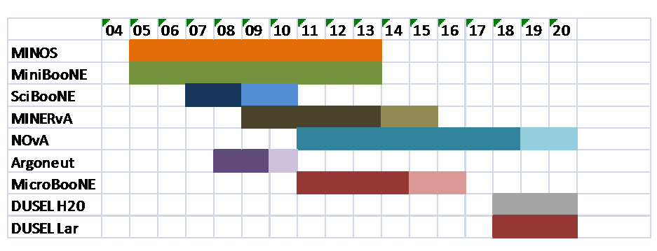
Figure 1. Schedule of running and analysis phases for the Fermilab Neutrino experiments.

The experiments divide into two major classes, those with photon readouts (MINOS, MiniBooNE, SciBooNE, MINERvA, NOvA, DUSEL H₂O) and those with Liquid Argon readout (ArgoNeut, MicroBooNE, DUSEL LAr). Event sizes for the PMT based experiments are in the 0.1-1 MByte range while those for the Liquid Argon experiments will be a factor of 100, or more, larger. Data rates are largely driven by the beam cycle of 0.5-10 Hz or < 1% live time. Some existing experiments (MINOS) and future very large experiments (NOvA, DUSEL) require that they run with 100% live-time to understand backgrounds and/or collect signal data. This greatly increase the data rates, storage and reconstruction needs.

Most collaborations have similar size, 100-200 total collaborators, with 20-40 active developers and/or heavy users of computing facilities at any given time. There is significant overlap among the various groups.

III. Major Computing and Software Needs and Issues

There were several general areas of common need that were discussed at the workshop, and they are summarized here.

- Software development and support: There are many common software tasks, for example simulations and common software tools, which will need to be developed and managed. Some of the software being used has been developed by and/or is already being supported by Fermilab CD. In some cases, new software is being used, for example new packages from CERN like GAUDI, CORAL, COOL. Having additional experts in these areas available for the Neutrino groups will be essential. Common Grid submission and monitoring tools are needed and will make the enormous data processing tasks at hand easier for both users and service providers.
- Simulation specific tasks: In the modern era, an ever-increasing amount of our computing is simulation. The Neutrino program uses simulations extensively to understand their detectors and data. It is understood that this will be a major effort in the coming years and must be properly accommodated in both manpower and computing resources.
- Infrastructure procurement and commissioning: Analysis clusters, desktop machines, central disk storage, tape archive, Grid computing, database servers, and network hardware all need to be procured, deployed and put into action. Establishing these resources with hardware and software common to all of the Neutrino groups makes it possible to maintain them with limited personnel.
- Support for infrastructure: Account management, software upgrades, and general support for analysis cluster and desktop computing resources are needed.
- Database: Data management catalog, conditions database, and other database related work is imperative for all of the Neutrino groups. Common approaches and shared resources when appropriate will be employed.
- Operations: Online data taking, offline production and physics analysis will have many tasks. Help with data cataloging and data migration is also required and critical.

IV. Computing Resource Growth Projections

Presentations were given by the experiments with estimates of their need for computing resources. The workshop provided initial information used to populate spreadsheets that will provide resource projections for the next 5 years in the areas of 1) Central Disk storage, 2) Grid farm CPU, 3) Tape archive size, and 4) the size of the Analysis and Batch cluster. These numbers are extremely important for planning and procurement scheduling for the entire program. Additional work is required to understand them in more detail.

V. Operations and Manpower

Developing software and operating the facilities will require dedicated manpower. Only MINOS currently has a full time CD person assigned to user support and general data handling issues. While some experiments may not need a full time person for either data handling or user support, the aggregate Neutrino effort will require this if they are going to use CD resources in a secure and efficient manner. Designation of shared, dedicated personnel to handle user support, computing and data handling issues will be essential to maintain coherence across the program.

VI. Committees, Meetings, Future Workshops, Mail lists

Several avenues for future coordination are being established. A working group, or steering committee, has been agreed to that will meet monthly to discuss common computing and software issues. Future workshops will be planned to concentrate on specific topics, or to gain a broad view of overall progress. In addition to these, several of the CD service providers have occasional meetings, for example the Grid Users’ Meeting, and appropriate Experiment representatives will attend these. A mailing list called “NuComp@fnal.gov” has been created to facilitate communication among the experiments and CD representatives.

