FERMI NATIONAL ACCELERATOR LABORATORY
COMPUTING DIVISION/ILC:
“BEAM SIMULATION OF THE MAIN LINAC OF THE ILC”
McDavis Fasugba

Lincoln University of Pennsylvania

SUMMER INTERNSHIPS IN SCIENCE AND TECHNOLOGY
Fermi National Accelerator Laboratory
Batavia, ILLINOIS
August 10, 2006
Project Supervisor: Paul Lebrun

Abstract: The purpose of this paper is to discuss the simulation the main –Linac of the ILC, study some key properties of the beam as it is been transported across the linac (Linear accelerator). It is programming intensive, and codes are made use of in the study of these properties. Changing various parameters gives us an insight to the physics behind these observed behaviors. It also helps understand it and see its correlation with already existing laws, in order to know if the simulation is correct.
Some parameters varied includes (but not limited to) the vertical offset, the normalized differential momentum, the KLE, KHE factor, etc.
Further explanation of these terms is provided in subsequent sections of this paper.

Introduction:
FERMI NATIONAL ACCELERATOR LABORATORY takes the understanding of the building blocks of our universe to another level. Research involving both collision of proton and anti-protons and even collision of a proton with a fixed metal target and analysis of the outcome is just a bit of the numerous experiments currently undergone at FERMILAB. The ILC stands for the ‘International Linear Collider”. It is proposed to be constructed in years to come, and it will be colliding electrons and its anti-matter counterpart positrons. It is hoped that many questions such as dark-matter, dark-energy, and many other scientific puzzles can be answered by the results obtained from this machine.
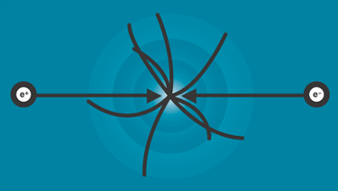
Figure 1

What is the ILC: The ILC is a proposed electron-positron collider; together with the large hadron collider at CERN would allow physicists explore energy regions beyond the capabilities of today’s accelerators. At these energies, scientists anticipate significant discoveries that will throw more light on what the universe is made up of.
The Design: In the ILC’s design, two facing linear accelerators of about 20 kilometers in length will smash beams of electrons and positrons close to the speed of light. As the particles move down the accelerator, superconducting RF (radio frequency) fields give these particles, more and more energy.
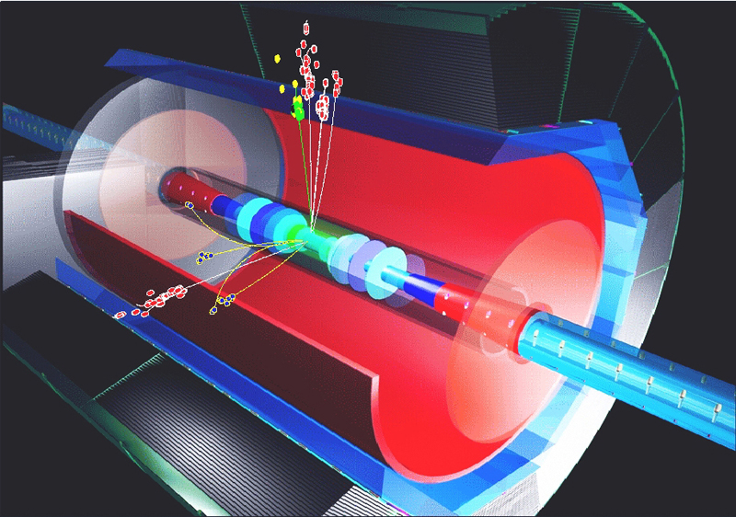
Figure 2(collision of electrons and positrons)

In order to understand certain concepts that are discussed in this paper, it is necessary to be familiar with certain terms and terminologies. A listing of these terms and their meanings are given below.
Terms and Terminologies:
Phase space: Phase space is the space in which states of a system are represented, with each possible state of the system corresponding to one unique point in the phase space. Phase space usually contains all possible values of position and momentum variables.
Emittance: Beam Emittance is the extent occupied by particles of a beam as it travels in an accelerator. In a colliding beam accelerator, low emittance means that the likelihood of particle interactions will be greater, therefore resulting in higher luminosity.
Quadrupoles: These are magnets designed to provide a magnetic field whose magnitude grows linearly with the radial distance from its longitudinal axis, which is usually centered on and parallel to main motion of the beam. The net result of these fields is a focusing force in one plane and a defocusing one in the perpendicular plane to it. In a particle accelerator, the various magnets required to bend, steer and correct the particle beam make up the “LATTICE”. Due to the laws of electromagnetism (Maxwell’s equations) it is impossible for a quadrupole to focus in both planes at the same time.
BEAM POSITION MONITORS (BPM’S): This is a device to detect and record the location of the beam bunches moving through a particular segment of the accelerator.
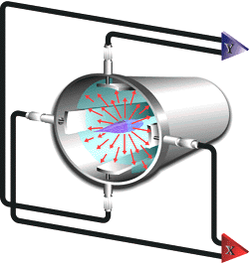
Figure 3 (a strip BPM)
The diagram above is a strip BPM. The information from the four strips can be used to measure the number of electrons or positrons in the bunch and their position as it passes between the strips.
Bunch: This is the total number of particles moving together as a 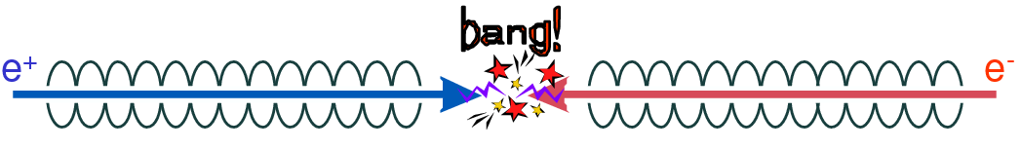group towards a target. Due to their size and nature, large magnets are used to keep them in position as they move along the beam pipe.

ILC MAIN LINAC
- It will accelerate electrons and positrons at 250 GeV, which is upgradeable to 500 GeV
- Two major design issues:
- Efficient acceleration of the beam
- Luminosity: Emittance Preservation
- ~20 km in length (will be the longest straight linear accelerator in the world).
- BEAM CONDITIONS

- Bunch Charge:2x10¹⁰ particles/bunch
- Bunch length: 300μm
- Normalized injection Emittance; γε_{γ} =20nm-rad
- Injection energy: 15Gev
- Final energy: 250Gev
- Acceleration Gradient: ~30MV/m
- Momentum spread:~1% at injection
- Transverse emittance: 400x20μm.mrad

The ILC will provide cleaner collisions that can be analyzed and can also make more accurate measurements and precision. This is due to fact that electrons and positrons are fundamental particles and as such are not made up of other particles. Therefore smashing one against the other produces cleaner results that can be analyzed.

SIMULATION OF THE MAIN LINAC: The simulation of the main linac involves an intense amount of programming. The language used for the coding is C++/C. A lattice file exists and contains all components that make up a complete Linac ( from the quadrupoles to the cryomodules) and much more. This serves as the input file for the program to utilize. Several header files have been designed to account for various functionalities of the linac.
The main body of the program consists of classes that simulate the propagation of the particle from one end of the linac to the other. The program also controls several properties of the beam such as its horizontal and vertical offsets, its normalized differential momentum and the beam position monitors.
A section of the codes written looks like this:
for (int i=0; i<1; i++){ // Example 2 loop
cerr<<"i=" << i<< endl;
Particle* prtEx2 = new Positron( bmlPtr->Energy() );
prtEx2->set_x ( myOptions.x );
//double newYInit = -500e-6 + i*1.0e-6;
double newPInit =-1e-3+i*1e-3;
prtEx2->set_y ( myOptions.y );
prtEx2->set_cdt( myOptions.cdt );
prtEx2->set_npx( myOptions.px );
prtEx2->set_npy( myOptions.py );
prtEx2->set_ndp(newPInit );

cout << " Ready to propagate " << endl;
BeamlineIterator biCK( bmlPtr );
cout << " got biCK Late Friday " << endl;
double s = 0.;
int numLinesPrinted= 0;
int step=0;
double minDistanceBetweenPrints = 10.; // in meter
double sAtPreviousPrint = -20.;
while(( q = biCK++ )) {
q->propagate( *prtEx2 );
s += q->Length();
double yNow = prtEx2->get_y();
if((s - sAtPreviousPrint ) > minDistanceBetweenPrints) {
out << s << setw(20) << yNow << endl;
numLinesPrinted++;
sAtPreviousPrint = s;
}
// cout<< " yNow" << yNow <<setw(20)<<s<<endl;
}
cout << " Number of line printed " << numLinesPrinted << endl;
double nyp = prtEx2->get_npy();

biCK.reset(); // Not really necessary here, but what the heck.

//Reporter clark_kent;
//clark_kent.interview( prtEx2 );

// obtain yFinal, the coordinate of the electron at the end of the Linac

delete prtEx2;

}
out.close();
// close the file yStudy1
// Clean house (a little) before leaving.
// -------------------------------------

// Now we can eliminate our Linac, not longer needed
bmlPtr->eliminate();
exit(2);
return 0;
}

The above code is the section of the main program that actually calls on several functions to propagate the positron across the linac, and provides several characteristics of the beam as it moves through the linac, in order for us to study them.
The code above simulates the propagation of a particle from one end of the linac to the other, it also provides us information on the nature of the beam such as its vertical and horizontal offset, and also its momenta. Also the code writes its output to a file, from which some scripts were written to generate plots. These plots throw more light on the nature of the beam as it moves down the linac.
The plot below , indicate a plot of the “trajectory” of the beam. This gives us what is known as the “betatron oscillation”. It tells us the extent of space occupied by the beam, and gives us an idea of the emittance. The goal is to create low emittance beams, so that there will be a greater probability of achieving higher luminosity.
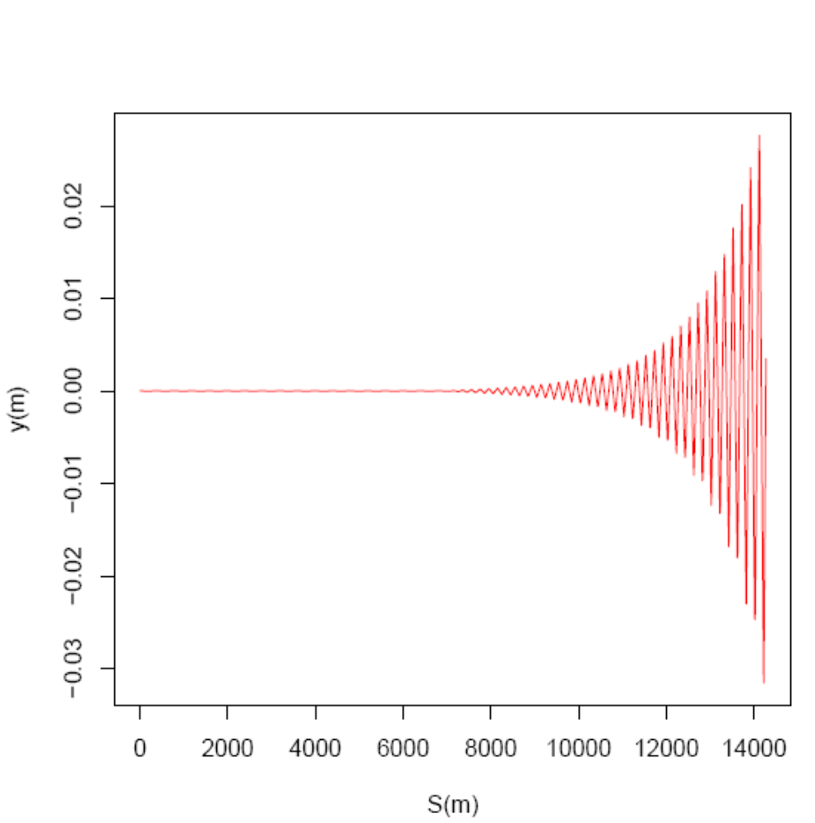

Figure 4 plot of vertical offset against distance
The above plot shows the oscillations inside the beam pipe as the beam moves through the linac. The beam was given a high kick due to the misalignment of the lattice as a result of an increase in the quadrupole strength, as it passes through each of the RF cavities, and as such it makes the beam have high amplitude of oscillation, which makes it really hard to keep the beam along the beam pipe.

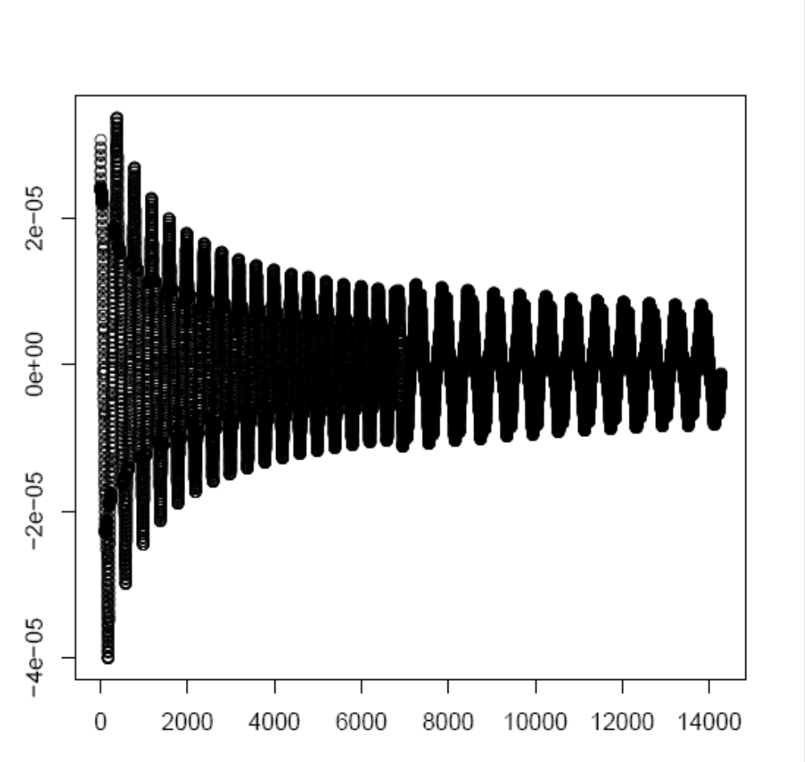
S(m)
y (m))
The plot above is a plot of the “trajectory” of the beam as it moves down the linac .For a perfectly aligned lattice, as the energy increases, the momentum increases, and the kicks given to the beam reduces. The oscillation gets damped as the beam moves towards the end of the linac. This is a good result given the fact that we want to keep our beam within the beam pipe and also to minimize the emittance. Hence the “betatron oscillation” as the beam moves from one end of the linac to the other is damped.

Every linear accelerator always has a physical aperture restriction, in the order of a few millimeters.
We then ask ourselves the question, when after injection of the beam, does the beam exceed the dynamic aperture restriction.
For the lattice (input file) used in this simulation, we want to simulate the violation of the dynamic aperture restriction if it occurs, by obtaining data from the BPM’s and making a plot of the BPM index against the normalized differential momentum.
The result is shown in the plot below:
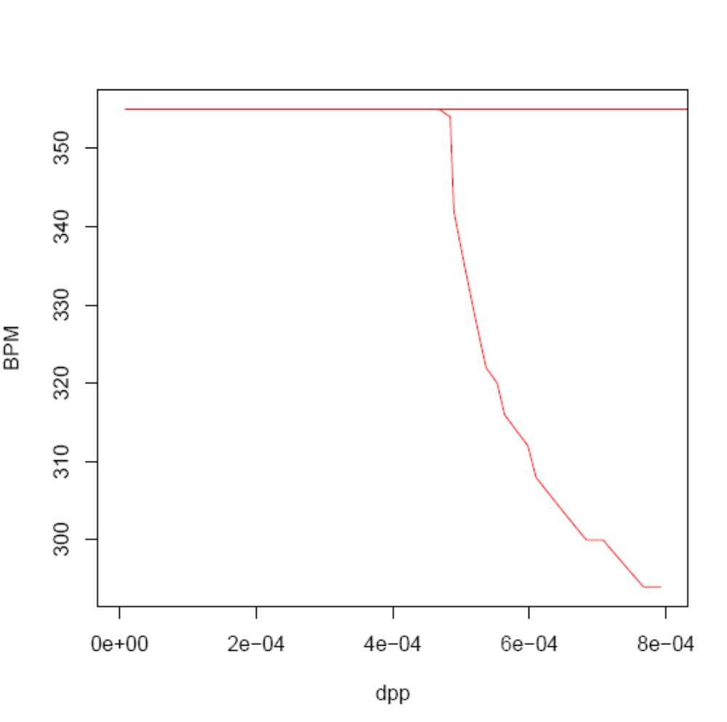
The above plot consists of two plots. A straight line at BPM index of 355, and a negative sloping curve at an absolute ndp (normalized differential momentum) of 5e-04, for a positive ndp, the particle goes through the Linac without exceeding the dynamic aperture restriction. On the other hand for a negative ndp, the particle exceeds this restriction, and the more the negativity, the sooner it exceeds this restriction.

Conclusion:
Simulation is a necessary first step in building high luminosity colliders. In this study, we have successfully simulated what takes place in linear accelerators. It has thrown more light on methods of designing low emittance transport system. It also gave a better understanding of some key aspects of the beam dynamics in a LINAC.

Acknowledgements:
- Almighty God
- Dianne Engram
- Elliott McCrory
- Jim Davenport
- Paul Lebrun
- SIST Committee

Reference:
- Accelerated C++ by Andrew Koenig&Barbara Moo.
- http://www.wikipedia.org
- Particle accelerator physics by Helmut Wiedermann
- http://ilc.fnal.gov/documents/talks.html
- The C++ Programming language by Bjarne Stroustrup

