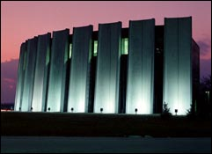
FCC

Temperature Monitoring in GCC

By

Constantine Mukasa
Bethune-Cookman College

Supervisor: David Ritchie


SIST. 2006

ABSTRACT

This document describes a continuation of previous work in Grid Computing Center (GCC) to implement a flexible web-based technique to monitor temperatures. By use of a Python program, the temperatures are read out from the Temperature Monitors and printed on an image map of GCC in the exact locations of the temperature probes. Also, the Python program generates a data table for future use.

FERMILAB HISTORY

Fermilab was originally known as National Accelerator Laboratory. Robert R. Wilson was the Founding Director who was committed to firm principles of scientific excellence, beauty, and stewardship of the land. The laboratory was later renamed in honor of 1938 Nobel Prize winner Enrico Fermi in 1974.

In 1983, the world’s highest-energy particle accelerator known as the Tevatron (Energy Doubler) which is four miles in circumference was made operational. Liquid helium was used in the magnets to make them superconducting by cooling them to about 4K (-450 ºF).

Since then, the research at the laboratory has resulted in the discoveries of the bottom quark in 1977 and the top quark in 1995. In 2000, Fermilab announced the first direct observation of the tau neutrino which is the last of the fundamental particle building blocks to be observed (See Figure 3 in the Appendix). This discovery filled the final slot in the Standard Model of Fundamental Particles and Forces and challenges the field to find new physics beyond that described by the standard model. [3]

NEED FOR COMPUTERS AT FERMILAB

At Fermi National Accelerator Laboratory, large numbers of computers are being used to perform various duties, such as to control the beam in the accelerator and to analyze data in the Feynman Computing Center (FCC), Grid Computing Centers (GCC), Lattice Computing Centers (LCC), and other data centers.

Due to the experiments going on at the laboratory, there are vast amounts of data coming in every second from the experiment detectors such as D0 and CDF. This data is sent out to various data centers on the Fermilab site, such as FCC, and GCC for analysis. Once the analyses have been successfully completed, the results are published to inform others scientists throughout the world.

PROJECT OBJECTIVE

In life, when there is a possibility for the uncertain to happen, monitoring for that uncertainty is no longer an option but a must. Hence, there is a need to detect and respond to those uncertainties if they do occur.

The objective of this project was to improve and complete the remote temperature monitoring technology put in place by previous students: Sirius Ben-Judah, Eric Rivera, and Kati Skelton. This project shows the temperatures at various points (front and back of a given rack) in the GCC Computer Room in a graphical easily understood way through the use of any web browser, and also generates a table containing the data used in the graphical display.

In GCC, there are 2800 computers housed in the 2000 square foot computer room known as Computer Room A. These computers operate around the clock analyzing data from the experiments. In doing so, they do generate a lot of heat which, if not removed by the nine Computer Room Air Conditioners units (CRACs), would quickly raise the room temperature to unacceptable levels (>100 ºF) and would destroy the computers.

Sometimes, the CRACs malfunction. In addition to the high heat load placed on the facility, the facility is remote from the main laboratory buildings and run in unattended fashion. Though this minimizes the cost of operation by not requiring staff, it does heighten the need for remote monitoring of critical parameters, such as temperature.

There are 52 temperature probes installed in GCC’s Computer Room A that are used for monitoring the temperature. By monitoring these temperatures, the proper functioning of the CRACs can be verified. Any large or unexpected change in temperature would be a sign of malfunction of a CRAC. This would require immediate attention.

Of course, there are several other alert systems, such as Metasys, LMsensors and Next Generation Operations monitoring (NGOP) that are in place. These however are more complicated to view. Further, these systems alert when certain limits are exceeded. By then, it may be too late.

PREPARATIONS

In order to accomplish this project, I had to prepare myself by learning a number of technologies. These were:

PYTHON

This language was invented around 1990 by Guido van Rossum, when he was at CWI in Amsterdam [5]. After a year of development, Python appeared on public domain scene. Since then, it has been developed and adapted by other programmers and companies to make sure that the needs of its user community are met.
Python provides services and features such as:
- A dynamic programming language for situations in which a compile/link step is not possible [5].
- A powerful but simple programming language designed for development speed and for situations in which the complexity of larger languages can be a liability.
- Object-oriented programming with notions such as polymorphism, operator overloading and inheritance [6].
- Python is freeware (i.e. open source software) and easy to learn.
- Python is a hybrid between traditional scripting (Perl, Tcl) languages and systems languages (C++, Java).
- Python has versions for almost all operating systems such as: Windows, MacOS, and also brands of UNIX.[6]

- XML

XML stands for eXtensible Markup Language. It is a protocol for containing and managing information. It can be used for formatting documents and filtering data. Its origin came about because Standard Generalized Markup Language (SGML) was too big and complicated for web browsers, while HTML was too simple for the task.
XML has the following characteristics:
- XML is user friendly.
- XML is flexible in that you can output the same data in multiple formats without rewriting the data file. You just have to re-apply different stylesheets and the data will be automatically generated in the new format.
- Document Type Definition (DTD) or Schema can be used to exchange data between incompatible systems and applications. This is similar to the way organizations with different departments exchange data on a given project [4].
- XML allows the opportunity to store structured information in a format that can be easily imported into a database.
- XML is readable by both humans and machines. It is also application neutral. In other words, it can be processed by any text editor.
- XML is hierarchical, and allows the creation of new tag elements of any type. Also one can stack other elements within those elements too [8].

- INSTALLING PYTHON AND IT’S MODULES

I had to install Python onto a computer from www.python.org.
Some other modules like Imagefont had to be downloaded separately. The other package was HTMLgen, which we downloaded from http://www.python.net/crew/friedrich
/HTMLgen/html/main.html for generating html scripts.

- CREATING XML DOCUMENT

I had to learn how to create an XML document for the data file and how to retrieve the data into my Python program. Python provides tools to work with XML files such as, SAX, PyXML, and 4Suite. But I opted to write my own program because these packages were too complicated for my task and also as a means to practice what I had learned during my XML and Python reading.

- TEMPERATURE SENSORS

I had to learn about the temperature sensors that were used. The process of monitoring temperatures in GCC CR-A is accomplished through the use of Temperature Monitors manufactured by Sensatronics (www.sensatronics.com ). Model E4 and E16 have four and sixteen temperature probes respectively. E4 and E16 are the models installed in GCC CR-A. The E4 and E16 are small microcomputers with their program stored in Read Only Memory (ROM). In addition to a power connection, a unit has an Ethernet connection, a probe connection and a configuration cable connection (See Fig. A). The configuration cable connection is used to connect a configuration cable from the Temperature Monitor to the serial port of the PC. The HyperTerminal program was used to configure the Temperature Monitors (this program is available on most Windows PC’s).

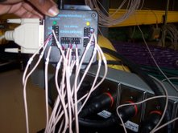
Power Cable
Probe Cables connected to the Temperature Monitor
Configuration cable.
A 50 foot cable installed

Fig. A The E16 Temperature Monitor.

Configuration and error sensing

The configuration involved setting the unit and specifying probe names according to a specific format.
The configuration format for the probe names was:[H|C]-[A-F]\d\d?-[T|M]
- ‘[H|C]’ designates whether the location of the probe is on the hot or cold side of the aisle.
- ‘[A-F]’ designates aisle name where the probe is located.
- ‘\d\d?’ stands for the rack number the probe is installed on in that aisle. The question mark specified the case where the probe was on any of the first nine (single digit) racks of an aisle [1].
- ‘[T|M]’ designates whether the probe is at the top or middle of the rack.
For instance, the name “H-A10-T” would mean that the probe is on Top of the Hot side of the 10th rack of the ‘A’ aisle.
- The data pattern (\d\d\d x \d\d\d) was used in the configuration of the real building coordinates for the probes. In this format, the first three digits designate the X- coordinate and the last three after the ‘x’ designate the Y-coordinates. These X-Y coordinates specify the location of the probe in GCC.

The configuration steps for the Temperature Monitor are as follows:
- Set the RS 232 port settings (Here the bits per second, data bits , flow control, and stop bits were set)
- Set its IP address (Here the IP address, Netmask, Gateway, HTTP Server Port and the Toggle Network Mode were set )
- Set its Unit Name and port identifiers (The Unit Name, and the Port Names were set )

- Ping the device using the IP address assigned to it [7].
If the ping is a success, then the web browser should be able to view the temperatures of the Monitor using its specified IP address (see Figure 5 in the Appendix).

The error sensing for the temperature Monitor is as follows:
- If the temperature displayed is -99.9 ºF, then probe is not connected. Check the connection.
- If the temperature displayed is 255 ºF, then there is a short in the line. Check the line for damage.[7]

PROJECT ENHANCEMENT

A problem was encountered when we tried to use the previous program to output on a different image map. Assumptions were made and they were successful at that moment. But, there are changes taking place at GCC, hence new image maps are drawn. Once a new image map is drawn, then the image map for the program should also change to show the new features.

We learned a lot from the previous project implementations, namely:
- Previous project implementations, while useful, were difficult to maintain. Every time the room was modified and a new map generated, the program had to be modified.

GOAL

Make the program read parameters from a data file. Format the parameters with the use of the XML protocol.
- Previous project implementations simply “eyeballed” the coordinates of the probes with the result that setting up new probes involved a lot of guess work.

GOAL

Have a formal procedure by which the probes were located. We defined a coordinate system for the room (units of tenth of an inch), an origin and a similar system for the map (units of pixels). We are to specify coordinate transformation equations which are to be used by the program to convert between tenths of inches and pixels. Then, we have to update the probe names to contain the coordinates in tenths of inches of the probe locations in the room.
- Previous project implementations could generate the image map, but could not specifically show when it was generated. This was a problem because the program ran automatically. This led to an assumption that the image map was current when in fact it could be hours old if the PC running the program had crashed. The image map didn’t display the time when the data was generated.

GOAL

Display the date and time the image map was generated on the map itself. This gave a better idea of when the temperatures were taken.
- The program only generated a graphical image of the temperatures. It was difficult to get the numerical values of the temperatures for use in other programs, such as Excel.

GOAL

In addition to generating a graphical image, we decided to make the program also generate an html table containing the numerical temperatures.

PROJECT ENHANCEMENT IMPLEMENTATION
- MAKE THE PROGRAM READ DATA FROM A FILE.
The complete XML data file is shown in Figure 4 in the Appendix. Below is a portion of it for illustrative purposes. See also Fig B on the following page.

<?xml version="1.0" encoding="ISO-8859-1"?>
<coords>
<cropX1>221</cropX1>
<cropY1>845</cropY1>
<cropX2>1056</cropX2>
<cropY2>40</cropY2>
<originX>380</originX>
<originY>132</originY>
<Xend>945</Xend>
<Yend>785</Yend>
<hdisplay>1000</hdisplay>
<vdisplay>850</vdisplay>
</coords>

The XML protocol lays out the data containing coordinates for the origin point (originX, originY), end point (Xend, Yend), the two cropping points (cropX1, cropY1, cropX2, cropY2) and the magnification value (hdisplay, vdisplay). The units are pixels as specified by the characteristics of the GCC image map and the display screen.
Cropping points.
GCCMap
X-axis
Y-axis
End point
Origin point
Fig. B Figure shows the target points and area from the entire image map.

This data is read by a Python program which makes an object with all the data variables from the XML file. The data is manipulated with two building fiducial points (origin and end points) using the coordinate transformation equations to crop and resize the image map.

Here is a snippet of the code that performs these manipulations:

Cropt = class_readxml.read_XML('cood.xml','filecontents')
GCCX1 = float (Cropt.getX1())
GCCRy =(float(GCCYO - GCCYe)* Vfactor)/float(BuildY1 - BuildY2)
GCCYoffset =(float (GCCYO - GCCY2) * Vfactor)
Croptmap = Origmap.crop((GCCX1, GCCY2, GCCMX2, GCCY1))
Newmap = Croptmap.resize((GCChdisplay, GCCvdisplay))

The first line makes an instance of an object via the “class_readxml” class definition. The read_XML method of that class is used to obtain the information in the “cood.xml” (a portion of which is shown above). The attributes of the Cropt object instance hold all the information specified by the XML file. Methods, such as getX1, are used to obtain the x value of the first cropping point for use in later lines of the code. With this code in place, changes in how the image is cropped and/or magnified can be handled simply by editing the XML file; no code changes are needed.

- COORDINATE SYSTEM TRANSFORMATION
With the use of the Python urllib module, the data was read from the Temperature Monitors into an object. The data is stored in the object as strings. These strings contain the probe name, the associated temperature, the real space coordinates in the room and other unwanted strings. We used the Regular Expression (RE) module to extract the information needed. In this way, the name and temperature values of each probe are obtained. The name contains the X-Y coordinates of the real world position of the temperature probe (units of tenths of an inch). Fig.C below shows the locations (Top and Middle) of the temperature probes on the rack.
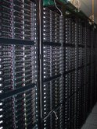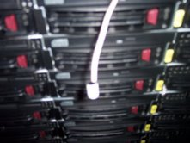
Temperature probes

Fig.C Temperature probes positioned on the front of a rack.

The coordinates had to be transformed from inches to pixels so that the temperature value could be drawn at the exact pixel position on the image map. The snippet of code below is for the Y-axis transformation:
coords = re.split('(\d\d\dx\d\d\d)', Info)
ycoord = re.split(‘\d\d\dx(\d\d\d)',coords[2*item+1])
YBuilding = float (ycoord[1])/10.0
Ymap = YBuilding * GCCRy + GCCYoffset
The first and second lines uses the split method of the Regular Expression module to extract the coordinates from the Info object (which was filled via an earlier urllib read of the IP address). The pattern as specified in the configuration of the temperature monitor is used in the split process. As a result, the coords object contains a coordinate list. The second element of the list holds the Y coordinate. The third and fourth lines process the coordinate according to the transformation equations, turning the value from a real world data in tenths of an inch into an image map value in pixels.
- TIME STAMPING
The technology to time stamp the image map is simple. The code snippet is as follows:
draw.text(X, Y, time.ctime(), fill=N, font=font type)
The text method of the draw object is invoked to write the current time into the image at the X and Y coordinate specified.

- HTML TABLE GENERATION
This was made possible by the use of HTMLgen. HTMLgen is a Python module that is used to generate HTML documents by means of Python code [2]. We used it to create HTML pages containing temperatures which change from time to time.

For a complete example of a Python program that uses HTMLgen to generate a table, see Figure 2 in the appendix.

We decided that the table would contain: the Row, the Rack number, the side the probe is located (Hot or Cold), the temperature, and the position of the probe (Top or Middle). In the operation of the program to create the graphical map, the values for the Rows, the Hot or Cold side, the Rack number, and the position are extracted and put into a list for sorting.

The list is then sorted by Row. The Python code invokes HTMLgen methods to generate a document containing the table. Finally an HTML file is written (see Figure 1 in the Appendix).The snippet code below was used to sort and write the html file.
# create a TempMonDoc instance of a SimpleDocument object
TempMonDoc = SimpleDocument(title="Temperature Monitors…",cgi=1)

# initialize lists and specify the table title
bodylist = []
Data = []
table = Table(tabletitle='GCC…',border=2,width=900)
table.heading = ["ROW","RACK No.","H/C","TEMP","POSITION"]

# The next two lines are invoked to
# fill the Data list for every row of the table)
# The code to do this is not shown.
STUFF = [Row[1],No[1],HC[1],temps[2*item+1],TM[1]]
Data.append(STUFF)

# Sort the Data by defining CmpRow to compare two rows
def CmpRow(Stuff1,Stuff2):
Result = cmp(Stuff1[0],Stuff2[0])
Data.sort(CmpRow)
# Transfer the sorted contents into the table body
for dataitem in range(len(Data)):
body = Data[dataitem]
bodylist.append(body)
table.body = bodylist

# Append the table to the document and write it to a file
TempMonDoc.append(table)
TempMonDoc.write(filename="Info.html" )

COMPARION OF RESULTS FROM OLD AND NEW PROGRAMS.
Fig. D below shows the image map generated by the previous program. As seen, temperatures shown where eyeballed (not in the exact location, but just made to fit) on to the image map. Also, many details such as the Tech/Network room were included.

Fig. E shows the image map that is now generated by the new program. The temperatures are shown in the exact location (as designated by the plus (+) sign) as specified by the coordinates. Also, the map is cropped and magnified to remove irrelevant images (like the Network/Tech room) and magnified to fit on the display screen.
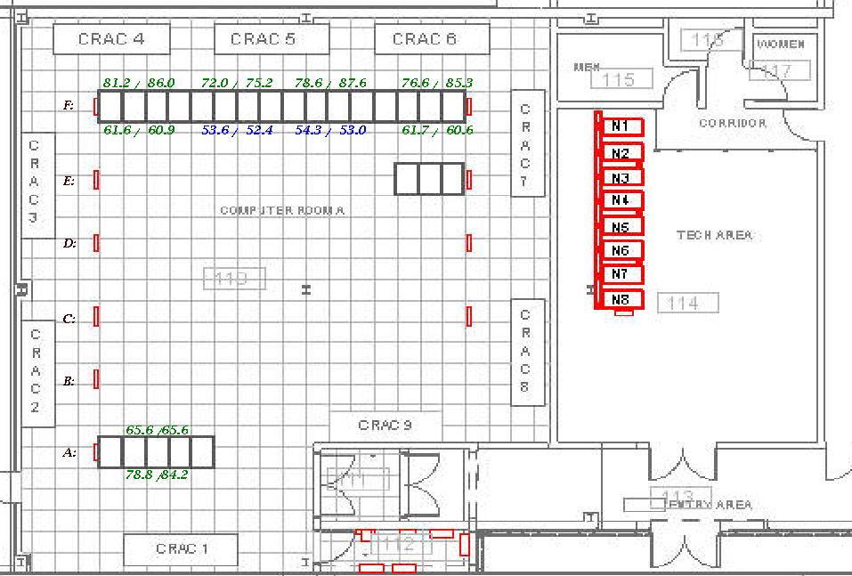

Fig. D The Image map of the GCC floor map using the original project

Time/date display

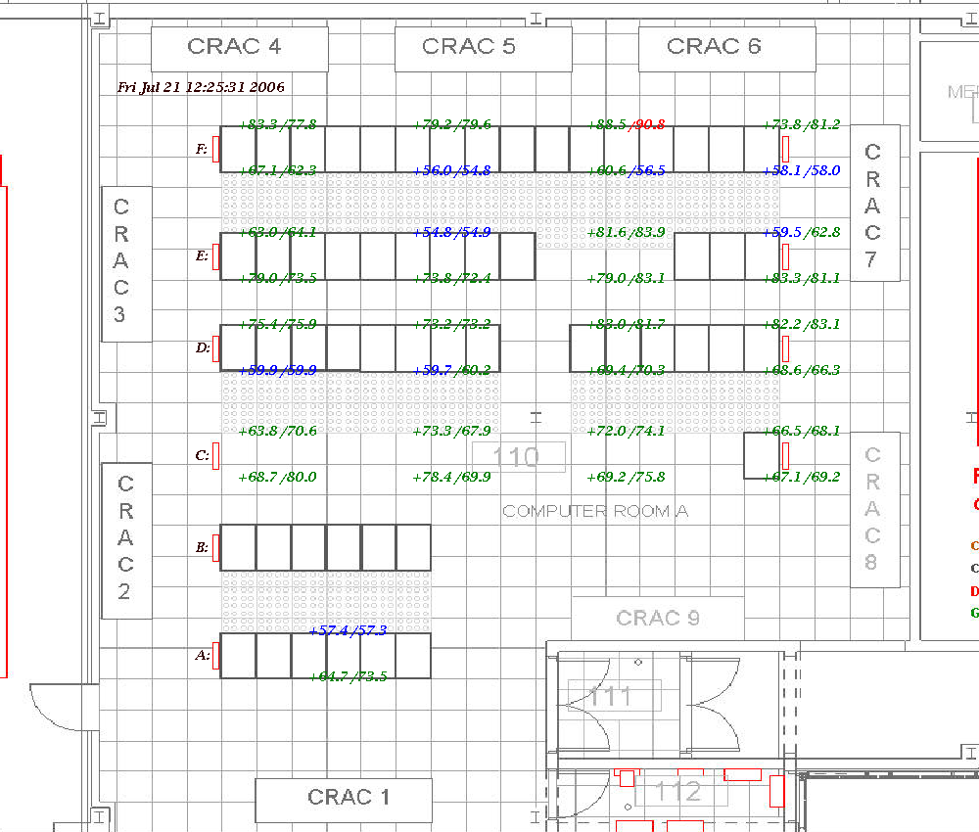

Fig. E The Image map of GCC CR_A floor map generated by the new project.

FUTURE WORK
In the future, we would like to implement a way to sort the table using the different column variables. This will make it easier for the users to be able to sort the table data according to their preferences.

Also, in the future, we would like to make the program generate bar graphs for temperatures
Verses time.

MERITS OF THE PROJECT
With such critical computer system in GCC, monitoring isn’t an option but rather a must. The completion of this project makes it possible to monitor the temperatures in GCC CR-A. An Image map display makes it possible for the users’ to vividly see the entire temperature distribution in the room. The distribution gives a clear view of the operation of the cooling system. The program generates an image map which can be viewed as a web page at any time.

This program has be coded in such a way that it can be adapted by other computer rooms such as the Networking/Tech room and Computer Room B under construction at GCC, and also data centers such as Lattice Computing Center(LCC), and Feynman Computing Centre(FCC) .
CONCLUSION
The project has been a success. The goals set have been accomplished. There is finally an easy way to adjust the program’s results to a new map. It is now easier to change the image maps for GCC as desired and there is a data table generated for future use.

ACKNOWLEDGEMENTS
I thank God for allowing me to have this golden research opportunity at Fermi National Accelerator Laboratory.

I am very grateful to Fermilab SIST selection committee especially Mrs. Dianne Engram and Mr. Elliott McCrory for giving me the opportunity to do research here at Fermi for the entire summer. Also, thanks go to Dr.James Davenport who provided guidance and insight into report documentation and writing, and my mentor Mr. Jamieson Olsen for his guidance and support.

I am grateful to my supervisor Dr. David Ritchie for his mentoring skills. He was patient with me throughout the entire project process and helped to point me in the right direction whenever I needed help. I do also like to express my gratitude to the Computing Division staff for their help to make this project a success. Also, I thank Rick Hill for allowing me to use the laptop to accomplish my installation at GCC

Thanks go to the School of Science and Mathematics at Bethune-Cookman College for their efforts to see to it that students do get such opportunities.

Finally, I thank my family and my fellow SIST interns for their extraordinary support.
REFERENCES

Ben-Judah, Sirius. Garnering Temperature Sensor Data to Display on a GCC Base
Diagram Illustration.2005
HTMLgen 2.2. <http://python.net/crew/friedrich/HTMLgen/html/main.html>.
History. <http://www.fnal.gov/pub/about/whatis/history.html>
Jones, Christopher, Drake, Fred. Python & XML.1st Edit. O’Reilly &Associates, Inc., CA, 2002
Lutz, Mark. Programming Python. 2nd Edit. O’Reilly & Associates, Inc., CA, 2001
Lutz, Mark, Ascher, David. Learning Python. O’Reilly & Associates, Inc., CA, 1999
Model E Temperature Monitor Device Manual.
Ray, Erik. Learning XML. 1st Edit. O’Reilly & Associates, Inc., CA, 2001.
The building blocks. < http://www.fnal.gov/pub/inquiring/matter/madeof/index.html >.

APPENDIX

Figure 1.The Data Table.

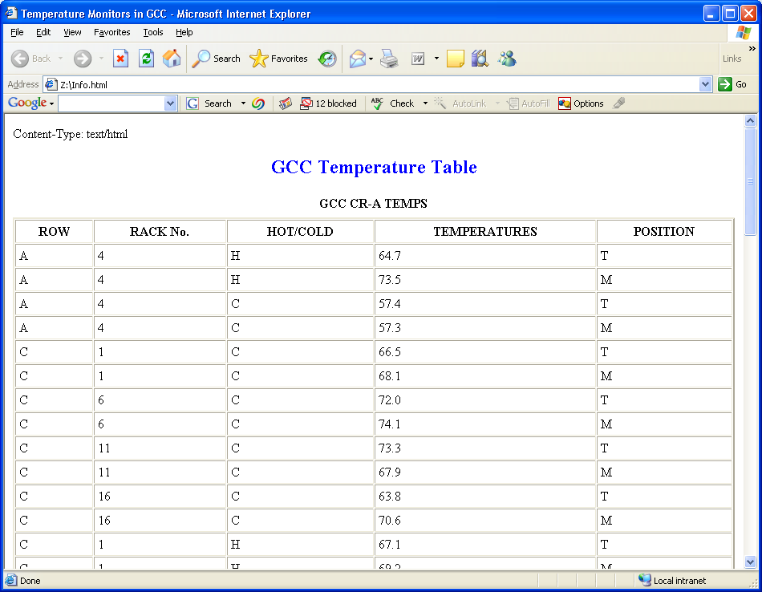

Figure 2. Python program example using HTMLgen.

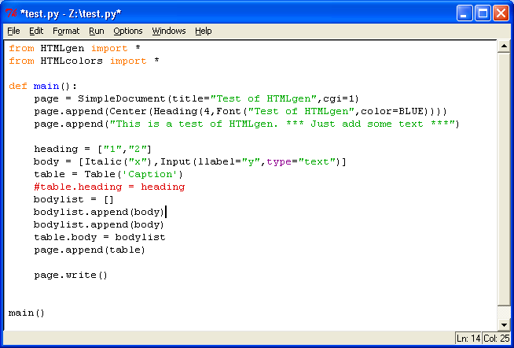

Figure 3. The Standard Model [9].

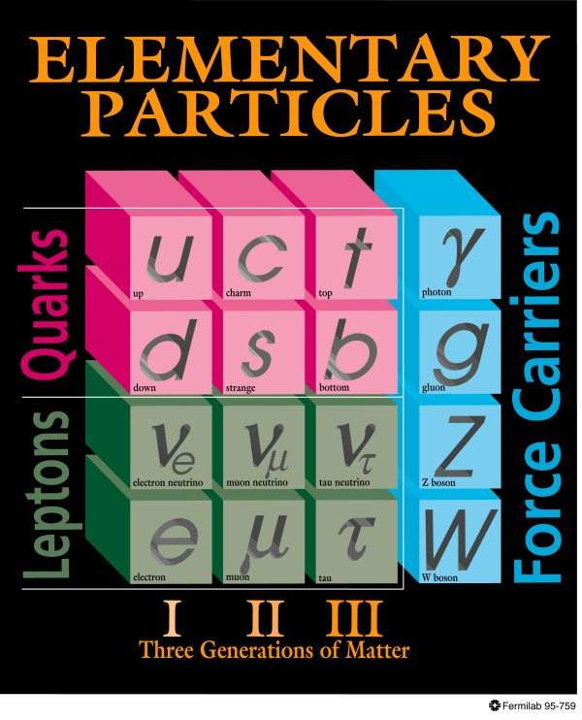

Figure 4. The XML data file.

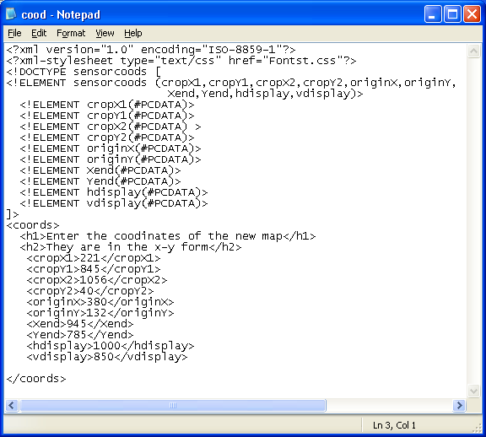

Figure 5. Temperature Monitor data display.



