Debuncher Beam Position Monitor Downconverter Board Field Programmable Gate Array Configuration

LaTToya Harris
University of Illinois at Chicago
Submitted August 8, 2006


Supervised by David Peterson, P.E., Accelerator Division, Antiproton Department Engineering Group Leader, Microwave and RF Systems Engineer


Summer Internship in Science and Technology (SIST)
Fermi National Accelerator Laboratory
P.O. Box 500 M/S 117
Batavia, IL 60510-0500

Outline

I. Abstract
II. Introduction
III. The Antiproton Source
IV. The Debuncher Beam Position Monitor
V. Debuncher Downconverter Board Version D
VI. Upgrade to Version E
VII. Field Programmable Gate Array Logic (FPGA)
VIII. Coding the FPGA
A. FPGA Specifications
IX. Configuring the Code
A. Allocating Memory
B. Creating Data Parameters
X. Testing the Code: Building a Test Signal Generator
XI. Expected Results
XII. Results
XIII. Discussion of Results, Possible Problems, and Future Work
A. Naming of Parameters
B. FPGA Phase Lock Loop (PLL)
C. Unsynchronized Trigger Timing
XIV. Conclusion
XV. References
XVI. Acknowledgements
XVII. Appendices

Abstract

The Fermilab Debuncher Beam Position Monitor Downconverter board is currently being upgraded by a team of scientists and engineers that include my supervisor Dave Peterson, Bill Ashmanskas, Sten Hansen, and Terry Kiper. The upgrade includes improved analog-to-digital conversion (ADC), and improved microprocessor control [1]. This upgrade will provide scientists with more precise digital data, improved signal to noise ratio (SNR), and faster data accesses. The new version of the board will be called Revision E while the current board in use is called Revision D. This paper discusses work which I did as a summer intern on this project. My concentration during this internship was the configuration of the Altera code for the FPGA on the Debuncher Downconverter board. The code was written as a Text Definition File (.tdf) using Altera software, and was loaded onto a Revision D board since the Revision E boards are not yet in commission. I tested the code by driving the reconfigured board with test signals generated by a test signal circuit that is described in this paper. This configuration and testing is necessary to ensure that the FPGA functions properly with the upgraded components on the Revision E board. I did this work while working for the Antiproton Source at Fermilab.

Introduction

What laws govern the nature of our universe? What are the fundamental principles of matter? These are a few of the questions scientists seek to answer through the study of particle physics. For many years, electrons, protons and neutrons were thought to be the elementary building blocks of all matter. However, an exciting and innovative science known as accelerator physics has allowed scientists to further decompose protons into even smaller elements, called quarks. Particle physicists study the characteristics of particles on these small scales in the hopes of adding to our understanding of the mysteries of the universe. Just as observing the characteristics of electrical charge have led to the manipulation of electricity for various practical purposes (i.e. lighting, manufacturing, medical devices, cell phones, televisions, computers, etc.), the study of particle physics promises to provide new innovations in technology and power generation.

Fermilab National Accelerator Laboratory (Fermilab) has been at the frontier of accelerator physics since being commissioned in 1967. Fermilab is home of the four (4) mile circumference Tevatron, which is presently the highest energy particle accelerator ring in the world. The job of the Tevatron is to accelerate protons and antiprotons to 0.9999 times the speed of light, and send them colliding into each other with a center of mass energy of 1.8 Teraelectronvolts (TeV) (0.9 TeV onto 0.9 TeV). The particles are shattered in these collisions, breaking apart into smaller particles. The forces that hold these particles together along with the characteristics of these elementary particles are very interesting to scientists, who continually want to know more about them.

Antiproton Source

During Tevatron operation, antiprotons are produced. The rate of production of antiprotons inherently determines the amount of experiments that can be done in the Tevatron. The painstaking task of producing and storing antiprotons for experiments is overseen by the Antiproton Source at Fermilab. In the underground tunnels of the Antiproton Source, there are two circular beam pipes, the Debuncher and the Accumulator. These beam pipes are the particle accelerators in which antiprotons are produced and stored for experimentation. The transfer lines that connect these accelerators to other accelerator rings at Fermilab also play a significant role in antiproton production. Periodic improvements to the Antiproton tunnel electronics result in an increase in the production and storing performance of the Antiproton Source.

Antiproton production takes a large amount of time and resources. Approximately 2 antiprotons are produced for every 100,000 protons used for production. To reduce the time and cost of experiments, it is important that a minimum amount of antiproton beam is wasted. The beam must be kept in the center of the beam pipe to prevent wall collisions which result in beam loss and damage to the beam pipes. An electronic device called a Beam Position Monitor (BPM) keeps track of the beam position as it orbits inside the beam pipe.

Debuncher Beam Position Monitor

Beam Position Monitor systems provide information which tells scientists and engineers how close a particle beam is to the central orbit within a beam pipe. This information is used to correct the orbit, measure lattice functions [2], and is useful as raw scientific data.

Within the underground beam pipe, the Fermilab Antiproton Source Debuncher ring has 120 BPM pickups divided into six “houses” which are numbered 10, 20… 60 [2], [3]. Half of the pickups are sensitive to horizontal displacements of the beam and the other half are sensitive to vertical displacements of the beam [3]. Each pickup consists of a pair of 100mm wide RF sensitive plates aligned for either vertical or horizontal sensitivity within the 135mm diameter Debuncher beam pipe (See Fig.1).

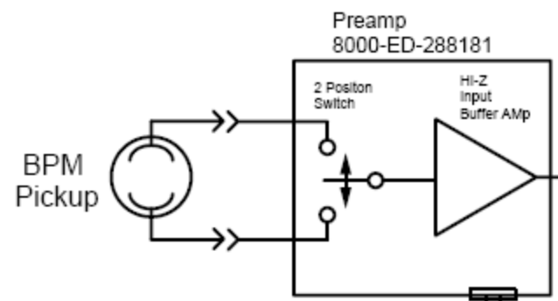
Plate A Signal
Plate B Signal

Fig.1 BPM Pickup aligned for vertical sensitivity. [4]

The plate signals are fed directly into a switching pre-amplifier which cycles between connection to Plate A and connection to Plate B at a frequency of 500 Hz. Hence, the plate switching signal is a 500 Hz square wave with a 50% duty cycle, where periods of assertion are times when the switch is connected to plate A and periods of desertion are times the switch is connected to plate B (See Fig.2). This means that the switch is at each plate for 1 millisecond at a time. In this way, both plate signals for one BPM are multiplexed on one coaxial cable. This eliminates problems associated with calibrating two separate signal paths. The output of the pre-amplifier is sent upstairs on a coaxial cable to the service building where it is processed on a Downconverter Board.

V
5V

Switch at Plate A

0V Switch at Plate B
time
0 ms 1 ms 2 ms 3 ms
Fig.2 Plate Switching Signal

Each plate can pickup the beam signal as a measure of beam intensity. The closer the beam is to a plate, the higher the intensity of the plate pickup signal. The amplitudes of the two plate signal measurements are used to determine the position of the beam orbit in the pipe. The beam position as a fraction of the full aperture is

Position = (MAG(A)-MAG(B))/(MAG(B)+MAG(A)),

Where MAG(A) = ((AI)² + (AQ)²)^{1/2} , and similarly for MAG(B) with A representing the intensity of the signal on plate A, B the intensity of the signal on plate B, I representing the in-phase component of the current, and Q representing the quadrature component.

Debuncher Downconverter Board Version D

The BPM Downconverter cards comply with Nuclear Instrumentation Methods (NIM) standards and sit in NIM crates in the Debuncher service building. Each card input can read both plate signals for one BPM, and each card has four inputs to read four BPM measurements. Thirty cards are needed to read the 120 BPM pickups with 5 cards in each house. The cards sit in NIM crates which are shelved on NIM racks and are powered by the NIM bus power supply (See Fig.3).

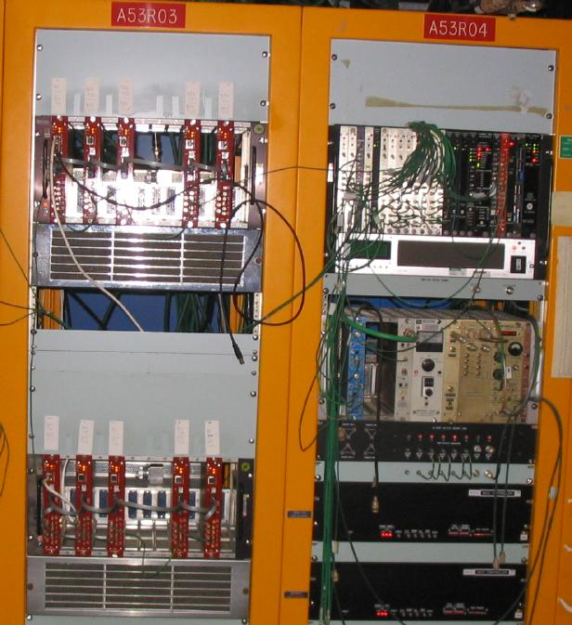
Fig.3 Photo of BPM NIM rack.

Once in the service building on Version D of the BPM Downconverter card, the amplified plate signal (either A or B) is sent into an Analog Devices (AD8348) quadrature demodulator in order to down convert the signal to a DC carrier. The demodulation allows accurate measurements to be made even if there is a phase error in the signals. The in-phase and quadrature (I and Q) outputs are sampled at 20 million samples/second (MSPS) and converted into 10 bit data by an Analog Devices (AD9201) Analog to Digital Converter (ADC). Since the A/B toggle switch is at A or B for 1 millisecond at a time, 20,000 10 bit samples each of AI and AQ or BI and BQ are output by the ADC every millisecond (Actually 26000 samples could be taken which is the max rate of the AD9201, but only 20,000 are). The samples are sent to the FPGA (Altera EP1C6Q240) where averaging of the samples begins. The average summation is done in the FPGA and the sum is buffered as a 32 bit value that is scaled on a different floating point chip. The magnitude of the signals intensity for the purpose of determining beam position is also calculated on a different floating point chip. Therefore, a magnitude reading and a beam position reading can be viewed once per millisecond by scientists. The summation data are stored on the internal FPGA SRAM and can be accessed remotely via a Wiznet 11M7010A card that provides TCP/IP implementation allowing Ethernet access by remote users. A Texas Instruments (M430F149) microcontroller oversees the board functions and stores/loads FPGA configuration code (See Fig.4).

SD RAM
16Mx16
Eth Ad
Eth Dat
D
A
IN0 A,B
EP1C6 Cyclone FPGA
10 Bit A/D
EthWrt
USB
M430F147 uC
A
D
Rd
Wrt
Ethernet
I/Q Dat
10 Bit A/D
Lo Pass
Lo Pass
AD8348
IN1 A,B
10 Bit A/D
I/Q Dat
10 Bit A/D
Lo Pass
Lo Pass
AD8348
IN2 A,B
10 Bit A/D
I/Q Dat
10 Bit A/D
Lo Pass
Lo Pass
AD8348
IN3 A,B
10 Bit A/D
I/Q Dat
10 Bit A/D
Lo Pass
Lo Pass
AD8348
I
Q
Q
Q
Q
I
I
I
Wiznet
11M7010A
EthRd
Fig.4 Downconverter Board Block Diagram

Upgrade to Version E

In order to achieve the specified BPM resolution of 30 micrometers (30 x 10^-6), the number of bits must be changed from 10 bits to 12 bits. This is determined by calculating the number of bits with the formula

RESOLUTION = 1.0
SPAN 2^N

Where the RESOLUTION is 30 x 10^-6, SPAN is the diameter of the beam pipe, which is 135 millimeters, and N is the number of bits required to obtain the given resolution over the given span. Solving this equation, we see that at least N = 12 bits are needed.

Version E of the board will have the mostly the same elements as Version D except it will have a 12 bit ADC in place of the 10 bit ADC. This will give the ADC a larger dynamic instantaneous range, provide improved SNR, and transfer the signals with less power degradation. Revision E will also replace the 16 bit Texas Instruments microcontroller for a 32 bit ARM7 controller, which will provide faster data transfers of the 32 bit ADC data. Because of delivery set backs, I was unable to work with a Revision E board, and I did all of my work with a Revision D board.

Field Programmable Gate Array Logic (FPGA)

A field programmable gate array (FPGA) is a semiconductor device that contains components called logic elements and programmable interconnects. The programmable interconnects and logic elements can be programmed to implement the functionality of basic logic gates such as AND, OR, XOR, NOT or more complex combinational logic functions such as decoders or simple math functions. In the Altera EP1C6Q240 FPGA, these programmable logic elements include memory elements such as flip-flops and larger complete blocks of memory. The FPGA is a simple way to perform the arithmetic that is done during BPM signal analysis. For the Debuncher BPM Downconverter board, an Altera EP1C6Q240 FPGA is used. This 185 pin FPGA has 5,980 logic elements, 20 M4K 4K Ram memory blocks for a total of 92,160 bits, and 2 phase lock loops (PLL).

Coding the FPGA

The FPGA code can be written with the Altera Quartus II software either as a Text Definition File (*.tdf) or as a Block Diagram File (*.bdf). Since the placement of thousands of logic elements, data busses, and memory in a *.bdf file would not be practical, the FPGA codes for the Downconverter board are written as *.tdf files. For the BPM project, the FPGA logic function is written using the Altera software, and then loaded onto the FPGA using a Python script via Ethernet. The Python script was written by Bill Ashmankas.

FPGA Specifications
There were some specific things that the FPGA code for the Downconverter board needed to do. The code must program the FPGA to read in 1 ms worth of the eight plate signals (one plates I and Q components is read at a time). After reading 20,000 (1 ms worth is 20,000 samples) samples of each input, the FPGA must sign extend the 10 bit values to 32 bits, and add each inputs 20,000 32 bit samples. The 32 bit sum is buffered on the FPGAs internal SRAM, and is scaled as an averaged value of the 20,000 samples on an off board floating point chip. The downconverter project also requires the use of one of the FPGAs internal PLLs. The VXO of the PLL must phase lock to the RF reference frequency of 53 MHz since the Debuncher RF system operates at 53MHz. The FPGA code must also program the FPGA to interface with the external SDRAM and also with the microcontroller. For the purpose of testing the downconverter board, the FPGA must provide a 1Hz trigger that represents the shut on of the RF system. In actuality, the RF in the Debuncher beam pipe does not turn on instantaneously, nor does it turn on once per second. It actually turns on once every injection cycle (approximately every two to three seconds) in order to give the particle beam enough time to be “debunched”, or in other words to give the particle beam enough time in the RF to have its momentum spread reduced. The RF is gradually ramped up to its maximum amplitude in order to keep the beam particles from being randomly excited and becoming heated, which would increase the beams momentum spread. The FPGA code must also provide a 500 Hz test signal which represents the 500 Hz switching signal that is used to switch the BPM plates. The FPGA synchronizes to this switching signal in order to read in one plate’s data every millisecond.

Configuring the Code

Once the Revision E boards are delivered and the FPGA code is completely configured, 30 Downconverter boards will completely replace the 120 old log amps now in use in the Debuncher BPM system. The FPGA code that was written by my supervisor, Dave Peterson, and Bill Ashmankas, was formatted to read in only one plate signal. This code was used by them to test the only Downconverter board being tested in the Debuncher at D1Q20. My task was to format the code so that it would read in all four plate signals and then test the code by driving the board with 53MHz test signals.

Allocating memory
One of the problems I encountered with the code was that it used almost all of the memory to buffer the data of the one input that it captured. The FPGA has 20 4K memory blocks that can be arranged to support different bit width x bit height configurations. The first code allocated four 4K memory blocks for each data parameter. Since there are four inputs, two plate signals per input, and two components per plate signal, there are a total of 16 data parameters. This means that 64 4K memory blocks would be needed to implement 16 data parameters with this memory allocation, which exceeded the available amount of memory. I reconfigured the FPGA memory blocks in order to fit the data from the four inputs onto the FPGAs internal SRAM by changing the memory allocation to one 4K memory block per data parameter. Please see Appendix 1a for a sample of the code used to allocate the memory and how I changed the code to execute storage of all four inputs.

Creating Data Parameters
Sixteen data parameters needed to be implemented in the code. These parameters hold the digital data samples that are read into the FPGA. The four physical inputs of the Downconverter board were defined in the “SUBDESIGN” section of the .tdf file. The data parameters associated with each input were declared in the “VARIABLE” section of the code. The data parameters needed to be accounted for in the “PIN PLANNER” section of the code project. This caused some problems that will be addressed in the Problems Encountered section of this paper.

Testing the Code: Building a Test Signal Generator

To test the code, I designed a test circuit to switch on a 53MHz RF signal for a time length of 25 ms every second. The 1 Hz trigger generated by the FPGA serves as the trigger for the test circuit. When this trigger is received by a PIC12F675 microcontroller, the microcontroller drives a 5V signal that throws a switch for 25 ms, enabling 53 MHz RF signal to pass into the Downconverter board. Here is a flow chart for the test signal circuit to demonstrate the logic:
YES
NO
Drive Pin 7
HI for 25 ms
If Pin 7 is HI,
switch closes and RF
input is allowed to pass
through
PIC12F675
Check Pin 6.
Pin 6 HI?
Fig.5 Test circuit Flow Chart.
Here is the first circuit I designed for this task:

1 7
8 6
5V
FPGA 1HZ
TRIGGER
53MHz
RF in
53MHz
RF out
0V
PIC12F675
PN Diode
0V
25ms Ramp Enable 0,5V
Fig.6 First test circuit design.
After analyzing this circuit and consulting with my supervisor, I changed the circuit to use only one diode:

1 7
8 6
5V
FPGA 1HZ
TRIGGER
25ms Ramp Enable- 0,5V
53MHz
RF in
53MHz
RF out
0V
PIC12F675
PN Diode Switch
Fig.7 Final test circuit design.

See also Appendix 2a and Appendix 2b for pictures of the circuit and code for the PIC12F675 microcontroller.

Expected Results

The averaged values that are buffered on the FPGA should be near zero for a brief time, and then reach some non-zero values for approximately 25 ms. The following graphs show an actual BPM Downconverter output of the test board at D1Q20. The first graph show the output over time with the 53 MHz RF causing spikes in the otherwise non excited beam. The second graph zooms in on one of the RF spikes. The FPGA averaged sample data should behave like this second graph.

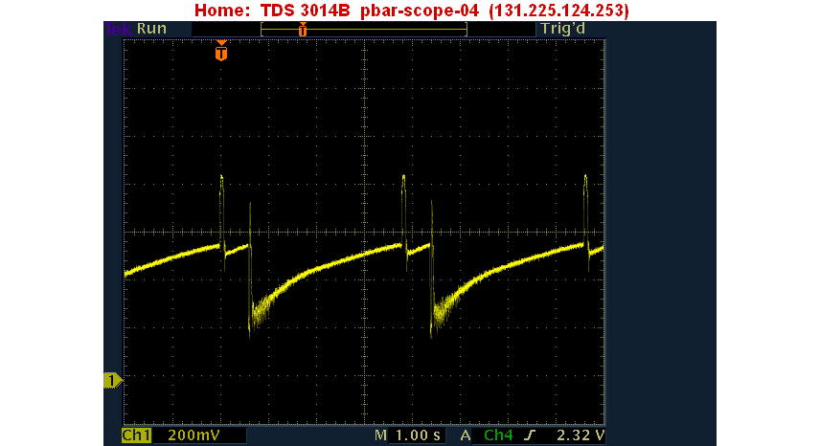
Beam with DC carrier (53MHz RF is off)
Beam signal spikes when RF is on.
Fig.9 Video from spectrum analyzer attached to BPM plates at D1Q20.

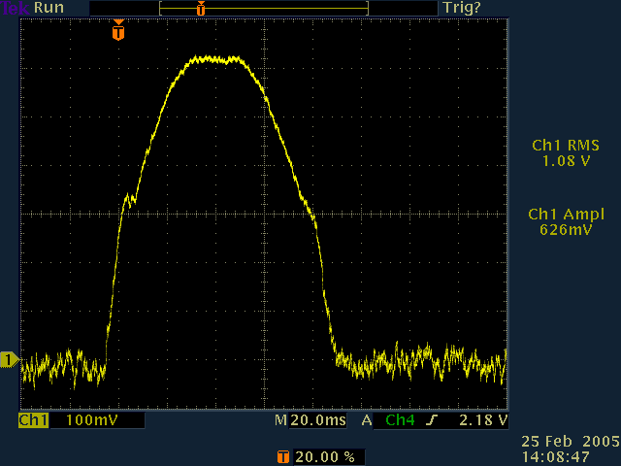
RF is gradually ramped to its max amplitude to avoid over excitation. Max amplitude ramp lasts for 25 ms.
25 ms
These little ripples are the switching action from plate A to Plate B
Fig.10 Close up view of 25 ms 53 MHz RF ramp.

Results

Data was read from the FPGA using telnet Ethernet server. The command used to connect to the Revision D board that I was testing looks like this:
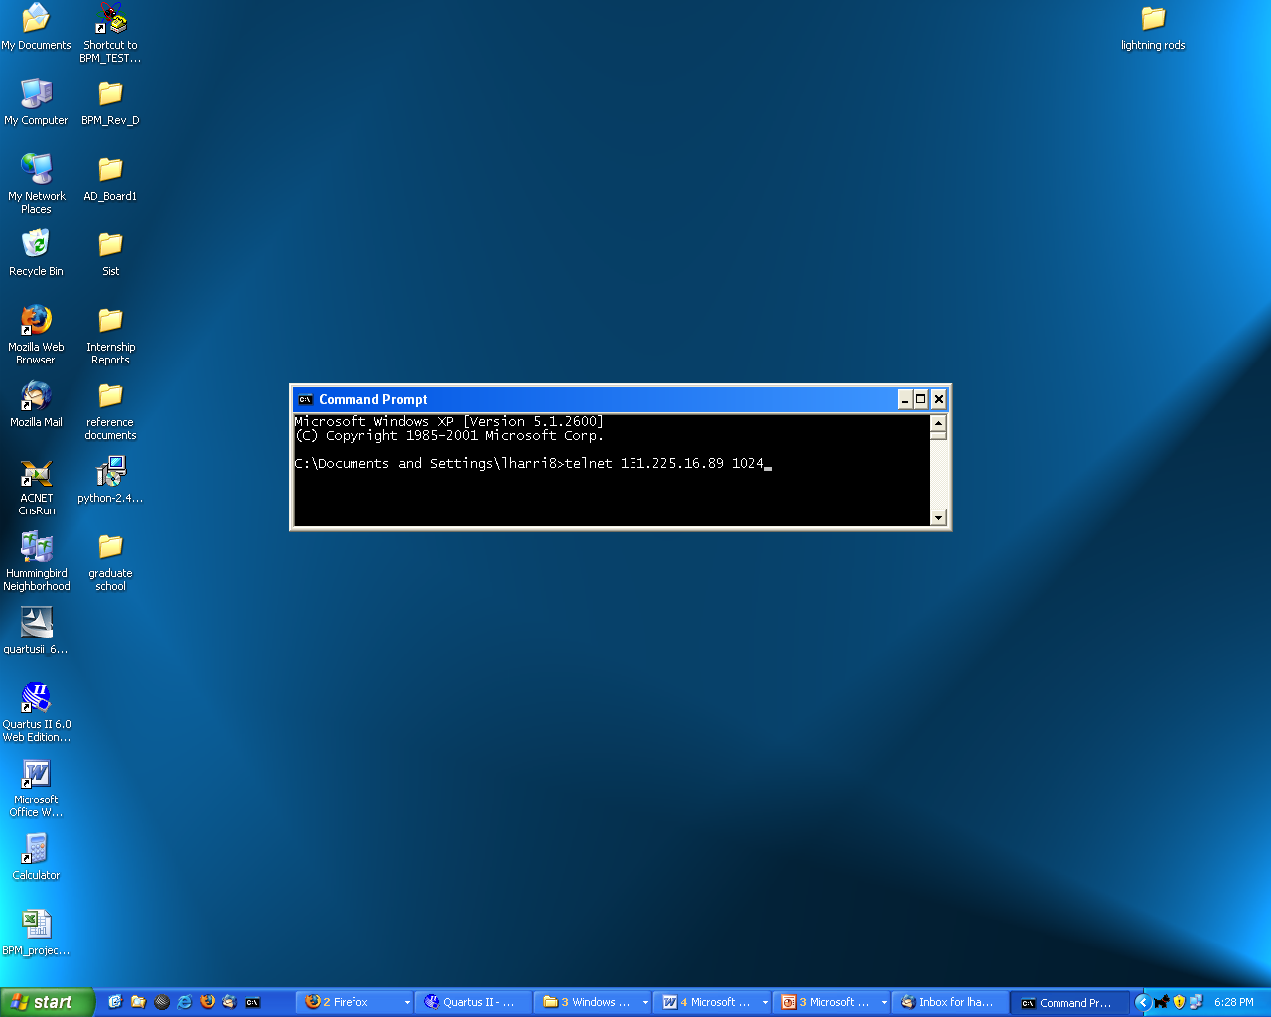

A command to read a section of the FPGAs internal SRAM would look something like this:
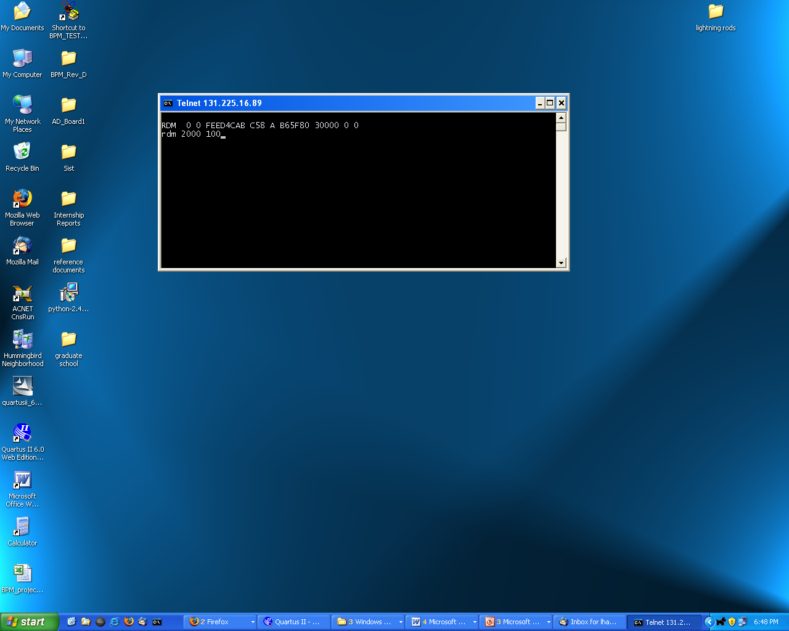
This command reads data for the first parameter which is Plate A’s In Phase component.
The data returned should have almost zero values in the beginning of the data string and then have approximately 25 nonzero values. However the data string looks like:
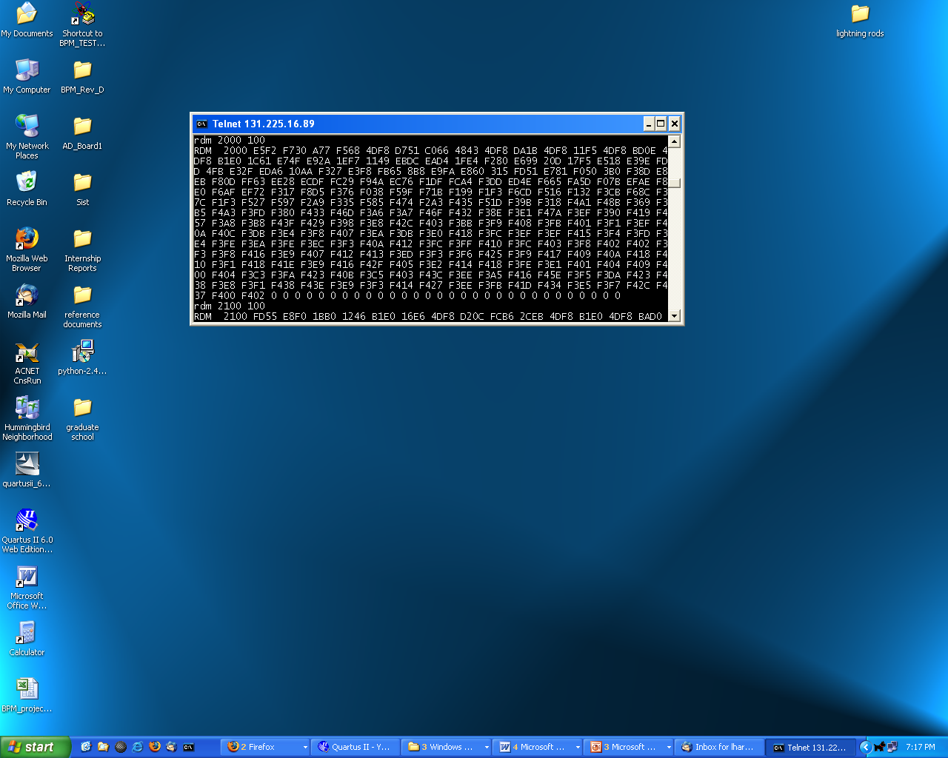
The data is stuck at one value which is inconsistent with the expected results.

Discussion of Results, Possible Problems, and Future Work

There are a few things that may be possible for causing this problem with the code. These possible problems are discussed in this section.

Naming of parameters
With more than 1000 lines of code, not including the pin out assignments, of an FPGA code, it is very possible that naming of the variables may be inconsistent in some unobvious section of the code. This is something that should be considered in future work.

FPGA Phase Lock Loop (PLL)
Once the parameter names have all been checked, the PLL should be considered next. The internal PLL used to reference the 53 MHz RF signal may not be locking. This may be due to the very small RF signal used in my test circuit. Its amplitude may be too small to successfully lock the Voltage Controlled Oscillator (VXO). This is the most likely cause of the inconsistent results. In future work, an amplifier should be added to the test signal generator circuit in order to ensure that it will lock the VXO.

Unsynchronized Trigger Timing
It is also possible that the 1 Hz enable is not synchronized properly with the 500 Hz switching signal. This means that instead of reading the beginning of one plate signal and then the other plate signal, the 1 Hz trigger may come in the middle of a plate reading and the data being read may not see the 25 ms ramp. This should also be considered in future work.

Conclusion

Configuring the code for the Downconverter board FPGA proved to be helpful for future work on the Revision E upgrade project. The FPGA now reads in four channels instead of one, and unlike the previous version does not exhaust the internal SRAM. The board was tested with a test signal generator and the results were analyzed. The resulting data was inconsistent with expected results. It was speculated that there may be some calibration work needed to lock the VXO and to synchronize the test signals. This may be helpful in future coding and testing procedure and in actual field troubleshooting of the device after its full installation in the Antiproton Source.

References

[1] FPGA-Based Instrumentation for the Fermilab Antiproton Source, W. Ashmanskas, et al., 2005
[2] Antiproton Rookie Book Version 1.1, Fermilab, 1999
[3] Debuncher Beam Position Monitor, by Dave Peterson http://www-bdnew.fnal.gov/pbar/Projects/Debuncher-BPM/debuncher_BPM.html
[4] Debuncher 53 MHz BPM Receiver Design Parameters Antiproton Source Debuncher BPM using Synchronous Detection, Beams Document submitted by Dave Peterson
[5] Debuncher 53 MHz BPM Receiver Design Parameters, 12-02-05 Power Point presentation by Dave Peterson

Acknowledgements

I am indebted to some very important figures for their constant advice, training, mentorship, encouragement, criticism, and inspiration: my Fermilab SIST mentors Cosmore Sylvester and Jean Slaughter; Elliott McCrory, Head of the SIST committee; Dave Peterson of the SIST committee and my supervisor on this project; Cecelia Gerber, my Physics I instructor at UIC and a Fermilab D0/CERN physicist; Denise Hayman, director of the UIC Minority Engineering Program and one of my mentors; Rashid Ansari, one of my favorite professors at UIC and my undergraduate research advisor; Vladimir Goncharoff, another one of my favorite professors at UIC and my academic advisor; the entire Antiproton source department; everyone at the UIC McNair program; my mentors Marjon Dean at IBM, and Elmie Peoples at Fermilab; my beautiful children Elijah and Isaiah; my mother; my great friend Julius Kweri; and several others.

Appendices
Appendix 1a. Portion of code used to allocate memory on FPGA
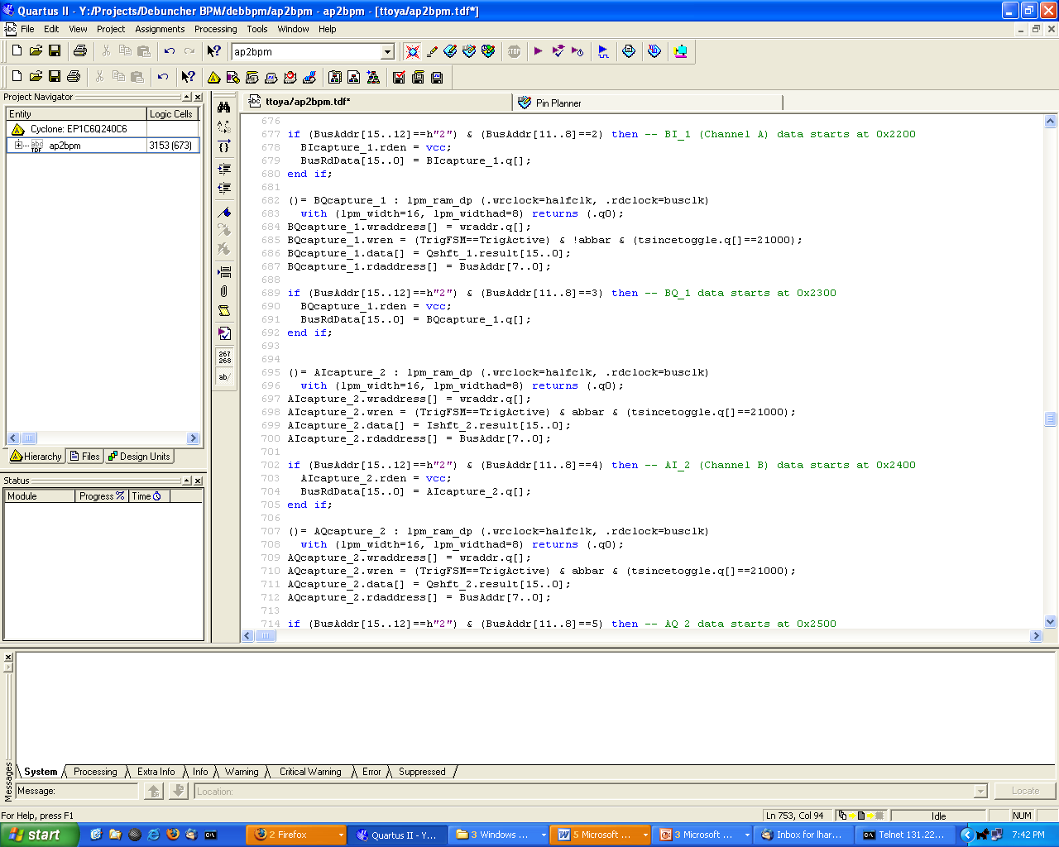

Appendix 2a. Code for PIC12F675 Microcontroller to implement test signal generator.

Version 1. Version 1 of the code doesn’t allow the RF to ramp unless the trigger has just gone HI, and did not go LO yet.
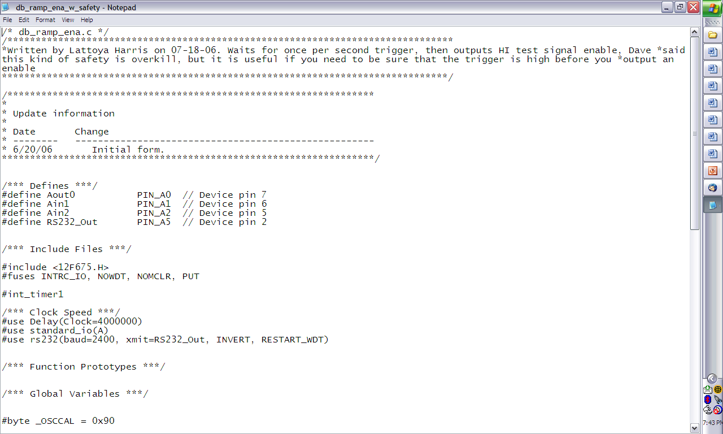
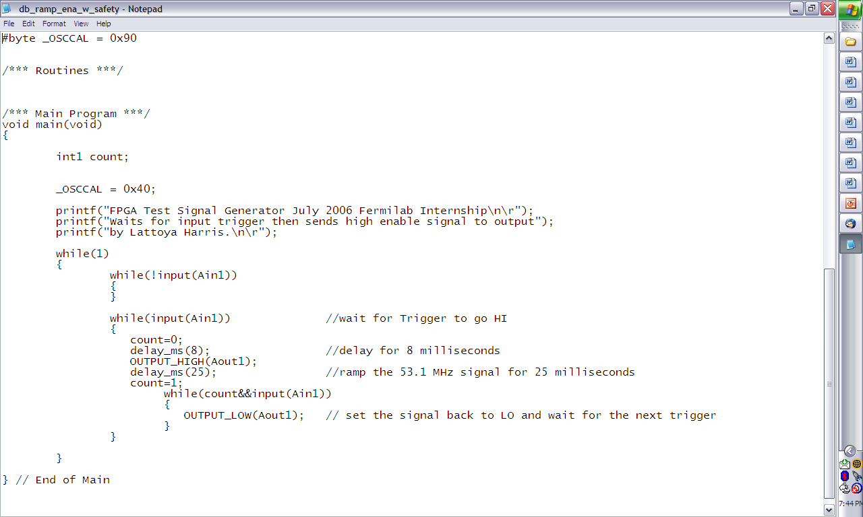
Version 2. This code is much simpler. It checks to see if the trigger is HI without checking to see if it just came on.
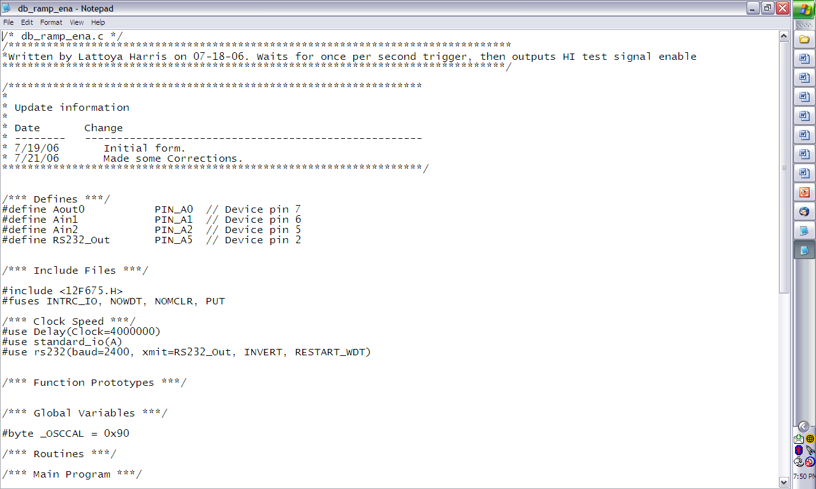
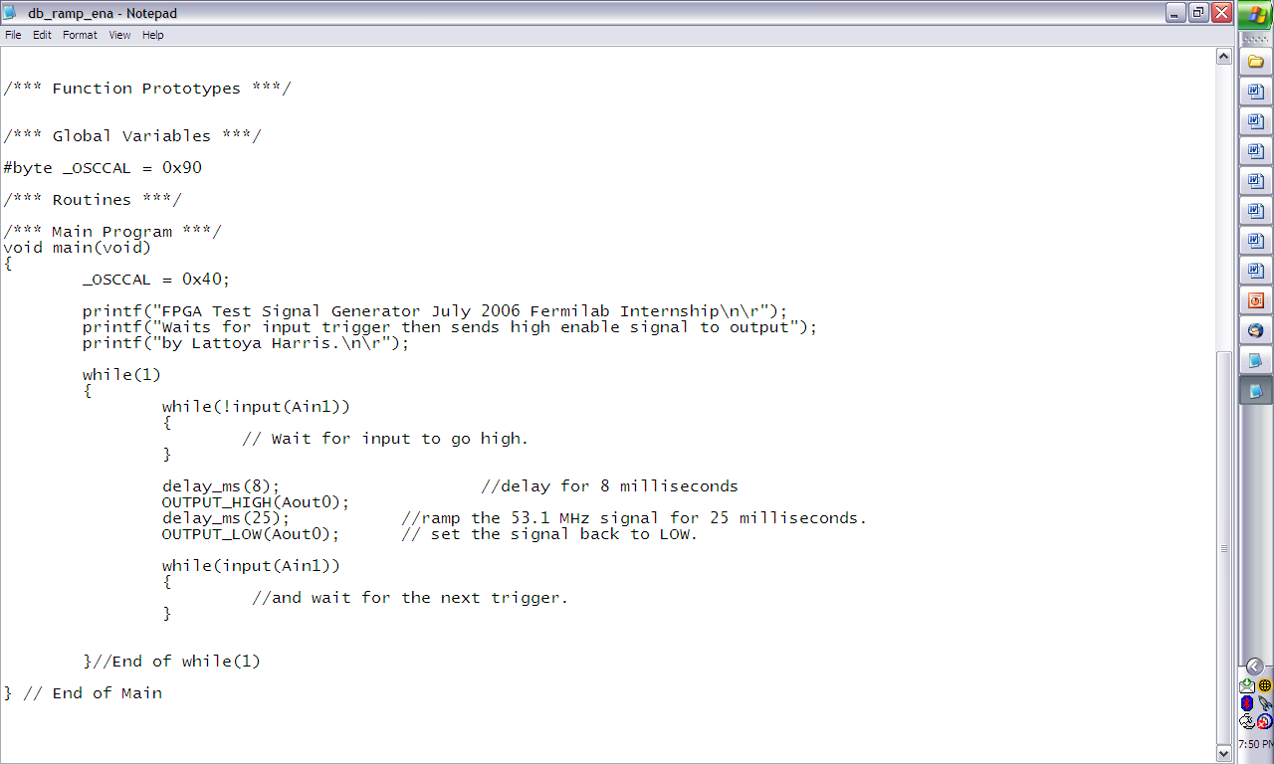

Appendix 2b. Pictures of test signal generator circuit
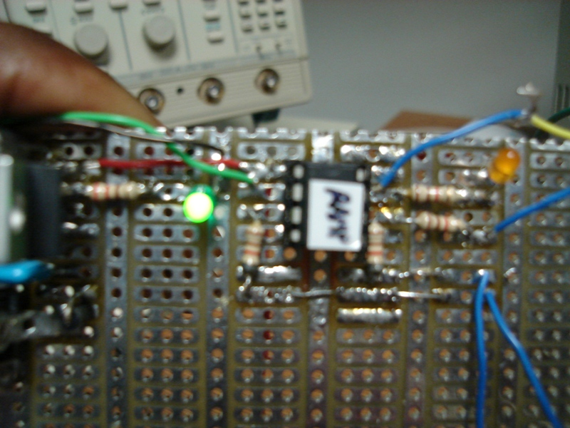
Pin 6 1 Hz Trigger from FPGA
Pin 7 25 ms ramp enable
PIC 12F675 Microcontroller and Power Supply
RF out
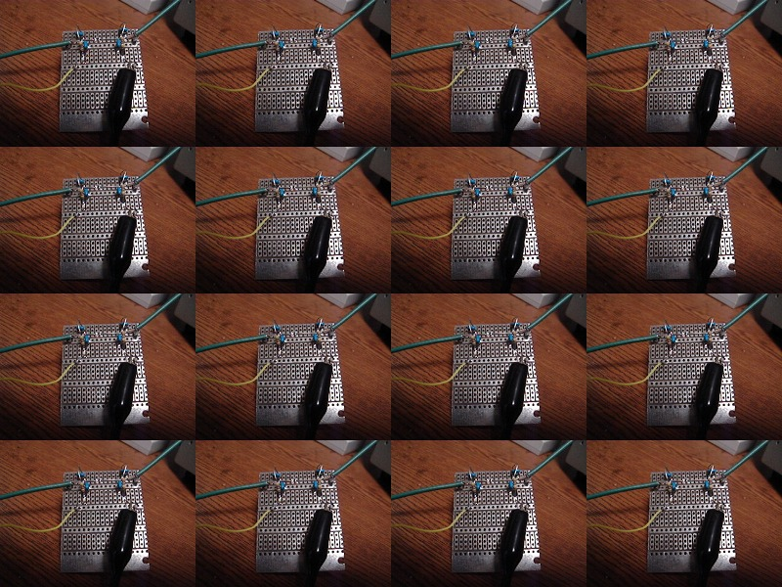
Very small PN diode
25 ms ramp enable from pin 7 of microcontroller
RF in
Ramp enable circuit

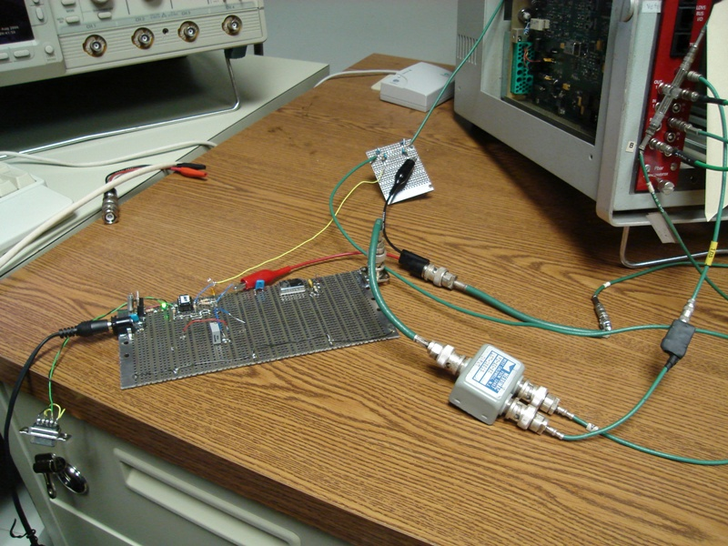
Downconverter board
53 MHz Oscillator
1 Hz trigger from Downconverter FPGA
Two-way splitter that sends 53 MHz RF into FPGA PLL and into ramp enable circuit
Complete test generator circuit

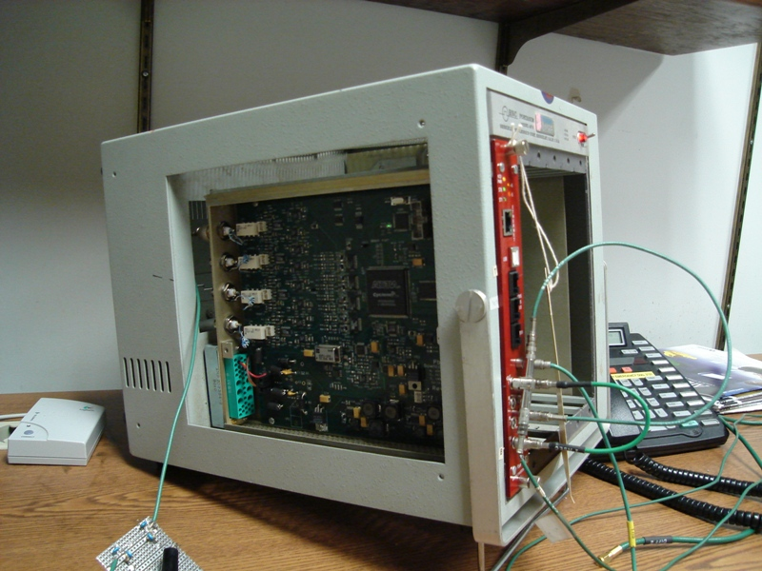
Debuncher BPM Downconverter Board in NIM Crate

