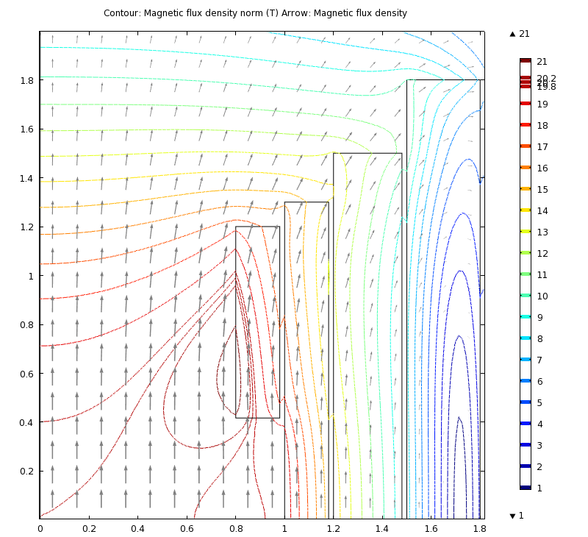 

Four-coil 20-T pion-capture magnet. Annular spacing = 2 cm. Inner HTS magnet: I.R. ≡ a11 = 80 cm; O.R. ≡ a21 = 98 cm; half length ≡ b1 = 120 cm; half gap ≡ g1 = 41.7 cm; coil current density ≡ j1 = 23.4 A/mm2; central field contribution ∆B1 = 2 T; maximum ambient field B1 = 21.5 T. Outer HTS coil: a22 = 118 cm; b2 = 130 cm; j2 = 23.1 A/mm2; ∆B2 = 4 T; B2 = 19.8 T. Nb3Sn coil: a23 = 148 cm; b3 = 150 cm; j3 = 19.0 A/mm2; ∆B3 = 5 T; B3 = 14.6 T. NbTi coil: a24 = b4 = 180 cm; j4 = 32.4 A/mm2; ∆B4 = 9 T; B4 = 10.8 T. Left: First-quadrant cross section, field magnitude (contours) & direction (arrows). Right: Field homogeneity is 1% over z = +/- 40 cm.

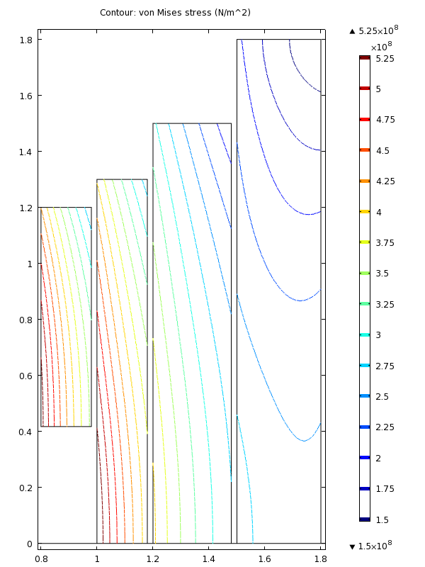 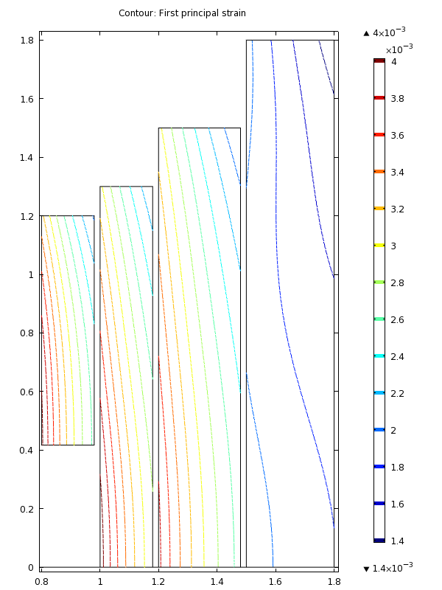 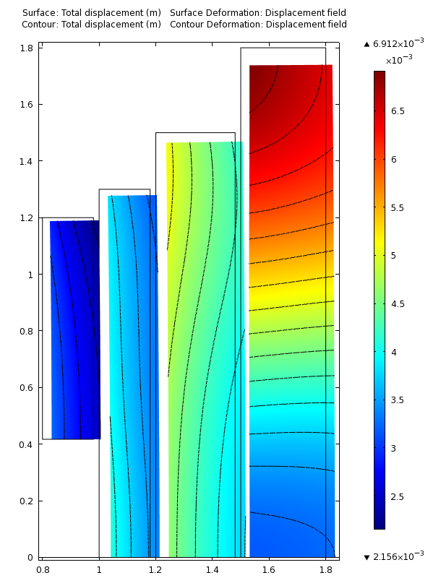

Stress, strain and deformation in Fig. 5 magnet with orthotropic windings. Young’s moduli {Er, Eφ, Ez} = {26, 130, 65} GPa in HTS coils and {20, 100, 40} GPa in LTS coils. 130 GPa derived from 50% Hastelloy of 220 GPa[13] + 25% copper of 80 GPa (320 MPa stress @ 0.4% strain) + 25% coolant & insulation (negligible stiffness). 100 GPa derived from 35% steel of ~230 GPa[14] + 25% Cu + 40% residual for Nb3Sn coil and, for NbTi coil, 20% steel + 40% Cu of ~135 GPa[15] + 40% residual. Left: Von Mises stress, averaged locally over winding; maximum stress in consecutive coils = {535, 549, 406, 288} MPa. Center: Hoop strain, εφ; max. percent = {0.40, 0.41, 0.38, 0.21}. Right: Deformation (magnified tenfold) ranges from 2.2 mm to 6.9 mm; contour interval = 0.25 mm.

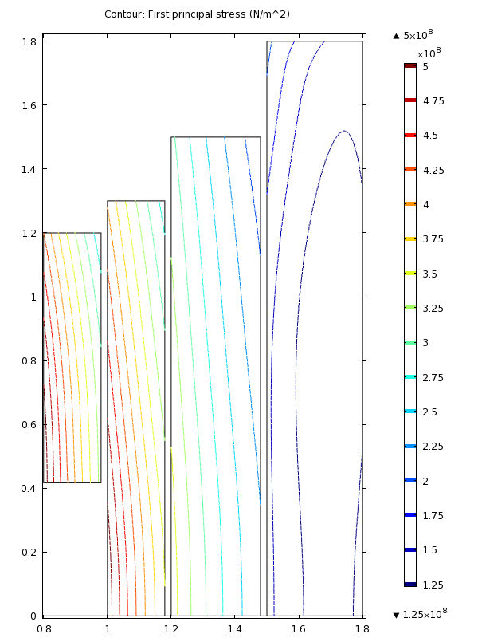 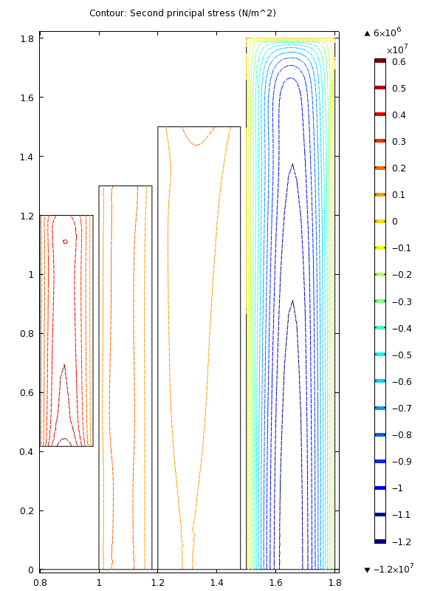 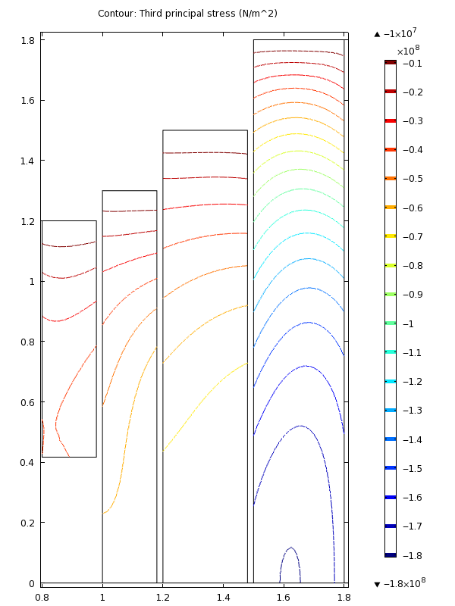

Principal stresses in magnet above. Left: Hoop stress σφ; max. MPa = {515, 516, 362, 159}. Center: Radial stress σr; max. MPa = {6.5, 2.6, 1.6, −12.4}. Right: Axial stress σz; max. MPa = {-49, −65, −78, −180}.

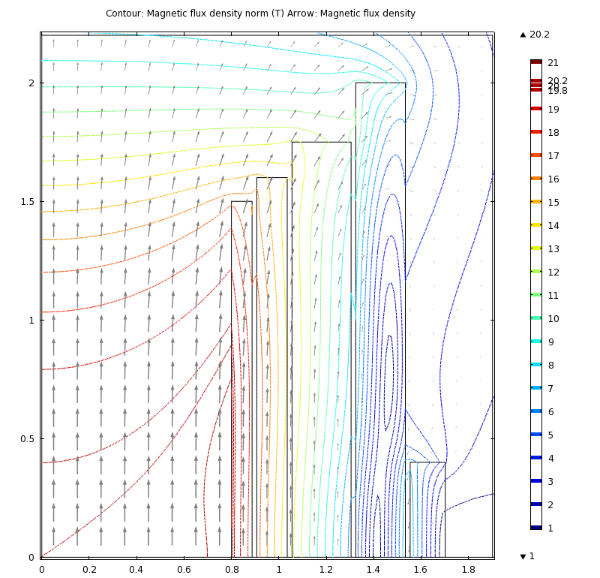 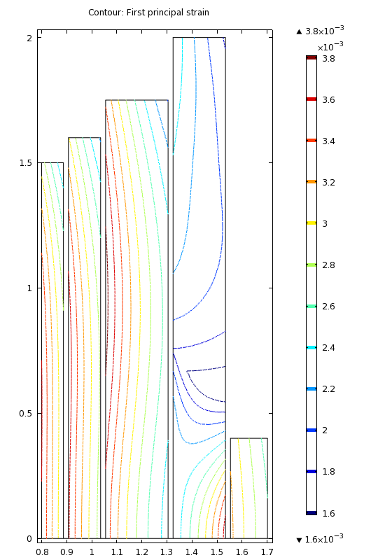 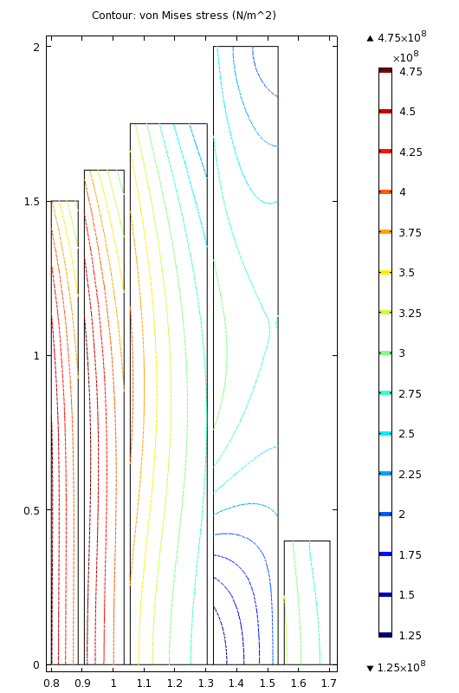

Design that eliminates midplane gap by use of reverse-current field-homogenization coil. Inner HTS coil: a11 = 80 cm; a21 = 88.7 cm; b1 = 150 cm; j1 = 25.2 A/mm2; ∆B1 = 2.4 T; B1 = 20.3 T. Outer HTS coil: a12 = 90.7 cm; a22 = 103.5 cm; b2 = 160 cm; j2 = 26.1 A/mm2; ∆B2 = 3.6 T; B2 = 17.7 T. Nb3Sn coil: a23 = 130.5 cm; b3 = 175 cm; j3 = 23.1 A/mm2; ∆B3 = 5 T; B3 = 14.1 T. NbTi coil: a24 = 153.4 cm; b4 = 200 cm; j4 = 47.2 A/mm2; ∆B4 = 10.1 T; B4 = 11.0 T. Field-homogenizing coil: a25 = 170.2 cm; b5 = 40 cm; j5 = −j4; ∆B5 = −2.09 T; B5 = 7.7 T. Left: First-quadrant cross section and field magnitude (contours) & direction (arrows). Center: Hoop strain εφ; max. percent εφ = {0.36, 0.37, 0.39, 0.37, 0.32}. Right: von Mises stress; max. MPa = {480, 496, 406, 315, 328}.



Magnet volume, kiloampere-meters & magnetic energy vs. bore diameter. Reducing the magnet bore by a factor of two would decrease its kA-m by a factor of three, and its volume and energy by a factor of six.