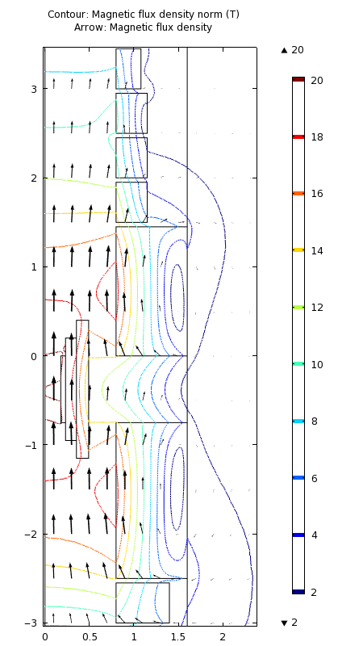 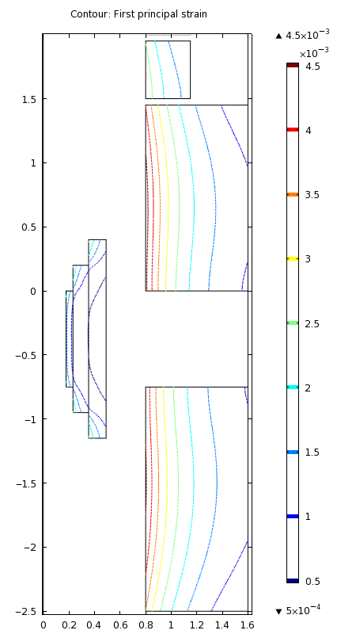 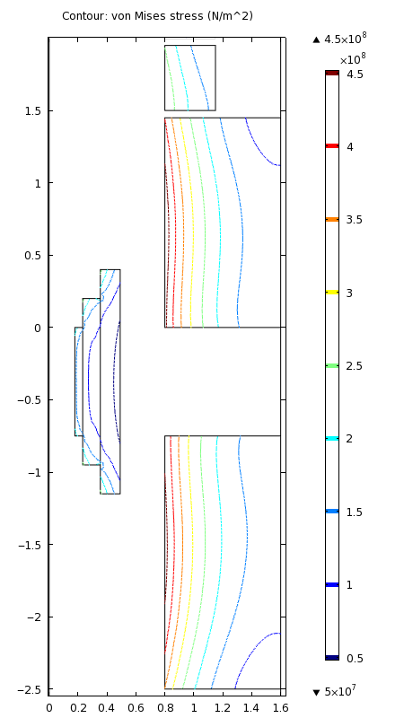

Upstream solenoids of 20 T, 2.3 GJ target magnet “ids80”. Left: Windings cross section and field magnitude (contours) & direction (arrows). Innermost three solenoids are copper hollow conductor (B = 6 T; P = 8.8 MW); others shown are Nb3Sn. Bmax = 20.08 T; B = 20 T at z = 0, −34 cm, −43 cm & −74 cm. Center: Hoop strain; εmax = 0.463% if orthotropic Young’s modulus components {Eφ, Er, Ez} = {100, 20, 20} GPa. Right: von Mises stress, σvM; max. σvM = 473 MPa.

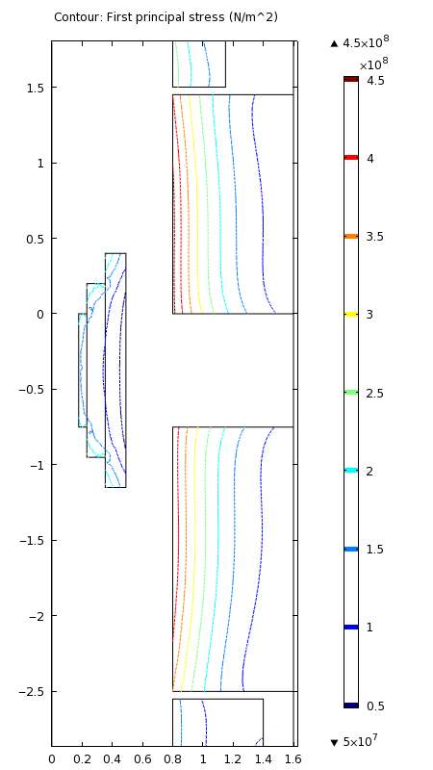 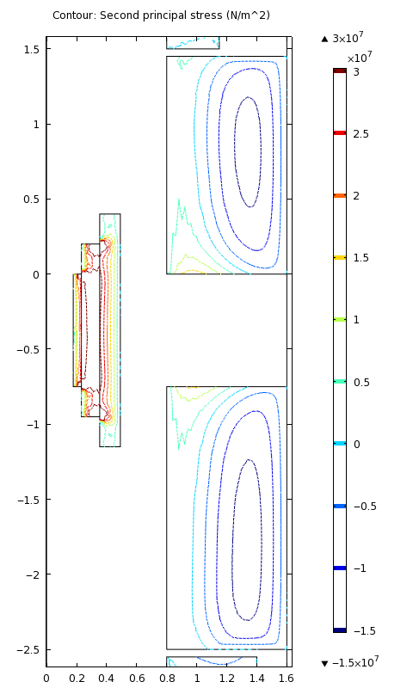 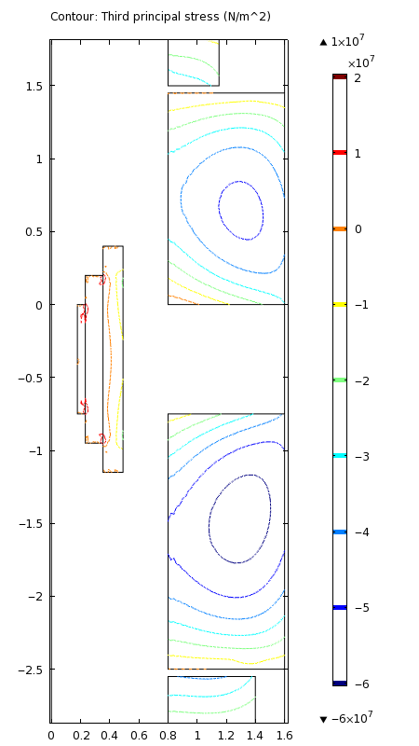

Principal stresses. Left: circumferential (hoop) stress, σφ; maximim σφ = 469 MPa. Center: radial stress, σr. Right: Axial stress, σz; max. compression = 62 MPa. Axial load on most-upstream Nb3Sn solenoid is 162 MN (downstream direction); loads, in MN, on successive solenoids = {142, −66, −71, −22, −35, −36}.



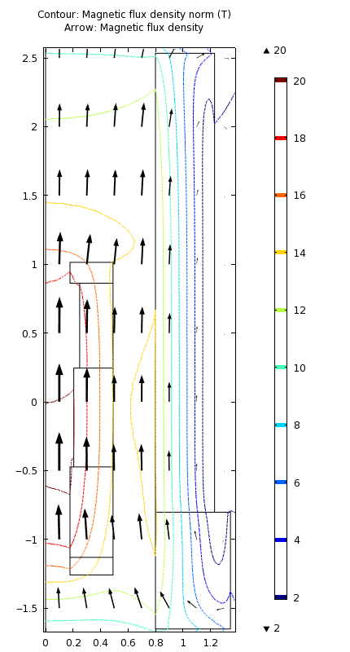 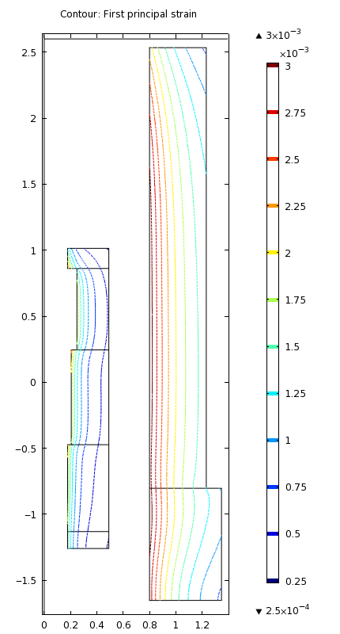 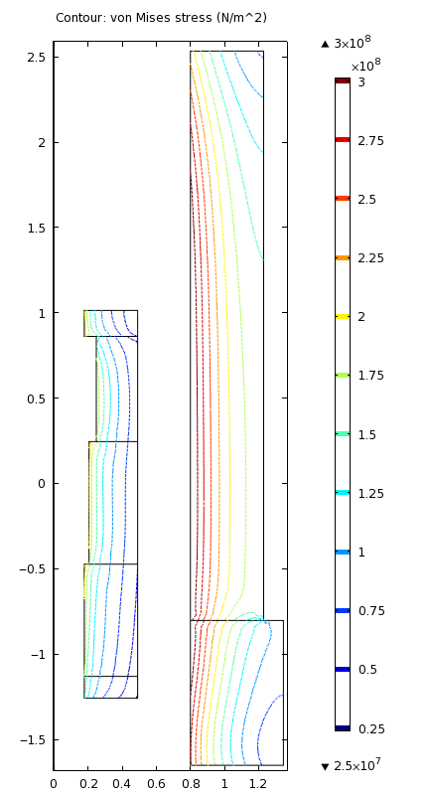

Upstream solenoids of HC&SC20T! target magnet with 6 T, 10.5 MW magnet of copper hollow conductor in 14 T SC magnet; magnetic energy = 1.17 gigajoules. Left: Windings cross section and field magnitude (contours) & direction (arrows); maximum ambient field in superconducting magnet is 14.3 T. Center: Hoop strain with orthotropic Young’s modulus components {Eφ, Er, Ez} = {100, 20, 20} GPa; εmax = 0.311%. Right: von Mises stress, σvM; max. σvM = 327 MPa.

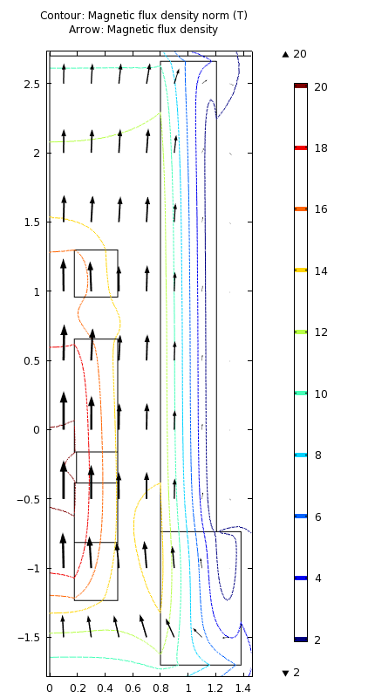 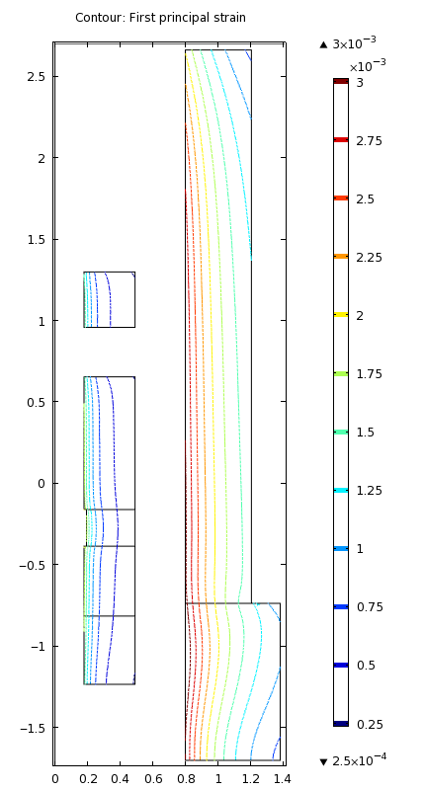 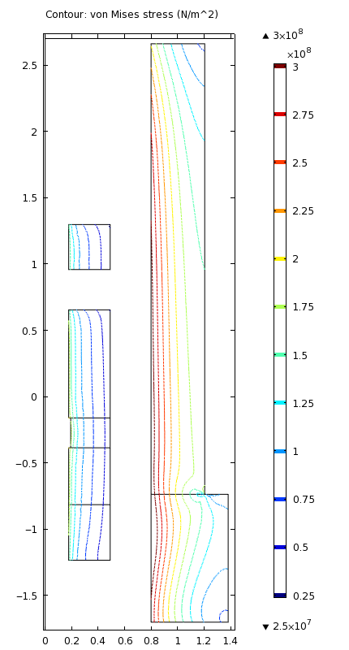

Upstream solenoids of HC&SC20T# target magnet with 6 T, 10.0 MW magnet of copper hollow conductor in 14 T SC magnet; magnetic energy = 1.18 GJ. Left: Windings cross section and field magnitude (contours) & direction (arrows); maximum BSC = 14.6 T. Center: Hoop strain with orthotropic Young’s modulus components {Eφ, Er, Ez} = {100, 20, 20} GPa; εmax = 0.326%. Right: von Mises stress, σvM; max. σvM = 340 MPa.



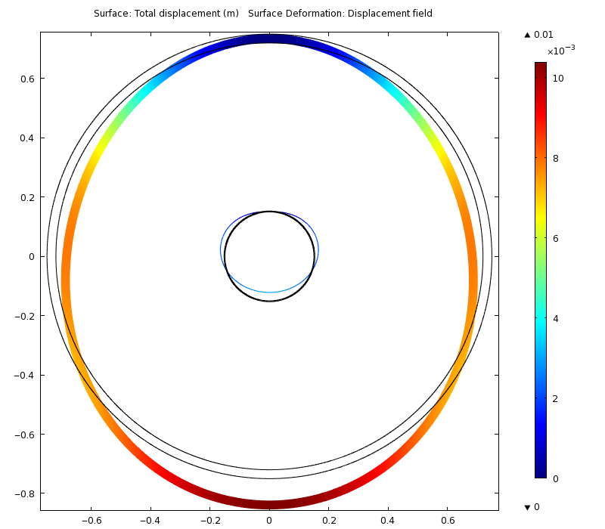

Deformation, magnified tenfold, of horizontal steel cylinders, fixed at 12 o’clock, with annulus of 10 g/cm3 fluid; r1 = 15 cm; dr1 = 3 mm; r2 = 72 cm; dr2= 3 cm.

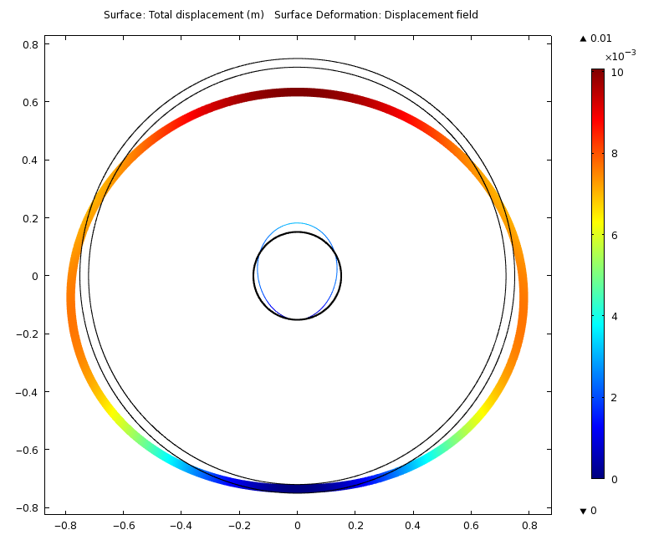

Deformation, magnified tenfold, of horizontal steel cylinders, fixed at 6 o’clock, with annulus of 10 g/cm3 fluid; r1 = 15 cm; dr1 = 3 mm; r2 = 72 cm; dr2= 3 cm.