PIP-II CDS FDR Charge and Agenda

Document number: ED0008570

Document Approval
Originator: Andrew Dalesandro  Org: PIP-II  Contact: andrewd@fnal.gov,  Role: CDS CAM/L3M, Review Coordinator | Date: 31 July 2020
Reviewer: Jeremiah Holzbauer  Org: PIP-II  Contact: genfa@fnal.gov  Role: SRF Coordinator | Date: 31 July 2020
Approver: Genfa Wu  Org: PIP-II  Contact: genfa@fnal.gov  Role: SRFCRYO L2M | Date: 03 Aug 2020

Revision History
Revision | Date Release | Originator:  Role: | Description of Change
0 | 03 Aug 2020 | CAM | Initial release
1 |  | CAM | Update schedule, document status, Finalize

Table of Contents

1. Introduction 4
2. Review Agenda 4
3. Review Charge Statement 6
4. Acronyms 6
5. Reference Documents 6

Introduction
The PIP-II Cryogenic Distribution System (CDS) is within Work Breakdown Structure (WBS) 121.2.06 and consists of the equipment needed to supply and return helium from the PIP-II Cryoplant via vacuum insulated cryogenic pipe lines and warm gas headers to the PIP-II Linac. The CDS includes cryogenic transfer lines, Distribution Valve Box, bayonet cans and turnaround can, warm gas headers, U-tubes, and a cryogenic controls system. A simplified CDS schematic is shown in Figure 1. Primary CDS helium cryogenic process circuits include:
- 4.5 K Supply
- 2 K Return, sub-atmospheric
- Low Temperature Thermal Shield (LTTS) Return
- High Temperature Thermal Shield (HTTS) Supply
- High Temperature Thermal Shield (HTTS) Return
- Cool Down (CD) Return

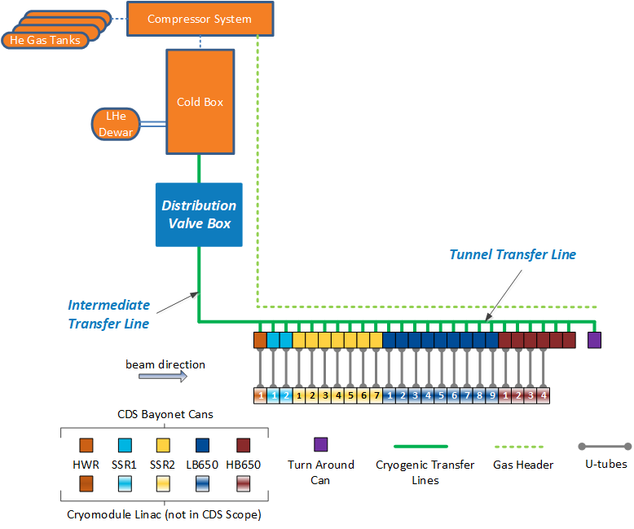
Figure 1. Scope of the PIP-II Cryogenic System (Cryomodules and Cryoplant not in CDS Scope)

Final Design Review (FDR) Agenda
Location: | Zoom, connection information sent through Outlook invitation
Date: | 12 August 2020
Time:  Indico Site: | 0800 - 1730  https://indico.fnal.gov/event/43804/

Participants:

Andrew Dalesandro  andrewd@fnal.gov | PIP-II CDS | Role: Review Coordinator
Jay Theilacker  theilacker@fnal.gov | APS-TD | Role: Review Chair
Josh Kaluzny  kaluzny@fnal.gov | LCLS-II-HE | Role: Reviewer
Michael Geynisman  hope@fnal.gov | ND/TSD | Role: Reviewer
Bill Soyars  Soyars@fnal.gov | LCLS-II-HE | Role: Reviewer
Ram Dhuley  dhuley@fnal.gov | APS-TD | Role: Presenter
Ashish Shukla  ashukla@fnal.gov | IIFC/PIP-II | Role: Presenter

Introduction: Dalesandro

Introduction of Reviewers and Approvers

PDR Recommendations

Scope of the FDR

Items not covered in the FDR

Management: Dalesandro

In-Kind Collaboration

Design Deliverables

Schedule and Resources

Procurements

Risks

Prevention through Design

Acceptance Plan

QC Plan

Pending BCRs

Requirements and Interfaces : Dalesandro

Functional Requirements

Technical Requirements

Interfaces

Reference Design: Dalesandro

Piping and Instrument Diagrams

3D Models

Distribution Valve Box

Intermediate Transfer-Line

Tunnel Transfer Line - Bayonet Can

Tunnel Transfer Line - Turnaround Can

U-tubes

Warm Headers

Process Design: Shukla, Dhuley

Operating Modes

Pressure Drop, valve sizing, flow rates

Pressure Safety

Vacuum Safety

Heat load

Installation Plan

Stress and Flexibility: Dhuley

Thermomechanical Analysis - DVB

Thermomechanical Analysis - ITL

Thermomechanical Analysis - BC

Thermomechanical Analysis – TC

Stress analysis – ITL Fixed Support

Closeout: Review Chair

Summary Statement

Findings

Comments

Recommendations

Final Report

Review Charge Statement
This document provides the PIP-II Cryogenic Distribution System (CDS) Final Design Review (FDR) overview and agenda, and is intended to consolidate relevant CDS FDR information sources to a central document. The scope of the CDS FDR includes the design deliverables presented in the PIP-II 121.02 SRF and Cryo Systems Design Plan (docdb # 2605) as well as the reference designs of CDS 3D model components and the schedule and planning outlined to accomplish the PIP-II project objectives.

The purpose of the CDS FDR is to engage a panel of independent reviewers and seek guidance regarding the design maturity of the CDS at the time of FDR, specifically to request a thorough evaluation of the CDS reference design maturity compared to the review committee’s expectations for a Final Design Review. To assist the CDS FDR committee in this evaluation the following charge questions, and any other questions in which the committee deems appropriate, should be addressed in the final evaluation and report.

Technical Scope
- Are all CDS specifications, requirements, and interfaces identified and documented at the level of maturity commensurate with a FDR?
- Are all external specifications, requirements, and interfaces identified and documented sufficiently to adequately evaluate the CDS design, at the current stage of the project?
- Is the reference design technically sufficient to satisfy the functional requirements?
- Have preliminary installation and commissioning issues been identified?
- Have all of the major technical risks been identified?
- Is the reference design maturity sufficient for FDR approval?

Design Management
- Have all recommendations from previous reviews been addressed?
- Are engineering support and resources sufficient to
  - successfully complete the reference design?
  - successfully manage the In-Kind collaboration and procurement deliverables?
  - successfully manage installation?
- Is the current budgeted effort and staffing level sufficient to complete the CDS on schedule?
- Are procurement and In-Kind management strategies appropriate to successfully deliver the CDS components?
- Are the reference design models at sufficient level of detail to satisfy CDS scope and interface requirements?
- Does the Distribution Valve Box design or functionality include any unnecessary redundancy?

Schedule
- Have all of the major schedule risks been identified?
- Is the CDS P6 schedule reasonable to achieve the planned scope?

ESHQ
- Have all related ES&H aspects been identified and planned to be properly addressed?
- Is the CDS QC Plan sufficient to ensure successful CDS installation and operation?

Miscellaneous
- Are there any other issues that have been identified that need to be addressed?

Acronyms

BC | CDS Bayonet Can
CDS | Cryogenic Distribution System
CM | Cryomodule
CP | Cryogenic Plant
DVB | CDS Distribution Valve Box
FRS | Functional Requirements Specification
ICD | Interface Control Document
IO | Input / Output modules and/or electronics
ITL | CDS Intermediate Transfer Line
PIP-II | Proton Improvement Plan II Project
TC | CDS Turnaround Can
TRS | Technical Requirements Specification
TTL | CDS Tunnel Transfer Line
QC | Quality Control
WBS | Work Breakdown Structure

Reference Documents
The following list of documents is presented for the review committee as guidance of review expectations.

1 | PIP-II Technical Review Plan – TC ED0008163
2 | PIP-II Quality Assurance Plan DocDB # 142
3 | PIP-II Systems Engineering Management Plan – TC ED0008164
4 | PIP-II IESH Management Plan DocDB # 141
5 | 121.02 SRF and Cryo Systems Design Plan DocDB # 2605
6 | 121.03 Accelerator Systems Design Plan DocDB # 2599
7 | 121.04 Linac Installation and Commissioning Design Plan DocDB # 2581
8 | 121.05 Accelerator Complex Upgrades Design Plan DocDB # 2593
9 | 121.06 Conventional Facilities Design Plan DocDB # 2587
10 | PIP-II Value Engineering Plan DocDB # 2830

The following list of documents comprise the scope of CDS deliverables to satisfy the FDR requirements as outlined in 121.02 SRF and Cryo Systems Design Plan (DocDB # 2605). Documents within the scope of the CDS FDR are located on OneDrive in the following directory: PIP-II CDS FDR Deliverables.
Table 1 - PIP-II CDS FDR Deliverables from the System Design Plan
 | Doc. Number | Document Title | Status | Comments
1 | ED0008570 | FDR Agenda and Charge Questions | final
2 | ED0008569 | Close-Out of previous Recommendations | released
3 | ED0008022 | Functional Requirements Specification | final
4 | ED0008552 | Technical Requirements Specification | final
5 | ED0010433 | Interface Control Document | released
6 | ED0007572 | Interface Specification Documents | final
7 | ED0008561 | Updated Risk Assessment Document | final
8 | ED0012444 | Up-to-date Risk Register | final
9 | ED0010908 | ODH Analysis | final | Submitted to PIP-II CSS for review
10 | ED0012445 | Installation Hazard Analysis | final
11 | ED0008560 | Failure Mode and Effect Analysis (FMEA) | final
12 | ED0011373 | Prevention through Design | final
13 | F10124028 | P&ID | final
14 | ED0008560 | Valve & Instrument List | final
15 | ED0008554 | Heat Leak Analysis | final
16 | ED0008555 | Pressure Drop Analysis | final
17 | ED0008556 | Pressure Relief Analysis | final
18 | ED0008562 | Vacuum Relief Analysis | final
19 | ED0008558 | Flexibility Analysis | final
20 | ED0012446 | Layout Drawings | final
21 | ED0011560 | Installation Plan | final
22 | ED0011565 | Management Plan | final
23 | DocDB, #3415 | SRF QA Plan | released
24 | ED0011346 | Quality Control Plan | final
25 | ED0012361 | Operating Procedures | final

