PIP-II Value Engineering Plan

Document number: PIP-II DocDB 2830

Document Approval
Signatures Required | Date Approved
Originator: Allan Rowe, Project Engineer | As in DocDB
Approver: Marc Kaducak, Project Manager | As in DocDB
Approver: Arkadiy Klebaner, Technical Director | As in DocDB
Approver: Lia Merminga, Project Director | As in DocDB

Revision History

Revision | Date Release | Description of Change
12/2/2019 | 12/2/2019 | Updated hyperlinks and references

Table of Contents

1. Introduction 3
2. Acronyms 3
3. Reference Documents 4
4. VE for Conventional Facilities 4
5. VE Workshops for Technical Systems 5
6. VE during Basis of Estimate Reviews 6
7. VE during Technical Design Reviews 7
8. Logging, Tracking, Evaluating, and Implementing VE Opportunities 7
8.1. Logging and Tracking VE Opportunities 7
8.2. Evaluating VE Opportunities 8
8.3. Opportunity Implementation 9
9. Records 9
9.1. Record Retention Schedule 10

Introduction
The DOE order 413.3B requires the PIP-II Project to engage in documented Value Engineering (VE) activities to ensure the Project delivers the maximum performance for the lowest cost [1]. Value is the relationship between performance and cost and is expressed by the following equation: Value = Performance/Cost. For a system undergoing a VE study, the performance and cost elements of the equation are considered. The boundary conditions for proposed VE opportunities are limited by the functional requirements (performance) and the allowable cost of the system under study. Typically, VE opportunities are sought to lower the cost of a system without lowering the performance below requirements. These opportunities are usually less costly methods of production, design, or operation that achieve the same functional requirements as the originally proposed solution. In some cases, value can also be increased by a large increase in performance with a modest increase in cost. This type of opportunity is often a by-product of research and development activities in advance of final production design.

The PIP-II Project will employ four methods to identify VE opportunities across the Project. The four methods include using the FESS VE process for Conventional Facilities (CF), identifying VE opportunities during WBS Level 2 (L2) Systems workshops, during Basis of Estimate (BOE) reviews, and during technical design reviews. This PIP-II Value Engineering Plan describes the four VE methods used to identify VE opportunities and how they will be tracked, evaluated, and incorporated into project planning.

Acronyms
ASTM | American Society for Testing and Materials
BOE | Basis of Estimate
CAM | Control Account Manager
CCB | Change Control Board
CF | Conventional Facilities
CMP | PIP-II Configuration Management Plan
DCB | Design Change Board
FNAL | Fermi National Accelerator Laboratory
L2 | WBS Level 2 System
L2M | WBS Level 2 Manager
L3 | WBS L3 System
WBS | Work Breakdown Structure
VE | Value Engineering

Reference Documents
1 | DOE Order 413.3B
2 | CF – Value Engineering Workshop VE Report DocDB # 1377
3 | PIP-II Value Engineering Opportunity Tracking Sheet DocDB # 4201
4 | PIP-II VE Opportunities List for Reviewers DocDB # 4201
5 | PIP-II Review Plan ED0008163
6 | PIP-II Configuration Management Plan DocDB # 2937

VE for Conventional Facilities System
Value Engineering for the scope of work contained in the Conventional Facilities (CF) L2 System is implemented using the Facilities and Engineering Site Services (FESS) process based on the methodology developed by the US Army Corps of Engineering and ASTM E1699-10 (Standard Practice for Performing Value Analysis of Buildings and Building systems and Other Constructed Projects). A summary of the process used for PIP-II Project CF scope is described as follows:

- Functional Analysis Phase – This step is completed by the design experts in advance of the VE workshop based on the technical requirements.
- Speculation/Creativity Phase – This step was conducted at a January 2018 workshop. During this workshop, design authorities, system and sub-system managers and other stakeholders generated potential VE opportunities within the CF scope of work.
- Evaluation/Development Phase – Promising VE opportunities are identified for further evaluation by the project team including cost and technical impact.
- Concurrence Phase – This phase presents the VE opportunities to the design authority (see Section 8 below) for concurrence prior to implementation.

The opportunities were recorded and evaluated following the VE workshop with the results logged in a CF VE Report and now included as part of the PIP-II Value Engineering Opportunity Tracking Sheet [2,3].

For the remainder of the PIP-II Project, the CF System L2 Manager (L2M) will maintain a CF-specific VE opportunities log within the PIP-II VE Opportunity Tracking Sheet to maintain the ongoing process previously established at the workshop and prescribed in this document. Figure 1 below is an image of the CF VE Opportunity tracking list included as a separate sheet for CF of the overall PIP-II VE Opportunity Tracking Sheet.

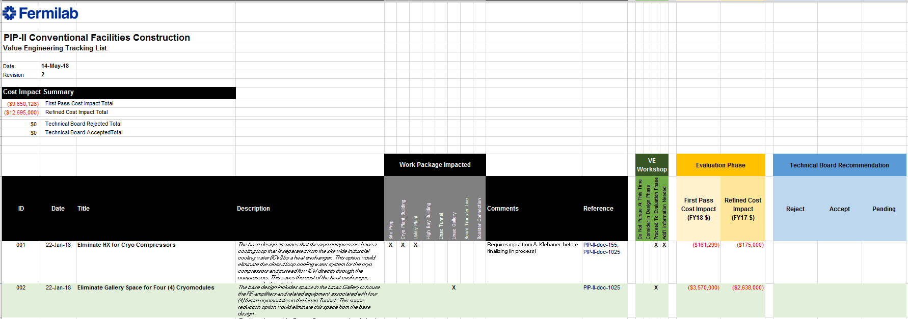

Figure 1: CF VE Opportunity tracking list.

As new opportunities arise through the design process, they will be included in the tracking sheet and evaluated on an ad-hoc basis.

VE Workshops for Technical Systems
The four technical L2 Systems will each perform a VE workshop that evaluates L3/4 sub-systems with estimated costs exceeding $10M. The list of sub-systems above this cost threshold is included in Table 1 below.

Table 2: L2 Systems and L3/4 sub-systems subject to VE Workshop evaluation.

121.02 SRF and Cryo | 121.03 Accel. Systems | 121.04 Instal. and Comm. | 121.05 Accel Upgrades
121.02.03.02 SSR1 | 121.03.03 HPRF-RF Dist | 121.04.04 Bldg. Infra. | 121.05.04 Booster
121.02.03.03 SSR2 | 121.03.04 LLRF | 121.04.05 Linac Install. | 121.05.05 MIRR
121.02.04.02 LB650 | 121.03.05 Mag & PS
121.02.04.03 HB650 | 121.03.06 Vacuum
121.02.05 Cryo. Plant | 121.03.07 Controls
121.02.06 CDS | 121.03.09 Beam Instrum.

The primary goal of the VE workshop is to generate as many VE opportunities for further consideration as possible. The sub-system being evaluated should be introduced sufficiently well (function, configuration, overall design, procurement strategy, etc.) to facilitate many ideas from participating PIP-II Project team members, experts, and other stakeholders. No opportunities will be rejected or otherwise evaluated during the workshop but will be recorded for future evaluation. A PIP-II Technical Integration group member will assist in facilitating the discussion.

The VE workshops for technical systems must be completed prior to establishing an overall baseline budget for the Project. As of this writing, the deadline to hold the VE workshop is February 15th, 2019. Establishing the list of potential opportunities by this time enables the Project to understand impact of VE to the overall Project budget in advance of setting the baseline cost in early March of 2019.

Opportunities identified in during the workshops will be logged using the PIP-II VE Opportunities List for Reviewers [4].

A general agenda for the System VE workshops is established below. The L2M should tailor this agenda to facilitate clear sub-system presentations and increase the likelihood of discovering VE opportunities.

GENERAL VE WORKSHOP AGENDA

- L2M Introduction
  - Charge overview
  - Definition of Value for this System
    - Value = (delivered performance)/cost
  - Purpose of VE workshop and charge to the committee
  - Format and Schedule of workshop
  - Introduction of L3 Managers and workshop participants
  - List of expected outcomes
- L3/4 Sub-system Talk #1
  - Functional requirements of L3 sub-system
    - Governing requirements necessary to meet performance
  - Proposed configuration/design
    - List reasons for key design decisions made to-date
  - Cost breakdown
    - Details of costs to whatever level necessary to inform reviewers
    - Important procurement and design strategies chosen
  - Known alternative configurations/designs that achieve the same function but may not have been chosen
- Opportunity Generation #1 (Brainstorming/speculation)
  - Produce list of VE opportunities by facilitating discussion
  - Engage of all stakeholders and workshop participants
  - Log opportunities
- L3/4 Sub-system Talk #2…
- Opportunity Generation #2…

It is important to note:
*No opportunities are evaluated during workshop
*Quantity of ideas essential to the effectiveness of the process

All identified opportunities must be logged in the PIP-II VE Opportunity Tracking Sheet following the workshop. Opportunities will be evaluated by the procedure defined in section 8 of this document.

VE during Basis of Estimate Reviews
The PIP-II Project cost estimate is broken down into multiple control accounts. Each control account has an associated Basis of Estimate (BOE) document that justifies the sum of the costs for its respective scope of work. Prior to formalizing the cost basis of the control account in the Resource Loaded Schedule (RLS), each BOE undergoes a formal review and approval process.

As part of the BOE review process, the PIP-II Project will instruct the BOE reviewers to examine the estimates and scope described in the documents and record any possible VE opportunities in the PIP-II VE Opportunities List for Reviewers. The recorded opportunities will be provided to the L2M as part of the review feedback.

Following the BOE review, all identified opportunities will be logged in the PIP-II VE Opportunity Tracking Sheet by the L2M. Opportunities will be evaluated by the procedure defined in section 8 of this document.

VE during Technical Design Reviews
L2 system and sub-system designs are formalized through the design review process established by the PIP-II Review Plan [5]. During the preliminary design reviews (PDR) held through the design cycles of the L3/4 sub-systems, technical reviewers are requested to identify potential VE opportunities for the respective system and sub-system managers to consider. VE opportunities are not included in the list of formal recommendations. The PDR Chair is responsible for recording any identified opportunities in the PIP-II VE Opportunities List for Reviewers spreadsheet as part of the final PDR Chair report.

Following the technical design reviews, the L2M will log all identified opportunities in the PIP-II VE Opportunity Tracking Sheet. Opportunities are evaluated by the procedure defined in section 8 of this document.

On occasion, additional VE opportunities may arise following the preliminary design phase. The L2M will record and evaluate these on an ad hoc basis.

Logging, Tracking, Evaluating, and Implementing VE Opportunities

Logging and Tracking VE Opportunities
The PIP-II Reviewer VE Opportunities List Template spreadsheet will be used as a standard form to collect identified VE opportunities in the VE workshops, BOE reviews, and design reviews. An image of the spreadsheet is shown below in Figure 2 with an example VE opportunity filled out.
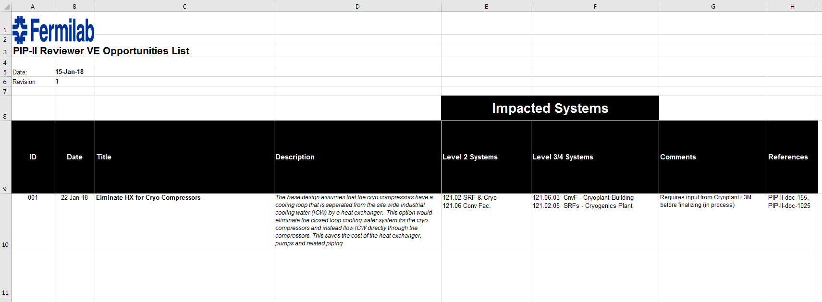

Figure 2: Example VE opportunity identified in the PIP-II VE Opportunities List for Reviewers

All columns of information are completed to the extent information is known at the time the opportunity is identified. The ‘Description’ and ‘Comments’ fields must be completed with enough detail to establish a basis to evaluate the opportunity.

When VE opportunities are identified, they are given to the affected L2M who records them in the PIP-II VE Opportunity Tracking Sheet located on PIP-II DocDB. These opportunities are added to the bottom of the running VE opportunity list. Each new entry will receive a unique ID.

Once VE opportunities are logged, the L2M is responsible for evaluating each opportunity and recording the results and status in the PIP-II VE Opportunity Tracking Sheet.

Evaluating VE Opportunities

Preliminary Assessment
The L2M and affected L3/CAMs complete the preliminary assessment of the proposed VE opportunity after it is logged in the PIP-II VE Opportunity Tracking Sheet. The preliminary assessment may be completed via discussion, analysis, or other means of examination as appropriate. The results of the assessment are documented by appending the fields in the VE opportunity with enough information to justify the conclusion. The goal of the preliminary assessment is to identify VE opportunities that should proceed to the Evaluation Phase which includes a formal cost and impact analysis.

During the preliminary assessment, a VE opportunity is discussed, documented, and characterized by the following classifications:

- Reject: (fails functional requirements, increases total lifecycle costs, lowers performance to level uncompensated by possible cost reduction, negatively impacts other systems, increases risks to an unacceptable level)
- Consider: (may achieve functional requirements, may improve performance, may lower total lifecycle costs, may not negatively impact other systems, does not increase risks to an unacceptable level)
- Proceed to Evaluation Phase: (achieves functional requirements, improves performance, may lower total lifecycle costs, not likely to negatively impact other systems, does not increase risks to an unacceptable level)
- Additional Information Needed: (assessment incomplete until additional information obtained and considered)

Rejected opportunities are documented with statements and information justifying the rejection. Considered opportunities may proceed to the Evaluation Phase at the discretion of the L2M. When additional information is needed, the L2M identifies and obtains what is required to complete the preliminary assessment.

Evaluation Phase

The L2M proceeds to evaluate compelling VE opportunities by performing a formal cost and impact analysis. For some VE opportunities, the cost and impact are contained solely within the L2 System boundaries. For others, VE opportunities may cross L2 System boundaries and affect the cost or impact other systems.

The cost analysis must include the total lifecycle cost of the proposed change for the primary system in question as well as all other impacted systems. A cost reduction in one system may be offset by a cost increase in another affected system. Care must be taken to identify and understand the total lifecycle costs of the opportunity.

The impact analysis must include an examination of possible changes to cross-cutting interfaces, functional requirements, and performance risks.

Both the cost and impact analyses must be documented sufficiently to justify either rejection, direct implementation, or presentation to the DCB or CCB as required.

A positive outcome of the Evaluation Phase is either directly included in the L2 system project plans or prepared for approval via the Design Change Board (DCB) or Change Control Board (CCB) according to process defined in the PIP-II Configuration Management Plan (CMP) [6].

Opportunity Implementation

VE opportunities that clear the evaluation phase with a positive outcome and are contained within L2 System boundaries may be implemented directly into the L2 System plans. Implemented opportunities must be logged and status updated in the PIP-II VE Opportunity Tracking Sheet.

VE opportunities that cross L2 System boundaries or potentially negatively impact functional requirements require a formal change control process as defined in the CMP. VE opportunities with these characteristics must also be logged and tracked in the PIP-II VE Opportunity Tracking Sheet.

For exceptional cases, VE opportunities can be included in the overall Project plan at the discretion of the PIP-II Project Director.

Records
PIP-II VE Opportunities List for Reviewers
PIP-II VE Opportunity Tracking Sheet

Record Retention Schedule
As of ADM 17 Section 30-C, the records associated with this process shall be stored throughout the life of the related systems/subsystems, assemblies, and components.

