FESHM 5031.1 PIPING ENGINEERING NOTE FORM

Prepared by: Joseph Hurd Preparation Date:

Piping System Title: Half-Beta 650MHz Adapter Cryogenic Transfer Line

Lab Location: CMTF Lab Location code:

Purpose of system / system description: Adapt the PIPII-IT transfer line to the HB650MHz cryomodule.

Piping System ID Number (obtain from Teamcenter):

Appropriate governing piping code: B31.3

Fluid Service Category (if B31.3):
Category-D / Normal / Category-M / High Pressure/High Purity (circle one)

Fluid Contents: Helium

Design Pressure: 275 psig Design Temperature: 5K & 40K

Piping Materials: 304 Stainless Steel

Drawing Numbers (PID’s, weldments, etc.):F10042546

Designer/Manufacturer: Fermilab

Leak Test Type: Hydrostatic, Pneumatic (circle one)

Reduced Test Pressure Qualification: In-Service, Low Stress, Not Applicable (circle one)

Test Pressure: Test Fluid: Test Date:

Statement of Compliance

Is this piping system considered exceptional? Yes ____ No____
If “Yes”, follow the requirements for an Extended Engineering Note for Exceptional Piping Systems.

Reviewed by:
(Print Name and lab ID #)
Signature: Date: _____________
(If Teamcenter electronic Workflow approval is used instead of a physical signature note this in the signature blank)

D/S/P Head or Designee:
(Print Name and lab ID #)
Signature: Date: _____________
(If Teamcenter electronic Workflow approval is used instead of a physical signature note this in the signature blank)

The following approvals are required for exceptional piping systems:

Chief Safety Officer or Designee:
(Print Name and lab ID #)
Signature: Date: _____________
(If Teamcenter electronic Workflow approval is used instead of a physical signature note this in the signature blank)

Director or Designee:
(Print Name and lab ID #)
Signature: Date: _____________
(If Teamcenter electronic Workflow approval is used instead of a physical signature note this in the signature blank)

Pipe Characteristics

Size: ½”, ¾” & 1” Length: See note Volume:

Relief Valve Information

Type: recloseable Manufacturer: Generate

Set Pressure: 275 psig Relief Capacity: 6 scfm

Relief Design Code: CGA

Is the system designed to meet the identified governing code? Yes / No

System Documentation

Process and instrumentation diagram appended? Yes / No

Process and instrumentation component list appended? Yes / No

Is an operating procedure necessary for safe operation? Yes / No
If ‘yes’, procedure must be appended.

Fabrication Quality Assurance

List vendor(s) for assemblies welded/brazed off site: None

List welder(s) for assemblies welded/brazed in-house:

Are welder qualification records available for in-house welded/brazed assemblies? Yes / No
If yes, append documents or make available to reviewer.

Are all quality verification records required by the identified code available? Yes / No
(e.g. examiner's certification, inspector's certification, test records, etc.)
If yes, append documents or make available to reviewer.

Amendments

A new piping engineering note form must be filled out and the applicable approvals obtained for piping engineering note amendments.
- Introduction

The 650 Cryogenic Transfer Line (650 CTL) is an adapter transfer line used to connect the Proton Improvement Plan II-Injector Test (PIPII-IT) transfer line to the HB650MHz cryomodule. Interfaces on the HB650 cryomodule did not match up well with the PIPII-IT transfer line so this adapter transfer line was made to correct this issue, see Figure 1 below. The three lines that run through the 650 CTL are the 5K return line, 40K supply line, and the 80K return line. Only the 5K supply line and 2K pumping line are connected to the HB650 cryomodule directly.

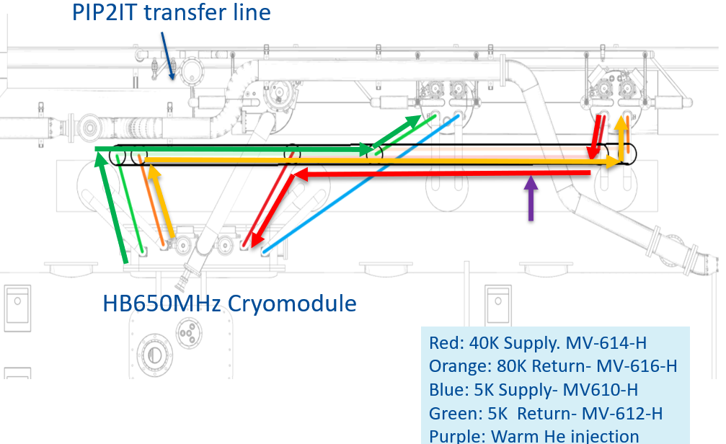

Each line is made of 304 stainless steel, 5K line is ¾” schedule 10 and the 40K & 80K lines are 1” schedule 10. They are connected to female bayonets via double braided flexible hose for thermal relief during the cooldown contraction. U-tubes are used to connect the PIPII-IT transfer line to the 650 CTL and then to the HB650 cryomodule. Ideally when testing starts only the 650CTL to HB650 CM u-tubes will be pulled when swapping out tested cryomodules.
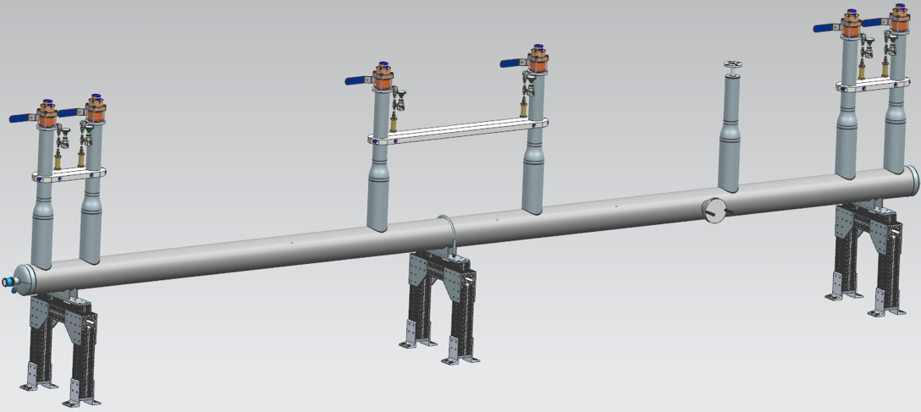

  - Code Compliance
The 650CTL was built to ASME B31.3 code and must also comply with FESHM 5031.1 Piping Engineering standards. This chapter outlines all of the requirements such as design, fabrication and testing of all piping systems used at Fermilab. All of these requirements are addressed in the pressure piping engineering note
.
The overall cryogenic system, which includes the CC1 transfer line, also must conform to the requirements of FESHM 5032 – Cryogenic System Review which is reviewed by the cryogenic safety panel for this area. This panel reviews all of the documents required by FESHM 5032 such as the Valve & Instrument List, FMEA, What-if Analysis, Engineering Notes and other required pieces of documentation for that chapter and ultimately issues a recommendation for cooldown to the Division once satisfied that all the requirements have been met.

- Pipe Stress
  - Straight Pipe

All piping within the 650 CTL has a minimum quality of 304 stainless steel. Using table A-1 from B31.3, it is discovered that the maximum allowable stress for 304 Stainless steel piping is 16.7 ksi. A minimum wall thickness for the various pipe sizes throughout the fill line can be calculated using equation 1 from B31.3 section 304.1.2 Straight pipe under pressure:

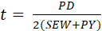 (1)

Where
P: design pressure, 400 psid
D: outside diameter of the pipe
S: allowable stress 16.7 ksi
E: quality factor of the pipe = 1.0
W: weld joint strength reduction factor = 1.0
Y: is a coefficient from table 304.1.1 = 0.4 for austenitic steels

See below in Table 1 the calculations for the Pipe thickness for the 650 CTL.

Table 1: B31.3 Wall thickness calculation

Pipe/Tube | Circuit | D(O.D.) | S_allow | P_design | t_min | t_act | t_act/t_min
Size |  | inch | psi | psid | inch | inch | -
1/2" sch 10 | He | 0.84 | 3340.00 | 289.00 | 0.035 | 0.083 | 2.36
3/4" sch 10 | He | 1.050 | 3340.00 | 290.00 | 0.044 | 0.083 | 1.88
1" sch 10 | He | 1.315 | 3340.00 | 290.00 | 0.055 | 0.109 | 1.98

  - Piping Components
    - Listed

Component | Location
Butt Weld pipe | All three circuits
Butt Weld tee | 40K supply line on WU/CD line
Butt Weld Elbow | All three circuits
But Weld Reducer | 40K supply line on WU/CD line
½” ANSI flange | 40K supply line on WU/CD line

    - Unlisted

Component | Location
¾” Hosemaster Flexhose | 40K Supply and 80K Return
½” Hosemaster Flexhose | 5K Return
DN15 WEKA control valve | Warm He mixing supply
¼” Nupro valves | All circuits
¼” Generant relief valves | All circuits
Fermi style Bayonets | All circuits

The Masterflex® double braided flex hoses that are welded to the bayonets and pipe to allow for thermal flexibility. This portion of pipe is considered safe as Hosemaster certifies the burst pressure for ¾” and 1” hose is 1347 psi & 1077 psi; well above the 275 psig design pressure. See below from the Hose Master website:

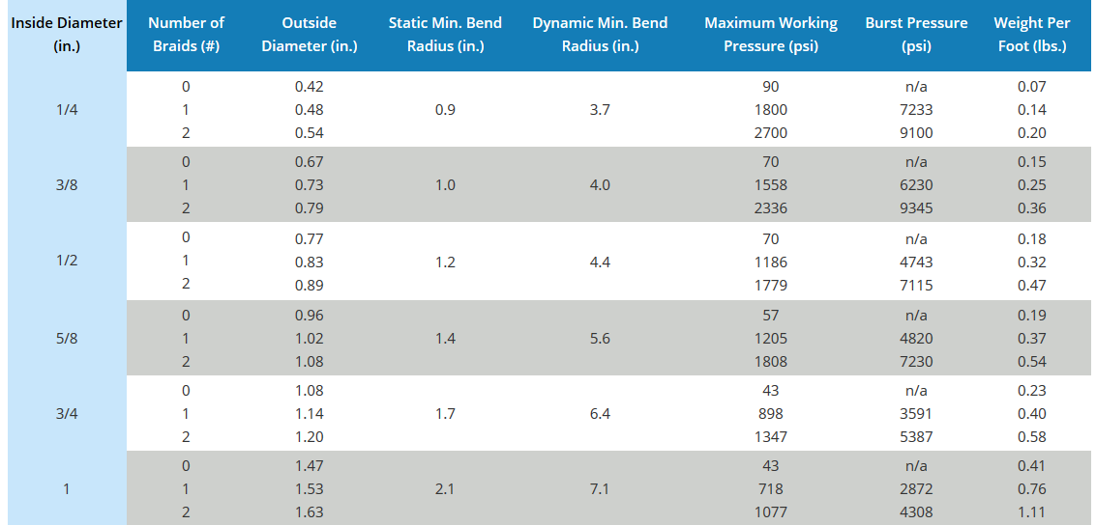
https://www.hosemaster.com/product/masterflex/

  - Thermal Flexibility

The 650 CTL is comprised of three straight runs with anchoring G10 spiders halfway down the length of the pipe. Each pipe also continues through additional spiders and sliders; there are three total spiders acting as anchors for one length of pipe. On the vertical section to each bayonet is a flexible hose that allows for thermal stress relief, each one is 5.5” of live length. Additionally, during fabrication each line was has an added length of preload equal or greater to the calculated contraction. This method is to allow the flexible hose to return to its neutral position after cooldown. See the table below for contractions of each line, required lived length, and factor of safety (FOS). Each line is adequately relieved from thermal stress due to thermal contraction. Note: Contraction in the table is defined as the contraction of half of each line due to the anchoring halfway down the length.

The necessary Live Length is calculated by using the equation in the Figure below

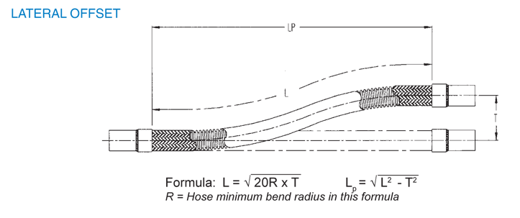
Where,

L= Live length
R= Minimum static bending radius
T= contraction distance.
It should be noted that in place of T in the eqation is (T- P) where P is equal to the preload distance. This accounts for the distance the flecible hose does not have to make up for contraction.

Line | Length | Contraction | Static Min bend radius Radius | Required Live length with preload | Current live length | FOS with preload
 | in | in |  | in | in
5K return | 57.13 | 0.17 | 1.70 | 1.26 | 5.50 | 4.38
80K return | 93.50 | 0.28 | 2.10 | 2.56 | 5.50 | 2.15
40K Supply | 54.50 | 0.16 | 2.10 | 1.27 | 5.50 | 4.33
Wu/CD | 27.25 | 0.04 | 1.20 | --- | 4.00 | 4.04

  - Pressure Relief

Each bayonet is equipped with a ¼” Generat pressure relief valve set at 275 psig, two relief valves per line. The relief calculations are done per the Compressed Gas Association S-1.3-2008 Section 6.2.2 standard. Below in the table the

Line | length | OD | t | A' | Qa | Safety Factor
 | in | in | in | ft2 | ft3/min_Air
5K R | 114.25 | 1.05 | 0.083 | 14.55367 | 6.128552039 | 11.27413627
80 K S | 187.00 | 1.315 | 0.109 | 15.92749 | 6.707067471 | 10.30169014
80K R | 109.00 | 1.315 | 0.109 | 14.80863 | 6.23591335 | 11.08003382

- Fabrication
  - Welding Documentation

According to FESHM 5031, all pressure piping systems at Fermilab fall under the scope of the ASME/ANSI B31 Code series unless specifically excluded. The code series stipulates that pressure piping systems be inspected and tested according to the specific requirements of the Code. For ASME/ANSI B31.3 Process Piping, which is the relevant code series for this piping system, the required testing is outlined in Chapter VI, Section 341. These requirements pertain to piping systems in Normal Fluid service which applies to piping systems at pressures above 150 psi or piping systems below 150 psi with design temperatures lower than -20ºF, which is the case here. Normally radiographic examination of at least 5% of the welds is required but in certain cases the use of radiographic examination is difficult or all together impossible. This is the case here where assembly techniques prevent access to specific welds for radiography. The B31.3 piping code allows the use of in-process examination in lieu of radiography on a weld-for-weld basis for these cases. In-process inspection forms were created in consultation with the Fermilab weld shop which documents items such as joint preparation and cleanliness, welding machine type, joint fit-up and alignment, filler material, purge gas (purity, flow, oxygen concentration), inspection of root pass and inspection of final pass.

The completed In-process inspection forms are attached as a dataset to this note. 5% of all welds were examined by Greg Johnson.

  - Pressure test
FESHM 5034 and the B31.3 Code require that all new pressure piping systems be subject to a pressure test to assure that they can be operated safely. The pressure test shall be performed at 110% of design pressure for pneumatic tests.

