PIP-II – PM – Cable Plant Pull and Documentation Plan

Authors: Ryan Crawford

Document Number: Doc-DB # 2892

Document Approval |  | Date Approved/Reviewed
Approver | Technical Director (?)
Approver | Cable Coordinator
Approver | PIP-II QA Manager
Approver | Linac Installation L2M
Approver | Linac Complex Installation L3M
Approver | Building Infrastructure L3M
Reviewer | BTL Installation L3M
Reviewer | HPRF L3M
Reviewer | LLRF L3M
Reviewer | Magnets/PS L3M
Reviewer | Vacuum L3M
Reviewer | Controls L3M
Reviewer | Instrumentation L3M

Revision History
Authors | Revision Date | Description of Change
Ryan Crawford | 6/12/2020 | New Procedure

1. Purpose 4
2. Scope 4
3. Acronyms 4
4. Management Hierarchies 5
5. Roles and Responsibilities 6
6. Deadlines 12
7. Cable & Connector Design 13
8. Budgeting for Cables and Connectors 13
9. Cable Documentation and Validation using the Cable DB and Quality Control 13
10. Summary 15
11. Reference Documents 17

Purpose
The PIP-II Cable Pull and Document Plan shall be used to define roles and responsibilities related to the design, documentation, installation, and validation of the PIP-II cable plant. This document will define a process for specifying, documenting, installing, validating and labeling control, signal, and electrical connections. Budgeting will also be addressed to provide guidance on standard and specialty cable. This plan will be used throughout the project lifecycle to maintain consistent and accurate deliverables.

Scope
This document covers all signal, control, and electrical connections between components for PIP-II excluding electrical utilities and Cryoplant Building cable and connectors.

Acronyms
Acronym | Meaning
AD | Fermilab’s Accelerator Division
ICD | Interface Control Document
ISD | Interface Specification Document
L2M | WBS Level 2 Manager
L3M | WBS Level 3 Manager
PIP-II | Proton Improvement Plan II Project
TM/CC | Task Manager/ Construction Coordinator
WBS | Work Breakdown Structure

Management Hierarchies
Two management hierarchies are presented below for the three major tasks related to the cable plant. Figure 1 presents the cable database design and entry phase. During the design phase the Installation L2M, the cable coordinator, and a database expert will modify a cable tracking database that has been used at the lab for decades. The technical integration group will provide feedback to the installation L2M and cable coordinator to ensure a useful system across the project. L3Ms and their designees will be used as beta testers to provide feedback and suggestions. The Cable DB itself is the deliverable for the cable database design phase. During the entry phase L3Ms and their designees will populate the Cable DB with entries. The L2Ms, the Cable Coordinator, and the Technical Integration Group will monitor the DB at this time to track entries. In the Cable DB entry phase, the deliverable is the Cable DB entries themselves. Lastly, Figure 2 shows the installation and validation phase. Each individual system will have a single point contact as described later during this phase. The deliverable for the installation and validation phase will be cables that are pulled and terminated according to the Cable DB. The installation L2M and L3M will oversee all activities during this phase. The TM/CC and contract electricians are responsible for pulling all cable according to the cable DB. The system L3Ms and engineers will validate that the cable was installed according to the database entry. The cable coordinator will work with all parties to verify that the cable is pulled accurately and provide updates to the TI group.

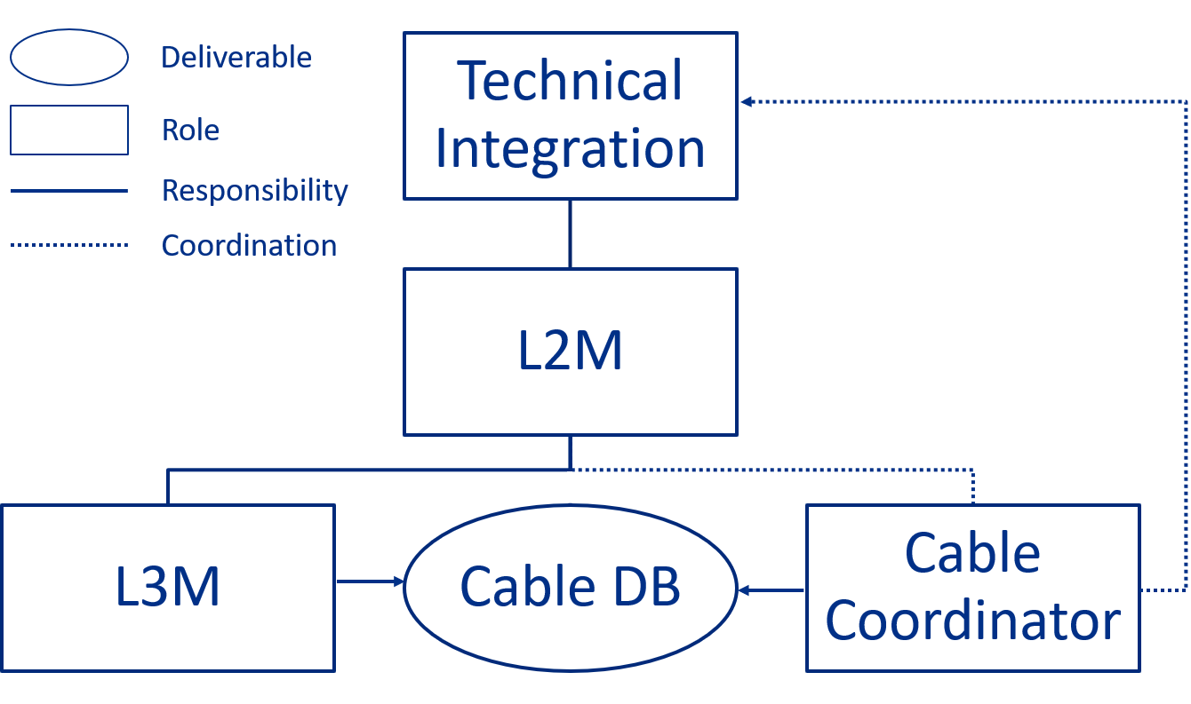

Figure 1. Cable DB Design and Entry Phase
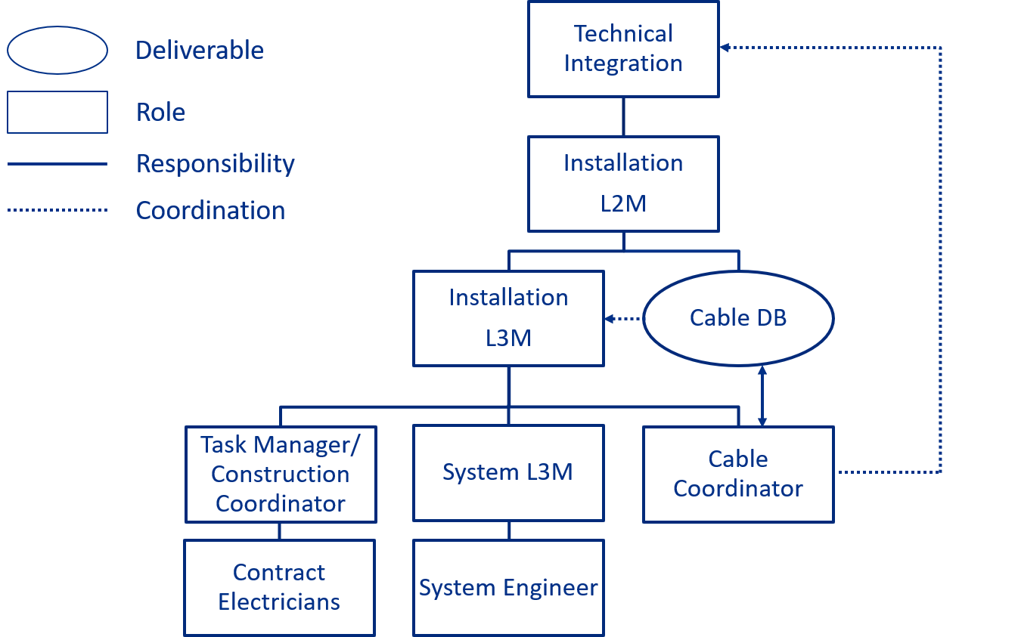

Figure 2. Installation and Validation Phase

Roles and Responsibilities

Roles

Technical Integration Group:
A project level group that oversees the cable database and cable pulls during the database entry, installation and validation phase of the cable plan.

L2Ms:
An individual responsible for managing a specific Level 2 scope of the PIP-II WBS. These individuals are knowledgeable of all the level 3 systems they manage. L2Ms are the design authorities responsible for the delivery of their respective systems.

L3Ms:
A subject matter expert for their respective level 3 system. They are responsible for managing a specific sub-system within PIP-II. The L3M will report to a L2M.

Sub-System Engineer:
A subject matter expert that is responsible for specifying cables and connectors for a level 3 sub-system. The sub-system engineer will report to a L3M.

In-house Electrical Technicians:
An individual responsible for terminating and labeling cables that are not terminated by the contract electricians. Technicians will report to a sub-system engineer or L3M.

Task Manager/ Construction Coordinator (TM/CC):
An individual knowledgeable in the cable and tray installation activities associated with PIP-II. This individual will manage tasks under the supervision of an installation L3M. The TM/CC is the single point contact for the contract electricians.

Contract Electricians:
Union electricians that are contracted through a fixed price agreement to pull, terminate (magnet and network only), and label cables for PIP-II.

Cable Coordinator:
An individual knowledgeable in the cable and tray installation activities associated with PIP-II. This individual will manage tasks under the supervision of an installation L3M. If the cable coordinator is unable to fulfill their role, the installation L3M will manage their responsibilities.

Cable DB Design Phase

Cable DB Entry Phase

  - Cable Installation and Validation Phase

Deadlines
Deadlines will be imposed to limit possible issues during the installation phase. Knowing what types of cables will be pulled, will allow the project to more accurately gauge penetration and cable tray fill. Updated cable counts and types are required by the 60% CF deadline so the fills can be recalculated to make sure a fill issue does not exist. Individual systems are able to modify cable/connector types and counts prior to the 90% CF drawings, but cannot be modified after this date since the conventional facility infrastructure will be locked in place at that time. Any cables that are not accounted for by the 90% drawing phase will be treated as specialty cable and the L3M WBS will be responsible for that material cost. Margin will be handled by CF and the Cable Coordinator, but L3Ms should not assume that the project can manage all their cable needs if they are not accounted for prior to the 90% CF drawing package. The table below lays out what the project requires, when it is required, who is responsible for providing it, and who they deliver it to.
Deliverable | Due Date | Party Responsible | Deliver To
Updated Cable Types as listed in Ref. 1 | Prior to 60% CF | L3Ms/ Cable Coordinator | Cable Coordinator
Updated Cable Counts | Prior to 60% CF | L3Ms | Cable Coordinator
Updated Connector Types as listed in Ref. 1 | Prior to 60% CF | L3Ms/ Cable Coordinator | Cable Coordinator
Updated Specialty Cable Information | Prior to 60% CF | L3Ms | Cable Coordinator
Final Cable Types as listed in Ref. 1 | Prior to 90% CF | L3Ms/ Cable Coordinator | Cable Coordinator
Final Cable Counts | Prior to 90% CF | L3Ms | Cable Coordinator
Final Connector Types as listed in Ref. 1 | Prior to 90% CF | L3Ms/ Cable Coordinator | Cable Coordinator
Final Specialty Cable information | Prior to 90% CF | L3Ms | Cable Coordinator
Enter Cable DB information | 6 months prior to lockout | L3Ms/ Cable Coordinator | N/A
Validate Cable Pulls | Maximum of 2 weeks after Contract Electricians marked as pulled | L3Ms | Installation L3M, TM/CC, Cable Coordinator only if issue occurs

Cable & Connector Design
As stated in the Responsibilities section above, sub-system L3 managers and sub-system L3 engineers are responsible for specifying cables and connectors within their L3 system. ISDs will be used to define required connectors between L3 level systems. The Master ICD will be used to capture the responsible parties for the connector design between L3 level systems. All specialty cable and connectors must abide by the PIP-II Cable Criteria Document (Ref. 4).

Budgeting for Cables and Connectors
PIP-II will procure cable and connectors via the most economical means possible, thus the Building Infrastructure L3M will procure all common/standard cable types and connectors in bulk instead of individual L3M’s ordering their own. Common cable types and connectors are captured in Reference 1. Intra-rack cable pulls will not be the responsibility of the Building Infrastructure L3 regardless of type, as such, this must be budgeted for by the individual L3M. The Installation L3M shall budget for all cable pulls except those for safety systems and network. L3Ms must communicate with the associated L2M and other L3Ms to manage multiple system or sub-system interfaces. The master ICD shall be consulted when multiple systems or sub-systems are involved.

Cable Documentation and Validation using the Cable DB and
Quality Control
The Building Infrastructure L3 manager or sub-system L3 managers must provide the maximum pulling tension, minimum bending radius, and special considerations or requirements to the Cable Coordinator prior to any cable pulls. The Cable Coordinator will store this information on the PIP-II electrical SharePoint. The PIP-II cable database will be used as the primary management system for PIP-II cables. It is vital that this information be entered accurately and in a timely fashion so that cable pulls are not delayed. The cable coordinator will ensure that spool identifiers are added to the cable DB once the required information is provided by the responsible L3Ms. The naming convention presented in Reference 2 shall be followed. The following must be entered in the AD cable database by the L3M or their approved alternate:
  - Cable Type
  - Cable Length
  - Origin Connector
  - Destination Connector
  - Origin Location
  - Destination Location
  - Function with a description (e.g. Function: BLMUEHVSP, Description: BLM HV Cable Spare)
  - Penetration #
Cable will undergo multiple validations prior to and after installation. The Building Infrastructure QA/QC document (Ref. 6) shall be used for all validation steps. Travelers will be used to track all QC validation prior to installation, and the Cable DB shall be used for all tracking after the cables are pulled. The following validations are required prior to release of material to the Contract Electricians:
- All cable will be checked for damage via a visual inspection
- Part numbers and lengths will be verified against the Cable DB and Purchase Order
- All cable will be checked for continuity and length requirements using a cable length meter
- The Installation L2M/Installation L3M will release the material for installation
  - Any issues tracked in the traveler system must be resolved prior to the installation phase

After the cable is pulled the following checks shall be performed:
- Electricians will verify that the correct cable type was pulled from the correct origin to the correct destination
  - At this point they will update the Cable DB to show that the cable was pulled
- The L3M or their approved designee will then perform the same check the Contract Electricians performed above
  - Any issues should immediately be reported to the TM/CC, Installation L3M, and Cable Coordinator who will document and attempt to rectify the issue
  - If no issues are present, mark as such on the Cable DB
- The cable shall be validated again once it is terminated.
  - For control cables: prove that fake or real signal can be read from the sensor or device back to the control device
  - For magnet cables: the cable shall have a small potential to ground applied at one end of the cable that shall be read at the other end of the cable
  - For network cables: A network cable analyzer shall be used to verify bandwidth requirements
  - Any issues should immediately be reported to the TM/CC, Installation L3M, and Cable Coordinator
  - If no issues present, record this response in the Cable DB

Summary
The PIP-II cable plant will undergo multiple management stages. Each stage will involve multiple parties entering and validating information. This plan should be used as a framework throughout the lifecycle of the PIP-II project for cables and connectors. This document may not answer every question that arises throughout this project; however, the Cable Coordinator, Technical Integration Group, TM/CC, and the Installation L2M and L3M are available to answer any questions that may arise. Please see the flowcharts presented below for a simplified presentation of the information contained within this document.

All Cable will undergo a multi-stage approval process via the cable database. The process shown below shall be followed at all times for cable procurement and cable DB entries:

Figure 4. Cable DB and Approval Process

The following QC process will be followed when the cable arrives on-site:

Figure 5. QC process at Cable Delivery

Lastly, the following describes the installation process:
Figure 6. Cable Installation Process

Reference Documents

1 | PIP-II Standard Cable and Connector List | PIP-II-doc-2824
2 | PIP-II Naming Convention | TCXXXXXXX
3 | PIP-II Cable Database | https://www-bd.fnal.gov/cable/pip2.html
4 | PIP-II Cable Criteria | PIP-II-doc-3054
5 | PIP-II Building Infrastructure QC Document | PIP-II-doc-XXXX
6 | Linac Inst. & Comm. QA & QC Planning | PIP-II-doc-2611

