PIP-II-LIN-Rack and Cable Tray

Author: Ryan Crawford

Document Number:PIP-II-DocDB-4924

Document Approval |  | Date Approved
Originator | Ryan Crawford | xxxx
Approver | Jonathan Hunt
Approver | Steve Dixon

Revision History
Author | Revision Date | Description of Change
Ryan Crawford | 8/10/2020 | Original

Contents
Purpose 3
Cable Tray System 3
Cable Tray/Penetration Fill Calculations 7
Cable Length Estimations 9
Rack Power 10
Rack Location and Allocation 10
Racks 12

Purpose
This document provides an overview of the cable routing and rack systems that will be used by the PIP-II project

Cable Tray System
The cable tray system has been designed to allow for flexibility while minimizing excess tray and cost. Tray has been sized based on expected cable counts and standard cable types. In almost all cases 20% overhead is maintained for fill calculations (there are a few instances where this is not possible). Tray in the gallery is split into three different categories: power, general signal, and clean signal. The tunnel presents space constraints and must be reduced to two levels. Tray dividers are being considered to allow for separation if needed. Please see the figures below provided by the Conventional Facilities A/E consultant, IMEG.

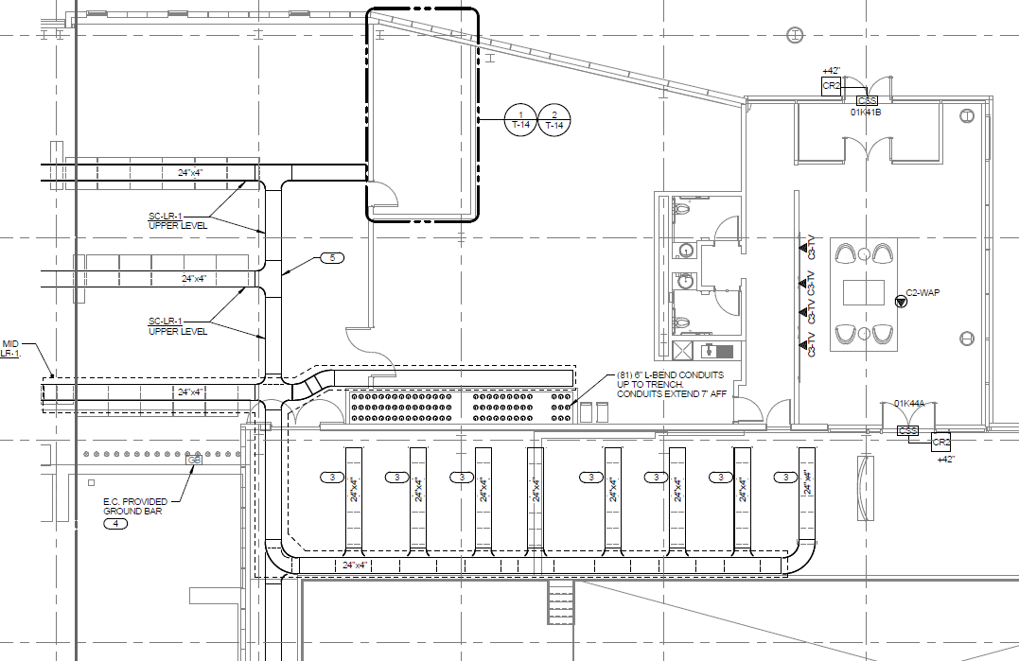
Figure 1. SSR1 and HBB

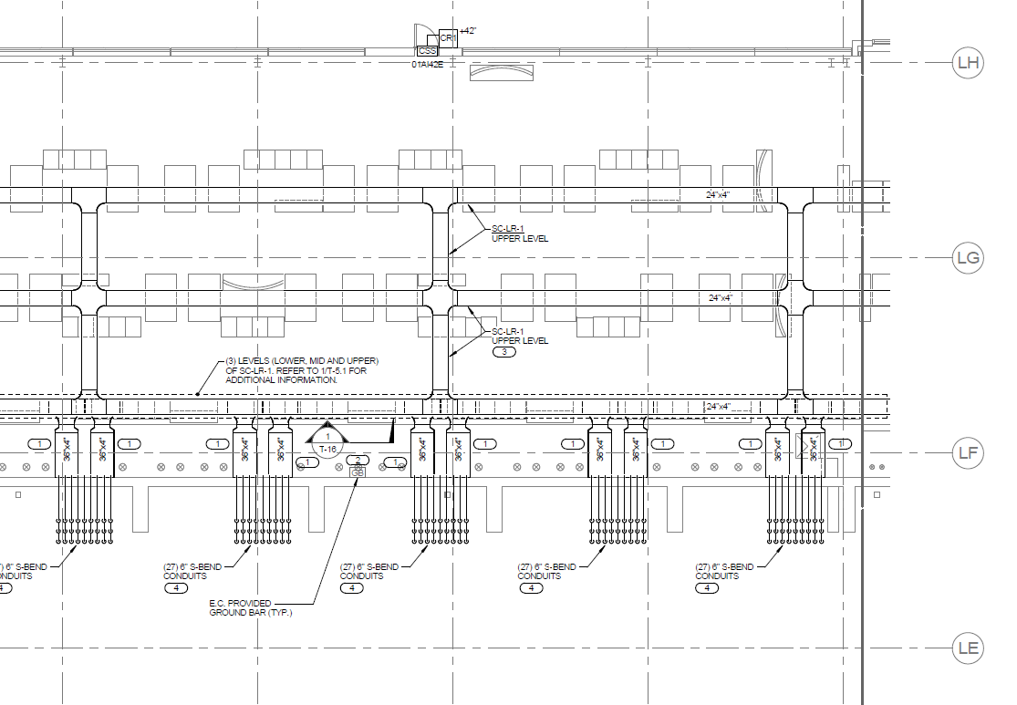
Figure 2. SSR2 Tray System

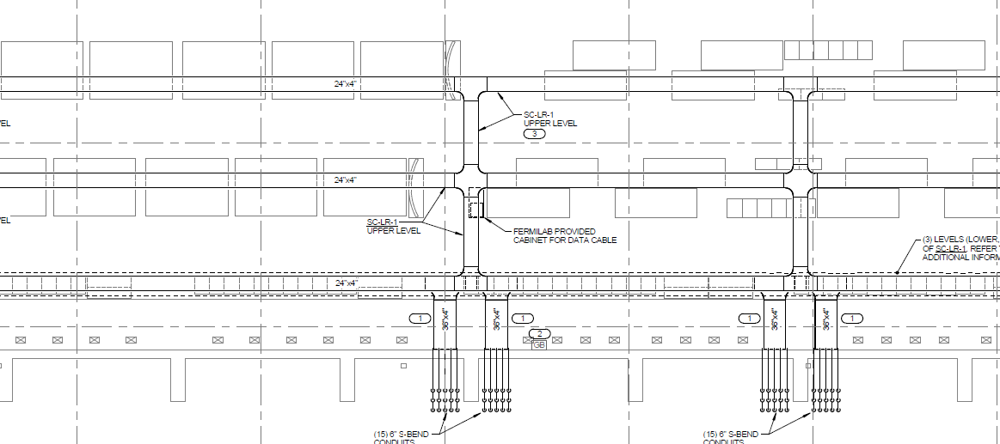
Figure 3. LB and HB
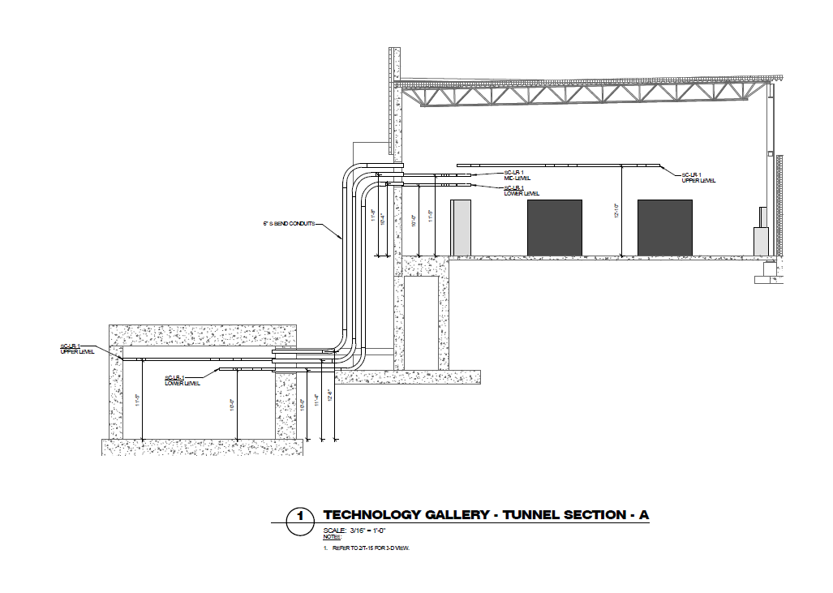
Figure 4. Gallery and Tunnel Section View

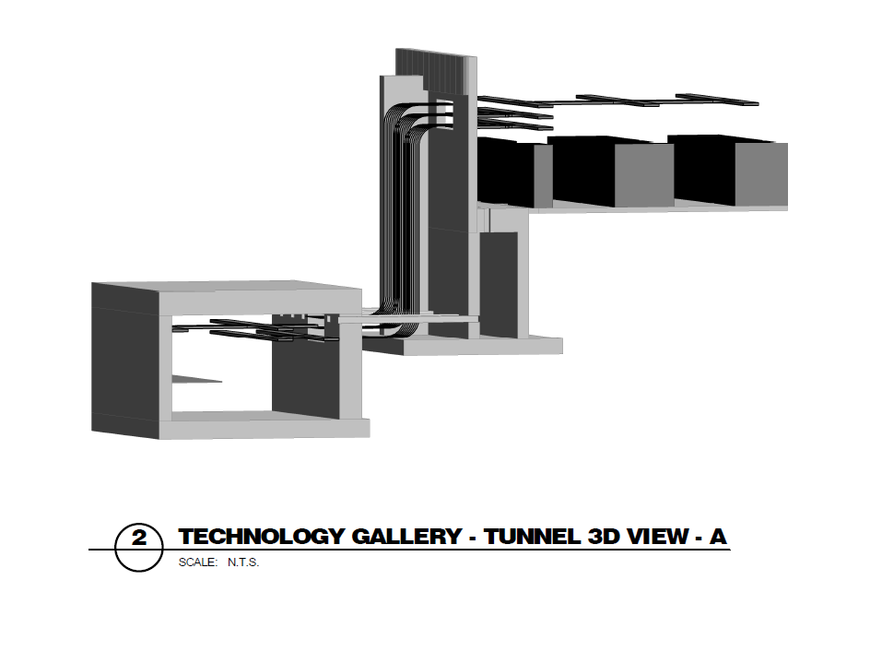
Figure 5. Tunnel and Gallery 3D View

Cable Tray/Penetration Fill Calculations
A spreadsheet was developed to track expected cable tray and penetration fills based on scaled cable counts. Currently the calculator assumes all cable originates in the gallery and enters the tunnel. This will be refined as system needs are continually addressed. An example spreadsheet is embedded in Document 1 below (double click to access document).

Document 1. Cable Tray and Penetration Fill Spreadsheet

Cable Length Estimations

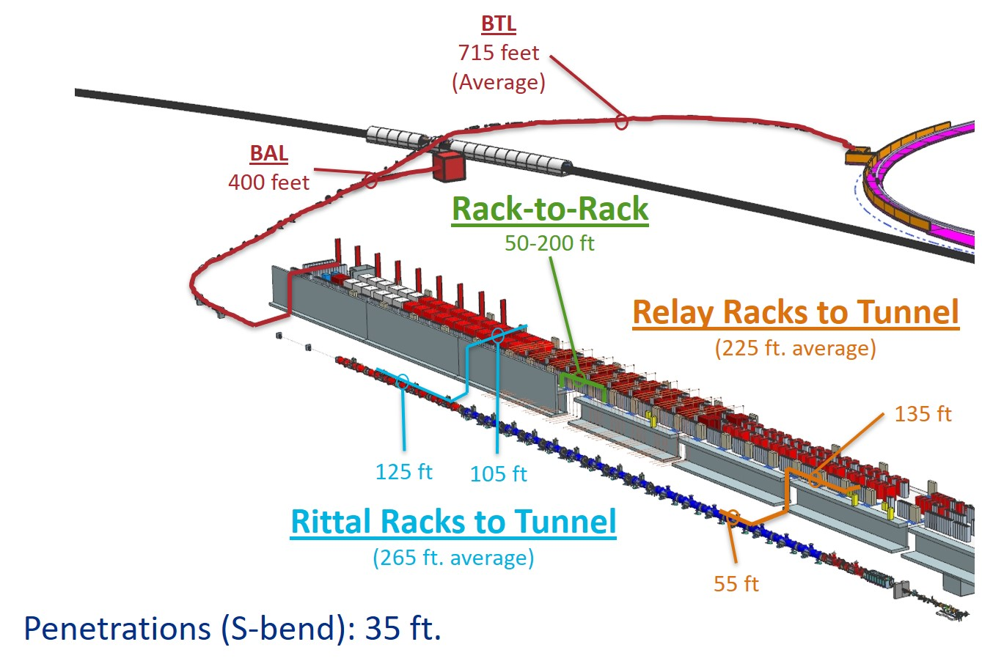

Figure 6. Cable Length Estimations

Rack Power
Racks will be powered via busway or wireway for 208Y/120V service and traditional conduit or liquid-tight for 480Y/277V service (HPRF enclosures use 480Y/277V busway). Each rack is individually overcurrent protected. LOTO will be achieved via plug and cord installation or breaker locks (480Y/277V). Filtered, customizable PDUs are being pursued within the rack to allow for standard plug configuration (minimize spares and one-off installations).

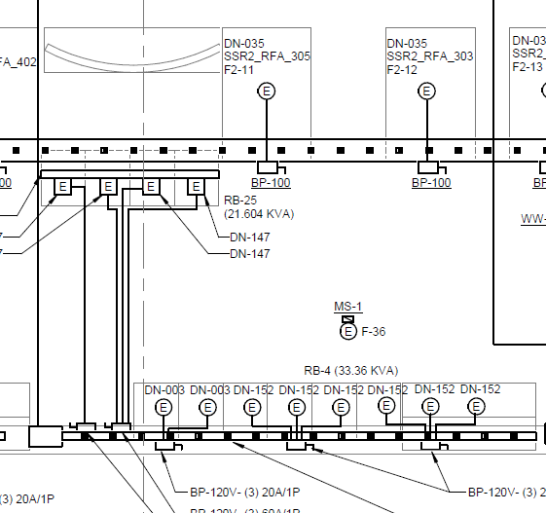

Figure 7. 208Y/120V busway and wireway

Rack Location and Allocation
Racks have been located throughout the gallery based on input from system owners and the LINAC installation team which has been assisting with the 3D modeling of the space. Two PDFs (double click to access file) are attached below in Documents 2 and 3 that list rack location, and a first pass at allocating racks to specific systems/devices.

Document 2. Rack Layout
Document 3. Rack Bank Allocation

Racks

Building infrastructure is working with a small working group of the main rack users including Low Level RF, Power Supplies, Instrumentation, and Controls to develop rack specifications. This group is considering the purchase of a prototype rack for on-site testing (comment and compliance review), prior to formalizing a final specification. The preliminary specification is embedded below in Document 4 (double click to access full document). A spreadsheet was developed to track rack needs (shelves, power, etc.) and is attached below in Document 5 (double click to access document).
Document 4. Preliminary Rack Specification

Document 5. Rack Layout Spreadsheet

