PIP-II Booster Dampers

Physics Requirement Document (PRD)

Document number: ED0010236-A

Document Approval

|  |  |
| --- | --- |
| Signatures Required | Date Approved |
| Originator: Ioanis Kourbanis, L2 Manager, Accelerator Upgrades | - |
| Concurrence: Dave Johnson, Booster L3 Manager | - |
| Concurrence: Alex Martinez, Integration Coordinator | - |
| Approver: Eduard Pozdeyev, Project Scientist | Signed in Teamcenter |

Revision History

|  |  |  |
| --- | --- | --- |
| Revision | Date of Release | Description of Change |
| - | 10/7/2109 | Initial Release |
| A | 03/13/2021 | Revise longitudinal Damper requirements description for clarity and add figure for 65 MHz cavity |

Page left intentionally blank for revision history.

Table of Contents

1. Purpose 4

2. Scope 4

3. Acronyms 4

4. Requirements 4

4.1. Physics requirements for the Booster Longitudinal Dampers 4

4.2. Physics requirements for the Booster Transverse Dampers 5

5. Reference Documents 6

# Purpose

Physics Requirement Documents (PRDs) contain the summary parameters and configuration definitions for systems, sub-systems, and devices that impact higher-level requirements established in the PIP-II Global Requirements Document (GRD) [1]. PRDs establish a traceable link to lower-level requirements (FRSs, TRSs) that affect the PIP-II beam or machine performance. In the aggregate, the PRDs for the PIP-II Project contain the essential parameters and configuration developed through the preliminary design phase to enable completion of the PIP-II accelerator and complex design.

# Scope

This document describes the high-level parameters for the Booster Dampers.

# Acronyms

|  |  |
| --- | --- |
| FRS | Functional Requirements Specification |
| GRD | Global Requirements Document |
| L2 | WBS Level 2 System |
| L3 | WBS Level 3 System |
| PIP-II | Proton Improvement Plan II Project |
| PRD | Physics Requirements Document |
| RF | Radio Frequency |
| TRS | Technical Requirements Specification |

# Requirements

This document describes the physics requirements for the Booster dampers:

## Physics requirements for the Booster Longitudinal Dampers

Longitudinal coupled-bunch instabilities in the Booster lead to emittance blow-up that can result in beam loss in the booster as well as slip stacking losses in the Recycler. The longitudinal coupled-bunch instabilities are driven by the Booster cavities higher order modes. There are three RF bands that are capable of for driving coupled bunch modes. Two of which are center around 65 MHz and one centered at 80 MHz. These cavity impedances correspond to modes that cover a frequency band of approximately 6 MHz at 80 MHz and 5 MHz at 65 MHz. Originally those modes were damped by installing a set of passive high-order mode dampers in the cavities [3]. In 1994, an active damping system was built and integrated with the Booster RF high level system. This system did not have adequate power and phase control at 80 MHz, so a dedicated longitudinal kicker cavity (center frequency 82.6 MHz, Q=11) was installed in 2002. In the mean time, modes 1 and 2 are still damped by using the Booster RF cavities. A schematic of the current Booster longitudinal damping is shown in Figure 4‑1.

For PIP-II, the Booster beam intensity is increased by 50%. The passive cavity dampers centered around 65 MHz (mode m=16) may not be able to damp these coupled bunch modes. A dedicated cavity with a center frequency of 62.5 MHz and a loaded Q of 16 will be installed for the active damping of these modes. An available cavity that meets the damper specifications is shown in Figure 4-2. A new damper board and a new RF amplifier will be needed.

Note: the impedance that causes the coupled bunch modes centered around 65 MHz has the same magnitude as the impedance that causes the coupled bunch modes centered around 80 MHz. Thus, a 3.5 kW amplifier which is used to drive the 80 MHz damper cavity will provide enough voltage for damping.

For the mode 2 instability, there are two options: (a) a dedicated cavity will be built with new electronics and a new amplifier (b) Phase modulating the present accelerating RF cavities with new electronics.



Figure ‑. Schematic of the current Booster longitudinal damping system

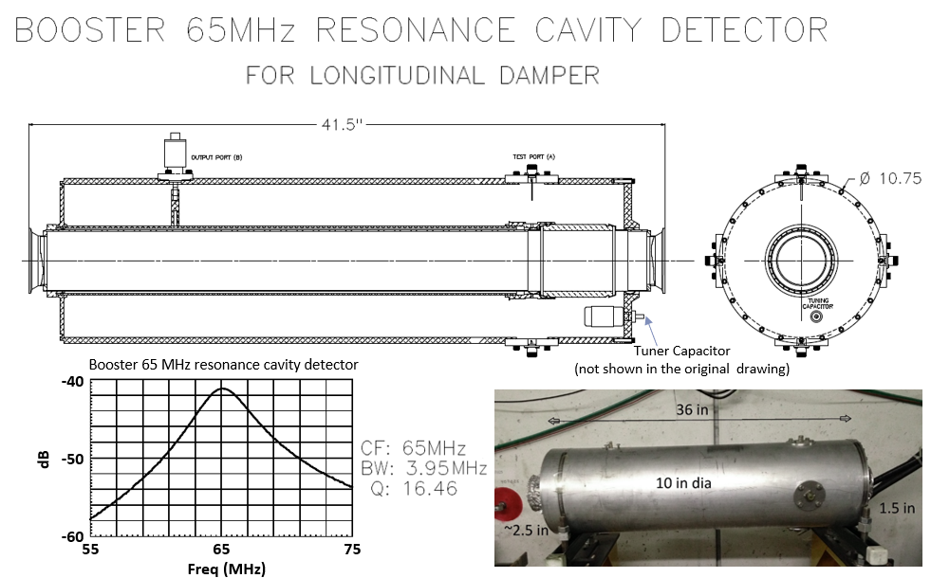

Figure 4‑2. Booster 65 MHz resonance cavity

## Physics requirements for the Booster Transverse Dampers

Currently, Booster is equipped with a bunch by bunch digital transverse damper system able to damp transverse dipole oscillations. An overview of the current Booster damper system is shown in Figure 4‑3. The current damper system is not effective in damping the Booster transverse instabilities early in the cycle [5],[6]. The Booster is currently operated with large chromaticity to stabilize the transverse head tail modes. The large chromaticity increases the tune spread and creates losses. In order to be able to damp the instabilities in the early Booster cycle and to reduce the chromaticity, we plan to upgrade the current damper system with new higher bandwidth (400 MHz) stripline kickers, a new broad band amplifier (2 kW) and a new damper board.



Figure ‑. Schematic of the current Booster transverse damper system

# Reference Documents

|  |  |  |
| --- | --- | --- |
| **#** | **Reference** | **Document #** |
| 1 | PIP-II Global Requirements Document (GRD) | ED0001222 |
| 2 | PIP-II Preliminary Design Report (PDR) | PIP-II DocDB# 2261 |
| 3 | “HOM RF Cavity Dampers for Suppressing Coupled Bunch Instabilities in the Fermilab Booster” PAC 1993. | - |
| 4 | “Booster’s Coupled Bunch Damper Upgrade” PAC 2003. | - |
| 5 | “Observation of Instabilities of Coherent Transverse Oscillations in the Fermilab Booster” FERMILAB-CONF-12-219-AD-APC | - |
| 6 | “Transverse Impedance and Transverse Instabilities in the Fermilab Booster” FERMILAB-CONF-13-431-CD | - |