ACLK & LCLK Clock Fanout Units

Some general notes on the Fiber and Local Fanout units planned for use distributing ACLK and LCLK around the Fermilab accelerator complex on new single-mode fiber links.

LCLK & ACLK
- 650 MHz base transmission frequency
- 48 bit data + start bit + parity bit
- Modified Manchester encoding
- Transmitted on single mode fiber
- LC type fiber connections
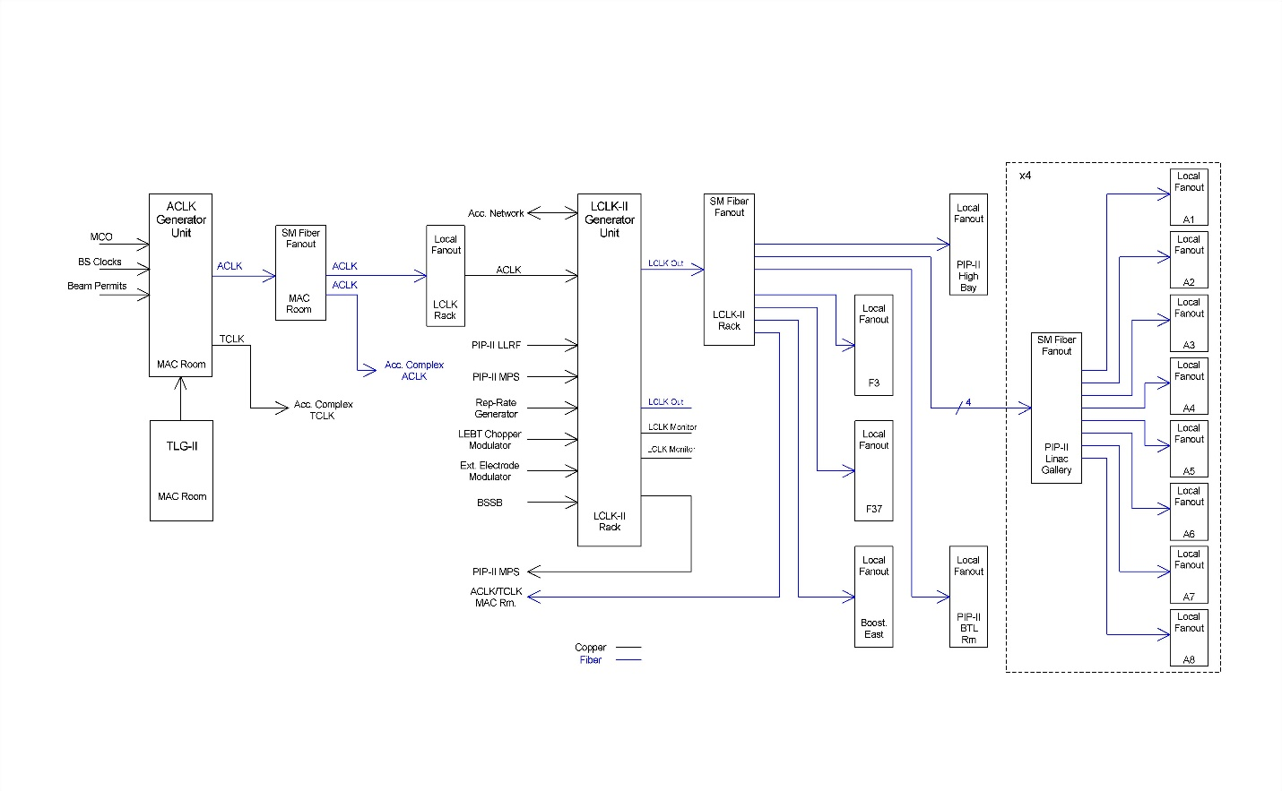
Fiber Fanout Unit
  - Single mode fiber receiver/transmitter chassis providing fanout of fiber clock signals for distribution around PIP-II and accelerator complex.

Local Fanout Unit
  - Clock fanout unit with single mode fiber receiver and copper output channels for distributing clock signals locally to decoder hardware.

The PIP-II Timing System design requirements:

- Highly reliable, fail-safe operation
- Compatible with the staged PIP-II commissioning
- Capable of logging and time stamping all changes of its state
- Restricted, documented privileges to access and modify configurations
- Expandable to support modifications and future upgrades such as new operational scenarios without major modifications
- Standard encoding scheme (Modified Manchester)
- Base transmission frequency of 650 MHz (allows phase locking to both 162.5 MHz & 10 MHz references)
- The system shall have console-based application interfaces
- The system shall have a device database
- The system shall have a console-based diagnostic application

General Fanout Unit Requirements
- System hardware shall be 19” rack mountable or be capable of installation in 19” rack mountable commercial crates (VME, ATCA, uTCA, etc.)
- System hardware units shall utilize 120VAC 60 Hz equipment rack power
- System hardware shall be installed in temperature & humidity controlled electronics spaces
- System hardware shall support firmware updating
- System hardware shall utilize Gigabit Ethernet (1000BaseT) networking or better

Fiber Fanout Unit Requirements
- Fiber Fanout Unit shall support a rear panel, single mode fiber input transceiver with LC connector
- Fiber Fanout Unit shall support a minimum of 8 rear panel, single mode fiber output transceivers with LC connectors
- Fiber Fanout Unit shall support a front panel LEMO, TTL into 50 ohms input monitor
- Fiber Fanout Unit shall support a minimum of 10 front panel LEDs
  - Power
  - Input Signal Status
  - Output Signal Status

Fiber Fanout Unit
The PIP-II Fiber Fanout unit design is expected to be a 19” rack mountable 1-U chassis with the clock inputs and outputs on the rear panel and ethernet port, indicator LEDs and an input clock monitor output on the front. Planned to be used for ACLK and LCLK distribution for PIP-II and ACORN. Unit status information to be made available to the system device database via network connection.
- Rear panel power input (120VAC 60Hz) with power switch and fuse
  - Front Panel Power LED (green)
- Rear Panel Clock Input single mode fiber transceiver with LC connectors
  - Input clock signal reflected back to clock source via transmitter
  - Input clock signal monitored for signal present status
  - Signal status indicated on front panel LED (green)
  - Signal status made available to control system via network
- Rear Panel Clock Output single mode fiber transceiver with LC connectors (8 min)
  - Transceiver input monitored for return signal present
  - Signal status indicated on front panel LEDs (green)
  - Signal status made available to control system via network
- Front Panel RJ-45 Ethernet Port
  - Support for Gigabit Ethernet (1000BaseT)

Local Fanout Unit Requirements
- Local Fanout Unit shall support a rear panel, single mode fiber input transceiver with LC connector
- Local Fanout Unit shall support a minimum of 16 rear panel copper outputs
- Local Fanout Unit shall support a front panel LEMO, TTL into 50 ohms input monitor
- Local Fanout Unit shall support a minimum of 18 front panel LEDs
  - Power
  - Input Signal Status
  - Output Signal Status

Local Fanout Unit
The PIP-II Local Fanout unit design is expected to be a 19” rack mountable 1-U chassis with the clock inputs and outputs on the rear panel and ethernet port, indicator LEDs and an input clock monitor output on the front. Planned to be used for local ACLK and LCLK distribution for PIP-II and ACORN. Unit status information to be made available to the system device database via network connection.
- Rear panel power input (120VAC 60Hz) with power switch and fuse
  - Front Panel Power LED (green)
- Rear Panel Clock Input single mode fiber transceiver with LC connectors
  - Input clock signal reflected back to clock source via transmitter
  - Input clock signal monitored for signal present status
  - Signal status indicated on front panel LED (green)
  - Signal status made available to control system via network
- Rear Panel Clock Output (RJ-45 connectors?) (16)
  - Signal status indicated on front panel LEDs (green)
  - Signal status made available to control system via network
- Front Panel RJ-45 Ethernet Port
  - Support for Gigabit Ethernet (1000BaseT)

