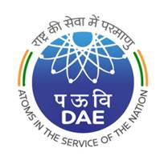
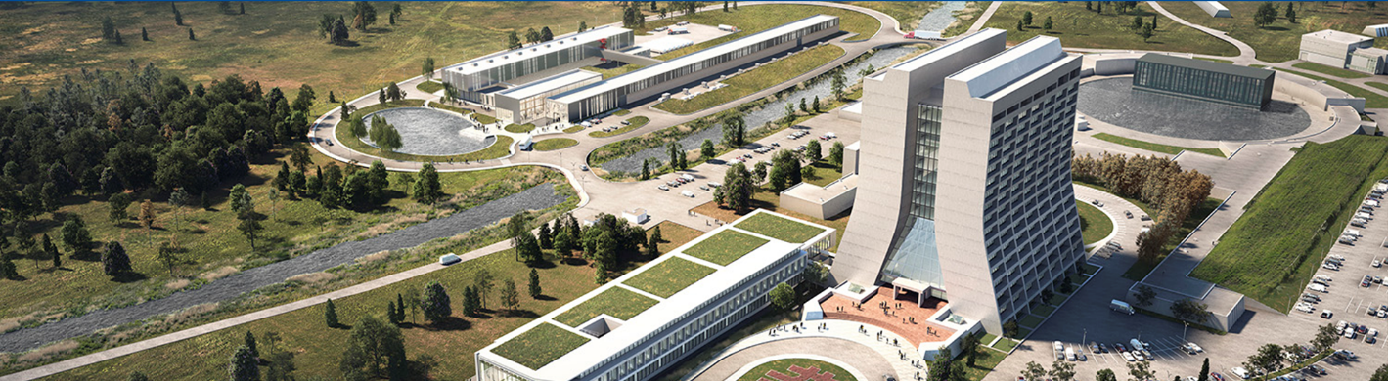
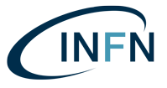
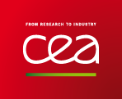
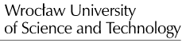

PIP-II Technical Workshop
Preamble
Partners supporting PIP-II who are also delivering to the European Spallation Source (ESS) project have recorded the benefit they have gained from attending a series of technical workshops held by the ESS team. The opportunity to exchange knowledge and learn from the experience of other organisations has helped drive forward this large project. It has been agreed that such a forum would be beneficial to achieving the mission of PIP-II.

Charge
The PIP-II Technical Workshop will bring together members of the delivery teams from all partner organisations in an environment where success can be shared, and issues openly discussed, such that opportunities to learn from the experience of others are maximised.
The PIP-II Technical Workshop through topic-specific working groups will:
- Focus on the people, processes and tools delivering tangible outputs to the PIP-II Project. Examples include:
  - Component production, integration, and assembly; [Process]
  - Manufacturing procedures; [Process]
  - Infrastructure development and compatibility; [Process]
  - Analysis consistency; [People, Tools]
  - Testing and commissioning – approaches and equipment; [Process, Tools]
  - Supply chain risk management; [Process]
  - Requirements management and achievement; [Process]

- Provide a forum for team members to:
  - Share best practice in the delivery of their contributions;
  - Highlight where they have made improvements to their processes so that other partners can benefit from similar approaches;
  - Flag areas of concern and suggest resolutions;
  - State what is not working well and why;
  - Identify future discussion topics.

Format and Management
The Technical Workshop will be coordinated by Fermilab with topics for discussion agreed by the Technical Workshop Committee. Parallel working groups will allow delegates to focus on specific areas of greatest benefit. Working group discussion summaries will be presented to all participants at the conclusion of the Workshop.

Expected Outcomes
Two tangible deliverables are expected from this process:
- A Learning from Experience (LfE) register (i.e. Lessons Learned log) available to all partners;
- A summary presentation from each working group Chair presented to all participants; and
- List of open issues to be discussed in future forums.
The LfE register will allow partners to optimise their processes based on the advice and guidance generated by others through the execution of the same, or similar tasks. The summary presentations will be combined with the LfE register as formal records of the outcomes of this Technical Workshop.
Non-tangible outcomes include:
- Process improvement through the exchange of best practice;
- An improved network of contacts for those charged with delivery;
- Free-flowing information exchange between partners; and
- Reduced timescales for implementation and reduction of re-work.

PIP-II Technical Workshop Planning Committee
Allan Rowe (arowe@fnal.gov) -- Chair, FNAL
Jon Lewis (jon.lewis@stfc.ac.uk) – Host, STFC-URKI
Claire Simon (claire.simon@cea.fr) -- CEA
Patricia Duchesne (duchesne@ipno.in2p3.fr) -- CNRS
Vinit Kumar (vinit@rrcat.gov.in) -- DAE-RRCAT
Rajesh Kumar (krajesh@barc.gov.in) -- DAE-BARC
Rocco Paparella (rocco.paparella@mi.infn.it) -- INFN
Pawel Duda (pawel.duda@pwr.edu.pl) -- WUST

