CERN, September 30th 2020

# Network for DAQ/SC at DUNE FD

### *Authored by G. Lehmann Miotto*

This document describes the requirements and specifications for the DAQ/SC network for the DUNE experiment, as well as its interfaces to other network equipment of the DUNE Network facility. It refines and clarifies the DAQ/SC networking aspects described [here](https://docs.google.com/document/d/1wNmD3UA5UkxbrMvWww4wS6ELGdCct6Wq/edit).

The DAQ/SC network is under the responsibility of the DAQ/SC consortium. Nevertheless, it is envisaged that the design will be carried out in collaboration with FNAL networking, that then will take care of its maintenance and operation.

The financial resources required for the construction of the DAQ/SC network (for each detector module) are split as follows:

* Facility: long range fibers, from the Ross Dry MCR, through Ross and Yates shafts, up to the underground CDR (or CUC); contract established and partially executed;
* I&I: network devices for SC (~60 48x1G switches distributed on detector mezzanine and DAQ barrack);
* DAQ/SC consortium: fibers from CDR (or CUC) to DAQ barracks/detector mezzanine, fibers from top of cryostat electronics to DAQ barrack, DAQ switches, DAQ/SC routers in DAQ barrack and Roos Dry MCR.

Additional networks, such as GPN (offices and wifi) and the technical network (for critical control & safety systems e.g. for electrical distribution, cooling & ventilation, cryogenics, etc) are not considered in this document.

## Assumptions

AS-1: The DAQ/SC equipment on surface is hosted in the Ross Dry MCR.

AS-2: The DAQ equipment underground is hosted within the DAQ barrack on the cryogenic mezzanine on top of each cryostat.

AS-3: The SC equipment underground is hosted within the DAQ barrack on the cryogenic mezzanine as well as in the racks of the detector mezzanine, on top of each cryostat.

AS-4: All the fibers from underground (going through the Ross and Yates shafts) for DAQ data transfers arrive at the Ross Dry MCR, without passing through any active equipment at Yates.

Note: as specified in existing contract; for each detector module there are 16x100G links + 1 link per shaft for DAQ and SC respectively.

AS-5: A backup path for control for underground DAQ/SC equipment, in case of a complete network failure on the Ross site, may be achieved through minimal network equipment on the Yates site (through a few LZ fibers coming up from the Yates shaft) or a separate location at Ross.

AS-6: If power underground is lost for a whole detector module, beyond the interim time that will keep DAQ/SC network equipment up through UPS (few minutes), it is acceptable to not have any network connectivity to DAQ/SC devices of that detector module.

Note: this means that no safety equipment requires DAQ/SC network connectivity and that, if any safety equipment is connected to the DAQ/SC network it is ok to not be able to monitor its status or send commands to it. This is most probably a major difference compared to the technical network requirement for cryogenics and infrastructure such as cooling/ventilation, electricity, let alone person safety systems (fire, ODH, …).

Note 2: if DDSS is part of SC (as normally is the case) then some equipment dedicated to this aspect should be on a separate network with high availability.

AS-7: The network technology of choice for the DAQ/SC is Ethernet, ranging from 1G to 100G. 400G may be used to interconnect routers, but not at any endpoints.

AS-8: A local instance of critical computing services (DNS, DHCP, LDAP, some database replicas,….) will be installed at SURF as a replica for the central services provided by FNAL, to keep systems in an operating way in case of temporary disconnections (or degraded connection) from FNAL.

## Constraints

CO-1: Loss of power in the Ross Dry MCR (even beyond the time covered by UPS) should not cause a loss of communication to the underground DAQ/SC systems, for the purposes of control and monitoring.

CO-2: Loss of power (or cooling failures) in the DAQ barrack of one detector, shall not cause a complete loss of communication to the SC equipment installed on the corresponding detector mezzanine.

## Requirements

UR-1: The DAQ/SC shall be connected via network to FNAL via two independent WAN links:

* 100 G link for physics data transfer, control and monitoring,
* 10 G backup link for control and monitoring.

UR-2: Any connections of the DAQ/SC network to active network devices leading to the WAN links shall be redundant and without single points of failure.

UR-3: The DAQ/SC network itself shall be designed avoiding single points of failure at least at the level of routers and their interconnecting fibers.

UR-4: The peak DAQ data rate of the first detector from underground to surface is expected to be in the range of 60 GB/s.

UR-6: The average DAQ data rate of the first detector is expected to be in the range of 2 GB/s.

UR-7: The DAQ/SC network shall be connected to FNAL/SURF GPN via gateways, subject to access control.

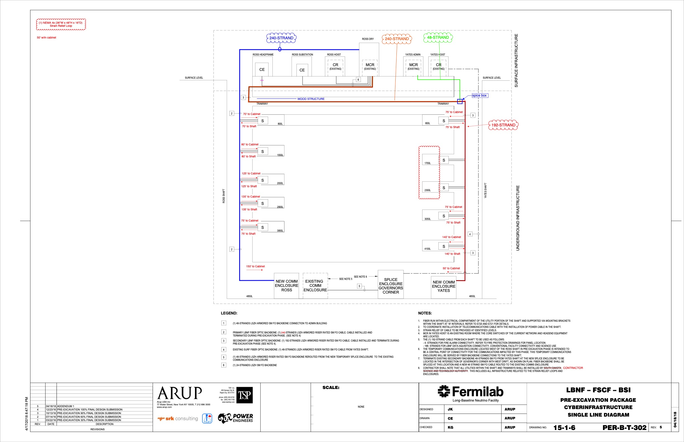

Figure 1 Fiber paths relevant for DUNE DAQ/SC in blue and red. The green path may be used as a backup control path for SC, if that path is indeed put in place as critical communications backup needed by DUNE.

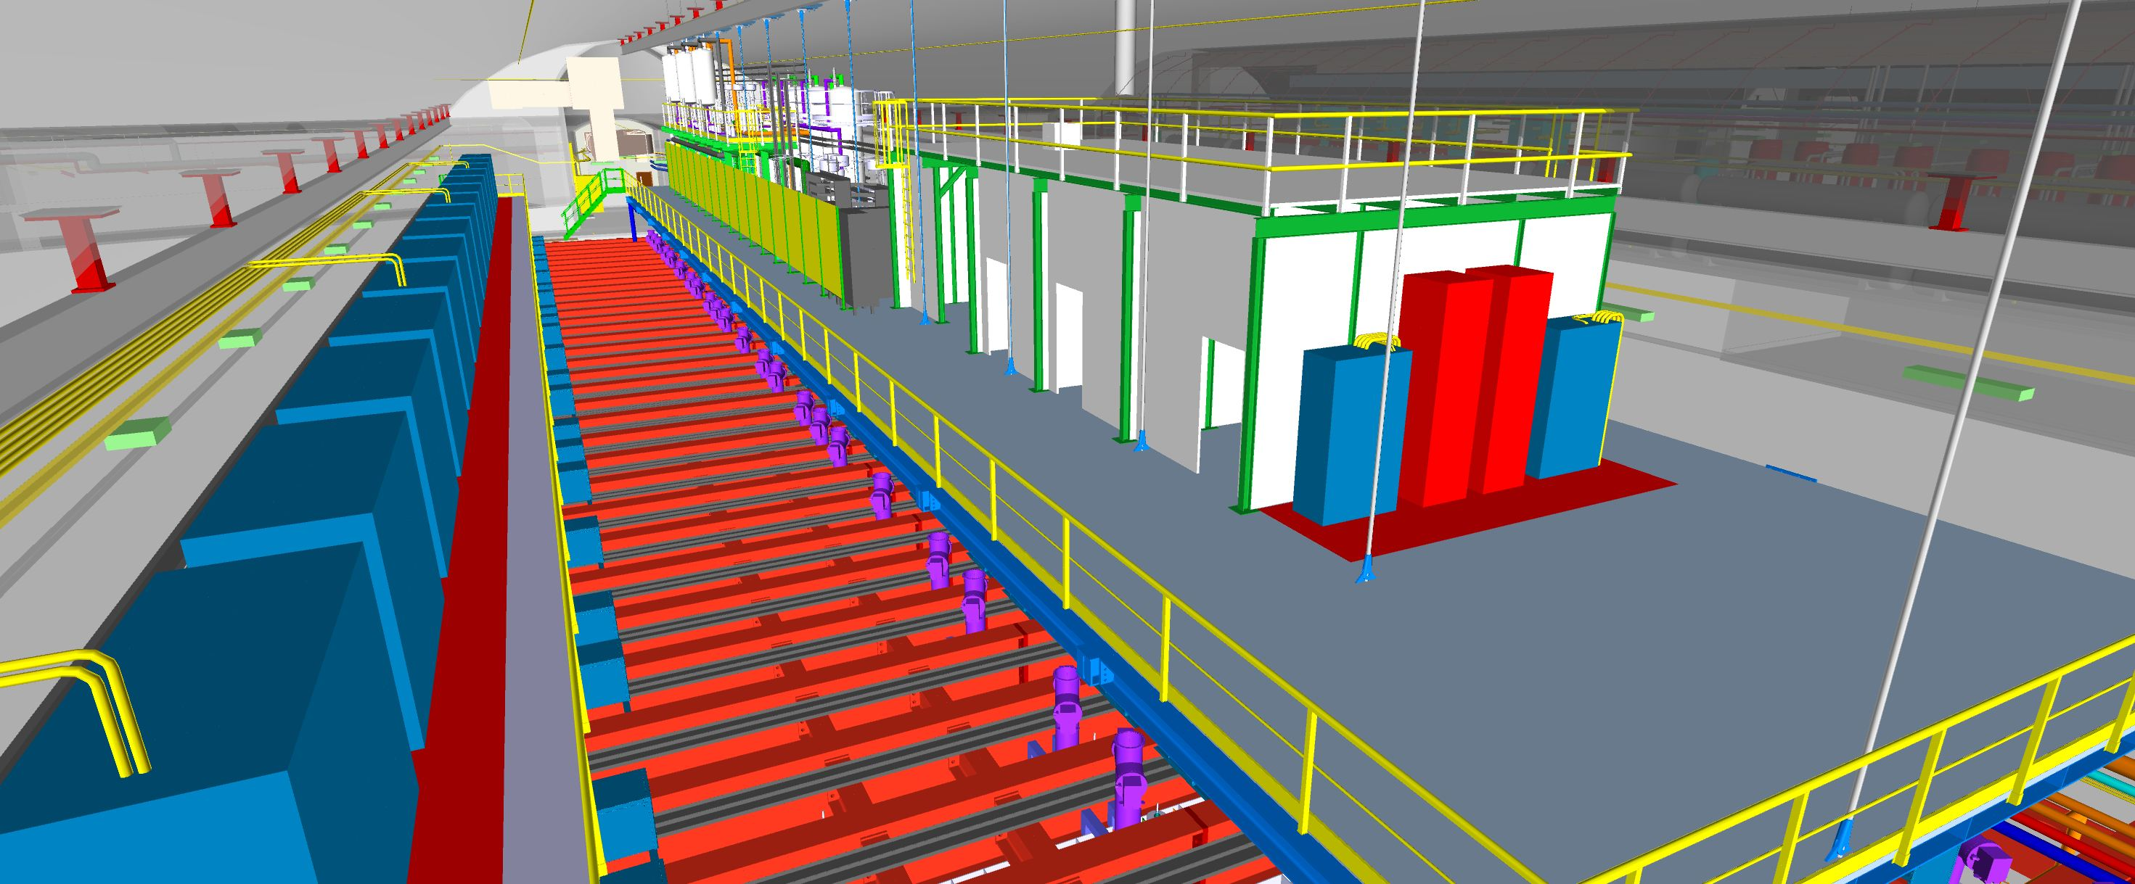

Figure 2 Top of one far detector cryostat. On the left, in blue, the racks on top of the detector mezzanine. On the right, the cryogenic mezzanine is visible with several barracks of which one is the DAQ barrack.

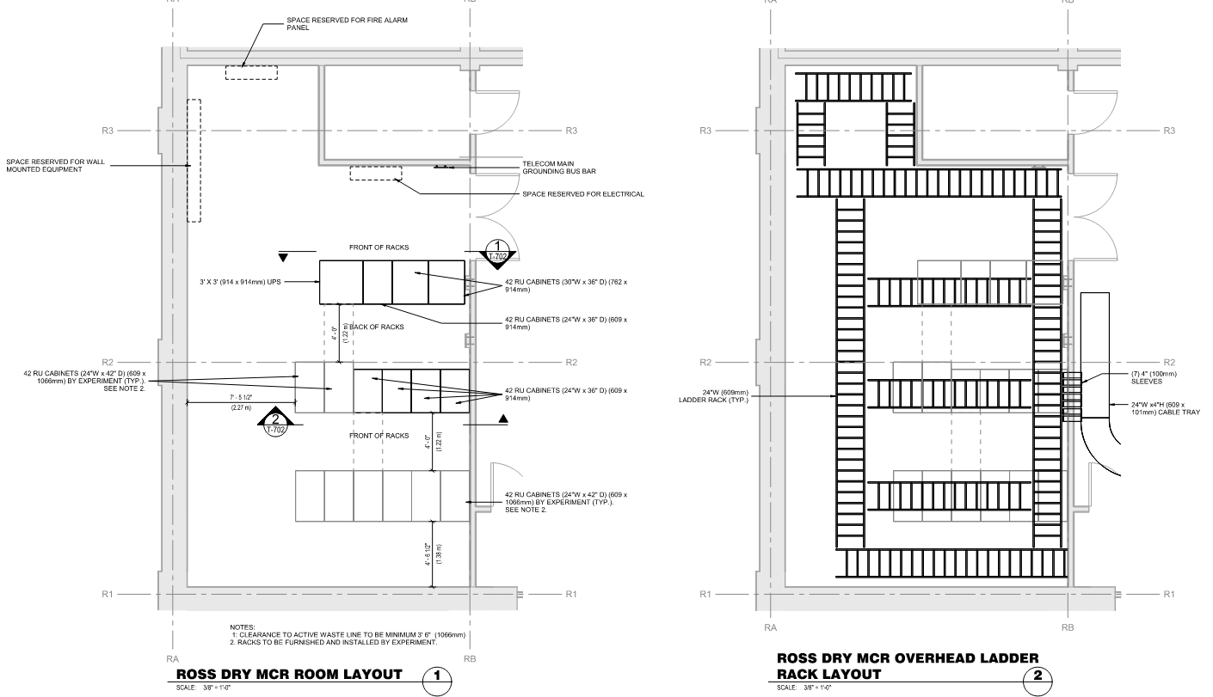

Figure Draft layout of the Ross Dry MCR in which all DAQ/SC surface equipment will be housed for DUNE.

## Preliminary DAQ/SC equipment layout

In this section we give an indicative (and very preliminary) layout of DAQ in order to be able to dimension the DAQ/SC network (or at least the core part of it).

In these sketches we assume

* “hubs” as 1U stackable 32x100G ports devices,
* DAQ switches as 48x10G (+2x100G uplinks) ports stackable devices,
* Ctrl switches as 48x1G (+2x10G uplinks) ports stackable devices,
* Ctrl-UP devices as similar to DAQ switches,
* IPMI switches being 48x1G ports.

Servers will be connected via one or two 10G network links (depending on whether redundancy is required). Storage servers are a particular case which will be connected directly via 2x100G links to the hubs.

Every server will have a IPMI connection.



Figure Draft DAQ/SC layout in underground DAQ barrack (very preliminary!). Servers in the first 7 racks are connected via 2x10G links (active-redundant) to the DAQ SW devices. Servers also have each one IPMI connection. DAQ and SC network are interconnected at the level of the DAQ/SC hub to allow for information exchange. The DAQ/SC hubs are only indicative: they may be located one in the DAQ barrack and one on the detector mezzanine (for higher independence, see CO-2), or they may both be in the CDR/CUC (shared hardware with other networks), or they may be skipped completely, with long range fibers going directly to the surface. On the detector mezzanine side there will be O(20) 1G switches, feeding into 2 switches with few 10G optical uplinks, part of the ctrl network.



Figure Very preliminary view of DAQ/SC equipment on surface, in the MCR, for the first two detector modules.