

**Developing High-Current, Mechanically Reinforced BSCCO 2212 Cable: A Survey of Compatible Materials**

**Alexander Matta**

Mechanical Engineering Department, Virginia Tech

**Supervisor: Tengming Shen**

Technical Division, Fermi National Accelerator Laboratory

2011 Summer Internship for Science and Technology (SIST) Program

**Abstract**

BSCCO 2212, a high temperature superconductor currently under extensive experimentation at Fermilab has the potential to be used in next generation accelerator magnets which would operate in the field range of 20 - 50T. However BSCCO 2212’s strain sensitivity is a considerable problem when operating in these high magnetic fields. In order to solve this problem alloy wire reinforcement to be used in high current multi-strand cables is being considered. These alloy wires have to fulfill two requirements, they must be mechanically strong, and they must be chemically compatible with 2212 wire. I performed tensile testing, and chemical compatibility testing on 5 different alloys, Inconel 600/625/X750, nickel chromium, and Kanthal A-1. Testing has indicated that Inconel X750 and Kanthal A-1 are possible candidates for 2212 reinforcement. Testing has also shown that titanium oxide and aluminum oxide coatings may be effective in reducing chemical interaction between 2212 wire and alloy wire.

**Introduction**

BSCCO 2212, a high temperature superconductor currently under extensive experimentation at Fermilab has the potential to be used in new high field magnets. However like with many new materials, implementing BSCCO 2212 has presented the lab with several design challenges. One of these challenges is that like many other superconductors 2212 is strain sensitive. When 2212 is fully processed grains on the order of several microns are formed inside the material [1]. If 2212 is put under a considerable amount of strain, the grains of the conductor will start to separate thus diminishing the superconductive properties of the wire [2]. This level of strain would exist when an electromagnet produces a very strong field, specifically 30 Tesla .This of course is an unacceptable side effect.

Unlike normal conductors, superconductors exhibit zero electrical resistance when brought below a material specific critical temperature. At this temperature electrons exist in pairs, and the ion electron collisions that would normally exist do not occur [3]. Thus no kinetic energy is lost and current flows unhindered. In addition to the critical temperature there are two other important limits to superconductivity. First superconductivity can’t be maintained when the superconductor is in a field stronger than a critical value [3]. Second superconductivity doesn’t mean an infinite current density, the surface area of the conductor still limits the amount of current that can passes across the conductor [3].

Currently niobium titanium, and niobium tin, both conventional superconductors, are used to make most industrial superconducting magnets. Both have low critical temperatures and thus are cooled using liquid helium which has a boiling temperature of 4.5 Kelvin. When installed in industrial electromagnets they are limited to fields of ~10 Tesla and ~ 15 Tesla respectively.

Recently there has been a lot of ongoing research into high temperature superconductors (abbreviated HTS). HTS have critical temperatures above 30 Kelvin; some are even able to operate at liquid nitrogen temperatures ~77 Kelvin. BSCCO 2212 being an HTS has a critical temperature of 95K. In addition to having a high critical temperature, 2212 is capable of remaining superconductive in high strength magnetic fields while still maintaining a large current density [4]. There are other HTS that have similar or better electrical properties, but unlike any other HTS, 2212 can be manufactured into round wire [4]. Collider magnets have been manufactured with conductor in this form for years, making 2212 a very practical choice for new prototypes. There is currently an effort to use 2212 in the electromagnets for the proposed Muon Collider. These magnets would need to produce a field of 30 Tesla a requirement 2212 seems able to meet [5].

As stated BSCCO 2212 has exhibited superior electrical properties compared with most other superconductors, however if the 2212 magnets are to operate at 30 Tesla an immense Lorentz force will be applied on the wire; this is where the big issue of strain sensitivity occurs. One plausible solution is to create a superconducting cable with six 2212 wires, twisted and transposed around a high strength alloy wire. This alloy wire would take some of the load off the six 2212 wires. To be suitable candidates these alloy wires have to exhibit strong mechanical properties and must remain chemically stable when cabled with the 2212 wires. A considerable portion of my work here at Fermilab consisted of running tests to help find the most appropriate candidate. I had five alloys I worked with, Inconel 600/625/X750, Nickel Chromium (Ni 80%, Ch 20%), and Kanthal A-1.

**Experimental Details**

The study consisted of two core experiments. The first experiment’s purpose was to determine the mechanical properties of the alloys, specifically yield strength, tensile strength, and Young’s Modulus. This experiment used tensile testing as the method of investigation. Yield strength is defined as the maximum amount of stress an object can undergo and still return to its original shape when the load is removed. Tensile strength is defined as the maximum amount of stress an object can undergo; breakage will immediately occur if a larger load is applied. Young’s Modulus is a measure of the stiffness of a material in its elastic region. The second experiment’s purpose was to determine the chemical compatibility of the alloy wires and BSCCO 2212 at high temperatures, in other words the purpose was to see if a reaction would occur between the 2212 and alloy wires that would diminish the electrical properties of the 2212.

To prepare for the tensile testing two sample groups had to be created. First was a raw unaltered sample group that consisted of 12 inch alloy wire specimens. The second sample group consisted of heat treated 12 inch alloy wire specimens.

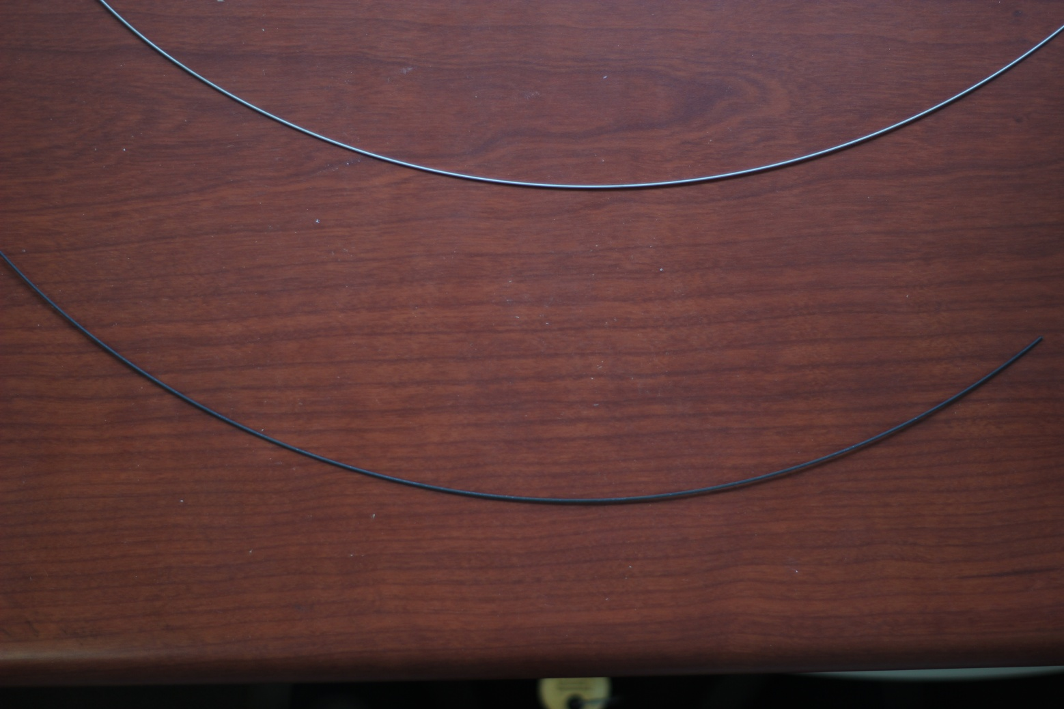

**Figure 1: On top is an unaltered wire and on the bottom is a heat treated wire**

The whole heat treatment process lasted 4 days and brought the samples to a maximum temperature of 890 Celsius. After the heat treatment we discovered that Inconel 625 was not a viable candidate. Inconel 625 completely reacted with the silver surrounding it, and BSCCO 2212 being encased in silver, would have also reacted with Inconel 625. Further testing on 625 was discontinued.

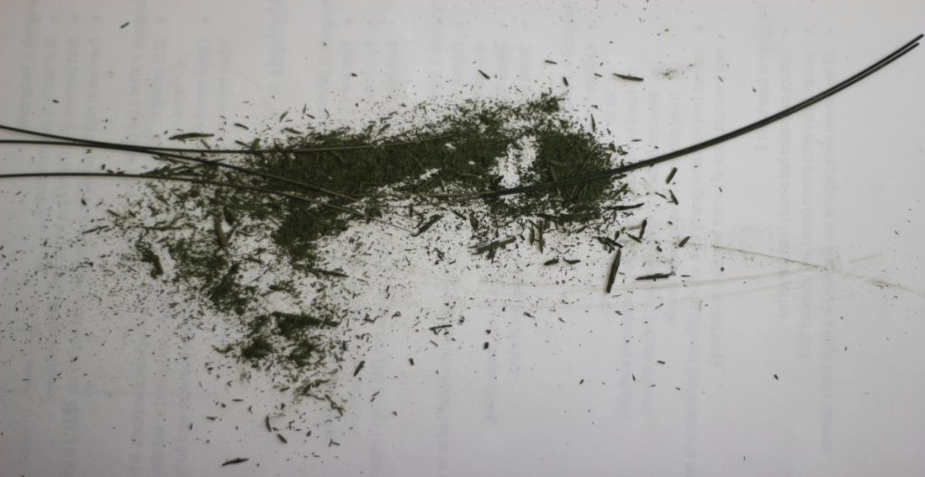

**Figure 2: Remnants of Inconel 625 reaction with silver.**

Tensile testing was performed with an Instron 4411, which could apply loads of up to 1000 pounds. The machine clasps specimen holders or the specimens themselves using two pneumatic clamps.

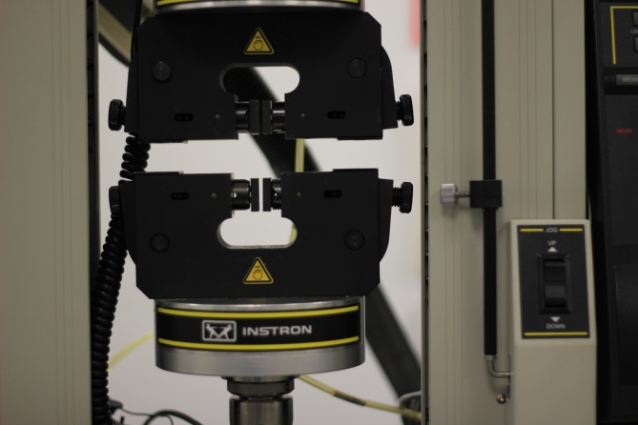

**Figure 3: Pneumatic Clamps**

The tensile testing was first attempted using a previously machined thin wire holder. However this holder produced stress concentrations in the specimens causing them to break prematurely. So before testing continued an effective holder had to be created. Using NX7 I designed a new holder that I believed would not cause early specimen breakage.

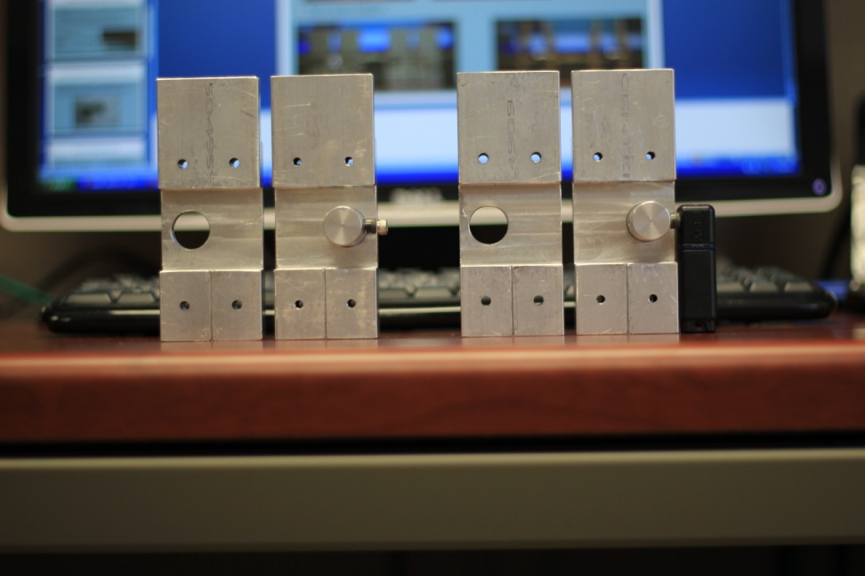 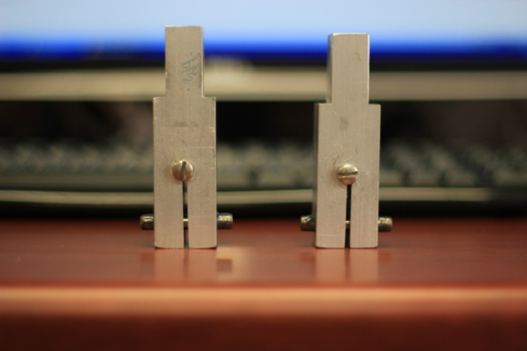

**Figure 3,4: Image on left is of the new wire holder, and image on right is of the old wire holder.**

Testing with the new holder began as soon as it had been made. At first the new holder seemed to be operating correctly; however when testing some samples there would be unexpected dips in the stress/strain graphs. These dips greatly affect the value of yield strength and Young’s modulus. After investigation I determined that the dips were not an intrinsic property of the material, but instead were most likely due to a problem with the testing method. I theorized that the samples were shifting inside the wire holder. As the specimen shifts the load on it will decrease and the measured length of the specimen will increase during that shift, thus explaining the dips in the stress/strain graph. I decided that testing the samples while directly holding them with the pneumatic clamps would be an ideal way to test my theory since sliding was very unlikely to occur using this method. After testing with this technique I discovered that none of the dips occurred in any of the plots. I believe that the data collected using just the clamps provides the most accurate and precise values for yield strength and Young’s modulus, but since the samples broke prematurely due to addition stress caused by the clamps, I do not believe that this method provides an accurate value for tensile strength. While testing with the newly designed holder did not produce accurate values for yield strength and Young’s modulus, it did provide an accurate value for tensile strength. So by combining the results from the two methods you obtain accurate values for all three of the properties of interest.

In order to prepare for chemical compatibility testing, a 1100 oC tube furnace had to be set up. Minor adjusts were made to the furnace itself, but what was most important was the identification of the homogeneity zone. The homogeneity zone is toward the center of the furnace. The homogeneity zone is defined as the zone where the largest area of temperature stability occurs. Discovery of the zone is important because it provides a testing area where all tested specimens undergo an identical process.

**Graph 1: Tube Furnace Homogeneity Zone. Zone exists between 36 - 46 inches inside the furnace.**

For the chemical compatibility testing, once again two sample groups were used. One consisted of specimens that included bare a 2212 wire, and the other consisted of specimens that included a coated 2212 wire. The coated wire had a 6µm layer of titanium oxide; this we hoped would act as a chemical barrier.

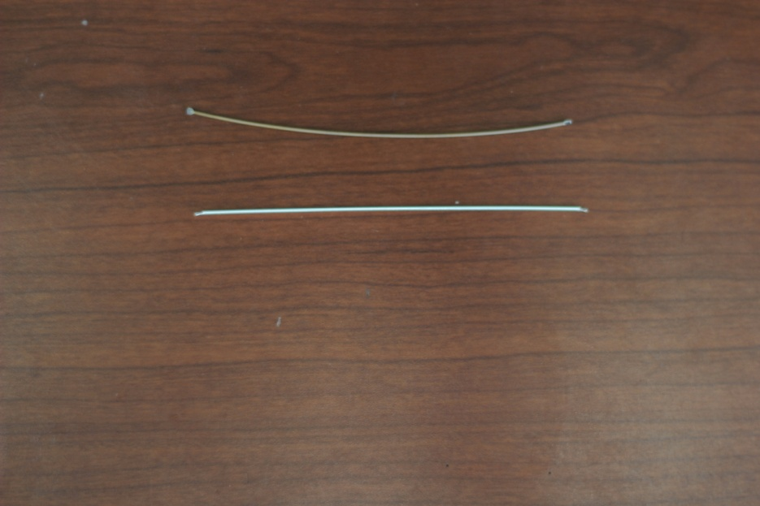

**Figure 5: On the top is the coated 2212 wire, and on the bottom is the bare 2212 wire**

The specimens were structured so that a single 2212 wire was encased by six alloy wires. The actual packaging of the 2212 wire with six alloy wires was very frustrating. I did not have access to a machine that could be used for such a specific task, so it had to be done by hand. This was made more difficult by the fact that alloy wires were almost impossible to get completely straight. Because of this the alloy wires did not fit smoothly around the 2212 wire. After trying many different techniques I found one that worked. Laying the 6 alloy wires down on two strips of tape and then wrapping them around the 2212 wire was the only way to force alignment. Silver wire was then tightly wrapped around the assembly and the tape was removed.

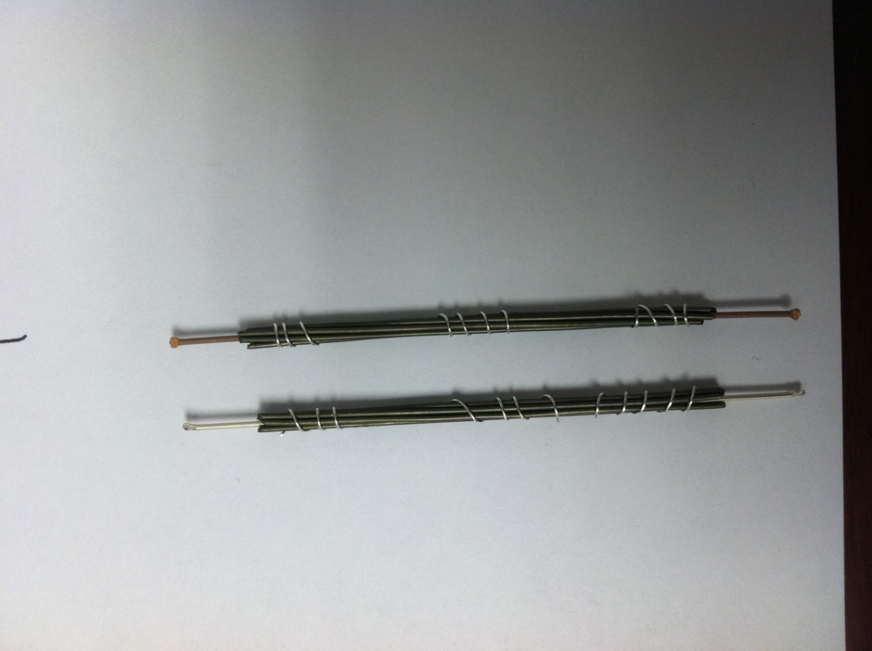

**Figure 6: Structure of the completed specimens**

Even though the amount of adhesive left on the alloy wires was very small, I was still concerned that the adhesive might have reacted with the alloys and then possibly with the 2212. Once specimen preparation was complete, there were six specimens per alloy, 24 total. Three of the six had an uncoated 2212 wire, and the other three had a coated 2212 wire. The specimens were then placed in the tube furnace and the 4 day heat treatment was started. This heat treatment followed the same parameters that the heat treatment for the alloy wire tensile testing did. During the heat treatment the furnace reached a maximum temperature of 890 oC. This peak temperature greatly affects the critical current density of BSCCO 2212, which was one of the properties that would be tested, so care was taken to ensure that the samples were at the center of the homogeneity zone. After the heat treatment my supervisor and I performed basic visual observation. The samples were then sent to the National High Magnetic Field Lab for more thorough testing.



**Figure 7: Heat treatment schedule for chemical compatibility testing, Tmax =890 C, tmax = 12 min.**

**Results**

|  |  |  |  |  |  |  |
| --- | --- | --- | --- | --- | --- | --- |
|  | **Before Heat Treatment** | | | **After Heat Treatment** | | |
|  | Yield Strength  (MPa) | Tensile Strength  (MPa) | Young's Modulus (GPa) | Yield Strength  (MPa) | Tensile Strength  (MPa) | Young's Modulus  (GPa) |
| **Inconel 600** | 1260 | 1386 | 187 | 225 | 730 | 102 |
| **Inconel X750** | 1442 | 1615 | 194 | 665 | 1073 | 182 |
| **Kanthal**  **A-1** | 495 | 713 | 122 | 372 | 449 | 116 |
| **Nickel Chrom.** | 320 | 791 | 127 | 311 | 780 | 106 |

**Table 1: Average values of tensile testing results**

Yield strength and Youngs’s Modulus values were taken from stress/strain graphs (Instron clamps used for sample testing). Tensile strength was calculated from the maximum recorded load on each specimen (new wire holder used for sample testing).

|  |  |  |
| --- | --- | --- |
|  | **Bare 2212 Wire** | **Coated 2212 Wire** |
| **Nickel Chromium** | -2212 leakage occurred  -2nd weakest bond between alloy and 2212 wire | -2212 leakage did not occur  -There was slight oxide coating removal |
| **Kanthal A-1** | -2212 leakage occurred  -1st weakest bond between alloy and 2212 wire | -2212 leakage did not occur  -There was slight oxide coating removal |
| **Inconel X750** | -2212 leakage occurred  - 3rd weakest bond between alloy and 2212 wire | -2212 leakage did not occur  -There was slight oxide coating removal |
| **Inconel 600** | -2212 leakage occurred  - 4th weakest bond between alloy and 2212 wire | -2212 leakage did not occur  -There was large oxide coating removal |

**Table 2: Visual Observations after Heat Treatment**

Actual thorough testing will be done at National High Magnetic Field Lab, above are just the basic visual observations. 2212 wire leakage sometimes occurs when there is contact between alloy wire and 2212 wire. When leakage occurs the critical current density allowed by the 2212 wire diminishes. Many of the alloy wires also bonded to 2212; this is a clear sign of reaction with the silver outer layer of the 2212 wire. Whether the strength of this bond actually affects the electrical properties of the 2212 filaments is unknown.

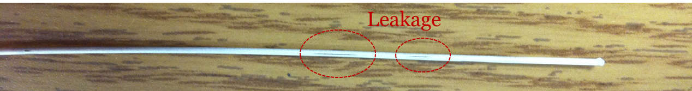

**Figure 8: 2212 wire leakages. Identified as thin black streaks (thin cracks in wire).**

**Conclusion**

The two best candidates seem to be Inconel X750 and Kanthal A-1. Inconel X750 demonstrated the best mechanical properties both before and after heat treatment. While X750 seemed to bond strongly to the bare 2212 wire, its compatibility with the 2212 wire coated with titanium oxide seemed adequate. Any alloy that would be cabled with 2212 wire would have to undergo the heat treatment process, and Kanthal A-1 demonstrated the second strongest mechanical properties after heat treatment, thus making it a good candidate. In addition, out of all the tested alloys Kanthal A-1 seems to be the most chemically compatible with 2212 wire. While these two alloys currently seem ideal, the full results of the chemical compatibility testing must be returned to Fermilab before any real conclusion can be reached.

**Future Work**

I only tested 5 alloys; there are potentially other alloys that might be better suited for cabling with 2212 wire. Kanthal A-1 was the only alloy not based on Nickel Chromium, and it was the most chemically compatible. After heat treatment alumina oxide forms on Kanthal, while chromium oxide formed on all the other alloys. Taking this into consideration maybe further testing should be done on wires were alumina oxide forms.

**Acknowledgements**

I would like to thank my supervisor Tengming Shen, I have learned a great deal working under him. I would like to thank the SIST committee for choosing me as a participant in this wonderful program; it has been a great experience. I would like to thank my mentors Jamieson Olsen and Elliot McCrory for helping me with my presentation. I would like to thank Dr. James Davenport for assisting me with this paper. Finally I would like to thank all the TD employees for hosting me in there division.

**References**

1. T. Shen, "Processing Microstructure and Critical Current Density of Ag-sheathed Bi2Sr2CaCu2Ox Multifilamentary Round Wire," Dissertation, Florida State University, Florida, 2010.
2. X. Lu and N. Cheggour, "Electromechanical Characterization of Bi-2212 Strands," IEEE Transactions on Applied Superconductivity, 2011.
3. M. Tinkham, Introduction to Superconductivity, 2nd ed., New York: Dover Publications, 1996.
4. H. Miao, "Development of Round Multifilament Bi-2212/Ag Wires for High Field Magnet Applications," IEEE Transactions on Applied Superconductivity, vol. 15, iss. 2, 2005.
5. S.A. Kahn et al. “High Field Solenoid Magnets for Muon Cooling”, Proc. of EPAC 2006, Edinburgh.