**Chapter 5. Facilities for the Intensity Frontier**

The Steering Group considered a variety of accelerator facilities and reconfigurations of the Fermilab accelerator complex utilizing the following criteria:

* Support a forefront Intensity Frontier physics research program,
* Potential for realization over the coming decade,
* Effectively utilize accelerator assets freed up at the end of Tevatron operations,
* Provide a long term platform for development of the Fermilab complex.

Since the original Steering Committee report was issued in 2007 a plan for evolution of the accelerator complex in has been developed consistent with these criteria. The plan features the following elements:

NOvA Upgrade: Upgrade the Recycler/Main Injector complex and NuMI beamline/target to 700 kW capability in support of the second generation long baseline neutrino experiment, NOvA.

Proton Improvement Plan: Upgrade the Proton Source to support beam operations at 15 Hz in support of elements of the Intensity Frontier program based on 8 GeV protons, in parallel with NOvA.

Project X: Construct a new facility to deliver 5 MW of beam power, including 3 MW beams at 3 GeV and 2 MW beams at 60-120 GeV simultaneously, in support of future rare processes and long baseline neutrino programs.

Longer Term Facilities: Prepare for the ultimate construction of either a Neutrino Factory or Muon Collider.

The evolution of the accelerator complex takes place in two stages. The first stage takes place over the next five years and is aimed at supporting a the intermediate program: MiniBoone, MicroBoone, Minerva, MINOS, NOvA, LBNE, Seaquest, mu2e, and g-2 experiments in addition to Test Beam facility in the Meson Lab. This stage is based on improvements to the existing complex implemented through the NOvA accelerator upgrades and the Proton Improvement Plan (PIP). The total demand for protons over the coming decade is shown in Figure 5.1. The total steady state demand beyond 2016, about 2.2 ×1017/hour, represents about a factor of two beyond the current. Thus, this stage targets the delivery of 700 kW of beam power to the long baseline production target simultaneous with roughly 30 kW to the 8 GeV program.

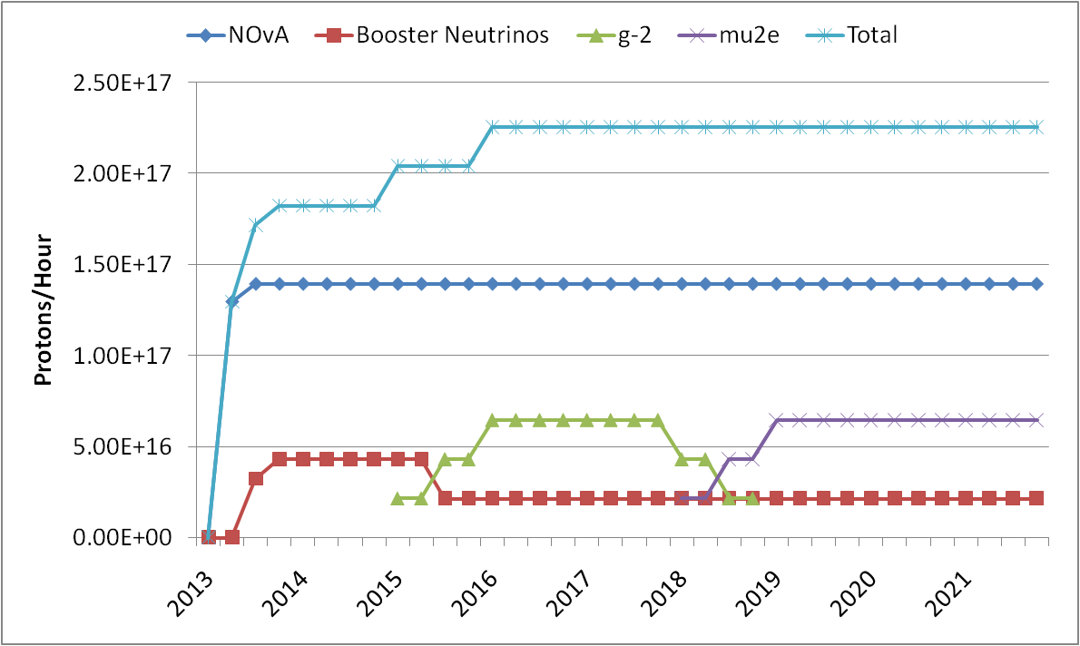

## Figure 5.1: Total proton demand (protons/hour) over the coming decade.

In the second stage the existing proton source facility is replaced by a modern high power H- linac, named Project X. Project X will greatly enhance the capabilities of the complex by allowing the simultaneous delivery of 2 MW at 60-120 GeV, 200 kW, at 8 GeV, and 3 MW at 3 GeV. The total number of delivered protons is a factor of one hundred beyond what is achieved following the PIP. The performance parameters associated with this evolution of the accelerator complex are summarized in Table 5.1. The first three columns represent current performance and improvements now underway. The last two column list the Project X parameters. All columns are based on injecting beam from the existing 8 GeV Booster, except for Project X, which eliminates the need for the Booster. While the table does not explicitly list beam power at 60 GeV from the Main Injector, 2 MW can be supported at this energy at the expense of decreasing the available beam power at 8 GeV to 70 kW.

|  |  |  |  |  |  |
| --- | --- | --- | --- | --- | --- |
|  | Present | NOvA | PIP | Project X |  |
| Batch Intensity | 4.3×1012 | 4.1×1012 | 4.1×1012 | 2.6×1013 | protons per pulse |
| Repetition Rate | 7.5 | 9 | 15 | 10 | Hz |
| Total Flux (8 GeV) | 1.2×1017 | 1.3×1017 | 2.2×1017 | 9.5×1017 | protons per hour |
| Total Flux (3 GeV) | NA | NA | NA | 2.2×1019 | protons per hour |
| Main Injector Batches | 11* | 12 | 12 | 6 |  |
| MI Cycle Time | 2.2 | 1.33 | 1.33 | 1.33 | seconds |
| MI Beam Power (120 GeV) | 400 | 700 | 700 | 2300 | kW |
| 8 GeV Beam Power (available) | 15 | 0 | 30 | 200 | kW |
| 3 GeV Beam Power (available) | NA | NA | NA | 2900 | kW |

**Table 5.1: Planned evolution of proton availability at Fermilab**

**\*Currently 9 batches are delivered to the NuMI target and 2 batches to the antiproton production target.**

## 5.1 Existing Proton Facility

The existing Proton Facility consists of the 400 MeV linac, 8 GeV Booster, and the 120 GeV Main Injector. The complex delivers beams to a variety of target stations including the MiniBoone target at 8 GeV and the NuMI target at 120 GeV. In parallel the complex supports the Test Beam Facility in the Meson Lab. The upstream end of the Proton Facility is quite old – both the upstream 181 MeV of the linac and the Booster have been in operations for 40 years and are reliant on components that are either no longer commercially available or are at risk of being discontinued. The linac and Booster complex operate at up to 15 Hz. The Booster magnet system is a resonant circuit at 15 Hz and the magnets systems is continuously operating at this rate. However, the Booster cannot deliver beam at 15 Hz due to limitations in the rf systems and the overall tolerance to beam loss. At present the Booster delivers beam at 7.5 Hz – approximately 1.2×1017 protons/hour are currently available at this rate. This is sufficient to support NuMI/MINOS and antiproton production at about 400 kW, while leaving approximately 15 KW for the MiniBoone experiment.

The 8 GeV Recycler and Antiproton Rings currently play no role in the delivery of protons. However, following the cessation of Tevatron operations both will be converted to support of the ongoing program – the Recycler to accumulate protons in support of NOvA and the Antiproton Rings to accumulate and then resonantly extract protons to the mu2e experiment.

## 5.2 NOvA Upgrades

The NOvA experiment is based on the delivery of 700 kW of beam power onto the NuMI target. The neutrino beam generated will support the off-axis neutrino detector (NOvA) currently under construction in Ash River, MN. The goal of 700 kW beam power onto the target is achieved by increasing the number of batches targeted and reducing the Main Injector cycle time – there is no increase in the batch intensity. The cycle time will be reduced by utilizing the Recycler as a proton accumulation ring, thereby eliminating approximately 0.6 seconds of 8 GeV dwell time in the Main Injector, and by increasing the Main Injector acceleration rate. The net result is reduction of the cycle time from 2.2 seconds to 1.333 seconds. In addition accumulation in the Recycler will accommodate 12 Booster batches, all of which are available for delivery to the NuMI target, thus increasing the number of targeted batches from 9 to 12. Modifications to the complex currently underway to support NOvA include:

* Implementation of slip-stacking into the Recycler Ring, with a capability of stacking 12 Booster batches.
* A new transfer lines for injection from the Booster to Recycler, and for transfers from the Recycler to Main Injector.
* Increasing the acceleration rate in the Main Injector through the addition of two rf cavities, an additional anode power supply, and upgrades to the quadrupole supplies.
* Modifications to the NuMI beamline.
* A new target design to support 700 kW
* A new target/horn configuration to provide the optimum neutrino spectrum.
* A variety of new fast kickers to support the above.

Component fabrication is currently underway and installation will take place during an 11 month shutdown to the accelerator complex scheduled to begin in March 2012. Startup of the NOvA program will begin in the spring of 2013.

## 5.3 Proton Improvement Plan

Without further upgrades to the proton source NOvA would utilize all protons generated by the Booster, leaving nothing to support the balance of the program – MicroBoone, mu2e, and g-2. The total demand is shown in Figure 5.1, and can be met by increasing the beam repetition rate in the Booster to 15 Hz while maintaining protons per batch at present levels. The Proton Improvement Plan (PIP) is being executed to implement this capability while dealing with a number of other issues in the 40 year old Linac/Booster complex. The goals of the PIP are:

* Increase the beam repetition rate to 15 Hz
* Eliminate major reliability vulnerabilities and maintain reliability at present levels (>85%) at the full repetition rate
* Eliminate major obsolescence issues
* Increase the proton source throughput to > 2×1017 protons/hour
* Ensure a useful operating life of the proton source through at least 2025

The last goal is meant to ensure continuity of operations in the face of potential delays in Project X. The major components of the PIP include:

* Replacing the Cockcroft-Walton ion sources with an RFQ
* Upgrades to the drift tube linac rf Power Systems
* Replacement of the Booster tube based power amplifiers with solid state amplifiers
* Modifications to Booster rf cavities, tuners, anode supplies, and bias supplies to allow operations at 15 Hz
* Enhanced beam instrumentation and controls
* Vacuum system upgrades
* Augmentation of the Booster gradient magnetspares pool

The PIP is currently underway and will be completed in 2016.

## 5.4 Project X

Project X is the centerpiece of the Fermilab long term strategy to develop a world leading Intensity Frontier program, and use this program as a stepping stone to a possible future Muon Collider at the Energy Frontier. Project X is a high intensity proton facility based on a 3 GeV continuous wave (CW) superconducting linac operating at an average current of 1 mA and a 3-8 GeV pulsed linac operating with a duty factor of 4%. These newly constructed facilities are augmented by upgrades to the Main Injector/Recycler complex to support higher power operations. A total of 5 MW beam power will be available at Project X: 3 MW at 3 GeV, 80-200 kW at 8 GeV, and 2 MW at 60-120 GeV.

Project X is currently in the pre-conceptual design and development stage and a R&D program targeting the critical technical issues is underway.

## 5.4.1 Project X Mission Elements

Project X is a multi-MW proton facility being designed to support a multi-faceted Intensity Frontier program at Fermilab. Development of Project X was recommended as part of the long range strategic plan of the U.S. Department of Energy as described in the P5 report of May 2008 [1]. This report outlined a number of missions that would be supported by Project X. Three of these have been adopted as providing the primary mission elements for Project X. A fourth mission element has been developed in discussions with scientific communities outside of elementary particle physics.

The primary mission elements assigned to Project X include:

1. Long baseline neutrinos: deliver 2 MW of proton beam power onto a neutrino production target at any energy between 60 – 120 GeV;
2. Rare processes: provide MW-class, multi-GeV proton beams supporting multiple kaon, muon, and neutrino based precision experiments. Simultaneous operations of the rare processes and neutrino programs is required;
3. Muon facilities: provide a path toward a muon source for a possible future Neutrino Factory or Muon Collider;
4. Non-HEP applications: provide opportunities for implementing a program on Standard Model tests with nuclei and/or nuclear energy applications.

These mission elements establish the fundamental design criteria for Project X.

## 5.4.2 Project X Reference Design

The design concept for Project X has gone through several iterations, since the publication of the initial steering group report. These iterations have resulted in significant performance improvements at each step, culminating in a concept designated the Project X Reference Design [2]. The Reference Design, shown schematically in Figure 5.1, meets the high level design criteria listed above in an innovative and flexible manner. The Reference Design is based on a 3 GeV CW superconducting linac, a 3-8 GeV superconducting pulsed linac, and modifications to the existing Main Injector/Recycler complex at Fermilab. The Reference Design represents a facility that will be unique in the world in its ability to deliver high power proton beams with flexible beam formats to multiple users.

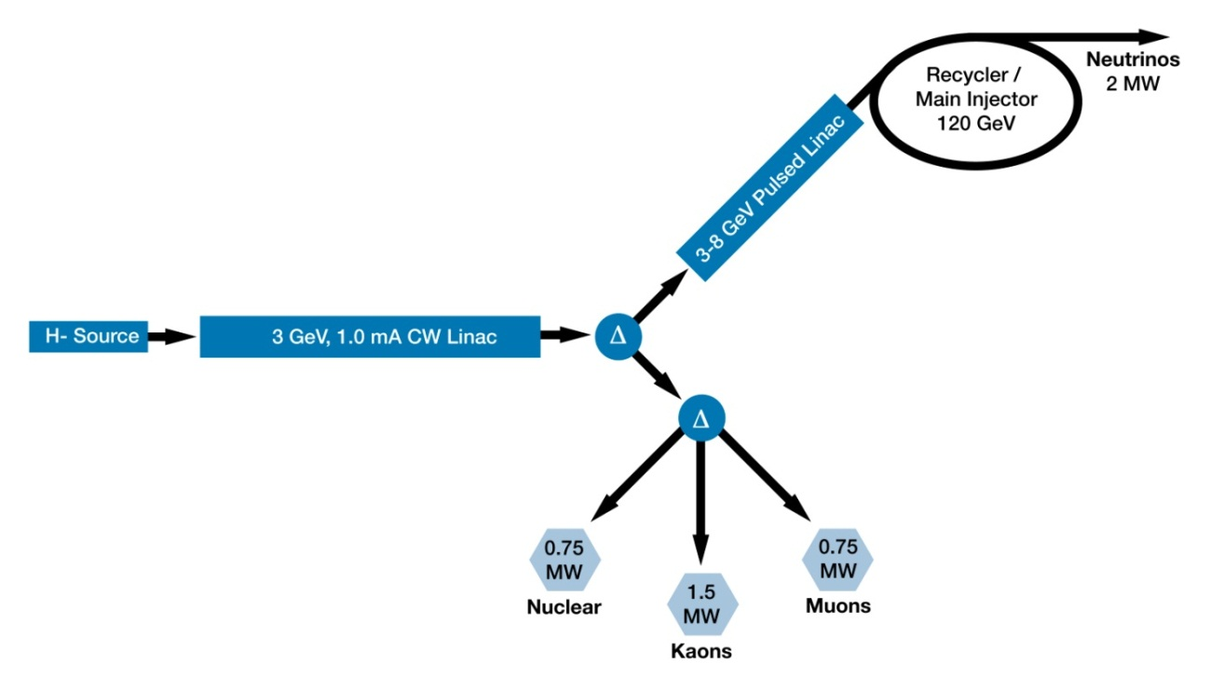

**Figure 5.1:** Project X Reference Design

The primary elements comprising the Reference Design are:

* An H- source consisting of a CW ion source, 2.1 MeV RFQ, and Medium Energy Beam Transport (MEBT) line with an integrated wideband beam chopper capable of accepting or rejecting bunches in arbitrary patterns at 162.5 MHz.
* A 3 GeV superconducting linac operating in CW mode and capable of accelerating an average (averaged over >1 sec) H- beam current of 1 mA, and a peak beam current (averaged over < 1 sec) of 10 mA.
* A 3 to 8 GeV pulsed linac capable of accelerating 1 mA of peak beam current at a duty factor of up to 4%.
* A pulsed dipole that can direct beam towards either the Main Injector/Recycler complex or the 3 GeV experimental areas.
* An rf beam splitter that can deliver the 3 GeV beam to multiple experimental areas.
* Modifications necessary to support 2 MW operations in the Main Injector/Recycler complex.
* All interconnecting beamlines.

Performance parameters associated with the Reference Design are given in Table 5.2.

|  |  |  |  |
| --- | --- | --- | --- |
| CW Linac |  |  |  |
|  | Particle Type | H- |  |
|  | Beam Kinetic Energy | 3.0 | GeV |
|  | Average Beam Current | 1.0 | mA |
|  | Linac Pulse Rate | CW |  |
|  | Beam Power | 3000 | kW |
|  | Beam Power to 3 GeV Program | 2870 | kW |
| Pulsed Linac |  |  |  |
|  | Particle Typ0e | H- |  |
|  | Beam Kinetic Energy | 8.0 | GeV |
|  | Pulse Rate | 10 | Hz |
|  | Pulse Width | 4.33 | msec |
|  | Cycles to Main Injector | 6 |  |
|  | Particles per cycle to MI | 2.6×1013 |  |
|  | Beam Power | 347 | kW |
|  | Beam Power to 8 GeV Program | 70-200 | kW |
|  | Upgraded Beam Power to 8 GeV | 4 | MW |
| Main Injector/Recycler |  |  |  |
|  | Beam Kinetic Energy | 60-120 | GeV |
|  | Cycle Time | 0.75-1.4 | sec |
|  | Particles per cycle | 1.6×1014 |  |
|  | Beam Power | 2000-2200 | kW |
|  |  |  |  |

**Table 5.2:** Project X Performance Goals

## 5.4.3 Operating Scenarios

The CW linac is primarily utilized to support a rare processes program at 3 GeV. A key element of the Reference Design concept is the coordinated utilization of a wideband chopper at the linac front end and a transverse deflecting rf separator at the exit of the 3 GeV linac to provide high duty factor bunch patterns to multiple users simultaneously. The transverse deflecting cavity operates at one fourth (or n+1/4) of the fundamental 162.5 MHz bunch frequency of Project X. Bunches are deflected to three distinct experimental areas by the transverse cavity depending upon the phase of their arrival. By accelerating bunched in an appropriate pattern, as determined by the wideband chopper, the requisite bunch patterns can be delivered to three experiments simultaneously.

The bunch structures delivered to three independently operating experiments are completely determined by the bunch pattern loaded into, and accelerated in, the 3 GeV linac. These bunch patterns are subject to two constraints: 1)the beam current when averaged over 1 sec must be 1 mA or less; and 2)the instantaneous beam current at time scales less than 1 sec cannot exceed the output of the ion source, nominally up to 10 mA. An example is shown in Figure 5.2. Buckets in the linac are color coded as red, green, or blue (R,G,B). In particular, the pattern of buckets in the linac is: R, G, R, B with the R buckets aligned at 0 and 180 degrees of phase with respect to the transverse deflector, and the G and B buckets at ±90 degrees respectively. In this manner any bunch occupying a red bucket will pass through the deflector without deflection, the green buckets will be deflected in one direction, and the blue buckets the opposite direction. Hence each bucket has a predetermined destination in one of the three experimental areas. In the particular example given ,the red area is receiving bunches with a 1 MHz macrostructure and a 80 MHz microstructure, the blue area is receiving bunches at 20 MHz, and the green area at 10 MHz. One can confirm that the average beam current in this example is 1 mA, the peak current is 4.2 mA, and the R, G, B areas are receiving 700, 770, and 1540 kW respectively.



**Figure 5.2**: Example linac loading pattern providing independent bunch patterns to three experiments (labeled R, G, B) simultaneously

The pulsed linac operates at 10 Hz and is utilized to support the long baseline neutrino program in concert with the Main Injector and Recycler. In the Reference Design the beam pulse from the pulsed linac is 4.33 msec in length, thus the beam duty factor is 4.33%. Beam is diverted into the pulsed linac via a pulsed dipole with a rise/falltime of 0.5 msec and a 4.4 msec flattop. With a 1 mA beam current delivered from the CW linac, the total beam power at the end of the 8 GeV linac is 350 kW. The diversion of 4.3% of the CW linac beam into the pulsed linac reduces the power available to the 3 GeV program to 2870 kW.

A total of >2 MW is generated for the neutrino program by accelerating 1.6×1014 protons to 60/120 GeV every 0.75/1.4 seconds. Generating the required number of protons requires 26 msec of 1 mA beam. This is achieved by delivering six 4.33 msec pulses into the Recycler where it is accumulated over six subsequent injections. This is then delivered in a single turn to the Main Injector for subsequent acceleration to either 60 or 120 GeV. The total cycle time depends on the beam energy: 2 MW at 60 GeV requires a 0.75 second cycle time, and 120 GeV requires a 1.4 second cycle time. Since neither cycle utilizes every available beam pulse in the linac there is extra power available to support an 8 GeV program amounting to about 200 kW if the Main Injector is operating at 120 GeV and 70 kW if operating at 60 GeV.

### 5.4.4 Project X R&D Program

The Project X R&D program been initiated and consists of facility design and systems optimization studies, and development of the critical underlying technologies of Project X. Foremost among the latter are the wideband chopper that provides the required bunch patterns, the system for providing multi-turn injection of H- into the Recycler Ring, and superconducting RF development at three different frequencies. The Project X R&D program is being undertaken by a collaboration consisting of ten U.S. laboratories and universities, and four laboratories in India.

Facility Layout

The Project X front end consists of a CW H- source capable of delivering up to 5 mA of beam current at 30 keV, a 2.1 MeV RFQ operating at 162.5 MHz, and a wideband chopper integrated into the MEBT and capable of removing bunches in arbitrary patterns while maintaining an average current of 1 mA. The beam from the MEBT enters directly into the CW linac which is entirely superconducting. The technology map for both the CW and pulsed linacs is shown in Figure 5.3 At total of six different cavity types operating at three different frequencies is imagined. The details of this layout (beta’s, breakpoints, and technology) are still being optimized. However at present acceleration to 160 MeV is imagined as being provided by three families of spoke resonator cavities at 325 MHz, acceleration from 160 MeV to 3 GeV is via two families of elliptical cavities at 650 MHz, and acceleration from 3-8 GeV is via one family of 1300 MHz elliptical cavities. A total of approximately 500 superconducting cavities, contained in approximately 60 cryomodules are required.

=0.11

=0.22

=0.4

=0.61

=0.9

325 MHz

2.5-160 MeV

=1.0

1.3 GHz

3-8 GeV

650 MHz

0.16-3 GeV

***Pulsed***

***CW***

**Figure 5.3:** Technology map of the Project X linacs

Wideband Chopper

Development of the wideband chopper is a key element of the R&D program. The chopper consists of a set of four kickers, separated by 180 degrees of betatron phase in the MEBT, and a corresponding set of kicker drivers. The system is required to deliver a 1 nsec rise and fall time, with a 1 nsec flattop. Kicker voltages in excess of ±200 V are required and a repetition rate of 60 MHz must be supported. The criterion applied to bunch removal is that surviving H- particles in a bunch that is disposed of should be less that 1×10-4. Helical transmission line structures have been developed that meet the kicker requirements, while MOSFET based wideband amplifiers are being investigated for the driver.

H- Injection

The pulsed linac is required to deliver 26 mA-msec of total beam charge to the Main Injector/Recycler complex each 0.75 seconds to support 2 MW of beam power at 60-120 GeV. In the Reference Design this is supplied via six 4.4 msec pulses of 1 mA H- current, repeating at 10 Hz. The H- are stripped during a multi-turn injection into the Recycler, representing a 400 turn injection. Simulations indicate that 400 turns is roughly the maximum number that can be tolerated when taking into account foil heating, emittance growth, and reasonable foil survival times. However, there would be advantages of injecting the full current directly into the Main Injector in a single 26 msec long, 1 mA, pulse – something that is not possible with the standard foil techniques.

Alternative techniques under investigation include moving/rotating foils and laser assisted stripping – a technique currently under development at the Spallation Neutron Source at Oak Ridge National Laboratory.

Superconducting RF Development

A very significant superconducting rf development program has been underway for several years, utilizing resources both at Fermilab and partner laboratories. As noted a total of six cavity shapes at three different frequencies are required for Project X. The emphasis within the program is on developing cavities with high Q0 and modest gradients (typically 2×1010 and 15 MV/m) for the CW linac, and more modest Q0 and higher gradients for the pulsed linac (typically 1×1010 and 25 MV/m). The pulsed linac development (1300 MHz) is most advanced at present, having strong overlap with the International Linear Collider (ILC) development program. A complete 1300 MHz cryomodule is currently under rf testing and a second cryomodule is under construction.

Development at 325 MHz is concentrated on the =0.22 single spoke resonator. Two cavities have been built and test, both achieving 15 MV/m with Q0 of 1.5×1010 at 2 K.

650 MHz cavity development is currently investigating a number of elliptical shapes, and is concentrating on single cell tests. Preliminary indications are that Q0 in excess of 2×1010 might be achievable.

In parallel significant effort is going into development of rf sources. Within the CW linac cavities will be driven by individual sources, with up to 30 kW per source required in the 650 MHz section. Solid state sources have been identified as the preferred technology at 325 MHz, and both solid state and inductive output tubes (IOTs) are being investigated at 650 MHz.

### 5.5 Project X as a Platform for Future Facilities

The high power linacs in Project X share many fundamental characteristics of the Proton Driver required as the front end of intense muon based facilities, e.g. a Neutrino Factory or Muon Collider. The requirements are approximately 4 MW of proton beam power at an energy within the range 5-15 GeV. However, requirements are for a very low duty factor beam, with very short, but intense, bunches. These requirements cannot be met be Project X alone, but will require some sort of beam reformatting after the linac. Self-consistent concepts for utilizing Project X as a platform for a muon facility are currently under development.

The Muon Collider requires approximately 4 MW of beam power delivered onto a production target at an energy between 5 and 15 GeV. Furthermore, the beam should be delivered in a single bunch, with a bunch length of 2-3 nsec, at a 15 Hz repetition rate. Requirements are modestly relaxed for a Neutrino Factory. It is highly desirable that the Project X Reference Design include provisions for supporting such requirements in the longer term.

Providing the required beam power and bunch structure requirements for a Muon Collider will require both an upgrade of the Project X 8 GeV beam power and additional facilities to reformat the high duty factor beam from Project X. A Task Force has been jointly sponsored by Project X and the U.S. Muon Accelerator Program (MAP) to develop a feasible concept and feed back this concept into the Project X planning activities. This Task Force is asked to report by the end of 2011; however certain concepts are already being investigated.

***Beam Power at 8 GeV***

Project X naturally provides 350 kW of beam power at 8 GeV (8 GeV × 1 mA × 4.4 msec ×10 Hz). The strategy for providing 4 MW at 15 Hz, as required by the Muon Collider, is to increase the current to 5 mA, increase the pulse length to 6.7 msec, and increase the repetition rate to 15 Hz. The result is a 10% duty factor at 5 mA, or 4 MW of delivered from the pulsed linac at 8 GeV. The required 15 Hz repetition rate is provided.

***Bunch Formatting at 8 GeV***

The beam delivered at 8 GeV must be reformatted to provide the very low duty factor required for muon facilities. It is believed that two rings will be required: 1) an accumulation ring that collects the 6.7 msec long H- pulse and segregates it into roughly 4-8 bunches; and 2) a compressor ring that reduces the bunch to the required 2-3 nsec. This would be followed by a “trombone” beam line that utilizes varying times of flight to deliver multiple bunches onto the production target simultaneously. This concept needs further development to establish viability. In particular, space charge effects and beam stability are very serious issues in both rings.

**References**

1. U.S. Particle Physics: Scientific Opportunities, A Strategic Plan for the Next Ten Years”, May 2008, <http://science.energy.gov/~/media/hep/pdf/files/pdfs/p5_report_06022008.pdf>
2. Project X Reference Design Report, November 2010, <http://projectx-docdb.fnal.gov/cgi-bin/ShowDocument?docid=776>