**Cosmic Frontier**

The universe starts with a microscopic speck of energy, and myriads of quantum particles lead to a vast expanding cosmic web of galaxies today. Black holes grab matter into cataclysmic spacetime vortices at the speed of light, and fling off particles with unprecedented energy. Particles of invisible dark matter create and bind galaxies and clusters together, and a mysterious dark energy accelerates the expansion of “empty” vacuum between them.

Such extraordinary things never happen in a laboratory, but they can reveal deeply hidden new laws of fundamental physics. Experiments on the “cosmic frontier” exploit extreme conditions created by the cosmos to discover and explore new physics, from the mysterious phenomena of dark matter and dark energy on the largest scales, to the quantum physics underlying space and time on the smallest scales.

For almost thirty years, Fermilab scientists have pioneered this cosmic frontier of particle physics. Although cosmic frontier experiments do not use accelerators, they do make use of the world leading technical capabilities of Fermilab, such as high precision, low noise silicon detector technology, large and ultra clean vacuum and cryogenic systems, fast electronics, and large scale data management, analysis and simulation tools. Fermilab serves as the host institution for world-leading experiments, providing scientific, technical and administrative support for widely distributed international consortia of researchers. The cosmos presents some of the most profound mysteries facing physics today, and some of the greatest opportunities for future new discoveries at relatively modest cost.

*Dark Energy*

Measurements of the distant cosmos reveal a new force that appears to accelerate the expansion of the universe, and comprises most of its total energy content. This mysterious “dark energy” can be studied by precision measurements of large scale behavior of the expansion and structure of the Universe, using massive surveys--- maps of the cosmos extending far into space and back in time.

Fermilab’s dark energy experiments began with its role as the anchor laboratory for the Sloan Digital Sky Survey (SDSS), the world’s first large, deep digital survey of the universe, and the highest-impact astronomy facility of the last decade. SDSS pioneered precision cosmology and has made many important contributions to dark energy measurements, such as the discovery of “Baryon Acoustic Oscillations”, a pattern in the galaxy distribution fossilized from primordial sound waves, that serves as a precise statistical length standard. Fermilab is currently leading a supernova survey with SDSS that is setting new standards of precision and error calibration in the use of supernovae to measure very large cosmic distances.

Fermilab is now leading an international collaboration in a new project: the Dark Energy Survey, a deeper, more precise successor to SDSS. A powerful new instrument called the Dark Energy Camera, capable of deep precision imaging over large patches of sky (3 square degrees), is being deployed on the 4-meter telescope at the Cerro Tololo Interamerican Observatory in the Chilean Andes. Starting in 2012, and in the course of about 525 nights over the next five years, DES will map about 5000 square degrees of the sky. The final petabyte-scale survey database will comprise about 300 million galaxies looking out into space, and back in time, more than half the age of the universe. It will reveal the growth of the large-scale “cosmic web” of galaxies with time, allowing us to distinguish the effects of various possible forms of Dark Energy from each other.

The Dark Energy Survey will probe dark energy using a variety of complementary techniques: galaxy clustering, weak gravitational lensing, baryon acoustic oscillations, and supernovae. Combined together they will provide unprecedented and powerful probes of the Dark Energy equation of state, and its effect on the growth of cosmic structure. These probes will sharpen our knowledge of dark energy’s behavior. For example, they will test whether it acts like a uniform energy of the physical vacuum--- Einstein’s “cosmological constant”--- or more like a modification of gravity, a fundamental overturning of Einstein’s theory of space and time.

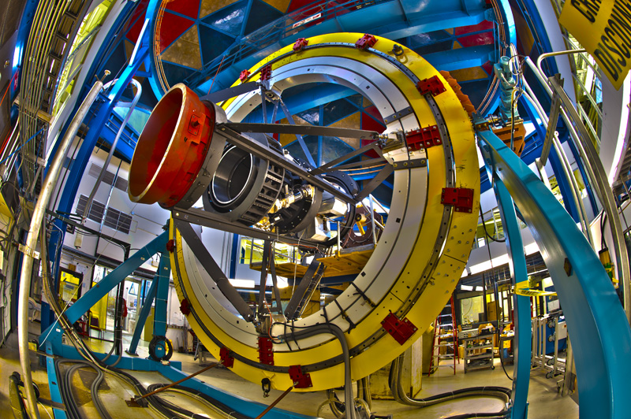

Above: Components of the Dark Energy Camera being tested at Fermilab in a full-scale simulator of the top end of the 4-meter-diameter Blanco telescope. Below: the back end of the camera, showing electronics and cryogenics systems surrounding the focal plane dewar.

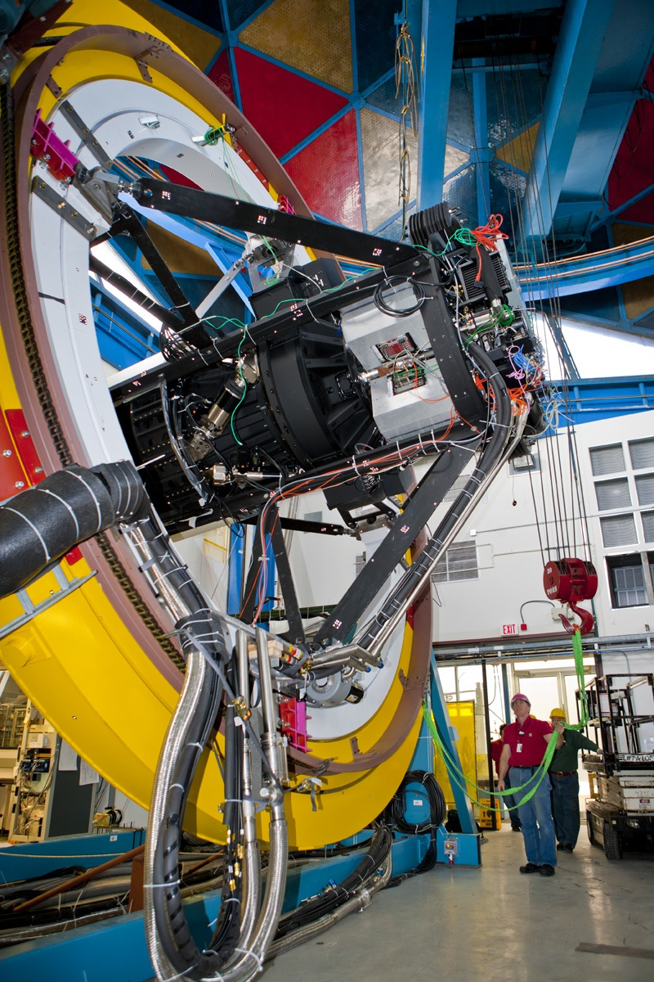

smith-blanco-sky.tiff

Above: the 4-meter Blanco telescope at Cerro Tololo in Chile, where the Dark Energy Camera is being installed for the survey.

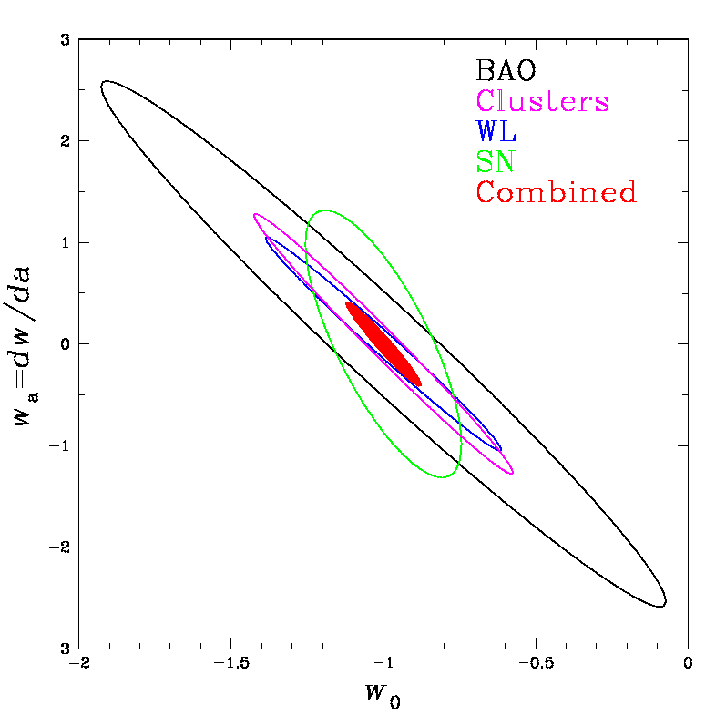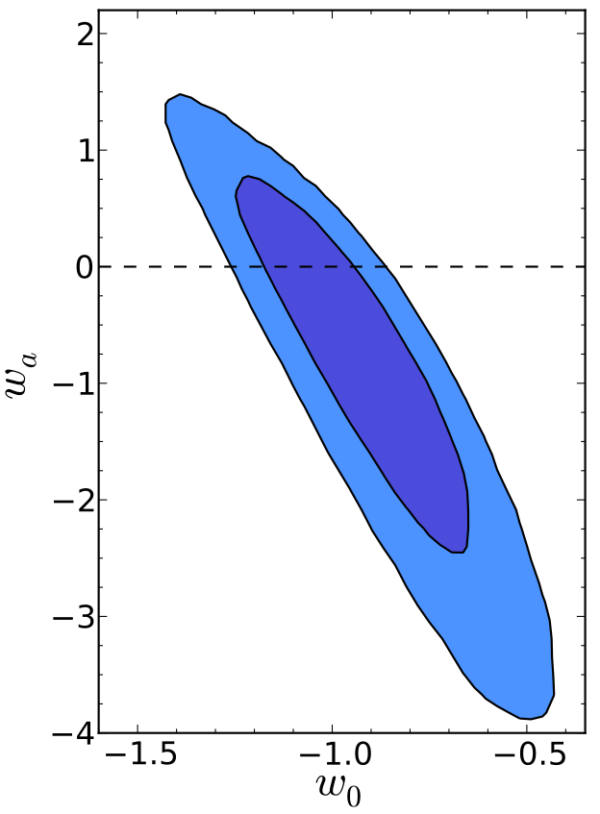

Above: Sensitivity of the Dark Energy Survey to equation-of-state parameters of Dark Energy: *w* denotes the ratio of mean pressure to density of the cosmic vacuum state, and *wa,* its derivative with respect to cosmic scale factor. Left plot shows error contours predicted to be achieved by the various techniques used by the Dark Energy Survey, separately and together. Right plot shows current limits (2011) on the same scale, showing the much larger uncertainties. Planck Surveyor priors are assumed in both cases.

The deep DES sky survey will be even more powerful if spectra are obtained of many of its galaxies, providing precise velocity and 3D position information. Fermilab and collaborators are developing technology to build a system that will obtain thousands of spectra at once. The goal is to create a catalog of 10 to 100 million spectra, a high-fidelity 3-dimensional map of the cosmic web of galaxies over most of its history, and provide exquisitely sensitive probes of dark energy effects on structure growth over time.

After DES, the next big upgrade in cosmic surveys is the Large Synoptic Survey Telescope. Now in the final stages of planning and design, this project proposes to create a dedicated telescope and camera system to survey the universe significantly wider, deeper and faster than DES. Fermilab is part of a consortium of institutions developing this project, which should start its survey near the start of the next decade.

*Dark Matter*

Astronomers established long ago that the mass whose gravity holds galaxies and clusters together far exceeds the amount of mass in normal atoms in any detectable, visible form, such as stars or gas. It has long been suspected that galaxies are bound by the gravity of invisible “dark matter”, made of some new kind of elementary particle left over from the early universe. A leading theoretical hunch, based on Big Bang cosmology and natural extensions of Standard Model physics, is that the dark matter is made of Weakly Interacting Massive Particles, or WIMPs. These hypothetical particles weigh more than atomic nuclei but are dark because they do not interact with light at all; like neutrinos, they interact only by the weak force and gravity. There is hope that some of them might one day be produced in accelerators such as the LHC, but they have never been detected directly.

Fermilab is a leader in the worldwide hunt for these particles, and plays a major role in four kinds of experimental search. These experiments all seek to detect the very rare instances where dark matter particles interact with nuclei of ordinary matter, in deep underground, very low background detectors. Fermilab is a lead laboratory in the Cryogenic Cold Dark Matter Search (CDMS and SuperCDMS), using silicon and germanium crystals; the Chicagoland Observatory for Underground Particle Physics (COUPP), using bubble chambers; and Darkside, using a liquid Argon detector similar to that being developed for Fermilab’s long baseline neutrino experiments. These experiments are deployed deep underground around the world, at the Soudan mine in Minnesota, SNOlab in Sudbury, Ontario, Canada, and Gran Sasso National Laboratory in Italy. In addition, a new technology based on CCD detectors (DAMIC), currently under development at Fermilab, aims to detect very low mass WIMPs.

So far, no experiment has made a confirmed detection of dark matter particles. The current generation of modest-scale experiments is already setting interesting limits on particles with properties favored by the favored theoretical extensions of Standard Model physics based on supersymmetry. In the near future, the next generation of experiments, with larger detector masses, and better control over particle backgrounds, will be able to either detect these particles for the first time--- revealing a new kind of matter and opening a new way to study the universe--- or to exclude many of the theoretical ideas that lead to the WIMP hypothesis. Eventually, some of these technologies will be deployed with about a ton or more of detector mass, leading to a conclusive test.

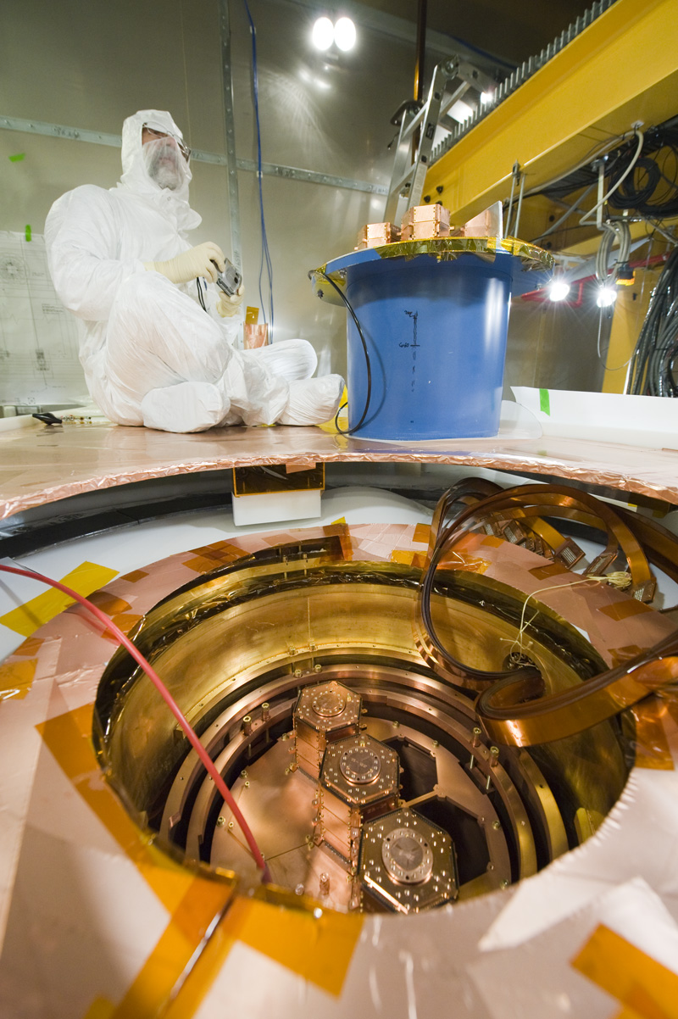

Fermilab scientist Dan Bauer during assembly of CDMS detector system in the cryostat at Soudan mine in Minnesota.

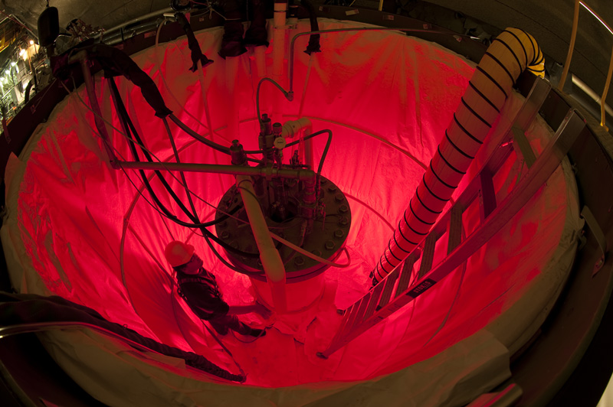

Fermilab scientist Andrew Sonnenschein with the COUPP 60-kg bubble chamber.

*High Energy Cosmic Particles*

The universe accelerates particles to energies far greater than human-made accelerators can. Although the highest energy particles are extremely rare, they can be studied by large arrays of detectors. Their composition, interactions, and natural history provide a unique window into high energy particle interactions, as well the exotic and extreme sources in the universe that accelerate them in the distant universe.

Fermilab is the lead laboratory supporting the Pierre Auger Observatory in Argentina, the world’s leading facility for studying the highest energy cosmic rays. When an ultra high energy cosmic ray enters the upper atmosphere, it collides with an atomic nucleus and generates a spray of many more particles, creating a cascade that can be seen as visible flash of fluorescent light in the night sky. PAO records these flashes, and also studies particles with a large array of ground detector tanks to detect electromagnetic particles of the showers that reach the ground. Auger’s international collaboration has published many pathbreaking results on the composition, interactions, anisotropy, and spectrum of these extraordinarily energetic and rare particles. These particles have interactions in the center of mass frame with energy 100 times larger than those at CERN’s Large Hadron Collider. The highest energy events can be statistically traced back to their sources on the sky, the nuclei of distant galaxies.

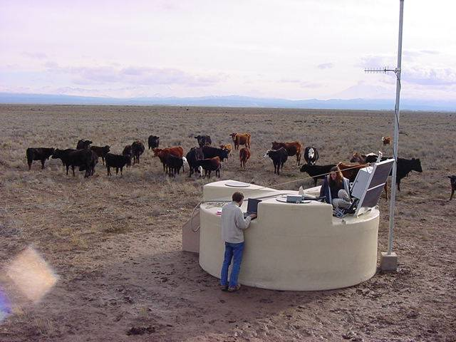

One of 1600 water tanks that are part of Pierre Auger Observatory.

*Quantum Spacetime*

Fermilab pursues laboratory experiments that search for effects of new physics beyond the energy reach of any accelerator, including new kinds of particles with ultra-weak interactions, and even the quantum behavior of space and time itself.

Fermilab’s goal is to take experimental physics to the Planck scale, the deepest layer of reality we can talk about with the tools of conventional physics. The Planck scale is special because it defines the intersection of two realms of physics: the quantum world, which describes the particle/wave behavior of all forms of mass and energy, and spacetime physics or relativity, which describes the space and time within which the mass and energy move and transform.



[Above: A simple plot showing the meaning of the Planck scale. Log of length is plotted against log of mass-energy. At upper left, the equation relating wavelength and energy for a quantum particle, Einstein’s photoelectric formula. At upper right, the equation relating the radius and mass of a black hole, predicted by Einstein’s theory of spacetime. These two realms cross at the Planck scale; experiments beyond the Planck scale probe a deeper level of quantum spacetime. ]

Planck-energy particles are impossible to study by conventional and direct means, such as particle accelerators, because they have such a high energy--- about 1016 TeV. At Fermilab we are developing an experiment, called the Fermilab Holometer, that seeks to study new Planckian physics in a less direct way, by detecting directionally coherent quantum noise in spacetime position. With collaborators from the gravitational wave community, Fermilab is developing this new experimental capability using intense, ultrastable laser cavities and interferometers. (Similar technologies can also be applied, together with Tevatron magnets, to search for certain new kinds of very weakly interacting “axion-like particles”.)

The target precision of the Fermilab Holometer is set by the Planckian amplitude of predicted “holographic noise” in spacetime. If holographic noise exists, it causes the difference of position compared in two different directions to wander randomly, by about a Planck length every Planck time. Although the Planck length itself is far too small to see directly, the effect of the accumulated wandering over the light crossing time of the 40-meter apparatus--- tens of attometers in a fraction of a microsecond--- can be detected. The holometer will find out whether or not such noise exists in nature. If it does, it will be our first experimental glimpse beyond spacetime as we know it.

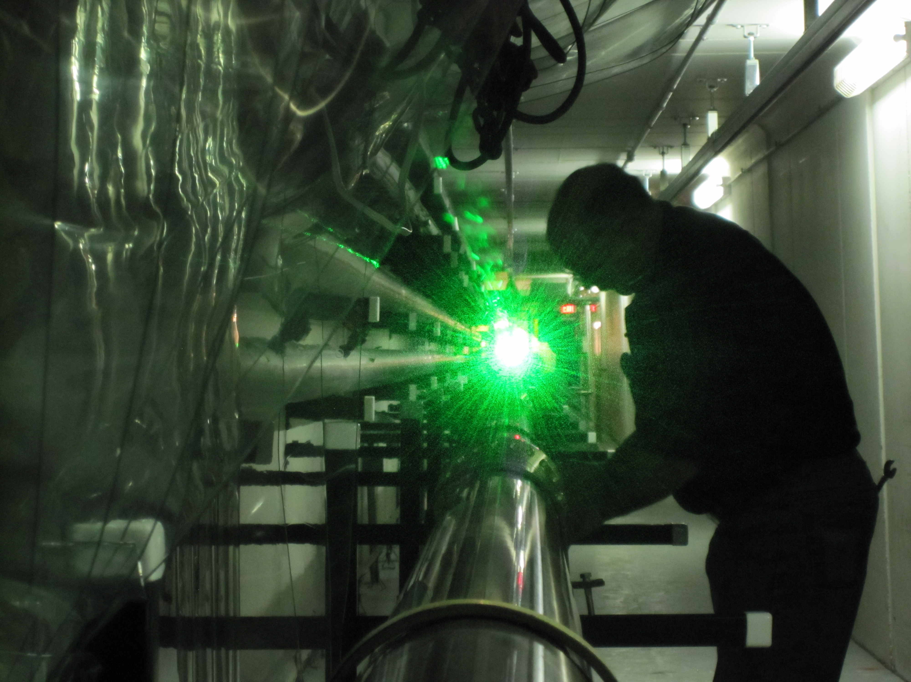

Fermilab scientist James Volk aligns a 40-meter prototype laser cavity for the Fermilab Holometer.