Chapter 4. Physics at the Intensity Frontier
The Standard Model of Particle Physics succeeds brilliantly at explaining the nature of the physical universe, but it leaves many open questions. Despite the development of myriad intriguing theories to address these questions, ultimately only experiment can light the way to discovery. In our own time, experiments at the energy frontier can search directly for new phenomena beyond the Standard Model. Alongside the compelling physics of Terascale explorations at the LHC and the ILC, another window on discovery has opened with the remarkable recent developments in neutrino science and with the ability to detect new physics phenomena in ultrarare events or in the small perturbations they induce in other processes. This chapter focuses on accelerator-based opportunities at the intensity frontier. Experiments in symmetry-violating processes and rare decays can provide windows into new mass scales of many thousands of TeV. Neutrino experiments may tell us about physics at even higher energies near unification or about an entirely new source of CP violation that may help explain the excess of matter over antimatter in the universe.

4.1 Neutrino science
An upgrade to the Fermilab proton complex could greatly enhance the laboratory's current world-class program of neutrino science by strengthening Fermilab's flagship program of long-baseline neutrino-oscillation experiments. It would provide for a next-generation experiment to discover CP violation in the leptonic sector, and consequently to explore leptogenesis as the source of matter-antimatter asymmetry in the evolution of the universe. The upgrade would also provide an opportunity for new, smaller-scale experiments using intense neutrino beams generated by 8 GeV and 800 GeV protons that would complement the long-baseline program.
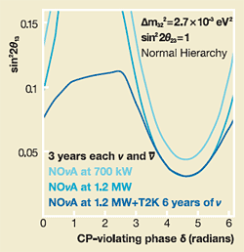
Sensitivity to mass hierarchy
Ability of NOνA and NOνA plus T2K experiments to resolve mass hierarchy at 95 percent confi dence level.

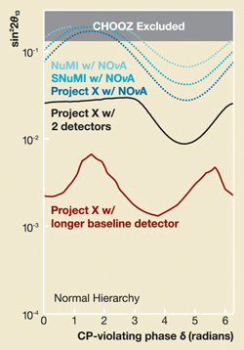
Sensitivity to mass hierarchy
Ability to resolve mass hierarchy at 95 percent confidence level (dotted lines) and 3σ (solid lines) of potential future Fermilab experiments. See details in Appendix C.

4.1.1 Long-baseline neutrino oscillations
The Neutrino Scientific Assessment Group, convened by HEPAP and the Nuclear Science Advisory Committee, and a study group originally commissioned by Fermilab and Brookhaven National Laboratory have recently studied and documented the physics opportunities of long-baseline neutrino experiments. As laid out by NuSAG, this accelerator- based program has as its primary goals to complete our understanding of neutrino mixing and oscillations, in particular to determine the ordering and splitting of the neutrino mass states, to measure the mixing angles and to determine whether there is CP violation in neutrino mixing¹. The study of CP violation in neutrino oscillations is especially compelling because CP violation in the leptonic sector may help explain the very fundamental problem of the matter-antimatter asymmetry of the universe through the process known as leptogenesis. Together, the Japanese T2K experiment and NOνA will begin to explore CP violation in neutrinos. Discovering the ordering of the neutrino mass states—the mass hierarchy—will help determine whether neutrino mass is related to the unification of the forces and whether neutrino oscillations violate CP symmetry. It may be key to interpreting the outcome of neutrinoless double-beta-decay experiments. Provided that neutrino mixing is large enough, the ability of the NOνA experiment to determine the ordering of the neutrino mass states makes the U.S. long-baseline neutrino program unique in the world.
Experiments to address these neutrino science goals will require both powerful beams and very large detectors, with the product of beam power and detector mass more than an order of magnitude larger than NOνA-generation experiments. Such "Phase II" experiments will require intense muon neutrino beams, regardless of detector technology and regard- less of whether the detector has an off-axis or wide-band beam energy configuration. The discovery potential of these experiments will greatly benefit from higher proton beam power (thus higher neutrino flux) and greater flexibility of beam energy than is presently planned.
The proposed Project X would provide 2 MW or more in the range of proton energy between 50 GeV and 120 GeV. Compared to the NuMI proton plan for NOνA, it would supply approximately a factor of seven higher power at 50 GeV and a factor of three higher power at 120 GeV. Project X's flexible beam energy and higher beam power, combined with the longer baselines of Phase II oscillation experiments such as those at the proposed Deep Underground Science and Engineering Laboratory, 1300 km from Fermilab, would confer impressive sensitivity to the neutrino mass hierarchy and CP violation.
A detector for a Phase II neutrino oscillation experiment, if located in the National Science Foundation's DUSEL, would also be a world-class detector for proton decay, addressing the question Do all the forces become one? This detector could also perform high-statistics studies of atmospheric neutrinos and carry out astrophysical searches including detection of relic-supernova neutrinos and neutrino bursts from supernovae in our galaxy and nearby.
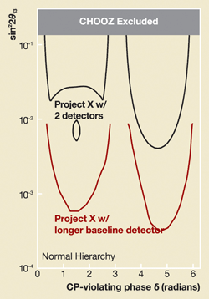
Sensitivity to CP violation
Sensitivity to CP violation at 3σ confidence level of potential future Fermilab experiments. See details in Appendix C.

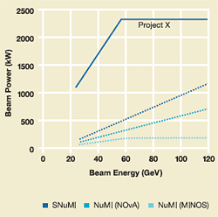
Proton beam power
Beam power versus beam energy for possible proton facilities at Fermilab.
The physics reach and competitiveness of the near-term NOνA experiment would also improve with SNuMI, an upgrade of NuMI that would increase 120 GeV proton power to 1.2 MW. (SNuMI's beam power with 50 GeV protons would be approximately 400 kW.) SNuMI would support a neutrino program that would be both competitive and complementary to the T2K program based on the Japanese Proton Accelerator Research Complex. The SNuMI beam power is roughly 60 percent higher than that planned for Phase I of the J-PARC facility, and would remain competitive at least through the latter half of the next decade, depending on upgrades undertaken at J-PARC. Project X would markedly increase NOνA's sensitivity to the mass hierarchy and, with a Phase II experiment, would likely exceed the capabilities of the J-PARC facility (see Appendix C).

4.1.2 Neutrino physics with 8 GeV and 800 GeV protons
The Booster neutrino beam generated by 8 GeV protons offers opportunities for neutrino studies beyond the existing experiments MiniBooNE and SciBooNE. In addition, experiments using high-energy neutrinos produced in a Tevatron fixed-target neutrino beam line would become possible if the Main Injector can provide sufficient 50-120 GeV protons both to feed the long-baseline neutrino program and to generate 800 GeV protons in the Tevatron. Some possible future experiments (see Appendix D) include:
Using 800 GeV protons
- an experiment to precisely measure the weak mixing angle.
Using 8 GeV protons
- an experiment to study low-energy neutrino interactions for neutrino-oscillation experiments such as MiniBooNE, NOνA and T2K, and to develop liquid-argon detector technology,
- an experiment to measure the strange quark contribution to the nucleon "spin."
The ability to conduct these experiments depends on the flexibility of the accelerator complex. Beam power at 8 GeV is currently available for Booster neutrino experiments, because NuMI cannot use all Booster pulses for the long-baseline neutrino program. This situation will continue with the NOνA program. The SNuMI design, however, will be capable of using all Booster pulses for running NOνA at higher intensity, leaving none for neutrino experiments at the Booster. Alternatively, the Booster neutrino beam can run simultaneously with SNuMI at a tax of approximately 15 to 20 percent on the NuMI beam. Project X, on the other hand, could deliver substantial 8 GeV beam power (an order of magnitude more than is currently available) to experiments without a tax on NuMI. An experiment with an 800 GeV proton beam would impose approximately a five percent tax on NuMI for both Project X and SNuMI. Proton-source upgrades, particularly Project X, make possible a stronger neutrino-science program.
¹ The long-baseline program could also unveil exotic effects due to sterile neutrinos, extra dimensions and dark energy.

4.2 Precision physics
Ultraprecise experiments using high-intensity sources of muons and quarks provide unique discovery potential. These experiments would complement those at the LHC as well as those in the worldwide program of neutrino science and precision physics. Results from these experiments would provide essential clues for interpreting discoveries and their implications for the great questions of particle physics.

4.2.1 Muons
Lepton flavor violation was discovered in neutrino experiments, where the three flavors of neutrinos are observed to morph, or oscillate, into one another. Physicists do not know why LFV occurs or if it is related to the flavor violation seen with quarks or to new phenomena at the Terascale. A key question is whether LFV also occurs with the charged leptons: electron, muon and tau. Theoretical models that incorporate ideas such as unification, supersymmetry or heavy-neutrino mixing predict charged LFV at rates that could be within reach of new experiments. Combined with results from neutrinos and the LHC, these experiments could point the way to leptogenesis or unification.
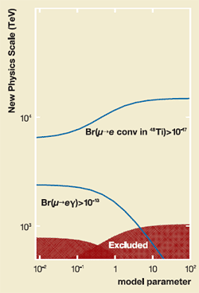
μ-to-e conversion sensitivity
Comparison of the sensitivity to lepton flavor violation of the MEG (μ→eγ ) experiment at a transition rate of 10⁻¹³ and a μ-to-e conversion experiment with Fermilab Booster at the rate of 10⁻¹⁷. Project X could reach the rate of 10⁻¹⁸. See details in Appendix E.
A new experiment could search for the direct coherent conversion of muons into electrons in the field of a nucleus. This muon-to-electron conversion experiment could detect LFV decays even if they occur at 10⁻¹⁷ the rate of standard muon processes. It would probe several distinct LFV processes. If a signal is detected, a μ→e conversion experiment could zero in on the new physics by repeated measurements with different nuclear targets. This experiment would have sensitivity to very high energy scales, beyond the direct reach of colliders.
The Muon-to-Electron-Gamma experiment at the Paul Scherrer Institute will soon begin to look for the LFV process μ→eγ, with predicted sensitivity at the 10⁻¹³ level. A μ→e conversion experiment at the 10⁻¹⁷ level would have greater sensitivity to the μ→eγ transition than MEG, and orders of magnitude better sensitivity for more general LFV processes. Other approaches to LFV using taus are not expected to have comparable sensitivity, due to the available flux of taus, which is much less than that of muons, and to the greater cleanliness of the muon experiment.
A μ→e conversion experiment at Fermilab could be 10,000 times more sensitive than previous experiments. An intense 8 GeV proton beam and the Accumulator and Debuncher rings, available after the end of antiproton production for the Tevatron collider program, would make this LFV search possible. The SNuMI accelerator upgrades would increase the total proton flux at 8 GeV, allowing a modest increase in beam power for the muon program while also increasing the beam power available to the neutrino program. Project X could increase the beam power available to the muon program by a factor of 10. Exploiting this increased intensity and a reoptimized muon beam (e.g. decreased energy spread and transverse beam size) has the potential to further improve sensitivity beyond that possible with the SNuMI upgrades.

4.2.2 Kaons
Theories of Terascale physics typically predict new contributions to flavor-violating processes involving quarks. New particles predicted by Terascale physics are expected to have flavor- violating and CP-violating couplings. Experiments at B factories or elsewhere have unexpectedly found no clear signals of such contributions. These results favor theoretical models with minimal flavor violation. The data suggest a strategy of concentrating on rare processes that are as theoretically and experimentally clean as possible, to maximize the sensitivity to small contributions from new physics.
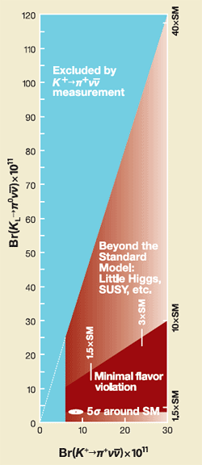
K→πνv sensitivity
Project X experiments based on 1000 Standard Model events could probe Terascale physics with greater than fi ve sigma sensitivity.
The ultrarare process K→πνv is the most promising opportunity for implementing this new strategy. The neutral K→πνv decay is extremely suppressed in the Standard Model and has not yet been observed. It is a clean, purely CP-violating process, with a Standard Model theoretical uncertainty no larger than two percent. A phased program at KEK and then J-PARC may eventually detect about 100 of these rare decays. The physics reviewed above shows the importance of a new experiment with the ultimate capability to detect about 1000 neutral decays, achieving a statistical error that approaches the theoretical uncertainty. Such an experiment would be even more powerful if combined with a precision measurement of charged K→πνv decays, which are also highly suppressed in the Standard Model and have a modest theoretical uncertainty.
Such experiments would be sensitive to new sources of CP violation involving quarks. They would also be sensitive to flavor-violating effects from new particles, even in cases where the only source of CP violation is the CKM phase of the Standard Model. Either way, rare kaon decays offer a unique window on these phenomena. For example, if superpartner particles are discovered at the LHC, kaon experiments could address such fundamental questions as distinguishing among different mechanisms for the breaking of supersymmetry.
Other rare kaon-decay modes offer opportunities for major surprises. They include possible detection of the lepton-flavor-violating decays K→πμe or K→μe, and exotic decays of kaons into axions or gravitons.
The high-intensity 8 GeV proton facilities and the Tevatron Stretcher concept described in the next chapter represent a potential for a breakthrough in ultrarare kaon-decay experiments. They would provide kaon beams at Fermilab of unprecedented purity and intensity. Discovery sensitivities would benefit from increased kaon beam power. Project X's ability to optimize kaon beam characteristics would simplify the experiments and reduce technical risk.

4.2.3 Charm and hyperon physics with antiprotons
Fermilab operates the world's most intense antiproton source, a distinction it will continue to hold even after the planned 2014 startup of the Facility for Antiproton and Ion Research in Germany. The anticipated shutdown of the Tevatron collider program presents the opportunity for a world-leading low- and medium-energy antiproton program capable of studying a range of physics questions with unequaled sensitivity: hyperon CP violation and rare decays, charm mixing, the charmonium spectrum and recently discovered nearby states, and CPT and antimatter-gravity tests with antihydrogen.

4.3 Summary
At the intensity frontier, the fields of neutrino science and precision physics offer promising pathways to physics breakthroughs not accessible to the LHC, the proposed ILC or nonaccelerator physics. In neutrino science:
- On the near horizon, NOνA will be the only experiment with sensitivity to the ordering of neutrino mass.
- The joint power of the Japanese T2K experiment and NOνA will begin to explore CP violation in neutrinos.
- In the post-NOνA era, a longer-baseline neutrino program with Project X and a very large detector would have unique capabilities to resolve neutrino-mass ordering. This program would remain unique even in the presence of the contemplated Japanese program with a very large detector in the Kamioka mine, fed by a multi-MW proton beam from J-PARC.
- By making possible 2 MW proton beams at any energy between 50 and 120 GeV, Project X would create the flexibility to have excellent neutrino physics reach with either wide-band or off-axis beams.
- Project X, with a very large detector in the proposed DUSEL, would greatly enhance neutrino science.
- A post-T2K Japanese neutrino oscillation program would work at a different energy and a different baseline from its U.S. counterpart. Together, these two programs could make discoveries not accessible to either one alone.
In precision physics:
- Lepton flavor violation in muon decays offers a new window on physics beyond the Terascale, including leptogenesis and unification.
- A muon-to-electron conversion experiment at Fermilab would have unprecedented sensitivity and provide the ability to zero in on the origins of lepton flavor violation.
- New sources of flavor and CP violation predicted by Terascale physics have yet to be detected. Rare kaon decays offer a theoretically clean method of searching for these phenomena.
- Project X would provide the opportunity for an experiment to detect 1000 neutral and charged K→πνv decays, offering a unique level of clean sensitivity to flavor- or CP-violating effects from Terascale physics.
What are neutrinos telling us? How did the universe come to be? Are there undiscovered principles of nature? What happened to the antimatter? Do all the forces become one?
An intensity-frontier program that provides unique experiments to address these profound questions of 21st-century physics would serve many scientific users. It would prepare future generations of U.S. particle physicists to exploit the potential of accelerator-based scientific opportunities in the U.S. and worldwide. At the intensity frontier, Project X would help pave the way to the extremely powerful energy- and intensity-frontier facilities—a neutrino factory and a muon collider—of the long-term future beyond the ILC.

