Chapter 1. Executive Summary: A Plan for Fermilab
As the national particle physics laboratory, Fermilab’s mission is to enable the U.S. scientific community to tackle the most fundamental physics questions of our era, and to integrate universities and other laboratories fully into national and international particle physics programs. Fermilab provides the only accelerator facilities in the United States for particle physics research. Particle physics is a central component of the physical sciences, focused on the fundamental nature of matter, energy, space and time. Discoveries in particle physics change our basic understanding of nature. For the U.S. to remain among the leaders in this field of science, it must maintain a laboratory that builds and exploits new facilities in partnership with universities and other national and international laboratories. Facilities for particle physics are global and ever more challenging to design, build and operate. A laboratory with a singular focus and consolidated particle physics facilities will give the U.S. a competitive advantage in the future.
The Standard Model of particle physics provides a remarkably accurate description of elementary particles and their interactions. However, experiment and observation strongly point to a deeper and more fundamental theory that breakthroughs in the coming decade will begin to reveal. To address the central questions of particle physics and thus to deliver on the missions of the Department of Energy’s Office of High Energy Physics, Fermilab uses a range of tools and techniques at the three interrelated frontiers of particle physics:
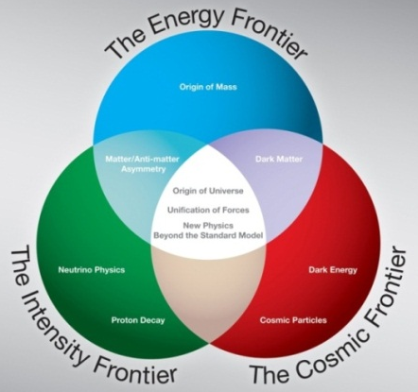
- The Energy Frontier, where high-energy particle colliders are used to discover new particles and directly probe the architecture of the fundamental forces of nature.
- The Intensity Frontier, where intense particle beams are used to uncover properties of neutrinos and observe rare processes that will tell us about new physics beyond the Standard Model.
- The Cosmic Frontier, where underground experiments and ground-based telescopes are used to reveal the natures of dark matter and dark energy, and high-energy particles from space are used to probe new physics phenomena.
These three approaches ask different questions and use different techniques, but answers to challenging questions about the fundamental physics of the universe will come from combining powerful insights and discoveries at each of the three frontiers. Fermilab’s scientific program supports the U.S. scientific community with world-leading research at all three interrelated frontiers of particle physics.
At the Energy Frontier, after a very successful 26 year program, Fermilab’s Tevatron collider and the CDF and DØ experiments will end data taking in September 2011. Fermilab’s accelerator, detector, computing and physics facilities support the ongoing LHC program. Fermilab is the principal U.S. contributor to the LHC accelerator and the CMS detector, and is the headquarters of the U.S. CMS collaboration. Fermilab’s Remote Operations Center and LHC Physics Center make the participation of U.S. institutions in the LHC and in CMS more effective, enhancing U.S. leadership in LHC science. Fermilab is a world-leading institution in the development of accelerator technologies for future lepton colliders such as the International Linear Collider and the Muon Collider.
In designing the laboratory strategy for the post-Tevatron era we need to meet the following criteria:
- Address timely, exciting questions
- Be bold and establish world leadership in at least one domain
- Attract partners to leverage our investments through international collaboration
- Fit within a global strategy for the field and within a realistic profile for U.S. funding
- Be robust enough to adapt to both physics discoveries and funding fluctuations
An analysis of the world’s particle physics program leads us to the conclusion that the greatest opportunity for U.S. leadership lies in experiments driven by high intensity proton beams at the Intensity Frontier. In this area we are sensitive to physics beyond the Standard Model up to energies much greater than the direct reach of the LHC. The most intense proton source enables the best set of neutrino experiments. The discovery of neutrino oscillations was the first experimentally observed phenomenon that departed from the very successful Standard Model of particle physics. This discovery strongly suggests a connection between neutrino physics and physics on a very high mass scale and identifies a number of key questions that could open a path to new discovery. These neutrino experiments would greatly increase our understanding of this still mysterious sector. Whether the LHC is physics “rich” or physics “poor” we need to connect the interpretation of the LHC results to lower energy quark and lepton processes where the same effects are visible as very rare transitions. These rare processes and precision measurements would be enabled by high intensity proton beams.
The Fermilab strategy is to fully exploit and expand the capabilities of the existing accelerator complex to enable world-leading experiments at the intensity frontier, including precision muon and neutrino experiments. Central to this strategy is a coordinated attack on some of the most important questions neutrino physics. Upgrades to the Main Injector complex, which already delivers the world’s most powerful high-energy neutrino beam to the MINOS and MINERvA experiments, will double the available beam power for the NOvA experiment, currently under construction. The flagship of this program will be the Long-Baseline Neutrino Experiment (LBNE), which will have unrivaled capability to search for and measure CP violating effects in neutrino oscillations. LBNE will be designed to able to take advantage of even higher beam power, when it becomes available -- up to an order of magnitude larger than currently available.
To increase the beam intensity further, Fermilab will build a high intensity continuous wave superconducting linac and to couple it to the rest of the existing Fermilab accelerator complex. We call it Project X. The design and construction of Project X will take at least the rest of the decade. When completed it will drive LBNE with ten times the flux of the present Fermilab NuMI beam, short baseline neutrino experiments with ten times current fluxes, and kaon, muon and EDM experiments with fluxes that are two orders of magnitude greater than the current capabilities. To get there we need to manage the transition from 26 years of Tevatron Collider operations to the world’s leading program at the Intensity FrontierDuring the Project X era the beam intensity up to 3 GeV would be a factor of a hundred greater than the present complex.
Project X would substantially re-use existing facilities such as the Main Injector and Recycler Ring, infrastructure that would be very costly to reproduce elsewhere. We have aligned the technology of Project X to the ILC superconducting technologies so that the project benefits from the advances developed by the ILC community. We have also placed a requirement that it should be usable with well understood improvements as the front end of a neutrino factory or a muon collider, thus allowing for the very long range development of the complex. The alignment of technology with the ILC also means that by developing Project X we will be in a position to take a leadership role if the ILC is eventually built.
Design of Project X, a multi-megawatt high-power proton facility. With unique capabilities and flexibility, Project X would support multiple world-leading experiments simultaneously at the Intensity Frontier.
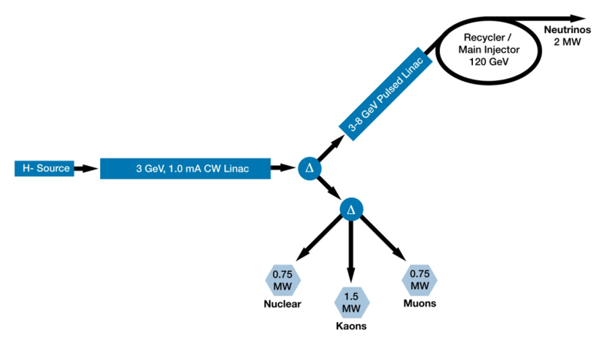
At the Cosmic Frontier, Fermilab has been the anchor laboratory for world-leading experiments. They include the Sloan Digital Sky Survey (SDSS) and the Dark Energy Survey (DES) that probe the properties of dark energy; the Cryogenic Dark Matter Search (CDMS) and the Chicago land Observatory for Underground Particle Physics (COUPP) that search for particles of dark matter; and the Pierre Auger Observatory that studies the source and nature of ultra-high-energy cosmic particles. Fermilab plans to continue a leading role for the following generation of experiments at the cosmic frontier.
Theoretical work in particle physics and particle astrophysics are an essential part of the laboratory. Theorists guide the development of experiments and elucidate their results, emphasizing the connection between theory and experiment to advance cutting-edge science.
As Fermilab addresses the defining questions in particle physics and delivers the DOE’s high energy physics mission, it pays special attention to educating future generations of scientists. Fermilab trains about 250 postdoctoral fellows and 540 graduate students each year, resulting in more than 100 Ph.D. degrees awarded each year based on research performed at laboratory facilities. Fermilab contributes to science, technology, engineering and mathematics (STEM) education with a broad program for undergraduate university students and K-12 students and teachers.

