Dipole Survey and Alignment of NSLS II*
M. Ke#, S. Seiler, F. Karl, M. Ilardo, C. Yu, R. Hubbard, D. Davis,
S. Pop, L. Borak, D. Gordon, E. Ulrich, R. Craig, BNL, Upton, NY, 11973, US

Abstract
NSLS-II project requires ±100 micron alignment accuracy between girders. There are 60 dipole girders totally which have the magnet gap width of either 35 mm or 90 mm. The work associated with dipoles can be categorized as pre-survey portion and alignment portion. The pre-survey of dipoles includes mechanical frame establishment, manufacturing dimension and vacuum clearance verification. There are 3~4 laser tracker setups in order to capture all the information needed. Pole tips are the major references. Measurement Plan (MP) was developed to streamline the computation process which has been proven to be effective. The alignment activities include the positioning of dipole relative to magnetic measurement system and tunnel alignment. The dipole survey and alignment is ongoing and has been carried out smoothly.

Introduction
The storage ring of NSLS-II has a 30 superperiod DBA (double bend achromat) structure, 3.0 GeV energy, 792 m circumference and a beam emittance of 0.6 nm-rad [1].
There are 1,040 magnets for storage ring in which the quantity of bending dipoles is 60. The amounts of dipoles with a gap of 35 mm and 90 mm are 54 and 6 respectively.
Each Dipole is supported by one girder. Table 1 lists the alignment requirements in which dipole girders has the same tolerance comparing to multipole girders.
Table 1: Alignment Tolerances
Tolerances | Magnet to magnet | Girder to girder | Globally
Horizontal positioning | ± 0.030 mm | ± 0.10 mm | ± 3 mm
Vertical positioning | ± 0.030 mm | ± 0.10 mm | ± 3 mm
Longitudinal |  | ± 0.50 mm
Roll angle |  | ± 0.50 mrad
The required magnetic field and alignment tolerances are the two primary considerations to ensure acceptable dynamic aperture for the electron beam. Survey group provides precise alignment to dipoles both relative to hall probe and tunnel control network to address those considerations.

*Work supported by the U.S. Department of Energy under contract DE-AC02-98CH10886. This manuscript has been authored by Brookhaven Science Associates, LLC under Contract No. DE AC02-98CH1-886 with the U.S. Department of Energy. The United States Government retains, and the publisher, by accepting the article for publication, acknowledges, a worldwide license to publish or reproduce the published form of this manuscript, or allow others to do so, for the United States Government purposes.
#mke@bnl.gov

Dipole pre-survey
The goals of dipole survey are to establish a local frame which can be used for further alignment work and to confirm the dimensions and tolerances of its interface control drawing (ICD).
Compared with multipoles, the dipole dimension is bigger. Laser tracker, not articulated arm, with scanning capability is used to perform the survey.

Fiducials
The dipoles have 7 or 8 fiducial marks created by the manufacturer. These are 1/4” holes on the top surface of the dipole magnet. A circular area with the 50mm diameter around the fiducial holes is machined flat and left unpainted.

Measurement setup
Usually the dipole will be set up at least a day before measuring and should be done in one day to minimize the impact from settling and relative movement.
Magnet’s top fiducials and 8 magnetic nests spatially for 1.5” SMR are glued to the stable rackets and magnet supports and served as common targets.
When a dipole is ready to be inspected, there are 3~4 laser tracker setups in order to capture all the information needed, as shown in Figure 1. Common targets are measured during each setup to orient instruments. Unified Spatial Metrology Network (USMN) of Spatial Analyzer (SA) is used to get the optimal coordinates.

Observation
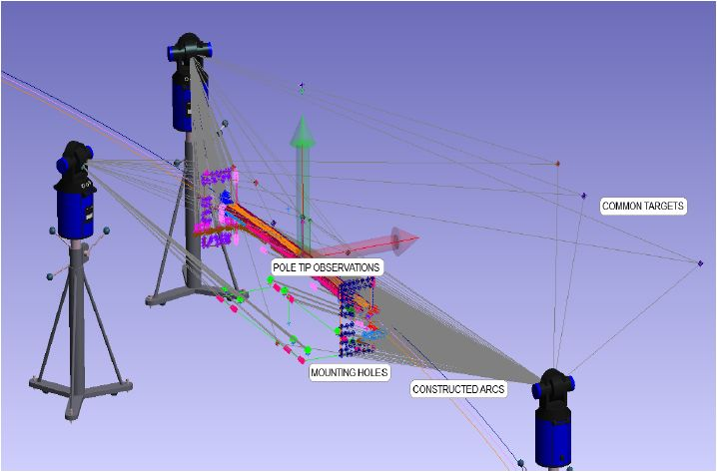
Figure 1: Dipole pre-survey setups.
Either 1.5” or 0.5” spherically mounted reflector (SMR) will be used depending on the features to be measured. The measurements include:
- Hundreds of points are measured on the pole surfaces that define the horizontal plane and can be used to compute the aperture of the dipole by use of the geometry triggered point mode to do scanning along the beam direction. Since the dipole pole surfaces have been machined, those points will be used primarily to define the frame.
- Using an edge nest for the SMR, points are measured on the upstream and downstream end of the top and bottom poles to control the beam longitudinal position.
- Two (for 35 mm dipoles) or four (for 90 mm dipoles) inboard and outboard circle points can be scanned to determine the bending circle.
- There are some points measured from upstream and downstream lamination planes and bottom base, mounting holes to check the ICD of dipole. There are also measurements to be taken at two ends, bottom, and radial direction of the coil to check the clearance of vacuum chamber.
- Inspection report is generated for each dipole. Discrepancy report will be submitted if the dimension is out of tolerance.
The inboard and outboard circle for 35mm aperture dipole can be easily obtained by 1.5” SMR, while it’s difficult for 90mm dipole. By use of edge nest to four groups of points the shape of circles can be characterized. The operator should make sure that the nest fits snuggly to the poles.

Frame establishment
The goal is to create a local Coordinate System (CS) that is tied to its outside fiducials. This CS is a premise for inserting dipole into the lattice and for reporting dimensions referenced in ICD.
The principle of definition the local frame for 90 mm and 35 mm gap dipole is the same. The following will take 90mm dipole as an example to illustrate how to establish the mechanical frame of dipole as shown in Figure 2 [2].

Points are constructed where each of these four circles intersected between the upstream and downstream yoke end planes. The four points on the upstream plane are averaged to become the US point and the DS point is created in the same way. A Center point can be generated by intersecting the four circles with the bisected end planes and averaging the generated points together.
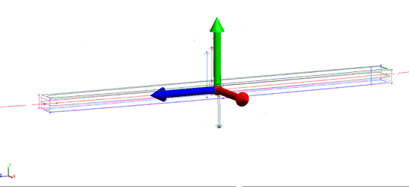
Figure 2: Dipole local frame establishment.
Using the US, DS, and Center points, a circle can be constructed to define the beam path. This beamline circle is fit through the three points, fixed to the nominal radius of 25019mm and projected to the horizontal middle plane. Now we have a circle with the nominal radius, parallel with the horizontal middle plane, and centered through the magnet by the edges of the poles. Due to the differences in orientation (roll and pitch) of the four circles fit to the pole edges, the beamline circle does not pass directly through the US, DS, and Center points. Instead, the deviation is divided equally.
The point where the beamline circle intersects the vertical middle plane becomes the origin for the CS. The primary axis is the normal direction of the horizontal middle plane to define the Y axis. The secondary axis to clock the X direction is defined by a line between the origin and the center of the beamline circle.
This frame created at the mechanical center of the dipole is the best representation of magnet geometry.

Data analysis automation
Spatial Analyzer is the software used to measure and process data. With the help of MP, repetitive measurement or computation tasks can be scripted to automatically analyze and report results. This functionality can greatly improve productivity by reducing analysis time while eliminating human errors.
The uniform interface and versatile functionality of the software is very helpful to the project. The data analysis for the dipole can be automated with MP. It has been proven to be very effective. Some measured elements of interest can be exported to excel directly and compared with the ideal values. Although the writing and debugging MP need some time, the result can be provided in a timely manner after the raw data is obtained.

Dipole align to hall probe
Dipole needs to be aligned to the Hall Probe (HP) bench for magnetic measurements (See Figure 3). In order to enhance magnetic measurement precision, the alignment goal of dipole relative to trajectory of HP is better than ±100 micron and the residuals of roll, pitch and yaw should be minimized.
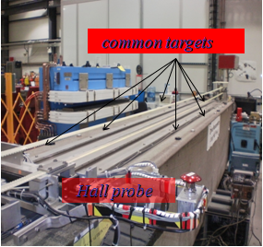
Figure 3: Magnet alignment relative to HP.
The main steps are listed in the following:
- HP frame was built at the beginning according to the movement of the probe and the supporting granite. The CS can be represented by the monuments glued on the granite surface as the common targets.
- Laser tracker will be used to measure the monuments to retrieve the HP frame and direct the adjustment of dipole.
- Use the watch window to get all the top fiducials zeroed in elevation direction. The small yaw residual is achieved by keeping the X reading of upstream and downstream fiducials almost the same.
- After adjustment, there will be 1~2 more laser tracker setups to verify the alignment precision.
- The alignment residuals will be reported to magnet group for further analysis.

Dipole installation
Dipole girder installation in SR will be a 2-step process as shown in Figure 4.
Dipole girder will be aligned relative to control network with about ±200 micron precision. Similar with the alignment of multipole girders, two trackers will be employed at the same time to streamline the adjustment process.
When the settlement of tunnel stabilizes and the environmental control are fully in action, multipole girders will be gone through a very precise girder profile reproduction process as reported in this workshop[3]. Along with that kind of activity, dipole girders will be re-aligned relative to the adjacent multipole girders and the girder alignment specification will be pursued and achieved.

Error estimate
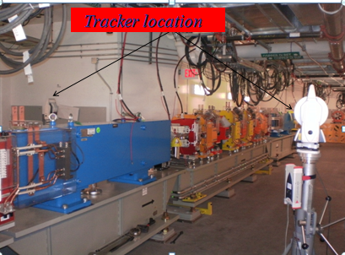
Figure 4: Tunnel alignment of dipole.
Dipole girder alignment error can be estimated based on the following error source:
- Pre-survey precision: ~± 50 micron.
- Tunnel control network: ~± 70 micron.
- Alignment residual: ~± 50 micron.
The final alignment precision is about ± 100 micron. As discussed above, in the future after multipole girders have been profiled, dipole will be re-aligned relative to the adjacent multipole girders to fulfill the girder-girder alignment requirement.

Summary
The pre-survey of dipole will establish a local frame and be used for further survey and alignment activities. Different from multipoles, the pre-survey is the final data to be used in tunnel which makes it more important.
The alignment of dipole relative to hall probe is seriously carried out to make sure a good relationship between them for obtaining the good and reliable magnetic measurement precision.
The dipole alignment in tunnel has been carried out smoothly with a ± 200 micron projected goal. There have been about 1/5 of the dipole girders aligned by the end of August, 2012. A more precise, relative alignment will be carried out to ensure the required ± 100 micron tolerance shortly before the scheduled commissioning, around May 2013.

References
[1] NSLS-II Preliminary Design Report, January 2008,
http://www.bnl.gov/nsls2/project/PDR/
[2] S. Seiler. Inter communication document
[3] C. Yu et al. NSLS-II girder profiling activities. Sep 2012, this proceeding.

