# Straight Line Reference System – Status Report on Poisson System Calibration

C. Schwalm, DESY, Hamburg, Germany

Abstract

For the Alignment of the European XFEL, a Straight Line Reference System will be used for minimizing refraction effects that affect the geodetic reference network. In recent years, a SLRS has been developed at DESY that is based on Poisson Alignment principles. A prototype has been built, and first tests have been performed. However, a decisive factor for system performance is a good system calibration. Several calibration methods, setups and algorithms have been developed and tested. The paper will outline our calibration efforts that are mainly based on a combination of Laser Tracker measurement, Photogrammetry and manual processing. The calibration process is explained step-by-step and first results are presented and interpreted.

## Introduction

The European XFEL, a facility with a total length of 3.4km, reaching from the DESY site in Hamburg to the neighbour town of Schenefeld, is currently under construction. The construction of the tunnels has been completed in 2012, commissioning is planned for the end of 2015 and research operation on the first beamline will start in 2016.

The Alignment of stretched structures like the European XFEL places high requirements on the survey methods, procedures and instrumentation. Especially optical refraction effects are considered to play a decisive role in survey error budget and accuracy. Unlike in circular structures, where the geodetic network can be closed to get a rough impression of the refraction errors that have cumulated, the refraction errors in stretched geodetic networks are not predictable and not detectable. Therefore, Straight Line Reference Systems are utilized to correct stretched geodetic reference networks for refraction effects.

In the European XFEL three SLRS will be used to fulfil the accuracy requirements for the Photon beamlines of 1 – 2 mm on a distance of 550 m. The total length of the SLR systems will range from 450 to 550 m. Each system starts at the first Undulator module and ends at the Bremsstrahlungscollimator.

## Poisson Alignment

### Poisson Principle

The basic principle of Poisson Alignment has been presented by Lee Griffith at the first IWAA workshop in 1989 [1]. Central element is a wide diameter laser beam, in which spherical targets are inserted. Two rigidly mounted spheres act as reference spheres and define the Straight Line in space. Additional spheres represent monitored points that are measured in relation to the reference line. Figure 1 depicts the Poisson principle.

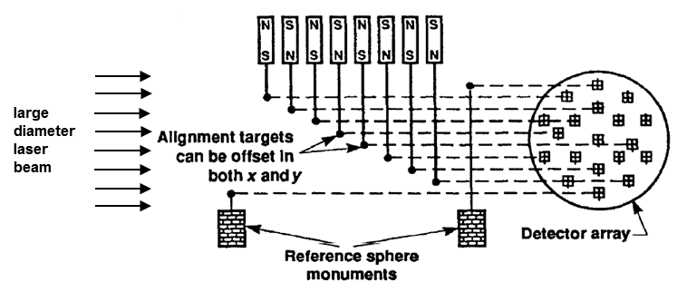

Figure 1: Poisson Principle [1]

Each spherical target creates a characteristic interference pattern on a detector array at the end of the measurement track, with a bright spot in its centre: Poisson’s Spot. Using cross-correlation techniques and artificially created patterns, which reproduce the central part of the interference pattern exactly, the spherical targets are measured and alignment information is derived. To improve the correlation result, a paraboloid is fit on the correlation maximum in order to achieve a subpixel solution.

### SLRS Prototype

During recent years, several prototypes have been developed to verify the Poisson principle, to test algorithms and system components and to evaluate system feasibility. The latest prototype, completed in 2010, has a total length of 48 m. The diameter of the vacuum chamber is 160 mm, which allows beam diameters up to 150 mm. In four measurement places targets can be introduced and tests / experiments performed.

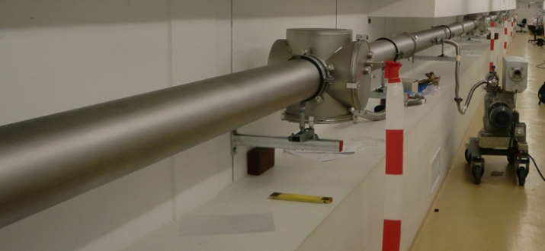

Figure 2: SLRS Prototype

A blue 405nm Diode Laser is utilized as light source which is fed into the vacuum chamber using an optical fibre. The fibre emits a spherical wave which is collimated to parallel light by an achromatic lens. At the end of the measurement track the laser beam is focused on a ½” CCD camera (1,600 x 1,200 pixels) by two plan-convex lenses (figure 3).

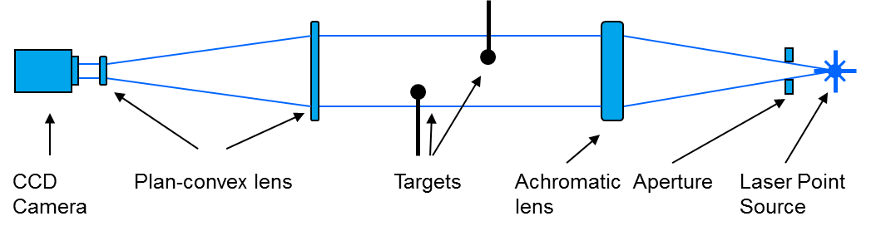

Figure 3: Optics Setup

First test results on the prototype are presented in [2].

### System Integration

Unlike as shown in Figure 1, where the SLRS spheres are directly connected to accelerator components, in this approach the SLRS will be used indirectly, providing correction parameters that are applied on the geodetic reference network (Figure 4). To do so, a connection between the reference network and the SLRS is necessary. When all SLRS points are determined in both systems (tunnel network and SLRS), the reference line and the alignment information for each measured point can be computed in both systems independently. Comparing the alignment information as derived from both systems, gives correction parameters for the geodetic network (in a refraction-free network the differences should tend to be zero).

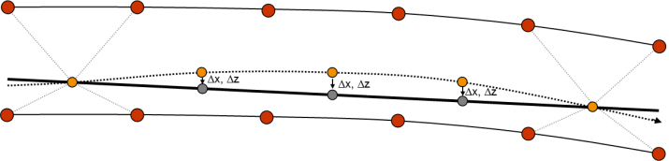

Figure 4: System Integration

For the connection of both systems, calibrated transfer pieces are utilized. These are vacuum flanges that are fitted with CCR fiducials on the atmosphere side and with the SLRS target sphere on the vacuum side (figure 5). By measuring the CCR fiducials, the SLRS sphere centre coordinates can be computed in the tunnel reference network system.

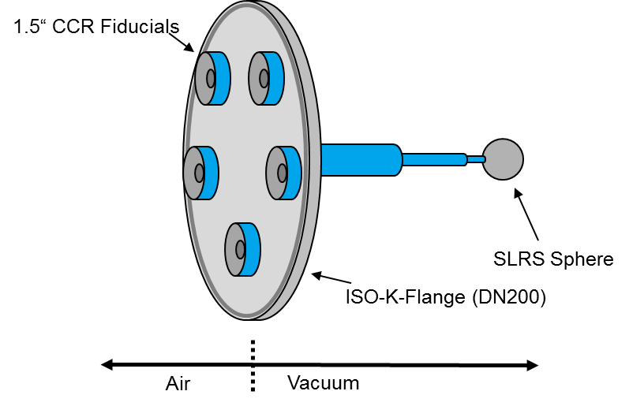

Figure 5: Transfer piece

## System Calibration

The main objective of the system calibration is to determine the transformation parameters that are needed to transform alignment information from the SLRS into the tunnel network system. For that purpose, two different transformation models have been selected for further testing. Closely linked to the calibration of the system, a system verification has to be conducted, in order to verify the calibration model and the measurement principles.

Ideally, a different, well-tested alignment system (e.g. WPS / HLS) is used as reference for the system verification. However, since suchlike systems are currently not available in the short term, for the first system verification a good laser tracker network (the 50 m prototype tunnel network) is used which is assumed to be refraction-free. The tunnel network is in a good approximation aligned with the SLRS laser beam axis. The 1st axis is aligned with the SLRS tube, the 2nd axis lies in the horizontal plane.

### Calibration in Theory

Figure 6 shows the actual alignment information as raw system output. Based on the reference line (R1-R2), coordinate offsets are computed for the measured points (Z1, Z2) in the image coordinate system.

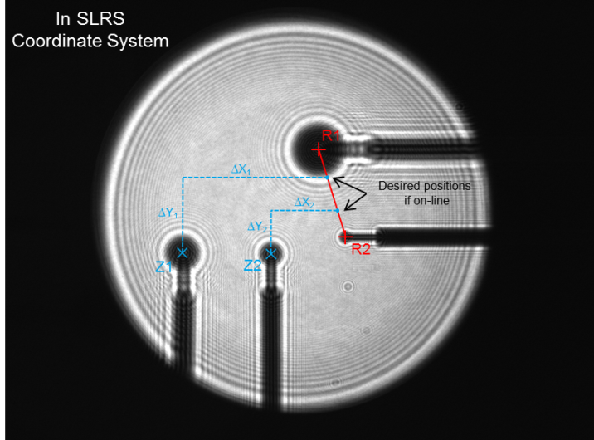

Figure 6: Alignment raw data

For the transformation of the SLRS data into the tunnel network as described above, a simple 5 parameter model and an extended 12 parameter model, that takes optical distortion into account, have been chosen and tested.

**The Simple Model** uses 5 parameters to connect the SLRS information with the tunnel network:

* 1 rotation angle **
* 2 scale factors *sx, sy*
* 2 translations *tx, ty* (not needed for further processing)

$$\left(\begin{matrix}x^{'} \\ y^{'}\end{matrix}\right)=\left(\begin{matrix}cosα & -sinα \\ sinα & cosα\end{matrix}\right)*\left(\begin{matrix}s_{x} & 0 \\ 0 & s_{y}\end{matrix}\right)*\left(\begin{matrix}x \\ y\end{matrix}\right)-\left(\begin{matrix}t_{x} \\ t_{y}\end{matrix}\right)$$

Lens characteristics and lens misalignment that result in optical distortions are not accounted for in the simple model. Since these distortions grow with the distance from the respective lens to the detector, they are getting increasingly important when considering system lengths of up to 550 m.

**The Extended Model** uses Brown’s distortion model [3] to eliminate distortion effects. 7 additional parameters are introduced:

* 3 parameters for radial distortion *k1, k2, k3*
* 2 parameters for tangential distortion *p1, p2*
* 2 parameters for the distortion centre *xM, yM*

The distorted coordinates (*x, y*) in the simple model are then replaced by the undistorted coordinates (*x*,y\**).

### Calibration in Practice

For a reliable determination of the transformation parameters, calibration grids have been developed, which are manufactured from 1 mm stainless steel plates using Wire Electrical Discharge Machining (WEDM). Three plates have been manufactured with a total of 49 circular targets with diameters of 12, 9 and 6 mm and a grid size of 20 mm (figure 7).

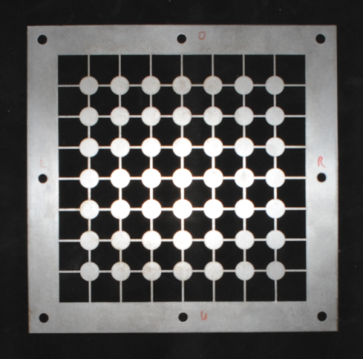

Figure 7: Calibration grid

For the intention to connect the SLRS with the tunnel network, it is important to have coordinates for all grid points available in both systems. Simply inserting the plate into the beam will not suffice; tilt and rotation of the plate would distort the transformation parameters. Having coordinates for each calibration point in the tunnel network will allow for determination of the grid orientation and for compensation of tilt / rotation effects accordingly.

This led to the development of calibration flanges. Central element is an ISO vacuum flange with CCR fiducials on the atmosphere side and a rigid frame on the vacuum side on which the calibration grid is mounted. In order to determine each grid coordinate by measuring the CCR fiducials with a Laser Tracker, a transfer measurement is necessary.

The **Transfer Measurement of Calibration Flanges** is done in two steps. As a first step, the CCR fiducials and the grid frame are fitted with photogrammetric targets that are suitable for the VSTARS photogrammetry system. The CCR targets are special adapter pieces that allow for measuring the CCR centre point (figure 8). For each calibration flange a bundle of photos (140-160 each) is shot and processed.

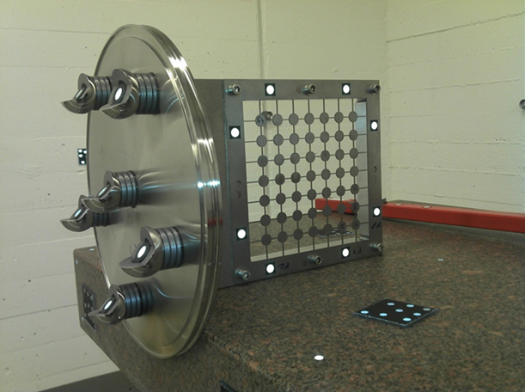

Figure 8: Calibration flange with VSTARS target marks

The bundle RMS for each flange ranges from 5 to 7 micron per axis, which is good and within the accuracy expectations for the VSTARS system. Unfortunately, the grid points cannot be measured with VSTARS directly.

In the second step of the transfer measurement the grid coordinates and the photogrammetric targets on the grid frame are measured using an ellipse operator in the LabView software (figure 9).

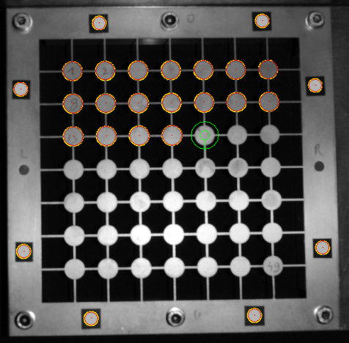

Figure 9: Measurement of grid coordinates

Since the images that are used here are raw images, the grid and frame coordinates need to be corrected for distortion, which is done using the respective parameters that are an outcome of the bundle adjustment in step one. Using the frame marks as reference points and a Homography (projective transform) as transformation model, the grid coordinates are transformed into the VSTARS coordinate system. Standard deviations of the residuals after the transform, which range from 11 to 17 micron per flange and axis, are considered to be acceptable. With all CCR fiducial coordinates and all grid coordinates in one common system, the transfer measurement is completed and the flanges are ready for calibration.

An **Extended Model Test**is performed before starting calibration. The extended model is tested on suitability for optical distortion compensation. By moving one lens out of focus, strong distortion effects can be created artificially. In the SLRS software the visible grid points are measured and then transformed on the design grid using both the simple and the extended model. With the extended model working properly, the transformation residuals should decrease significantly in comparison to the simple model. Figures 10 and 11 show the residuals after applying the simple and the extended model.

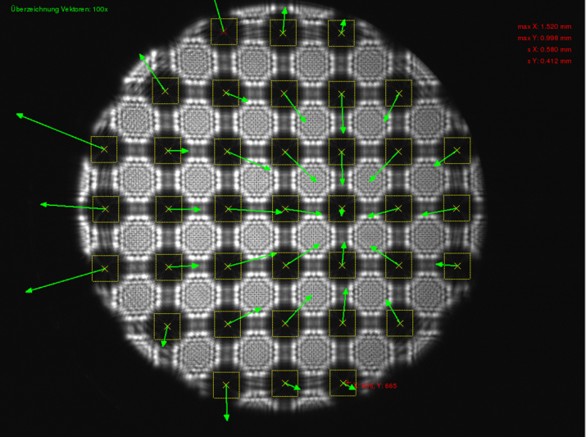

Figure 10: Simple model residuals

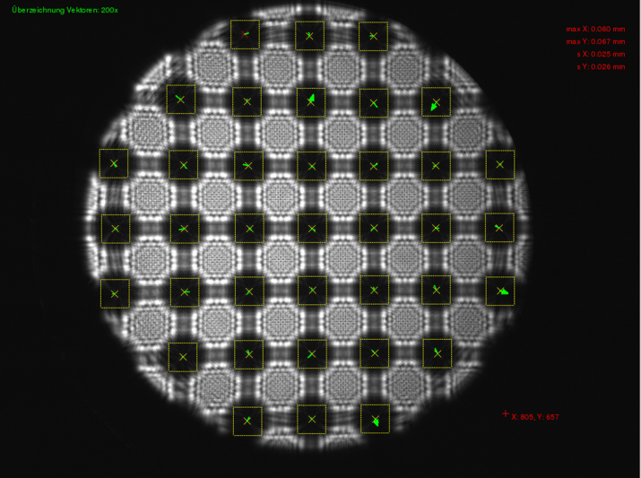

Figure 11: Extended model residuals

The **System Calibration** is done for each measurement place. The coordinates of each visible grid point are measured using the SLRS Software (correlation and subpixel estimation) in the SLRS coordinate system. Simultaneously, the CCR fiducials are measured with a Laser Tracker and the grid coordinates are determined in the tunnel system. The projection of the grid coordinates as measured in the SLRS onto the grid coordinates in the tunnel reference network gives the transformation parameters. The transformation results for both models and for all measurement places are shown in Table 1.

Table 1: Transformation results

|  |  |  |  |  |  |
| --- | --- | --- | --- | --- | --- |
| **Std. Dev.** | **5 Parameters** | | | **12 Parameters** | |
|  | **X** | **Y** | | **X** | **Y** |
| R1 | 0.065 | | 0.082 | 0.047 | 0.043 |
| Z1 | 0.055 | | 0.085 | 0.042 | 0.041 |
| Z2 | 0.051 | | 0.082 | 0.029 | 0.038 |
| R2 | 0.027 | | 0.031 | 0.027 | 0.031 |

As expected, the results for the 12 parameter model are slightly better, with standard deviations of the residuals ranging from 27 to 47 micron. On the other hand, it can be observed that properly aligned lenses create significant less optical distortions than misaligned lenses as shown in the previous subsection.

## System Verification

In the course of calibration, transformation parameters for all measurement places for both models have been determined. These calibration parameters are to be verified by a “real-world measurement application”. With the assumption of a refraction-free prototype tunnel network the SLRS alignment information and the alignment information as derived from the tunnel network should largely coincide.

For system verification, four different point setups have been used, including two extreme scenarios, whereof in one all points are lying closely to the reference line and in the other all points are lying at the edge of the visible area, where the strongest distortion effects are assumed (Figure 12). Table 2 shows the alignment information (line offsets) for Z1 and Z2 as derived from the network.

Table 2: Alignment information from tunnel network

|  |  |  |  |  |  |
| --- | --- | --- | --- | --- | --- |
|  | **Z1** | | | **Z2** | |
|  | **X** | **Y** | | **X** | **Y** |
| V.1 | -2.76 | | +3.04 | -1.89 | +0.12 |
| V.2 | -14.81 | | +22.38 | -18.62 | +8.87 |
| V.3 | -15.17 | | +11.26 | -7.91 | +2.88 |
| V.4 | -88.74 | | +28.61 | -24.39 | +96.37 |

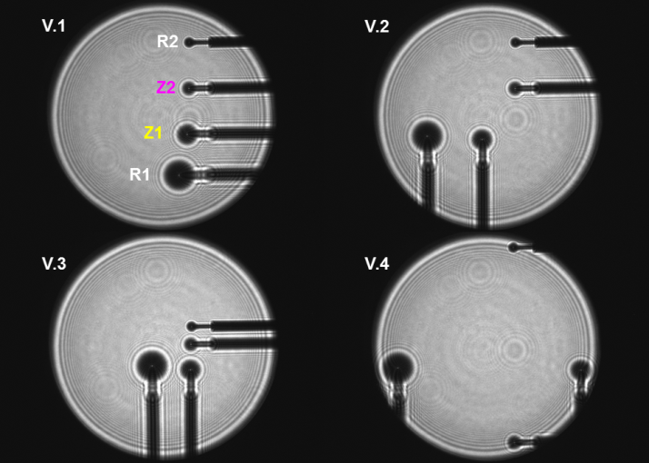

Figure 12: Point setups for system verification

Table 3 presents the differences in alignment information between the SLRS solution and the tunnel network solution. The results for the simple model are very satisfying and within expectations. However, the results for the extended model that were assumed to be slightly better show larger differences in the X-Axis. Here should be mentioned, that the presented data is very recent and therefore to be seen as tentative. The underlying data and processing algorithm, especially the data fusion from the four measurement places will be reviewed in the upcoming weeks. The author is still confident that the extended model has large potential and that future data and processing will yield better results here.

Table 3: Differences in alignment information

|  |  |  |  |  |  |
| --- | --- | --- | --- | --- | --- |
| **Differences** | **5 Parameters** | | | **12 Parameters** | |
|  | **X** | **Y** | | **X** | **Y** |
| V.1 Z1 | +0.09 | | +0.02 | +0.28 | +0.00 |
| V.1 Z2 | +0.10 | | +0.17 | +0.36 | +0.13 |
| V.2 Z1 | +0.04 | | -0.05 | +0.28 | -0.06 |
| V.2 Z2 | +0.11 | | +0.14 | +0.39 | +0.09 |
| V.3 Z1 | +0.09 | | +0.03 | +0.25 | -0.11 |
| V.3 Z2 | +0.08 | | +0.18 | +0.32 | +0.06 |
| V.4 Z1 | +0.09 | | +0.01 | +0.42 | -0.06 |
| V.4 Z2 | -0.04 | | +0.07 | +0.38 | -0.10 |

### Critical Discussion

When evaluating the differences that are shown in table 3, the error sources that affect these differences as final results should be taken into account. A lot of successive, interdependent steps are necessary for the determination of these differences. Error sources are:

* Geodetic network measurement (Laser Tracker)
* Refraction (the network is in fact not refraction-free)
* Transfer measurement of transition pieces (Laser Tracker)
* Transfer measurement of the calibration flanges (LabView, VSTARS)
* SLRS System errors
* Calibration measurements (comprising Laser Tracker and SLRS measurements)

Considering these error sources when evaluating the verification differences of the simple model leads to the conclusion that the results (max. difference of 0.18 mm) are very satisfying for that particular experimental setup. Without putting further effort in the elimination resp. minimization of error sources, better verification results (meaning smaller differences) cannot be expected.

Basically, it can be concluded from the data that the Poisson Alignment principle is verified and that the verification result lies within the expected range. However, there is still work to do regarding the extended model. In View of system lengths exceeding 450 m, optical distortion effects which propagate with the distance, cannot be neglected. Using a calibration model that corrects for optical distortions will be necessary in order to obtain reliable alignment information from the SLRS.

## Outlook on a 550m system

### Network-Backed Calibration

The presented network-backed calibration approach is considered to be suitable for the operational 550 m system that will be used in the XFEL. Although the network is refraction-affected, it can be used to support the system calibration process. Primarily, the network is used to determine the calibration flange orientation which makes the calibration independent from flange tilt or rotation, promoting easy flange handling during the calibration process.

The scales are refraction-free and derived from the calibration plate resp. the calibration plate transfer measurement.

The translations, that are an outcome of each calibration measurement as well, are fully affected by refraction. However, since the final alignment information is computed without using these translations, the translational refraction error of the network is not transferred to the SLRS. In contrast, a first impression of the total refraction error can be obtained by a comparison of the different translations that are computed on each measurement place.

For the determination of the camera roll angle, torsional refraction is an issue. Torsional refraction distorts a stretched geodetic network helix-like along the longitudinal axis. That effect can be eliminated by lateral levelling in advance, or during the calibration, analysing camera roll angel variations. In a refraction-free network, the rotation angle will not change throughout the measurement places. Variations in the rotation angle directly reflect the torsional refraction error of the network. Ideally, the combination of both approaches gives a good opportunity for mutual control.

### Alternative Calibration Method

As an alternative, a classical system calibration that is totally free from the tunnel network is conceivable. Because the grid-coordinates are not corrected for flange tilt and rotation here, it is important to minimize these effects by inserting the calibration grid into the beam thoroughly, ideally in a way that the grid axes are parallel to the SLRS coordinate axes. The system scales would then be derived directly from the calibration plate. Information regarding the camera roll angle or network torsion cannot be obtained without additional measurements. Here, either additional inclinometer measurements during calibration have to be performed, or a two-point-solution during system operation has to be used, which provides rotation information by the use of two instead of one single sphere per measurement place.

Although the network-backed calibration method is favoured, further investigation effort will be made on this alternative method in the future.

## Conclusions

Based on the latest test results it can be stated that the SLRS measurement principle and the shown calibration procedure are verified. The verification results for the simple model are satisfying and lie within a range that has been expected for that particular experimental setup.

The correct implementation of the extended model is, especially with respect to long distances, from utmost importance for future work. Beyond that, a global distortion model is desirable, which allows for determination of the transformation and distortion parameters based on calibration data from all measurement places in one holistic adjustment model. Up to now, the calibration parameters are computed for each measurement place separately.

Further system improvement potential lies in the elimination and minimization of error sources. The use of a coordinate measurement machine e.g. can improve the results of the calibration flange and transition piece transfer measurement significantly.

With the error budget minimized and the extended model working properly, a future total system accuracy of 0.1 - 0.2 mm is estimated.

## References

[1] L.V.Griffith, “The Poisson Line as a Straight Line Reference”, IWAA 1989, Stanford, CA, August 1989.

[2] C. Schwalm, “Straight Line Reference System – Considerations on Poisson Alignment and Classical Alignment Laser” Presentation slides, IWAA 2010, Hamburg, September 2010.

[3] D.C. Brown, “Decentering Distortion of Lenses” Photometric Engineering, 32(3): 444-462, 1966.