HydroStatic level systems at fermilab and surf*
J Volk#, V Shiltsev, Fermilab, Batavia, IL 60510, USA
A Chupyra, M Kondaurov, S Singatulin, Budker Institute of Nuclear Physics, Novosibirsk, Russia D Fratta, A Meulemans, C Potier, H Wang, University of Wisconsin-Madison, USA

Abstract
Hydrostatic Level Systems (HLS) have been in use at Fermilab for over a decade. Other HLS have been installed in nearby mines and at the Sanford Underground Research Facility (SURF) in Lead South Dakota since 2008. This paper reports on the status of these systems, data collected, and results of calculations of the ATL law.

Hydrostatic Level Systems fundamentals
Hydrostatic Level Systems (HLS) use connected reservoirs of water to determine the relative difference in elevation at the locations of the reservoirs. Fermilab and the Budker Institute have collaborated for over ten years in the design, construction, installation, and analysis of these systems. Since 2008, researchers from the University of Wisconsin Madison have joined both groups using these systems at the Sanford Underground Research Facility (SURF) at Lead South Dakota. The theory of operations, details on design, construction, and operation has been reported elsewhere [1, 2, 3, 4, 5, and 6].

Active and inactive systems
There are several active HLS installation at Fermilab and SURF. Table 1 lists the active systems. There are three types of sensors the SAS, SAS-E, and ULSE. The SAS and SAS-E types measure the capacitance of the pools to determine the height of the water. The readout protocol for both types is different; the SAS type uses a serial port on the data acquisition computer and a daisy chain read out system, the SAS-E type uses a Power-over-Ethernet switch and TCP/IP protocol to readout each sensor. The SAS system is simpler and more resistant to radiation damage so it is useful in accelerator enclosures. The SAS-E allows for individual control of each sensor system and avoids the “Christmas Tree Light Syndrome” where if one sensor fails all the downstream sensors fail.

The ULSE type uses ultrasonic pulses that reflect off of the water surface to determine the height of the water in the reservoir. By employing fixed position in the reservoir the speed of sound in water can be calculated on a pulse by pulse basis to provide higher resolution.

Details of electronics, read out systems, and plumping systems can be found in reference 6.

The inactive systems are listed in Table 2; these systems are no longer in use due to the decommissioning of the Tevatron or the necessity to move the existing systems for
construction or other activity. Data for these systems remain available on the ILC ground motion data base.

Table 1: Active HLS installations at Fermilab and SURF
Name | Location | Sensor type | Number | Separation
MINOS-2 | Fermilab | SAS-E | 10 | 10 m
LaFarge | North Aurora Ill | SAS | 5 | 30 m
Array C | SURF | SAS-E | 6 | 30 m
NML | Fermilab | SAS | 4 | Varies
MP7 | Fermilab | ULSE | 3 | 20 m
Stability test | Fermilab | SAS | 12
MT ULSE | Fermilab | ULSE | 12 | 1 m

Table 2: Inactive HLS installations at Fermilab and SURF
Name | Location | Sensor type | Number | Separation
MINOS-1 | Fermilab | SAS-E | 4 | 7 m
Array D | SURF | ULSE | 12 | 30 m
B0 low beta quads | Fermilab Tevatron | SAS | 9 | Varies
D0 low beta quads | Fermilab Tevatron | SAS | 9 | Varies
Tev Quads | Fermilab Tevatron | Balluff | 204 | 30 m

MINOS systEms
The MINOS experiment [7] is a search for neutrino oscillations utilizing two neutrino detectors on located at Fermilab and the other in Soudan, Minnesota. For cosmic ray shielding requirements both detectors are located underground. The near detector on the Fermilab site is 100 m below grade at the interface of the Maquokata shale and the Galena Plattville dolomite. This is an interesting geological interface for accelerator physicists. Future accelerators built at Fermilab will need to be in geologically stable formations due to the small beam size and constraints on emmitance growth. The Galena Plattville dolomite is easily mined with either tunnel boring machines or drill and blast techniques. Since 2006 HLS sensors have been installed on the floor of the MINOS hall to determine the characteristics of the ground motion.

*Work supported by DoE Contract De-AC02-07CH11359 and by NSF Grant # 0900351
# volk@fnal.gov

The original system (MINOS-1) consisted of 7 SAS type sensors in a two fully filled pipe system; 4 in a north south arrangement along the west wall and 3 SAS-E sensors in an east west arrangement along the north wall. With the approval of the off axis Noνa [8] experiment, a new near detector hall is being constructed to the west of the existing detector. The Noνa construction has just begun. The system extends beyond the limits of the Noνa construction. This work will consist of excavation 1 or 2 caverns 24 m by 10 m by 7 m to accommodate the new near detector. It is anticipated that there will be floor motion associated with the removal of the rock.

This construction project required the removal of the north south array. In January of 2012 a new north south array consisting of 7 SAS-E type sensors with a single half-filled pipe was installed on the east side of the detector hall. The east west leg was retained. Figure 1 shows a schematic layout of the systems. Figure 2 shows the new north south system. To make up for uneven floor granite slabs were used. These slabs are of uniform size and can be glued together with construction adhesive.

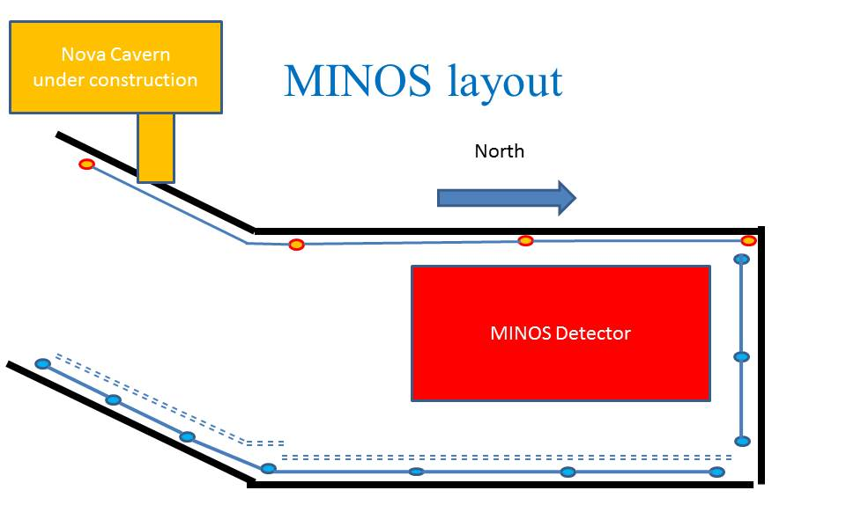
Figure 1: Schematic of MINOS HLS systems the circles indicate sensor

Typical data are shown in figure 3. These results show the difference in two sensors 70 m apart from February 2012 until mid-August 2012. The data show the floor tilt, the tidal motion with a 12.6 hour period is visible in the data. Fast Fourier Transformation shows the tidal peaks figure 4. 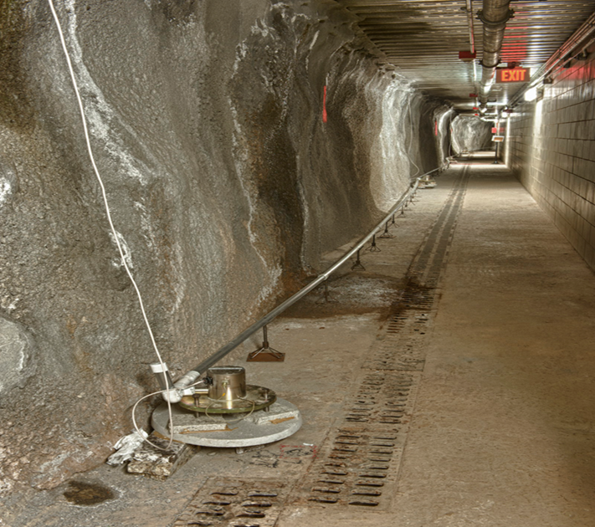
Figure 2: MINOS HLS system in the emergency passageway
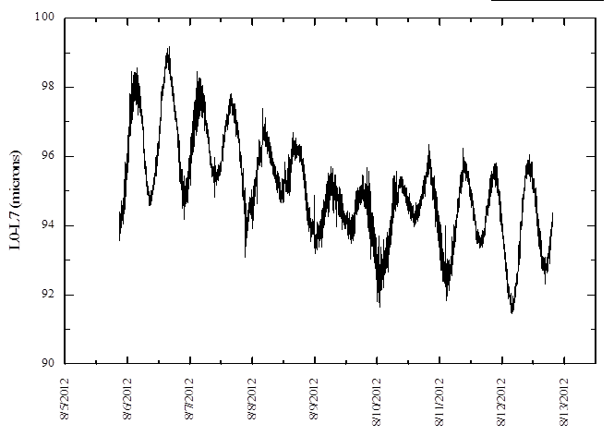
Figure 3: Difference in two sensors 70 m apart
Other changes in the floor tilt can be seen, however it is still not clear what the cause of this motion is. The spikes are due either to rapid changes in air pressure or un-intended disruptions to the system (e.g., a sensor was accidentally kicked).
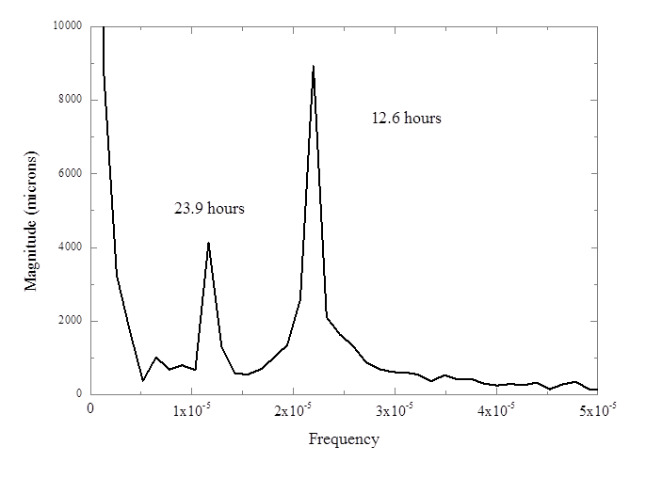Figure 4 FFT of the difference in two sensors 70 m apart

LaFarge Mine North Aurora, Ill
The Lafarge mine is a dolomite mine operation 10 km south west of the Fermilab site. It is a room and pillar mine with drifts 20 meters wide by 20 meters high. The mine is in the Galena Plattville dolomite. Excavation is done via drill and blast. Figure 4 shows the difference in two sensors 120 meters apart the spikes are due to the blasts that occur every workday afternoon at 14:30 hours, there is no blasting on the weekends. Figure 5 shows the difference in two sensors for a period from June 2008 to December 2008. These data are from a north south array. The slope indicates the shift in the floor level caused by removal of material. The shift stops at the time the mine ceased operation due to the economic recession of late 2008.
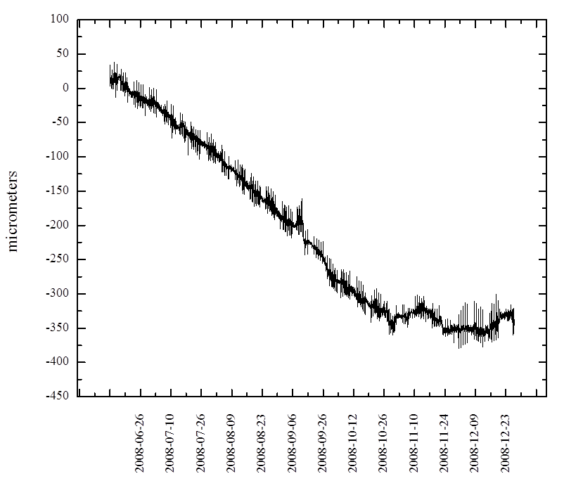
Figure 5: difference in two sensors 120 meters apart LaFarge min June to December 2008.
Large seismic events are detectable with HLS. Figure 6 shows tilt data from March of 2011 at the time of the Tohoku Japan earthquake. The tidal motions of the floor and the sharp jumps due to the local blasts can be clearly seen. The large displacement and subsequent motions is due to the Tohoku earthquake. This does pose issues for future accelerators in dealing with ground motion caused by large earthquakes.
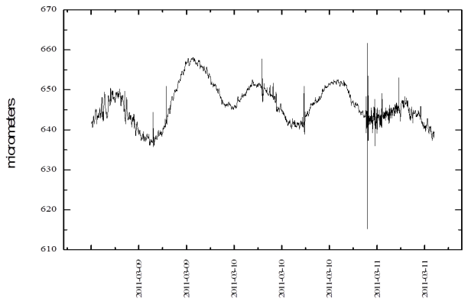
Figure 6: differences in two sensors showing earth motion due to Tohoku earthquake March 2011.

Sanford Underground Research Facility

The Sandford Underground Research Facility (SURF) [9] is located in the Homestake goldmine in Lead, South Dakota. The mine extends to a depth of 2720 m (8000 ft) and has over 500 km of drifts. When Barrick ceased mine operations in 2003 the mine pumps were turned off allowing the lower levels of the mine to flood. Water reached the 4100 foot level. Since the start of the work converting the mine the water levels have decreased to the 6000 foot level. HLS sensors were installed at the 2000 and 4850 foot level to observe the change in floor tilt due to removal of the large mass of water. Figure 7 shows the floor tilt as measured by two sets of sensors on the 2000 foot level of the mine. This plot is the double differences between three sensors spaced 60 m apart. The jump in the one is due to an accidental re-adjustment of a sensor. The slope shows the continual motion of the mine floor. Water removal has ceased as of the summer of 2012 and the water level is being maintained at the 6000 foot level it is anticipated that the slope of these graphs will change as the rock readjusts to the water loads.
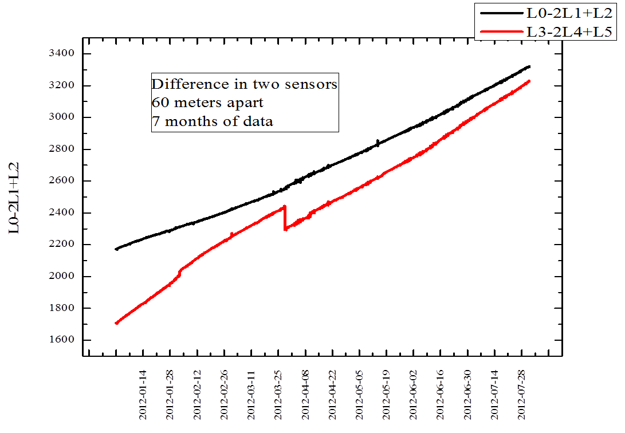
Figure 7: floor tilt at the 2000 foot level at SURF.
At the 4850 foot level, 12 Ultra Sonic Level Sensors were installed in two half-filled pipe systems at an angle of 105 degrees. Figure 8 shows the difference in two sensors. The floor shows much less motion than at the 2000 foot level. The spikes are due to electronic noise in the sensors. The system had to be removed after only 9 months of data due to construction work. It is anticipated that a similar arrangement will be setup soon.

NML and Project X HLS

At NML a test stand for superconducting RF models for use in Project X [10] has been setup. The cryo modules will have a small aperture and high intensity beams. Active alignment of all accelerator components will be critical for operations. A simple half-filled pipe HLS system has been installed to monitor the motion of the cryo model stands. Due to the anticipated radiation levels during operation SAS type sensors have been installed. Figure 9 shows typical data for movement of the stands.

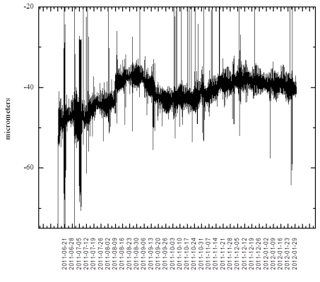
Figure 8: Difference in two sensors 50 m apart 4850 foot level SURF.

Due to the level of activity in the area it is difficult to obtain low noise data. The system is disturbed from time to time by technicians working on other aspects of the cryo modules. For example, the sudden jumps in the levels are due to unintentional bumps of the sensors. During the weekends when there is no activity in the hall the tidal motion can be clearly seen.

The HLS system will be expanded as more components are installed. The next major pieces will be the electron gun upstream of the cryo modules. Eventually a downstream spectrometer will be added. HLS will extend the entire length of the system.
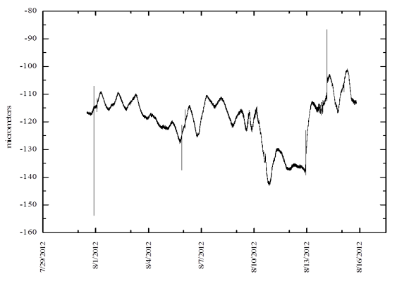
Figure 9: Sensors on cryo module stand at NML the sharp jumps are due to unintentional disturbances of the system.

ATL law analysis

Ground motion data indicate long-term systematic drifts. If the area and HLS system are stabilized diffusive motions (non-systematic, random) can be detected, these motions represent the “background” motion of the ground’s fractals. Such motion follows the ATL Law [11, 12] which describes the rms motion of two points relative to each other over time averaged over different observation points and different time series. The fundamental equation is [13] :

$${<ds>}^{2}=ATL$$

where variable T is the time interval, L the initial separation of the two points and A is a constant in µm² per second per meter. The diffusion A constant has been calculated for several of the systems on a month by month basis. In some cases the months were split where the system was disturbed and a large displacement in positions were observed. The process is to calculate the double differences for sets of three sensors. The double differences are defined as

ds = (S₀-S₁)-(S₁-S₂)

Where S_{i} is the level value for a given sensor. A least squares fit is applied to the double differences as a function of time. This is to remove the systematic shifts caused by motion such as observed in the 2000 foot level at SURF. Then the differences for various time slices from 1 minute up to two weeks are calculated. These values are then plotted versus time and the slope of the line yields the value of the constant A in µ² per second per meter. Table 3 lists the A dependence values for the systems.

Table 3: A values for HLS systems
Name | Sensors | Depth  meters | Average A  µm²/s/m  x 10 ⁻⁵
LaFarge | 4 | 110 | 1.61
Minos1 | 4 | 100 | 3.01
Minos2 | 7 | 100 | 3.91
Array C | 6 | 680 | 0.09
Array D | 12 | 1650 | 0.06

Long Baseline Neutrino experiment

A proposal for a Long Baseline Neutrino Oscillation Experiment (LBNE) [14] is in CD-1 review. To reduce the costs associated with underground work the beam from the Main Injector will be extracted upward to a height of 20 meters above grade. The beam will then be bent back down into the earth at an angle such that the neutrino beam will appear at the SURF in Lead South Dakota see figure 10. HLS will be used to monitor the extracted beam line during and after construction so that adjustments can be made to the beam line elements as needed.

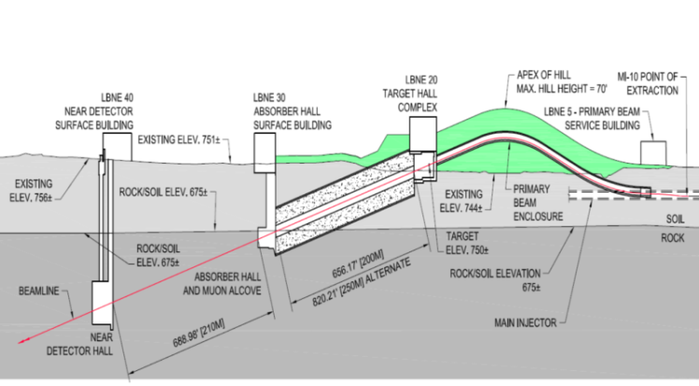
Figure 10: LBNE primary beam and target design.

ConcLusionS

Hydrostatic Level Systems have been in use at Fermilab for over 12 years. There is a great deal of available data on ground and accelerator component motion available. These systems will continue into the future to provide more such data. For future accelerator systems HLS will be used to monitor and move accelerator components

Acknowledgements
The authors would like to thank the staff of the Fermi National Laboratory, the Sanford Underground Research Facility, and the Conco Lafarge mine for their continued support.

References
- D. C. Agnew, Rev. Geophys. 1986, 24, p. 579
- S. Takeda, Development of New Hydrostatic Leveling Equipment for Large Next Generation accelerators, Proceedings of EPAC 2004 p. 2113.
- N. Sunikumar et al. Characterization of Slow Orbit Motion in SPEAR3. IPSC 2010, pp. 1215-1217.
- F.Q. Wei, et Al., Experiences with the Hydrostatic Leveling System at the SLS, Proceedings of EPAC 2004, p.1651.
- A. Seryi, et. al, Hydrostatic Level Systems for Slow Ground Motion Studies at Fermilab and SLAC, Proceedings of IEEEPAC 2001, p. 1479.
- J. Volk et al., Hydrostatic Level Sensors as High Precision Ground Motion Instrumentation for Tevatron and Other Energy Frontier Accelerators, J. Instrumentation, 2012, P01004.
- MINOS, The Main Injector Neutrino Oscillation Search URL: www-numi.fnal.gov/
- Noνa URL: www-nova.fnal.gov/index.html
- Sanford Underground Research Facility (SURF) URL:www.sanfordundergroundlaboratoryat homestake.org
- Project X URL: projectx.fnal.gov/
- B.A. Baklakov, et al Sov Tech. Phy. 38, 894 (1993)
- V. Shiltsev, Phys. Rev. Lett. 104, 238501 (2010)
- V. Shiltsev Phys. Rev. St Accel. Beams, 12 094801 (2010)
- Long Baseline Neutrino Experiment URL: lbne.fnal.gov

