# STATUS REPORT ON STORAGE RING REALIGNMENT AT SLRI

S. Srichan#, A. Kwankasem, S. Boonsuya, B. Boonwanna, V. Sooksrimuang, P. Klysubun Synchrotron Light Research Institute, 111 University Ave, Muang District, Nakhon Ratchasima 30000, Thailand

Abstract

Siam Photon Source (SPS), a synchrotron light source operated by Synchrotron Light Research Institute (SLRI) in Thailand, was installed and commissioned in the year 2001. During the past eleven years since the commissioning, the 1.2 GeV electron storage ring had been realigned in total three times. The first realignment was carried out and the result was reported in 2002. Optical survey has been regularly carried out on an annual basis afterwards, with the survey data providing assessment whether realignment is necessary. In this report, we describe the realignment procedures at the SPS, together with the results from the second realignment performed in 2006 and the most recent storage ring realignment in June 2012.

## introduction

SLRI is a synchrotron radiation research facility located in Nakhon Ratchasima, Thailand. The SPS accelerator complex consists of two 20 MeV injector linacs, a 1.0 GeV booster synchrotron (SYN) and a 1.2 GeV electron storage ring (STR). The storage ring has a double bend achromat (DBA) lattice with four super periods. In total there are 8 bending magnets, 28 quadrupoles in four families, 16 sextupoles, and 28 correctors. The ring circumference is 81.3 meters. [1] Machine specifications of SPS can be summarized as listed in Table 1. The layout of the SPS accelerator is as shown in Figure 1.

In this report we focus mainly on the survey data and realignment of the SPS storage ring. We will describe the survey instruments involved, the realignment procedures for all the components, and finally the results of the latest realignment in June 2012.

#supawan@slri.or.th

Table 1: Summary of SPS machine specifications. [2]

|  |  |
| --- | --- |
| Electron beam energy | 1.2 |
| Beam current [mA] | 150 |
| Lattice | DBA |
| Superperiod | 4 |
| Horizontal emittance [nm.rad] | 41 |
| Emittance ratio [%] | 3.5 |
| Circumference [m] | 81.3 |
| Number of straight sections | 4 (7 m) |
| Betatron tunes νx, νy | 4.76, 2.83 |
| Synchrotron tune νs | 0.0026 |
| Natural chromaticities ξx, ξy | -9.21, -6.56 |
| Momentum compaction factor αc | 0.0169 |
| Radio frequency [MHz] | 118.0 |
| Harmonic number | 32 |
| RF voltage [kV] | 120 |
| RF power [kW] | 30 |
| Energy loss per turn [keV] | 66.0 |
| Injection beam energy [GeV] | 1.0 |
| Number of RF cavity | 1 |
| Number of insertion device | 1 (U60 undulator) |
| Number of bending magnet | 8 |
| Number of quadruple magnet | 28 |
| Number of sextupole magnet | 16 |
| Number of steering magnet | 28 |

|  |
| --- |
|  |
| Figure 1: Layout of the SPS accelerator complex. |

## survey and realignment activity

After the installation of SPS accelerator complex was completed in December 2000, the booster synchrotron had undergone realignment in June 2001, and the first machine commissioning was succeeded in October 2001. One year after the commissioning, the maximum difference of STR dipole magnet levels was found to be 4.2 mm. The first STR realignment was carried out in June 2002, resulting in increased beam lifetime. [3] Table 2 shows an overview of the SPS survey and alignment activities, together with the equipments used, approximate time required, and frequency of each activity. Horizontal and vertical adjustments for STR and SYN magnets are made using hand tools. The machine realignment is performed during machine shutdown period, and the responsibility falls with an engineer team in Accelerator Technology Division.

Table 2: Overview of survey and realignment activities of SPS accelerator.

|  |  |  |  |
| --- | --- | --- | --- |
| Activity | Instrument | Time requirement | Frequency of occurrence |
| *Storage Ring* | | | |
| STR level survey | Manual precise level | 1 day | Once per year |
| STR  horizontal and vertical realignment | Laser tracker,  Manual precise level | 4-6 weeks | 3 times up till now:  *I-June 2002*  *II-November 2006*  *III-June 2012* |
| *Booster Synchrotron* | | | |
| SYN level survey | Manual precise level | 1 day | At least every 2 years |
| SYN  horizontal and vertical realignment | Laser tracker,  Manual precise level | 4 weeks | Once up till now:  *June 2001* |

Figure 2 shows the elevation survey data after the first

STR realignment (labeled 'May 2003') and two survey data taken before the latter two STR realignments

(labeled 'March 2006' and 'May 2012'). The data shown uses the level of horizontal bending magnet 2 (BH2), the final magnet of the high energy beam transport (HBT), as reference (zero). The vertical displacement in May 2003, about one year after the first realignment, was in range of ±1.00 mm. The displacement then grew to about 2.5 mm in March 2006. During the second machine shutdown of 2006 at the end of the year, the SPS storage ring was realigned. The position of all the components was brought to within ±0.2 mm with respect to design values. [1, 4]

In the latest optical survey in May 2012, almost 6 years after the second realignment, the maximum vertical displacement grew to almost 3.0 mm. It was decided that STR realignment would be carried out during the machine shutdown in June 2012.

What is interesting in the survey data is that, as seen in Fig. 2, the variations in the STR magnet heights from the three separate occasions follow roughly the same pattern. For example, the vertical deviation of the BM05 and BM06 dipoles magnets are much more than that of the others. It is very likely that the misalignment was primarily due to the effect of floor settlement. This finding suggests the displacement of pile foundation under the storage ring, together with the distortion of the floor, should be investigated and analyzed.

Figure 2: Surveying data of SPS storage ring magnets.

## storage ring alignment procedure

During the installation of the SPS, survey network was established and reference marks were installed. [5] Table 3 shows the alignment tolerance allowed for each of the STR component, and Table 4 lists the survey instrumentation involved. The alignment process can be summarized as shown in the flow chart in Figure 3.

The alignment process is as followed. First, the individual storage ring component is adjusted to the reference height, and its tilt reset to zero, simultaneously. After that, fine adjustment of the position in 3-D space is carried out with the help of a laser tracker. This whole process is iterated until the position in 3-D space of all the components converges to the design values.

Table 3: Alignment tolerance. [5]

|  |  |  |  |  |
| --- | --- | --- | --- | --- |
| Components | Reference components or marks | Required precision (mm) | | Tilt  (mm/m) |
| X and Y | Beam stream |
| Dipoles | Dipole reference marks / Level marks | +0.2 | +0.2 | +0.2 |
| Multipoles | Dipole reference marks / Level marks | +0.2 | +0.2 | +0.2 |
| Steering magnets | Quadrupoles | +0.5 | +0.5 | +0.5 |
| Beam Position Monitor | Quadrupoles | +0.5 | +0.5 | +0.5 |

Table 4: Alignment instrumentation.

|  |  |  |
| --- | --- | --- |
| Measurement | Instrument | Accuracy |
| Coordinates | Laser tracker  FARO-CAM2 | Angular resolution 0.02 arc seconds  Angular repeatability 3 µm + 1 µm/m  Angular accuracy  18 µm + 3 µm/m  Interferometer max working range 35 m |
| Centering | Optical plummet  LEICA-NL | Standard deviation when plumbing with two observations at 180o = 1:200,000 |
| Elevation | Precision level  LEICA-NAK2  Parallel plate micrometer  LEICA-GMP3 | Standard deviation per 1 km Double-run leveling ±0.3 mm |
| Inclination | Electronic tilt meter  WYLER-NT41H | Sensitivity :  0.001 mm/m  Base dimension : 45x150 mm |

Alignment

START

BM alignment

QM alignment

Survey check

Alignment of other machine components

(SXF, SXD, STH, STV, BPM, etc.)

Does the component align to the ideal position with targeted accuracy?

END

Realign the component whose position lies outside the tolerance limit

NO

YES

Figure 3: Storage ring alignment procedure. [6]

### Adjusting elevation

As stated earlier, all the storage ring components are adjusted using the height of the horizontal bending magnet BH2 as a reference. The tools for the adjustment process are a LEICA-NAK2, an invar staff, and a survey target.

### C:\Users\USER\Desktop\STR Re-alignment2012\DSC04038.JPG

Figure 4: Zero elevation is set at BH2 magnet.

### Adjusting inclination (tilt)

Tilting of each storage ring component is adjusted using an electronic tilt meter resting on a survey target plate.

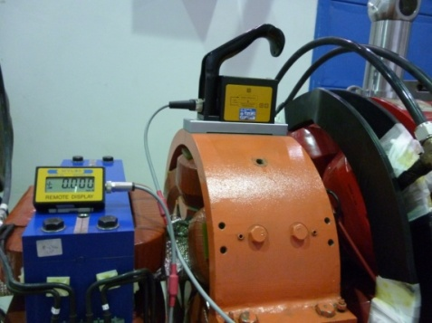

Figure 5: Inclination of each component is adjusted using an electronic tilt meter.

### Adjusting horizontal position

Horizontal position is adjusted with the aid of a laser tracker. The horizontal plane is defined with three or more reference marks. During the alignment process the horizontal plane needs to be redefined whenever the laser tracker is moved to a new location around the storage ring.

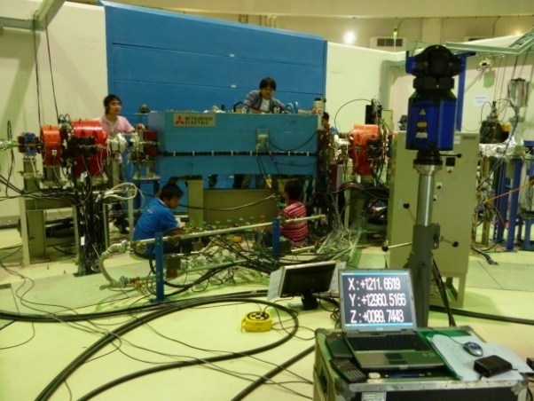

Figure 6: Laser tracker is used for adjusting position in the horizontal plane.

## alignment of THE storage ring magnet

### Dipole magnets

Elevation of all the dipole magnets was adjusted to be equal to the height of the datum reference. The tilt was also adjusted to be within ±0.2 mm/m. The laser tracker was used to monitor horizontal positions. The position of the laser tracker was carefully chosen such that the survey can be carried out over the whole area of the storage ring, without any obstruction from numerous equipments blocking the line of sight. The dipole magnet position was adjusted to the design coordinates. The beam trajectory is established by a set of straight lines connecting these dipoles.

### Quadrupole magnets

As mentioned above, the dipole magnets were used to project a straight line needed for the alignment of other magnets in between. There are two sets of quadrupole magnets in the SPS storage ring. The old ones have only one target hole at the center, while the new quadrupoles have two target holes, one upstream and one downstream. The height and tilt adjustment of the new quadrupoles can be done with more precision than in the case of the old magnets. For horizontal adjustment with the laser tracker, both target holes on the new magnet are used for setting the reflector. After the realignment, all the quadrupole magnets were brought to be within ± 0.2 mm with respect to the design values. The tilt was measured to be the within ± 0.2 mm/m.

### Sextupole magnets, steering magnets, and beam position monitors

Sextupoles magnets, steering magnets, and beam position monitors are aligned using the precision level and the laser tracker in the same manner as for dipoles and quadrupoles, with both as the reference.

### Septum magnet, bump magnets, RF cavity, and insertion devices

In the case of septum magnet, it was impossible to use the same alignment method as was done in the machine installation because the centre of magnet was not precisely known. Therefore, we only made the survey without adjusting the magnet position. The three bump magnets are adjusted to design coordinates with the precision level and the laser tracker. For the RF cavity, the same precision level/laser tracker combo is used, and the position of the cavity is also brought to be within the ±0.2 mm tolerance limit. The same is true for the only insertion device installed in the SPS ring, the U60 permanent magnet planar undulator.

|  |
| --- |
| manget alignmentdd.bmp |
| Figure 7: Survey data of SPS dipoles and quadrupoles, before and after the June 2012 realignment. |

## MOST RECENT results

Figure 7 shows the vertical displacement of the dipoles and quadrupoles before and after the most recent realignment performed in June, 2012, all of which satisfies the tolerance requirement as listed in Table 3.

## conclusion

Realignment of the 1.2 GeV electron storage ring of Siam Photon Source has been successfully carried out in June 2012. The alignment was based on the existing network. All the magnets were moved to the design positions. After realignment, the beam can be injected and stored in the SPS ring without the need for orbit correction by steering magnets.

## acknowledgment

The works presented in this report could not have been accomplished without the hard work of many colleagues at SLRI. The authors would like to thank all colleagues who have contributed to this work.

## References

[1] P.Klysubun et al., “Operation and improvement of the Siam Photon Source”, APAC’07, Indore, February 2007, p.607-609.

[2] SLRI Annual report, 2011, p.56.

[3] N.Sanguansak et al., “Realignment magnets of Siam Photon Source storage ring”, 7th IWAA2002, Spring-8, 2002, p.55-58.

[4] A.Kwankasem et al., “Realignment storage ring” , NSRC Technical Note TN-2006/13, December 2006.

[5] Mitsubishi Elec., PASCO Corp., “The report for the survey for the reference marks and the alignment for the storage ring component on the National Synchrotron Research Center in Thailand”, May 2001.

[6] K. Mishima, K. Endo, T. Ishii, M. Sugawara and W. Pairsuwan, “Survey and alignment for the Siam Photon Project”, APAC’01, Beijing, Chaina, 2001, p.571-578.