**SURVEY AND ALIGNMENT DESIGN OF HITFIL**

CAI. Guozhu, MAN. Kaidi, IMP,Lanzhou,China

*Abstract:*

The biggest challenge of survey and alignment of HITFiL（Heavy ion Therapy Facility in Lanzhou） is the tight positioning requirement and the big scale vertical beam installation. The laser trackers with their software –Spatial analyzer was used in the Survey and alignment of HITFiL, and the key survey steps are control network；fiducialisation and installation. Particularly, error budget should be within 0.06mm for control network；fiducialisation is 0.05mm,and installation is 0.08mm, which is a little smaller than the overall requirement of 0.10 mm. Besides the target of error control ,reliability , efficiency ,cost are factors considered in the design.

*Key words:* SpatialAnalyzer ；laser tracker; Survey and alignment of accelerator; Control network

*1, Introduction*

The HITFiL is the first medical accelerator facility for deep hadron therapy with C6+ in China and will be built in 2014. an ECR(Electron Cyclotron Resonance) ion sources produce a beam injected into a littler Cyclotron where it is accelerated at 7 MeV/u; A 56m circumference synchrotron store ring, it is the smallest scale ring in the world, accelerates carbon ion beam up to 400MeV/u; The beam extracted from the synchrotron can be delivered on five lines in the four treatment rooms, A 3D sketch of the accelerator is depicted in fig1.Almost each component on the beam line need to be accurately aligned in a well defined position in order to accomplish their tasks. This paper shows the alignment method, discusses of the survey instruments and software used for positioning both beam diagnostic devices and magnets.

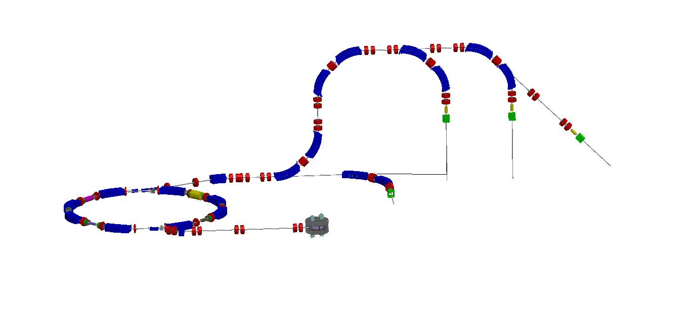

Fig.1 The layout of the magnets in the HITFiL

The tighter tolerances on alignment, which are required the SYNC’s conventional magnets, are summarized in table1.

Table1: SYNC Magnets alignment tolerances(RMS)

|  |  |  |  |  |  |  |  |
| --- | --- | --- | --- | --- | --- | --- | --- |
| Error（RMS） | B | Q | S | C | B M | RF | Vacuum Chamber |
| ΔX (mm)，ΔY (mm) | 0.5 | 0.1 | 0.2 | 0.2 | 0.2 | 0.5 | 0.5 |
| ΔZ (mm) | 2.0 | 0.5 | 2.0 | 2.0 | 2.0 | 2.0 | 1mm/m |
| Δφ (mrad)，Δθ (mrad) | 0.5 | 0.5 | 0.5 | 0.5 | 0.5 | 0.5 | 0.5 |
| Δψ (mrad) | 0.2 | 0.5 | 0.5 | 0.5 | 0.5 |  |  |

Work supported by IMP

caiguozhu@impcas.ac.cn

***2,HITFiL main coordinate frame and error estimation***

HITFiL main frame used cartesian coordinate system and it defined by:

X, from the center of ring to point of extraction on the short axis of ring;

Y, Direction of height in accordance with the lateral beam in the physics;

Z, accord with right hand rule in the coordinate system;

Ф, zero begin from +Z, and added anticlockwise.

A sketch of frame is depicted in fig2:

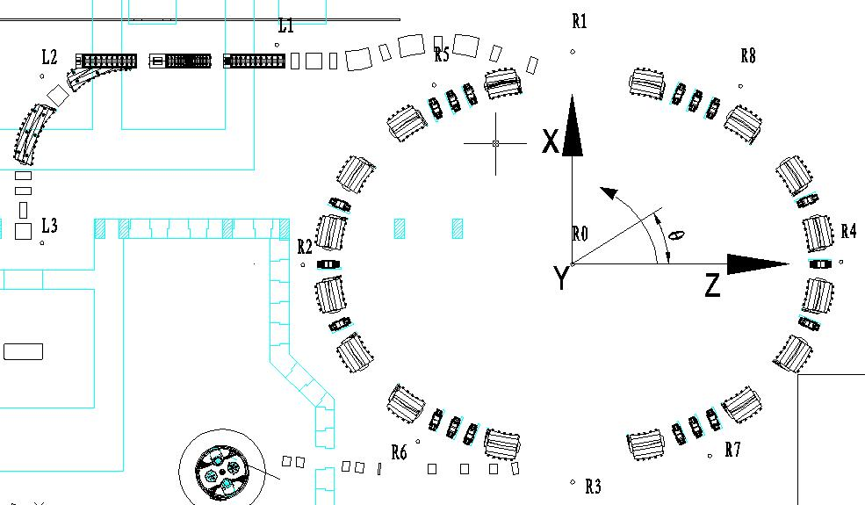

Fig.2 the coordinate frame in the HITFiL

The alignment errors associated with the 3 activities listed in Table 2 below should be taken into count. The maximum error budget for the 3 activities is±0.08 mm. Assuming that the errors are random, normally distributed and can be added quadratically, the error budget has been broken down as shown. Three key activities will be the responsibility of the survey group and controlled by them.

|  |  |
| --- | --- |
| Fiducialisation | 0.05mm |
| Survey network | 0.04mm |
| Installment | 0.08mm |

Table2: alignment activities



Among the installment，it’s including three parts too:free station in the network, measurement and solved by 7 parameters and residual error listed in Table3。

Table3: installment activities

|  |  |
| --- | --- |
| Free station | 0.03mm |
| Measurement and solve | 0.03mm |
| residual error | 0.07mm |



*3,HITFiL survey network*

The survey network is made up the global network and local network. The global network, it been designed for laser tracker AT401 or API T3, instead of the total station, is composed by 13 pillars stably，9 pillars around the synchrotron ring, 4 pillars line up beam straight line, and the ring center is R0[1]. All net points on the pillars is designed for 3D points, which can be surveyed by AT401 and Level, so 3D network can be built conveniently.

The Leica AT401 is used during surveying global network, its distance performance 4um,and its angular performance is 7.5um+3um/m, the accuracy of AT401 is outstanding better than the best total station in Leica, so it’s not necessary to use the total station again[2]. Leica LEVEL DNA03 is also used in order to measure level of monuments, its performance is 10um in the short distance, which come from a serial of the tests indoor by others[3].

A simulation of survey for globe network by the SA[4] and estimation of points error in the application of “adjustment and optimization design of control network” are processed simultaneously[5]. The both results are about 0.04mm.

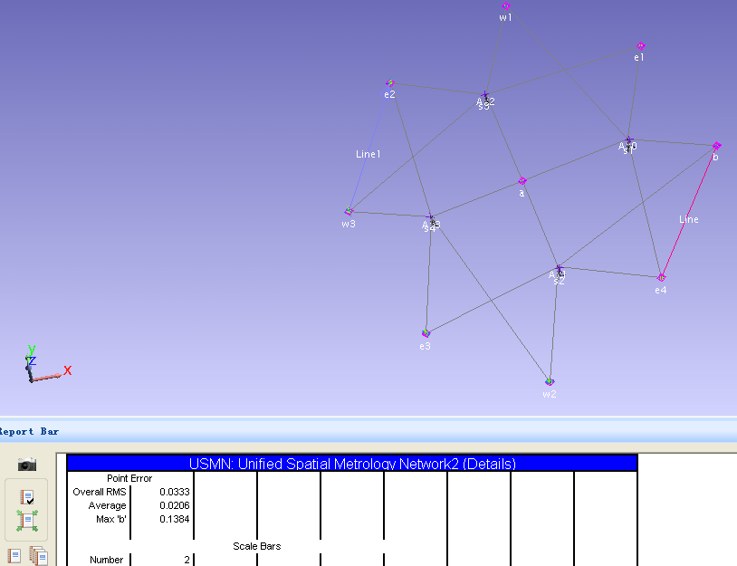

Fig.2 The simulation in the software of SA

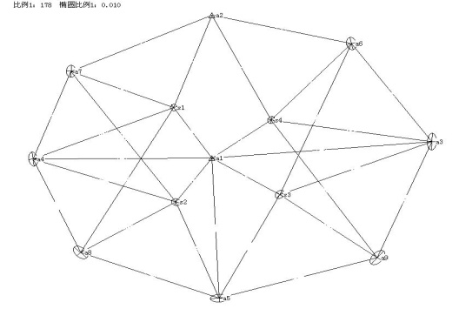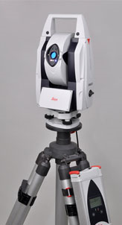

Fig.3 Optimization design of the survey control network and AT401

The local network is composed by some pillars can be seen and net points on the wall and ground，which coordinate system inherits from the global network through points on the pillars. The laser tracker of API T3 combined with Spatial Analyzer software is good choice, it have provided an adaptable, portable 3D measurement system that has been regularly applied to survey network and installation process, and which performance is better than AT401 in the short distance indoor.

*4,Fiducailization*

Quadrupoles and sextupoles must be positioned by basing the magnetic centre according to the physics design, so, the coordinate values of six targets on the magnet must be got under the magnetic center with help of engineer in charge of magnetic measurement. The method used is the axis of rotating coil used by magnetic measurement. Firstly, six targets need be measured under the frame of basing the axis of rotating coil. Secondly, the offset between magnetic centre and the axis of rotating coil can be get after the magnetic measurement. Finally, the 3D data is compensated by offset respectively.

For diagnostics devices, the method is easier than magnet, the targets is necessary and ought to be measured in the mechanical reference coordinate system. All measurements can be done by ARM or tracker. Accuracy of this process is controlled under 0.05mm[6]

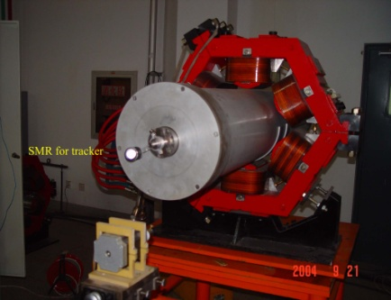 Fig6.fiducialisation with rotating coil used by the magnetic measurement

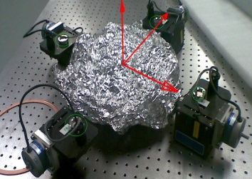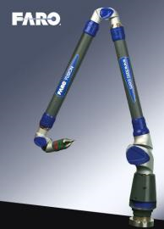

Fig7.fiducialisation of Slit with ARM

*5,Installation*

The installation is the last step for alignment, it’s necessary and key step to adjust the magnet and beam monitor precisely after they were located roughly. Some steps will be followed ,

1st, Located instrument beside the monitored magnet in the 3D survey control network depended on the nets around it;

2nd,Changed the live frame to this magnet part frame;

3rd,The 6 reference points were measured on the magnet would be the actual data;

4th, An application of best-fit programmed by Matlab (also can do this in SA) can solve them with the actual data and the nominal data come from fiducialized magnet before, the parameters: ⊿X, ⊿Y, ⊿Z, *Δφ*, *Δθ*, *Δψ* imply how much the magnet need to be adjusted and if it is OK[7];

*5th,* Each equipment, including all kinds of Beam monitors need to check with the same method mentioned above.Figure8 illustrated the process respectively.

When all the magnets were installed, the statistical result will be got, here 0.08mm is the tolerance.

Fig8. an example of best-fit with 7parameters

For the dipole, the rotating angle of beam is the most important ,so the method of using DNA03 level was applied to check it. In the manufacturing process, the lamination was designed with “V” groove on the both sides of dipole, so the “V” groove is the best fiducialisation for the dipole to be level.

，  is ⊿ height come from level, and its uncertainty is 0.01mm；is wide of magnet ,and its uncertainty is 1mm。

Error propagation rate：

So,simplified,，The wide of magnet is about 1000mm,so the uncertainty of the rotated angle is about 0.02mrad(0.0206265),which is enough for check theΔψ( 0.2mrad ) of dipole.

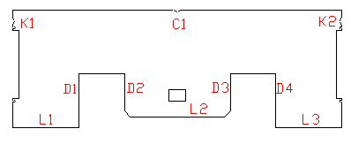



Fig9. illustration of rotating angle of dipole and the “V” groove on the lamination

*6,Conclusion:*

The three-dimensional coordinates of the network or fiducial are measured by the tracker or ARM in the reference system was widely applied in alignment of HiTFiL, which is understanding and convenient for each component to be installed. The total station was give up since it isn’t more accurate and portable than AT401,and ARM was used widely in the fiducialisation, SA software will be applied all the process.

*7,Acknowledgment*

The author wants to thanks all the colleagues gave me the materials and experiences for their help and scientific support.

*8,References*

[1] Bianculli et al, “accelerator survey and alignment at the Italian national center for oncological hadrontherapy”,IWAA 2010

[2] Leica, AT401 User Manual,Leica Geosystems

[3] Leica, DNA03 User Manual,Leica Geosystems

[4] New River Kinematics - Spatial Analyzer http://www.kinematics.com

[5] Y.junzhi,et al,The principle & calibration for digital level,(surveying and mapping press,2005),59-60.

[6] Faro, Arm, http://www.faro.com/edge/faroarms

[7] Cai Guozhu et al, “a combined application of laser tracker and spatial analyzer in alignment and survey of Hirfl-CSR”,IWAA 2010.