Purpose of This Procedure

The purpose is to determine the effects of facility operations, if any, on ground water quality by regularly monitoring for chemicals and radionuclides at up-gradient background wells.

Materials/Pre-requisites Needed

Special Instructions
- Approximately two weeks prior to the sampling event contact the chemical analysis laboratory (Appendix D) with the current sampling event parameter list and arrange for the proper bottles (including preservative as required) and coolers to be delivered to the Fermilab Shipping/Receiving Warehouse 2. Upon arrival the bottles should be inspected to ensure the correct preservatives are in the appropriate bottles and the correct number of bottles has been received.
- Wear disposable latex or Nitrile™ gloves when inspecting the bottles in case any have leaked preservative. Be suspicious of any fluids found in the coolers.
- Successful completion of FN000125/CR (Material Move Survey) is required of all personnel using a Material Move Request (MMR) form.
- Because these wells are sampled annually, the annual well inspections may be performed concurrently with the sampling event. Refer to EP Group procedure EP 105 (Procedure for Well Maintenance Program Checks) for the necessary equipment.
- Do not operate the generator in the rain. The generator produces 120VAC current that is sufficient to cause serious injury or death.
- Each well sampled using the Grundfos® system will be purged for a minimum of two bore volumes and until the pH, temperature, and conductivity parameters have stabilized or until it purges dry, whichever occurs first. After purging two bore volumes, the indicator parameters may be considered stabilized if, over the span of three consecutive minutes, the pH, temperature, and conductivity have not varied more than 0.01, 0.1 °C, and 10%, respectively.

Equation 1 gives the calculation for determining bore volume in gallons.

Equation 1. V = π r² (A - B) x 7.48

Where: V = Well bore volume (gallons)
A = Well total depth (feet)
B = Depth to water from the top of the casing (feet)
r = Radius of the well inner casing (feet)
7.48 = Conversion factor (ft³ to gallons)
For two-inch diameter wells Equation 1 can be simplified to:

Equation 2. V = (A - B) x 0.163

To convert the volume to liters, multiply the resulting volume by 3.785.

Equipment

WH7E
Background Well Field Logbook
Flow Thru Cell Log Sheets - Form EP 001
Chain-of-Custody (COC) - Form EP 002
Chemical Analysis Laboratory COC
Sample Identification (SID) Labels
Calculator
A6 Key

Site 39
Calibrated pH/Temperature Meter
Conductivity Meter
Electronic Water Level Meter
Multi-probe Monitoring Chamber (MMC)
Grundfos® Power Converter Box
Grundfos® Sampling Tube with Tubing Adapter
Electrical Generator with GFCI Cord
Disposable Latex or Nitrile™ Gloves
5-Gallon Rinse Bucket with Distilled Water
5-Gallon Carboy
Appropriate Sample Bottle(s)
Coolers with Ice (chemical analysis)
Stopwatch

References

1) Geotech Multiprobe Monitoring Chamber, Geotech Environmental Equipment, Inc.
2) Orion Laboratory Products Group Portable pH. ISE Meters Instruction Manual Mode 250, Orion Research Incorporated, 1991.
3) Orion Model 124 Conductivity/TDS Meter Instruction Manual, Orion Research Incorporated, 1991.
4) Making the Most of Field-Measurable Ground Water Quality Parameters, Garner, Stuart, Hydrolab Corporation, Pub No. 3043-688.
5) Practical Guide for Ground Water Sampling, M. Barcelona et al, Illinois State Water Survey, Contract Report 374, 1985.
6) Redi Flo 2 Installation and Operating Instructions, Grundfos Pumps Corporation, 11/94.

RESPONSIBILITIES

Samples are routinely taken from monitoring and supply wells throughout the Fermi National Accelerator Laboratory (Fermilab). Up-gradient Background Monitoring Wells (BMW) are utilized to detect chemicals and radionuclides that may be entering the site in the ground water and for background comparison to samples taken from source-specific (MS, NS, S) monitoring wells. Source-specific monitoring wells are located and constructed solely for the purpose of early detection of contaminants from a potential source so that quick and effective preventive or remedial action may be taken. BMW locations are illustrated in Appendix A and digital images are in Appendix B.

The background wells are sampled annually for both chemicals and accelerator-produced radionuclides. For any given year, the parameters for the chemical samples are the same as for the CUB Tile Field (EP 102) and Meson Hill (EP 104). Refer to Appendix C for the appropriate chemical parameters. Radionuclide analyses are “Type-1” for all accelerator-produced radionuclides (H-3, Be-7, Na-22, Mn-54, Co-60). Radionuclide samples are submitted to the Radionuclide Analysis Facility (RAF) at Site 39 and samples for chemical analysis are either taken to Warehouse 2 (shipping & receiving) for pickup by the chemical analysis laboratory’s agent or taken directly to the laboratory.

A Multi-probe Monitoring Chamber (MMC) is used in-line with a Grundfos® Redi-Flo 2 pump to enable real-time collection of pH, temperature, and conductivity data throughout each purge event. Evaluation of these three parameters allows the determination of their stabilization, indicating that water representative of the screened stratigraphic unit is being withdrawn, at which time a sample is collected.

DETAILED PROCEDURE

- Calibrate the pH/temperature meter following the steps outlined in EP Group procedure EP 091 (Calibration of the Model 250A pH/Temperature Meter), fill the generator with gasoline, and load all listed equipment into the field vehicle.
- At the well site, unlock the casing using the A6 key.
- Record the field sampling conditions in the logbook.
- Wearing a pair of disposable latex or Nitrile™ gloves use the electronic water level meter to measure the depth-to-water. Reference each measurement from the top of the outer protective casing.
- Decontaminate the water level meter tape by running it through the five-gallon bucket of distilled water.
- Calculate the bore volume (gallons), using Equation 2 (given in the Special Instructions section of this document), and record the depth-to-water and the bore volume in the field logbook.
- Assemble the MMC and generator apparatus (Figure 1). Loosen the appropriate fittings on the MMC and insert the pH/temperature and conductivity sensors. The sensors should be adjusted so that the tips are hanging just above the bottom of the MMC to ensure accurate readings. Carefully tighten the fittings. Do not over-tighten or the sensors may be damaged. Screw the threaded end of the tubing adapter to the sampling port on the well and clip the quick-connect together linking the well to the MMC. Fit one end of the motor lead plug to the power converter box and the other end to the well. Plug the power converter box into the GFCI outlet and plug the GFCI cord into the generator.
- On the generator, set the Engine switch to the “on” position and the A/C circuit breaker to the “off” position and start the generator allowing it to warm if necessary. Adjust the choke as needed.
- Turn the pH/temperature and conductivity meters on, making sure that the pH/temperature meter is in the measure mode and the conductivity meter is displaying µmho/sec. Consult the instruction manual in the top cover of the black carrying case for instructions.
- Set the A/C circuit breaker on the generator to the “on” position.

Figure 1: Equipment Setup

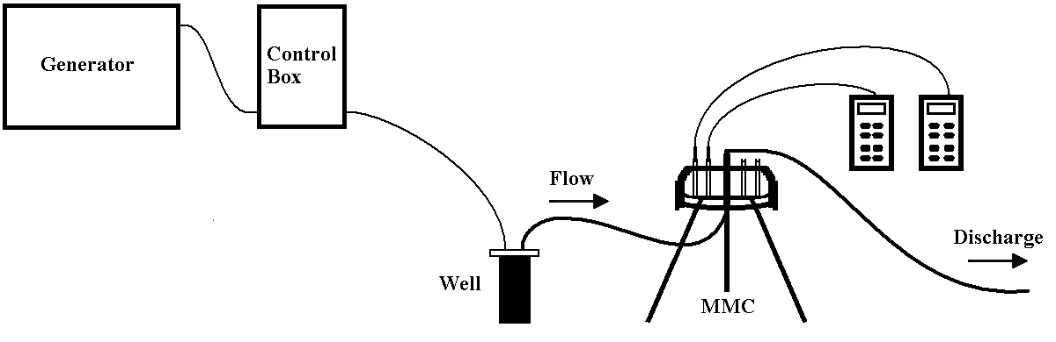

- Check the frequency display on the converter, it should read “0”. Start the pump by turning the Start/Stop switch into the “Start” position. Increase the flow of water by turning the speed dial until water is steadily flowing out of the MMC discharge. Do not exceed 8-psi inside the MMC. There is no gauge that shows the pressure inside the chamber, but a frequency setting of about 200 should ensure the 8-psi limit is not exceeded.
- Record pH, temperature, and conductivity readings every minute on an EPG Form 001 (Flow Thru Cell).
- Measure the time taken to fill the five-gallon carboy and record the flow rate.
- When at least two bore volumes have purged and the three parameters stabilize, as described in the Special Instructions, it is assumed water representative of the screened geological unit is being discharged and a sample is drawn from the MMC discharge tube. If the parameters do not stabilize after twenty minutes, take readings every five minutes until stabilization or until the well purges dry. If a well purges dry, collect a sample as soon as it has recharged sufficiently.

Note: Keep the samples away from any sources of contamination, i.e. the generator, samples from other wells, etc.

- Turn the Start/Stop switch on the converter box to the “Stop” position and, to prevent damage to the converter box, set the generator’s A/C circuit breaker to the “off” position BEFORE shutting down the generator. Dismantle the sampling apparatus.
- Label the bottles with the proper Sample Identification (SID), location, date, time, and analysis type (as appropriate) and place the bottles for chemical analysis in the cooler for storage.
- Complete all appropriate entries in the field logbook and the COC’s.
- Take the samples to Site 39 to ensure that all labels are accurate and attached securely to the bottles. Also ensure that the COC is complete and accurate.
- Complete a Radiochemical Analysis Facility (RAF) Work Request Form and relinquish custody of the Type-1 samples to RAF personnel. After they sign the COC, make a copy for the EP Group file on WH7E.
- Decontaminate the MMC and related tubing with Liqui-Nox™, tap water, and a final rinse of distilled water.
- Deliver the chemical samples to Shipping/Receiving (Warehouse 2) and complete a MMR. Relinquish the samples to shipping personnel and instruct them to do the same when the chemical analysis laboratory’s agent picks up the samples. Remove the bottom (pink) copies of both the signed COC and MMR. Return the copies to the EP Group file on WH7E for storage until analytical results are received. Call the chemical analysis laboratory to confirm pickup of the samples. Alternatively, the samples may be taken directly to the chemical analysis laboratory. In this instance a MMR is not necessary.
- Return the COC copies to the EP Group files on WH7E for storage until analytical results are received.
- At WH7E enter all depth-to-water and flow-thru-cell data in their appropriate locations on the Fermilab Environmental Database (FED).
Appendix A

Well Location Map

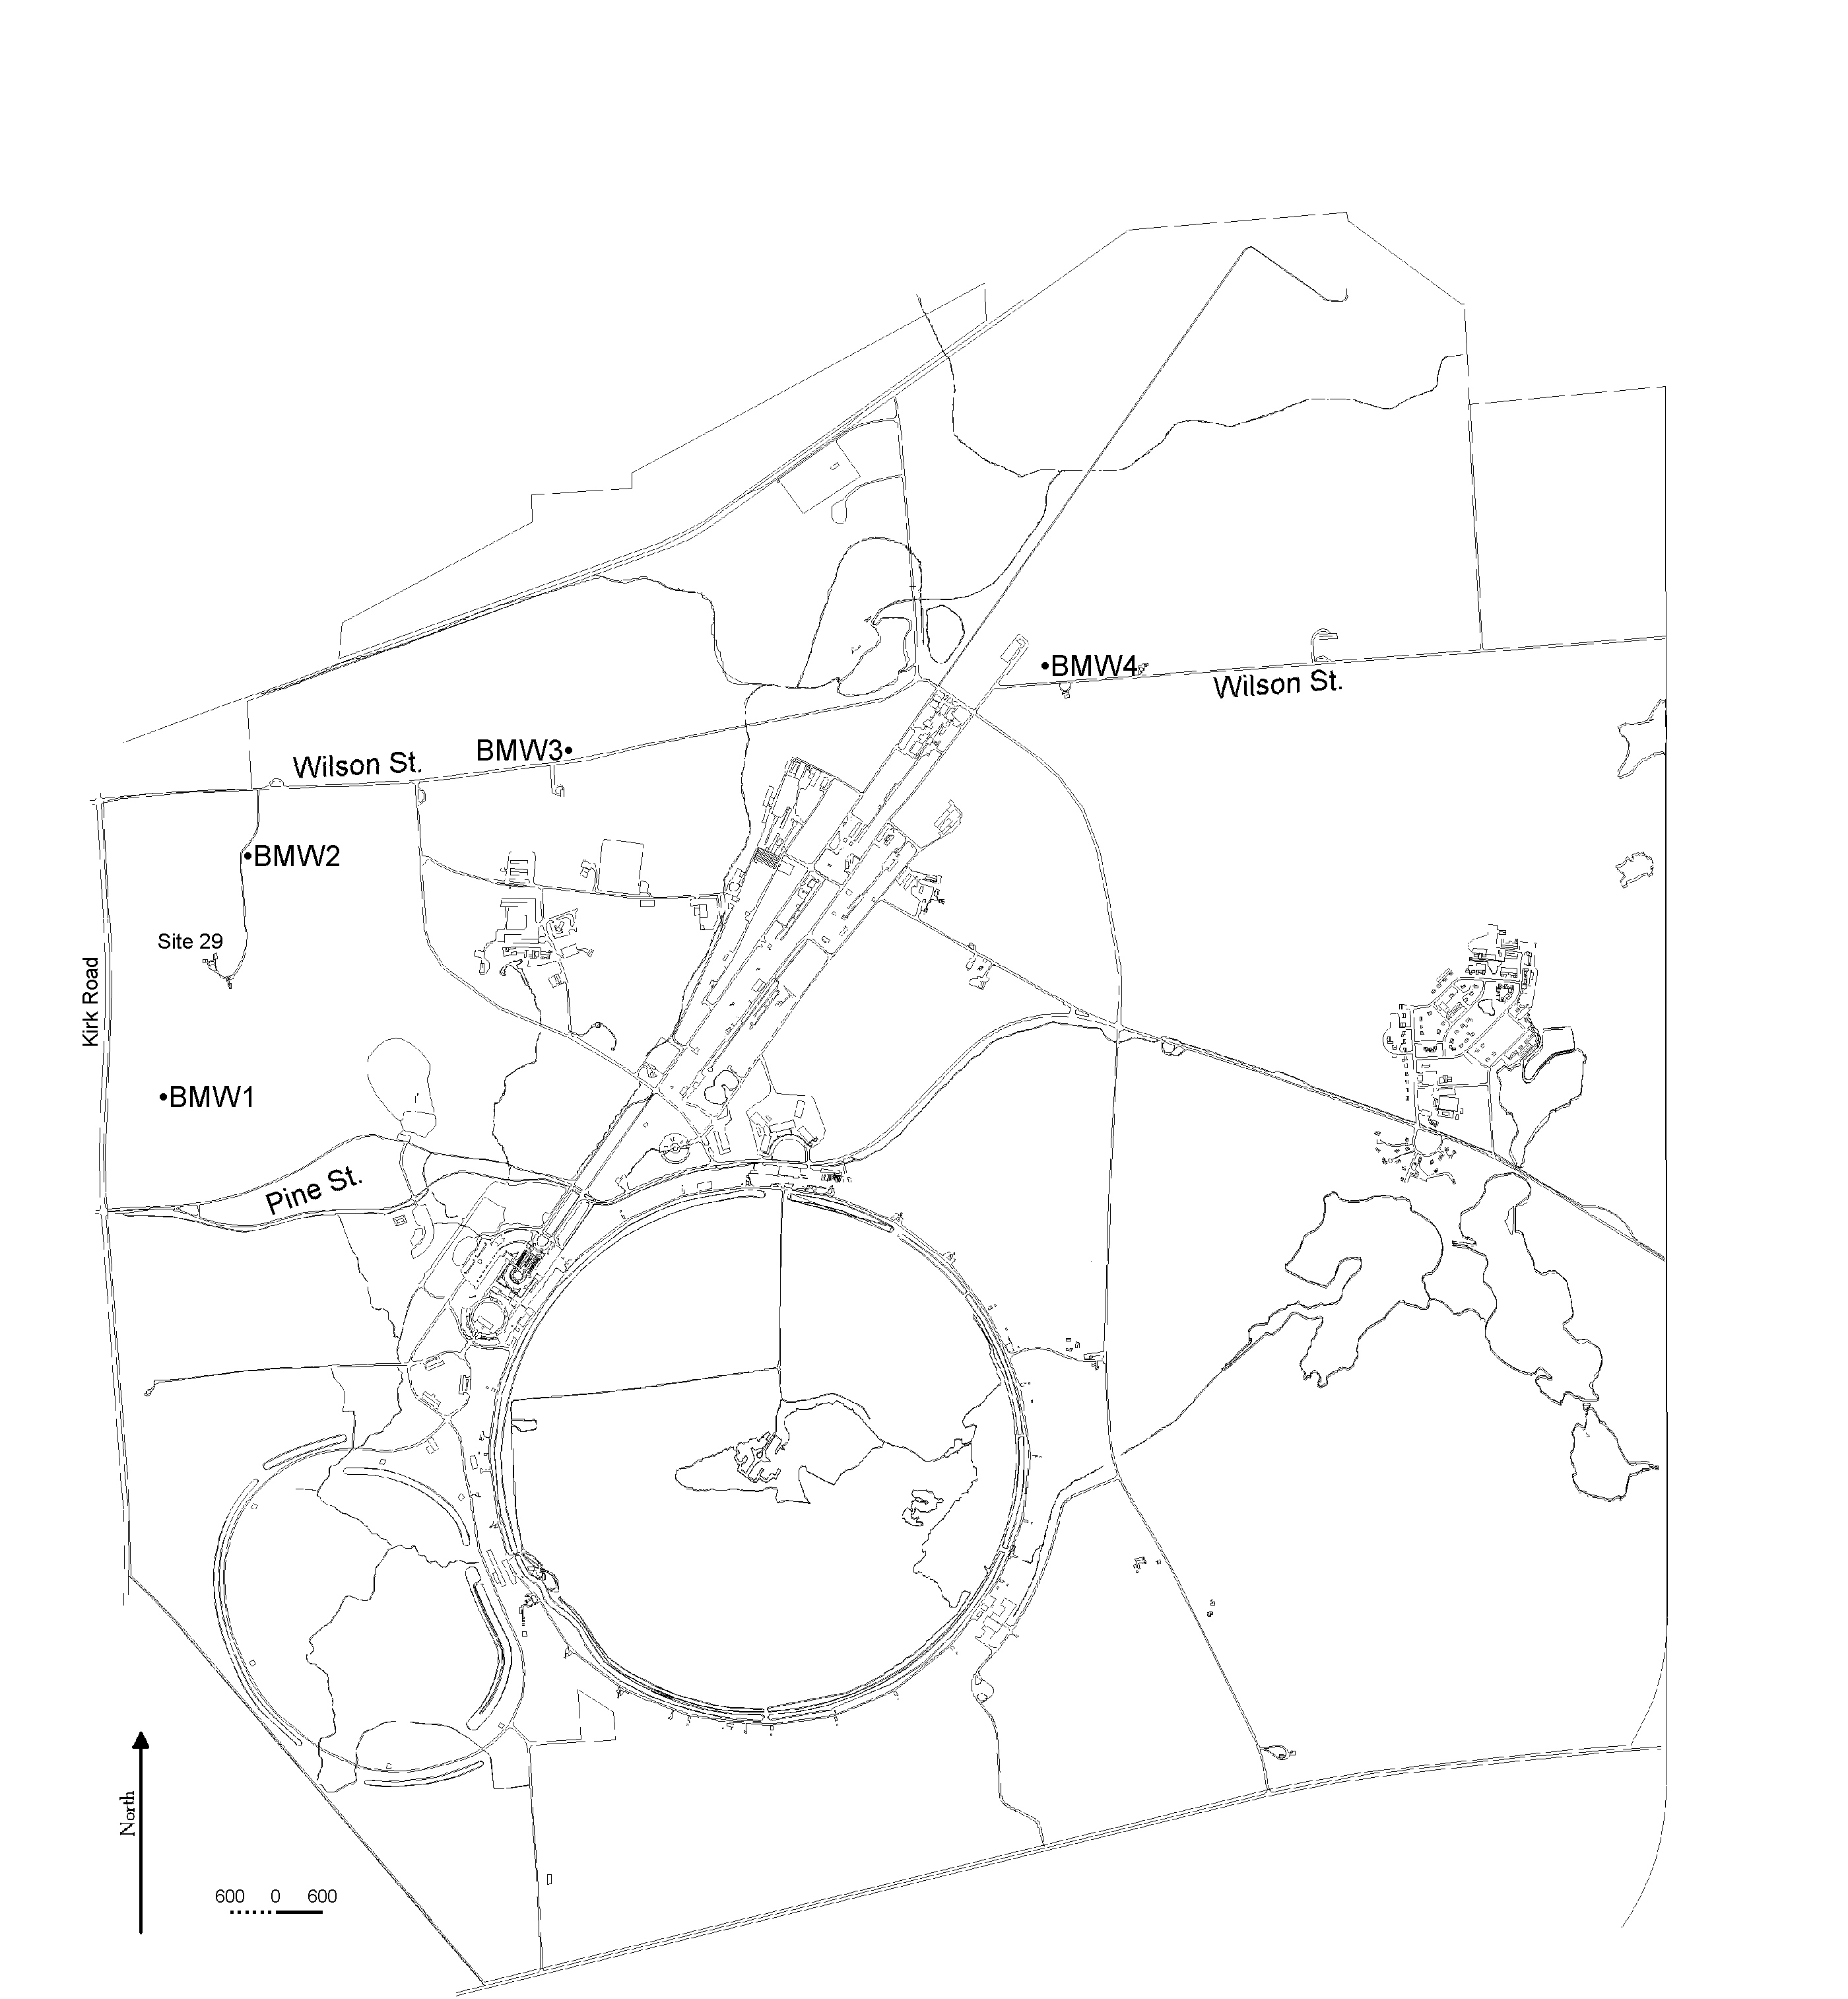

Appendix B
Digital Images
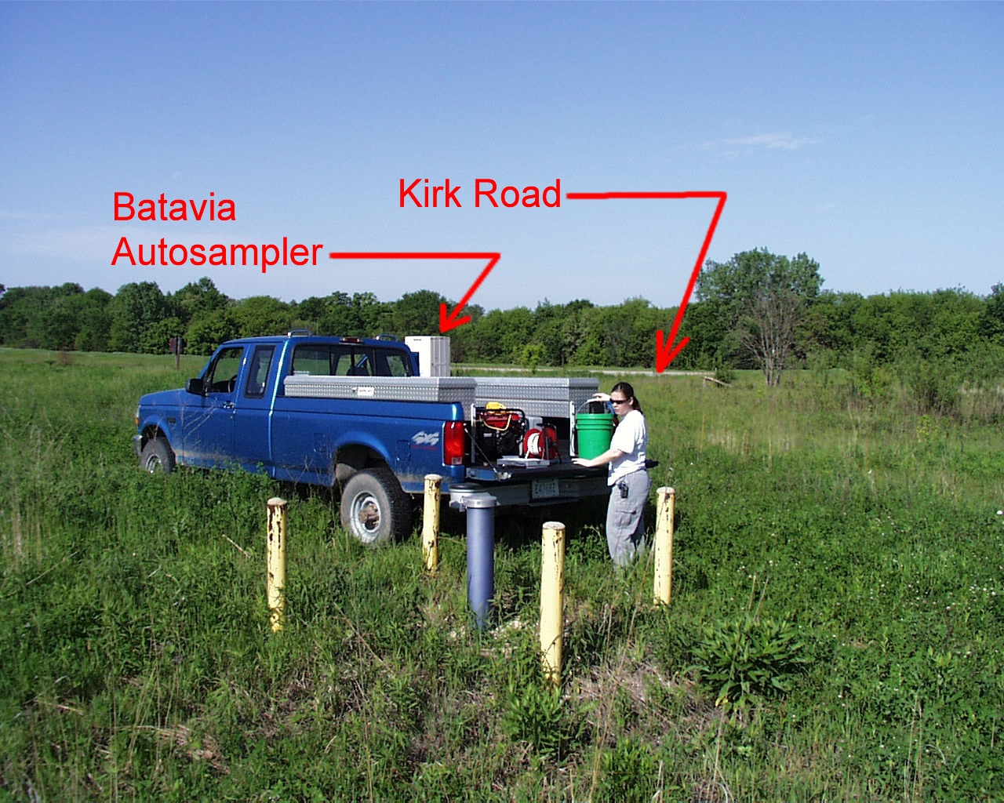

BMW1 – Located northeast of the Batavia Autosampler east of Kirk Road. Access is from Pine Street along mowed area around power lines. View is westerly.

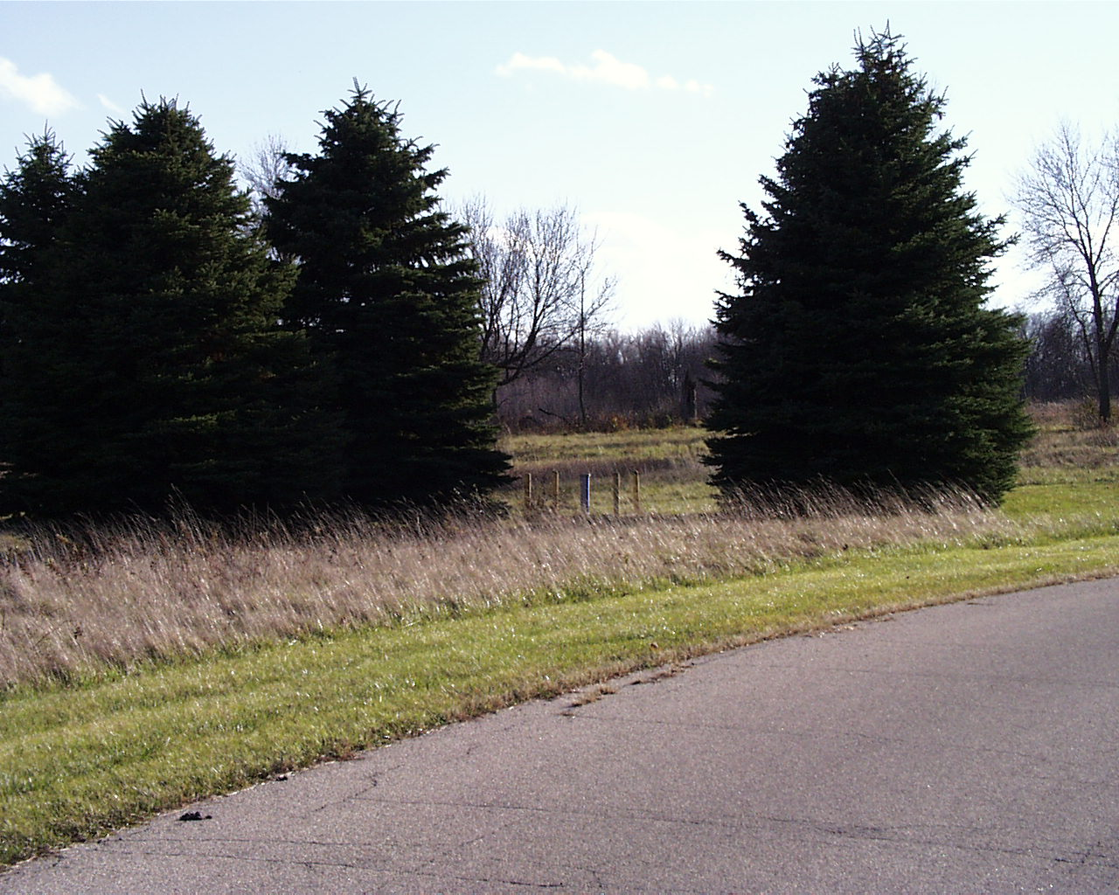

BMW2 – Located east of the drive to Site 29 (Director’s Residence) about 1000’ south of Wilson Street. View is southerly.
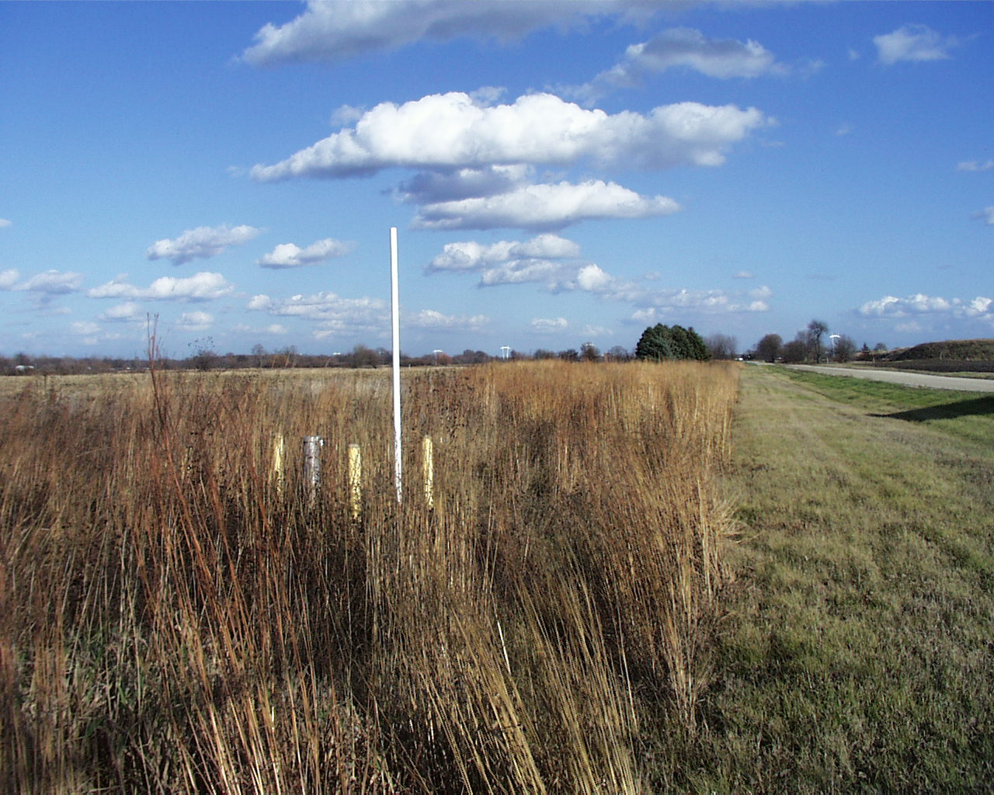

BMW3 – Located north of Wilson Street east of Site 56. View is easterly.

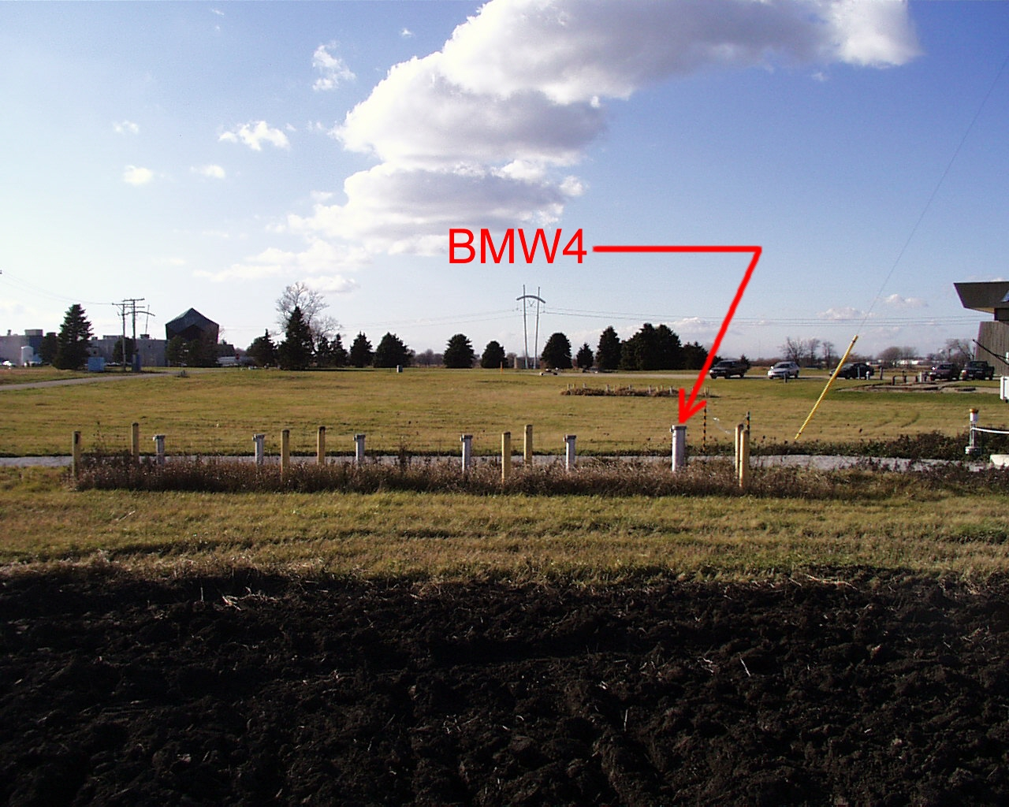

BMW4 – Located in the field east of New Muon Lab next to the meteorological station. View is westerly.

Appendix C

Indicator Parameters

Indicator Parameters

Filtered
N-Ammonia (dissolved)
Arsenic (dissolved)
Cadmium (dissolved)
Chloride (dissolved)
Iron (dissolved)
Lead (dissolved)
Manganese (dissolved)
Mercury (dissolved)
Sulfate (dissolved)
Total Dissolved Solids (TDS)

Unfiltered
Chromium (total)
Iron (total)
Lead (total)
Sulfate (total)
Cyanide (total)
Chloride (total)
Phenols (total recoverable)
Total Organic Carbons (TOC)
Total Organic Halogens (TOX)

Appendix D

Chemical Analysis Laboratory Contact Information
First Environmental Laboratories, Inc.
1600 Shore Road, Suite D
Naperville, IL 60563

Contact: Lorrie Franklin
Office: 630-778-1200
Fax: 630-778-1233
Pager: 708-569-7507
Email: lorrie@firstenv.com

