Purpose of This Procedure
The objective is to monitor surface water outfalls for compliance with National Pollutant Discharge Elimination System (NPDES) permits issued to Fermi National Accelerator Laboratory (Fermilab).

Fermilab holds an Illinois Environmental Protection Agency (IEPA) NPDES permit (IL0026123) concerning the discharge of storm water and non-contact cooling water. As part of compliance with the permit, surface water analyses are required on a monthly basis (flow dependant) at six outfall locations: Outfall 001 Ferry Creek, Outfall 002 Kress Creek Transfer Ditch, Outfall 003 Indian Creek Spillway, Outfall 004 MINOS ICW Emergency Overflow to Indian Creek , Outfall 005 MI Pond C, and Outfall 006 MI Pond D. The sample locations are illustrated in Appendix A. At each location pH, temperature, and flow rate are measured, and samples are taken for tritium (³H). Additionally, total residual chlorine is measured at Outfall 002 Kress Creek Transfer Ditch and Outfall 003 Indian Creek Spillway. Each outfall needs to be visually inspected for signs of deterioration and ability to slow and/or stop flow as needed in accordance with our SPCC plan (Spill Prevention Control and Countermeasure Plan) and the Storm Water Pollution Prevention Plan (SWPPP). This shall be documented in the logbook and reported to FESS. The procedure for each location is described separately due to the differences in sampling parameters and methods at each location.

Materials/Pre-requisites Needed

- NPDES Field Logbook
- Flow Data Collection Sheet - Form EP 006
- Chain-of-Custody - Form EP 002
- Sample Identification (SID) Labels
- Calibrated pH/Temperature Meter
- Tape Measure & Ruler
- Stopwatch
- Calculator
- Hach DR 900 Colorimeter Kit
- 3 floats (such as sticks or leaves)
- Long-handled Polyethylene Dipper
- Kaydry Wipes
- Distilled Water
- Disposable Nitrile Gloves
- 125ml Polyethylene Sample Bottles
- Poly Bottle with Hazardous Waste Sticker (for Sodium Arsenite Solution Disposal)

References
- Dr 900 Colorimeter Total Chlorine (0-2.00 mg/L) Analysis Procedure Method 8167
- NPDES Compliance Sampling Inspection Manual, (US.) Environmental Protection Agency, May 1979.
- Sension 156 Portable Multiparameter Meter Instruction Manual, Hach Company, 05/2001.
- Solving the Mysteries, Collecting Environmental Samples, Halliburton NUS Environmental Corporation 1991.
- Water Analysis Handbook, Hach Company 1992.
- National Pollutant Discharge Elimination System Under the Clean Water Act, 33 U.S.C. 125.
- 35 Illinois Administrative Code, Subtitle C, Part 305.

RESPONSIBILITIES

- Calibrate the pH/Temperature meter in the EP Group Room at Site 39.
- When sampling at outfalls, use caution, as creek banks may be steep and slippery.
- Have a cellular phone in order to contact EP group or security in the event of an emergency.
- When performing the chlorine test at Outfalls 002 and 003 using the Hach DR 900 Colorimeter, it is necessary to shield the sample from sunlight after the reagent has been added. The reaction between halogens and the DPD (N, N-diethyl-p-phenylenediamine) reagent in the presence of UV light causes a more intense color production that results in a non-representative high concentration measurement.
- Dirty glassware can also cause poor results. Following each field use, thoroughly clean the two glass sample cells using a brush, Liqui-Nox, tap water and a final rinse with distilled water. To prevent formation of water spots, dry the exterior of the sample cells with a Kaydry wipe and invert them on the dish rack (in the EP Group Room at Site 39) to allow any water on the inside to drain and air dry.

DETAILED PROCEDURE
Outfall 001 Ferry Creek Spillway

- Gather all necessary equipment from the EP Group Office and Site 39.
- Flow Measurements:
  - If water is flowing over the spillway:
    - Hold the ruler parallel to the water flow and measure to the nearest ¼ inch, the depth of water going over the spillway at the removable board.
    - At WH7E, find the worksheet for Ferry Creek in the Excel workbook titled Flow Calculators.xls found in the EPG Shared Drive.
  - If there is flow through the corrugated metal pipe west of the outfall:
    - Measure the depth of the water flowing through the pipe and record in step 1B of the Flow Data Collection Sheet.
    - Drop a floating object such as a twig or a leaf on the upstream end of the pipe and measure the time it takes to travel through the pipe with the stopwatch. Repeat for a total of three passes, recording each time on step 2A of the Flow Data Collection Sheet.
    - At WH7E, enter the relevant data into the Excel workbook titled Flow Calculators.xls found in the EPG Shared Drive.
    - Add the results from the Discharge Flow Scale and the result from the Flow Calculators workbook calculation.
    - Record the flow rate as MGD in the NPDES Field Logbook.
- Measure pH and temperature with the portable meter and record in the logbook. Take both measurements by submerging the probe directly in front of the spillway. Rinse the electrode with distilled water before storage.
- Following the steps specified in Procedure EP 207, collect a 125-ml sample to be analyzed for tritium. Record in the NPDES logbook and fill out a Chain-of-Custody Record.
- At WH7E enter all pH, temperature, and flow data in the EPG Shared Drive.
- If there is no measureable flow a sample still needs to be taken at the A.E. Sea Spillway for tritium anaylsis. Please refer to Procedure EP 207 Sampling Surface Water for Radionuclide Analysis for futher information. Record “No Flow” in the NPDES Field Logbook.

Outfall 002 Kress Creek Transfer Ditch

- Flow Measurement:
  - To the nearest inch, measure the width of the water at a point between the two posts (spaced 10’ apart) on the bank of the ditch and record on step 1A of the Flow Data Collection Sheet.
  - Measure the water depth to the nearest ¼ inch in the approximate right, left, and center. Determine the average depth of the ditch by adding the depths together and dividing by three and record on step 1A of the Flow Data Collection Sheet.
  - Drop a floating object such as a twig or a leaf in the center of the ditch upstream of the first marker post. Start the stopwatch when the float passes the post and stop it when the float passes the downstream marker post. Repeat for a total of three passes, recording each time on step 2A of the Flow Data Collection Sheet.
  - At WH7E, enter the relevant data into the Excel workbook titled Flow Calculators.xls found in the EPG Shared Drive.
  - Record the flow rate as MGD in the NPDES Field Logbook.
- Use the long-handled polyethylene dipper to collect a sample for chlorine analysis. Perform the chlorine measurement with addition of chlorine spikes (quaterly) following the steps outlined for using the colorimeter (Appendix C and Appendix D). Also see the notes regarding “Reagent Blank Value” in the “Special Precautions” section at the beginning of this document. Record the results in the logbook.
- Measure the pH and temperature at the same location where the sample was collected and record in the logbook.
- Take two additional temperature readings: 1) in Kress Creek, upstream of the transfer ditch, 2) in Kress Creek at the Power Line Road culvert, downstream of the transfer ditch. See the photographs in Appendix A indicating the sample and measurement locations. Clean the electrode with distilled water before storage.
- Following the steps specified in Procedure EP 207, collect a 125-ml sample to be analyzed for tritium. Record in the NPDES logbook and fill out a Chain-of-Custody Record.
- At WH7E enter all pH, temperature, flow, and chlorine data in the EPG Shared Drive.
- If there is no measureable flow a sample still needs to be taken upstream of the Outfall at Kress Creek Transfer Ditch Spillway for tritium and chlorine anaylsis. Please refer to Procedure EP 207 Sampling Surface Water for Radionuclide Analysis for futher information. Record “No Flow” in the NPDES Field Logbook.

Outfall 003 Indian Creek Spillway

- If water is flowing over the spillway determine the discharge rate in millions of gallons per day (MGD).
  - Hold the ruler parallel to the water flow and measure to the nearest ¼ inch, the depth of water going over the spillway at the weir plate.
  - At WH7E, find the worksheet for Ferry Creek in the Excel workbook titled Flow Calculators.xls found in the EPG Shared Drive.
  - Record the flow rate as MGD in the NPDES Field Logbook.
- Use the long-handled polyethylene dipper to collect a sample for chlorine analysis. Perform the chlorine measurement following the steps outlined for using the colorimeter (Appendix B).
  - Note: Indian Creek may have levels of manganese that interfere with the halogen analysis performed at this outfall. If the measured concentration is > 0.05mg/L, the following two-part pre-treatment method is required in order to compensate for the manganese. (see also Appendix B)
    - Using the plastic 50ml beaker in the colorimeter kit, adjust a sample (25ml minimum) to a pH of 6-7 with 1N sodium hydroxide or 1N sulfuric acid.
    - Pour 25ml of the adjusted-pH sample into the sample cell. Add 3 drops of potassium iodide solution (30g/L) mix and wait one minute.
    - Add 3 drops of sodium arsenite solution (5g/L) to the sample and mix. Analyze the sample using the spectrophotometer as described in Appendix C. This gives the concentration of manganese in the sample. Record the results.
    - Subtract the result of the treated second (manganese) test from the untreated first (chlorine + manganese - RBV) test result. This is the chlorine concentration of the sample. If the calculated value is < 0.00 mg/L, report it as < 0.01mg/L.
    - Properly dispose of the sodium arsenite treated sample as hazardous waste by pouring it into the bottle marked “Hazardous Waste”, and complete a Hazardous Waste Disposal request form when the bottle is full.
- Record the chlorine concentration in the NPDES Field Logbook.
- Measure pH and temperature where the chlorine sample was takenand record in the logbook. Clean the electrode with distilled water before storage.
- Following the steps specified in Procedure EP 207, collect a 125-ml sample to be analyzed for tritium. Record in the NPDES logbook and fill out a Chain-of-Custody Record.
- At WH7E enter all pH, temperature, flow, chlorine in the EPG Shared Drive.

Outfall 004 MINOS ICW Emergency Overflow to Indian Creek

Flow at this outfall would occur if two pumps at the NuMI ICW Holding Tank failed or would need to be turned off for maintenance or repairs. In the event of pump failure, Facilities Engineering would be alerted by alarms. Although it is not expected to happen, water could eventually drain into the grassy swale that leads towards a ditch tributary of Indian Creek. FESS will call the EP group to notify of a discharge. FESS would provide flow measurement via email.
- Visually inspect grassy swale to determine flow reaching the ditch tributary. If it is determined that flow occurred, proceed with the following steps.
- Measure pH and temperature with the portable meter. Take both measurements by submerging the probe. Rinse the electrode with distilled water before storage.
- Following the steps specified in Procedure EP 207, collect a 125-ml sample to be analyzed for tritium. Record in the NPDES logbook and fill out a Chain-of-Custody Record.
- At WH7E enter all pH, temperature, flow, in the EPG Shared Drive.

Outfall 005 Main Injector (MI) Pond C and Outfall 006 MI Pond D

These outfalls will have intermittent discharge and will be sampled and monitored if the flow is measurable over the concrete curtains that lead toward Indian Creek (see photo and map).

- To determine flow measurement:
- To the nearest inch, measure the width and length of the water flowing over the concrete apron and record on step 1A and 2A of the Flow Data Collection Sheet.
- Measure the water depth to the nearest ¼ inch in the approximate right, left, and center. Determine the average depth of the flow by adding the depths together and dividing by three and record on step 1A of the Flow Data Collection Sheet.
- Drop a floating object such as a twig or a leaf in the center of the flow at the upstream edge of the apron. Start the stopwatch when the float passes the upstream edge and stop it when the float passes the downstream edge. Repeat for a total of three passes, recording each time on step 2A of the Flow Data Collection Sheet.
- At WH7E, enter the relevant data into the Excel workbook titled Flow Calculators.xls found in the EPG Shared Drive.
- Record the flow rate as MGD in the NPDES Field Logbook.
- Measure pH and temperature with the portable meter and record in the logbook.
- Measure the temperature of Indian Creek upstream and downstream of where the ponds flow into the creek and record in the logbook.
- If there is no measureable flow a sample still needs to be taken at the MI Pond C for tritium anaylsis. Please refer to Procedure EP 207 Sampling Surface Water for Radionuclide Anaysis for further information. Record “No Flow” in the NPDES Field Logbook.

Appendix A

Outfall Maps and Photos

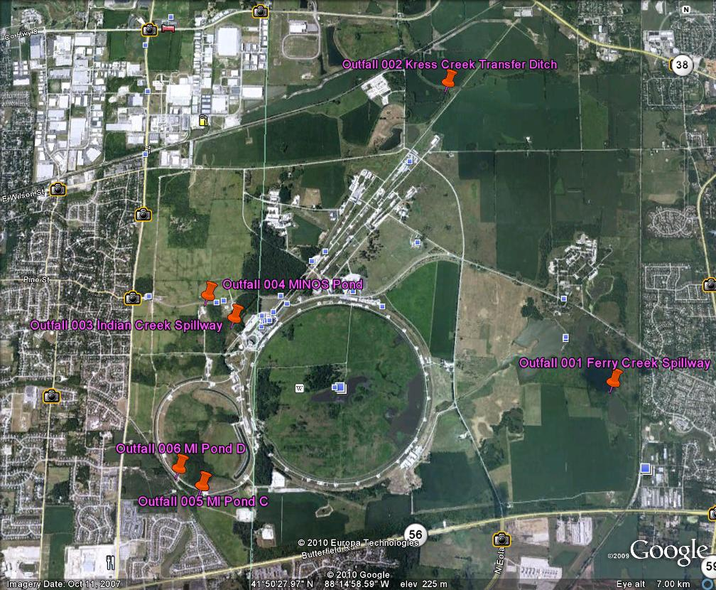
NPDES Outfall Location Overiew

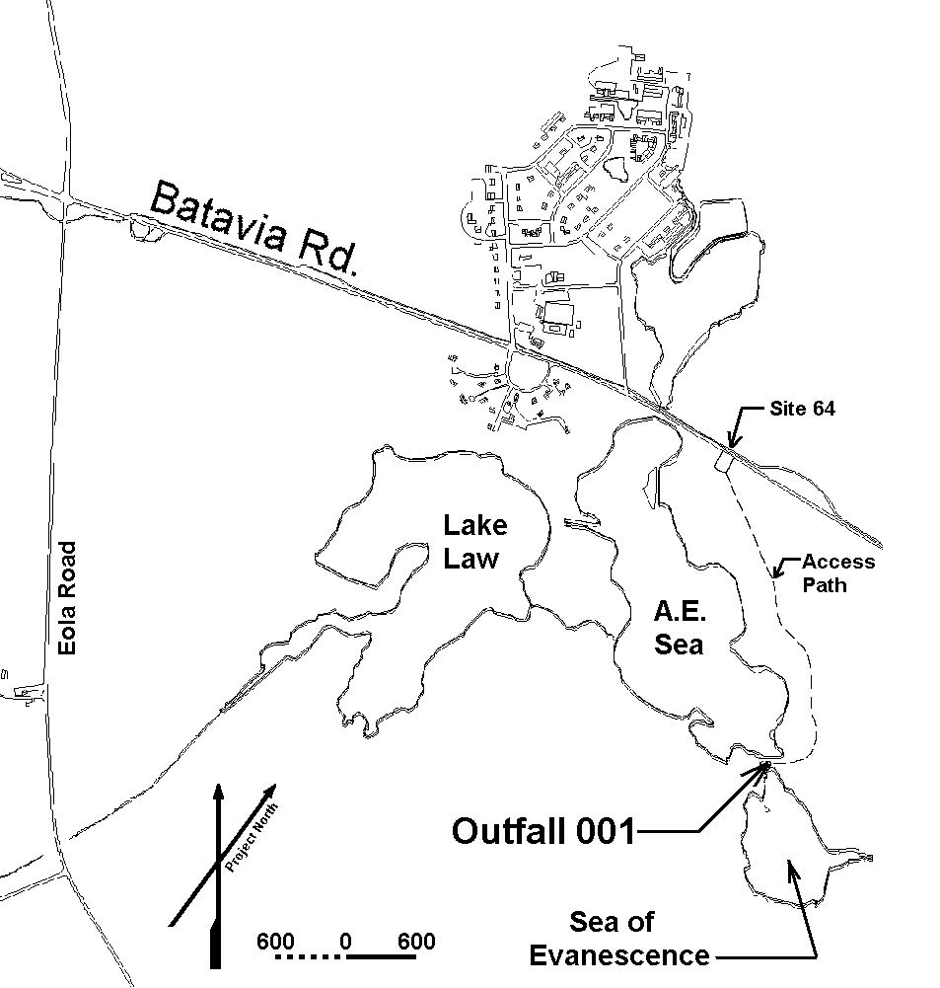

Outfall 001 Ferry Creek Spillway

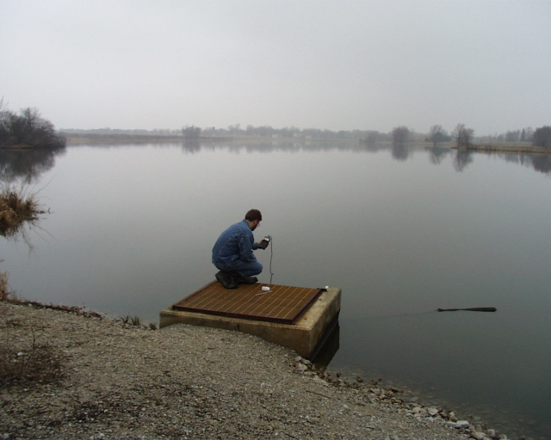

Ferry Creek Spillway sample location. View is notherly.

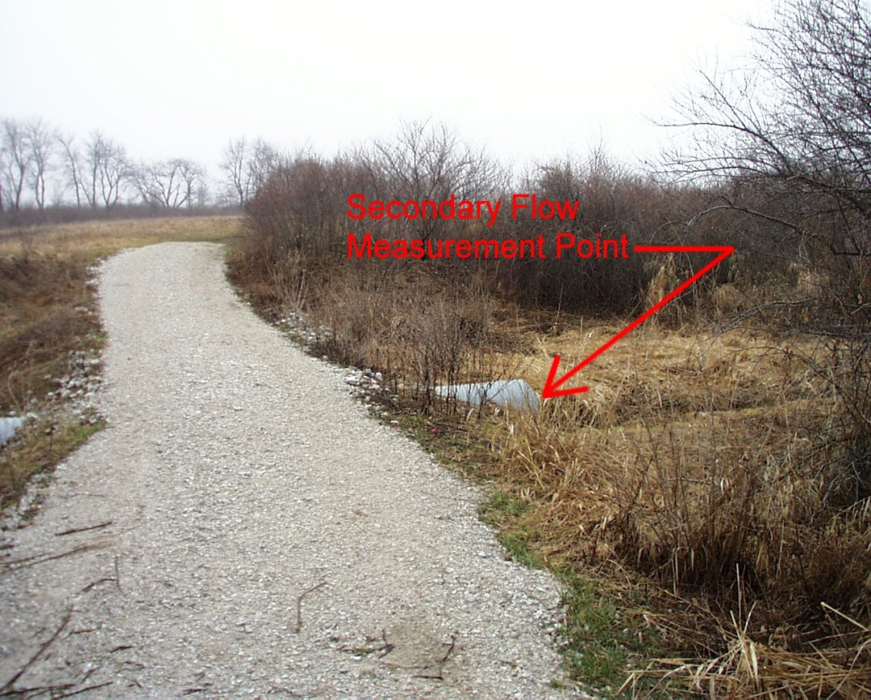
Ferry Creek Spillway Seconday Discharge. View is westerly.

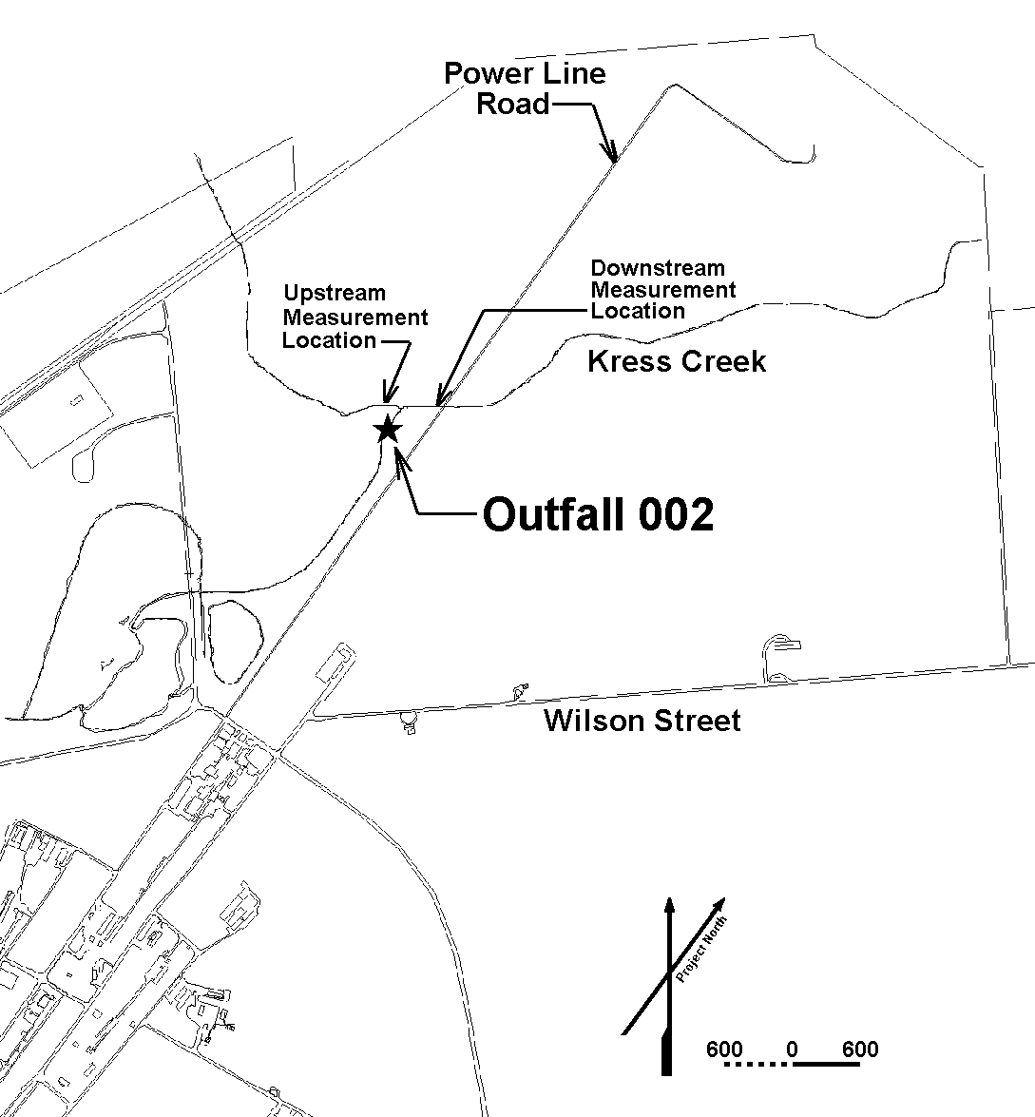

Outfall 002 Kress Creek Transfer Ditch

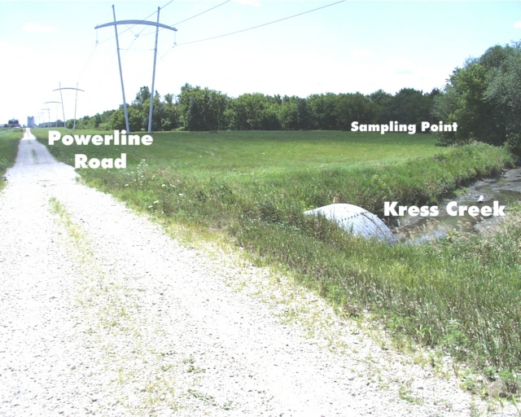

Kress Creek Location Overview. View is southerly.

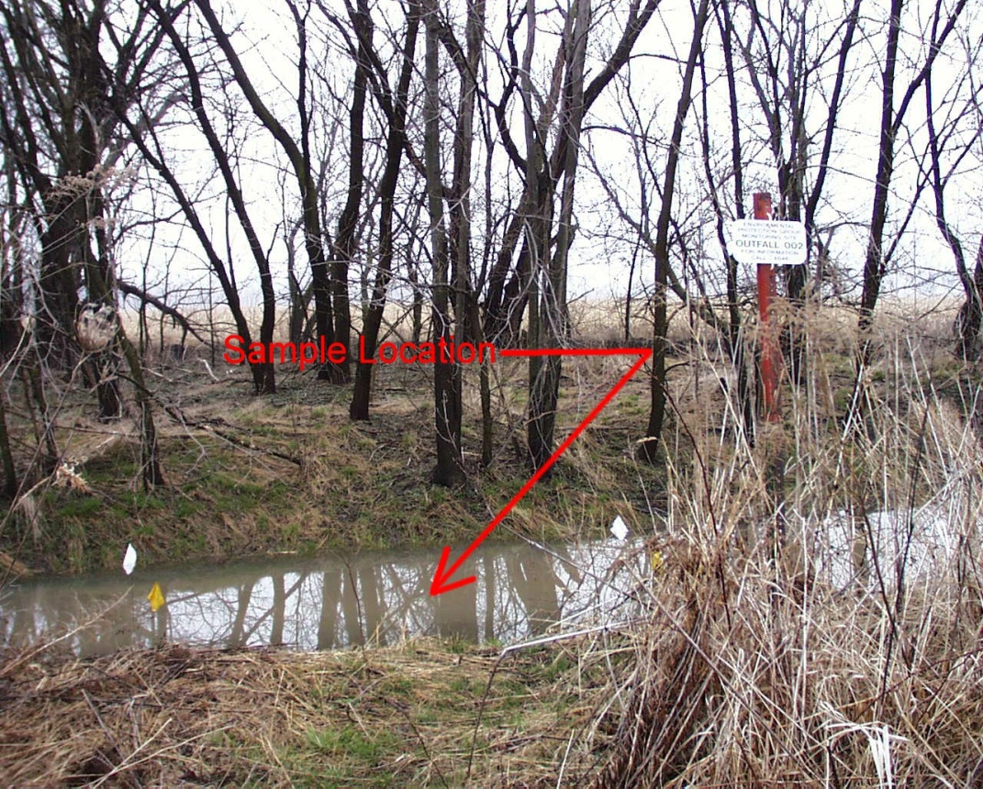

Kress Creek Transfer Ditch Sample point (if flowing). View is notherwesterly.

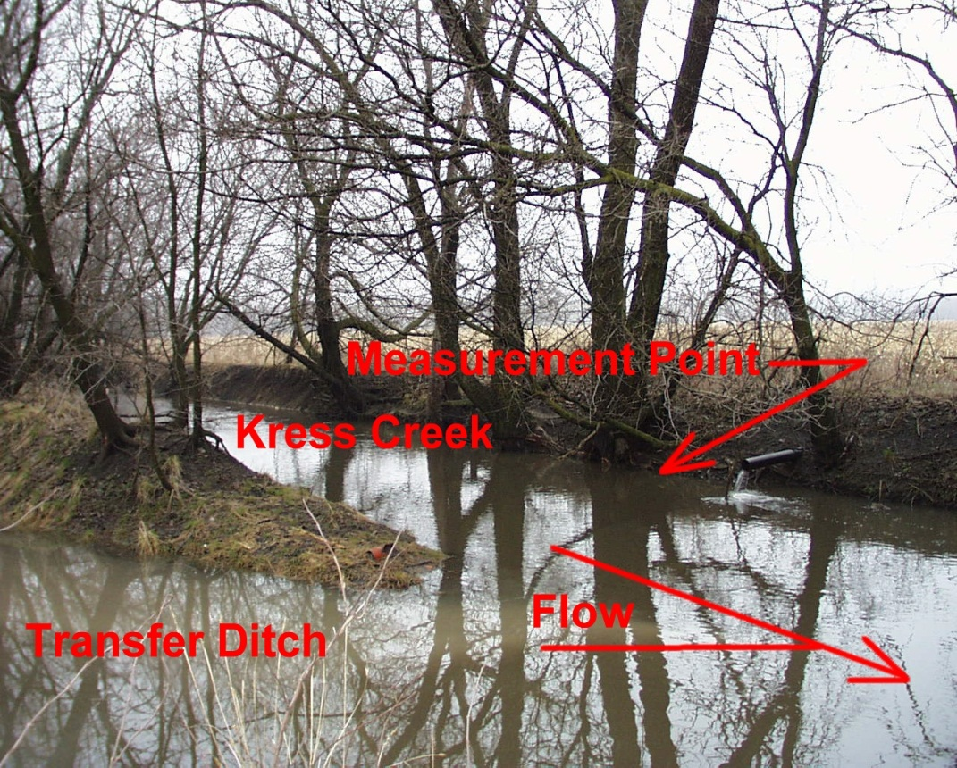

Kress Creek upstream temperature point. View is Westerly.

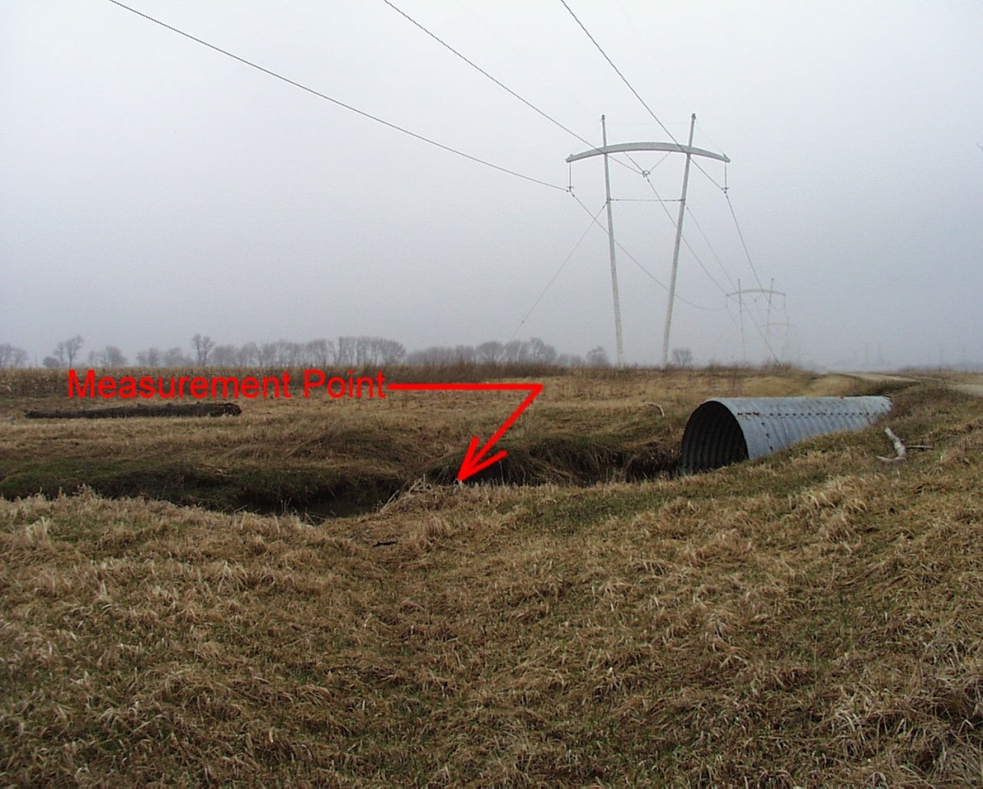
Kress Creek downstream temperature measurement point. View is northerly.
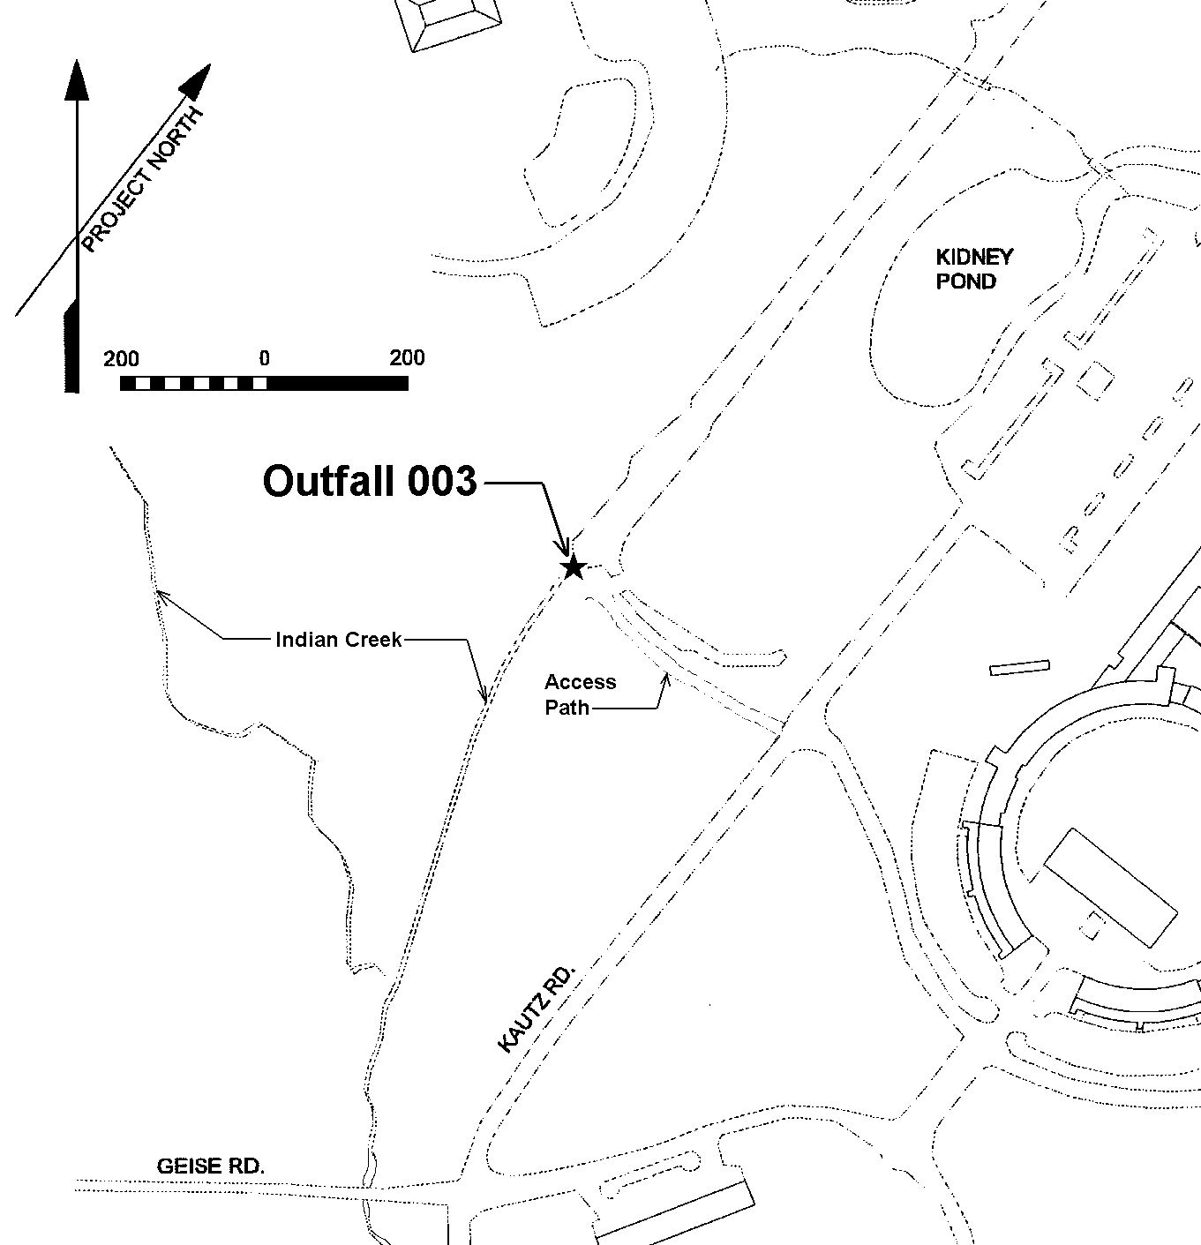

Outfall 003 Indian Creek Spillway
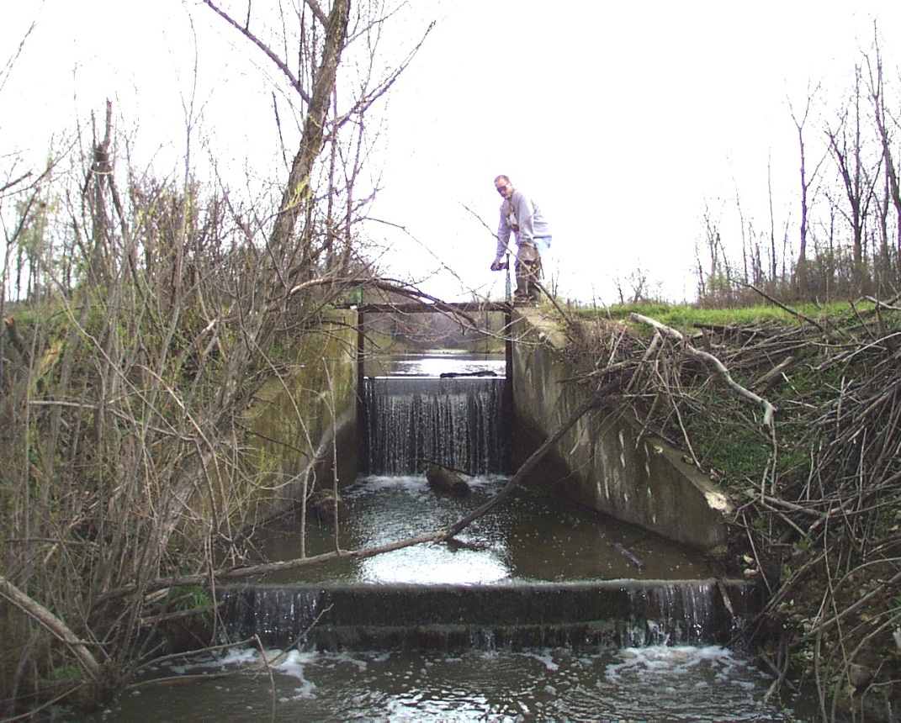
Indian Creek Spillway. View is northerly.

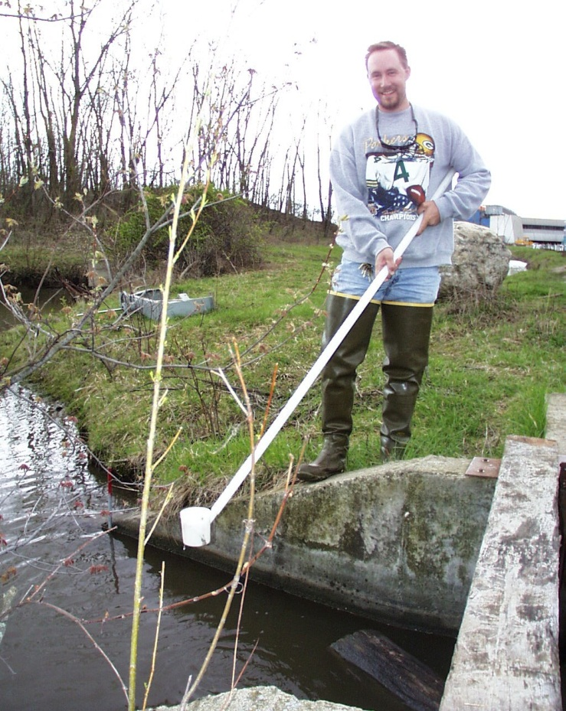
Indian Creek Spillway sample location. View is easterly.

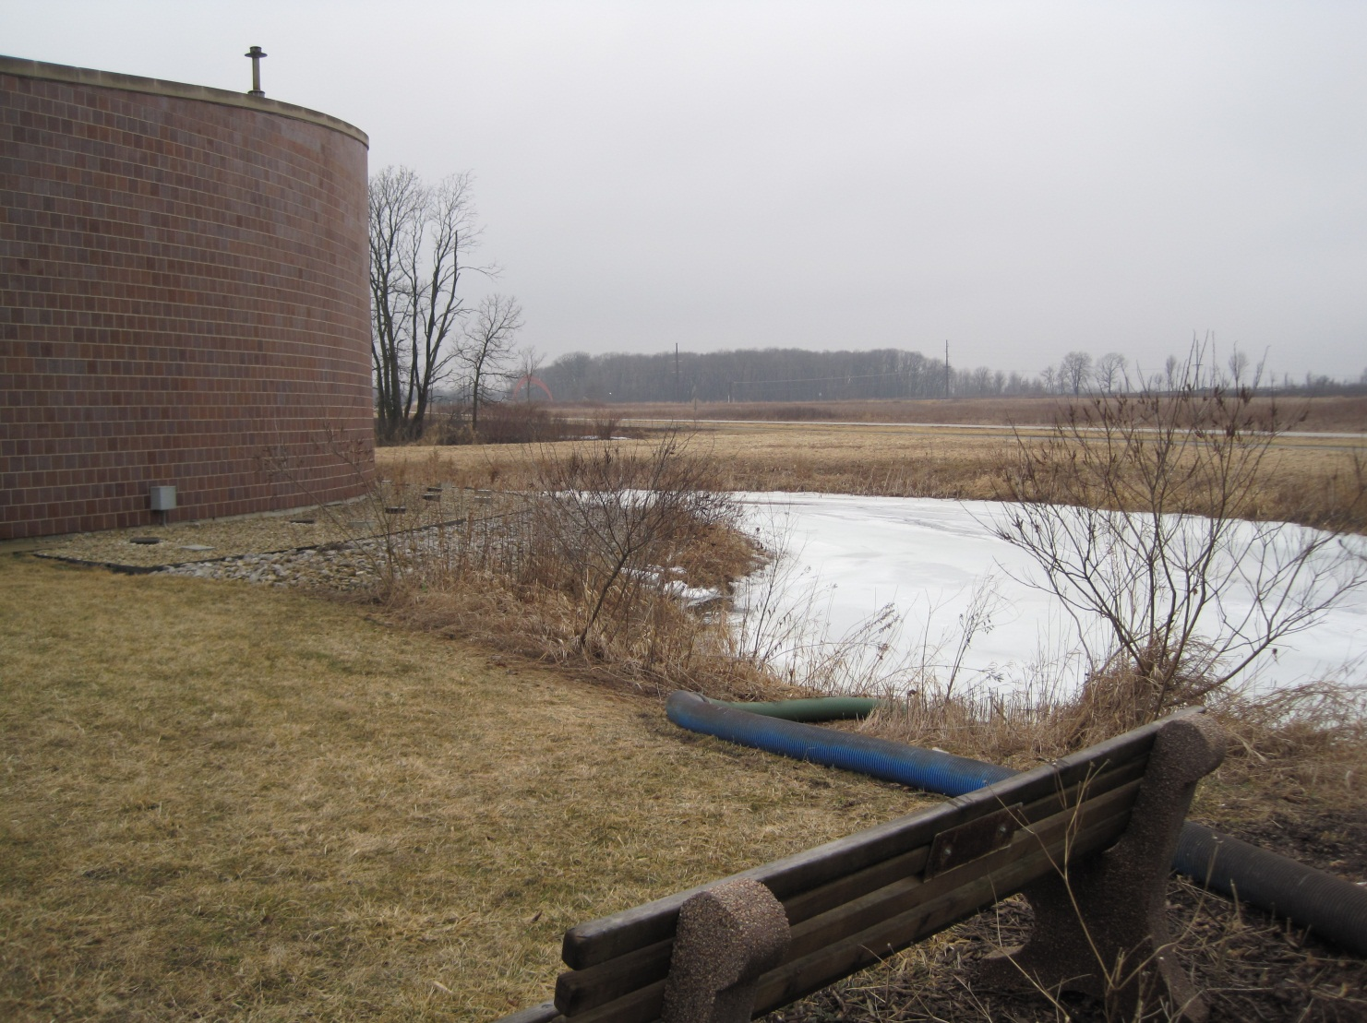
Outfall 004 MINOS (ICW Emergency Overflow to Indian Creek)

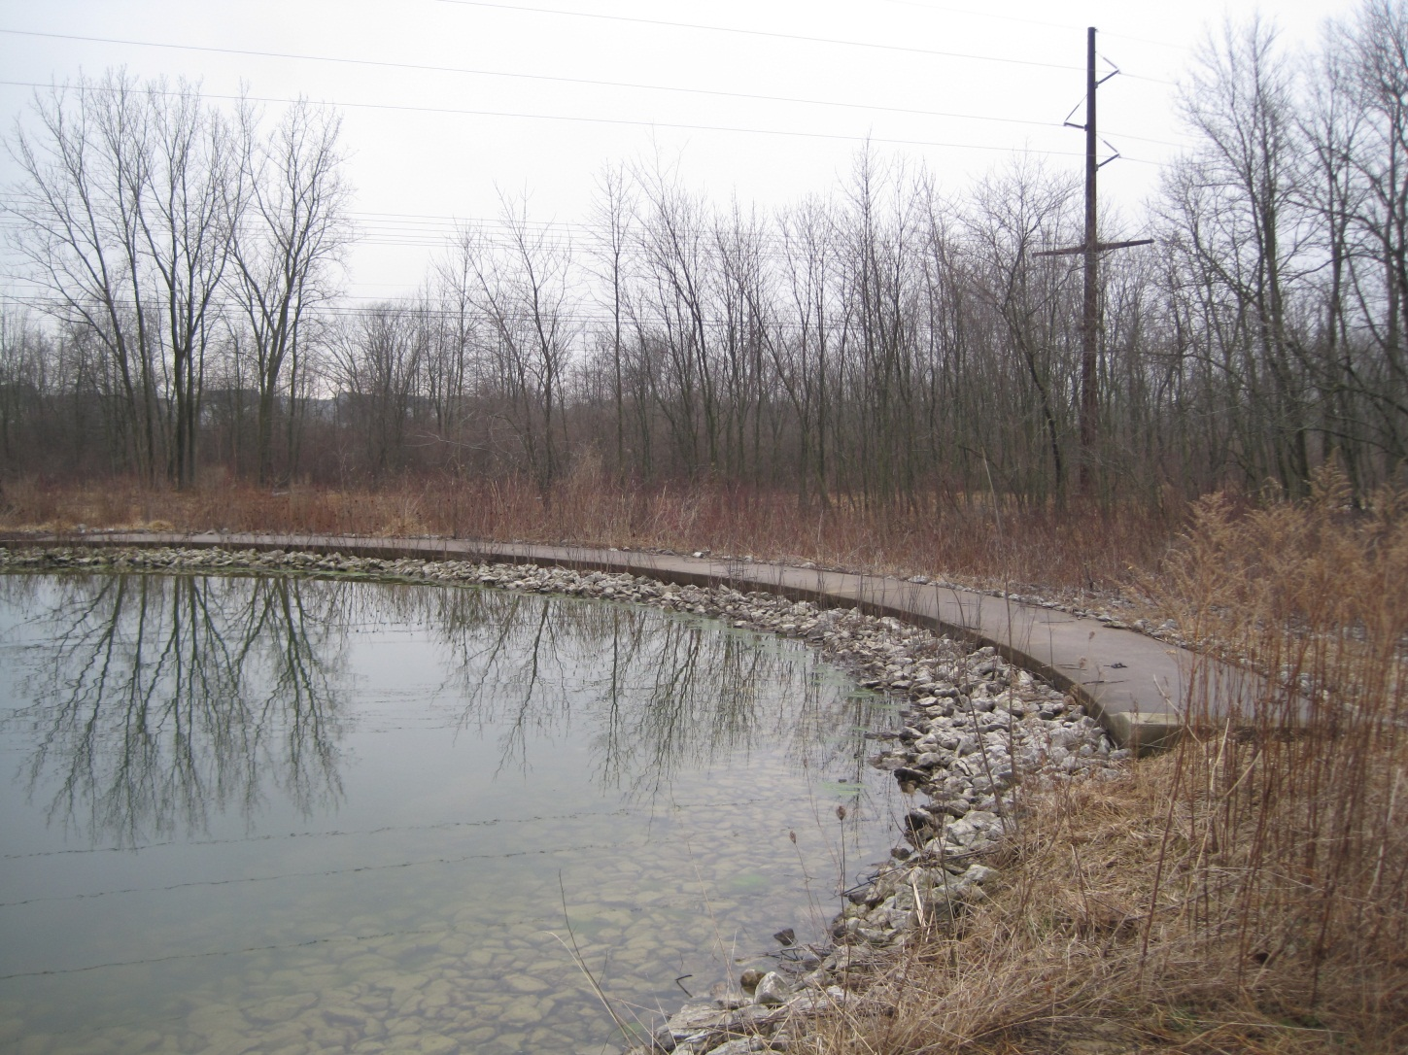
Outfall 005 MI Pond C

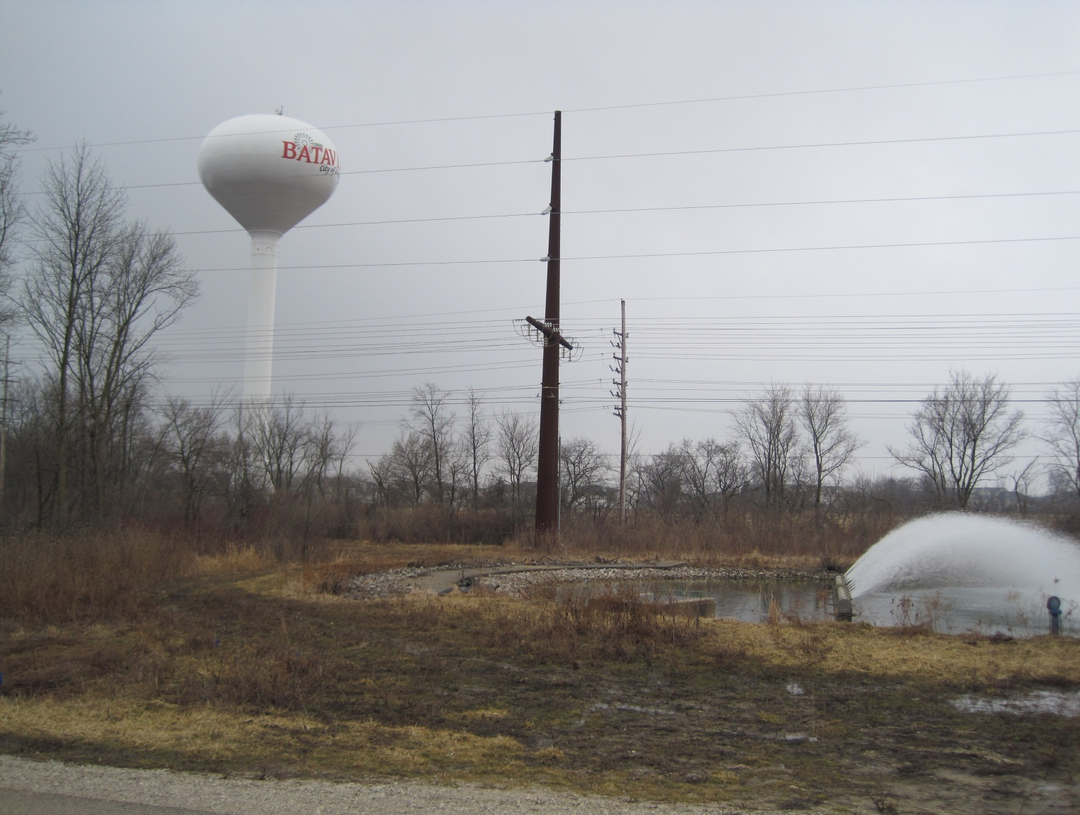
Outfall 006 MI Pond D

Appendix B
DR900 Colorimeter Total Chlorine (0-2.00 mg/L) Analysis Procedure, Method 8167

Chlorine, Total DOC316.53.01027

USEPA DPD Method1 Method 8167
®

0.02 to 2.00 mg/L Cl2 Powder Pillows or AccuVac
Ampuls

Scope and application: For testing residual chlorine and chloramines in water, wastewater, estuary water and seawater; USEPA-accepted for reporting for drinking and wastewater analyses.2 This product has not been evaluated to test for chlorine and chloramines in medical applications in the United States.
1 Adapted from Standard Methods for the Examination of Water and Wastewater.
2 Procedure is equivalent to USEPA and Standard Method 4500-Cl G for drinking water and wastewater analysis.

Test preparation

Instrument-specific information
Table 1 shows sample cell and orientation requirements for reagent addition tests, such as powder pillow or bulk reagent tests. Table 2 shows sample cell and adapter requirements for AccuVac Ampul tests. The tables also show all of the instruments that have the program for this test.
To use the table, select an instrument, then read across to find the applicable information for this test.

Table 1 Instrument-specific information for reagent addition

Instrument | Sample cell orientation | Sample cell
DR 6000  DR 3800  DR 2800  DR 2700  DR 1900 | The fill line is to the right. | 2495402  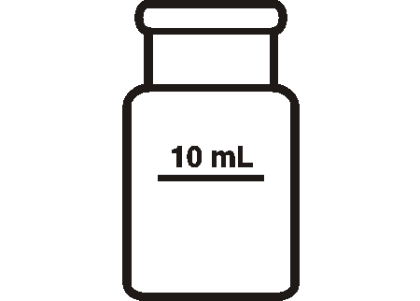
DR 5000  DR 3900 | The fill line is toward the user.
DR 900 | The orientation mark is toward the user. | 2401906  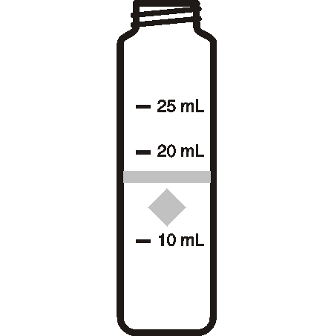

Table 2 Instrument-specific information for AccuVac Ampuls

Instrument | Adapter | Sample cell
DR 6000  DR 5000  DR 900 | — | 2427606  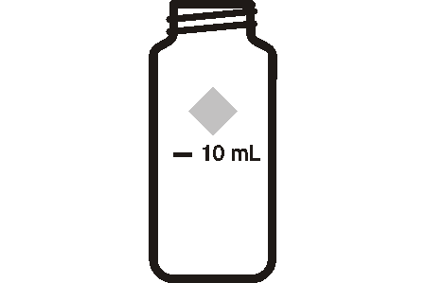
DR 3900 | LZV846 (A)
DR 1900 | 9609900 or 9609800 (C)
DR 3800  DR 2800  DR 2700 | LZV584 (C) | 2122800

Before starting

Samples must be analyzed immediately after collection and cannot be preserved for later analysis.
Install the instrument cap on the DR 900 cell holder before ZERO or READ is pushed.
If the test result is over-range, or if the sample temporarily turns yellow after the reagent addition, dilute the sample with a known volume of high quality, chlorine demand-free water and do the test again. Some loss of chlorine may occur due to the dilution. Multiply the result by the dilution factor. Additional methods are available to measure chlorine without dilution.
For chloramination disinfection control, use one of the available Chloramine (Mono) methods.
For the best results, measure the reagent blank value for each new lot of reagent. Replace the sample with deionized water in the test procedure to determine the reagent blank value. Subtract the reagent blank value from the sample results automatically with the reagent blank adjust option.
Review the Safety Data Sheets (MSDS/SDS) for the chemicals that are used. Use the recommended personal protective equipment.
Dispose of reacted solutions according to local, state and federal regulations. Refer to the Safety Data Sheets for disposal information for unused reagents. Refer to the environmental, health and safety staff for your facility and/or local regulatory agencies for further disposal information.
The SwifTest Dispenser for Total Chlorine can be used in place of the powder pillow in the test procedure. One dispensation is equal to one powder pillow for 10-mL samples.
An AccuVac Ampul for Blanks can be used to zero the instrument in the AccuVac test procedure.

Items to collect
Powder pillows

Description | Quantity
DPD Total Chlorine Reagent Powder Pillow, 10-mL | 1
Sample cells. (For information about sample cells, adapters or light shields, refer to Instrument-
specific information on page 1.) | 2

Refer to Consumables and replacement items on page 6 for order information.

AccuVac Ampuls

Description | Quantity
DPD Total Chlorine Reagent AccuVac® Ampul | 1
Beaker, 50-mL | 1
Sample cells (For information about sample cells, adapters or light shields, re | fer to Instrument-
specific information on page 1.) | 1
Stopper for 18-mm tubes and AccuVac Ampuls | 1

Refer to Consumables and replacement items on page 6 for order information.

Sample collection

- Analyze the samples immediately. The samples cannot be preserved for later analysis.
- Chlorine is a strong oxidizing agent and is unstable in natural waters. Chlorine reacts quickly with various inorganic compounds and more slowly with organic compounds. Many factors, including reactant concentrations, sunlight, pH, temperature and salinity influence the decomposition of chlorine in water.
- Collect samples in clean glass bottles. Do not use plastic containers because these can have a large chlorine demand.

  - Pretreat glass sample containers to remove chlorine demand. Soak the containers in a weak bleach solution (1 mL commercial bleach to 1 liter of deionized water) for at least 1 hour. Rinse fully with deionized or distilled water. If sample containers are rinsed fully with deionized or distilled water after use, only occasional pretreatment is necessary.
  - Make sure to get a representative sample. If the sample is taken from a spigot or faucet, let the water flow for at least 5 minutes. Let the container overflow with the sample several times and then put the cap on the sample container so that there is no headspace (air) above the sample.

Powder pillow procedure

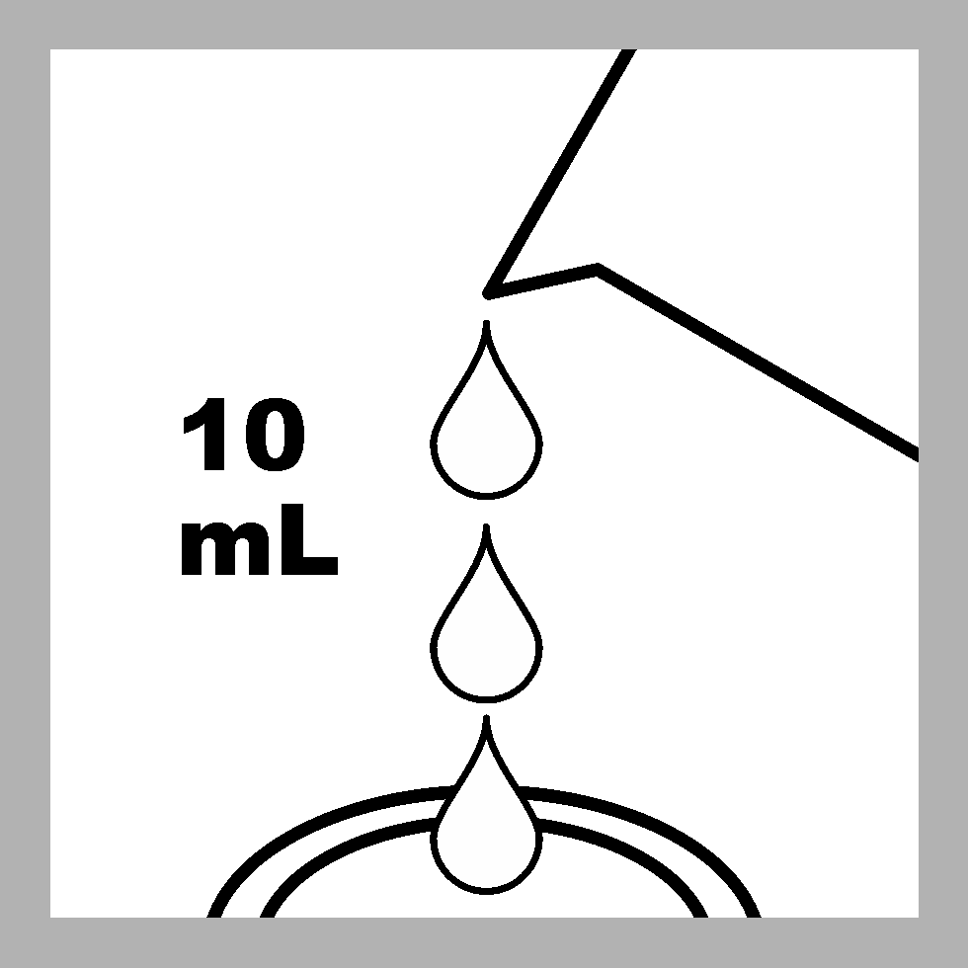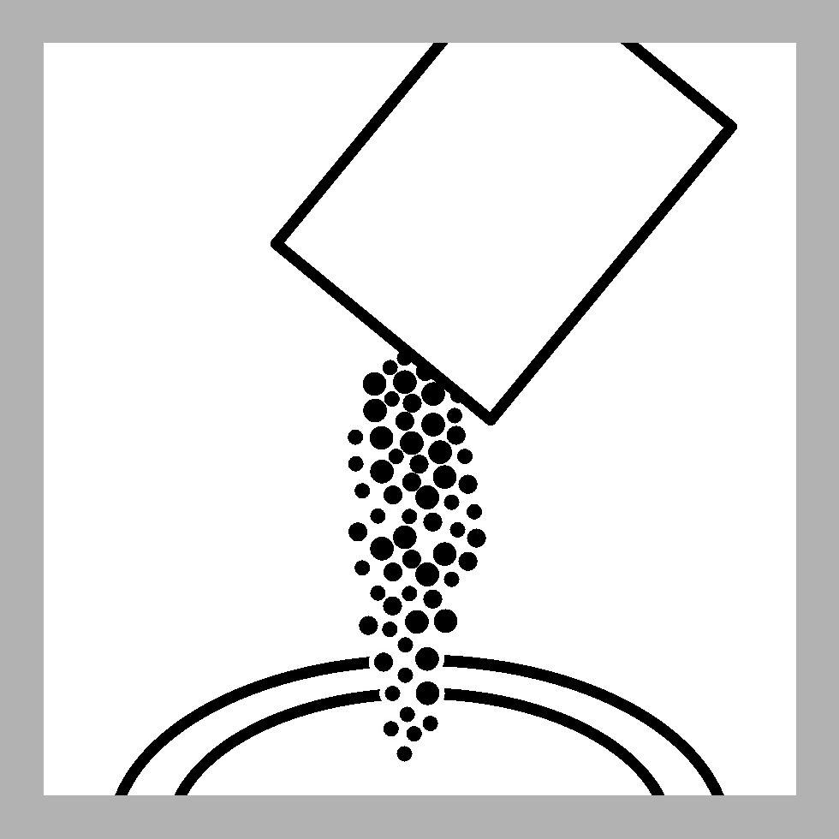
Start

1. Start program 80 Chlorine F&T PP. For information about sample cells, adapters or light shields, refer to Instrument- specific information
on page 1.
Note: Although the program name can be different between instruments, the program number does not change.

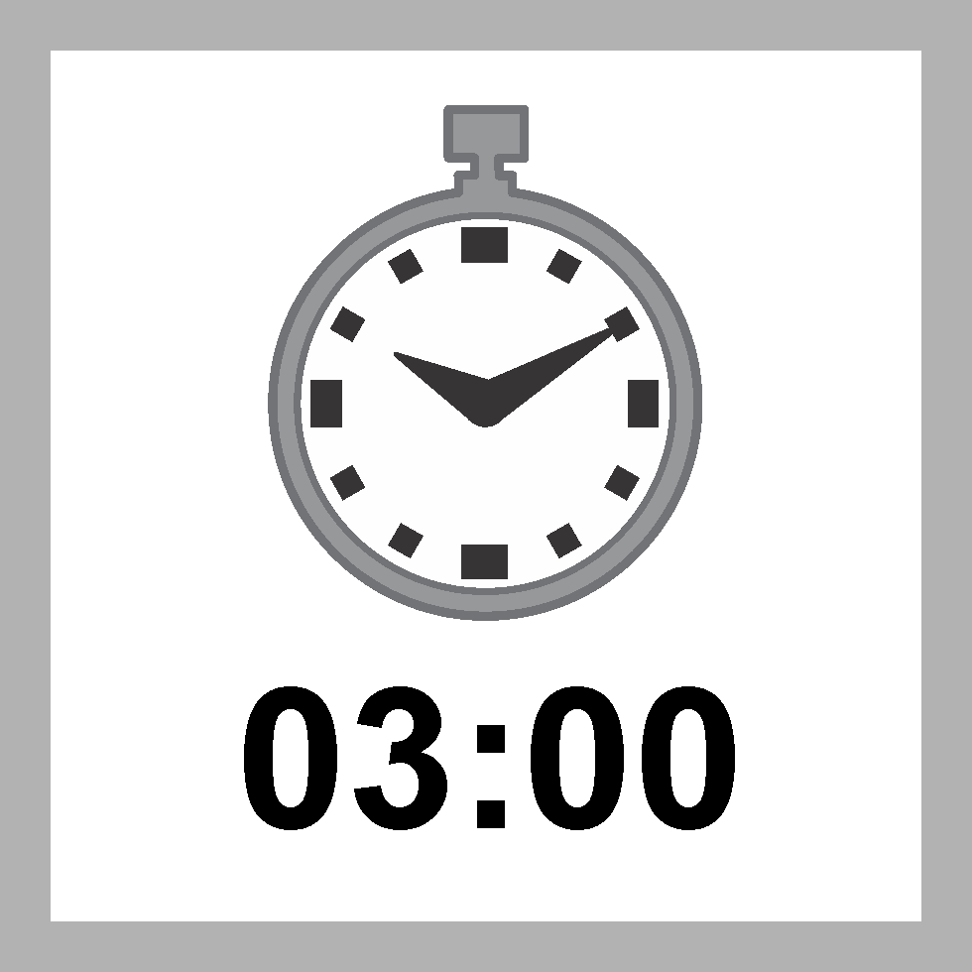

5. Start the instrument timer. A 3-minute reaction time starts.
Prepare the sample blank and set the instrument to zero during the reaction time.
2. Fill a sample cell with 10 mL of sample.

6. Prepare the blank: Fill a second sample cell with
10 mL of sample.
3. Prepare the sample: Add the contents of one powder pillow to the sample cell.



7. Clean the blank sample cell.
4. Swirl the sample cell for 20 seconds to mix.
A pink color shows if chlorine is present in the sample.



- Insert the blank into the cell holder.

Zero
Read

- Push ZERO. The display shows 0.00 mg/L Cl2.
- Clean the prepared sample cell.
- Within 3 minutes after the timer expires, insert the prepared sample into the cell holder.
- Push READ. Results show in mg/L Cl2.

AccuVac Ampul procedure

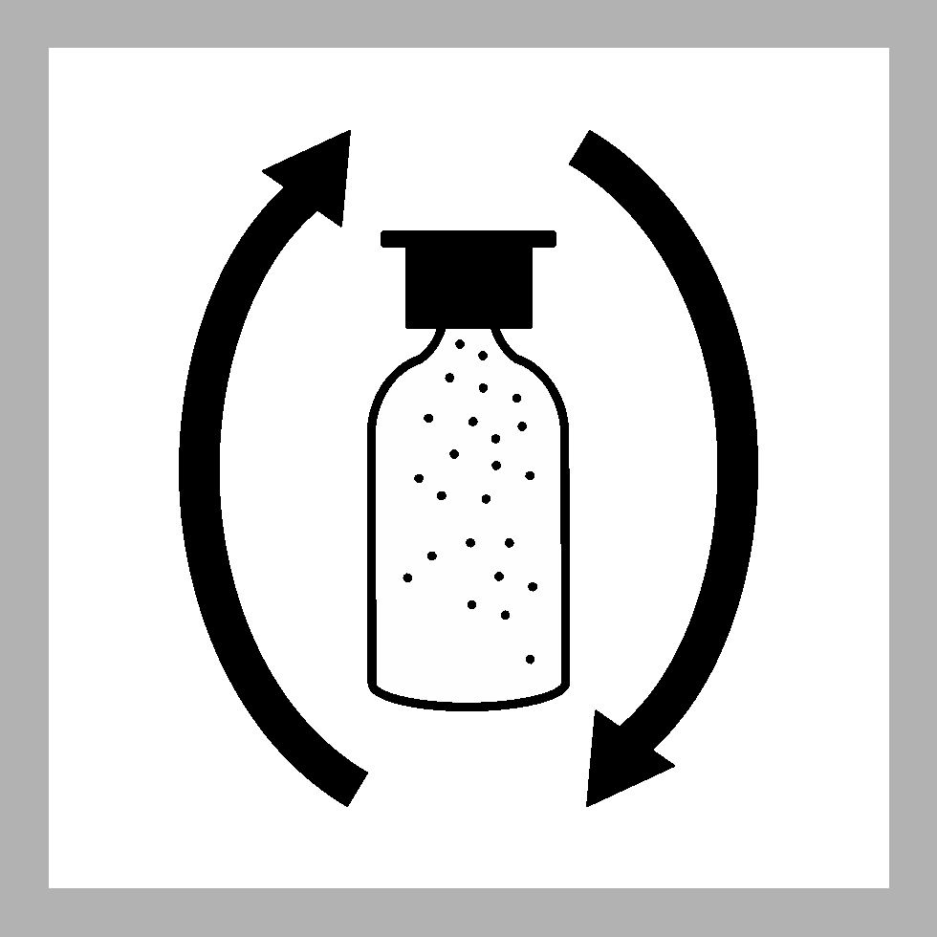
Start

1. Start program 85 Chlorine F&T AV. For information about sample cells, adapters or light shields, refer to Instrument- specific information
on page 1.
Note: Although the program name can be different between instruments, the program number does not change.

5. Start the instrument timer. A 3-minute reaction time starts.
Prepare the sample blank and set the instrument to zero during the reaction time.
2. Prepare the blank: Fill the sample cell with 10 mL of sample.

6. Clean the blank sample cell.
3. Prepare the sample: Collect at least 40 mL of sample in a 50-mL beaker. Fill the AccuVac Ampul with sample. Keep the tip immersed while the AccuVac Ampul fills completely.

7. Insert the blank into the cell holder.
4. Quickly invert the AccuVac Ampul several times to mix.

Zero

- Push ZERO. The display shows 0.00 mg/L Cl2.

Read

- Clean the AccuVac Ampul.
- Within 3 minutes after the timer expires, insert the prepared sample AccuVac Ampul into the cell holder.
- Push READ. Results show in mg/L Cl2.

Interferences

Interfering substance | Interference level
Acidity | More than 150 mg/L CaCO3. The full color may not develop or the color may fade instantly. Adjust to pH 6–7 with 1 N Sodium Hydroxide. Measure the amount to add on a separate sample aliquot, then add the same amount to the sample that is tested. Correct the test result for the dilution from the volume addition.
Alkalinity | More than 250 mg/L CaCO3. The full color may not develop or the color may fade instantly. Adjust to pH 6–7 with 1 N Sulfuric Acid. Measure the amount to add on a separate sample aliquot, then add the same amount to the sample that is tested. Correct the test result for the dilution from the volume addition.
Bromine, Br2 | Positive interference at all levels
Chlorine Dioxide, ClO2 | Positive interference at all levels
Inorganic chloramines | Positive interference at all levels
Chloramines, organic | May interfere
Hardness | No effect at less than 1000 mg/L as CaCO3
Manganese, Oxidized (Mn4+, Mn7+) or Chromium, Oxidized (Cr6+) | Pre-treat the sample as follows:  - Adjust the sample pH to 6–7.  - Add 3 drops of Potassium Iodide (30-g/L) to 10 mL of sample.  - Mix and wait 1 minute.  - Add 3 drops of Sodium Arsenite (5-g/L) and mix.  - Use the test procedure to measure the concentration of the treated sample.  - Subtract this result from the result without the treatment to obtain the correct chlorine concentration.
Ozone | Positive interference at all levels
Peroxides | May interfere
Highly buffered samples or extreme sample pH | Can prevent the correct pH adjustment of the sample by the reagents. Sample pre-treatment may be necessary. Adjust to pH 6–7 with acid (Sulfuric Acid, 1.000 N) or base (Sodium Hydroxide,  1.00 N).

Accuracy check

Standard additions method (sample spike)
Use the standard additions method (for applicable instruments) to validate the test procedure, reagents and instrument and to find if there is an interference in the sample.

Items to collect:
  - Chlorine Standard Solution, 2-mL PourRite® Ampule, 25–30 mg/L (use mg/L on label)
  - Breaker, PourRite Ampules
  - Pipet, TenSette®, 0.1–1.0 mL and tips
- Use the test procedure to measure the concentration of the sample, then keep the (unspiked) sample in the instrument.
- Go to the Standard Additions option in the instrument menu.
- Select the values for standard concentration, sample volume and spike volumes.
- Open the standard solution.
- Prepare three spiked samples: use the TenSette pipet to add 0.1 mL, 0.2 mL and
0.3 mL of the standard solution, respectively, to three 10-mL portions of fresh sample. Mix well.
Note: For AccuVac® Ampuls, add 0.4 mL, 0.8 mL and 1.2 mL of the standard solution to three 50-mL portions of fresh sample.
- Use the test procedure to measure the concentration of each of the spiked samples. Start with the smallest sample spike. Measure each of the spiked samples in the instrument.
- Select Graph to compare the expected results to the actual results.
Note: If the actual results are significantly different from the expected results, make sure that the sample volumes and sample spikes are measured accurately. The sample volumes and sample spikes that are used should agree with the selections in the standard additions menu. If the results are not within acceptable limits, the sample may contain an interference.

Method performance
The method performance data that follows was derived from laboratory tests that were measured on a spectrophotometer during ideal test conditions. Users can get different results under different test conditions.

Program | Standard | Precision (95% Confidence Interval) | Sensitivity  Concentration change per 0.010 Abs change
80 | 1.25 mg/L Cl2 | 1.23–1.27 mg/L Cl2 | 0.02 mg/L Cl2
85 | 1.25 mg/L Cl2 | 1.21–1.29 mg/L Cl2 | 0.02 mg/L Cl2

Summary of method
Chlorine can be present in water as free chlorine and as combined chlorine. Both forms can exist in the same water and be determined together as total chlorine. Free chlorine is present as hypochlorous acid and/or hypochlorite ion. Combined chlorine exists as monochloramine, dichloramine, nitrogen trichloride and other chloro derivatives. The combined chlorine oxidizes iodide in the reagent to iodine. The iodine and free chlorine react with DPD (N,N-diethyl-p-phenylenediamine) to form a pink color which is proportional to the total chlorine concentration.
To find the concentration of combined chlorine, run a free chlorine test and a total chlorine test. Subtract the results of the free chlorine test from the total chlorine test to obtain the combined chlorine concentration. The measurement wavelength is 530 nm for spectrophotometers or 520 nm for colorimeters.

Consumables and replacement items

Required reagents

Description | Quantity/Test | Unit | Item no.
DPD Total Chlorine Reagent Powder Pillow, 10-mL | 1 | 100/pkg | 2105669
OR
DPD Total Chlorine Reagent AccuVac® Ampul | 1 | 25/pkg | 2503025

Required apparatus

Description | Quantity/Test | Unit | Item no.
AccuVac Snapper | 1 | each | 2405200
Beaker, 50-mL | 1 | each | 50041H
Stoppers for 18-mm tubes and AccuVac Ampuls | 2 | 6/pkg | 173106

Recommended standards

Description | Unit | Item no.
Chlorine Standard Solution, 10-mL Voluette® Ampule, 50–75 mg/L | 16/pkg | 1426810
Chlorine Standard Solution, 2-mL PourRite® Ampules, 50–75 mg/L | 20/pkg | 1426820
Chlorine Standard Solution, 2-mL PourRite® Ampules, 25–30 mg/L | 20/pkg | 2630020

Optional reagents and apparatus

Description | Unit | Item no.
AccuVac® Ampul vials for sample blanks | 25/pkg | 2677925
Ampule Breaker, 2-mL PourRite® Ampules | each | 2484600
Ampule Breaker, 10-mL Voluette® Ampules | each | 2196800
Water, Chlorine-demand Free | 500 mL | 2641549
Mixing cylinder, graduated, 25-mL | each | 2088640
Mixing cylinder, graduated, 50-mL | each | 189641
DPD Total Chlorine Reagent Powder Pillows, 10-mL | 1000/pkg | 2105628
DPD Total Chlorine Reagent Powder Pillows, 10-mL | 300/pkg | 2105603
DPD Total Chlorine Reagent, 10-mL, SwifTest™ Dispenser refill vial | 250 tests | 2105660
Paper, pH, 0–14 pH range | 100/pkg | 2601300
Pipet, TenSette®, 0.1–1.0 mL | each | 1970001
Pipet tips for TenSette® Pipet, 0.1–1.0 mL | 50/pkg | 2185696
Pipet tips for TenSette® Pipet, 0.1–1.0 mL | 1000/pkg | 2185628
Potassium Iodide, 30-g/L | 100 mL | 34332
Sodium Arsenite, 5-g/L | 100 mL | 104732
Sodium Hydroxide Standard Solution, 1.0 N | 100 mL MDB | 104532
SpecCheck™ Secondary Standard Kit, Chlorine DPD, 0–2.0 mg/L Set | each | 2635300
Sulfuric Acid Standard Solution, 1 N | 100 mL MDB | 127032
Water, deionized | 4 L | 27256

FOR TECHNICAL ASSISTANCE, PRICE INFORMATION AND ORDERING:
In the U.S.A. – Call toll-free 800-227-4224
Outside the U.S.A. – Contact the HACH office or distributor serving you.
On the Worldwide Web – www.hach.com; E-mail – techhelp@hach.com

© Hach Company/Hach Lange GmbH, 1989–2014. All rights reserved. 01/2014, Edition 9
HACH COMPANY
WORLD HEADQUARTERS
Telephone: (970) 669-3050
FAX: (970) 669-2932

Appendix C

Flow Data Collection Sheet

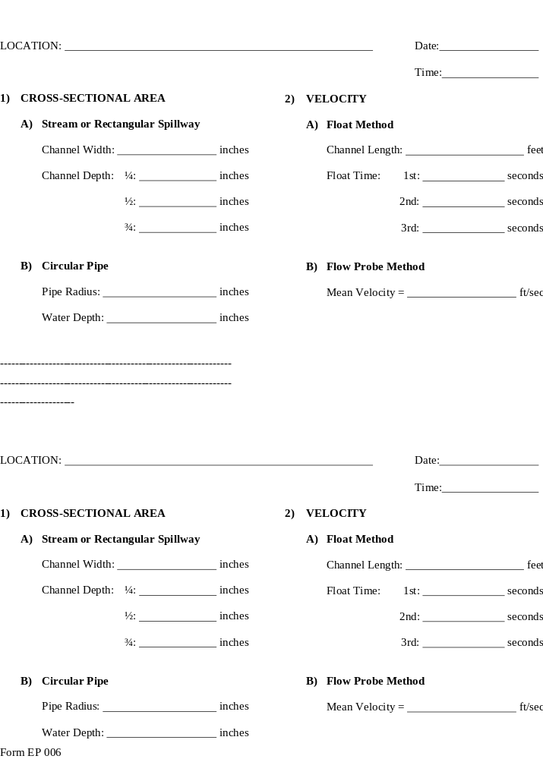

Appendix D

Sample Chain of Custody



