Purpose of This Procedure
The objective is to sample sanitary water that accurately reflects the nature of the operational and sanitary effluent the lab discharges to Batavia and Warrenville/Naperville (W/N).

Materials/Pre-requisites Needed

Special Precautions
- Personal protective equipment (PPE) (disposable Nitrile gloves and safety glasses with side shields) must be worn whenever handling/transferring sample water from the autosamplers to prevent personal contamination and acid burns.
- Concentrated HNO₃ is EXTREMELY HAZARDOUS. Never work with HNO₃ without proper PPE.
- Protect the HNO₃ containing composite bottles from sunlight as much as possible. HNO₃ is volatilized by sunlight to a brown colored vapor. Inhalation of HNO₃ vapor can be FATAL. At each autosampler open the carboy in the open air, away from any work area, and allow the vapors to dissipate before moving it to the enclosure.
- Noxious vapors given off by the sanitary-water/HNO₃ mixture in the carboys and vapors rising from the manholes can cause dizziness and disorientation. Minimize your exposure to an open manhole.
- An up-to-date tetanus vaccination is required prior to sampling or handling autosampler equipment.
- Wash hands thoroughly with a disinfectant soap following contact with sample water and/or related equipment.
- Transport all bottles containing samples or preservative (HNO₃) in the bed of the truck, not inside the cab.
- Personnel completing a Chemical Waste Pickup Request Form must have successfully completed FN000240/CR Waste Generator training.
- Successful completion of FN000125/CR (Material Move Survey) is required of all personnel using a Material Move Request (MMR) form.
- Prevent extreme temperatures within the autosampler shelters. Maintain a winter temperature above 40ºF by plugging in electrical heat tape (attached to tubing) as well as covering top vents of hut with tape. Maintain a summer temperature below 100ºF by adjusting the fan control knob mounted on the wall.
- In case of a power failure at either location:
- Check to see if the ground fault interrupter circuit inside the shelter is tripped. Reset it by pushing the reset button.
- Outside each location is an electrical box with a switch that controls power to the shelter. Check to see that the switch is “on.”
- Batavia only - A safety fuse is located in a locked box on the north, outside wall of the Pine Street Guard Station. Call the site duty electrician at x3434, or page 0101 to unlock the box and inspect to ensure that the fuse has not blown (20-amp fuse on the right with the red wire). Allow the electrician to perform any necessary electrical work.
- Liqui-Nox is an eye irritant. Always wear eye protection when cleaning equipment.

Material Safety Data Sheets (MSDS)
Fermi #
6548 Trade Name: Sodium Carbonate
Manufacturer: Aldrich Chemical Co.

11904 Trade Name: Sodium Hydroxide
Manufacturer: J. T. Baker, Inc.

17023 Trade Name: Liqui-Nox
Manufacturer: Alconox, Inc.

17054 Trade Name: Nitric Acid, 50-70%
Manufacturer: Mallinckrodt Baker, Inc. (J. T. Baker)

All MSDS are viewable online at the ES&H website MSDS page. Read each MSDS, understand the hazards, and follow the precautions.

Equipment

WH7E
- Autosampler Field Logbook
- Fermilab Chain-of-Custody (COC) Form EP 002
- Off-Site Analytical Laboratory COC
- Sample Identification (SID) Labels
- CH751 Key

Site 39
- 5-Gallon Polyethylene Composite Bottles (2) with HNO₃
- pH strips
- Sodium Carbonate Powder
- Disposable Nitrile Gloves
- Kaydry Wipes
- Safety Glasses with Side Shields or Goggles
- 125ml Poly Sample Bottles (2)
- 1L Poly Sample Bottles (2)
- Manhole Cover Hook
- Silicone Head Tubing

References
- Operating and Maintenance Manual for the Streamline 800SL Refrigerated Sampler. (Model #1880 and Model #3000). American Sigma, Inc., Medina, NY, July 21, 1994.

- Operating and Maintenance Manual Sigma 950 Flow Meter. American Sigma, Inc., Medina, NY, September 22, 1995.

- Sigma SD900 Refrigerated Sampler and All Weather Refrigerated Sampler User Manual, Edition 4, DOC026.53.00799. Hach Company, August, 2008.

RESPONSIBILITIES
Routine monitoring of the sanitary effluent generated at Fermilab is facilitated by two automated effluent sampling stations (autosamplers) located at the connections to the off-site sanitary sewer treatment works for Batavia and W/N. The autosampler locations are illustrated in Appendix A.

Each autosampler consists of a programmable peristaltic pump that draws samples from a sanitary sewer. The autosamplers are programmed to collect one 30ml sample every hour throughout the month. The samples are composited into five-gallon polyethylene bottles containing concentrated nitric acid (HNO₃) and housed in refrigerated units for preservation.

At the end of each month samples are extracted from the five-gallon composite bottles and analyzed for metals and tritium monthly and API annually. Additionally, the sample schedule periodically includes analysis for gamma producing radionuclides. The metals analyzed (Table 1) are determined from standards listed in the municipal discharge questionnaire and knowledge of the processes discharging into the sanitary systems. Discharge limits are set by both the Batavia and Warrenville/Naperville Treatment Works.

Table 1
Chemical Parameters:
Total Metals

Arsenic As
Barium Ba
Cadmium Cd
Copper Cu
Chromium Cr
Iron Fe
Lead Pb
Manganese Mn
Nickel Ni
Selenium Se
Silver Ag
Zinc Zn

Formerly, a data logger was used to collect data on effluent pH at each autosampler plus flow and effluent levels at the Batavia autosampler; however, these data were prone to inconsistencies and the hardware was problematic to maintain. Consequently, that portion of the program has been discontinued. These data reside in the Fermi Environmental Database (FED). Results of the chemical and radionuclide analyses are maintained in the Oracle Environmental Database.

DETAILED PROCEDURE

Sampling

- Gather the necessary equipment. Wearing proper PPE, use the repetitive dispenser (set at 10ml) located in the Chemical Fume Hood at the Site 39 Chemistry Lab, to dispense the appropriate volume of HNO₃ (30ml) into each 5-gallon sample container, immediately securing the lid on each container for transport to the field.
Note: the volumes of acid are determined by trial and error to produce pH levels of ~ pH 2, but not « pH 2 in the 5-gallon poly bottles at the end of the month (following the run of the sampling programs). The actual pH should be reviewed each month to determine whether any adjustment is indicated.

- At the sampler, open the carboy in the open air, away from any work area, and allow the vapors to dissipate. Unlock the enclosure door using the CH751 key. To secure the door in the open position, remove the top carriage bolt from the pipe attached to the inside of the door and lower the pipe into the stabilizer in the ground. Allow the building to air out before entering.

- The display on the top of the refrigerated sampling unit should read “PROGRAM COMPLETE.” If a problem with the month’s sampling is suspected (i.e. no sample collected or a small volume collected) the status of the samples taken during the program may be checked by pressing the “Display Feedback” key. The computer will run through the program most recently completed.

- Wearing the specified PPE (disposable Nitrile gloves and eye protection), remove the 5-gallon composite bottle from the refrigerator and replace it with the new bottle. Try to disturb the contents of the composite bottle as little as possible before pouring the samples to minimize the amount of solid matter in the sample.

- Pour a 125ml and a 1L sample from the composite bottle. Empty the remaining contents of the 5-gallon sample container into the sanitary manhole, and replace the manhole lid (effluent with a pH of < 2 should not be discharged into sanitary systems).

- Affix a label with the proper SID and analysis type (2/RAF or 2/RAF + API) to the 125ml sample bottle and complete a Fermilab COC. Complete the required information on the Off-Site Analytical Laboratory 1L sample bottle label and COC for the metals sample. Record the sample event in the field logbook.

- Take the samples to Site 39 for pH adjustment (see pH Adjustment and Sample Relinquishment below). Using the Sodium Carbonate, adjust the pH of the effluent remaining in the composite bottle to between 4 and 9.

- Due to wear the pump-head tubing must be replaced every second month to prevent a reduction in the volume of sample water collection. Refer to the Autosampler Logbook to identify the most recent replacement. Change the tubing by loosening the thumbscrews on the faceplate of the pump and the liquid sensor on the top of the refrigerator. Take the covers off and carefully remove the old tubing. Wipe out any debris and replace the tubing with a new piece of the same length. Reattach the faceplates, making sure the thumbscrews are tightened, and insert the hose through the top of the refrigerator and into the lid of the 5-gallon composite bottle.

Programming

To create a sampler program for automatic sampling routines:

- Select PROGRAM SETUP from the main menu.
- Select MODIFY ALL. The first parameter, bottle quantity, will be shown.
- Select the number of bottles in the sampler (1).
- Enter the volume of the individual bottle (5 gal or 18927.1 mL).
- Continue to select or enter values for each parameter until complete.
- Once all values have been entered into the program press the RUN/HALT key to start the program.
  - Wait to observe that the first sample has been taken.

Trouble Shooting

Grab Samples

Grab samples can be collected to verify the sample volume is correct throughout the month.
- Press the RUN/HALT PROGRAM key
- Select the HALT option to temporarily stop the program.
- Wearing the proper PPE (Nitrile gloves and safety glasses), carefully remove the outlet pump tubing from the sample bottle (inside the refrigerator).
- Place the tubing into the 500 mL graduated cylinder found in the EPG’s Truck.
- Press the MANUAL OPERATION key.
- Select GRAB SAMPLE
- Press ENTER.
- The pump will purge the intake tube and then collect the specified volume of sample. The pump will then purge the intake tube.
Note: To stop the pump at any time during the sample cycle, press the STOP key.
- If the sample is the correct volume
  - Remove the outlet pump tubing from the graduated cylinder and replace it in the 5gal sample bottle.
  - Press the RUN/HALT PROGRAM key and select RESUME, the program will resume from the point at which it was halted.
  - Use Liqui-Nox and tap water to thoroughly clean the graduated cylinder; return the cylinder to the EPG truck.
- If the sample is not the correct volume:
  - Re-adjust the volume calibration based on time (see Volume Calibration Based on Time below) until the desired volume is sampled.
  - Follow steps 9 a-c above.

Volume Calibration Based on Time

- Make sure the program has been halted.
- Make sure the liquid sensor is disabled by selecting PROGRAM SETUP>MODIFY SELECTED>LIQUID SENSOR>DISABLE.
- Press VOLUME CALIBRATION.
- With the outlet pump tube in a graduated cylinder select START. The pump will purge the intake tube and then begin to collect a sample.
- Observe the volume in the graduated cylinder and press the STOP key when the correct volume for the program (30ml) is collected.
- If the pump was stopped at the correct volume select DONE. To repeat the calibration select repeat.
- When finished, remove the outlet pump tubing from the graduated cylinder and replace it in the 5gal sample bottle.
- Use Liqui-Nox and tap water to thoroughly clean the graduated cylinder; return the cylinder to the EPG truck.
- Select START to resume the sampling program.

pH Adjustment and Sample Relinquishment

- Take the samples to Site 39.

Radionuclide Samples (125ml bottles):
The sample is preserved to a pH of ~2. Prior to submitting the sample to the Radiochemical Analysis Facility (RAF) it must be neutralized to a pH of 6.5 > 7.5. Use the 0.1N NaOH solution, a fine-tipped disposable eyedropper, electric magnetic stirrer, and the pH strips to adjust the pH of each sample. Perform the pH adjustment in the Chemical Fume Hood at the Site 39 Chemistry Lab.

Note: To make more 0.1N NaOH from concentrate, use the following equation:

V_{c} = N_{d} V_{d} / N_{c}

Where: V_{c} = Volume of concentrated solution
N_{c} = Normality of concentrated solution
V_{d} = Volume of dilute solution
N_{d} = Normality of dilute solution

Record the initial and neutralized pH on the Fermilab COC. The initial pH is used for determination of the volume of HNO₃ to dispense into the 5-gallon poly composite bottle in step #1 of the Sampling section of this procedure each month.

To prevent cross-contamination wash all equipment used to adjust the pH with Liqui-Nox and tap water, then rinse with distilled water and dry with a Kaydry between each sample.

Complete an electronic RAF Work Request Form and relinquish custody of the samples to RAF personnel. Make a copy of the signed COC for the SEP Group files on WH7E.

Metals Samples (1L bottles):
Deliver the samples to Shipping/Receiving (Warehouse 2) and complete a Material Move Request (MMR). Relinquish the samples to shipping personnel and instruct them to do the same when the off-site analysis laboratory agent picks up the samples. Remove the bottom (pink) copies of both the signed COC and MMR. Return the copies to the EP Group file on WH7E for storage until the analytical results are received. Call the off-site laboratory to confirm pickup of the samples. Alternatively, the samples may be taken directly to the off-site laboratory. In this instance a MMR is not necessary.

- Wearing eye protection, use Liqui-Nox and tap water to thoroughly clean all the equipment used in the sampling procedure. Hand-dry all glassware with a Kaydry to prevent mineral deposits.

- Once received, enter the analytical results into the EPG Oracle Sample Database and check to ensure that no discharge limits have been exceeded.

References
- Operating and Maintenance Manual for the Streamline 800SL Refrigerated Sampler. (Model #1880 and Model #3000). American Sigma, Inc., Medina, NY, July 21, 1994.

- Operating and Maintenance Manual Sigma 950 Flow Meter. American Sigma, Inc., Medina, NY, September 22, 1995.

- Sigma SD900 Refrigerated Sampler and All Weather Refrigerated Sampler User Manual, Edition 4, DOC026.53.00799. Hach Company, August, 2008.

Appendix A

Autosampler Locations Map

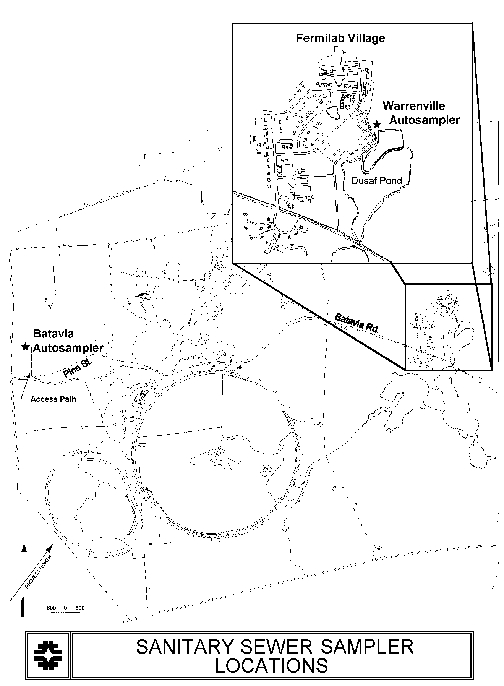

Appendix B

MSDS

