Material Move Request Survey Authorization Training
Course FN000125
Introduction
A Material Move Request (MMR) requires a determination of whether the material is radioactive. If the possibility exists that the material is radioactive, a radiation survey must be performed. Only specially trained personnel can perform this survey. This training qualifies you to conduct a Material Move Request survey and sign the Material Move Request form.
This training course does NOT permit you to complete the sections of the Material Move Request that addresses DOT Hazardous Material.
There are some instances in which a survey does not have to be performed. If the person initiating the material move request is positive the item to be transported has not been in a beamline enclosure and is not radioactive, a radiation survey is not required based on process knowledge. If the possibility exists that the material may be radioactive, a survey must be performed.
Material Move Request Requirements
A Material Move Request must be completed when:
- An item is to be transported on-site between divisions/sections/centers by Facilities Engineering Services Section (FESS).
- An item is to be transported off-site.
- An item determined to be radioactive Class 3 or higher is to be transported on-site (even if it remains within the same division/section/center).
Instrumentation
The Analyst, Frisker and the Portable Frisker (E140N) are the only radiation survey instruments approved for performing Material Move Request surveys.
If you need an instrument to perform a survey, contact the ESH&Q Section Radiation Protection Instrumentation Team at the Radiation Physics Calibration Facility (RPCF) at Site 38, X4625.
Repairs, battery replacements, and calibration of all survey instruments are to be done by the ESH&Q Section Radiation Protection Instrumentation Team located at the RPCF (Site 38).
- Analyst

- The Analyst should be your first instrument of choice if you have the option.
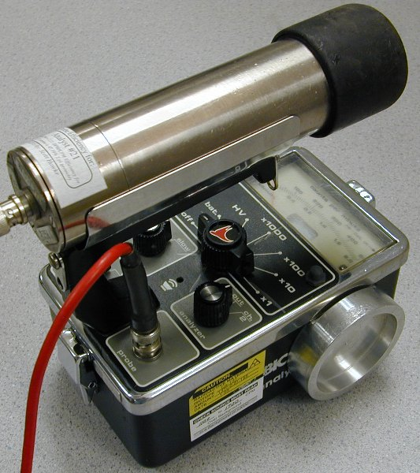
- Used to find radioactive materials and determine if objects have been activated. An extremely sensitive gamma ray detection instrument.
- Portable battery operated scintillation detector. Scintillation detectors emit light following excitation by ionizing radiation. A photomultiplier tube (PMT) is used to detect the light pulses, then convert and amplify these pulses to a usable electrical signal.
- The detector probes are fragile due to the glass PMT. Handle with care.
- Photomultiplier tubes are sensitive to magnetic fields. Keep in mind that the Analyst may not respond appropriately if magnetic fields are present. If you are approaching an item to be surveyed and the reading is decreasing instead of increasing as you move closer to the object, magnetic fields are most likely interfering with the detector. If this occurs, you must use a Frisker or Portable Frisker (E140N) to conduct a survey.
- The response switch on the front of the meter should be set to slow.
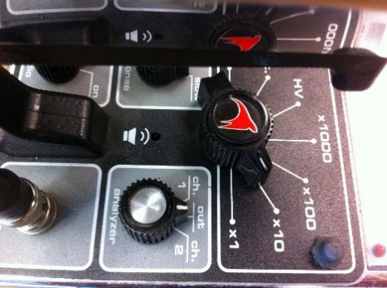
- 4 range display count rate meter that reads out in counts per minute (CPM) used for detection of very low levels of radioactivity. Set Analyst on X10 scale. If the meter pegs, set it to the next higher scale, and so on.
To read counts per minute, multiply the reading by the scale setting. For example, 350 cpm x 10 scale = 3,500 cpm.
- A speaker provides an audible 'chirp' indication in the presence of radiation.
- A Cesium-137 (137Cs) check source is mounted on the chassis to assure consistent calibration stability.

- Frisker (Ludlum 177-4)

- AC powered frisker or wipe counter utilizing a 2 inch diameter pancake Geiger-Meuller (GM) detector. Used for conducting activation surveys and contamination surveys.
- The GM tube pancake probe is extremely fragile. Handle with care. Surveying objects which may easily protrude past the protective screen can easily result in a ruptured detector window.
- The response switch on the back of the meter should be set to slow.
- 3 range display in CPM with a variable alarm point setting. Set Frisker on X1 scale. If the meter pegs, set it to the next higher scale, and so on.
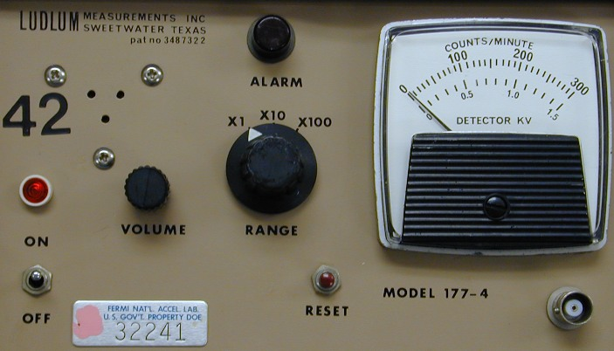
- To read counts per minute, multiply the reading by the scale setting. For example, 250 cpm x 100 scale = 25,000 cpm.
- A speaker provides an audible 'chirp' indication in the presence of radiation and also a continuous audible trip alarm.
- A 137Cs check source is mounted on the chassis to assure consistent calibration stability.

- Portable Frisker (Eberline E140N)
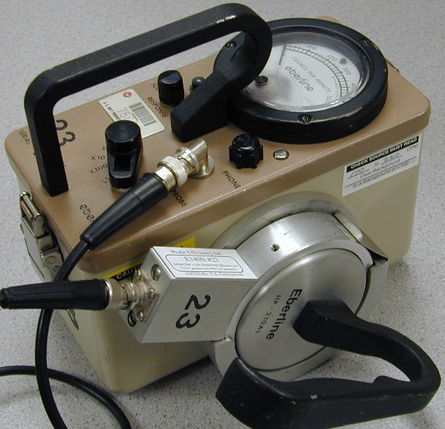
- This detector is the portable version of the AC powered Frisker.
- A battery powered Portable Frisker and wipe counter utilizing a 2 inch diameter pancake GM detector for conducting activation surveys and contamination surveys.
- The GM tube face is extremely fragile. Handle with care. Surveying objects which may easily protrude past the protective screen can easily result in a ruptured detector window.
- The response switch on the front of the meter should be set to slow.
- 3 range display in CPM. Set Portable Frisker on X1 scale. If the meter pegs, set it to the next higher scale, and so on.
- To read counts per minute, multiply the reading by the scale setting. For example, 400 cpm x 1 scale = 400 cpm.
- A speaker provides an audible 'click' indication of the presence of radiation.
- A 137Cs check source is mounted on the chassis to assure consistent calibration stability.
Procedure for Performing a Material Move Request Survey Using an Analyst
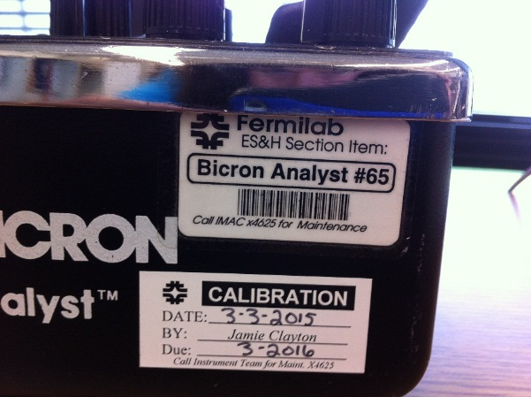
- Check the calibration date on the Analyst. The due date is the last day of the month indicated on the sticker. If the calibration is not current, return the instrument to RPCF for calibration.
- Check the overall condition of the instrument. If the instrument appears to have been abused, consider returning it for repair.
- Perform a battery check or power check.
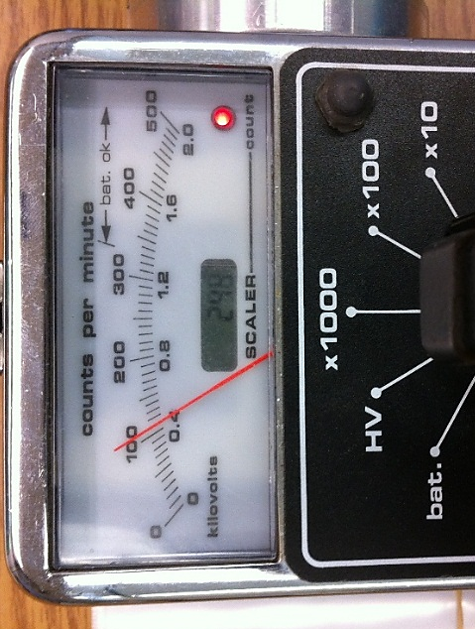
- Determine background for the area. A material move survey cannot be conducted in a high background area. The background reading on the Analyst must be less than 3,000 cpm. Move to an area where background levels are lower if necessary.
- Perform a source check. The sticker on the side of the Analyst indicates what the instrument should read when the probe is inserted into the source check holder. Keep in mind that the range quoted does not include background levels. Wait until the needle stabilizes before determining if the instrument source check is within the specified range.
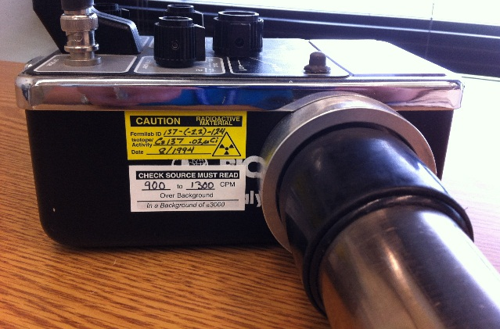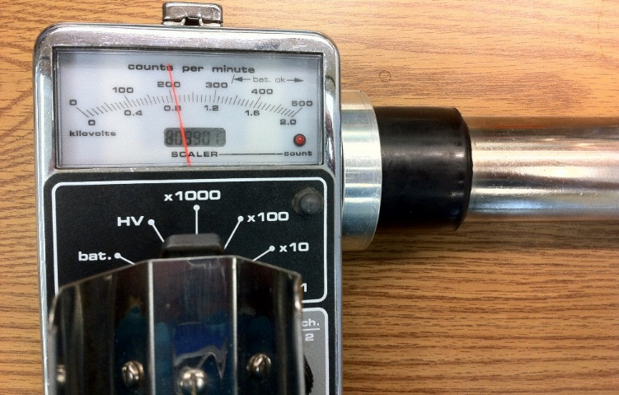
- If any of the above instrument checks do not pass, return the instrument to the ESH&Q Section Radiation Protection Instrumentation Team at RPCF, Site 38 for an instrument exchange.
- Perform a survey on contact on ALL accessible surfaces of the object. The survey should be done slowly as it takes some time for the Analyst to respond. If the count or audio rate goes up, pause over the area for 5-10 seconds or until the needle stabilizes to obtain the most accurate measurement. Closed containers should be opened as packaging materials could provide some shielding of the object.
- The object is radioactive if the reading is greater than 2,000 cpm above background if the background is between 2,000 cpm and 3,000 cpm OR if the object reads twice the background rate if the background is less than 2,000 cpm (on contact readings).
- Follow the step by step instructions to complete the online Material Move Request at:
- FESS website at http://fess.fnal.gov/logistics_property/index.html OR
- Fermilab ServiceNow website at https://fermi.service-now.com/navpage.do
- If the object is radioactive and is being shipped offsite, call the ESH&Q Section Hazard Control Technology Team at X4498 so that it can be packaged appropriately for transportation.
Procedure for Performing a Material Move Request Survey Using a Frisker or Portable Frisker (E140N)
- Check the calibration date on the Frisker/
Portable Frisker. The due date is the last day of the month indicated on the sticker. If the calibration is not current, return the instrument to RPCF for calibration.
- Check the overall condition of the instrument. If the instrument appears to have been abused, consider returning it for repair.
- Perform a battery check or power check.
- Determine background for the area.
A material move survey cannot be conducted in a high background area. The background reading for the Frisker/Portable Frisker must be less than 100 cpm. If the area background levels exceed 100 cpm, move to a lower background area.
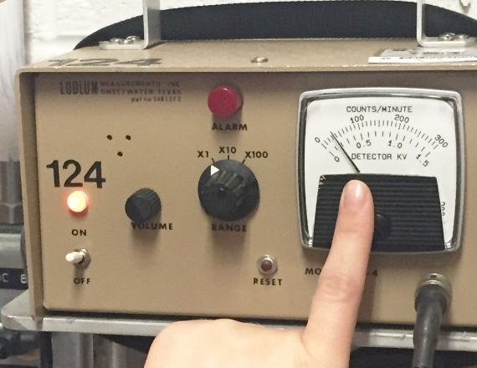
- Perform a source check. The sticker on the side of the Frisker/Portable Frisker indicates what the instrument should read when the probe is positioned on contact over the source check holder. Keep in mind that the range quoted does not include background levels. Wait until the needle stabilizes before determining if the instrument source check is correct.
- If any of the above instrument checks do not pass, return the instrument to the ESH&Q Section Radiation Protection Instrumentation Team at RPCF, Site 38 for an instrument exchange.
- Perform a survey on contact on ALL accessible surfaces of the object. The survey should be done slowly as it takes some time for the Frisker/Portable Frisker to respond. If the count or audio rate goes up, pause over the area for 5-10 seconds or until the needle stabilizes to obtain the most accurate measurement. Closed containers should be opened as packaging materials could provide some shielding of the object.
- The object is radioactive if the reading is greater than 50 cpm above background if the background is less than 100 cpm (on contact reading).
- Follow the step by step instructions to complete the online Material Move Request at:
- FESS website at http://fess.fnal.gov/logistics_property/index.html OR
- Fermilab ServiceNow website at https://fermi.service-now.com/navpage.do
- If the object is radioactive and is being shipped offsite, call the ESH&Q Section Hazard Control Technology Team at X4498 so that it can be packaged appropriately for transportation.

Online Material Move Request Surveyor Review Instructions

*Surveyor Review
- You will have received notification that a shipment needs to be surveyed. Log into your ServiceNow account by clicking on the button to the right. You will enter your Services account log on and password.
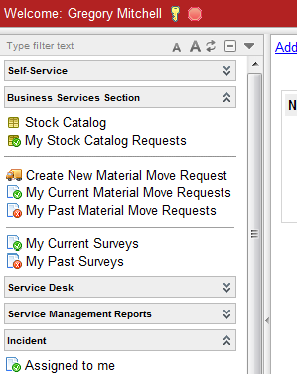
- You will need to click on “My Current Surveys” in the Business Services Section on the left-side of the screen. If you want to view previously surveyed items, you can select “My Past Surveys”.
ServiceNow website

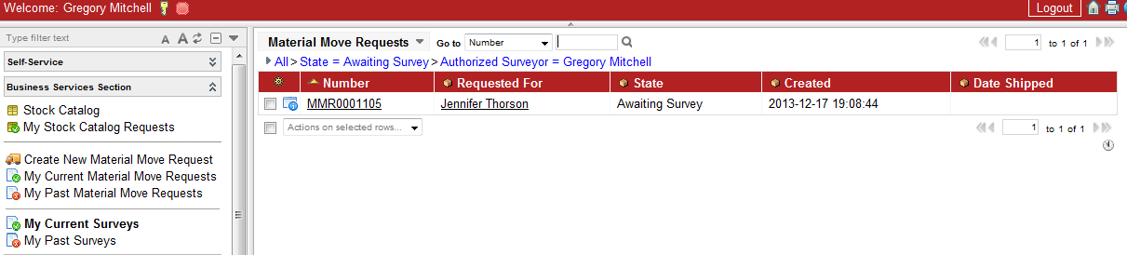
- You will click on the MMR that has a status of “Awaiting Survey”

- When you open the MMR, you need to “Enter Survey Data” by selecting the button at the top-middle of the screen.
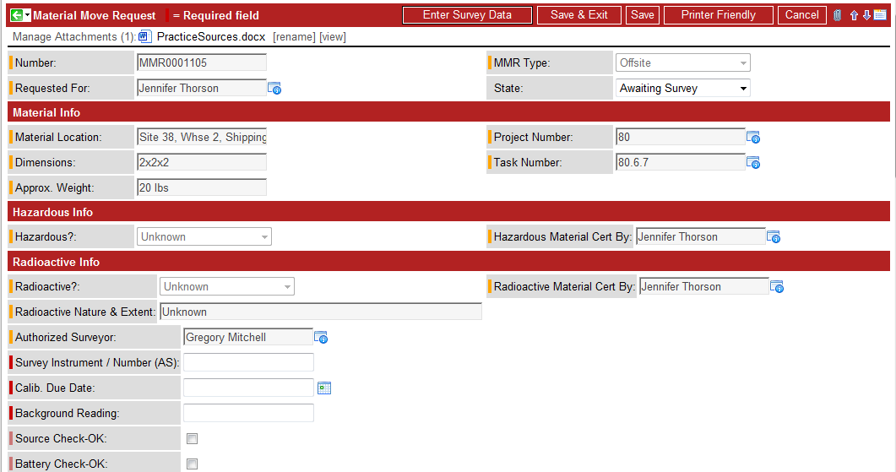

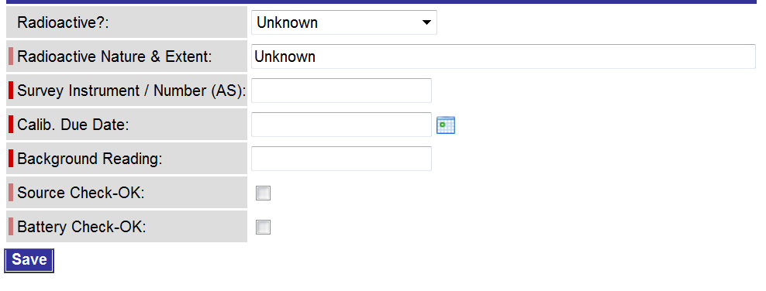
- The following box will pop up:

- Perform your survey.
If “Unknown” was answered for being Radioactive, change this to “Yes” or “No” based on the results of your survey, by selecting the drop-down arrow. You also will need to enter the appropriate verbiage for “Radioactive Nature & Extent:” (e.g. UN2910 Radioactive material, excepted package-limited quantity of material 7). You will then need to finish entering all remaining information.
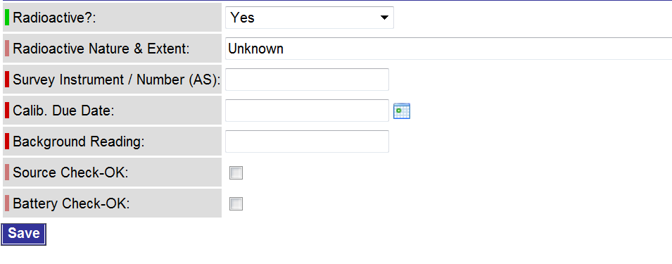
If “Yes” was answered for being Radioactive, you should confirm with your survey. You also will need to enter the appropriate verbiage for “Radioactive Nature & Extent:” (e.g. UN2910 Radioactive material, excepted package-limited quantity of material 7). You will then need to finish entering all remaining information.
When all information has been entered, select the SAVE button.

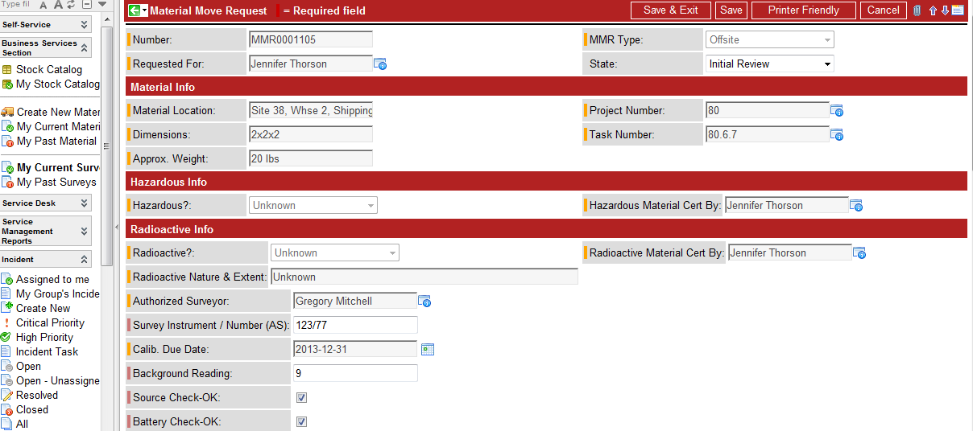
- After you select the save button, you should notice the State field changes to “Initial Review”.
You can now print a copy of the MMR with your survey information included. If you do not need a copy of the MMR, you can click the Save & Exit button.
- You have finished your survey review of the MMR.
- A notice will now be sent to the requestor on the MMR that your survey is complete and they need to print and attach a copy of the MMR to the item(s) being picked up.

