**Fermilab LDRD Proposal**

**Project Title: Argonaut: A Robotic System for Cryogenic Environments**

**Principal Investigator: William Pellico**

**Lead Division/Sector/Section:**

**Co-Investigators (w/institutions):** Noah Curfman, Flavio Cavanna, Reggiald Martin (JPL), Giovanna Lehmann (CERN)

**Proposed FY and Total Budgets:** (summary of budget page (in dollars))

SWF: Salary, Wages, Fringe SWF OH: overhead on SWF

M&S: Material and Supplies M&S OH: overhead on M&S

Contingency (estimate of additional funds that might be required with justification)

**Initiative:** 2021 Broad Scope

**Project Description** (150-200 words):

Fermilab and the HEP community invest significant resources into liquid argon detectors. The largest and most expensive of these detectors will be located in the Deep Underground Neutrino Experiment (DUNE). However, recent experiences have shown that there are limited avenues of monitoring, intervention and interaction in the internal liquid environment. This proposal shows a technological path that could provide a valuable tool to ensure or at least improve management of these HEP detectors. The development of a robotic system named Argonaut will demonstrate several technologies including: 1) demonstration of suitable mobility of a small robotic device at liquid argon temperatures, 2) demonstration of wireless communication, 3) demonstration of improved diagnostics capabilities – such as tunable optics with motion control, 4) demonstration of interconnectivity of a robotic system with hardware residing within the detector. We have received strong support from potential collaborators interested in similar capabilities: including NASA (JPL), CERN, UIC (ME Robotics) and UC Berkley (Robotics & nano lab). This work has many possible research avenues and benefits and we expect this LDRD to act as a seed for extended development in cold robotics and associated technologies. DUNE’s success relies significantly upon contributions. Much of the recent effort to develop better diagnostics and cameras systems in particular, has been done by others. This LDRD will allow FNAL to play a significant role in future diagnostic and detector operations management. For further information on extent of DUNE camera effort see DUNE CALCI Scope Workshop/Review 2020-05-14.

**Significance** (~1-2 pages):

The Deep Underground Neutrino Experiment (DUNE) will use large detectors consisting of modules with a fiducial mass of 10 ktons of liquid argon (LAr). As part of the development of LAr detector technologies, much has been learned from years of design efforts and detector operations on smaller systems. Significant effort is required in preparing and testing of planned hardware for the reliability and expected performance requirements for systems. These systems must last longer than anything the HEP community has ever built before without the option of access to the inside of the detector for diagnosing or repairing problems.

Lessons learned from recent experiences working with LAr detectors have highlighted shortcomings in both diagnostics and accessibility. We propose Argonaut, a robotic system that resides inside of a LAr detector. The first goal for this robotic system is to improve the diagnostics capabilities such as the monitoring of temperatures, electronics, high voltage systems, and assisting in assembly, filling and any required maintenance. The next goal is to show Argonaut’s repair capability which is not an option in existing LAr detectors or currently planned for DUNE. A final goal is to improve the operations of the LAr detectors by showing the feasibility of a robotic system to assist in calibrating the detector.

**Diagnostics:**

The ProtoDUNE detector illustrates the shortcomings in diagnostic capabilities of current LAr detectors. The dual phase ProtoDune detector had a LAr mass of 0.3 kt. ProtoDune had cameras strategically placed to monitor all the necessary areas. However, ProtoDune experienced bubbles which formed in areas not seen by the cameras. The experiment was left theorizing the bubble formation location because the cameras were not mobile. Even had a camera been fortunate to be pointing at the location, a firm analysis may not have been possible because the cameras could not autofocus. Argonaut would take advantage of the latest camera technology by using complementary metal-oxide semiconductor (CMOS) cameras to monitor inside the LAr detectors. The use of CMOS cameras at cryogenic temperatures within LAr has made significant progress and continues to be developed. Argonaut can provide the mobile platform to bring the CMOS camera(s) to investigate any problems.

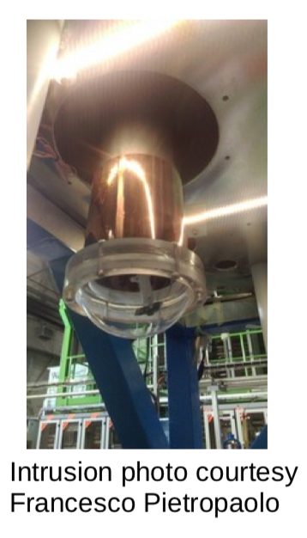

Image 2 View Port Camera System

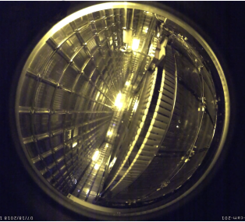

Image 1 Birdseye view through top view port

Argonaut can help with monitoring the drift voltage in the high voltage area of the LAr detector’s Time Projection Chamber (TPC). CMOS cameras with isolated power sources such as power over fiber (PoF) offer the possibility of use near high voltage.

For instance, the drift field required for DUNE is 500Vcm−1, implying a nominal drift voltage as high as approximately -200 kV. This may be high enough for HV breakdown. Having Argonaut bring a camera to the TPC in a detector as large as DUNE can aid in monitoring its drift voltage.

ProtoDune offers another example of limitations of stationary cameras. The two-year experiment experienced HV sparks and trips. Then, a serious failure occurred in the second year of operations while conditioning the HV system after an extended downtime period. Extensive trouble shooting determined that a HV support near the top of the HV feed structure was the source of the failure. No camera recorded sparking which would have helped diagnose the problem. In addition, with great difficulty, new cameras were installed to assist in the repair process.

Argonaut has the potential to bring in a camera that can identify this kind of problem in a timelier manner. Argonaut looks to deploy recent camera technology with the added ability to adjust focus and positioning. Initial camera parameters (to be adjusted in coordination with DUNE/ND experts): include

* Resolution 1 mm (field cage, HV feed areas)
* Frame Rate 60
* Pixels > 712x486

Argonaut is the key move a camera near HV systems made possible with PoF capabilities. Additional diagnostics onboard a robotic system could include:

Infrared camera, Lighting, Temperature sensors and Differential Voltage meter

**Repair Capability:**

As previously noted, a failed HV support on ProtoDune could not be repaired without significant downtime and costs. Loss of electronic components were expected and did occur but with no option for repair. If the DUNE detectors are designed with a robotic system in mind, field cage circuit boards and SiPMs systems could be made to be exchangeable. We propose that Argonaut have small armatures with specific grip technologies. Recent success at CERN has shown that clippers and graspers are good candidates, but others need to be examined. The ability to house a set of accessible arm appendages would allow a robotic system to change from one tool to another as needed. Power limitations and weight are likely to drive the design and capability of the appendage(s).

**Calibration:**

In the current LAr detector design, the use of calibration systems is limited and challenging. Typically, laser or radioactive sources are used for calibrating photon and ion detectors. A large LAr detector would require extensive fiber and mirror distributions for the photon detector system which would reside external to the LAr detector’s vessel wall. However, Argonaut may be able to carry a multi-watt laser system or LEDs for calibration. The robotic system could maneuver around to openings in the field cage for use.

A hot source that is stored in a shielded container would be accessed by Argonaut, then moved to areas where it could assist in an external calibration system or, if shown adequate, act as the primary calibration source. This capability would require a robotic armature and source linkage capability. Using Argnonaut as an internal movable calibration option could extend the calibration capability or reduce costly standard methods being planned for the large DUNE detectors.

Future detectors will be larger and more complicated and expected to operate for over a decade. The ability to make repairs or to improve their operations, diagnostics and viability is critical to our HEP program. If this LDRD approved it could provide a path to implement a system capable of reducing risks along with improved operations, such as additional calibration capabilities, and it would be significant contribution to the DUNE design.

**Research Plan** (3-4 pages)

This LDRD has three overlapping objectives which together demonstrate capabilities that will provide a path for cold liquid environments diagnostics and operations management. The work is split into three components. The LDRD team consists of experts in each of the three areas and has collaborated to lay out the following research roadmap.

**1)Robotic motion 2) Expanded Diagnostics/Electronics Capability 3**) **Appendage use**

**Robotic Motion:**  
Argonaut’s mechanical design will be led by Noah Curfman. Students from University of Illinois, Chicago have worked under Noah’s guidance and will participate in this design effort. The prototypes developed under this LDRD aim to be a proof of principle mechanical system operating in a liquid cryogen environment.

While a 3D motion capability would be a final goal for DUNE or any large detector robotic system, we will initially focus on 1- and then 2-dimensional motion. The initial idea is to have a nonconducting rail system braced against either the ceiling, floor or wall. The rails would act as guides and leverage supports. This design is prevalent in many 2D mechanical coverage systems. The third-dimensional motion would be a gripper extension with the capability demonstration of 5 to 10 cm of a robotic body extension. The ultimate goal of over a meter extension is desirable, but the short extension demonstration planned for this LDRD will provide us needed mechanical testing. Several concepts have been discussed, such as scissor-type extension which has a short stroke and proportionality. This third dimension of movement would provide the critical path for close visual inspection as well as surface measurements and minor repair capability. The design of this system requires the integration of onboard controls and feedback.

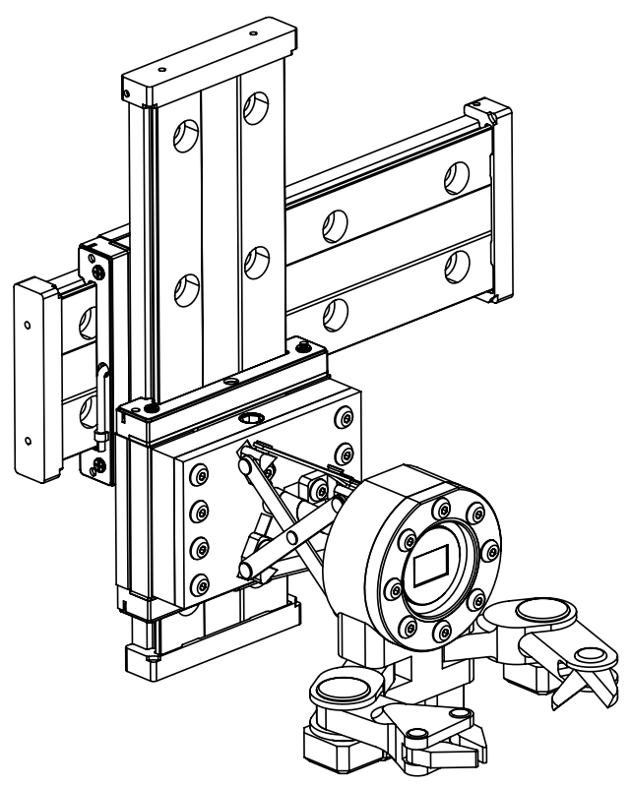

Figure 2: Argonaut preliminary concept design with 3-axis movement, inspection camera, and multiple tool arms

There are a number of system operational issues to consider related to the unique environment of LAr. These issues will be investigated as part of the proof-of-principle prototype. Commercial systems will be selected where it is feasible in order to be economical. Material selection, method of assembly, and maximum allowable heat load into the environment will be considered. The device’s longevity in liquid argon will be tested by determining if a regularly scheduled movement sequence is necessary.

Building upon recent effort of the Accelerator Division Robotics Initiative, this LDRD will make use of student effort and laboratory facilities to carry out testing that is nearly impossible to conduct almost anywhere else in the world.

**Cold Electronics: Power:** Total power budget 15 to 20 W goal.

The LDRD cold electronics will be led by William Pellico. The Argonaut will require power for motion both spatially as well as armatures and for diagnostics. We have estimated our power budget to be approximately between 5 and 10 watts. The power budget estimate outline for the LDRD Argonaut is:

* Camera(s): 40 to 50 V at 150 to 300 mA.
* LEDs lighting: Low voltage at 50 mA
* Transmitter and electronics: 12 V at 80 mA (20 meters)
* Logic sensing electronics: 12 V at 120 mA for position, temp, health systems
* Motion Control Motors: 24 V at 600 to 1000 mA (design to be based upon miniature robotics motion)

The LDRD will test some cutting-edge nano robotics and electronics concepts. Recent advances in IoT has provided a number of advances in low power electronics and communication. One example micropower component in this LDRD concept will be a low power wireless communication chip being implemented for in home IoT systems. Additionally, Argonaut will leverage work being done with power over fiber PoF being deployed for the first time in LAr environment. A recent PoF system that has been delivered to CERN DUNE collaborators is capable of delivering 60 V at 800 mA (see figure 3). Power over Fiber (PoF) delivers electrical power by sending laser light through lightweight, non-conductive fiber optic cable to a remote photovoltaic receiver or photovoltaic power converter (PPC) to power remote sensors or electrical devices. This innovative PoF solution provides three major benefits: (1) noise immunity, (2) voltage isolation, and (3) spark free operation. Preliminary testing has shown the system to have very good thermal stability while operating at LAr temperatures. Testing will include thermal modeling of internal temperatures and conductivity requirements for Argonaut. The heat generated within Argonaut will be controlled, via heat sink to argon vessel, to set a temperature for maximum operational efficiency and reliability.

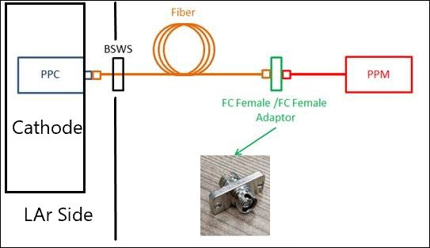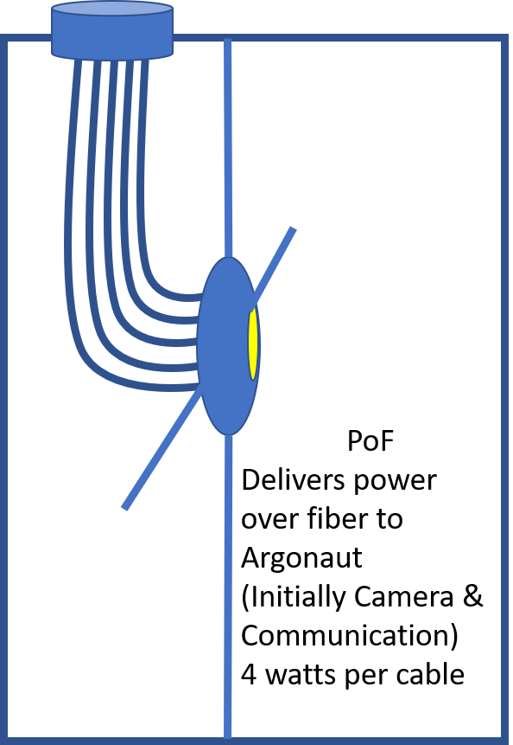

Figure 3 PoF system for DUNE cathode electronics and PoF Argonaut system

The electronics required to operate camera(s) will provide 40 to 55 V (depending upon camera choice) at approximately 200 to 400 mA. We are developing a series of tests to confirm quality and viability of several camera system options. One such test is the standard resolution test in both air and liquid nitrogen (see figure 5).

**Communication:**

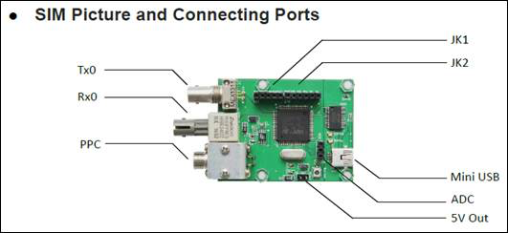

Figure 4 PoF based transceiver with PPC

As previously mentioned, there are three options being considered for communication with the Argonaut. The choices are from more standard Rx/Tx fiber links to crystal free wireless. The decision will be made after purchasing the hardware and then performing a series of video and remote-control tests. There will be tradeoffs for each choice of communication hardware. The low power transceiver hardware is more standard in terms of protocol and tools but consumes more power and requires a fiber links. One such example is shown in figure 4 and would be a prime test candidate for Argonaut (some components shown on eval board are not required for this LDRD project). At the other end of the options are very tiny crystal free transceivers that use far less power, require no fiber links and take up very little space. However, they are not yet fully proven and have a much smaller amount of documentation to base a design. This technology is progressing quickly and may in a few years become more standard. This wireless technology is being explored by our JPL partners and IoT companies. CERN has also voiced an interest in pursuing this technology for internal use in DUNE detectors. After the low power feeds. and fiber transceivers are chosen, they will use fiber pigtails passed through BSWS vacuum seal that would additionally be epoxy sealed. Direct modulation is the likely choice since this is the only architecture not limited to any specific standard. This LDRD will not develop transmitter architectures but looks to exploit the recent advances and employ the best option in Argonaut.

**Sensors:**

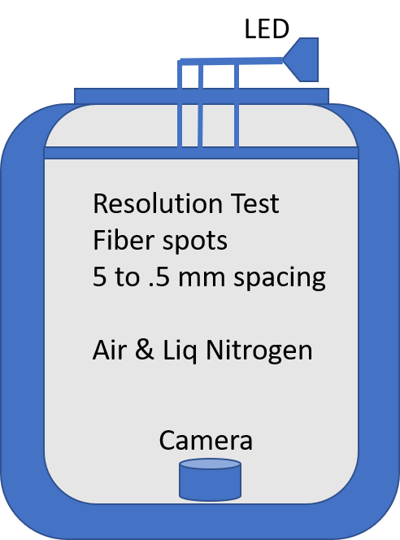

Figure 5 Camera resolution test in dewar.

The primary sensor will be camera(s) for visual inspection. In addition to the already mentioned camera parameters, the weight, size and power are all parameters that all need to be optimized. Expected weight for a low power CMOS device with a 3-volt video transmitter (such as TX5823) is around 10 ounces. Peripherals, like whip antenna and passive filtering circuit, contribute minimal weight and power.

Additionally, we would like to explore adding a temperature probe. The hardware requirements for temperature probes is minimal. Typically, the probes are three pin low voltage devices with a data transmission rate of 1 Hz at 8-bits. Argonaut would have both an internal, platinum rt like PT100, and external temperature probe. In addition to temperature probes, we will explore adding a differential voltage monitoring circuit with external probe tips. Although not ideal for actual measurements, this would allow us to test some internal hardware. Since this is a prototype, gaining as much knowledge on power, weight and communication requirements for anticipated diagnostics is advantageous to future success.

**Materials:**

There is significant attention being paid to the material being installed within the liquid argon environment. All materials will be reviewed by experts for contamination. The selection of materials with proven use in LAr will be a factor when specifying sub-systems such as the rail system, Argonaut module, fibers, epoxy, and extension diagnostics hardware. For example, multiple liquid argon detectors have used communication fiber from which we can choose. Peek (Polyether ether ketone) has been used to some extent in cyro environments and has properties superior to those being used such as G10.

PEEK has some ideal properties: low water absorption, small thermal expansion, chemical-resistant, very good insulator, machinable, and high strength. Additionally, a recent purchase of a PEEK material 3D printer will allow us to quickly test prototype Argonaut designs.

**Timetable:**

**First Year:**

* Workshop with collaborators and interested parties: Map out areas of interest and of shared effort.
* Purchase diagnostics hardware to be tested, PoF system, communication hardware, fiber and bulk PEEK material
* Preliminary design of Argonaut, Prototype PEEK Argonaut module
* Preliminary design of test rail system, Review with CERN/DUNE module experts
* Preliminary design of motion control
* Preliminary design of controls network

**Second Year:**

* Testing of camera(s) with PoF system in Peek housing unit (Test unit will not be final), power, controls at room and liquid nitrogen temperatures.
* Communication testing in various environments, S/N data quality, power, signal strength optimization, fiber link testing in cryo
* Thermal simulations based upon selected hardware. (Motion control will need to be understood)
* Prototype beta design ready for PS1 cyro test – motion control and if possible, camera with PoF connections test

**Final Year:**

* Complete a 2D rail system design, test at PS1
* Remote software control of Argonaut – PC based controls only via Labview and or wireless IP.
* Image capture and video capture - use application developed for video capture of wireless laser notching system camera
* PoF Longevity testing, communication, diagnostics &datalogging of essential parameters
* Review with collaborators final test results and lessons learned

**Facility:**

As part of the Accelerator Division’s Robotic Initiative, we will utilize an area designated to the effort. The area will house Target System robotic team members, students, and small apparatus setup and testing. This area is expected to be expanded in a few years as required to house the large robotic systems being developed for Target Systems department. The area is large enough to house approximately 12 people, 8 of whom will be student areas. Argonaut is hoping to take advantage of embedded systems and controls software being developed for the Target robotics. The use of machine learning (ML) being applied to those systems is a powerful tool however, it is not necessary for the first pass Argonaut system

**Future Funding**: (½ page)

We believe if this concept proves successful it would have a good chance of being adopted by the DUNE collaboration. The work would pave the way for a more extensive system optimized for a particular detector design. CERN and in particular the DUNE- CERN personnel has already noted the concept and has applied for their own funding through the European Union. CERN personnel realize the extent of the work to be done and feels that FNAL could pave the way to make this a viable option to be considered in the DUNE module approval process.

Recently, the DOE has encouraged FNAL and other labs to engage with NASA on technology development. Although we had initiated our effort before the DOE call to engage, the support could lead to additional funding from both the DOE and NASA. We have exchanged ideas with NASA/JPL engineers and scientists, and we have been invited to give engineering talks. There is close alignment between Argonaut and what NASA/JPL is trying to accomplish in deep space exploration. NASA/JPL is ramping up their robotics efforts, especially in the area of mechanical engineering. However, HEP has the facilities to test concepts and NASA has extensive experience in cold electronics and detection systems. We feel it is highly likely that the DOE through robotics or joint NASA/JPL collaboration would see future research funding opportunities. Additionally, partnerships are starting to develop with vendors interested in testing wireless communication and PoF in such an environment. Presently, systems do not perform well below -40°C. Those restriction are dimensioning with development of solid state batteries, crystal free clock systems and miniaturized mechanical systems embedded directly on silicon. Argonaut can provide an opportunity to test and provide reliability data for vendor products.

**Documentation and Journals:**

Argonaut will find an interested audience in several professional fields. This will be the first of a kind cryogenic robotic system used in HEP and we will look to publish in journals such as IEEE and JINST. In addition, the space technology journals has shown interest in low power cold electronics and mechanical devices. Hardware we are exploring has been noted in articles published by NASA and related journals. Finally, mechanical engineering journals would be extremely interested in this concept and we will look to promote FNAL ME advances in the field.

**References** (not included in 6 page limit): Cite a concise set of relevant literature that supports the scientific/technical significance of your project and the innovativeness of your proposed methodologies.

**Qualifications** (optional, not included in 6 page limit): The C.V. of the PI may be attached and/or a brief statement (~1/2 page) discussing the qualifications of the PI to carry out the proposed research may be described.

**Resource Availability and Recent LDRD Funding**

1. Discuss scientific or technical obligations of the investigators:
2. PI Pellico is involved in several efforts but overlap with this LDRD and can meet the FTE requirements. The other two critical members have approved the LDRD time commitments.
3. None
4. None

**Budget Table** (not included in 6 page limit, separate document): The last page of the proposal consists of a completed budget table. In the budget table, include a cost breakdown for each objective/ aim discussed in the Research Plan. There is no specific budget limitation, but keep in mind that the LDRD funding has limited resources. If subcontracting work, it should be clear in the proposal what work is being subcontracted and justified why that work is not able to be performed within Fermilab.

Labor consists of the three types: Electrical/PI/Management, ME/Design, Scientific/Testing:

**The M&S consists of three categories: Mechanical hardware, power systems, diagnostics:**

**The total cost from AD budget office:**