US HL-LHC Accelerator Upgrade Project

MQXFA07 Inspection Plan

G. Ambrosio, M. Baldini, D. Cheng, P. Ferracin, S. Prestemon, Katherine Ray

Revision History

Revision | Date | Section No. | Revision Description
v0 | TBD | All | Initial Release

- Introduction and Scope

MQXFA07 magnet was tested at BNL Vertical Test facility in August 2021. During vertical test MQXFA07 did not reached nominal current at 1.9 K and 20 A/s ramp rate [1]. Test performance and analysis [2] showed that MQXFA07 is limited by self-field instability triggered by an unknown issue in coil 214. MQXFA07 will be sent to LBNL for disassembly and inspection.
This document describes MQXFA07 inspection plan after arrival at LBNL, inspection of all coils after magnet dis-assembly, and investigation plan for coil 214.

- Inspection and Magnetic Measurements at LBNL before Magnet Dis-assembly

After magnet is delivered to LBNL, it should be visually inspected in order to detect and record any possible anomaly or difference vs as built conditions. Magnetic measurements should be performed in order to compare with the magnetic measurements after loading.
The pre-disassembly inspection is described in the MQXFA Dis-assembly WI [3] and it will include the following measurements
- Pi tape measurements of magnet OD
- Magnet overall length
- Magnetic measurements (field quality and alignment)
All data will be compared with the ones taken after assembly.

- Splice box disassembly and magnet unloading

After inspection and magnetic measurements, the magnet should be dis-assembled following the MQXFA Dis-assembly WI [3]. A summary of the key work instruction is given below:
- Disassembly of splice box
- Un-wiring
- Unloading with bladders
  - During unloading strain on shell, rods, and coils will be recorded by strain gauges
- Removal of end plates and axial rods
  - The residual strain in the rods should be measured and compared to initial offsets, to check for possible plastic deformation
  - The end plates’ flatness should be verified, to check for possible plastic deformation
- Extraction of master keys
  - Master keys will be visually inspected, and cleaned of any surface rust from moisture, etc.
- Extraction of coil pack
  - The following measurements will be performed on the coil pack and compared with values before loading
    - Vertical dimensions
    - Horizontal dimensions
    - Pole key gaps
- Measurements on the shell-yoke sub-assemblies, to be compared with values before loading
  - Yoke protrusions
  - Yoke opening/cavity
  - Pi tape measurement of shell OD
  - Shell strain measured by strain gauges
- Disassembly of coil pack
- Removal and visual inspection of coil GPI
- Inspection of collar Radial layers (G11/Kapton); to be replaced in case of damage
- Measurements of pad/collar stacks overall lengths and comparison with values before loading
- CMM measurements of all the coils, comparison with values before loading, and check that coil dimensions are within specs
- Photographs should be taken along the length of all coils on both inner and outer layers.

Specifically related to MQXFA07, it is important to point out that both end plates and splice box will need to be modified to provide clearance for the heat exchanger tubes.

- Inspection after magnet unloading and disassembly

Once the magnet is unloaded, the following operations and measurements shall be carried out

- Tests and Investigation of Coil 214

Coil 214 has been rejected because it limited MQXFA07. Therefore, it can be used for possibly destructive measurements, in order to assess if margins at coil peak production are equal or higher than at the beginning of the project. After these tests and measurements, coil 214 will be cut for tomography.

  - Coils visual inspections

Visual inspection and photographs analysis will be done to compare coil 214 with the other 3 coils (212, 124 and 114) of MQXFA07 looking for differences between coil 214 and the other 3 coils. In addition, photographs of MQXFA07 coils should be compared with other MQXFA/P coils after prototype test.

  - Heater-Coil Hipot

Heater-coil Hipot of each quench heater of Coil 214 should be performed up to 5 kV, after 30 sec plateau at 460 V.

  - CMM

CMM measurements of Coil 214 should be taken at original locations [4] for comparison with pre-assembly measurements.

  - Tomography of Lead End and Return End

Coil 214 Lead End (with some straight section) and Return End must be cut in order to allow for shipment to CERN (to the attention of Bartosz Bulat) and subsequent tomography. The Lead End sample must be around 600 mm from the end of the Lead End extension. The Return End sample must be around 300 mm from the end of the Return End Saddle. Figure 1 shows where tomography will be done. The cut must be performed with care to minimize damage to coil integrity where tomography will be done.
CT scans will be done by Diondo (www.diondo.com). At CERN Bartosz Bulat will coordinate effort at Diondo and perform image reconstruction, under supervision of Stefano Sgobba.

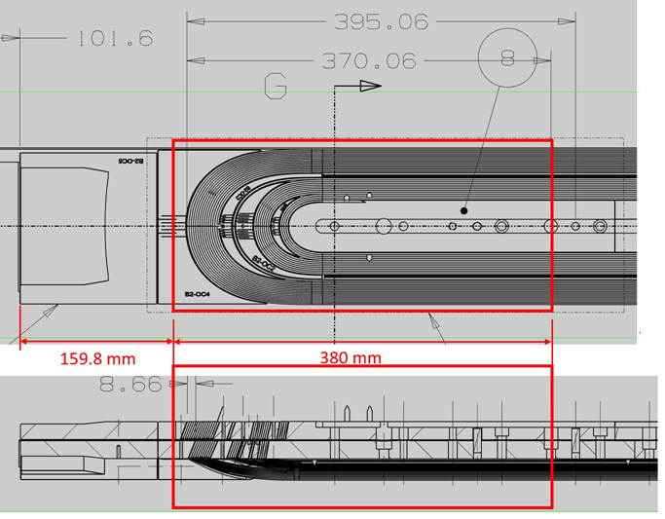
Figure 1: Drawing of MQXFA coil Outer Layer Lead End showing area for coil-214 tomography (in red box).

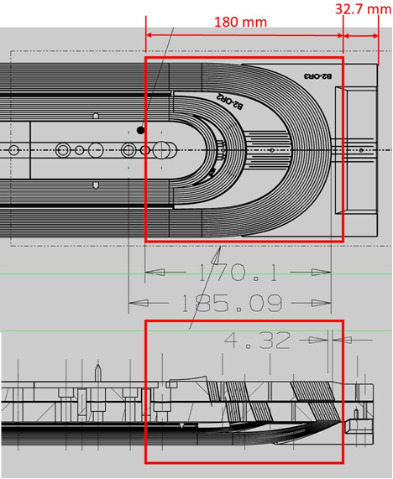
Figure 2: Drawing of MQXFA coil Outer Layer Return End showing area for coil-214 tomography (in red box).

  - Micrography

After tomography is complete, coil 214 Lead End and Return End samples must be sent to FNAL (to the attention of Maria Baldini) for micrographic analysis of selected x-sections. Some x-sections are on critical spots: wedge to end-spacer transitions, and at tip of spacer B2-IC1 (Figure 3).
Other x-sections may be added if tomography shows issues such as popped strands or large strand/cable deformation. The goal of this analysis is to detect and count filament cracks at these locations.

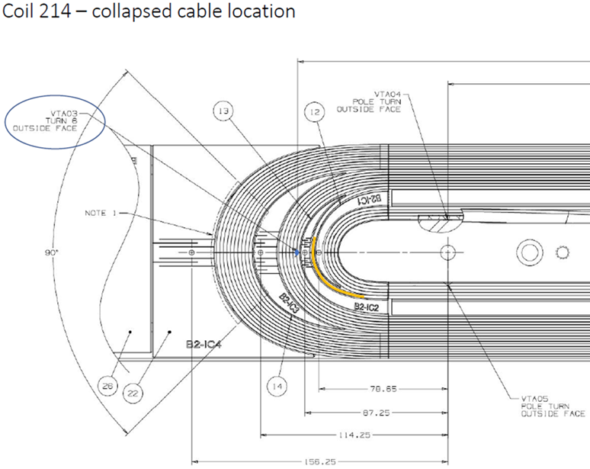
Figure 3: Drawing of MQXFA coil Inner Layer Lead End showing location where cable collapsed during winding of coil 214 (in yellow).

- References

- MQXFA07 Test Results, https://indico.fnal.gov/event/51196/
- MQXFA07 Limitation Mechanism, https://indico.fnal.gov/event/51196/
- MQXFA Magnet Dis-assembly Work Instruction, …
- MQXFA Coil CMM Profile Measurement Locations, US-HiLumi-doc-2362

