US HL-LHC Accelerator Upgrade Project

Coils Acceptance Review
for MQXFA07b and MQXFA11

TABLE OF CONTENTS

1. Goal & scope 3
2. Charges 3
3. Technical information 4
4. References 4

- Goal & scope

The HL-LHC AUP project is planning to start re-assembly of MQXFA07b in November 2021 and subsequently assembly of MQXFA11 in December 2021.
MQXFA07b is the first re-assembly of an MQXFA magnet. MQXFA07 showed detraining to 15 kA after it reached 16.1 kA. All detraining and limiting quenches were in coil 214 [1]. The other three coils of MQXFA07 did not show any issue and will be re-used if they pass QC tests (electrical and CMM) after disassembly.
MQXFA11 is the fourth series low-beta quadrupole magnet (MQXFA) for HL-LHC. If MQXFA07b and MQXFA11 meet MQXFA requirements [2] they will be used in a Q1/Q3 cryo-assembly to be installed in the HL-LHC.
AUP is planning to use one new coil for MQXFA07b and four new coils for MQXFA11 out of this list: 134, 135, 218, 219, 222 and 223.
Conductor and series coil specifications are presented in [3-7]. Discrepancy or Non-conformity Reports are generated whenever a component does not meet specifications.
The reviewers are requested to review discrepancies and non-conformities in strands, cables and coils, for the following coils: 134 (cable P43OL1153), 135 (cable P43OL1154), 218 (cable P43OL1133), 219 (cable P43OL1134), 222 (cable P43OL1144) and 223 (cable P43OL1145).

- Charge questions

The committee is requested to answer the following questions:

- Have Discrepancies and Non-conformities been adequately documented and processed?
Yes. The critical discrepancies and non-conformance to specification were adequately recorded and processed.
Strand and Cable: The non-conformances observed for the cables were all judged to be minor and unlikely to affect coil dimensions. The slightly higher HT temperature for cable 1153 and 1154 is reflected in the 4% higher Ic(15T) for the qualification samples from these cables compared to the other cables;1135, 1134, 1144 and 1145.
FNAL Coils 134 and 135: Discrepancies in coil winding, reaction and impregnation steps were carefully noted for these coils.
For Coil 134 several DR’s were recorded; only one critical. This coil had a an incident of popped strands in winding layer 2, 6th turn at the RE going into the turn. The critical DR-12437 was inspected carefully and judged to be minor.
For Coil 135 a CDR was recorded after impregnation. An exposed section of the cable on the ID edge of the midplane was seen; probable random epoxy fracture while removing epoxy flash. It was repaired using Stycast and outer dimension was checked for conformance.
BNL Coils 218, 219, 222 and 223: Here too all discrepancies were recoded and where required corrective action was implemented. None of the DR’s were critical.
Coil Dimensions: The “Pole” inner radius deviations (greater than maximum allowed value) in the straight section were recorded for nearly all the coils (see plot below as shown at the review). Corrective action: The coil bumper thickness needs to be corrected to compensate during magnet assembly.
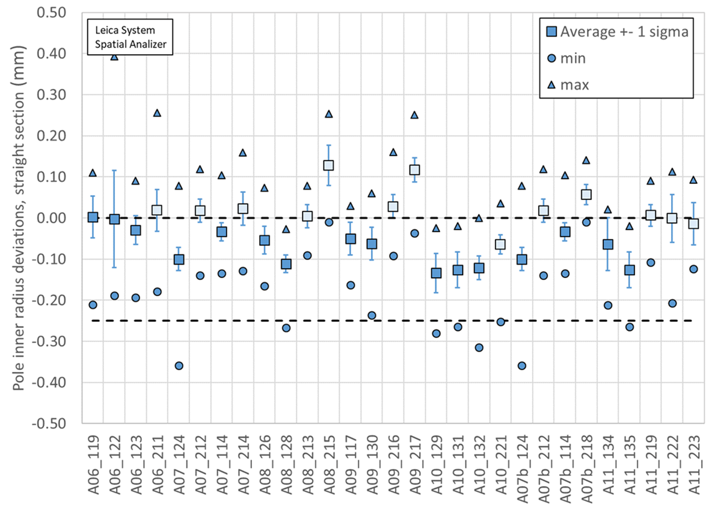
- If there are critical Discrepancies/Non-conformities, have they been adequately documented and processed?
Yes.
- Did the L3s properly identify critical Discrepancies/Non-conformities?
Yes.
- Is there any coil that you recommend not to use in MQXFA07b or MQXFA11?

No, all coils are acceptable. AUP has decided to use coil 218 as a replacement for coil 214 in the re-assembly of Magnet MQXFA07b.
Inner Radius coil deviations (excess material) are observed for coil 218, 219, 222 and 223. Coil bumper thickness is to be corrected to compensate. It appears that previous BNL coils have exhibited similar behavior – Coil 215, 216 and 217.

- Do you have any other comment or recommendation regarding these coils and their conductor for allowing MQXFA07b and MQXFA11 to meet MQXFA requirements [2]?

COMMENTS

All cables are dimensionally within specification and fairly uniform. Although no coil-reaction witness sample tests were presented, we find that, based on history of the pre-series coils, the expected cable performance should have significant margin at operating current and temperature to ensure easily reaching the required operating current. This has been demonstrated for the pre-series coils.

Cable insulation at NEEWT show good consistency in the thickness measurements done at the vendor and that performed at LBNL and is within specification.

In the absence of coil witness sample data, the analysis presented for coil ordering using the minor edge RRR of the extracted strands measured at LBNL and the rolled strand data from the supplier is deemed acceptable. Seems like there are many options available for coil assembly for a voltage criterion of < 353 V.

For these Coils the incidence of “popped” strands was observed during coil winding for only coil 135.

Coil production has become fairly stable with only a few non-conformities occurring. There is a shared concern that given the performance issues with a couple of the quads (most recently MQXFA08) that there may be some critical aspect of coil winding that is being missed. The observation of popped strands could be a possible cause but it is certainly possible that there are others, including the assembly and loading process.

- Technical information

Committee
Steve Gourlay (chairperson), LBNL
Arup Ghosh, BNL retired
Susana Izquierdo Bermudez, CERN

Date and Time
November 12, 2021. Start time is 7/9/10/16 (LBNL/FNAL/BNL-FSU/CERN)

Location/Connection
Video-link by Zoom, info by email.

Link to agenda with talks and other documents
https://indico.fnal.gov/event/51729/

- References

- MQXFA07 Test Results, https://indico.fnal.gov/event/51196/
- MQXFA Functional Requirements Specification, US-HiLumi-doc-36
- Specification for Quadrupole Magnet Conductor, US-HiLumi-doc-40
- Cable Specification, US-HiLumi-doc-74
- Quadrupole Magnet Cable Insulation, US-HiLumi-doc-75
- QXFA Series Coil Production Specification, US-HiLumi-doc-2986
- QXFA Series Coil Fabrication Electrical QC plan, US-HiLumi-doc-521

