**Memorandum**

TO: Distribution

FROM: B.A. Smith

DATE: December 19, 2011

SUBJ: Quench Analysis of the Mice Coupling Coil

REF: MiceCC-MIT-BASmith-111219-01

**Executive Summary**

A round of quench analyses has been completed on the Mice coupling coil solenoid using the author’s quench code[[1]](#footnote-1). After an initial scoping run, a total of six cases have been run to explore alternative protection circuits and the benefits of coil subdivision. The scoping run was made with a coarse mesh on a single coil without subdivision and 4.75  dump resistor to evaluate quench propagation and the rate of growth of the normal zone size. The scoping run showed the normal zone resistance grows quickly, dominating the dump resistor in under 0.5 s, and eventually grows to over 200  by the end of the transient while limiting the hot spot temperature to 134 K. These results confirmed that the coupling coil can be self-protected, and that a dump resistor is not necessary.

The follow-on six cases evaluated two alternative circuit options using a finer mesh and those results are presented in detail. Finer mesh size usually results in lower hot spot temperatures but can resolve higher voltages because of the accompanying smaller time step size. The first case uses warm and cold dump resistors, warm and cold diodes, and redundant power-supply-disconnect switches. See Fig. 1. The last five cases use cold diodes and redundant power-supply-disconnect switches only. See Fig. 2. Of the last five cases, four are for one, two, four and eight subdivisions of the magnet with quench being initiated from the location of the *maximum* field location at the ID of the winding. The last case is for eight subdivisions with quench initiating from the *minimum* field location, which is close to the axial center of the winding and radially near the OD. None of the cases consider quench back from the aluminum coil case. In both the Fig. 1 and Fig. 2 circuits most of the stored energy of the magnet (12.9 MJ) is dumped into the winding. The Fig. 1 approach was used initially to see if the magnet is self-protecting (it is) but then dropped in favor of the lower component count and lower risk approach of Fig. 2. Fig.1 case results are included for completeness.

The analyses show the maximum voltages in the winding vary inversely with the number of subdivisions. The analyses also show that the hot spot temperature varies inversely with the number of subdivisions, but only by a small amount. With eight subdivisions and a quench initiated from the Bmax location, the hot spot temperature is calculated at 122 K, and the maximum voltage differential within the winding is limited to 78 V. Maximum layer to layer voltage is 68 V and maximum turn to turn voltage is about 7 V. Quench from the Bmin location with 8 subdivisions shows a hot spot temperature of 127 K but lower voltages. By comparison, one subdivision and quench from Bmax results in a hot spot temperature of 136 K, but the maximum voltage differential within the winding is over 2100 V, the maximum layer to layer voltage is 155 V, and the maximum turn to turn voltage is 97 V.

The best results are provided by the 8-subdivision case. Based on the results presented, the case for 4 subdivisions, presented in detail below, warrants further consideration for those coupling coils which are not yet built, especially given that each lead penetration of the coil housing increases the risk of failure at some point in the magnet lifetime.

**Introduction**

The first of three Mice coupling coils has been fabricated and will be tested at Fermi Lab. It has 96 radial layers and eight subdivisions with each subdivision comprised of 12 layers. The leads at the ends of the subdivision in the one already-wound coil are brought outside of the aluminum housing of the coil, form a small loop, and are returned without a break directly back inside the coil to continue the winding. The leads are therefore available for use to divide the coil into separate sections for quench protection should this prove desirable. The remaining two Mice coupling coils are yet to be built. One of the objectives of this round of analyses is to determine whether to deploy subdivision in the protection of the coil, since bringing the leads outside the housing carries some risk.

**Coil and Code Discussion**

The Mice coupling coil has 12.9 MJ of stored energy when carrying the maximum operating current of 210.1A. The coil has an inner radius of 0.75 m, a radial build of 0.102 m, an axial length of 0.285 m. The magnet is wound with a monolithic NbTi superconducting wire with a copper to superconductor ratio of about 4:1. The wire has a Jc(T,B) parameterization provided by LBNL[[2]](#footnote-2). Although bulk thermal conductivities as a function of temperature in the transverse directions (r,z) were also provided by LBNL[[3]](#footnote-3),[[4]](#footnote-4), these were not used because the bulk properties were separately developed at MIT using ANSYS[[5]](#footnote-5). The ANSYS transverse thermal conductivities were similar in magnitude to those found by LBNL. Thermal conductivity along the conductor is taken as that of copper as a function of temperature, with appropriate account of the Cu fractional cross-sectional area and also with account of its magnetoresistance at the local value of the magnetic induction as a function of time. Bulk specific heat is calculated at each temperature with account of the volume-weighted individual component specific heats.

The quench solver inputs are created via a separate meshing program, which had also been previously developed by the author. For the Mice coupling coils, both the meshing program and the quench solver were modified so as to easily allow changing the subdivision definition and the associated loop current equations.

A single coil without iron will have its field everywhere proportional to the coil current. With coil subdivision, the individual coil currents decay at different rates, so the fields in each element from each coil must be calculated at every time step.

Temperatures are calculated at every time step by solving the energy balance equation within each element using finite differences. Temperature data at every element and time step for the entire transient can be voluminous and is output only at selected time points, about every 0.5 seconds in these cases. The hot spot temperature is calculated at every time step and output more frequently than the individual element temperatures.

Voltages are calculated throughout the winding by calculating both the inductive and resistive components within each element and summing them algebraically with proper accounting for the element to conductor cross sections. The elements are sorted in winding order and the element voltages are summed beginning with one end of the coil arbitrarily set at zero. These voltages must be further post processed to get the correct the maximum differential voltages at the winding, layer and turn levels. As with the temperature data, voltage data can be voluminous and is output in these cases about every 0.25 seconds.

As an aside, it is noted that the net voltages along the winding reported here are significantly different from and smaller than the resistive component of the voltage developed across the normal zone. Although the real voltage to ground cannot be determined until a ground point is chosen for the magnet circuit, the voltages along the winding may be used to directly calculate such voltages once a ground point is defined for the circuit. It is also noted that the voltages reported here differ from and are smaller than the voltages reported by Green[[6]](#footnote-6) and later by Guo[[7]](#footnote-7). The reason for these differences is not known. LBNL has a winding voltage analysis capability, and it would be useful to explore the voltage results further.

**Circuits Analyzed**

Aside from the differences in subdivision, two types of quench protection circuits were analyzed in detail. These are shown in Figs. 1 and 2. For the Fig. 1 circuit, when the normal zone voltage exceeds the forward voltage of the room temperature diode, which is generally lower than the initial turn-on voltage for the cold diodes, the power supply is disconnected forcing magnet current initially through the room temperature resistor. Current through the room temperature resistor develops sufficient voltage to forward bias all of the cold diodes. Current decay then begins in all loops whether or not that loop’s coil has gone normal. Of course, as the quench propagates throughout the winding, eventually all coils are in the normal state. For the Fig. 2 circuit, current decay following quench detection relies almost entirely (except for the small amount of diode forward voltage) on the growth of the coil normal zone resistance for protection, since no dump resistors are used.

Case 1 relates to the Fig. 1 circuit and was run before the capability for the simplifying features of the Fig. 2 circuit were fully realized. The room temperature dump resistor was set at 0.4 ohms, presumably just large enough to develop sufficient voltage to forward bias all the cold diodes. Each of the cold dump resistors were set at 0.1 ohms. The Fig. 1 approach was dropped after the first run because the simplicity of the Fig. 2 approach is more appealing. Without dump resistors, it carries lower risk of failure. Another appealing aspect of the Fig. 2 approach is that it does not rely on current conduction through the high temperature superconducting leads once quench is detected and the power supply is disconnected.

C:\Users\bsmith\Documents\MIT\Projects\MICE\Coupling coils\Work\BAS\Quench circuit.wmf

**Fig. 1**

**Protection with warm and diodes and dump resistors and power supply disconnect switches**

**Results of the Quench Analyses**

Table 1 lists hot spot temperature and voltage results for the 6 cases for comparison. Each increase in subdivision count results in a significant reduction in the maximum V in coil. At the same time, the hot spot temperature is reduced only slightly or not at all. The case may be made that 4-subdivisions offers a reasonable compromise of fewer diodes and exposed leads against higher, but probably tolerable voltages when compared with the 8-subdivision case.

**Table 1**

**Summary of all Quench Cases**

|  |  |  |  |  |  |  |
| --- | --- | --- | --- | --- | --- | --- |
| Case Number | Description, Initiation Location | Related circuit | Thot  (K) | Maximum V in coil (V), Time (s) | Maximum Layer to Layer Voltage (V) | Maximum Turn to Turn Voltage (V) |
| 1 | 8-sub, dump resistors, Bmax | Fig. 1 | 122 | 105, 0.75 | 69 | 7 |
| 2 | 1-sub, Bmax | Fig. 2 | 136 | 2114, 3.32 | 155 | 97 |
| 3 | 2-sub, Bmax | Fig. 2 | 124 | 1074, 2.28 | 100 | 58 |
| 4 | 4-sub, Bmax | Fig. 2 | 122 | 281, 3.0 | 71 | 21 |
| 5 | 8-sub, Bmax | Fig. 2 | 122 | 78, 2.75 | 68 | 7 |
| 6 | 8-sub, Bmin | Fig. 2 | 127 | 72, 3..25 | 32 | 6 |

C:\Users\bsmith\Documents\MIT\Projects\MICE\Coupling coils\Work\BAS\Quench circuit-No D0-R0 leg.wmf

**Fig. 2**

**Protection with cold diodes and power supply disconnect switch**

Most of the plots that follow are for Case 5, since that is perhaps the most relevant, certainly for the magnet to be tested at Fermi Lab. However, all of the plots can be provided for any of the cases, if needed.

Currents for Case 5 are plotted in Fig. 3. There is a fair amount of transient activity in the 0 - 2.5 s range. The quench initiates at the Bmax location which is in Coil 1 (at the ID), so its current initially decreases. The outer coils try to maintain flux by increasing their currents. This actually drives those coils normal faster than would otherwise happen. As the interaction between the coils plays out, eventually all coils are driven normal and their currents then decay at nearly the same rates. Rates of change of coil currents (dI/dt) are plotted in Fig. 4. Coil resistances are plotted in Fig. 5. Note that each coil resistance grows to 25-30  by the end of the transient, and the resistance of the entire magnet is over 200 . These large resistances result in fairly rapid current decays and all currents are close to zero before 15 seconds.

**Fig. 3**

**Coil currents, 8 subdivisions, quench from Bmax (Case 5)**

**Fig. 4**

**Coil dI/dt, 8 subdivisions, quench from Bmax (Case 5)**

**Fig. 5**

**Coil resistances, 8 subdivisions, quench from Bmax (Case 5)**

It is instructive to plot the voltages along the winding at the point in time where V in the coil is a maximum for each of the cases. These plots are include as Figs. 6-11 for the 6 cases. The number of subdivisions and their locations relative to the voltage values are distinctly observable in the plots, with the voltage being close to zero at the ends of each subdivision where the only offsets are caused by the diode voltage drops, taken as 1 V each. At the locations when the voltage is increasing along the winding, the resistive voltage is dominating and where it is decreasing, the inductive voltage is dominating. The small, high frequency fluctuations in the plots are due to the individual layer voltages of the 96 winding layers.

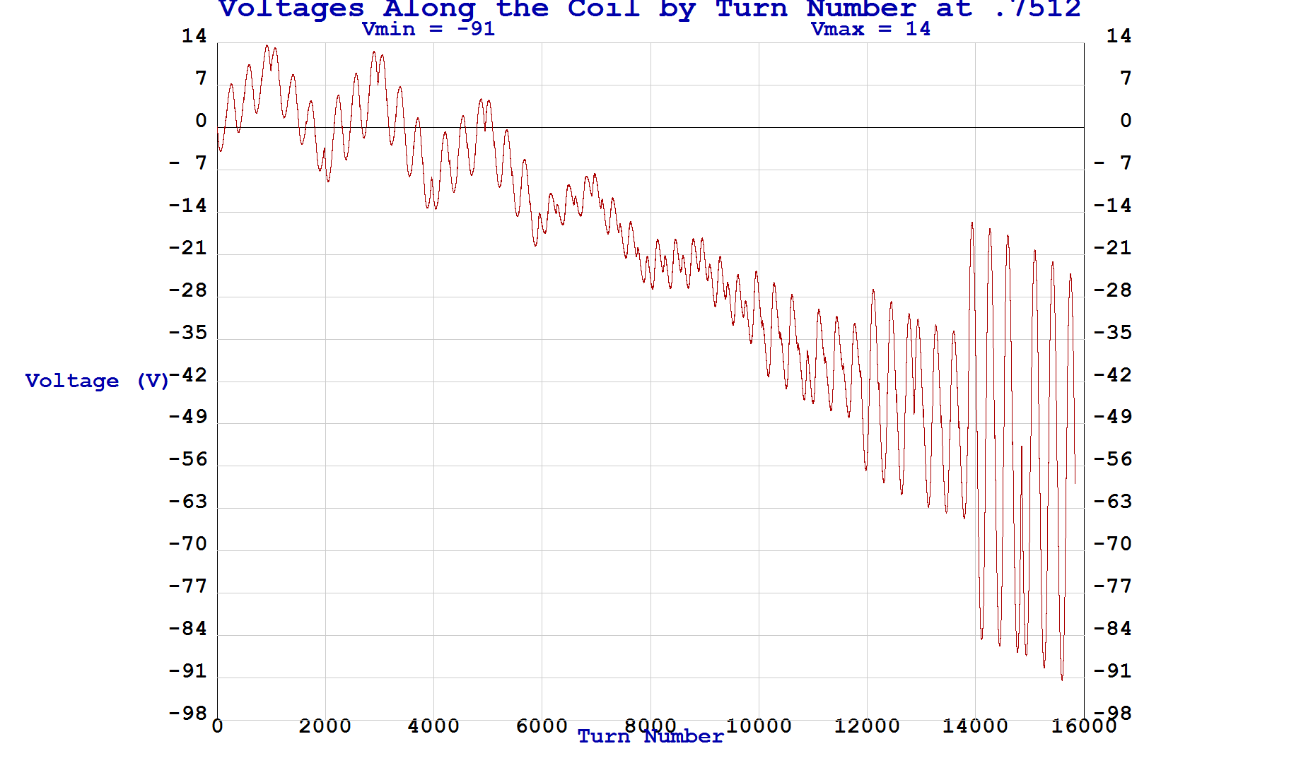

**Fig. 6 8-subdivisions, Case 1, Circuit Fig. 1**

**Quench from Bmax**

**Voltages along the coil at time of maximum V in the coil**

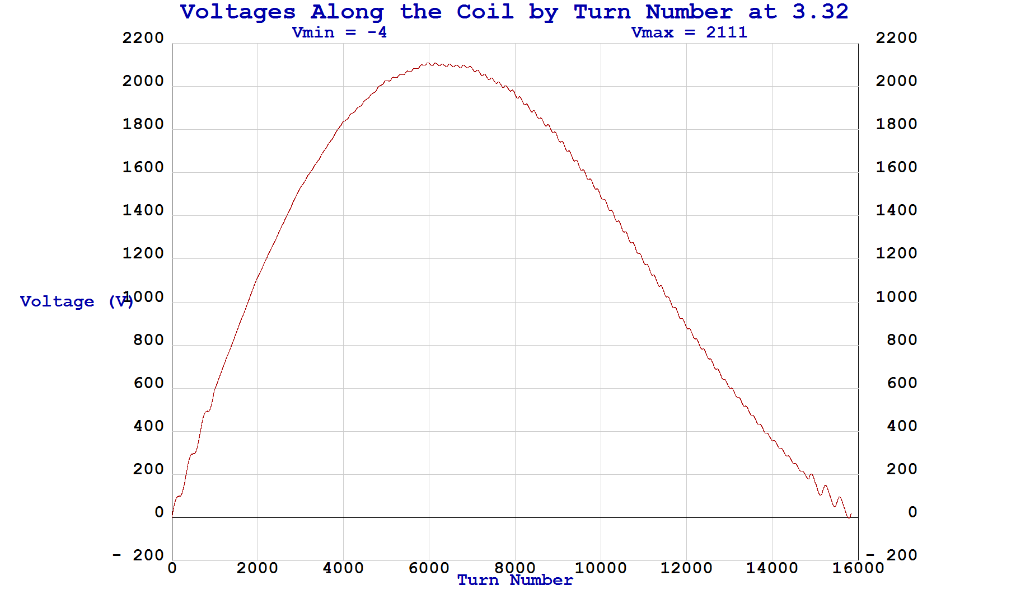

**Fig. 7 1-subdivision, Case 2, Circuit Fig. 2**

**Quench from Bmax**

**Voltages along the coil at time of maximum V in the coil**

C:\Users\bsmith\Documents\Visual Studio 2010\Projects\Quench\MiceCC\MiceCC_Sub_One_Ext_Rd, Cold Diodes\Cold_Diodes_One_ExtRd_Out\2 sub\Voltages\2.28.bmp

**Fig. 8 2-subdivisions, Case 3, Circuit Fig. 2**

**Quench from Bmax**

**Voltages along the coil at time of maximum V in the coil**

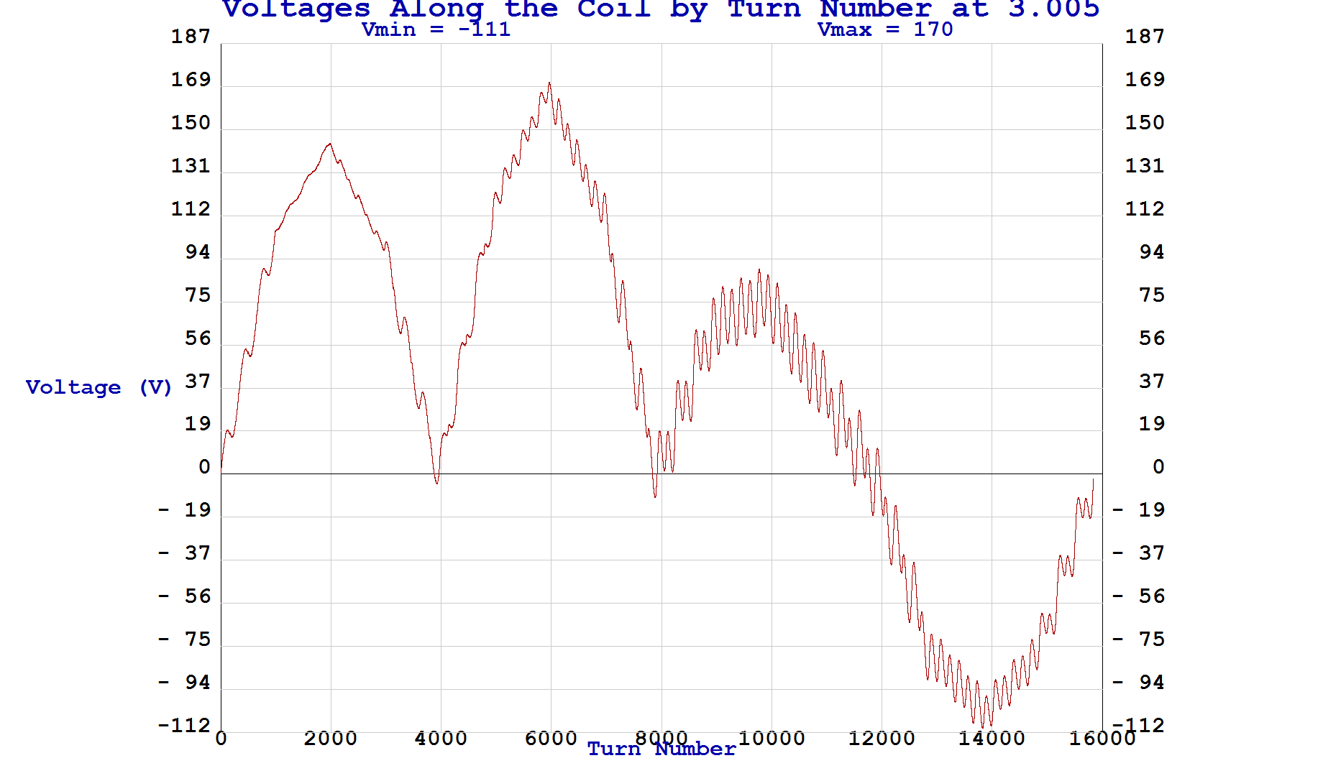

**Fig. 9 4-subdivisions, Case 4, Circuit Fig. 2**

**Quench from Bmax**

**Voltages along the coil at time of maximum V in the coil**

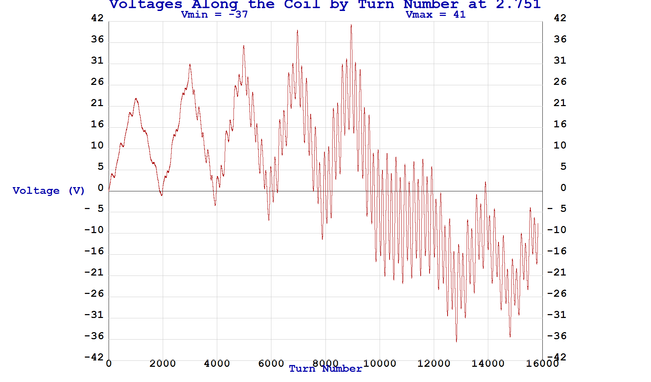

**Fig. 10 8-subdivisions, Case 5, Circuit Fig. 2**

**Quench from Bmax**

**Voltages along the coil at time of maximum V in the coil**

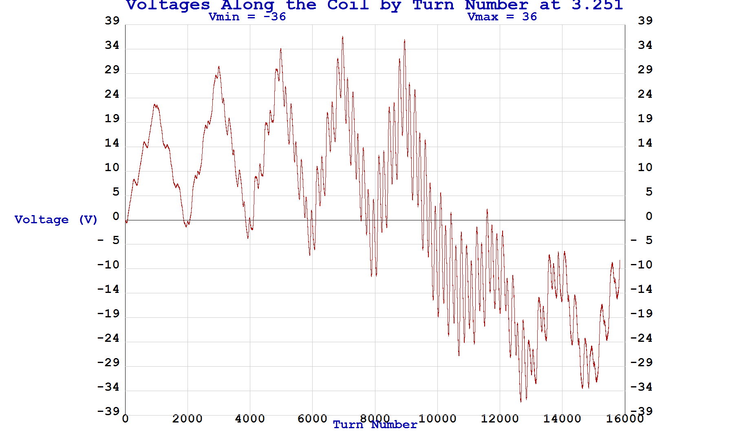

**Fig. 11 8-subdivisions, Case 6**

**Quench from Bmin**

**Voltages along the coil at time of maximum V in the coil**

Temperatures at a number of time points are plotted in Figs. 12-16. The left-hand panel of each figure gives the color coded temperature scale, the time point of the plot, and the fraction of the winding that is normal at that time. The right hand panel of each figure shows the temperature distribution in the r-z plane at 14 uniformly spaced slices in  around the coil. In the plots, r is vertical and z is horizontal. The  slices enable visualization of the quench propagation axially along the conductor. It is interesting to note that although the quench is initiated at the ID of the winding at the maximum field point, that toward the end of the transient, the hottest spot is actually in Coil 6. This is not surprising after looking in more detail at Fig. 3, which shows Coil 6 current is the highest for the longest period of time therefore giving Coil 6 the largest value of all the coils.

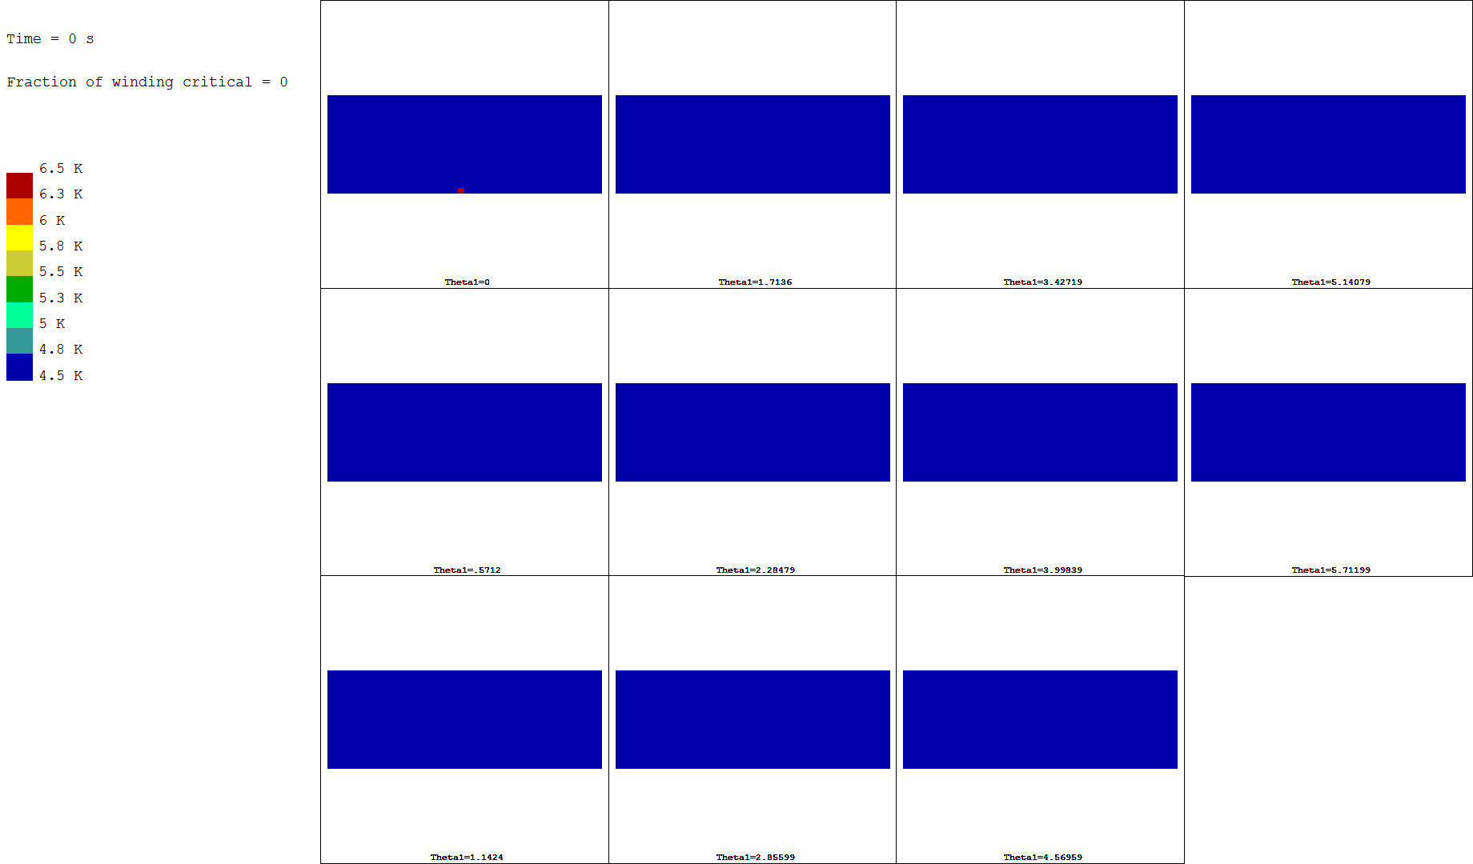

**Fig. 12**

**Three dimensional temperature distribution at 0 s.**

**The small red point (barely visible) at the ID in the =0 plot (upper left) shows the location of the quench initiation. This is the point in the winding where the magnetic induction is maximum (Bmax).**

**Each small window represents a view of the r (vertical) – z (horizontal) plane at one of 14 evenly distributed azimuthal ( direction) slices around the coil.**

**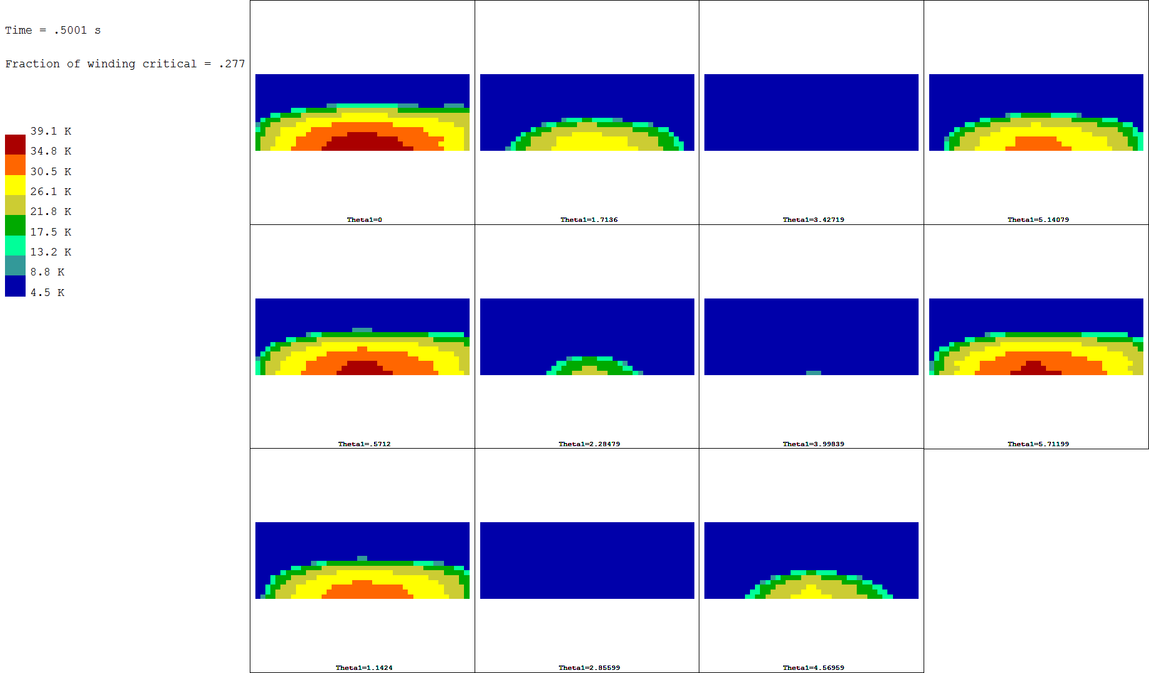**

**Fig. 13**

**Three dimensional temperature distribution at 0.5 s.**

**Although the normal zone has grown to over half the cross section at =0, at =180, the coil is still cold. The winding is about 28% normal.**

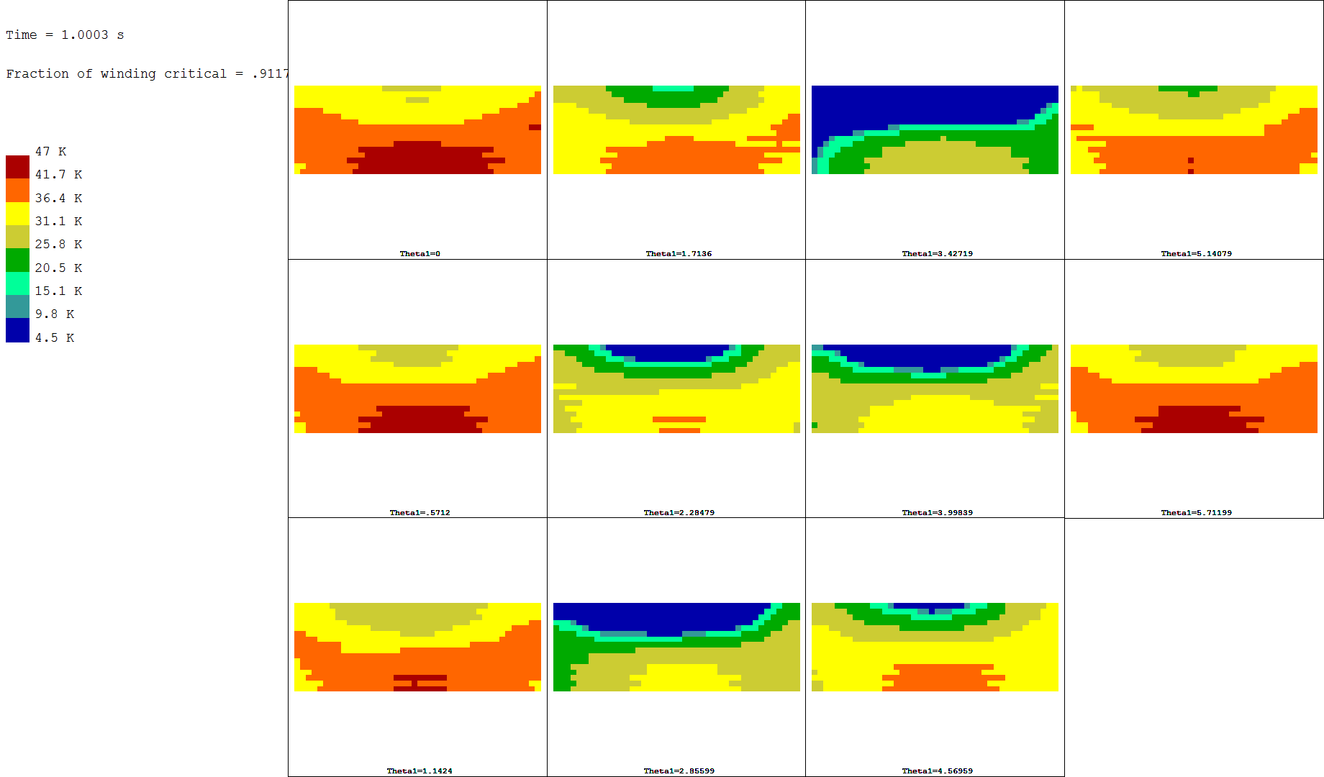

**Fig. 15**

**Three dimensional temperature distribution at 1.0 s.**

**The winding is about 91% normal.**

**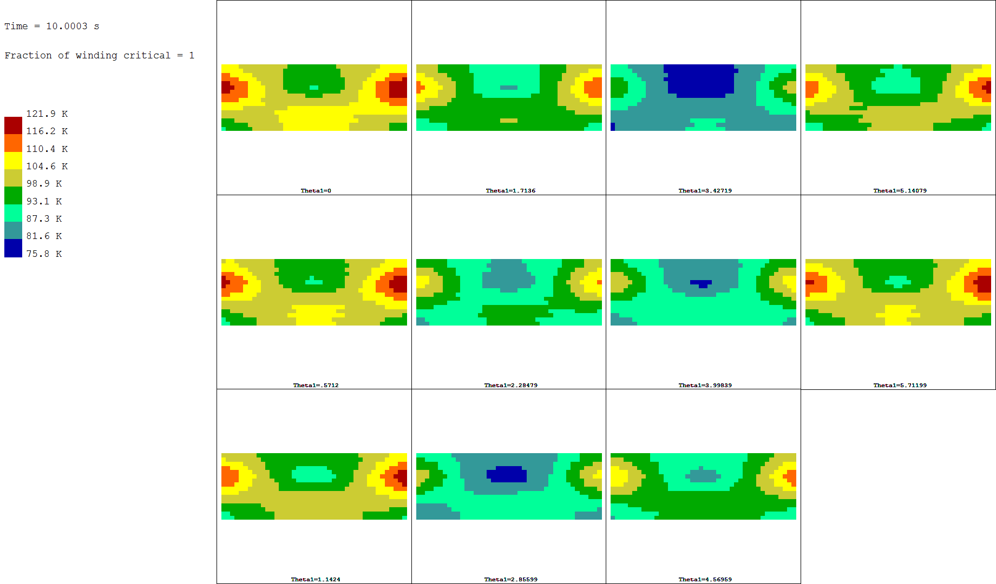**

**Fig. 16**

**Three dimensional temperature distribution at 10.0 s when the hot spot temperature is maximum and located within Coil 6.**

**The winding is 100% normal.**

**Conclusions**

A total of seven quench analyses have been run on the Mice Coupling Coil. The analyses lead sequentially to concluding that the coil can be self-protected, resulting in reasonable hot spot temperatures (below 140 K), dump resistors are an unnecessary complication, and that there are benefits to coil subdivision for quench protection. Adding subdivisions has its greatest effect in reducing coil voltages while reducing hot spot temperature slightly. Eight subdivisions with cold diodes will nicely protect the coil that is already wound and to be tested at Fermi Lab. For those coils that are yet to be wound, 4-subdivisions may offer a lower risk approach with coil voltages that are still acceptable.

1. B.A. Smith, “Superconducting Magnet Quench Code Description”, November 3, 2010 [↑](#footnote-ref-1)
2. Heng Pan, “A Fit for the Critical Current Used in the MICE Magnets”, undated. [↑](#footnote-ref-2)
3. Heng Pan, “Effective Properties of coil compound structure”, undated [↑](#footnote-ref-3)
4. Heng Pan, “Properties of Copper, epoxy, NbTi and G10.xls” [↑](#footnote-ref-4)
5. Craig Miller, “Smeared k - Compounds Wires.xlsx” [↑](#footnote-ref-5)
6. M.A. Green et al, “Quench Protection for the MICE Cooling Channel Coupling Magnet”, <http://escholarship.org/uc/item/00x4x199>, 11-20-2007 [↑](#footnote-ref-6)
7. X.L. Guo et al., “Quench Protection for the MICE Cooling Channel Coupling Magnet”, *IEEE Transactions on Applied Superconductivity,* Vol 19, No. 3, June 2009. [↑](#footnote-ref-7)