Dec 16, 2021 Electronics Integration Meeting
- Attendees:
Howard, Abbey, Andrew, Anne, Cindy, Everardo, Faiza, Lane, Lee, Mike Z, Min Jeong, Jeremy, Steve H, Alan H, Sasha, Linda, James Mateyark, Dan Dwyer, Trevor, Matt, Alan Bross and Ting
- Status and progress
  - Minerva bookend and module set #11 installation, alignment – Min Jeong
    - Alignment of bookend is almost complete. Tom’s crew will install module #11 set afterward
  - AC electrical work schedule: final walkthrough with Leyden this week – Steve
    - Steve did the final walkthrough with Leyden this week. Leyden crew is familiar with MINOS
    - Competing job to LArTF AC work. Contract requires to get the job done before end of the year
    - Cindy and Howard to back up next week when Steve is away
    - Steve to confirm the transformer to be use for this work
      - TR-DHP-MNB-1-B (see picture below)
  - Lab F DAQ is working and make data for nearline? – Geoff/Howard/Abbey
    - Geoff got the DAQ working. Next to make nearline file for Abbey
  - pORC of Minerva readout and LI racks – Howard/Linda
    - Still needs AC diagram from Linda. It is coming
    - Expect to final walkthrough review first week of January
  - Rack builds for networking and DAQ server – Geoff/Linda/Steve
    - New switch boxes to be installed and then transferred to underground
    - Rack is ready and powered. You can install the network switch – updated from Geoff
    - Rack will not be ready until 2022.
  - Minerva electronics preparation – Faiza/Howard/Everardo
    - Faiza: we are ready
  - Aerial Lift training and fall protection classes – how many people around for the week of Jan 10?
    - Will ask Angela to arrange a new class in the week of Jan 10
    - Please spread the news. We need more people to attend
  - 2 TTi PLH120-P (120VDC/0.75A) were purchased for light readout system – Linda
    - Sasha: current 100mA per TPC is likely fine.
  - Quote from Weiner on MPOD LV system received – Linda/Jeremy
    - Like to do around of voltage drop calculation before placing order
  - TPC module-0 in LArTF, QA/QC software being installed to the servers – Lane/Jeremy/Lee/Geoff
    - Work started this week on software installation
- MPOD PS for Pacman and sensor RPi (Jeremy/Linda/Armin/Ting)
  - MPV 4030I and MPV 8030I; Interlock function
    - One Interlock per DB connectors. There are two DB connectors per MPV module
    - 2 LV channels receive same interlock signal for MPV 4030i; 4 LV channel for MPV8030i
  - LV channel map – see DUNE docDB 24124
    - Each MPV4030 to power 2 PACMAN power. Spare channels for sensor RPi
    - PACMAN fan LV from MVP8030
  - DB37 cables:
    - 7wires for 4030I LV lines: 7x24AWG16AWG: voltage drop calculation for 24V/2A
    - 3wires for 8030I LV lines: 3x28AWG23AWG
    - Patch panel from DB37Pacman/fans/sensor Rpi?
- Cryogenics AC SOW for 2x2 in MINOS (Min Jeong/Mike Z/ Trevor/Steve H/Linda)
  - Cryo power budget – DUNE docDB 23175 (attached below)
    - Detector power new transformer of low noise AC for LAr pump
    - Building power one of the four transformer to be decided later
    - EPP Design for 60A, NOvA use some. Steve to find available
    - UPSnew purchase – likely around 50A, to use the ICRAUS model
    - DocDB needs to be updated.
    - PLC/ODH needs to be on EPP power this is about 40A already
      - Trevor check the 30A required for PLC
      - ODH power can be estimated from the building existing fan on the surface
        - Mike Z has the fan module number
    - We are still waiting information from CryoMech on trim heater etc.
    - Need a decision on whether we need to run a new EPP line to MINOS hall
  - Locations of outlets for cryo equipment --- Next round discussion
    - final equipment placement (Gary and Min Jeong)
    - AC outlets on west and east.
    - Spares
- AOB:
  - Which transformer is to supply power for 2 Minerva racks and DAQ Servers/PLC/gas analyzer under west catwalk – current contract work
    - TR-DHP-MNB-1-B (see picture below)

Near Term Tasks Now-January
- Specify and procure 120V/1A DC PS, MPOD mini-crate and MPOD MPV 80xx (Linda/Jeremy/Dubna)
- Finish pORC for on-detector electronics: HV filter and monitoring, RPi slow control (Lane/Andrew)
  - Need to figure out building AC situation in the LArTF garage
  - Clean AC likely to be ready in mid Jan
- Prepare three racks at NDOS (Joe H/Linda)
  - Off-detector electronics from module-0 goes to NDOS for SEDR and ORC
- Complete DAQ servers and networking installation and ORC (Geoff)
- Rack builds documentation and fill the racks with components (Jeremy/Linda)
- System schematics diagram for the three racks (Jeremy/Linda)
- Start cabling design and install for Rack 3 (Jeremy/Linda/Lane)
  - Developing cable naming scheme
- Complete SEDR and pORC for Rack 3 (Jeremy/Lane/Linda) (Dec-Jan)
  - Spellman_eSL50-300?, RPi boxes, DC for RPi,
  - Use R&S HMP4040 for Pacman and fans for single TPC module if needed
- Complete SEDR and pORC for Rack 2 (Jan-Feb)
  - ADC and 120V/0.75A DC PS
- Start SEDR for Rack 1 (Feb)
  - HV filter box, two VME crates and new electronics
- Rack builds for purity monitor (Jan-Feb)

TPC Module-0 Test Tasks in LArTF
- pORC for sensor RPi slow control system, HV filter box and monitoring
- pORC for DAQ server; adding a linux box with monitor
- Install ArgonCube DAQ and readout, RPi slow control
- Cabling up PACMAN, sensor RPi and pORC before powering up
- QA/QC LArPix on module-0
- Readout Pacman and DAQ development for charge readout
- Install 3 racks for TPC readout
- Control and monitoring of HV system, MPOD PS
- Light readout electronics installation

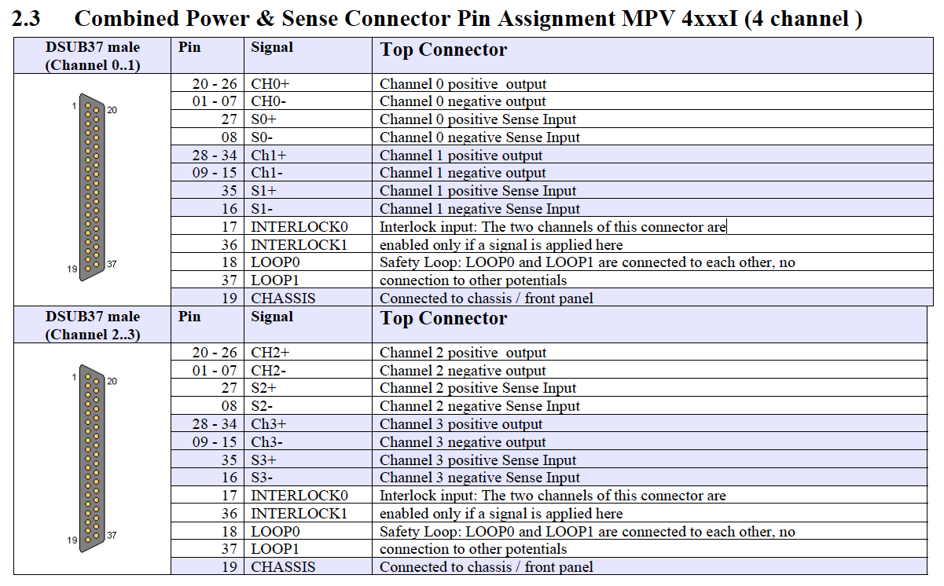
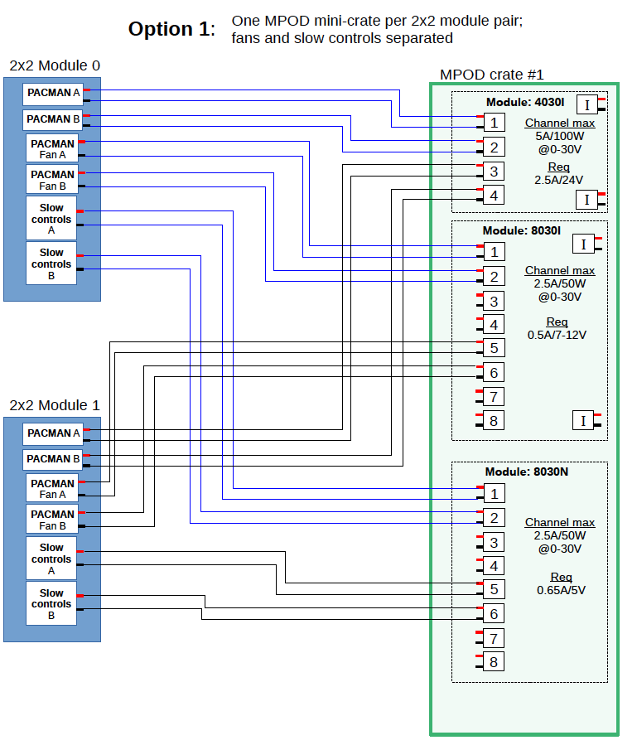
Power Requirements for 2x2 Cryogenic Equipment in MINOS
M. Zuckerbrot, Min Jeong Kim

Equipment Name | Electrical Rating and Power Consumption  (per each) | Quantity | Hardwire  Outlet | Power Service,  UPS/EPP  (Yes/No)
LAr Submersible Pump  (DUNE -doc-23112) | 208 V, 3 Ph., 15 A | 1 | Hardwire | Detector,  No
Vacuum Pumping Station  (DUNE -doc-23096) | 100-115 VAC, 50/60 Hz, 968 W§ | 1 | Outlet | Building,  Yes [EPP]
Cryocooler Compressors  (DUNE-doc-23090) | 440/480 VAC, 3 Ph., 60 Hz, 12.5 kW | 5 | *  (w/ disconnect) | Building,  Yes [EPP]
Water Chiller  (DUNE-doc-23093) | 460 V, 3 Ph., 60 Hz,  Minimum Circuit Ampacity: 45.76 A  Maximum Overcurrent Protection: 60 A | 1 | Hardwire  (w/ disconnect) | Building,  Yes [EPP]
Electric Vaporizer  (DUNE-doc-23106) | 480 VAC, 3 Ph., 50/60 Hz, 36 A, 30 kW | 1 | Hardwire  (w/ disconnect) | Building,  No
Trim Heaters | ~500W initial estimate from Cryomech | 1 | * | Building,  Yes [EPP]
Gas Analyzer | 120 V, 50/60Hz, 1.3A max (lower for 3 of 4), 200W max (lower for 3 of 4) | 4 | Outlet | Building,  Yes [UPS]
Vapor Pump (possibly) | 120V, 50/60Hz, 5.4 A max | 1 | Outlet | Building, No
Temporary Stuff  (e.g. Vacuum Pumps, etc.) | A few 110 VAC outlets | A few | Outlets | Building,  No
ODH Equipment (fans, louvers, heads, etc.) |  | A few |  | Building  Yes [UPS]
Cryogenics Control Rack  (DUNE-doc-21459) | 120 V, 30 A | 1 | Outlet | Building,  Yes [UPS]

Location

west
east
east
west
east
west
west
west
east
west
west
*No information/details available yet.
♣The maximum power consumption is 968 W, but this assumes that both the roughing pump and turbo are drawing as much current as they are able. In practice, it will be lower than this value, and in most cases, significantly lower.

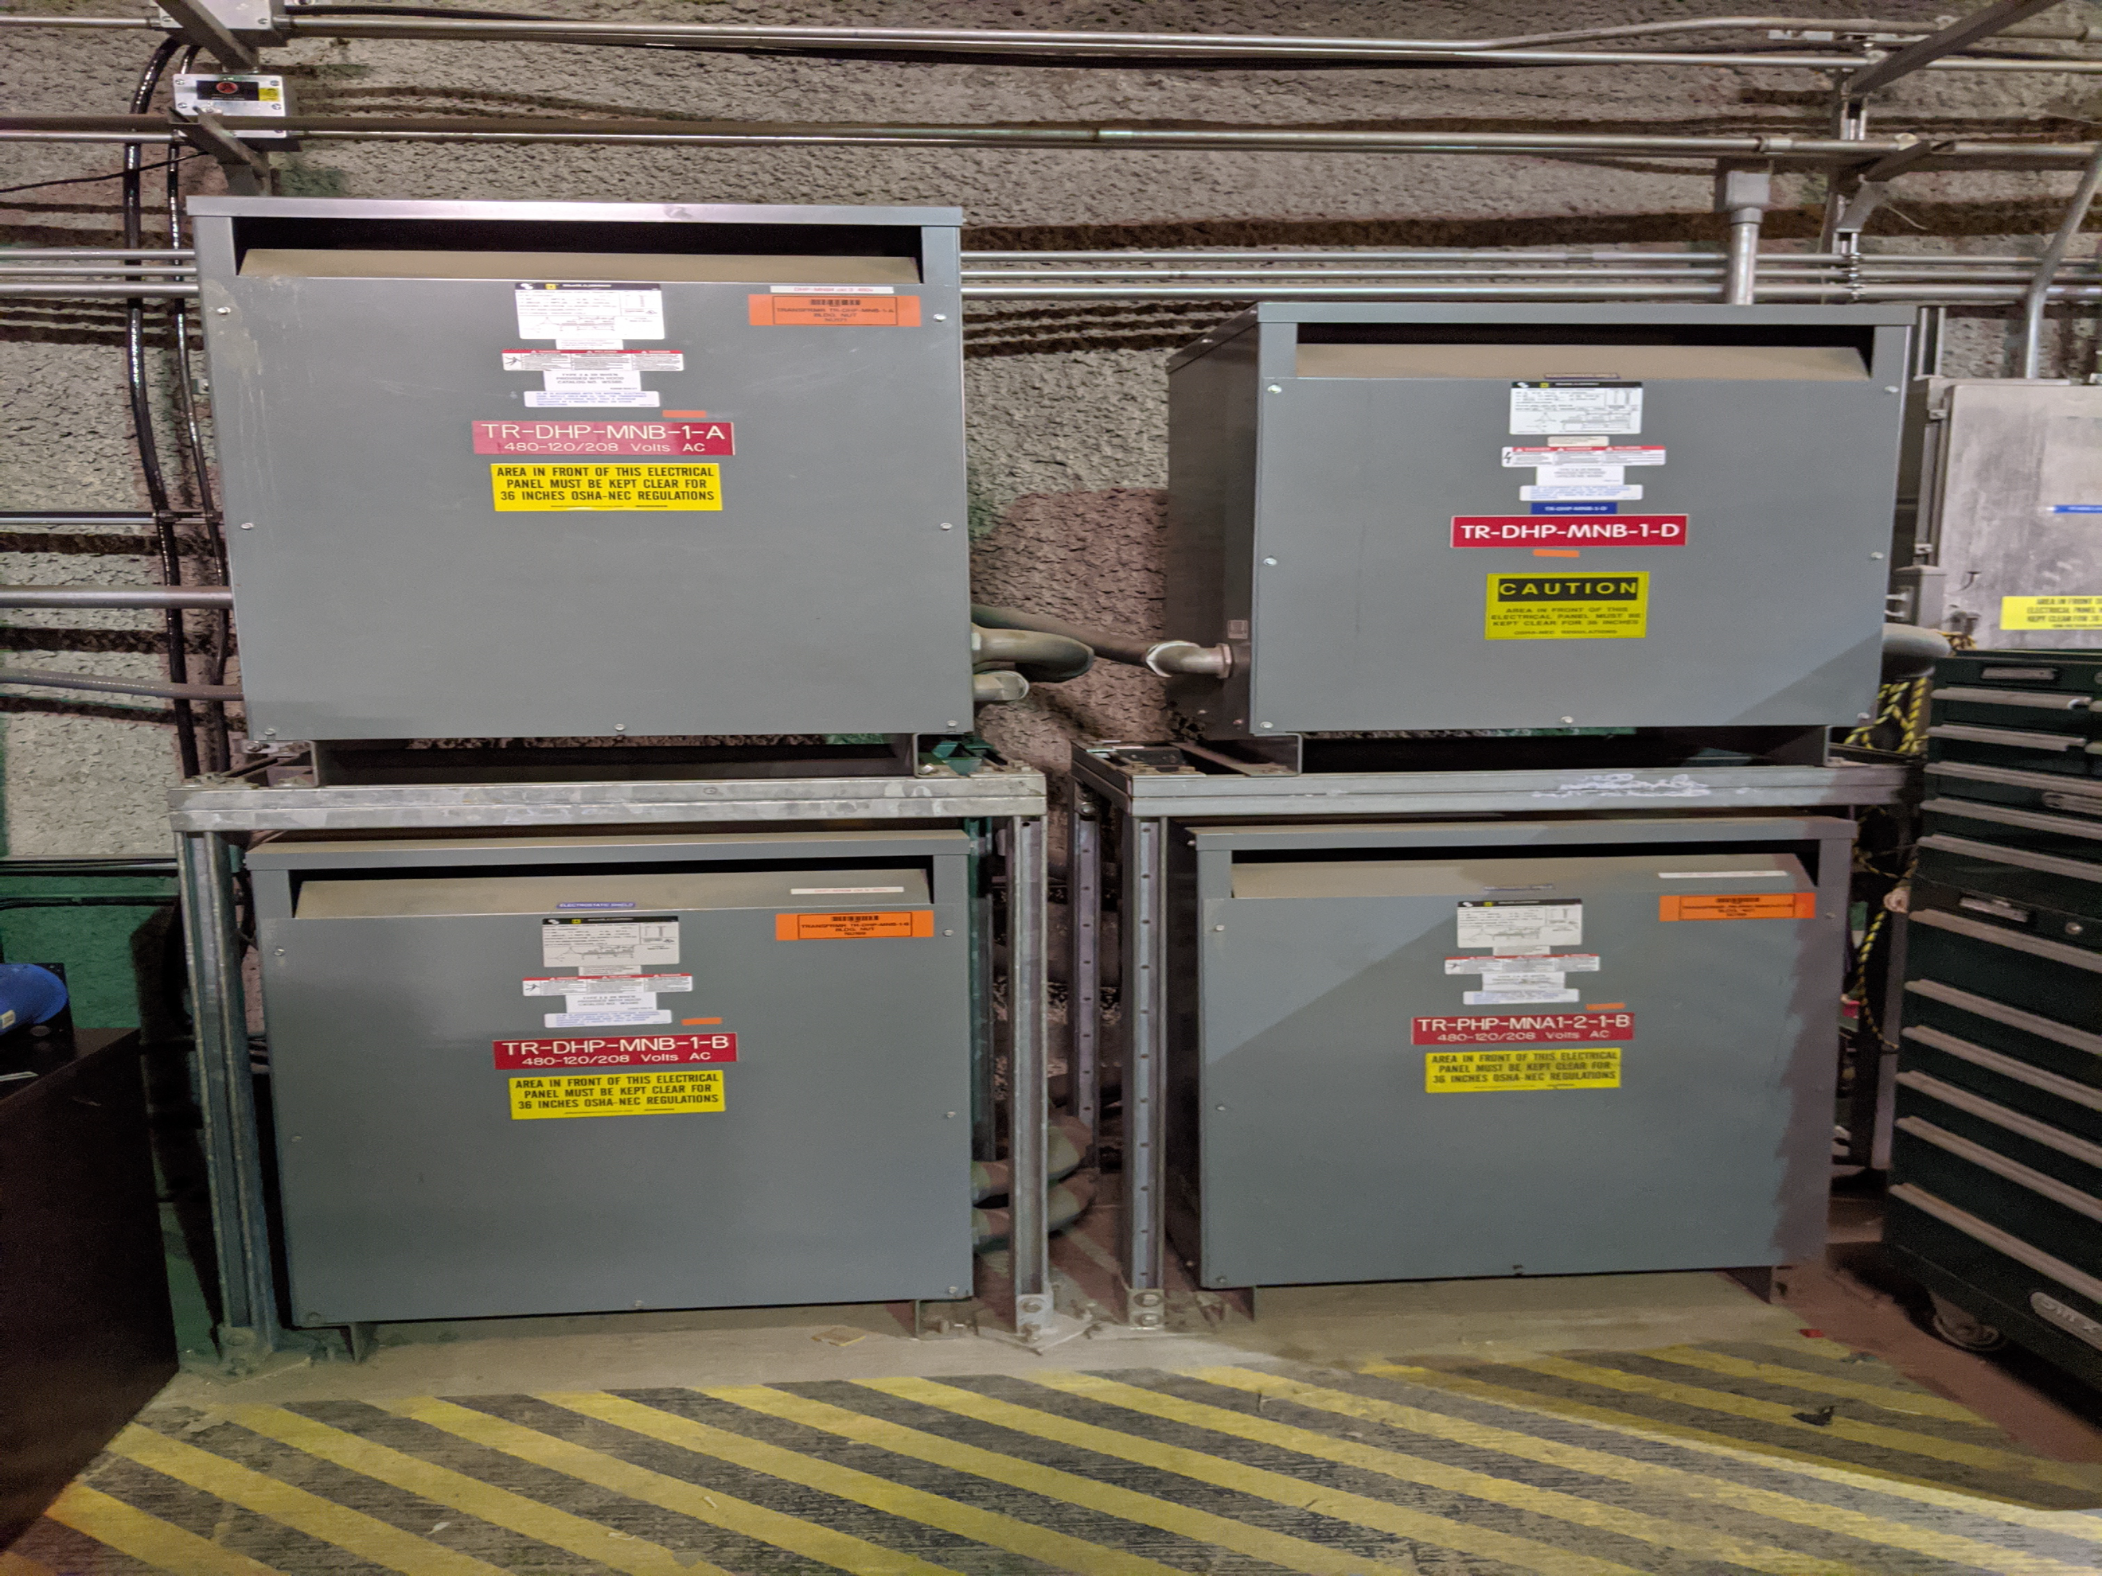
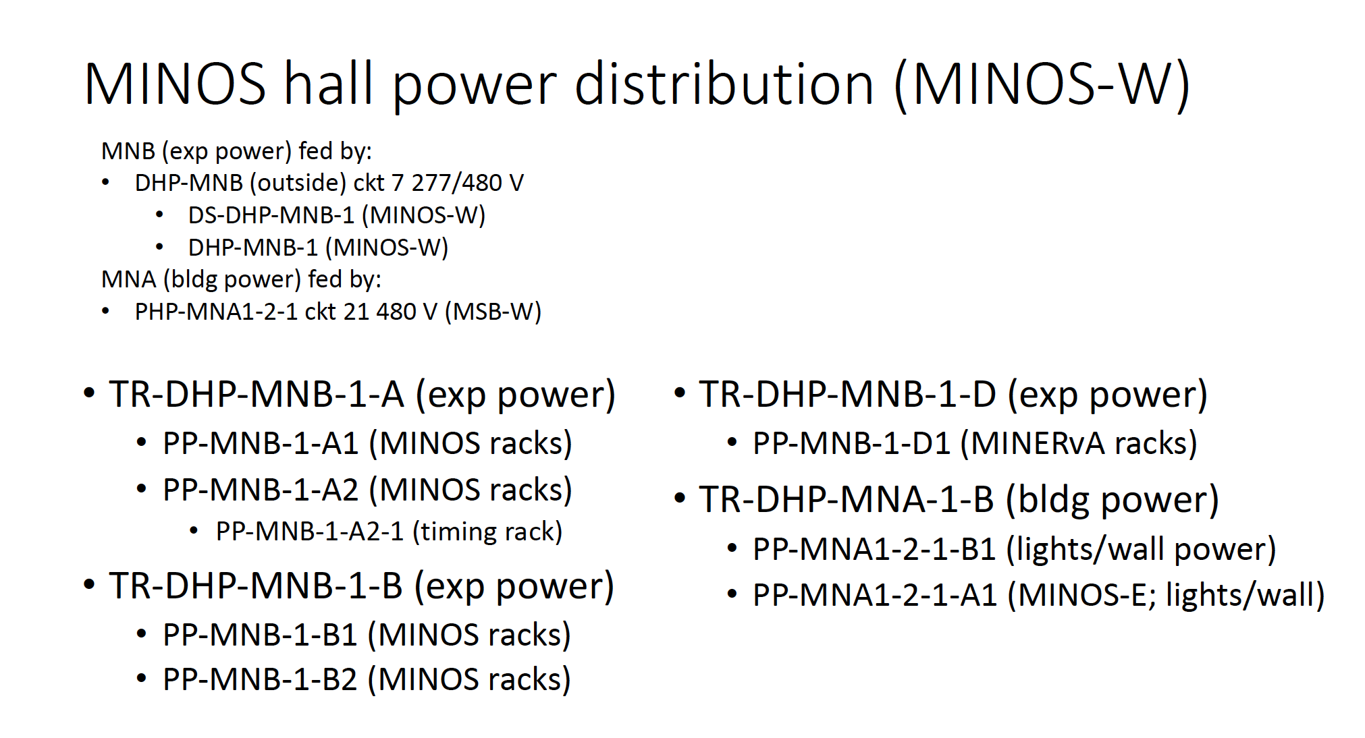

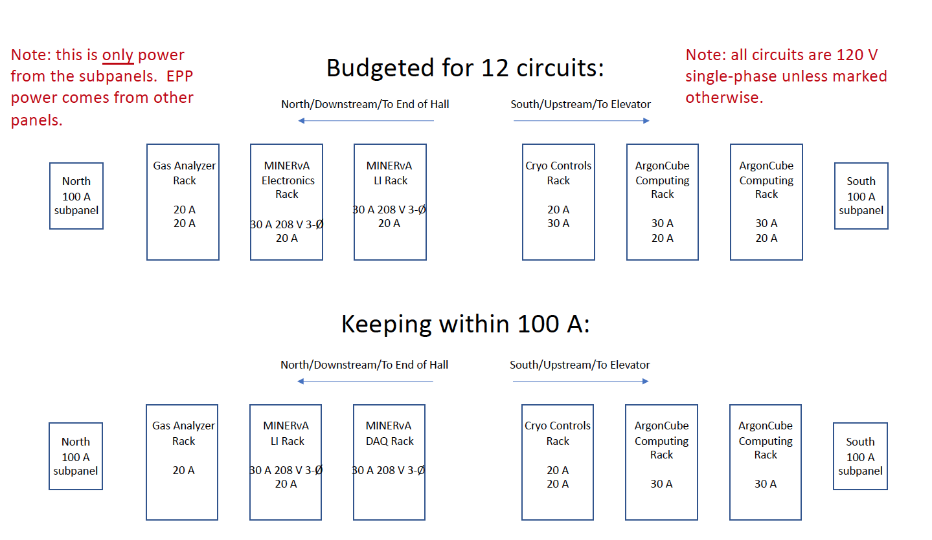
Power Requirements for 2x2 Cryogenic Equipment at LArTF
M. Zuckerbrot, Min Jeong Kim

Equipment Name | Electrical Rating and Power Consumption  (per each) | Quantity | Hardwire  Outlet | Power Service,  UPS/EPP  (Yes/No)
LAr Submersible Pump  (DUNE -doc-23112) | 208 V, 3 Ph., 15 A | 1 | Hardwire | Detector,  No
Vacuum Pumping Station  (DUNE -doc-23096) | 100-115 VAC, 50/60 Hz, 968 W§ | 1 | Outlet | Building,  No
Cryocooler Compressors  (DUNE-doc-23090) | 440/480 VAC, 3 Ph., 60 Hz, 12.5 kW | 3 | *  (w/ disconnect) | Building,  No
Water Chiller  (DUNE-doc-23093) | 460 V, 3 Ph., 60 Hz,  Minimum Circuit Ampacity: 45.76 A  Maximum Overcurrent Protection: 60 A | 1 | Hardwire  (w/ disconnect) | Building,  No
Electric Vaporizer  (DUNE-doc-23106) | 480 VAC, 3 Ph., 50/60 Hz, 36 A, 30 kW | 1 | Hardwire  (w/ disconnect) | Building,  No
Trim Heaters | ~500W initial estimate from Cryomech | 1 | * | Building,  No
Temporary Stuff  (e.g. Vacuum Pumps, etc.) | A few 110 VAC outlets | A few | Outlets | Building,  No
Cryogenics Control Rack  (DUNE-doc-21459) | 120 V, 30 A | 1 | Outlet | Building,  Yes [UPS]

*No information/details available yet.
♣The maximum power consumption is 968 W, but this assumes that both the roughing pump and turbo are drawing as much current as they are able. In practice, it will be lower than this value, and in most

