Present: Brian Drendel, Greg Vogel, Greg Brown, Al Franck, Carol Johnstone, Jim Budlong, Al Sondgertoth

Purpose: The purpose of this meeting was to outline getting controls to the g-2 and Mu2e experimental buildings, talk about the potential break in communication duct work caused by the M4 and g-2 line construction and the impact of this to controls in the Delivery ring and beam lines. Interruption of the existing cable duct could result in a sizable cost risk for the project. We also discussed radiation issues with the controls fiber optic cable that runs through the tunnel.

Background Material:

1. Interactive FESS Site Maps
   1. GIS viewer: <http://fessesri.fnal.gov:8080/FessViewer/index.html>
   2. FNAL Planning: <http://fessesri.fnal.gov:8080/Planning/index.html>
2. Network cable path: Here is a review of the photo tour taken by Brian Drendel and Greg Brown.
   1. Photo Tour by: <http://www-bdnew.fnal.gov/pbar/photos/Pbar-Web-Album/web-album/Systems%20and%20Accelerators/Controls/index.html>
   2. Summary of Pbar Photo tour
      1. We found the network enters the Rings on the Debuncher side above DQ18, near the center of the D20 arc.   There are four unlabeled penetrations; the 1000Base-LH/LX long haul multimode fiber optic network cable comes through the upper left penetration.  ~~It is believed, but not verified, that these penetrations go to the large concrete manhole in the road between AP30 and AP10 and then on to CUB.~~ The cable does not go through the large concrete well. Instead it goes through a manhole just to the east side of Booster Tower West.
      2. Incoming network then goes through the tunnel cable trays on the Debuncher side around to D10, where it goes upstairs via penetration D104-3, which is above D1Q5.  The network cable is nicely hidden behind a green coax near the center of the penetration.
      3. Once in AP-10, the network cable goes via cable trays over to the Accumulator side in rack B16R02.
      4. From B16R02, two orange plastic conduits go through penetration A104-2.   Inside of each conduit is 1000Base-Sx multimode fiber.
      5. The two orange plastic conduits enter the tunnel at penetration A104-2 about A:ISEP2.  One goes toward AP30 and the other toward AP50.
      6. Following the cable going to AP30, it travels around the Accumulator side via cable tray to penetration A203-7, which is above CMAG at the A30 stub.  Coming down that penetration is a second orange plastic conduit that heads toward AP50.
      7. Upstairs both network conduits go over to the Debuncher side at rack A33R07.
      8. Back in the tunnel, headed from AP30 to AP50, the orange plastic conduit goes through the cable tray on the Accumulator side.  There is a junction box above A3B7.
      9. When we get to the A50 experimental pit, the orange plastic conduit goes to cable tray along the ceiling in the center of the aisle.  There is another junction box in the middle of the aisle ceiling at A4Q2.
      10. At the other side of the pit, the orange plastic conduit goes back to the Accumulator side cable tray.
      11. The orange cables from AP10 and AP50 both go up penetration A500-1, just past the pit.
      12. Upstairs the both fiber connections go to AP50 counting room rack #20.
      13. Back in the tunnel headed from AP50 to AP10, the orange plastic conduit continues along the Accumulator side.  There is another junction box at A5B10.
      14. The orange plastic conduit continues on the Accumulator side back around to A104-2 where we started.
      15. Back upstairs at AP10, we can start to trace the network path to AP0.  From rack B16R02, yellow 10Base5 Thickwire cable goes through cable trays in the service building Accumulator side to the AP10 control room, where it goes to a patch panel in the top of rack B14R04, turns into black helix and disappears into the cable tray.
      16. A little more work will need to be done to trace the thickwire to AP0.  I think it goes to the Pbar/Muon rings to AP30 (maybe upstairs and back down) and on to AP0 via the transport enclosure.   The Thickwire goes to Rack 3 at AP0.

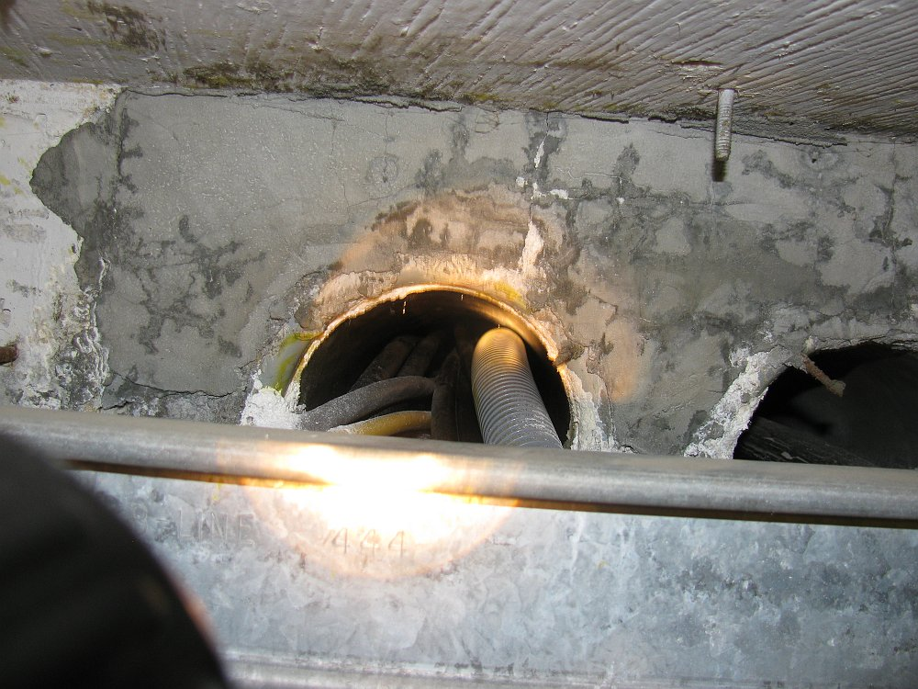

Figure 1: Four penetrations enter the Delivery Ring from CUB along the ceiling above DQ18, near the center of the D20 arc. Two penetrations are at ceiling level and two more approximately one foot lower.

1. Duct Path: The first issue is the existing communication duct path from the MAC Room to the Pbar/Muon complex.

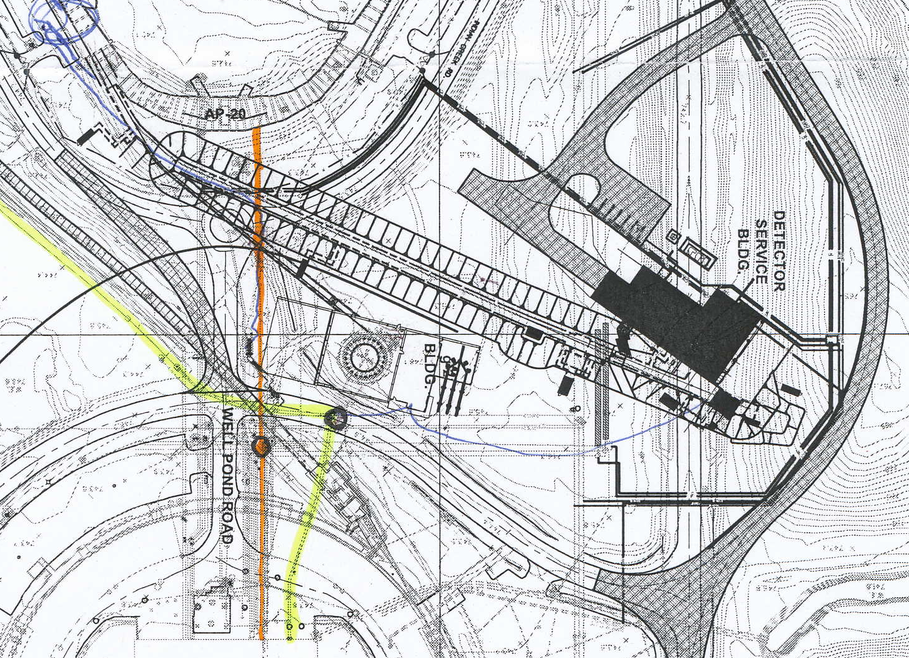

Figure 2: The Orange line is the current duct path from CUB to the Debuncher Tunnel. The Yellow line is the current communication duct path to MI. The two black circles are the communication duct manholes.

* 1. FESS’s initial plan is to support the communication duct in place when constructing the M4 and g-2 line enclosures.

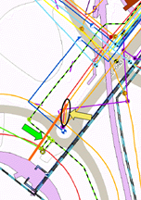

Figure 3: FESS Map is in error

* 1. But the FESS map appears to be in error (See figure 3). Their map shows the communications line (orange) coming from CUB, but going into the well (black circle and yellow arrow). Instead, the communication ducts continue straight (green arrow) to the Debuncher tunnel.
     1. This was verified by Greg Vogel and Rupe Crouch by pinging the cable duct with a metal detector.
     2. It is believed but not verified that the duct bank is PVC cased in a concrete bank.
     3. 18 heliax controls cables as well as one network fiber go through these ducts.
  2. There is concern that the construction of the M4 and g-2 lines will interfere with the communications duct.



Figure 4: Communications Duct (black with white text) in relation to M4 and g-2 enclosures.

* 1. Greg Vogel and Rupe Crouch pinged the duct bank depth. It measured 78” deep at the North edge of the Pbar road and 90” at the South edge (basically between the white letters c and t of the word “duct” in Figure 4. The duct that was being pinged was the bottom West duct at the CUB end.
  2. **Carol Johnstone will get elevation information to determine if this goes through the new tunnels.**

1. Controls Cable Plans: The big question is if the communications duct can remain intact. Until this question is answered, we need to consider two plans:
   1. Plan A: How to manage controls if the duct bank remains intact.
   2. Plan B: How to manage controls if the duct bank does not remain intact.
2. Phased plans: Limitations in funding may force us to implement enough controls in a phased plan.
   1. The g-2 experiment would turn on in FY’16. Beam losses in the Delivery Ring and extraction line are expected to be low as a result of the low intensity secondary beams that run through the enclosure. Existing controls network fiber optic cable will not as likely be impacted by this.
   2. The Mu2e experiment will turn on in FY’19. Beam losses in the Delivery Ring and extraction lines are expected to be higher due to the high intensity proton beam. We are assuming that losses may be equivalent to losses seen in the Booster. AP30 is the injection and extraction area and would be expected to be an area of high losses.
   3. If funding limits us to a phased implementation, we would first do whatever controls was necessary to get the controls operational for g-2 operational conditions, and later upgrade to a more robust system for Mu2e operations.
3. **Plan A: If the duct band remains intact**: Existing Accelerator Beam Line and Storage Rings controls costing has been written based on the assumption that the existing communication duct bank remains intact.
   1. Existing Camac, Links, and Network will not be interrupted to the existing service buildings. The task will be to get controls to the g-2 and Mu2e experimental buildings. The costing for this will be covered in Carol Johnstone’s extraction beam line controls BoE.
   2. New fiber optic cable from the MAC Room to the new experimental buildings will be run in one of two paths.
      1. Path #1: The shortest path is to run controls fiber optic cable via the MI-8 line communication duct (yellow line in Figure 2). The manhole, marked with a black dot, is very close to the g-2 service building at this point.
         1. We would need to verify that there is room in these duct banks for another cable run.
         2. We would need a new short run of cable duct from the manhole to the g-2 building.
         3. From the g-2 service building we would run through the penetrations to the M4 enclosure, along the M4 beam line, and to the Mu2e service building.
      2. Path #2: Using the existing CUB to Debuncher Rings duct bank (orange line on Figure 2).
         1. Run the controls fiber optic cable to the Debuncher Ring, in the tunnel back around toward AP30, around the corner into the M4 -> g-2 beam to the g-2 service building.
         2. From the g-2 service building we would run through the penetrations to the M4 enclosure, along the M4 beam line, and to the Mu2e service building.
      3. We will want to install rad hardened fiber optic cable. Greg Brown is getting estimates. Rad hardened cable can handle radiation levels up to 60MR (Mega-Rad).
   3. Controls in each experimental building will be completely run over the fiber optic cable.
      1. We can run Network, Recycler beam synch, TCLK, HRM and the Debuncher beam abort permit all over fiber.
      2. One VME crate Hot Rack Monitor (HRM) in each experimental building.
         1. Each HRM provides
            1. 64 channels of A/D
            2. 64 channels of digital I/O
            3. Eight 16 bit DAQ channels
            4. Eight 377 timing channels
            5. VME beam clock decoder card (RR beam synch)
         2. If more channels are needed, another HRM can be installed in the VME crate.
      3. No Camac would be run to the new buildings.
      4. The Debuncher beam permit signal will be would also be run over fiber back to the MAC room.
   4. For Mu2e operations, the existing tunnel fiber optic cable for the Network would need to be replaced with rad hardened fiber (See section 2.b above).
      1. The fiber coming to the tunnel from CUB runs along the Debuncher side from the D20 arc to AP10. A new rad hardened cable may need to be pulled to shield the network from losses (see section 2.b for a summary of the cable path).
      2. The existing building to building tunnel fiber runs in the tunnel on the Accumulator side, which gets it away from the losses.
      3. The rad hardened fiber could also be run through the enclosure, back through one of the transport enclosure branches back to AP0, an then to F23 and F27.
4. **Plan B: How to manage controls if the duct bank does not remain intact.** If the communications duct bank gets interrupted, there is a significant impact to not only bringing controls to the experimental buildings, but also the existing service buildings.
   1. If the cable duct is cut, the existing cable duct would need to be connected to the tunnel at the g-2 beam line (See Figure 4).
      1. **Controls (but not network) for Existing Buildings** (AP10, AP30,….): The 18 Heliax controls cables (Camac, links, etc..) could be spliced where they are cut, and run through the enclosure back up the g-2 line to AP30.
         1. There are no issues running the Heliax cable in a radiation environment.
         2. Beam abort permit uses existing Pbar Permit cables as outlined in the Storage Rings Controls BoE.
      2. The 1000Base-LH/LX long haul multimode fiber optic network cable cannot be spliced. Greg reports that it is too brittle.
         1. Rad hardened fiber optic cables would be run from the MAC room through the same cable duct bank (still orange line on Figure 2) until we get to the new g-2 tunnel.
         2. **Network Controls for Existing Buildings** (AP10, AP30, …_): When we get to the g-2 beam line tunnel, one fiber goes back toward AP30 where it would provide the network connection to the existing service buildings. Rad hardened fiber optic cables will be required in the radiation environment expected in the 30 straight section of the tunnel.
            1. Repeat the fiber optic cable replacement with rad hardened fiber covered in section 6.d.
         3. **Controls for Experimental Buildings:** Another fiber set would go down the g-2 beam line to the g-2 experimental building. From the g-2 service building we would run through the penetrations to the M4 enclosure, along the M4 beam line, and to the Mu2e service building.
            1. Repeat the g-2 and Mu2e service building control plans outlined in section 6.c. All controls will be run over fiber optic cable.
            2. We can run Network, Recycler beam synch, TCLK, HRM and the Debuncher beam abort permit all over fiber.
5. **Action Items!**
   1. Carol will gather tunnel elevation information to determine if the controls cable duct from CUB to the Delivery Ring can remain intact.
   2. Controls experts will provide cost (M&S and Labor) estimate to for the controls work.
      1. If the cable duct remains intact:
         1. The existing Accelerator BoEs don’t change much, with the exception of upgrading to rad hardened fiber optic cable
            1. We could add this additional cost into the BoEs?
            2. We could do this as a risk registry entry?
            3. We could do this as a phased implementation, where the rad hardened fiber does not get installed until Mu2e operations.
         2. New BoE will be written for extraction line controls
      2. If the cable duct does not remain intact:
         1. Existing Accelerator BoEs will need to be expanded to include the additional required upgrades.
         2. New BoE will be written for extraction line controls.
   3. Rough costing numbers, enough to write the BoEs, really need to be available on the order of a week.
6. Duct Bank Geometry Information:
   1. Figure 5 below shows the relative spacing between the extraction enclosures and the communication duct bank.
   2. Greg Vogel and Rupe Crouch measured the duct bank depth to be
      1. 78” (6.5’) at the red dot
      2. 90” (7.5’) at the purple dot
      3. 95” just beyond the green dot
      4. Assuming the road is level, this gives the duct bank a 1.4° downward trajectory to the Pbar/Muon tunnel.
   3. Carol provided the following elevation information
      1. The road runs between 743.5 and 746.3'
      2. Top of the Mu2e enclosure at 736.5.
      3. The top of the PBAR enclosure is 734' so the penetrations come into the Debuncher enclosure around 732' - the ducts must be inclined downward.

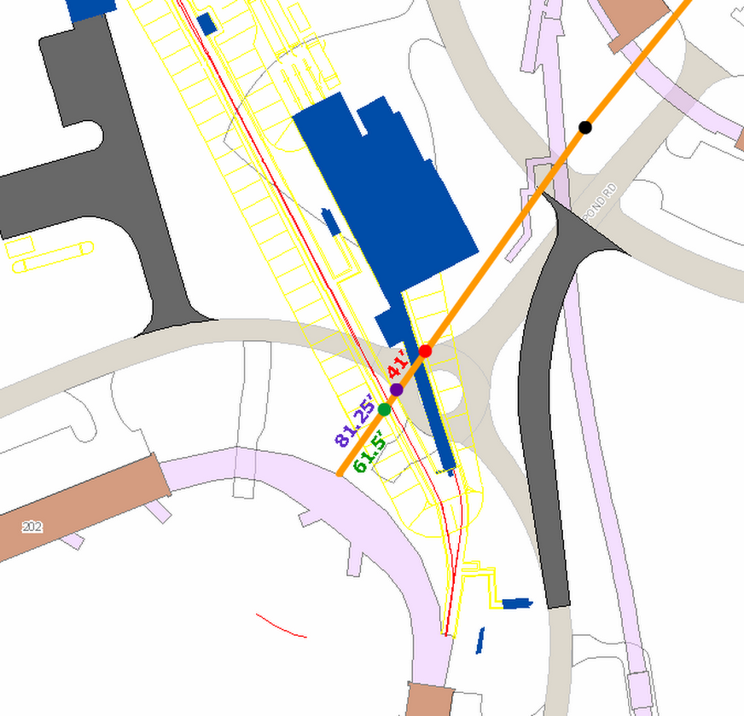

Figure 5: Communications Duct band in relation to Mu2e and g-2 Enclosures

* 1. A little simple trigonometry gives us
     1. 3’ drop of red dot to rings enclosure
     2. 2’ drop from purple dot to rings enclosure
     3. 1.5’ drop from green dot to rings enclosure.
  2. Mu2e Enclosure 2’ above Pbar Enclosure > 1.5’ rise between Pbar and Mu2e enclosures.
     1. It appears the duct bank will be cut by the addition of the Mu2e enclosure.

1. References:
   1. Storage Rings Controls BoE (Mu2e Doc #1468)
   2. Beam Line Controls BoE (Mu2e Doc #1572)
   3. Machine Protection – Beam Abort permit BoE (Mu2e Doc 1639)