Physics Education Meeting
Tuesday, April 5, 2022
1:00 PM –
Attended: Randal Ruchti, Sijbrand de Jong, David DeMuth, Vetri Velan, Steven Goldfarb, Olivia Bitter, Sudhir Malik, Tiffany Lewis, Kenneth Cecire, Kétévi Assamagan, Daria Wang

Summary:
- Final status of CPs: 3 have been submitted, waiting for 1.
  - Particle Physics Specific Education CP update: the paper is coming together well. Almost at a complete first draft. Would appreciate feedback from CEF4 conveners. Action item: Vetri will conveners know via email when the complete draft is ready for review.
- CEF4 TG report is in progress. CEF4 conveners are currently working on it. Once the first draft is ready, comments will be welcome. Goal is roughly one page per each CP + overview, introduction, summary, bibliography.
- CEF TG Convener meeting from April 1
  - Timeline ahead for Snowmass Documentation Preparations
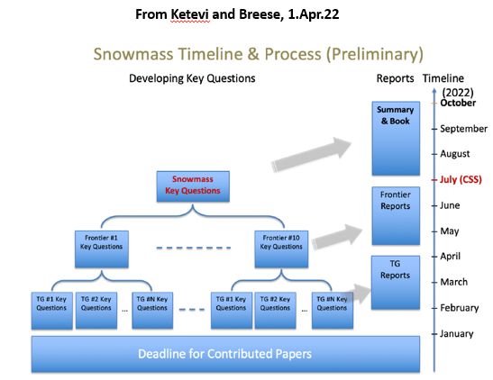
  - CEF Workshop (now fully online) 24-26.May.22: Will be discussing various reports from TGs. The workshop is CEF-wide. Action item: Please, register for the workshop: https://indico.fnal.gov/event/52461/
  - Request for ideas for Community Engagement at the Snowmass CSS Meeting in Seattle, July.22
  - CEF4 Contributions to the meeting - potential template for TG Reports in Overleaf to be used by all TGs: https://www.overleaf.com/project/623f4646a6bd6458eb0c0095
  - APS Innovation Fund preproposal submission and community-wide opportunity it represents. If accepted, full proposal would have to be written. Motivation coming from CPD group, theme is to set up networking platform for non-academic jobs, can also be used as a platform for CEF if we expand it. Other frontiers have natural progression. This platform will make Community Engagement a continuous process.
- Snowmass Accessibility Survey
  - Dear Snowmass Enthusiasts! We are extending the deadline for the updated Accessibility Survey an additional two weeks. If you haven’t done so already, please fill out the short survey below by April 15th. This anonymous survey is vitally important to the high energy community and its aggregated results will be included in the final version of Accessibility in High Energy Physics: Lessons from the Snowmass Process. The current version of the paper can be found on arXiv: https://arxiv.org/abs/2203.08748
    - https://forms.gle/xBhtfxB4ye8rPuBi6
- Developing Ideas for Community Engagement at the Snowmass CSS in Seattle, 17-27.Jul.22 (see PPT slides 5-13 for more details)
  - Career Fair (CPD TG is discussing this event)
  - Physics Slam (QuarkNet?)
    - Quarknet Coding camp at UW at the same time as CSS. Quarknet could use this as an opportunity. Could invite them to Physics Slam or public lectures, participate in workshops etc.
  - Outreach & Public Engagement
  - Snowmass Outreach Program Proposal
  - Inreach
  - Accessibility
  - Public Lecture
  - Poster Session (what is the scope of this session? – Ketevi will find out)
  - Diversity, Equity, Inclusion, Climate
- CEF involvement is expected during CSS. Kétévi will be sharing more information shortly.

