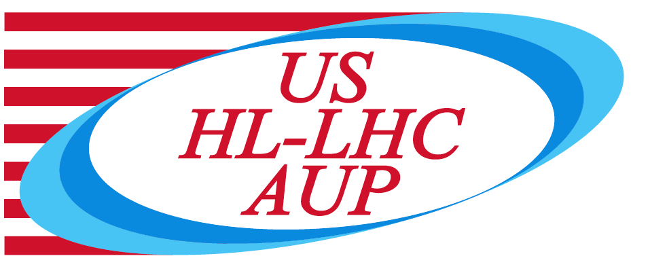

U.S. HL-LHC Accelerator Upgrade Project

CM01 Longitudinal Welding Readiness Mini Review

TABLE OF CONTENTS

1. Goal and Scope 3
2. Charges 3
3. Technical Information 3

Goal and Scope

This review is a limited review, and it is intended to evaluate the readiness status for the longitudinal welding.

We have already conducted a pre-series production readiness review about a year and half ago and this review is not intended to replace that review. Since then, however there was a change in the interface requirements by the magnet group namely it has been requested to lower the prestress that the SS shell is providing on the magnets. This new requirement change has initiated a change in the design and imposed a quite tight tolerance values on the fabrication process.

The design change has been internally reviewed by series of meetings in the fall and it was outlined how to proceed with the fabrication. This mini review is not intended to revisit this part, it will focus on the fabrication process to assure that the status of the fabrication and additional tests and measurement results are adequate that after the welding is complete the CM will satisfy the new requirement.

Charges

The committee is requested to answer the following questions:

- Evaluate the readiness of the CM fabrication for performing the longitudinal welding the SS shells onto the magnets.
  - Are the shell dimension and weld shrinkage measurements being adequate not to overstress the magnets?
  - Are the shipping requirements induced specifications are addressed correctly by the fabrication process?
  - Are the weld qualification values so far acquired fulfill the code requirements?
  - Raise any other concerns that might arise during the review.

Technical Information

Committee
Thomas Page (FNAL), chairperson
Michael Anerella (BNL)
Thomas Nicol (FNAL)

Date and Time
March 11, 2022, starting at 12:30 / 14:30 /15:30 (LBNL/FNAL/BNL)

Location/Connection
Video-link by Zoom, info by email.

Link to agenda with talks and other documents:
CM01 Longitudinal welding readiness mini review (March 11, 2022) · INDICO-FNAL (Indico)

