Image Analysis Capabilities and Methodologies of Nb₃Sn Rutherford Cables

A. Baskys, I. Pong IEEE senior member, C. Sanabria, and E. M. Lee

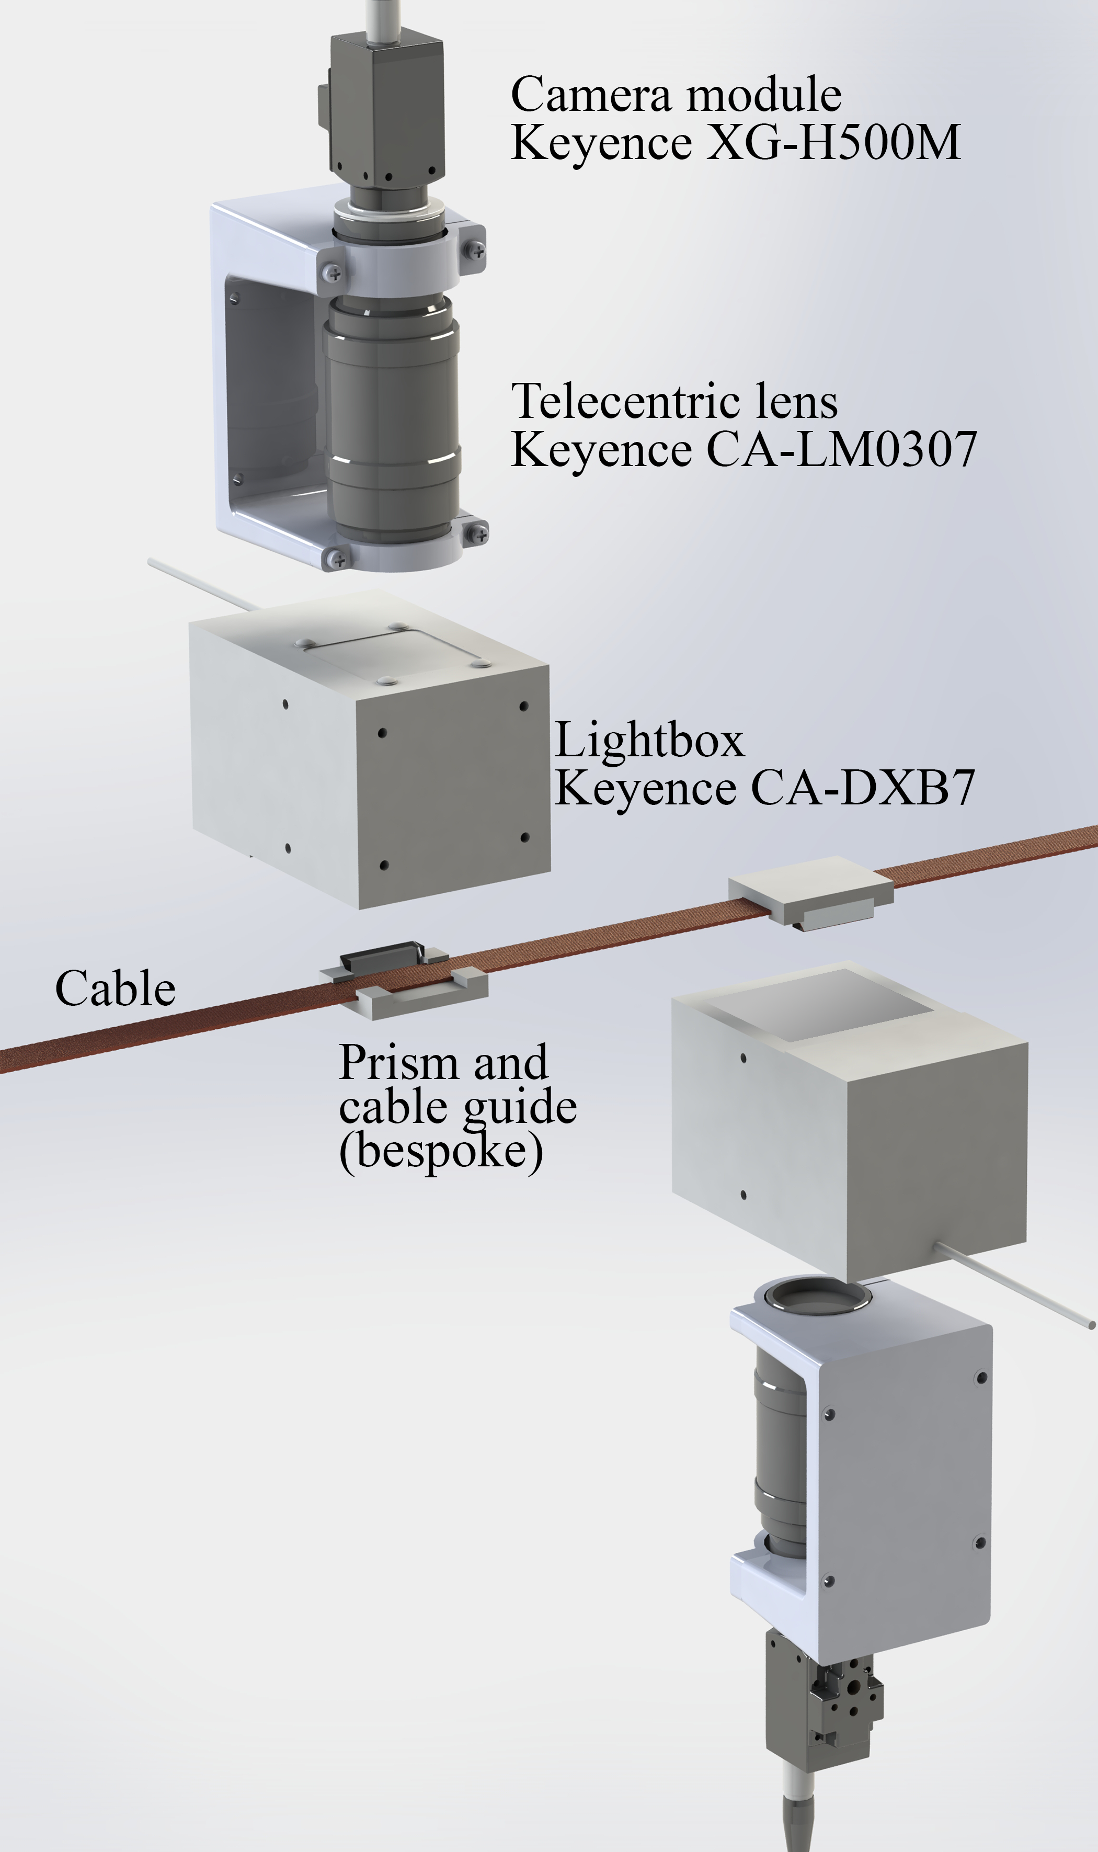
Fig. 1. The overview of the in-line cable imaging system, which comprises two sets of imaging assemblies each imaging one cable face and one cable edge. Each assembly consists of a camera module, a telecentric lens assembly, a light box and a cable guide with a prism. Image capture and storage is handled by the Keyence XG-8702P Image processing system.

Abstract— The unique Rutherford cabling facility at the Berkeley Center for Magnet Technology, LBNL, has been leading the production of a range of Nb₃Sn cables for a variety of magnet projects domestically and internationally. Cable fabrication is a critical step in accelerator magnet production: to ensure tight dimensional control of the multi-turn coils, fine tolerances must be kept on the cable width, thickness, keystone angle [1] with minimal degradation to the conductor. In addition to these dimensional measurements, we implemented an in-line image acquisition system that can monitor for critical defects such as cross-overs, as well as track the extent of strand deformation at the cable edges. At LBNL, we have collected a large dataset to establish the association between the cable edge facet dimension and the cross-sectional subelement damages. We thus can use image analysis on the facet as an integral and critical quick turn-around-time quality control monitor. Although such measurements are not direct and require a baseline for a given conductor and cable geometry combination, they are non-destructive. They can be measured across the entire length of the cable, which contrasts with critical current or residual resistance ratio measurements, which are only made at the point and tail of the cable and require a lengthy heat-treatment.
Moreover, the high frequency of image acquisition coupled with Fast Fourier Transform analysis can give us insights into the key components of the cabling machine as they tend to produce periodic variations within the cable. Such analysis can help find potential faults and inform maintenance planning. This work describes our setup of in-line imaging of Rutherford cables during manufacture, the subsequent image analysis, and data processing. Several case studies illustrate typical usage of the system and lessons learned.
Index Terms— Nb₃Sn wire, cables and current leads, superconducting magnets, image analysis.

Introduction
C
abling is an important aspect of accelerator magnet production. The superconducting Nb-Ti or Nb₃Sn wire along with Rutherford cable manufacturing constitutes a considerable part of the financial, labor and time cost of magnet production process [2]. For this reason, strict process control as well as rigorous post-production QC is required. Most of the post-production analysis can only be done on the point or tail of the cable as it involves sampling the cable for destructive testing, such as metallographic sectioning, residual twist, cable 10-stack thickness, critical current and residual resistance ratio measurements. These tests do not indicate if there is any variation in the said parameters along the length of cable. The cable dimensions (width, thickness, and keystone angle) are measured every 1 m by a machine that clamps a length of 15.2 cm at a set pressure and holds for a set duration, however the specific strands within the cable sections that are clamped and measured (and the corresponding strands’ deformation by the Turkshead rollers) may change even if the overall cable dimensions do not appear to be different. This may lead to superconducting performance variation along the cable which may not be observed in cable test pieces and in extracted strands taken from the ends of the cable. However, changes in the strand configuration in the cable could be revealed by changes in the cable edge facet size and strand compaction across the broad face of the cable. For this reason, the in-line cable imaging system and subsequent analysis forms an integral part of Rutherford cable fabrication quality control at LBNL.
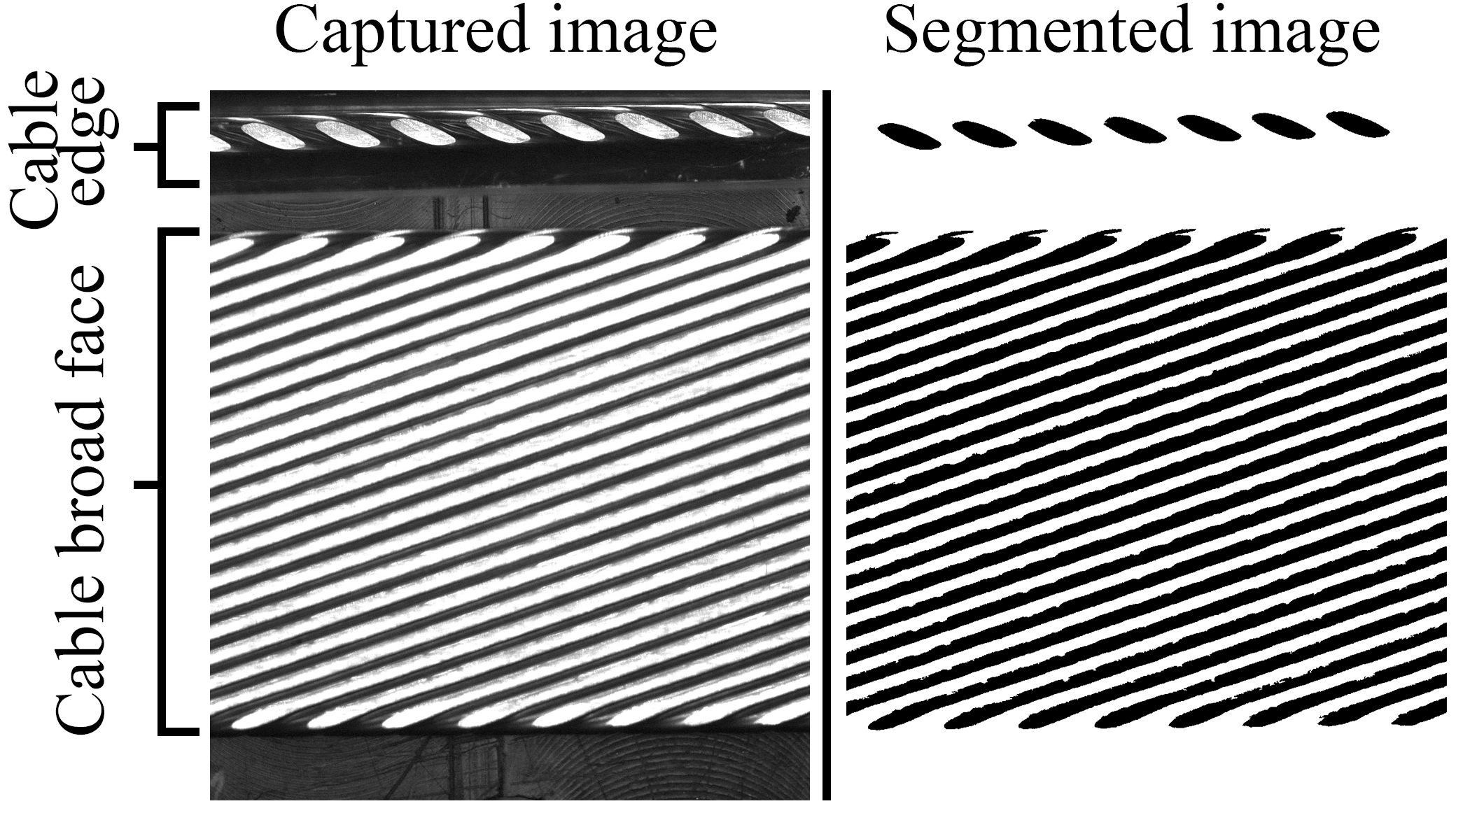
Fig. 2. Representative image of a Rutherford Cable obtained by the cable imaging system. Image of the cable edge is obtained through a prism. The segmented image (showing only the features of the cable) is then used for analysis.

Methods

Image acquisition system
The overview of the image acquisition system is depicted in Fig. 1. The system comprises two Keyence XG-H500M monochromatic camera assemblies each of which takes images of one cable face and one cable edge. The 5-megapixel CCD camera modules are paired with CA-LM0307 telecentric macro zoom lenses (image dimensions do not change with changing object to lens distance). The cable is imaged through a CA-DXB7 blue coaxial LED lightbox which introduces co-axial illumination using a half-mirror at 45-degree angle to both the light source and the lens axis. Directional illumination (as opposed to diffuse illumination) is used to enhance the contrast of flat reflective faces of the compacted strands. For reference, the images Fig. 4b and Fig. 4c were imaged using diffuse and directional light respectively. Lastly, the cable edge facets are imaged using prisms that reflect the image toward the camera and eliminate the need for two additional cameras. The prisms are affixed to the cable guides that maintain the cable in the field of view of the cameras.
The field of view of the cameras can be adjusted and is typically about 2 cm. The rate of image acquisition, which is triggered by an encoder that tracks the length of the cable passing though the imaging system, is set such that the cable is imaged on all four sides throughout its entire length with a small amount of overlap. At a typical cable production rate of ~3 m/min, every second each camera takes ~2.5 images, all of which are saved to a network-attached storage. For a typical 470 m MQXFA cable production, ~60 GB of images are collected for off-line analysis.

Image analysis
The rate of image acquisition during the cabling run is typically too fast to be fully analyzed in real-time by our system which was acquired in 2013. Therefore, the images are analyzed off-line using scripts, initially written in FIJI/ImageJ by Sanabria and modified by Lee, later written in Python, utilizing the NumPy and SciPy libraries and the SciPy Toolkits SciKit-image and SciKit-learn by Baskys. With increasingly powerful commercial computer processors and improved scripts over the years, the analysis duration has shrunk by an order of magnitude. Today, when the image analysis is parallelized across all available cores in a standard 10-core desktop workstation, it takes around 4 hours to complete the analysis (of an MQXFA cable which takes ~2.5 hours to fabricate), with ample further optimization possible.
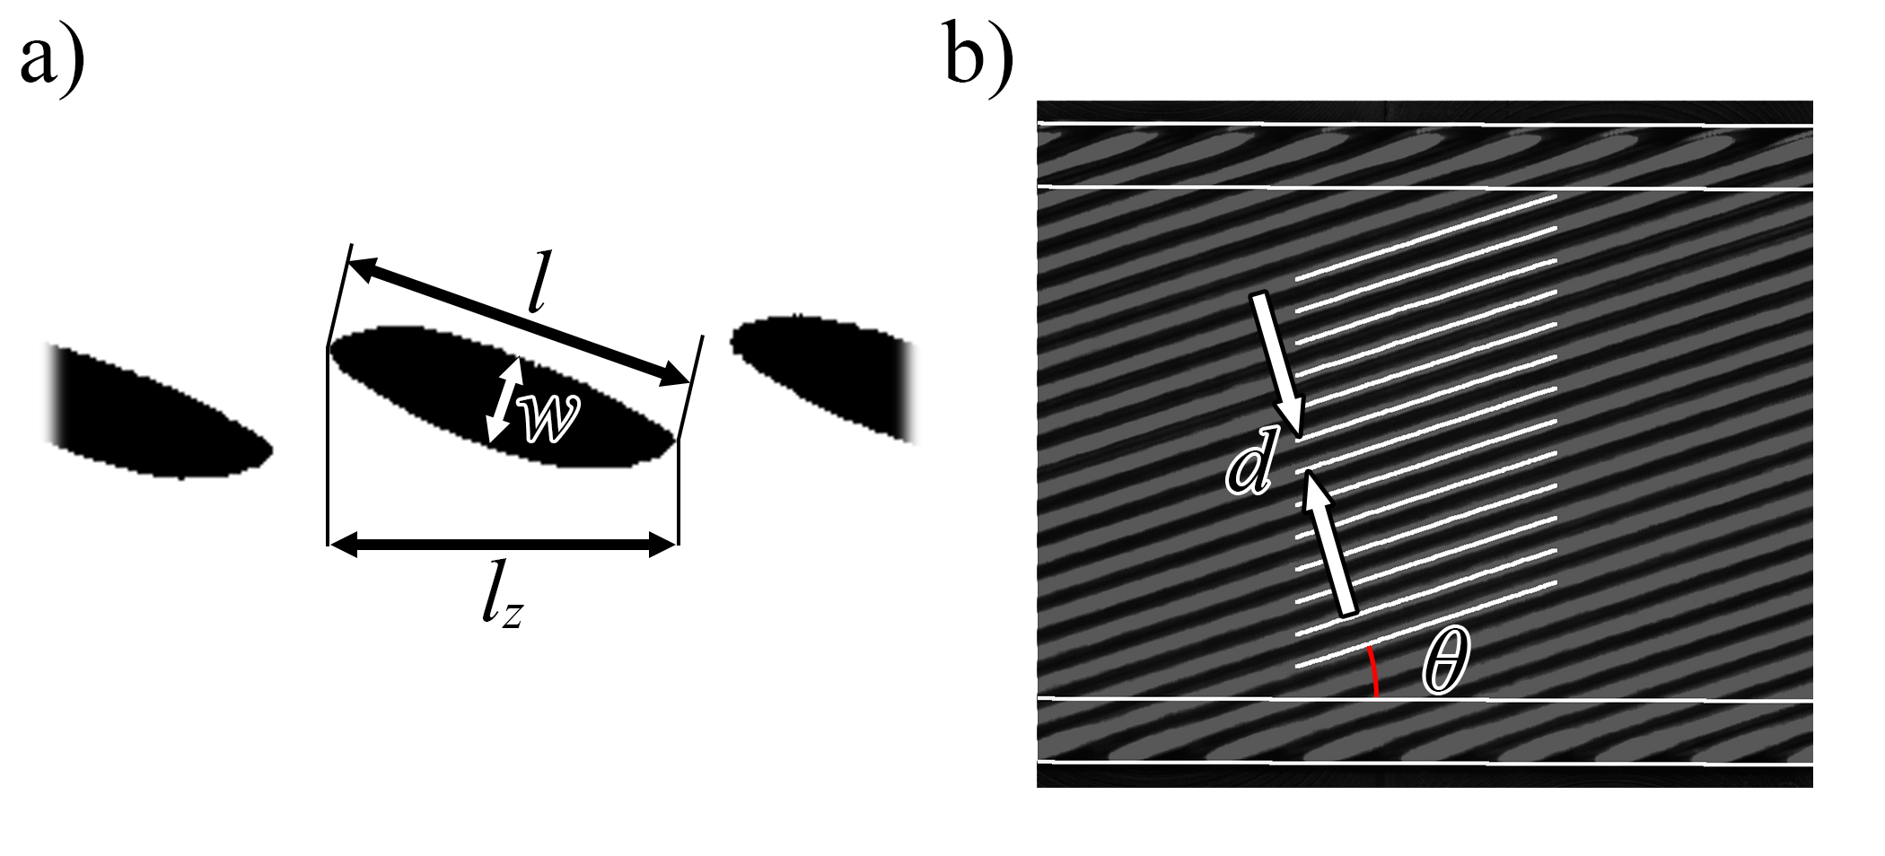
Fig. 3. Parameters typically measured using the data from cable imaging system: a) cable edge facet dimensions (length l, width w and length along cable direction l_{z}) and b) cable face image is used to calculate strand-to-strand dimensions d as well as cable half-pitch angle θ and length.
The acquired images are segmented, isolating the flattened strand faces of the Rutherford cable (Fig. 2). From there, two separate analyses are performed on the cable broad face and cable edge images.
Broad face images are used for cable twist pitch analysis as well as strand-to-strand distance measurement. The cable twist pitch is set by the combination of rotation of the cabling machine bay and the caterpuller which controls how fast the cable travels out of the Turkshead aperture during steady state production [3]. The bay and the caterpuller are mechanically linked by a gear system. However, the cable twist pitch may be unevenly distributed between the top and bottom faces as indicated in section III.D. Strand-to-strand distance indicates how tightly the strands pack on each of the cable faces. Changes in strand-to-strand distance may indicate gaps forming on the cable faces and may be precursor to crossover defects.
In the segmented image of the cable face, the edges of the cable are found utilizing Hough line transform [4]. The edges of the cable are marked and the cable angle with respect to the image frame is determined. Margin of the cable (nominally 10% of the cable width from both edges) is excluded from the analysis as wires in the cable margins already have some lateral curvature. The segmented region of the wires within the margins and in the central region of the cable are skeletonized (Fig. 3b). Their mean angle (and therefore the twist-pitch) and mean strand-to-strand distance are calculated. At this point the overall cable angle is subtracted from the wire angle to compensate for cable alignment within the frame.
Images of the cable edges are also analyzed to determine the wire facet sizes (Fig. 3a, the dimensions of the flattened strand at the cable edge). The facet sizes are indicative of the amount of strand deformation at the cable edge which in turn is indicative of the subelement diffusion barrier rupture (a.k.a. “shearing”) frequency in internal tin distributed barrier type Nb₃Sn wire that can lead to degradation of superconducting properties such as Residual Resistance Ratio (RRR) and critical current I_{c}. The width and the length of the facets, measured as the major and minor axes' length of a best-fit ellipse, are measured and the average is recorded. The facet length along the cable direction is also measured and the average is recorded. The measurements are calibrated using a microscope calibration slide.
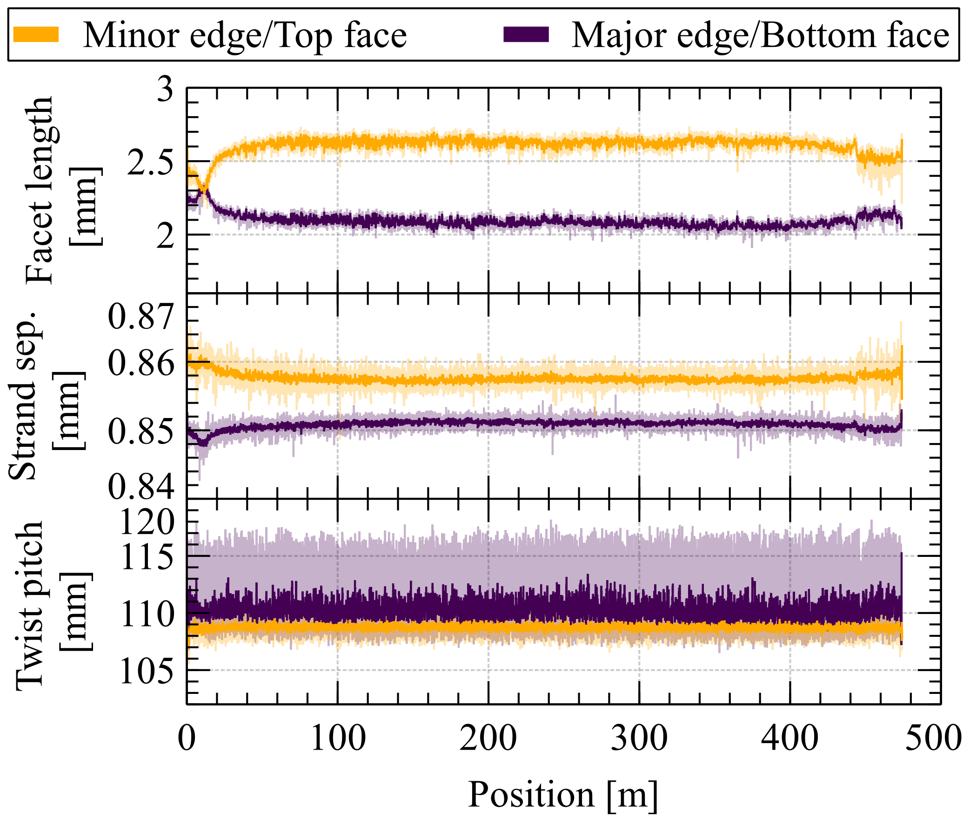
Fig. 5. Typical dataset with stable cable parameters after initial transient. The darker lines are running averages over 20 cm window. Cable ID: P43OL1196.
In addition to the standard measurements, additional subroutines are tasked with detecting specific defects: cross-over strands [5], popped strands and irregular gaps in the cable's broad face (see Fig. 4). This is achieved by inspecting the periodicity of gaps between wires in the segmented image. Defects such as cross-over strands would interrupt the periodicity in the gaps seen in the segmented image of the cable face. Likewise, if a defect is seen at the cable edge, it typically results in extreme facet dimensions and in reduced number of facets seen in an image. The script flags any images with suspected defects, which are then confirmed manually.
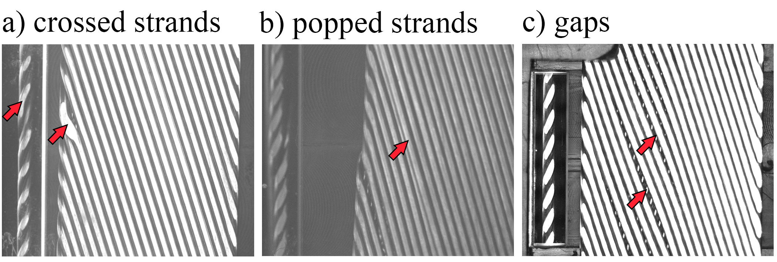
Fig. 4. Three examples of types of defects that are flagged by the image analysis: a) cross-overs – where two adjacent strands swap positions; b) popped strands where a strand is dislodged from its position vertically; c) irregular gaps in the cable face, revealing the cable face below. Figures a) and b) were imaged using diffuse lighting, figure c) - using directional lighting.

Results and Discussion

Typical dataset from a cabling run
A typical dataset collected during cable manufacture for MQXFA magnets [6] is shown in Fig. 5. It can be noted that all cable parameters, after the initial transient, remain stable during the cabling production run, which is the desired outcome. However, this is not always the case and especially during new cable development or in the case of equipment failure or setup issues. In instances such as these, the data from the cable imaging system can be an invaluable resource for troubleshooting. The following sections illustrate this in several examples.

Case study I: uneven strand tension
Prior to a full production run, a startup run is performed where several meters of the cable are manufactured and QC performed, such as cable dimensions measurements, residual twist, metallographic inspection, and image analysis of the cable segment. In this example of an MQXFA cable P43OL1187 startup, a large periodic oscillation was observed in the facet size analysis (section II.B). The magnitude of the variation of up to 0.5 mm is much higher than observed typically (see Fig. 6, cf. Fig. 5). The periodicity in the facet size corresponds to the cable twist-pitch and it was correlated with incorrect strand tension (~10% deviation) in just one of 40 strands on the cabling machine. This illustrates both the superb sensitivity of the technique as well as the large impact of the strand tension imbalance to the cable geometry. Load-cell based cable tension monitoring system installed on the Turkshead does not have enough sensitivity in this case to reliably show 0.25% change in the overall tension. The fault in strand tension was corrected before the cabling run, which was successful.

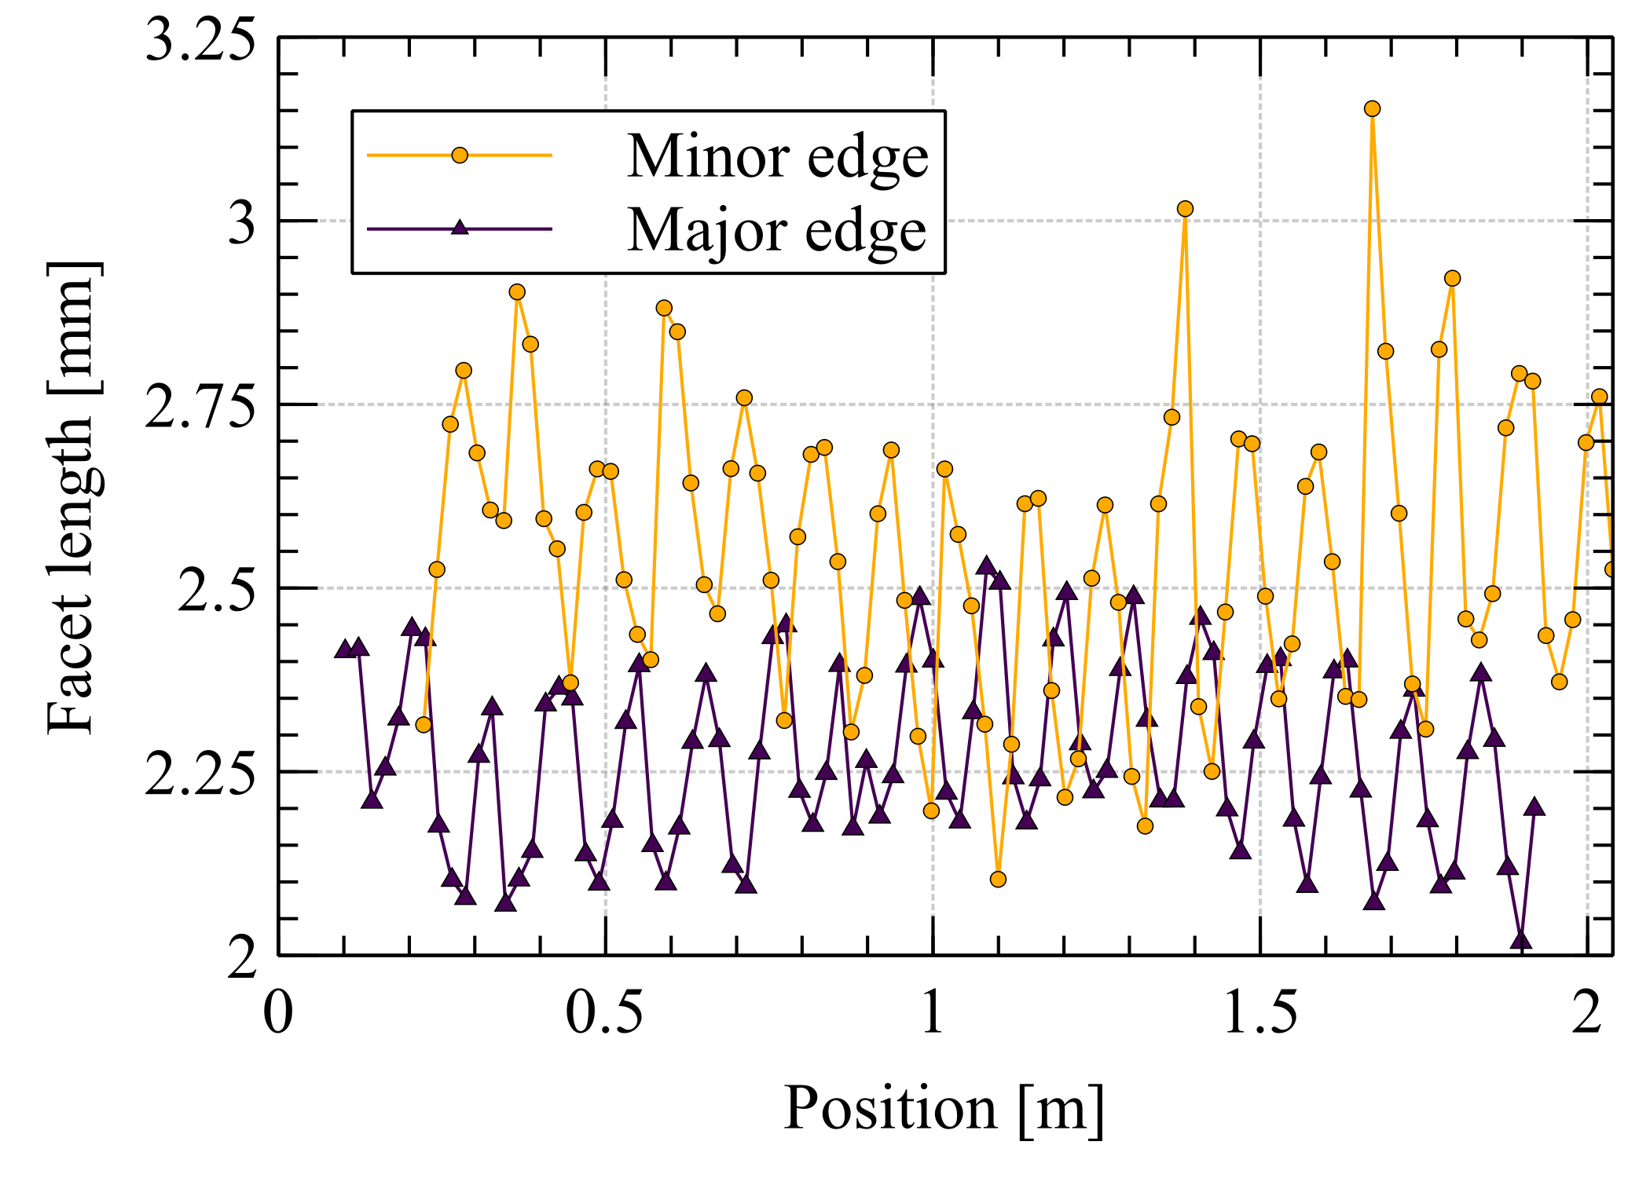
Fig. 6. Large variation in cable edge facet sizes at a period of one twist-pitch observed during a cable startup run of cable P43OL1187. The variation was traced to one strand having incorrect tension.

Case study II: lubrication change
A majority of MQXFA [1], [7] cabling runs at LBNL exhibit a mild change in facet size at the beginning of cable production and recovery at the end of the cabling run. The reason for this change is not completely understood but is believed to be a combination of tribological conditions at the Turkshead, power supplied to the Turkshead rollers, and cable tension. The facet dimensions are not typically a part of cable specification, but as the facet size is an indicator of the amount of plastic deformation in the strand, it may affect the number of sheared subelements, RRR and I_{c} which are a part of the cable specification. A separate study [8] has shown that MQXFA cable samples with average minor edge facet length of the best-fit ellipse of 3 mm (corresponding to ~2.7 mm of facet length in the cable direction, or limit of overlapping facets in a 40-strand cable with a 109 mm pitch length) and maximum facet length 10% longer still exceed the minimum RRR specification with ample margin and stay comfortably below the upper limit of sheared subelements in cable cross-sections. Therefore, the typical facet size variation observed during cabling is normally of little concern. Nevertheless, understanding of the reasons for the variation is important for cabling research and development, and it may be critical when cabling more deformation sensitive strands such as powder-in-tube PIT conductors [9]. Cable imaging is a well-suited tool for such investigation.
During an MQXFA cabling run designated P43OL1174, a facet change, or divergence was observed. After about 200 m of cable was produced, the lubricant pump which dispenses a vanishing lubricant on to the cabling mandrel at a constant drip rate failed. The lubricant dispensing was then performed manually, but without accurate control, the 4BR was applied in excess. A rapid facet recovery was observed (Fig. 7). There was a significant redistribution of strands within the cable cross-section as indicated by the stand-to-strand distance and by the cable half-pitch change between the cable top and bottom faces.
The cable was not sectioned at the location of change and therefore no RRR measurements were made before and after the facet recovery. Nevertheless, the recovery would likely be accompanied by an increase in RRR of the conductor at the minor edge of the cable where the facet size (and thus the amount of plastic deformation) reduced. This event illustrates the importance of adequate lubrication, keeping note that the lubricant must be allowed to evaporate before reaching the cable take-up spool, cannot be applied arbitrarily liberally, and is not the only parameter for controlling facet sizes.
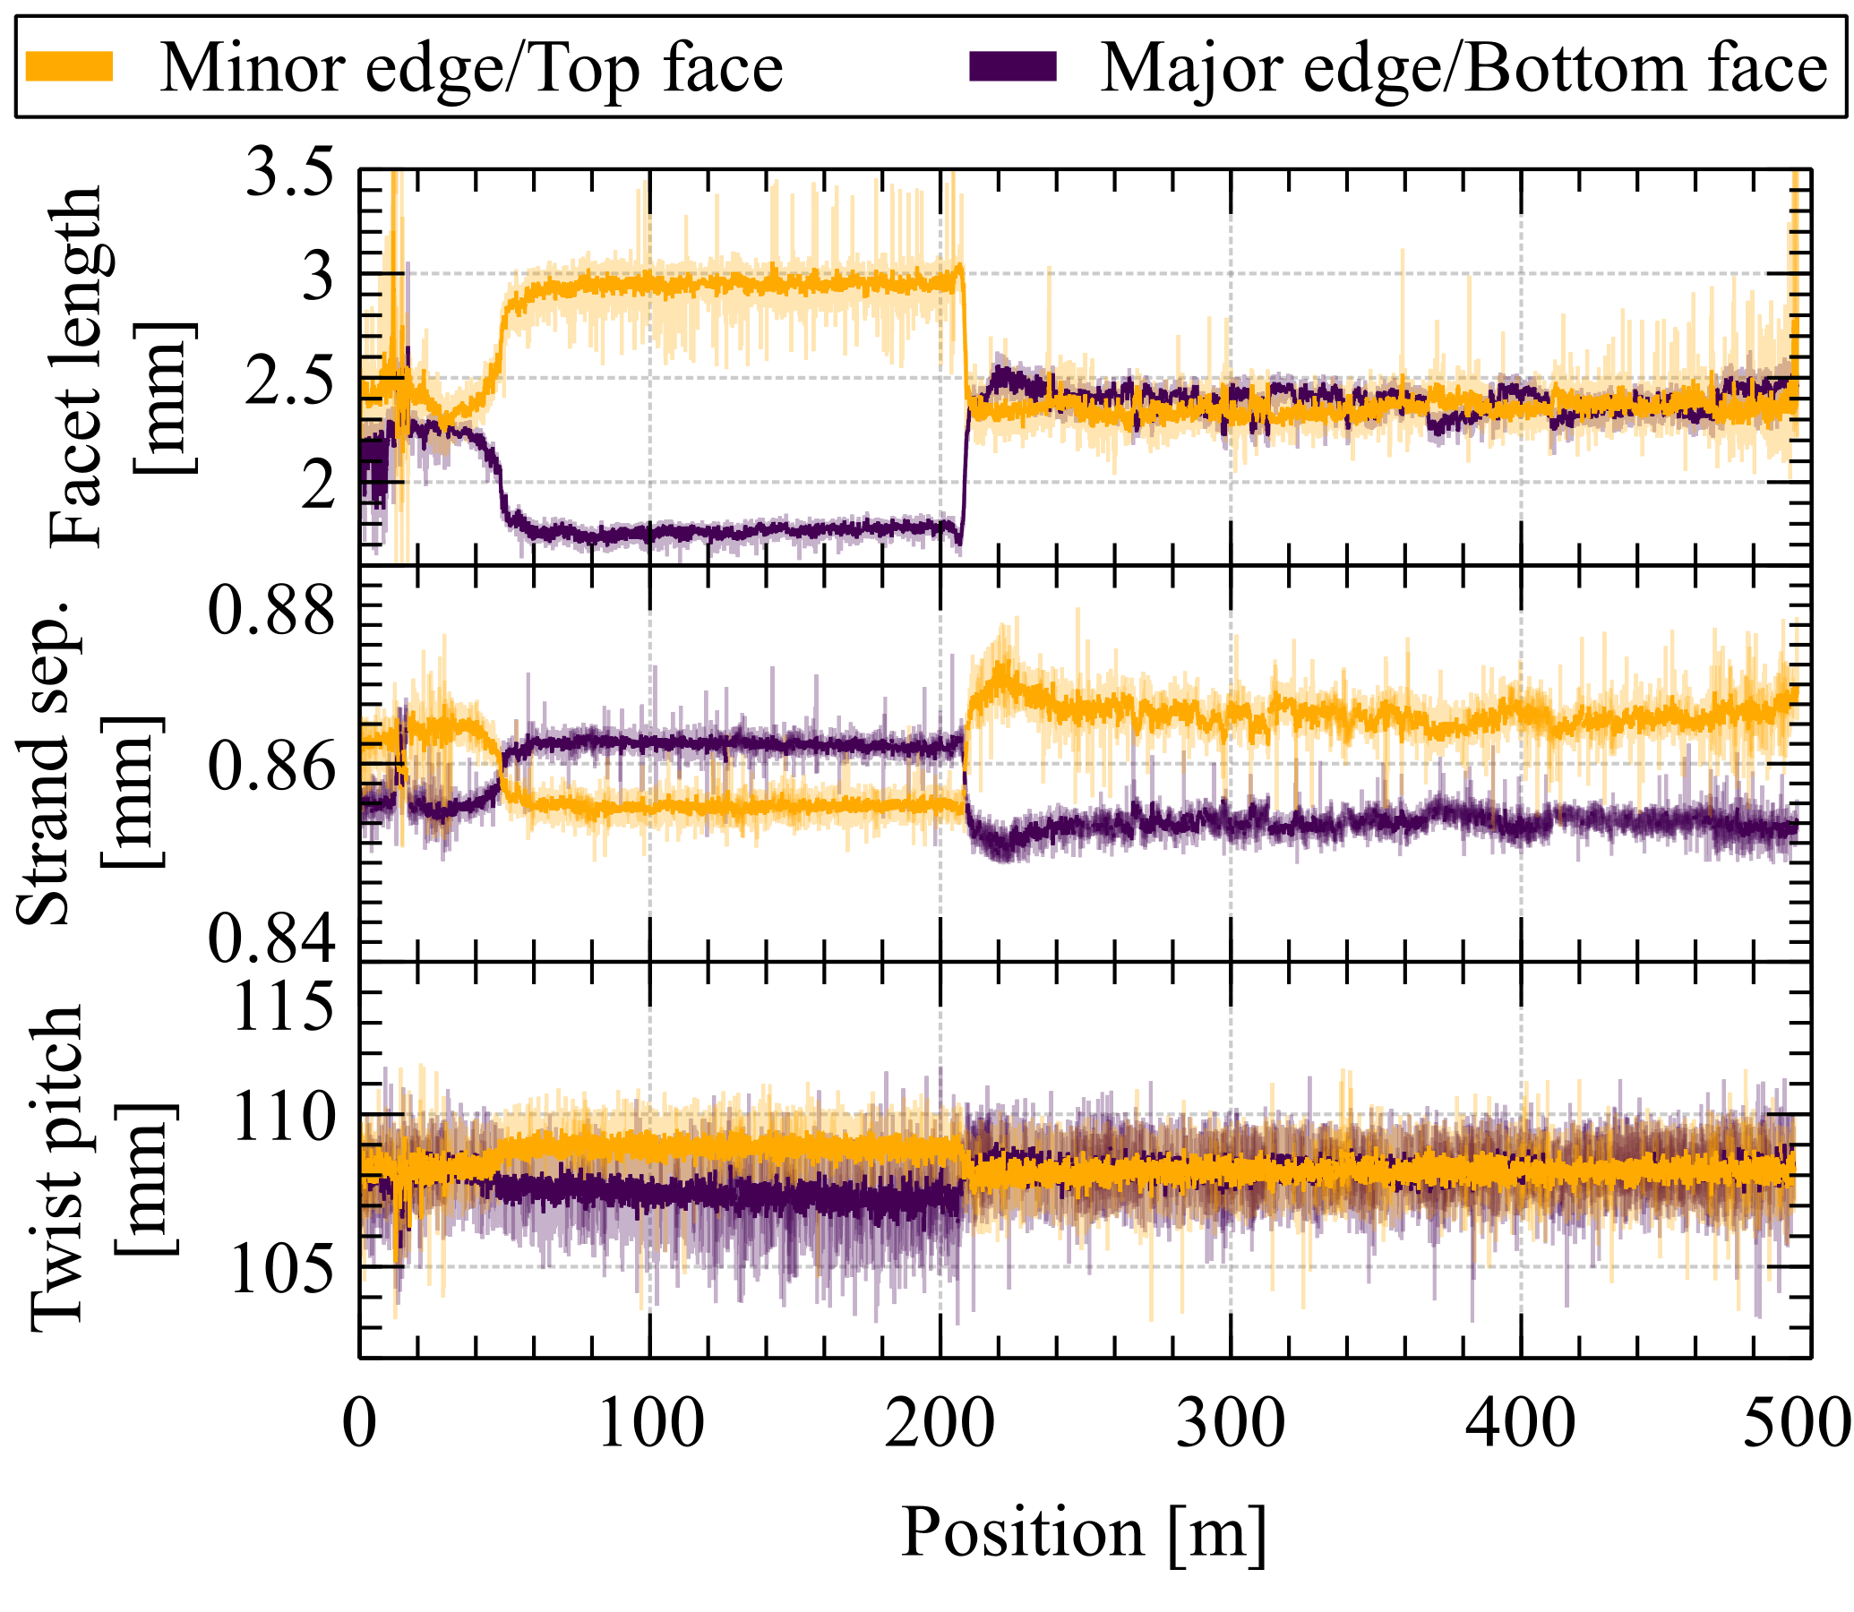
Fig. 7. Changes in deformation of strands within a cable during cable production run due to application of excess lubricant from ~200th m.
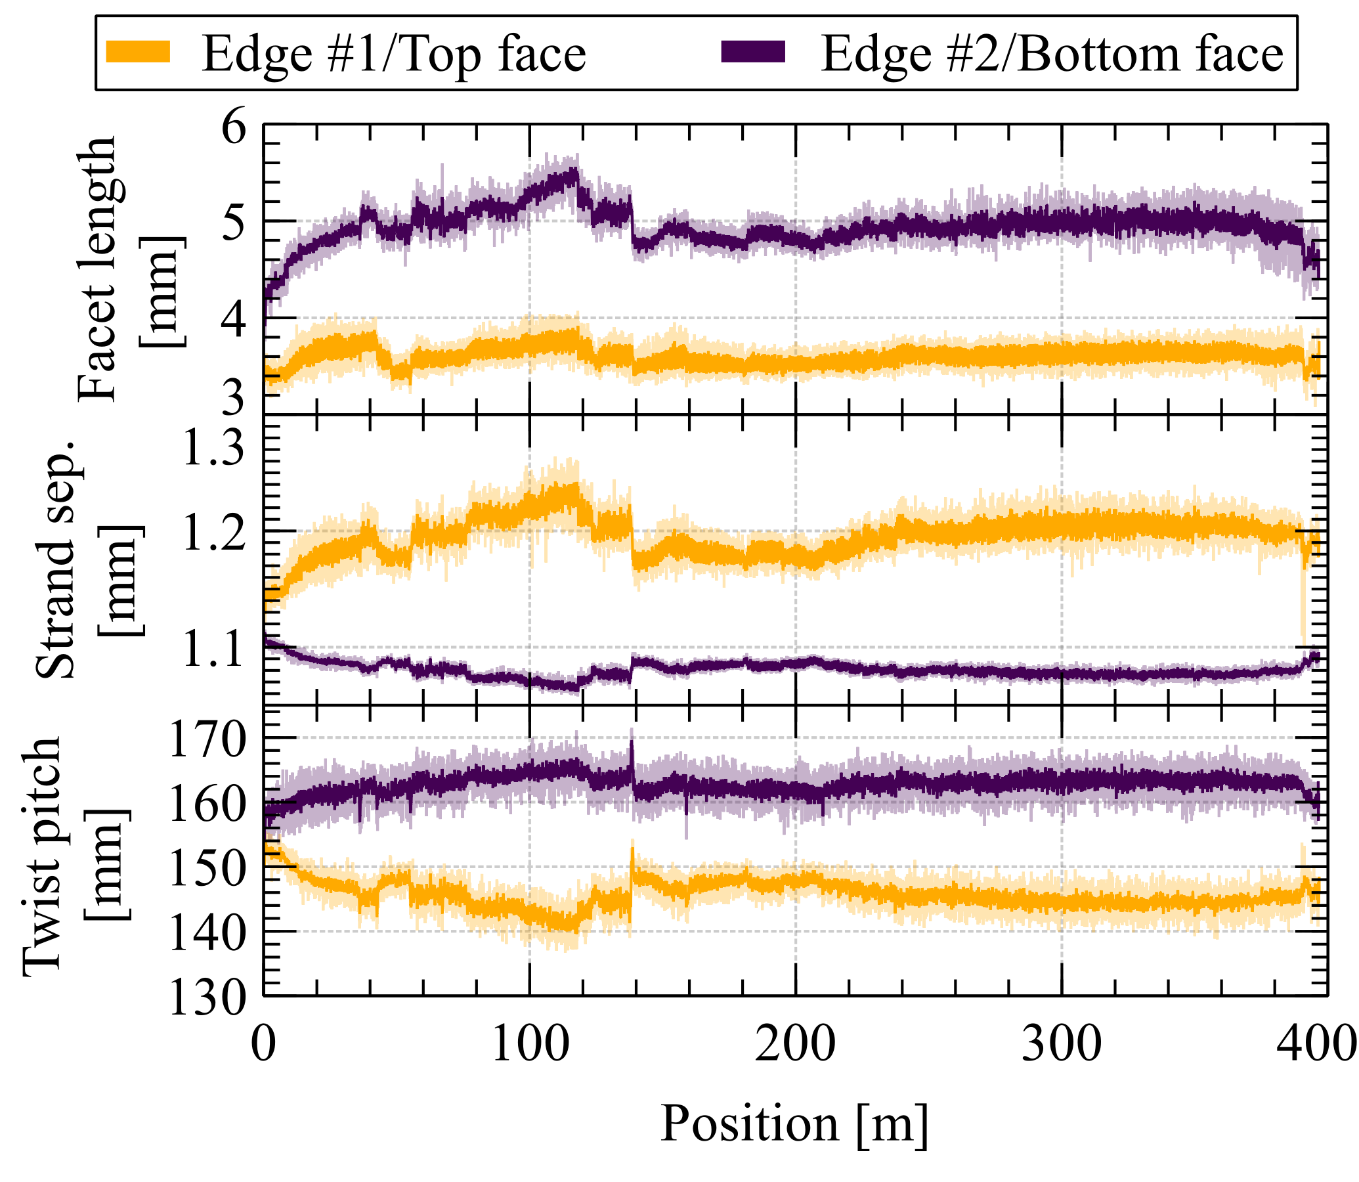
Fig. 8. Image analysis of data captured during cabling run W12OL1303, showing large facet sizes, large variation in strand-to-strand distance and divergence of cable half-pitch at the top and bottom cable faces.

Case study III: cable development
In this example, we will describe the prototyping of a challenging 44 strand cable using 1.1 mm diameter RRP® strands of 162/169 restack design (cable ID: W12OL1303). This is the scaled-up prototype run of the TFD cable [10] with a 155 mm cable twist pitch. The expected facet length was 3.5 mm in the cable direction (or ~3.9 mm facet length by the best-fit ellipse) at the overlapping limit.
It was observed that, upon reaching the target cable dimensions and production rate, a large size difference between cable edge facets on either edge of the cable developed, even though the cable does not have a keystone angle. This is evident in Fig. 8. In addition, the stand separation on the top face of the cable showed a large variation which presented itself as gaps between strands on the top cable face.
Several adjustments such as rosette position as well as amount of lubrication were made during the run up to cable length of ~150 m, but they did not yield significant improvements. Nevertheless, the cable parameters remained stable for the remainder of the cabling run.
Not evident from the cable appearance but revealed by the image analysis was a notable difference in the cable twist half pitch as measured from strand angles on the top and bottom faces of the cable. The total twist-pitch, which was controlled by gear, was still within specification. This difference in strand deformation between the top and bottom cable faces was identified to be misaligned mandrel position, biased towards the top roller and causing an apparently asymmetry of the mandrel. The initially centered mandrel had become misaligned as larger than expected displacement of top roller was needed to compensate for a large spring-back upon the cable’s exit from roller aperture, in order to achieve the target cable thickness. Although the cable dimensions as well as RRR (extracted strand cable edges >100) met the required specifications, the potential mandrel misalignment will nevertheless be mitigated in the subsequent cabling runs.
Additional frequency (Fast Fourier Transform, FFT, see Fig. 9a) analysis can convert what appears to be signal noise into useful information. For instance, in the present case study, it shows a presence of periodicities within the measured parameters that are consistent with the twist pitch of the cable as well as the vertical roller circumference. Periodicity at twist pitch can be caused by a number of cable manufacturing parameters that can slightly change at that frequency, such as slight differences in strand tensions within the cable (see III.B) or even small non-uniformity in wire diameter among the strands in the cable, among other things. On the other hand, strong periodicity matching roller circumference may indicate roller wear or manufacturing defect, or compliance somewhere along the drivetrain of the vertical rollers that are each actively and independently driven by a DC motor. In case of quality issues, the suspected reasons can then be eliminated one-by-one through inspection of the components matching the identified periodicities.
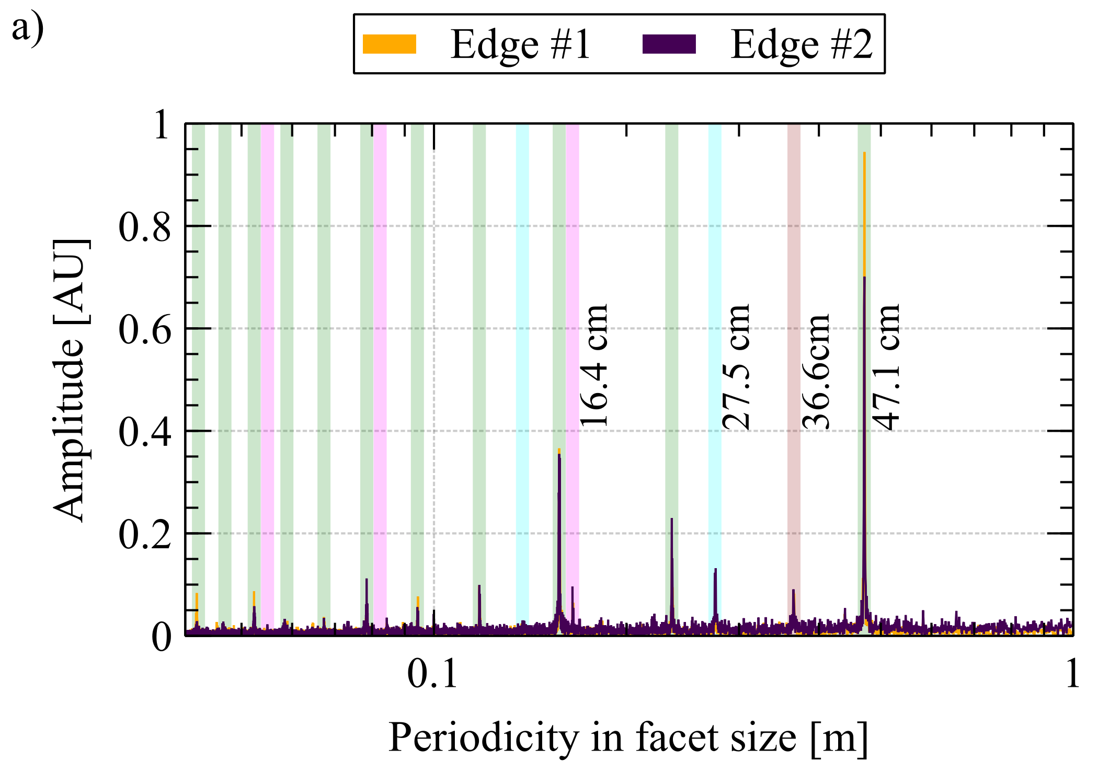
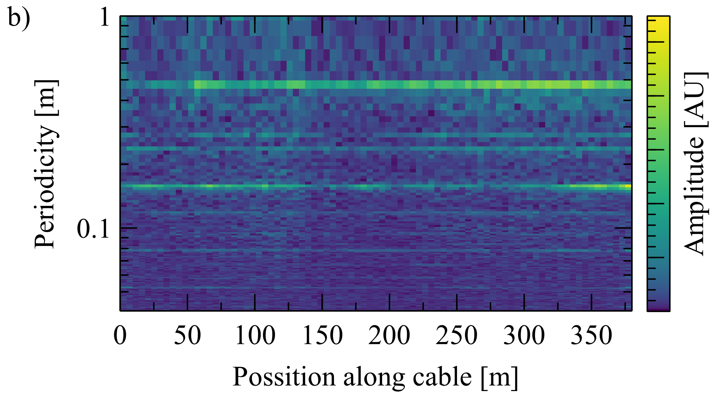
Fig. 9. a) FFT of the cable edge facet size showing periodic features present. The spectrum is dominated by the 47.1 cm peak (corresponding to vertical roller circumference) and its harmonics. The peak at 16.4 cm is related to the cable twist pitch, peaks at 27.5 and 36.6 cm are related to the roller guides present near the imaging cameras. Each principal peak and its corresponding harmonics are indicated by the same color, b) spectrogram showing how peak intensities in a) vary during cabling run.
Furthermore, the FFT can be performed for small discrete cable length intervals and then plotted as color intensity spectrogram over the entire cable length to show any subtle changes in the period peak positions and their intensities over time (Fig. 9b). When the spectrogram analysis is combined with other observations such as the cable tension measured by the load cell on the Turkshead, or sound at specific frequency occurring at regular intervals, these together can become powerful diagnostic tools. Hitherto, our analyses have focused only on the principal frequencies, but it is likely that the harmonics also contain a wealth of information to be explored.

Conclusion
Imaging coupled with appropriate analysis has been established as a powerful quality control and troubleshooting tool for Rutherford cable fabrication at LBNL. Not only do the continually captured images provide assurance of the cables manufactured being defect-free and yield useful information non-destructively of the strand deformation state throughout the entire length of the cable, but advanced FFT analyses can also give insights into the state of the components of cabling machine. This is invaluable for diagnosing potential issues that can arise during routine cable manufacture but especially when new cable geometries are being developed.
Experience at LBNL has shown that the imaged strand facet sizes can serve as a good indicator of the local RRR preservation at the cable edge, without having to performing the lengthy heat treatment and cryogenic temperature measurements. It also has the advantage of having a quicker turnaround time than transverse cross section metallography. However, the quality association requires considerable efforts to establish with different Nb₃Sn wire designs (e.g. RRP® vs. PIT). At LBNL, such baseline data has been collected for the AUP MQXFA cables, and is being used as a guideline for new cable geometries using similar strand types.
Although parts of the analyses described here can be done in real time, storage and offline image processing has allowed for more thorough analysis. This also provides an advantage of allowing us to reexamine data if new analysis methods are developed. Nevertheless, with advancing computer power, a hybrid approach is being actively considered to provide the cabling machine operator and engineer with real-time feedback.

Acknowledgment
The authors gratefully acknowledge the contributions of Daryl Barth, Dan Dieterich, Hugh Higley, Mariusz Juchno, and Abdi Salehi who procured and set up the Keyence system, including the prisms and computer storage, and of Jonathan Lee, Ethan Sprague, and Edward Stafford, intern students who helped processed some of the acquired data.
The work performed at Lawrence Berkeley National Laboratory was supported by the Office of High Energy and Nuclear Physics, U. S. Department of Energy, under contract No. DE-AC02-05CH11231.

References
[1] L. D. Cooley, A. K. Ghosh, D. R. Dietderich, and I. Pong, “Conductor Specification and Validation for High-Luminosity LHC Quadrupole Magnets,” IEEE Trans. Appl. Supercond., vol. 27, no. 4, pp. 1–5, Jun. 2017, doi: 10.1109/TASC.2017.2648738.
[2] L. Rossi, “Manufacturing and Testing of Accelerator Superconducting Magnets,” CAS-CERN Accel. Sch. Supercond. Accel. - Proc., pp. 517–546, Jan. 2015, doi: 10.5170/CERN-2014-005.517.
[3] J. Royet and R. Scanlan, “Manufacture of keystoned flat superconducting cables for use in SSC dipoles,” IEEE Trans. Magn., vol. 23, no. 2, pp. 480–483, Mar. 1987, doi: 10.1109/TMAG.1987.1064926.
[4] P. V. C. Hough, “Machine Analysis of Bubble Chamber Pictures,” Conf. Proc. C, vol. 590914, pp. 554–558, 1959.
[5] J. Fleiter, S. Peggiani, A. Bonasia, and A. Ballarino, “Characterization of Nb₃Sn Rutherford Cable Degradation Due to Strands Cross-Over,” IEEE Trans. Appl. Supercond., vol. 28, no. 4, pp. 1–5, Jun. 2018, doi: 10.1109/TASC.2018.2809474.
[6] G. Apollinari, R. Carcagno, G. Ambrosio, S. Feher, and L. Ristori, “US contribution to the High Luminosity LHC Upgrade: Focusing quadrupoles and crab cavities,” J. Phys. Conf. Ser., vol. 1350, no. 1, 2019, doi: 10.1088/1742-6596/1350/1/012005.
[7] I. Pong, L. D. Cooley, A. Lin, H. C. Higley, and C. Sanabria, “Diameter quality control of Nb₃Sn wires for MQXF cables in the USA,” IEEE Trans. Appl. Supercond., vol. 29, no. 5, 2019, doi: 10.1109/TASC.2019.2909238.
[8] I. Pong, M. Naus, and E. M. Lee, “302.2.03 Report on cable P43OL1139,” [Online], 2020. https://us-hilumi-docdb.fnal.gov/cgi-bin/private/ShowDocument?docid=3337.
[9] B. Bordini et al., “The Bundle-Barrier PIT Wire Developed for the HiLumi LHC Project,” IEEE Trans. Appl. Supercond., vol. 27, no. 4, p. 6000706, Jun. 2017, doi: 10.1109/TASC.2016.2640760.
[10] I. Pong et al., “Cable Design and Development for the High-Temperature Superconductor Cable Test Facility Magnet,” IEEE Trans. Appl. Supercond., vol. 31, no. 7, 2021, doi: 10.1109/TASC.2021.3094410.

The work performed at Lawrence Berkeley National Laboratory was supported by the Office of High Energy and Nuclear Physics, U. S. Department of Energy, under contract No. DE-AC02-05CH11231. (Corresponding author: Algirdas Baskys.) A. Baskys, I. Pong, and E. M. Lee are with Lawrence Berkeley National Lab, Berkeley, CA 94720 USA (e-mail: abaskys@lbl.gov). C. Sanabria was with Lawrence Berkeley National Lab, Berkeley, CA 94720 USA. He is now with Commonwealth Fusion Systems, Cambridge, MA 02139 USA. Color versions of one or more of the figures in this paper are available online at http://ieeexplore.ieee.org. Digital Object Identifier will be inserted here upon acceptance.

