Strategic Plan for the LHC Accelerator Research Program

Eric Prebys, Giorgio Ambrosio, Rama Calaga, John Fox, Tom Markiewicz, GianLuca Sabbi, Peter Wanderer, Alexander Zlobin

# Introduction

The United States has played and will continue to play a large in the Large Hadron Collider. In addition to the major role that US groups play on the LHC experiments, the US has also contributed significantly to the accelerator itself. This began with the construction of the final focusing triplets and feedboxes, and has continued through a number smaller construction and R&D projects over the years since. Starting in 2004, much of the work has been managed by the US LHC Accelerator Research Program (LARP), but there have been some projects organized through bilateral agreements between CERN and individual US labs.

CERN is in the process of formal design study to finalize plans for a series of upgrades over the next decade, with the ultimate goals of a *leveled* luminosity of 5x1034 cm-2s-1 for at least several hours. The key components of this upgrade will be

* Large aperture, high gradient quadrupoles in the final focusing triplet. These may also have to be significantly more radiation hard than the present quadrupoles. The baseline plan is to use Nb3Sn, based on the R&D work done by LARP.
* Crab cavities to reduce the crossing angle of the bunches at collision. Crossing angle has only a minor effect on the luminosity now, but at smaller beta function the effect becomes much more important, and in fact the new quadrupoles would have little benefit without some sort of compensation. Crab cavities can also provide a straightforward method of luminosity leveling.

LARP has played a significant role in the development of both of these technologies, and the adoption of Nb3Sn as the baseline technology for the triplet upgrade is due largely to the demonstration magnets built by LARP. It would therefore be natural to assume that the US would play a role in the construction and implementation of these technologies into the LHC. However, the scope of these projects is well beyond what could be reasonably managed within the LARP infrastructure.

The purpose of this document is to summarize possible US contributions to the LHC, based both on the work of LARP and relationships between CERN and individual US labs. The cost scale of all possible contributions could exceed $200M, so it’s important to articulate a long-term plan, begin work to secure funding, and set priorities in the likely event that such funding will not be sufficient to pursue all opportunities.

The goals of the proposed projects are in harmony with those expressed in the Strategic Plan of the DOE Office of Science to “explore the fundamental interactions of energy, matter, time and space,” as well as with its mission to “keep the U.S. at the forefront of intellectual leadership” (DOE/SC-0079, February 2004). These goals have been endorsed through internal as well as external reviews of the U.S. GAD Program and LARP, and were supported by the EPP-2010 study conducted by the National Academy. For example, the first itemized finding of the EPP-2010 report states: “The study of LHC physics will be at the center of the U.S. particle physics program during the coming decade,” and the report’s major action item commends: “The highest priority for the U.S. national effort in elementary particle physics should be to continue to be an active partner in realizing the physics potential of the LHC experimental program.” This envisions full participation in LHC upgrades: “As potential upgrades to the detectors and the accelerator are motivated and defined through scientific results, the U.S. particle physics program should consider the provision of in kind contributions as appropriate.” The most recent P5 subpanel of HEPAP in its 2008 report “U.S. Particle Physics: Scientific Opportunities - A Strategic Plan for the Next Ten Years” states: “Significant U.S. participation in the full exploitation of the LHC has the highest priority in the US high-energy physics program. The panel recommends support for the US-LHC program, including U.S. involvement in the planned detector and accelerator upgrades.”

# Potential US Contributions to the LHC

There are many areas in which the US could contribute to the LHC. In this document, we are focusing on large projects, those which would cost on the order of at least $10M each. We have identified the following as the most interesting

## Nb3SN Quadrupoles for the Final Focus

The optics required to go to the design luminosity for the LHC upgrade go beyond what is possible with traditional NbTi magnets, and the baseline assumption is that the upgrade will use focusing quadrupoles with 150 mm aperture, based on Nb3Sn. The development and production of such magnets would follow naturally on the Nb3Sn work done within LARP, which has made the US a clear leader in this technology.

Significant investments in National Laboratory base programs and LARP have given the US a leadership position in Nb3Sn accelerator magnet technology. Following the successful tests of the LARP LR, TQ, LQ and HQ models, Nb3Sn technology is now regarded as the baseline for the new LHC IR. The development and construction of Nb3Sn quadrupoles for the LHC luminosity upgrade will contribute to further refining and expanding the unique US capabilities in this critical sector of accelerator technology.

We therefore consider it a high priority that the US would play a major role in the production of such magnets. The large cost of this production (discussed in the next section) makes it clear that this would be the dominant US contribution in all scenarios.

At the moment, the LARP magnet program is scheduled to end with the production and testing of the “LHQ” – a 4m long quadrupole with a 120 mm aperture. CERN has agreed that this magnet will serve to “establish the technology” as viable for the production of the actual triplets. The test is scheduled to take place in 2014. By then of course, planning will already have to be well along for the production of the actual triplet magnets.

Because the aperture of the magnet has changed the production project would likely include a short demonstration magnet with a 150 mm aperture, followed by a prototype, which would include all necessary alignment and cooling features. It is currently envisioned that the production magnets will use a two layer coil design with a continuously wound 18 mm wide cable. The baseline conductor is OST-RRP, although CERN is investigating PIT as an alternative.

The effective length of each magnet needs to be ~8 m, which will be assembled by combining two 4 m cold masses in a single cryostat. The construction of 8 m cold masses was discussed, but it was decided that the 4 m lengths posed less technical risk, as the infrastructure to produce these lengths already exists at US labs.

The inner and outer quad in each triplet will be comprised of two 4 m cold masses in single cryostats while the central quad will be four 4 m cold masses in one or two cryostats. The production would consist of the 16 required cold masses (4 cold masses x 2 sides x 2 interaction points) plus four spares.

It is currently planned that the US contribution will focus on the production of the cold masses, while the cryostats will be designed and built at CERN.

## Crab Cavities

Because the bunch spacing in the beams is shorter than the distance to the separation dipoles, the beams must cross at an angle to avoid parasitic collisions. This causes a reduction in luminosity, which grows as * decreases. It is a small effect at the current value of *, but would largely cancel out any benefit of decreasing the * if not corrected or compensated in some way.

The baseline plan is to use “crab cavities” to transversely deflect the head and tail of each bunch, such that they collide head on in spite of the fact that the beams are crossing. It is currently planned to use a local crabbing scheme, in which each bunch in each beam is crabbed before each of the two high luminosity interaction regions, and returned to a nominal orientation by a complementary cavity afterwards. Thus, a total of eight crabbing stations would be required, each likely consisting of two cavities to provide the required transverse kick.

Crab cavities also provide a very natural way to level the luminosity, but starting out un-crabbed, or even *anti*-crabbed, and then introducing crabbing angle as the beam current is reduced.

Because of the length of the LHC bunches, the cavities will need to run at 400 MHz to avoid filamenting at the head and tail of the bunch. This presents a significant technical challenge, in that the beams are only 19.2 cm apart, and separation doglegs near the interaction regions are not feasible. This means that traditional elliptical cavities are far too large and these cavities will have to be of a novel “compact” design. As a result of an intense R&D program initiated within the LARP and EuCARD networks over the last 4-5 years, novel high performance compact deflecting cavities at 400 MHz have been proposed and are under development. These new topologies make it possible to integrate the cryomodules in the present LHC interaction region and also allow for the horizontal/vertical alternating crossing scheme which is a prerequisite.

There are currently three designs being considered: two being developed by LARP and one being developed in the UK at Lancaster University.

There is still some concern over the safe operation of crab cavities in the LHC; that is, whether there are failure modes which could result in damage to the machine. Establishing a safe mode of operation is the key milestone to the project’s moving forward.

Once the technological down selection is made, the plan is to place two prototype cavities in a cryomodule, and test them in early 2015 in the SM18 test facility at CERN. The test module would then be placed in the SPS, to be tested during the planned beam test period in 2016, just before LS2.

The final production would consist of the 8 required cryomodules (2 beams x 2 sides x 2 experimental regions) plus 2 spares. These would have to be ready for installation during LS3.

The scope of US contribution to the overall crab effort is a matter for discussion and depends largely on funding. The US could contribute to the design and R&D, or to the fabrication of just the cavities, or perhaps to complete cryomodules.

With these proposed contributions, LARP would continue to play a key role in the LHC and its luminosity upgrade, at the same time maintaining and promoting development of US expertise in the field of novel superconducting RF cavity and cryomodule design.

## 11 Tesla Dipoles

The LHC operational experience at 3.5 TeV proton beam energy and approximately 30% of the design luminosity indicates that the losses in the experimental regions from interaction debris can be an issue for both proton and for ion beams. The losses in the dispersion suppressors of interaction regions IR1 (ATLAS), IR2 (ALICE) and IR5 (CMS) have already affected the LHC operational efficiency including radiation effects on electronics, delayed access to the machine during beam operation due to radiation constraints, potential impact on magnet lifetime, etc. To improve the collimation efficiency by a factor of 15-90, additional collimators are foreseen in the DS regions around several LHC straight sections.

The mission of this project is participation in and contribution to upgrades of the LHC beam collimation system planned at CERN for 2017-2021. The goal of the LHC collimation system upgrades is to provide reliable and efficient machine operation with proton and ion beams at the nominal and later at the ultimate beam intensity and luminosity. These upgrades involve installation of additional collimators in LHC lattice in the dispersion suppression (DS) areas around interaction regions (IR) in points 1, 2, and 5 and in the momentum and betatron cleaning insertions near points 3 and 7. The required space for the collimators will be provided by replacing some regular LHC dipoles (MB) with shorter but stronger dipoles with the same bending strength.

To provide a 3.5 m longitudinal space needed for the additional cryo-collimators, a solution based on 11 T Nb3Sn dipoles as a replacement for several 8.33 T Nb-Ti LHC MBs is being considered. These twin-aperture dipoles will operate at 1.9 K and be powered in series with the main dipoles. They will deliver the same integrated strength of 119 T∙m at the LHC nominal current of 11.85 kA. Recent progress in the development of Nb3Sn accelerator magnets in U.S. indicates that this technology can meet the requirements. Providing the same space for warm collimators in the cold LHC ring without using 11 T dipoles would involve design and fabrication of several complicate cryo-components as well as removing, bringing to the surface and re-installing 32 cold objects including 24 main magnets, 2 connection cryostats (new types), 2 shuffling modules, 2 DFBAs, 2 warm-cold transitions (new design). The longitudinal and radial displacement of several quadrupole and dipole magnets will certainly provide a negative impact on beam dynamics jeopardizing the LHC performance.

Technical risks for the LHC associated with implementation of 11 T Nb3Sn magnets are limited since thanks to the positive results achieved at FNAL during the past decade in the framework of core High Field Magnet R&D program and participation in US-LARP. The back-up plan to the construction and installation of Nb3Sn dipoles in LHC is the painful, but viable, relocation of existing magnets and cryoboxes in the LHC lattice.

To demonstrate the feasibility of this approach, CERN and FNAL have started in 2010 a joint R&D program with the goal of building by the end of 2014 a 5.5-m long twin-aperture Nb3Sn dipole prototype suitable for the DS region upgrade. This joint R&D effort will provide also conditions for the transfer of Nb3Sn magnet technology to CERN.

The first phase of this program is the design and construction of a single-aperture 2-m long demonstrator dipole magnet, delivering 11 T at 1.9 K in a 60 mm bore with 20% margin. The main goal of this model is to demonstrate the quench performance, nominal field, and operation margin of the Nb3Sn coils in a single aperture structure. In addition, the data on magnet field quality and quench protection will be acquired for the further optimization and selection of conductor, magnet design and fabrication technologies. The first single-aperture 2-m long demonstrator dipole has been designed and manufactured and now is being tested at FNAL.

The second phase of the program includes the fabrication and test of two 2 m long, twin-aperture demonstrator dipoles in 2013 to confirm the final magnet design, demonstrate the magnet performance parameters and their reproducibility as well as transfer Nb3Sn technology to CERN/Europe. And finally, the third phase will focus on the design scale up and prototype development and test in 2014.

Following the successful long dipole prototype and the completion of the LHC consolidation in 2014, CERN would be in the position to make a decision on the feasibility of the overall scheme to replace Nb-Ti magnets with 11 T Nb3Sn magnets for the insertion of additional collimators around the LHC ring in IR1, IR2 & IR5 and later, in IR2 and IR7. If this approach will be accepted, CERN and FNAL would share the responsibility for design, construction and collaring of the coils, while CERN would assemble the collared coils with iron yokes, install the cold masses in cryostats, and test the magnets. The construction phase would be managed by CERN with active participation by FNAL as deemed appropriate and approved by funding agencies.

Both FNAL and CERN have appropriate infrastructure including laboratories for SC strand and cable testing; cabling machines to produce multi-strand Rutherford-type cables; magnet production facilities with short and long tooling for coil fabrication and equipment for magnet assembly; magnet test facilities to test magnet models and prototypes in superfluid and normal helium. Both laboratories have skillful personnel including magnet scientists, engineers and technicians capable of designing, fabricating and testing SC accelerator magnets as well as supporting infrastructures to provide magnet and tooling design, components procurement and quality control. To perform the described R&D and later to accomplish the collared coil fabrication according to CERN schedule for LS2 and LS3, FNAL infrastructure will need some upgrades as well as the FNAL magnet group staff has to be adjusted accordingly.

## D2 Separator Magnets

As part of the High Luminosity Upgrade of the LHC (LHC-HL), CERN plans to increase the aperture of the D2 IR dipoles located near ATLAS and CMS. Present CERN plans call for a twin-aperture dipole with an integral field of 40 T·m, an effective length of 9.45 m (the same length as that of the 80 mm-aperture dipoles previously supplied by BNL), a central field of 4.23 T, and an aperture separation of 186 mm. The operating temperature is 1.9 K. The RHIC D0 dipole, which has an aperture of 100 mm, has been used as the D2 starting point for optics studies for the HL upgrade, and it is assumed that if these magnets are built in the US, they would be built entirely at BNL. Optics studies reported at LARP-LHC CM18 point to a coil aperture of 105 mm as being optimal. However, there are engineering and cost/schedule issues related to a 5 mm increase in aperture that need careful evaluation.

Production at BNL would take advantage of the 10 m coil production tooling (winding machine, cure press, ancillary tooling) that is being restored for use of the APUL project. The 10 m cold mass assembly tooling (collar, yoke, helium vessel, cryostat insertion) has been retained following its use in the US-LHC Project (although collaring tooling would need to be modified for the larger collars). The cryo test facility is also being modified for the APUL project, to accept 10 m magnets. The floor space in the production area now used by the NSLS II light source project will be vacated early in 2013, so there will be sufficient floor space for both D2 dipole and Nb3Sn quadrupole production. The coils for the two types of magnets will most likely be wound and cured on separate fixtures.

The existing RHIC D0 coil tooling is available for use in building a 3.6 m model magnet with 100 mm coils. This tooling would need to be designed and purchased if the coil aperture is 105 mm.

If the coil i.d. is 100 mm, no design work for the coil or its components has to be done, except to extend the length from 3.6 m (RHIC D0) to 9.45 m where appropriate. A complete new design would be needed for 105 mm coils. A new collar design is needed for either coil, since the RHIC D0 used the yoke as collar. If the yoke perimeter does not change from that used for the US-LHC twin-aperture magnets, no design work will be needed for the heat shield, cryostat, etc. The wall thickness of the coil’s cold bore tube needs study. An initial check of vendors found none who would make 10 m lengths of seamless tube in non-standard sizes.

Magnet components that require Long Lead Procurement include NbTi cable, yoke, shell, cold bore tube, collars, and cryostat. (Yoke material should probably be purchased at the same time as the yoke material for the quads.) LLP tooling includes the mandrel and coil form block.

The final production would be 4 cryostated magnets (2 sides x 2 experiments) plus 2 spares. These would be completed in time for LS3.

## High Bandwidth Feedback System

One significant area of R&D within LARP has been GHz bandwidth transverse feedback systems for the SPS. This effort has been focused on overcoming intensity limitations in the injector complex, and potentially LHC, from Ecloud and TMCI ( impedance driven) instabilities. The research has led to techniques and technical components which address intra-bunch instabilities, and has included significant machine measurements and beam dynamics simulations necessary to characterize the possible performance of these feedback techniques.

The task combines accelerator physics, simulation models of particle motion, control of dynamic systems, and high speed digital signal processing. The project continues to provide excellent material for Ph.D. students in accelerator physics and engineering throughout the task plan, including MD measurements and dynamics simulations as well as technical development of system functions.

The plan builds and continues the LARP effort for SPS instability control. This research path will use the proof-of-principle testbed and SPS machine measurements to specify a system architecture and system design for scalable and reconfigurable Instability signal processing. The major system elements include:

* Wideband beam motion pickups ( vacuum structures)
* Wideband beam kickers ( vacuum structures)
* Beam motion receiver and processing electronics
* 4 – 8 GS/sec. digital signal processing for intra-bunch instability control
* High-power GHz bandwidth RF amplifiers for beam excitation
* Signal processing firmware and data flow hardware
* System Timing and synchronization system to interface with SPS or LHC RF and accelerator systems
* Operator interfaces, control and monitoring software
* Beam diagnostic software and beam instrumentation systems necessary to configure and adjust the instability control system

The work must continue the machine measurement and technology development program building on the proof of principle system to be tested at the SPS in 2012 and continuing with wideband kicker installation in the 2013 shutdown..

This injector upgrade path will use the proof-of-principle testbed and SPS machine measurements to specify a system architecture and system design for scalable and reconfigurable Instability signal processing in the SPS and LHC . The dynamics measurements and achieved performance of the demonstrator will guide the functions and architecture of the full-function prototype system, with necessary diagnostics and operational software, be designed, fabricated and evaluated after the restart of the SPS.

This is an area of particular US expertise and potentially a high impact contribution to the LHC upgrades. There is a significant range in the possible scope of US contribution. It could consist of the planned prototype system, followed by modeling and design specifications of a full-feature production system , in which case it could probably be supported entirely within LARP. The work could be extended to the design and fabrication of the complete hardware/software for the signal processing, including high power RF amplifiers, pickups and kickers needed by the system. It is likely that these same techniques will be useful for the PS and the LHC, so that the number of systems fabricated, and the expense of the signal processing systems, RF power amplifiers, etc. would be fairly large and would have to be supported by an independent project.

In a related area, LARP expects to continue its involvement in the low level RF (LLRF) systems for the SPS and LHC upgrades. The existing LARP program has developed a beam dynamics/ LLRF system model which uses nonlinear simulation techniques to estimate the stability of the LHC beams and the RF systems. These models and related analysis has been highly-valued by the LHC commissioning team. The SPS RF upgrade will include new RF systems ( 2 frequencies) with new LLRF electronic systems. Based on the CERN requests, this simulation model can be updated to study the new SPS RF systems over a range of operating parameters, and can be used to develop technical specifications for the LLRF functions to quantify the impact of imperfections and technical characteristics on the beam. This type of beam-RF nonlinear modeling is also potentially a base to study the crab cavity LLRF and beam interaction in future years.

The major results are in models, software and knowledge, though it is possible that the insights from the work could lead to the development of new control techniques, with a related set of new LLRF system modules and functions. This effort scale is consistent with the existing LARP support. Many of the new ideas might be implemented as firmware updates to the next-generation LLRF functions in design at CERN. If the work went in the direction of developing a set of next generation LLRF control techniques, it is possible to include the design and fabrication of demonstration prototype LLRF hardware as a future expenses to be supported by an independent project.

## Collimation

Over the years, LARP has supported a number of R&D projects related to collimation. The most significant effort in terms of time and resources had been the rotatable collimator project. The collimators contain two multi-faceted jaws in which successive faces could be rotated into place in the event the previous face had been damaged by beam loss. These were originally conceived as a possible technology for secondary collimators around the ring, but now are being considered as protection devices for the experiments. At the moment, no concrete plan for production or installation is in place.

Although CERN has not finalized its plans for collimation, some activity has been scheduled. During LS1, it is planned to replace the tertiary Tungsten collimators in all IRs with similar collimators which have integrated BPMs. All other decisions on improvements to the collimation system will be taken after it is seen how the LHC performs post LS1. The list of possible enhancements to the collimation system includes extra collimators in the dispersion suppressors, with or without 11T dipoles, around the interaction points and/or the IR3 and IR7 collimation regions. Depending on radiation aging and impedance limitations, metallic secondary collimators might be installed. These may be made with the manufactured composite metals (Cu-Diamond, Mo-Graphite, ..) being investigated by CERN or made with elemental copper using the SLAC design. They will include BPMs if the so-equipped TCTs are seen to provide operational or benefits. The collimation system performance will depend on the required apertures, which will speak to impedance, which will depend on orbit stability and the lattice. Which hardware is installed during LS2 and which during LS3 is still an open question.

What is important to the LHC, CERN and to LARP is that LARP remain deeply involved, as it is, in all these areas of R&D, and be ready, when a definite direction is clearly indicated, to transition to a more project oriented organization.

Another area of LARP R&D involved the use of bent crystals which could be used as primary collimators to direct beam halo more cleanly into secondary collimators than an ordinary scattering collimator could. Beam tests of this technology at both Fermilab and CERN have shown promising results.

More recently, hollow electron beams have been investigated as a potential tool to remove beam halo. This work grew out of the studies of electron beams as a method of compensation for beam-beam effects. Collimation by hollow beams was demonstrated at the Tevatron, and plans are underway to possibly transfer the system to CERN for tests in the SPS and/or LHC.

Although crystal collimation and hollow electron beam collimation show promise, they are not yet part of the base line plan. Nevertheless, we must prepare for the possibility that they will be part of our long term planning.

In then end, there will be no final plan for collimation until after LS1, when it is seen how the machine behaves with 7 TeV beams.

# Cost and Schedule Estimates

In this section, we will present approximate costs for these proposals, with the caveat that some projects have more accurate funding projections than others. For example, the magnet program is at a fairly advanced stage of planning, so the cost estimates can be considered reasonably accurate. At the other extreme is collimation, for which the scope of even potential involvement is extremely uncertain, so a discussion of the scale of cost is the best we can hope for.

We assume that LARP will continue to be funded at some level throughout the upgrade, and R&D covered by LARP funding will be considered separately from the other costs of the projects. LARP is currently funded at $12-13M/year, about half of which is for the magnet program. We assume that the LARP magnet program will perform valuable work toward the launch of the production, but that once that production is fully under way, they LARP magnet program would likely be terminated. This will probably happen starting in roughly FY15. On the other hand, we assume that the Accelerator Systems and Programmatic Activities parts of LARP will continue to be funded at more or less the current level.

## Nb3SN Quadrupoles for the Final Focus

The LARP program has been largely defined by the magnet program since the beginning, but only in recent years has serious work gone into integrating the LARP activities into an overall plan to deliver magnets to the LHC for the high luminosity upgrade in 2022. Our current plan is for the US to deliver half the required cold masses, with Europe building the rest, as well as the cryostats. The proposed overall schedule is shown in Figure 1. The new short model and prototype represent an augmentation of the ongoing LARP efforts, which we estimate would cost about $42M over 6 years, which is roughly $15M over the LARP budget. The above estimate does not include the CERN contributions to the development of the 150 mm aperture short models, which is currently expected to be of the order of $7 M. The cost to build half the required cold masses would be $140M, including at 30% contingency. An approximate spending profile is shown in Table 1.

Table 1: Spending profile for Nb3Sn magnets, in M$. The total cost is shown, as well as the net cost after subtracting the assumed LARP contribution until the LARP magnet program is phased out.

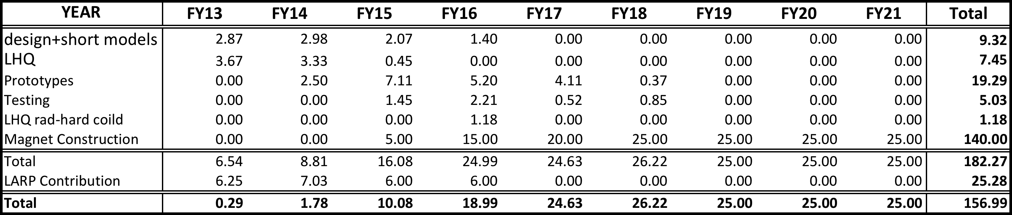



Figure 1: Schedule for development and production of Nb3Sn IR Quadrupoles. LARP-only activity is shown in the top third. LARP would also manage the prototype development, while the construction project would have to be an independent entity.

## Crab Cavities

The LARP contribution is significantly ramped up in FY12 to $946k, primarily allocated for cavity design studies of the two U.S. prototypes and beam dynamics studies in the presence of crab crossing. An additional request of $180k was requested from the contingency for material procurement and partial fabrication of the two U.S. prototypes.

The present level of funding in FY13 will allow for the completion of the surface treatment and cryogenic testing of the two U.S. prototypes and be delivered to CERN for further testing. It will also allow for the design of the HOM couplers and tuning structures along with studies related to multipacting of the cavity assembly. The fabrication of a Niobium model of the HOM coupler model is also anticipated within this funding which could be added to the prototype cavity for further tests. The use of existing vertical test facilities both in the U.S. and CERN are expected to be in kind. Some beam dynamics studies related to beam-beam and machine protection will be carried under this funding request.

To align/evolve the LARP R&D with the planned beam tests in the SPS, the budgets of FY13 and beyond would have to be adjusted to fabricate a two cavity beam line ready cryostat. Therefore, an additional $400k/lab/yr (ODU & BNL) from FY13-15 will be required to construct the two cavities for the SPS beams tests. These cavities will be dressed with a Helium vessel, tuner fixture, HOM couplers, vacuum and temperature gauges and other ancillaries that can be integrated into a horizontal cryostat. The power coupler design,material and integration will be the responsibility of CERN. An additional 700k/yr for the next 3 years (FY13-15) is requested to accommodate the FNAL proposal to design and fabricate a prototype cryomodule to host two cavities for SPS beam tests in collaboration with ODU-JLab and BNL. The SPS test is a major project milestone, and has to be done in 2016, to fit in with CERN’s long term planning.

The total cost for the the construction of the final 10 cryomodules by 2022 is estimated by CERN to be approximately $90M[1], as broken down in Table 1, with the approximate schedule shown in Figure 2: Approximate schedule for crab cavity production.

Table 2: Cost breakdown for construction of crab cavities, in M$. This assumes that US R&D work is done within LARP.

## 

## 

Figure 2: Approximate schedule for crab cavity production. This table includes the R&D and test work that would presumably be funded under LARP.

## 11 Tesla Dipoles

The cost and profile is shown in Table 2. The production period is planned for 6 years and assumes 50-50 distribution of the collared coil production between FNAL and CERN. It divided in two phases, 3 years each, starting collared coil production for 11 T dipoles in FY2015. The preliminary cost estimate for the 11 T dipole project is shown in Table below using fully loaded Labor rates for various categories at FNAL in FY11 and 3.5% per year escalation rate. A 30% contingency is added to take into account the program risks. The cost range estimate was made using inputs from US-LHC project, US-LARP Magnet R&D and FNAL HFM core program.

The 11 T dipole R&D is in progress at FNAL and CERN. Funds of 4M$ are needed to develop the 11 T dipole preliminary engineering design and fabricate and test two 2-m long twin aperture demonstrators in FY13, and then 5.5-m long dipole prototype in FY14. Additional funds of 1M$ are needed in FY15 to support the development and modification of critical infrastructure for the construction of 5.5 m long Nb**3**Sn dipole magnets.

Table 3: Cost Summary for 11 Tesla Dipoles, in M$

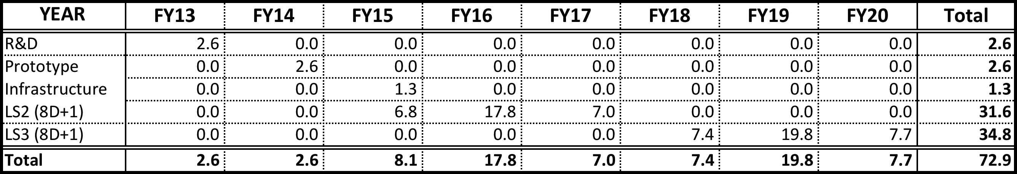

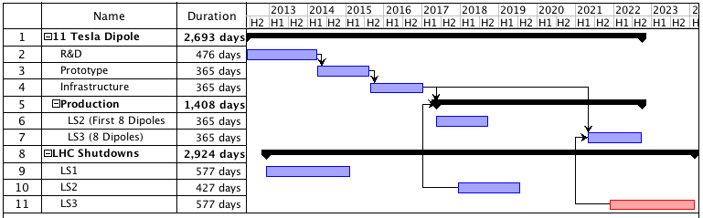

Figure 3: Schedule for full 11 Tesla dipole production

## D2 Separator Magnets

An estimate of the cost of the D2 magnets has been made based on the existing D2 magnets. The engineering cost and increased production cost associated with the larger aperture has been included, as has inflation since 2001. A 30% contingency is included The summary is shown in Table 3, and a schedule for the 105 mm option, assuming a construction start in FY15, is shown in Figure 1.

Table 4: Cost of D2 magnets, in M$

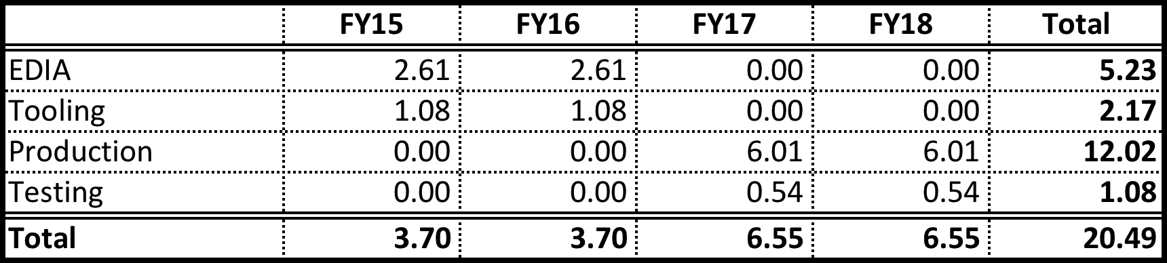

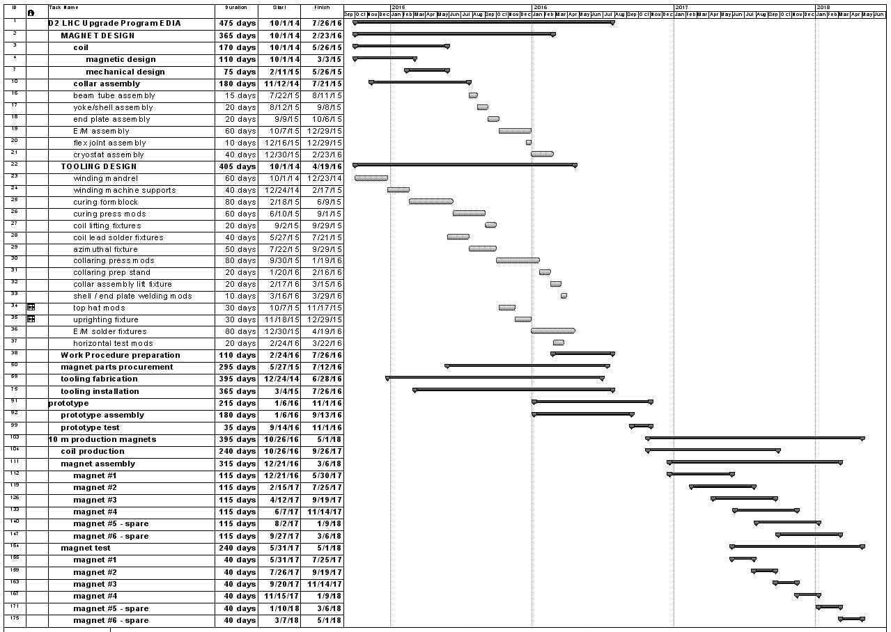

Figure 4: Schedule for construction of D2 separator dipoles

## High Bandwidth Feedback System

The current plan for the feedback system is to produce a fully functional prototype by 2019 which would be installed in either the SPS or the LHC. R&D and simulations would continue through 2014, with design of the prototype starting in 2015. Fabrication and implementation would begin in 2017. The associated costs are shown in Table 3, and the schedule in Figure 4.

Table 5: Cost Summary for feedback system, in k$.

|  |  |  |  |  |  |
| --- | --- | --- | --- | --- | --- |
|  | **Activities** | **Labor (k$)** | **M&S  (k$)** | **Travel  (k$)** | **Total, M$** |
| **FY13** | Develop proof of principle, simulations. Hardware prototyping. | 1000 | 100 | 40 | 1140 |
| **FY14** | 1000 | 100 | 40 | 1140 |
| **FY15** | Design of full function prototype. Control dynamics simulation | 1000 | 100 | 45 | 1145 |
| **FY16** | 1000 | 100 | 45 | 1145 |
| **FY17** | Production and implementation of full function prototype. | 1250 | 700 | 50 | 2000 |
| **FY18** | 1250 | 700 | 50 | 2000 |
| **Total** |  | 6500 | 1800 | 270 | 8570 |

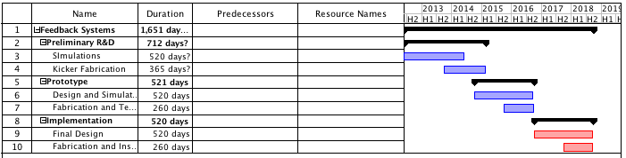

Figure 5: Schedule for implementation of feedback prototype

## Collimation

Because the collimation plans are highly uncertain, it’s impossible to give an accurate cost estimate. The most likely US contribution to the LHC would be some number of rotatable collimators. The estimated cost for each collimator is $300k, assuming CERN provides the motion system and controls. There are 15 slots in each beam for secondary metallic collimators, so if rotatable collimators are chosen for that application, we will be 30 collimators plus 5 spares, for a total of $9M Other possible scenarios would involve limited implementation of rotatable collimators and could be as few as five, or $1.5M.

## Budget Summary and Possible Options

Table 5 shows a summary of the maximum contributions for all projects discussed here. We assume LARP funding continues at the present level through FY16, after which, the magnet part of LARP is re-tasked to a magnet production project, reducing the annual funding to $7M. This would be a total spend on LARP of $85M. As we see, if the US pursues all potential opportunities, then the total would be roughly $434M, including the ongoing LARP funding. In this section, we will consider several options for scaling back the project.

Table 6: Cost summary by FY for all projects, in M$

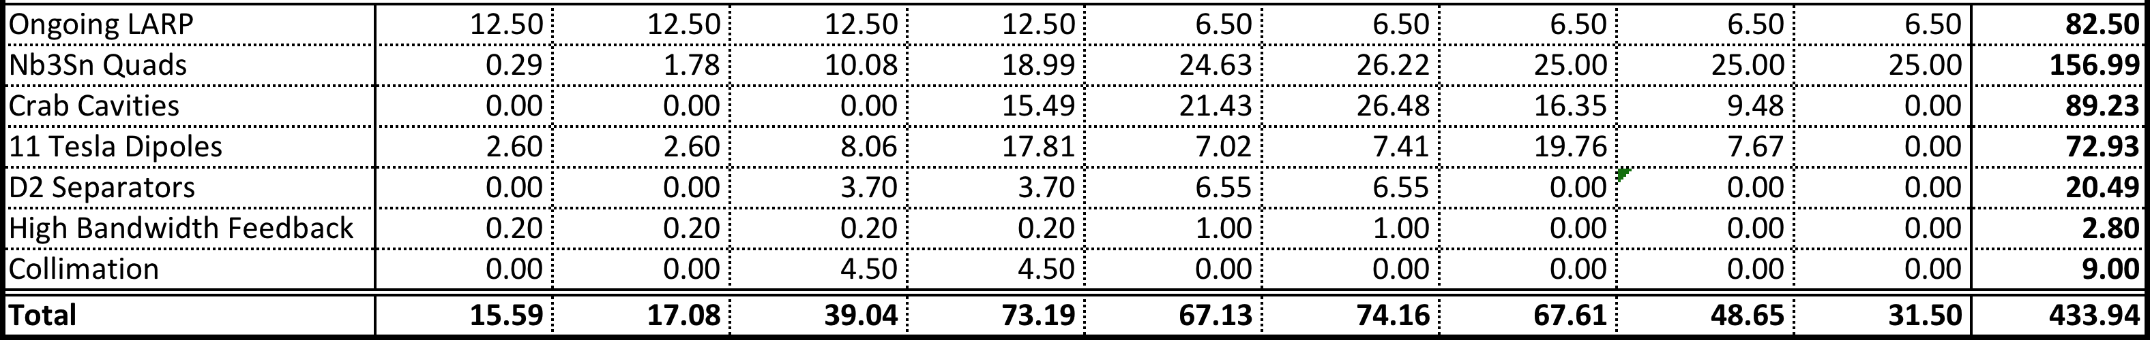

Three projects deserve special consideration:

* The Nb3Sn quadrupoles: The development of Nb3Sn has been the centerpiece of LARP R&D, so we consider US involvement in that program to be the highest priority. If we commit to build half the cold masses, then that would set a floor of $165M on funding above and beyond LARP. Should be 155=140+15 for prototype if LARP MS stays until FY18, otherwise add 6M$/year for each year w/o LARP On the other hand, it might be possible to scale back the commitment down to a smaller fraction of the cold masses, with the lower end being just involvement in the development of the prototype, which would be $25M.
* 11 Tesla Dipoles: This project exists as a bi-lateral agreement between CERN and Fermilab, and it is a very attractive project, because it leverages US expertise in Nb3Sn. The current budget is $73M to deliver all the cold masses. However, this could potentially be scaled back to half the cold masses, which would reduce the budget to about $40M.
* Note: At first look IR Quad and 11T estimates do not seem consistent with each other, perhaps by a factor 2 or more.
* D2 Separators: This project is also outside of LARP, and is being investigated as an agreement between CERN and BNL, at a total cost of $20M. Given the special tooling and infrastructure required, it is unlikely that this project could be broken down any further.

A critical question is whether or not to pursue the crab cavities. LARP has played a key role in advancing them to their current position as the base line option for the luminosity upgrade, but with an estimated $90M to produce the cavities, the US would probably only play a major part in the production under the more generous funding scenarios.

# Milestones and Decision Points

As we have shown, there is a broad range of possibilities for US involvement in the LHC upgrades. The most important consideration is the size of the US financial commitment to the project. Additionally, for each possible project, there are important milestones and decision points.

## Nb3SN Quadrupoles for the Final Focus

The recent choice of 150 mm as the aperture for the final focus quads was a very important milestone. Now, work can begin in earnest on concrete planning for production of magnets.

The most important single milestone is the completion and testing of the LHQ in 2014. It’s important to safeguard funding to insure that is achieved.

Now that the aperture has been chosen, it’s important to begin the CD process for the magnet production as soon as possible. The project requires extra funding outside of LARP starting in FY14, with construction funds beginning in FY16.

## Crab Cavities

The most important milestone in the continuation of the crab cavity effort is the determination as to whether the system can be operated safely; that is, whether the machine protection system will prevent damage to the LHC in the event of a cavity malfunction. This determination is scheduled to take place this year.

Following that, the next important milestone is testing of the two most promising prototypes in the SPS in 2015. This will establish whether the cavities have unforeseen consequences for beam stability.

## 11 Tesla Dipoles

The critical milestone in this project is the demonstration of the prototype in 2014. The decision also has to be made how many magnets to install. This will decided based on the needs for the collimation system, and the decision should be made within the next year.

## D2 Separator Magnets

These magnets are a straightforward application of established technology, so there are no particularly important milestones in the R&D process. The only important decision is whether the US will commit to the project.

## High Bandwidth Feedback System

The viability of the concept will be demonstrated at the end of 2014. If the technology looks promising, the design of the full scale prototype will be completed in 2016, with the functional prototype complete and ready for installation in 2018.

## Collimation

There is no concrete plan for the use of collimation being developed in LARP, but there are some important milestones in the development of individual technologies. The rotatable collimators have been a central part of LARP R&D since the beginning. The operational prototype will be shipped to CERN this year, for testing in the SPS and in the HiRadMat facility. This will establish the viability of the technology, after which a decision will have to be made how and if to incorporate this technology into the LHC.

Hollow electron beams as a method to remove beam halo have generated a great deal of interest. We are considering plans to move the electron gun form the Tevatron to CERN, for testing and possibly installation in the LHC during LS1 (2013).

# Conclusions and Future Plans

It’s clear that there are many options for important US involvement in the LHC luminosity upgrade. The key question is to determine the likely level of US funding for such upgrades. As we showed, if we were to pursue all possible opportunities, the cost would be roughly $434M, including ongoing funding of LARP.

If this is cost is determined to be too high, then we will have to prioritize based on the likely level of funding. We will proceed under the assumption that involvement with the Nb3Sn quadrupoles will remain the highest priority. Given the time scale of the project, it is important to begin the CD process as soon as possible now that the aperture decision has been made.

1. The CERN estimate was in FTEs for labor and CHF for M&S. We have converted this to US$ using $275k/(fully burdened FTE) and $1.04/CHF. We have removed the portion of the CERN cost estimate for R&D, as we assumed that is covered by the money being spent in LARP.